Linking Object-Z with Spec#

Graham Odds

May 2006

Word Count:

This report is submitted as part of the degree of Computer Science to the Board of Examiners in the Department of Computer Science, Durham University

Abstract

Contents

Chapter 1: Introduction . . . . . . . . . . . . . . . . . . . . . . . . . . . . . . . . . . . . . . 7
1.1 Chapter Introduction . . . . . . . . . . . . . . . . . . . . . . . . . . . . . . . . . . . . . . . . 7
1.2 Project Motivation . . . . . . . . . . . . . . . . . . . . . . . . . . . . . . . . . . . . . . . . . . 7
1.3 Terminology Definition . . . . . . . . . . . . . . . . . . . . . . . . . . . . . . . . . . . . . . 7
1.4 Project Objectives and Deliverables . . . . . . . . . . . . . . . . . . . . . . . . . . . 8
1.5 Project Plan . . . . . . . . . . . . . . . . . . . . . . . . . . . . . . . . . . . . . . . . . . . . . . . 9
1.5.1 Original Project Plan . . . . . . . . . . . . . . . . . . . . . . . . . . . . . . . . . . . . . . . . . 9
1.6 Report Structure . . . . . . . . . . . . . . . . . . . . . . . . . . . . . . . . . . . . . . . . . . . 10
1.7 Chapter Summary . . . . . . . . . . . . . . . . . . . . . . . . . . . . . . . . . . . . . . . . . . 11

Chapter 2: Project Background . . . . . . . . . . . . . . . . . . . . . . . . . . . . . . . 12
2.1 Chapter Introduction . . . . . . . . . . . . . . . . . . . . . . . . . . . . . . . . . . . . . . . 12
2.2 Specification . . . . . . . . . . . . . . . . . . . . . . . . . . . . . . . . . . . . . . . . . . . . . . 12
2.3 Object-Z . . . . . . . . . . . . . . . . . . . . . . . . . . . . . . . . . . . . . . . . . . . . . . . . . . 13
2.3.1 Community Z Tools (CZT) . . . . . . . . . . . . . . . . . . . . . . . . . . . . . . . . . . . . 14
2.4 Spec# . . . . . . . . . . . . . . . . . . . . . . . . . . . . . . . . . . . . . . . . . . . . . . . . . . . . 15
2.5 Compiler Design . . . . . . . . . . . . . . . . . . . . . . . . . . . . . . . . . . . . . . . . . . . 16
2.5.1 Parser Generators . . . . . . . . . . . . . . . . . . . . . . . . . . . . . . . . . . . . . . . . . . . 16
2.6 Chapter Summary . . . . . . . . . . . . . . . . . . . . . . . . . . . . . . . . . . . . . . . . . . 17

Chapter 3: Initial Design . . . . . . . . . . . . . . . . . . . . . . . . . . . . . . . . . . . . . 18
3.1 Chapter Introduction . . . . . . . . . . . . . . . . . . . . . . . . . . . . . . . . . . . . . . . 18
3.2 Design Decisions . . . . . . . . . . . . . . . . . . . . . . . . . . . . . . . . . . . . . . . . . . 18
3.2.1 Development Model . . . . . . . . . . . . . . . . . . . . . . . . . . . . . . . . . . . . . . . . . 18
3.2.2 Design Approach . . . . . . . . . . . . . . . . . . . . . . . . . . . . . . . . . . . . . . . . . . . 18
3.2.3 Design Principles . . . . . . . . . . . . . . . . . . . . . . . . . . . . . . . . . . . . . . . . . . . 19
3.3 System Architecture . . . . . . . . . . . . . . . . . . . . . . . . . . . . . . . . . . . . . . . . 20
3.4 Data Flow . . . . . . . . . . . . . . . . . . . . . . . . . . . . . . . . . . . . . . . . . . . . . . . . . 21
3.5 Component Designs . . . . . . . . . . . . . . . . . . . . . . . . . . . . . . . . . . . . . . . . 22
3.5.1 Lexer and Parser . . . . . . . . . . . . . . . . . . . . . . . . . . . . . . . . . . . . . . . . . . . . 22
3.5.2 Control . . . . . . . . . . . . . . . . . . . . . . . . . . . . . . . . . . . . . . . . . . . . . . . . . . . . 22
3.5.3 Transformer . . . . . . . . . . . . . . . . . . . . . . . . . . . . . . . . . . . . . . . . . . . . . . . . 22
3.5.4 SyntaxTree . . . . . . . . . . . . . . . . . . . . . . . . . . . . . . . . . . . . . . . . . . . . . . . . . 23
3.5.5 Exporter . . . . . . . . . . . . . . . . . . . . . . . . . . . . . . . . . . . . . . . . . . . . . . . . . . . 23
3.5.6 GUI . . . . . . . . . . . . . . . . . . . . . . . . . . . . . . . . . . . . . . . . . . . . . . . . . . . . . . . 24
3.6 Grammars . . . . . . . . . . . . . . . . . . . . . . . . . . . . . . . . . . . . . . . . . . . . . . . . 25
3.6.1 Grammar for Basic Deliverables . . . . . . . . . . . . . . . . . . . . . . . . . . . . . . . 26
3.6.2 Grammar for Intermediate Deliverables . . . . . . . . . . . . . . . . . . . . . . . . . . 27
3.7 Language Incompatibilities . . . . . . . . . . . . . . . . . . . . . . . . . . . . . . . . . . 30
3.8 Chapter Summary . . . . . . . . . . . . . . . . . . . . . . . . . . . . . . . . . . . . . . . . . . 30

Chapter 4: Implementation and Exploratory Work . . . . . . . . . . . . . . . . 31
4.1 Chapter Introduction . . . . . . . . . . . . . . . . . . . . . . . . . . . . . . . . . . . . . . . . 31
4.2 Configuration Management . . . . . . . . . . . . . . . . . . . . . . . . . . . . . . . . . . 31
4.2.1 Microsoft Sourcesafe . . . . . . . . . . . . . . . . . . . . . . . . . . . . . . . . . . . . . . . . 31
4.2.2 Eclipse . . . . . . . . . . . . . . . . . . . . . . . . . . . . . . . . . . . . . . . . . . . . . . . . . . . . 32
4.3 Input Syntax . . . . . . . . . . . . . . . . . . . . . . . . . . . . . . . . . . . . . . . . . . . . . . . 32
4.4 Parser Generator . . . . . . . . . . . . . . . . . . . . . . . . . . . . . . . . . . . . . . . . . . . 32
4.4.1 SableCC . . . . . . . . . . . . . . . . . . . . . . . . . . . . . . . . . . . . . . . . . . . . . . . . . . . 33
4.5 Mapping . . . . . . . . . . . . . . . . . . . . . . . . . . . . . . . . . . . . . . . . . . . . . . . . . . 34
4.5.1 Class Schema, including Axiomatic Definition and State Schema . . . . 34
4.5.2 Initial Schema . . . . . . . . . . . . . . . . . . . . . . . . . . . . . . . . . . . . . . . . . . . . . . . 35
4.5.3 Operational Schema . . . . . . . . . . . . . . . . . . . . . . . . . . . . . . . . . . . . . . . . . 35
4.5.4 Operation Promotion . . . . . . . . . . . . . . . . . . . . . . . . . . . . . . . . . . . . . . . . . 36
4.5.5 Operation Compositions . . . . . . . . . . . . . . . . . . . . . . . . . . . . . . . . . . . . . . 37
4.5.6 Visibility List . . . . . . . . . . . . . . . . . . . . . . . . . . . . . . . . . . . . . . . . . . . . . . . . 39
4.5.7 Predicates . . . . . . . . . . . . . . . . . . . . . . . . . . . . . . . . . . . . . . . . . . . . . . . . . . 40
4.6 Refinement . . . . . . . . . . . . . . . . . . . . . . . . . . . . . . . . . . . . . . . . . . . . . . . . 40
4.6.1 Methods . . . . . . . . . . . . . . . . . . . . . . . . . . . . . . . . . . . . . . . . . . . . . . . . . . . 41
4.6.2 Constructors . . . . . . . . . . . . . . . . . . . . . . . . . . . . . . . . . . . . . . . . . . . . . . . 41
4.7 Examples . . . . . . . . . . . . . . . . . . . . . . . . . . . . . . . . . . . . . . . . . . . . . . . . . 43
4.7.1 Example for Basic Deliverables . . . . . . . . . . . . . . . . . . . . . . . . . . . . . . . . 43
4.7.2 Example for Intermediate Deliverables . . . . . . . . . . . . . . . . . . . . . . . . . . 44
4.8 System Limits and Restrictions . . . . . . . . . . . . . . . . . . . . . . . . . . . . . . . 46
4.9 Chapter Summary . . . . . . . . . . . . . . . . . . . . . . . . . . . . . . . . . . . . . . . . . . 47

Chapter 5: Evaluation . . . . . . . . . . . . . . . . . . . . . . . . . . . . . . . . . . . . . . . 48
5.1 Chapter Introduction . . . . . . . . . . . . . . . . . . . . . . . . . . . . . . . . . . . . . . . 48
5.2 Soundness of Mapping . . . . . . . . . . . . . . . . . . . . . . . . . . . . . . . . . . . . . 48
5.2.1 Class Schema . . . . . . . . . . . . . . . . . . . . . . . . . . . . . . . . . . . . . . . . . . . . . . 48
5.2.2 Axiomatic Definition . . . . . . . . . . . . . . . . . . . . . . . . . . . . . . . . . . . . . . . . 48
5.2.3 State Schema . . . . . . . . . . . . . . . . . . . . . . . . . . . . . . . . . . . . . . . . . . . . . . 49
5.2.4 Initial Schema . . . . . . . . . . . . . . . . . . . . . . . . . . . . . . . . . . . . . . . . . . . . . . 49
5.2.5 Operational Schema . . . . . . . . . . . . . . . . . . . . . . . . . . . . . . . . . . . . . . . . . 49
5.2.6 Operation Promotion . . . . . . . . . . . . . . . . . . . . . . . . . . . . . . . . . . . . . . . . 50
5.2.7 Sequential Composition . . . . . . . . . . . . . . . . . . . . . . . . . . . . . . . . . . . . . 50
5.2.8 Conjunction Operator . . . . . . . . . . . . . . . . . . . . . . . . . . . . . . . . . . . . . . . 51
5.2.9 Choice Operator . . . . . . . . . . . . . . . . . . . . . . . . . . . . . . . . . . . . . . . . . . . . 51
5.2.10 Visibility List . . . . . . . . . . . . . . . . . . . . . . . . . . . . . . . . . . . . . . . . . . . . . . 51
5.2.11 Equality and Inequality . . . . . . . . . . . . . . . . . . . . . . . . . . . . . . . . . . . . . . 52
5.2.12 Membership and Non-Membership . . . . . . . . . . . . . . . . . . . . . . . . . . . . 52
5.3 Soundness of Refinement . . . . . . . . . . . . . . . . . . . . . . . . . . . . . . . . . . . 52
5.3.1 Methods . . . . . . . . . . . . . . . . . . . . . . . . . . . . . . . . . . . . . . . . . . . . . . . . . . . 52
5.3.2 Constructors . . . . . . . . . . . . . . . . . . . . . . . . . . . . . . . . . . . . . . . . . . . . . . . 53
5.4 Output . . . . . . . . . . . . . . . . . . . . . . . . . . . . . . . . . . . . . . . . . . . . . . . . . . . 53
5.4.1 Verification . . . . . . . . . . . . . . . . . . . . . . . . . . . . . . . . . . . . . . . . . . . . . . . . 53
5.4.2 Elegance . . . . . . . . . . . . . . . . . . . . . . . . . . . . . . . . . . . . . . . . . . . . . . . . . . 54
5.5 Project Plan . . . . . . . . . . . . . . . . . . . . . . . . . . . . . . . . . . . . . . . . . . . . . . . 54
5.6 Chapter Summary . . . . . . . . . . . . . . . . . . . . . . . . . . . . . . . . . . . . . . . . . . 55

Chapter 6: Conclusion . . . . . . . . . . . . . . . . . . . . . . . . . . . . . . . . . . . . . . . 56
6.1 Chapter Introduction . . . . . . . . . . . . . . . . . . . . . . . . . . . . . . . . . . . . . . . 56
6.2 Satisfaction of Deliverables . . . . . . . . . . . . . . . . . . . . . . . . . . . . . . . . . . 56
6.2.1 Satisfaction of Basic Deliverables . . . . . . . . . . . . . . . . . . . . . . . . . . . . . . 56
6.2.2 Satisfaction of Intermediate Deliverables . . . . . . . . . . . . . . . . . . . . . . . . 56
6.2.3 Satisfaction of Advanced Deliverables . . . . . . . . . . . . . . . . . . . . . . . . . . 56
6.3 Further Work . . . . . . . . . . . . . . . . . . . . . . . . . . . . . . . . . . . . . . . . . . . . . . 57
6.4 Project Summary . . . . . . . . . . . . . . . . . . . . . . . . . . . . . . . . . . . . . . . . . . . 57
6.5 Chapter Summary . . . . . . . . . . . . . . . . . . . . . . . . . . . . . . . . . . . . . . . . . . 58

References . . . . . . . . . . . . . . . . . . . . . . . . . . . . . . . . . . . . . . . . . . . . . . . . 59
Books and Journals . . . . . . . . . . . . . . . . . . . . . . . . . . . . . . . . . . . . . . . . . . . 59
Websites . . . . . . . . . . . . . . . . . . . . . . . . . . . . . . . . . . . . . . . . . . . . . . . . . . . . 59

Bibliography . . . . . . . . . . . . . . . . . . . . . . . . . . . . . . . . . . . . . . . . . . . . . . . 61

Appendices . . . . . . . . . . . . . . . . . . . . . . . . . . . . . . . . . . . . . . . . . . . . . . . . 62
Appendix A: Original Project Plan Gantt Chart . . . . . . . . . . . . . . . . . . . . . 62
Appendix B: Final Project Progress Gantt Chart . . . . . . . . . . . . . . . . . . . . 63
Appendix C: Explicit Grammar for Basic Deliverables . . . . . . . . . . . . . . . 64
Appendix D: Explicit Grammar for Intermediate Deliverables . . . . . . . . . 67
Appendix E: Input Syntax Symbol Table . . . . . . . . . . . . . . . . . . . . . . . . . . 71
Appendix F: Concrete Input for Basic Deliverables Example . . . . . . . . . 72
Appendix G: Concrete Input for Intermediate Deliverables Example . . . . 72

List of Figures

Chapter 1: Introduction
Figure 1.5.1: Original project plan task list . . . . . . . . . . . . . . . . . . . . . . . . 9

Chapter 2: Project Background
Figure 2.3.1: Example Object-Z specification . . . . . . . . . . . . . . . . . . . . . . 14

Chapter 3: Initial Design
Figure 3.3.1: System Architecture . . . . . . . . . . . . . . . . . . . . . . . . . . . . . . . 20
Figure 3.4.1: Basic data flow through high-level system . . . . . . . . . . . . . 21
Figure 3.5.1: Post-order traversal example . . . . . . . . . . . . . . . . . . . . . . . . 23
Figure 3.5.2: Exporter component design, with extensibility indicated . . 24
Figure 3.5.3: GUI design . . . . . . . . . . . . . . . . . . . . . . . . . . . . . . . . . . . . . . . 25
Figure 3.6.1: Abstract grammar abbreviations . . . . . . . . . . . . . . . . . . . . . 26
Figure 3.6.2: Abstract grammar for basic deliverables . . . . . . . . . . . . . . 26
Figure 3.6.3: Object-Z specification example for basic deliverables . . . . 27
Figure 3.6.4: Abstract grammar for intermediate deliverables . . . . . . . . . 28
Figure 3.6.5: Object-Z specification example for intermediate
deliverables . . . . . . . . . . . . . . . . . . . . . . . . . . . . . . . . . . . . . . . 29

Chapter 4: Implementation and Exploratory Work
Figure 4.4.1: SableCC generated packages overview . . . . . . . . . . . . . . . 33
Figure 4.5.1: Class schema, axiomatic definition and state schema
mapping . . . . . . . . . . . . . . . . . . . . . . . . . . . . . . . . . . . . . . . . . 34

Figure 4.5.2: Initial schema mapping . . . . . . . . . . . . . . . . . . . . . . . . . . . . . 35
Figure 4.5.3: Operational schema mapping example . . . . . . . . . . . . . . . . 36
Figure 4.5.4: Operation promotion mapping example . . . . . . . . . . . . . . . 37
Figure 4.5.5: Sequential composition mapping example . . . . . . . . . . . . . 38
Figure 4.5.6: Conjunction operator mapping example . . . . . . . . . . . . . . . 38
Figure 4.5.7: Choice operator mapping example . . . . . . . . . . . . . . . . . . . . 39
Figure 4.5.8: Object-Z and Spec# equality and inequality symbols . . . . . 40
Figure 4.5.9: Membership mapping example . . . . . . . . . . . . . . . . . . . . . . . 40
Figure 4.5.10: Non-Membership mapping example . . . . . . . . . . . . . . . . . . 40
Figure 4.6.1: Example of the constructor refinement involving non-null variable instantiation . . . . . . . . . . . . . . . . . . . . . . . . . . . . . . . 42

Figure 4.6.2: Example of the constructor refinement involving a membership object invariant expression . . . . . . . . . . . . . . . 43

Figure 4.7.1: System output for example for basic deliverables . . . . . . . 44
Figure 4.7.2: System output for example for intermediate deliverables . . 44

Chapter 1: Introduction

1.1 Chapter Introduction

This chapter discusses the project’s motivation and objectives. It also details the project deliverables and original project plan that were created based on these objectives. A definition of terminology used in the report is given and the structure of the remainder of the report is detailed.

1.2 Project Motivation

Because object-oriented programming has become the norm in computer science much research has been done into developing object-oriented specification languages in order to keep formal specification up to date with modern programming approaches. An important formal specification language for procedural programming, Z, had an object-oriented extension proposed in the form of Object-Z. Spec# is another recently proposed specification language. It is an extension to Microsoft’s popular .NET language C#. A tie-in Microsoft research development is a program verifier called Boogie. Boogie allows Spec# specifications to be verified statically. The aim of this project is to create a link between Object-Z and Spec# so that high-level Object-Z specifications can be translated into Spec#. This would allow certain properties of the specification to be verified by use of tools associated with Spec#, such as Boogie.

1.3 Terminology Definition

Object invariant – A specification that constrains the value space of an implementation’s data [Bar04]
Method Contract – “A specification that describes its [a method’s] use, outlining a contract between callers and implementations” [Bar04]; consists of a number of pre-, post- and frame conditions
Pre-condition – A condition defining the system state prior to the execution of some operation
Post-condition – A condition defining the system state after the execution of some operation
Frame condition – A condition restricting the elements of the system state that can be modified by some operation
.NET Framework – Created by Microsoft, it is a software development platform that includes technologies designed specifically for the rapid development of applications, particularly Internet and intranet applications
GUI – Graphical User Interface
CST – Concrete Syntax Tree
AST – Abstract Syntax Tree
ASCII – American Standard Code for Information Interchange
XML – eXtensible Markup Language
1.4 Project Objectives and Deliverables

A set of relatively abstract objectives was initially laid out as a means of assessing the progress of the project. Based on the abstract objectives, concrete deliverables were drawn up that corresponded to each of the three levels of objectives.

Basic Objectives:
To create a system that can transform Object-Z specifications consisting of only the core features of Object-Z into Spec# and to illustrate the transformations by use of examples.

Basic Deliverables
In order to achieve the basic objectives laid out, the following deliverables have been identified:
- Learn Object-Z and Spec#
- Identify the core features of Object-Z
- Create abstract and explicit grammars for the core features of Object-Z
- Map the grammar for the core Object-Z features to Spec#
- Create a transformer that implements the mapping

Intermediate Objectives:
To extend the sub-set of Object-Z features that the system can transform, so that specifications with pre- and post-conditions and object invariants are transformable and to illustrate the transformations with appropriately more advanced examples.

Intermediate Deliverables
In order to achieve the intermediate objectives laid out, the following deliverables have been identified:
- Identify a further set of features of Object-Z
- Extend the grammar for Object-Z to incorporate the additional features identified
- Extend the transformer to incorporate the additional features identified

Advanced Objectives:
To build a graphical interface, possibly web-based, for the system. Depending on the availability of Boogie, use it to verify the transformed examples in Spec# produced for the basic and intermediate deliverables. To have a preliminary discussion on the soundness issue of linking between Object-Z and Spec#.

Advanced Deliverables
In order to achieve the advanced objectives laid out, the following deliverables have been identified:
- Create a GUI for the transformer
- Use Boogie to perform verification on the Spec# output of the transfomer
- Document a discussion on the soundness issue of linking between Object-Z and Spec#
1.5 Project Plan

The project plan detailed in Section 1.5.1 is the project plan that was created at the outset of the project. Various unforeseen problems resulted in the periods of work having to be changed. These are all identified and explained in Section 5.5.

1.5.1 Original Project Plan

The exploratory nature of this project meant that detailed planning was impractical, especially breaking the project up into the standard design, implementation and testing phases. The approach that is outlined in the task list shown in Figure 1.5.1 and the Gantt Chart in Appendix A loosely follows an evolutionary model; it passes through a research-implement cycle for each of the levels of objectives. The research phase of the cycle involved identifying the features that were to be used for the appropriate level of objective that was being reached, as well as specification of those features in terms of both an abstract and an explicit grammar for each language. The final task of the research phase was to link the new features between the two languages, thereby producing a very abstract design for the implementation. All design and testing of the actual implementation was carried out during the creation and extension of the transformer. The cycle phases were planned to be linear but it was known that realistically there would be frequent iteration between the research and implementation during all the cycles. That was not portrayed in the initial project plan as the resultant chart would have been unwieldy.

Task Name |  |  | Duration | Start Date | End Date | Predecessors
Document Creation |  |  | 145 days | 23/10/05 | 17/03/06
 | Chapter 1 |  | 28 days | 23/10/05 | 20/11/05
 | Chapter 2 |  | 28 days | 23/10/05 | 20/11/05
 | Chapter 3 |  | 28 days | 15/01/06 | 12/02/06
 | Chapter 4 |  | 28 days | 15/01/06 | 12/02/06
 | Chapter 5 |  | 28 days | 15/01/06 | 12/02/06
 | Chapter 6 |  | 28 days | 15/01/06 | 12/02/06
 | Finalise Document |  | 26 days | 19/02/06 | 17/03/06 | Chapters 1-6
Oral Presentation |  |  | 11 days | 11/01/06 | 22/01/06
Basic Deliverables |  |  | 61 days | 14/10/05 | 14/12/05
 | Learn Object-Z |  | 16 days | 14/10/05 | 30/10/05
 | Learn Spec# |  | 16 days | 14/10/05 | 30/10/05
 | Identify Core Features |  | 14 days | 23/10/05 | 06/11/05
 | Create Grammar |  | 13 days | 07/11/05 | 20/11/05 | Identify Core Features
 |  | Abstract Grammar | 13 days | 07/11/05 | 20/11/05
 |  | Explicit Grammar | 13 days | 07/11/05 | 20/11/05
 | Mapping |  | 7 days | 13/11/05 | 20/11/05
 | Create Transformer |  | 23 days | 21/11/05 | 14/12/05 | Mapping
Intermediate Deliverables |  |  | 56 days | 04/12/05 | 29/01/06
 | Identify Additional Features |  | 7 days | 04/12/05 | 11/12/05
 | Extend Grammar |  | 7 days | 08/12/05 | 15/12/05
 | Extend Transformer |  | 44 days | 16/12/05 | 29/01/06 | Extend Grammar
Advanced Deliverables |  |  | 91 days | 16/12/05 | 17/03/06
 | Create GUI |  | 44 days | 16/12/05 | 29/01/06
 | Boogie Verification |  | 39 days | 06/02/06 | 17/03/06
 | Soundness Discussion |  | 39 days | 06/02/06 | 17/03/06

Figure 1.5.1: Original project plan task list
Specific deadlines for draft chapters of the project document had not been agreed between myself and my supervisor at the time the plan was created. Therefore approximate deadlines are indicated on the chart. The times allocated on the chart were exclusive for first drafts but clearly there was time left available for scrutinising and redrafting of chapters. Since deadlines had not been agreed at the time no explicit time was indicated for redrafting of chapters (see Figure 1.5.1 and Appendix A). However, these were added to revisions of the plan as soon as deadlines had been agreed.

The task list detailed in Figure 1.5.1 shows the plan as it was originally created in the infant stages of the project, prior to any design or implementation (see Appendix A for the corresponding Gantt Chart). As such it is only a rough guide.

1.6 Report Structure

The structure of the remainder of this report will adhere to the following breakdown of chapters:

Chapter 2: Project Background
This chapter documents the results of an investigation of existing literature relevant to the project, such as specification, Object-Z, Spec# and compiler design. This background information forms the basis for the work undertaken in the project.

Chapter 3: Initial Design
Chapter 3 presents the initial design created for the implementation of the project and the exploratory work. It includes a discussion of the grammars created, an overview of the architectural design of the system and a description of the design principles applied. The design approach adopted is also rationalised.

Chapter 4: Implementation and Exploratory Work
Chapter 4 documents the mapping and refinement produced as a result of the exploratory work carried out for the project, any decisions that were taken regarding the implementation of the mapping and refinement produced and the restrictions placed on and limitations of the implementation. It also details the configuration management tools used during the implementation process.

Chapter 5: Evaluation
Chapter 5 revolves around the critical evaluation of the results of the exploratory work, the output produced by the system implemented for the project and the project plan. Objective evaluations of the soundness of the mapping and refinement produced, the semantics and understandability of the system output and the project progress against the original project plan are presented.

Chapter 6: Conclusion
Chapter 6 is used to summarise the achievements of the project, to discuss any open issues regarding the project, to discuss further work that could be carried out in the project’s area and to detail the satisfaction of the deliverables defined in Section 1.4.

1.7 Chapter Summary

Chapter 1 has explained the motivation behind the project (Section 1.2), defined terminology used (Section 1.3) and detailed the project objectives and the resulting deliverables (Section 1.4). The original project plan has been presented and clarified (Section 1.5) and the structure of the remainder of the report has been described (Section 1.6).

Chapter 2: Project Background

2.1 Chapter Introduction

To form a solid grounding for the project, a literature survey was carried out to investigate existing literature in areas relevant to the project. The areas identified as relevant were specification, Object-Z, Spec# and compiler design. The investigation of specification was primarily to enable full understanding of the motivation behind formal specification and identification of its relevance to modern computer science and software engineering. Compiler design was identified because the nature of the system that was to be created overlapped with many compiler design concepts. The relevance of Object-Z and Spec# is self-evident from the project title.

2.2 Specification

The process of specifying what a system is to do is the principal process in the early stages of software development. The specification document that is produced often forms the contractual basis for software development as well as being the foundation for the creation of test cases and verification conditions. However, the natural language that is regularly used for specification can be ambiguous and assumptions are often overlooked. In order to overcome such problems, formal specification languages using mathematical concepts and notations have been developed. The reasons for formal specification not being widely adopted in software development, according to Sommerville [Som01], are that the market has moved from having a focus on software quality to focusing on time-to-market, that formal methods are unsuited to specifying user interfaces and interaction and that formal methods have limited scalability. Despite these limitations, it appears that the use of formal specification reduces the likelihood of system failure and is therefore often adopted during the creation of safety critical systems. Formal methods have proved so successful in reducing failures in critical systems that the British Ministry Of Defence has mandated their use for this type of application [MOD95]. The reason that formal specification reduces failure seems to be because it forces detailed analysis of the informal specifications, thereby improving the specifier’s understanding of the specification and revealing any errors or inconsistencies. Hall [Hal90] identifies this error detection as the biggest argument for the use of formal methods.

To date, only two different approaches have been adopted for formal specification of non-trivial software. Within the two approaches some specification languages have been developed so as to be suitable to sequential systems, while others have been developed for the specification of concurrent systems, all requiring their formal notation to be supplemented by informal natural language. The first of the two approaches is algebraic. Guttag [Gut77] originally discussed such an approach to specification when he described how to specify abstract data types by defining the type operations rather than the type representations. Since then, this approach has been extended to allow specification of complete systems. The nature of the algebraic approach means that it is most suitable for interface specification, in that an operation should have no dependence on the results of previous operations. Examples of specification languages using the algebraic approach are Larch [Gut85] [Gut93] for sequential systems and LOTOS [Bol87] for concurrent systems. The second approach is model-based. With this approach to formal specification, a system state model is used to express the system’s specification. The result is that the model-based approach is suitable for behavioural specification, since operations are defined by how they affect the state of the model. Model-based specification languages include Z [Spi92], VDM (Vienna Development Model) [Jon86] and CSP (Communicating Sequential Processes) [Hoa85]. Z is the most widely used specification language in general and is best suited to specification of sequential systems. CSP, on the other hand, is more suited to concurrent systems.

2.3 Object-Z

Object-Z [Smi00] is an object-oriented extension of the model-based specification language Z. An object-oriented specification describes a system as a collection of interacting objects, each of which has a pre-described structure and behaviour [Duk95]. The object-oriented approach to creating a system is currently the popular approach as it is arguable truer to the real world and therefore easier to understand than procedural and functional programming languages. This extension to Z eases the integration of specification with other common software engineering methods such as UML, as exemplified in [Kim99] and [Mia02]. Z is often considered complex and difficult to comprehend, at first glance, yet the study conducted by Snook and Harrison [Sno04], where the comprehension of a Z specification and its Java implementation were compared, showed that the difference between the two was insignificant. The modularity that Object-Z introduces cannot but improve the clarity of a specification.

The key feature of Object-Z, as always with the object-oriented approach, is its focus on classes. They are represented by use of class schemas, an example of which is shown in Figure 2.3.1. The example includes many of the basic Object-Z features. A is a visibility list: a list of all the operations and variables that are visible to outside of the class. If no visibility list is present then all variables and operations are visible by default. Axiomatic definitions are used when a variable to be known throughout a specification, i.e. a global variable, is to be declared along with some constraints on the variable in the form of predicates, an example of which is B. This kind of variable is known as a primary variable in an Object-Z class schema. A predicate can consist of any first-order logic or standard set theory expression. Therefore, the = symbol indicates equality rather than assignment. A state schema uses its declarations to introduce variables and its predicates to introduce object invariants, as shown in D. If the predicates that make up the initial schema, C, and all the object invariants hold then the model is said to be in its initial configuration. The remaining schemas within the class schema in the example are all operational schemas. Operational schemas consist of declarations to introduce required variables, indicated by E, and predicates defining a method contract, indicated by F. If the method contract results in a change in a primary variable’s value then that variable must be included in the operational schema’s delta list, highlighted by G, and the primary variable’s name within the predicate must end with the ‘ symbol, as seen at I. Other naming conventions within operational schemas are that a variable name ending in the ? symbol, see H, indicates an input variable, while a variable name ending in the ! symbol, see J, indicates an output variable. The expression highlighted by K is a composite operation. This is an operation defined in terms of a combination of other operations that can be combined in several different ways. For details of the different combination methods and further details of more advanced features of Object-Z specifications, such as inheritance, object containment and polymorphism, see [Smi00] and [Duk00].
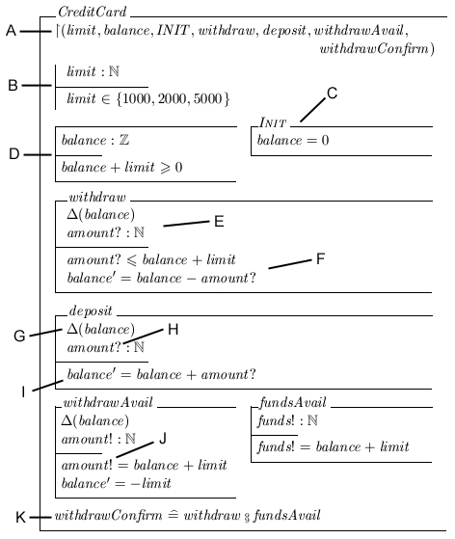
Figure 2.3.1: Example Object-Z specification

2.3.1 Community Z Tools (CZT)

The Z specification language was adopted as an ISO standard in 2002 and it was recognised that one of the barriers for its widespread use was the lack of support tools [MarNet]. However, Andrew Martin proposed “to establish an Internet-based community project to build first a framework/core for Z tool integration, and ultimately numerous plug-in tools” [MarNet] in the form of CZT [CZTNet]. The CZT framework includes an XML schema markup for Z, Java classes for Z annotated syntax trees, a parser for Z with an extension that is capable of outputting Z in various notations and a Z animation tool called ZLive. Early on the CZT framework was extended to handle Object-Z, with the result that all the aforementioned tools also support Object-Z. Some of these tools may facilitate aspects of the current project and the feasibility of integrating the project’s system into the CZT framework will be considered.

2.4 Spec#

Spec# [SpeNet] is an extension of Microsoft’s .NET framework programming language C#, and the only development environment currently offering support for the Spec# programming system is Microsoft Visual Studio [VisNet]. Spec# is a programming system incorporating specification concepts, rather than a formal specification language. Features the Spec# system has introduced into C# include object invariants, non-null types and method contracts. Object invariants are “specifications that constrain the value space of the implementation’s data” [Bar04], i.e. conditions on variables of a class that must always hold, and are declared with the invariant keyword. In some cases it is possible that a series of statements in a method will break an invariant. To be able to handle such a situation, Spec# has introduced the block statement identified by the expose keyword. Within an expose statement invariants can be broken, as long as all invariants hold again by the end of the statement. The concept of non-null types allows “programmers to discriminate between expressions that may evaluate to null and those that are sure not to” [Bar04]. To declare a variable as a non-null type, its type T is declared T!.

Method contracts consist of a series of conditions known as pre-conditions, post-conditions and frame conditions. Pre-conditions, preceded by the requires keyword, define the state in which the system must be to be able to call the method, while post-conditions, preceded by the ensures keyword, describe the state in which the method is allowed to return. Frame conditions “restrict which pieces of the program state a method implementation is allowed to be modified” [Bar04] and are preceded by the modifies keyword. Further details of features of the Spec# programming system and resulting complexities are detailed in [Mat04] and [Bar04].

In addition to extending the C# programming language, Spec# also introduces the Boogie verification tool. Boogie operates by verifying the object code rather than the source code, thereby allowing code written in languages other than Spec# to be verified. It can perform both static verification and run-time checks. Static verification is where Boogie uses automated theorem proving to verify a source program. For example, Boogie can verify methods according to specified post-conditions and can ascertain whether the post-conditions are required or not, i.e. if the verification is successful then the run-time checks are excessive since they would never fail. The run-time checks are performed on any pre- or post-conditions, which are turned into inline code that is identifiable as method contract, to ensure that they hold.

2.5 Compiler Design

Compilers are “the tools which translate a high-level language program into an equivalent machine language program that is executable on the intended system” [Kio97]. Both [Kio97] and [Ber94] break compiler design into roughly the following phases: lexical analysis, parsing, code generation and code optimisation. The system required for the current project will not be a compiler since it requires the linking of two high-level languages, neither of which is directly executable, and therefore not all the phases of compilers are relevant. Lexical analysis is the process of identifying tokens such as key words, operators and comments in a file and passing these on to the parsing stage, i.e. transformation of a stream of characters into a stream of tokens that can be parsed. Parsing identifies the underlying structure of the source file and carries out semantic analysis, checking whether the source program contains any errors such as the breach of language or mathematical restrictions and verifying that declared data types are abided by. The result of the parsing process is a parse-tree that identifies the derivation used in accordance with specified grammar’s production rules. Before a flat, text source file can be manipulated by an application, it needs to be transformed into a data structure such as a tree. This is precisely what lexing and parsing a source file does and, therefore, these two phases of compiler design are relevant to the current project.

There are two approaches to parsing: top-down and bottom-up. Top-down parsing is also known as predictive parsing and, technically, LL(k) parsing. The input is scanned left to right and the leftmost derivation construction, the result of expanding the leftmost non-terminals before others, is produced with the use of k symbols of look-ahead, i.e. the next k characters can impact on the decision as to which production rule of the grammar is followed. Bottom-up parsing is technically known as LR(k) parsing. With this form of parsing the input is scanned left to right and the rightmost derivation construction, the result of expanding the rightmost non-terminals before others, is produced using k symbols of look-ahead. The advantage of top-down over bottom-up is that it is easier to implement. However, the disadvantage is that some simple grammars, such as the natural versions of many programming languages, are not accepted by top-down parsers (but are accepted by bottom-up parsers).

2.5.1 Parser Generators

A result of the widespread need for lexer/parser code is that programs that automatically generate such code are available for the majority of programming languages. For example, Bison [BisNet] produces parsers in C, and Grammatica [GraNet] can generate both C# and Java parsers. As described above, there is a marked difference between the top-down and bottom-up approaches to parsers. Both top-down and bottom-up parser generators exist for the major programming languages. For example, Java has SableCC [SabNet] as a bottom-up parser generator and JavaCC [JavNet] as a top-down parser generator. Generally, the approach to producing a parser by use of a parser generator only requires the user to construct the grammar for the parser in whatever form the tool necessitates, since the rest is automated by the tools processes. As parser generators are commonplace, it is safe to assume that generally they are relatively bug-free and well-documented and, therefore, the use of a tool of this nature would facilitate the current project rather than hinder it.

2.6 Chapter Summary

Chapter 2 has introduced the notion of specification and formal methods (Section 2.2) and a basic understanding of Object-Z (Section 2.3) and Spec# (Section 2.4). It has also identified the relevant parts of compiler design and explained parser generator tools (Section 2.5). This background information is necessary for full understanding of the motivation behind and many of the techniques and decisions involved in the project.

Chapter 3: Initial Design

3.1 Chapter Introduction

Chapter 3 presents the proposed initial design for the implementation of the system and the framework for the exploratory work as specified by the deliverables in Chapter 1. The overall approach to the design and the principles adopted in its creation are detailed first, followed by a top-down detailing of the initial design for the entire system and definitions of the input grammars for the three levels of deliverables.

3.2 Design Decisions

Section 3.2 details, and justifies, all the decisions that were taken regarding the development model for the entire project and the design approach and principles. This will clarify the structure of the rest of Chapter 3 and will also identify the thought processes involved at this stage of the project.

3.2.1 Development Model

It was clear from the outset of the project that the evolutionary model would be the most suitable development model. This is because the project centred primarily on exploratory work, so it was not possible to predict exactly how development would proceed and how things might change as the project progressed. The nature of the deliverables also mean that, at each level, the deliverables involved extension of lower level deliverables, so how the former developed would depend on the progress of relevant lower level deliverables.

The waterfall development model was considered to be unsuitable because such a model demands strict delineation of the different stages of the development. This inflexibility was deemed inappropriate because of the exploratory and iterative nature of the work required by the project. The spiral development model would have been sufficiently flexible and iterative for the project. However, this model focuses primarily on management activities and as such was judged to be out of place in a computer science project requiring investigative work.

3.2.2 Design Approach

Although the overall project loosely followed an evolutionary model, it was possible for large parts of the design to be carried out early on. The reason for an evolutionary approach for the project as a whole was that the levels of deliverables largely required extending the lower level deliverables. However, since this was a case of extending the functionality of existing components, it was only the low-level, concrete design rather than the overall, abstract design that would not be affected by these extensions. Therefore the higher-level, black-box design for the entire system could be produced at the start of the project and required almost no refinement later on in the project.

This meant that a top-down approach to the initial design would be more appropriate than a bottom-up approach. A top-down approach means that first an abstract system overview is produced and then levels of abstraction are reduced, thereby producing increasingly detailed and lower-level design specifications. The consequence is a detailed design framework where most of the levels involve black-box modelling, with the result that the design is largely independent of implementation choices such as programming language and implementation order. It also allows for simpler and more extensive testing as stub programs can easily be produced to simulate any component on which another is dependent. Another aspect of testing that a top-down approach encourages is a “component → interface → unit → system” order to testing since this order follows a top-down design in reverse. This means the design can be used to identify how and where testing should be carried out and which areas and levels of the system require the most concentrated testing, if there is insufficient time to extensively test every aspect and level of the system.

The nature of the project does not dictate that it should be implemented in a particular type of programming language – object-oriented, procedural or functional – and although it may appear that this should be decided at the implementation stage, this choice has a large impact on the design for the system and as such must be made prior to the start of the design. It was decided to use the object-oriented approach for several reasons. Firstly, the use of UML can greatly improve the clarity of a design, while reducing ambiguity and UML is inherently object-oriented. Secondly, object-oriented design has gradually become the world-wide standard approach, largely because of the benefits in clarity, ambiguity and understanding it offers. Finally, it encourages and accommodates all the design principles described in Section 3.2.2 (see below) and is therefore beneficial to the entire development.

3.2.2 Design Principles

The major design principles that were adopted during the project were those of encapsulation, loose coupling and reuse. Encapsulation is the ability of a component to veil its eternal detail from the rest of the environment. Ideal encapsulation would result in all components appearing as black boxes to one another. Coupling is the interdependency of components in a system. Therefore, loose coupling means that changes to one component have negligible impact on other components. Although the object-oriented and top-down approaches both encourage encapsulation and loose coupling, they do not guarantee either so care must be taken to maximise these attributes of the design. Incorporating them into the design will result in a more extensible system, thereby assisting the exploratory work.

The principle of reuse has a less direct impact on a system’s design. However, reuse of components in a system allows for functionality to be introduced that has, normally, already been tested thoroughly and which might take considerable time to produce from scratch. This saved time can be put to use in producing other functionality in the system, so the scope of the design can be extended. However, it is possible for reused components to introduce errors or complexities into the system that may not have been there otherwise and this must be taken into consideration during the design as well.

3.3 System Architecture

The overall system architecture is a high-level overview of the structure of the system. It allows for the major components and their respective dependencies to be identified easily. Starting with a design for the system architecture ensures that the top-down approach is followed. The black-box nature of the components in a system architecture encourages loose coupling throughout the system since such an overview means dependencies between components can be identified and minimised at the outset of the design.

Figure 3.3.1 depicts the system architecture for this project. It is readily apparent that there are very few dependencies amongst most of the components. The structure of the system clarifies why this is the case: the components have independent functionality that the Control component links together. Section 3.5 details the individual components’ design and explains the dependencies.
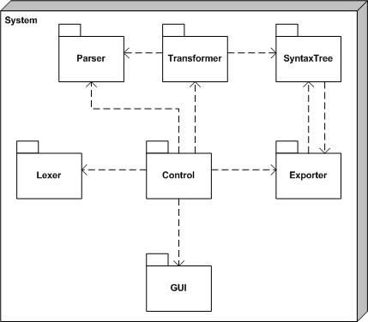

Figure 3.3.1: System Architecture
Although this system architecture results in the entire system being heavily dependent on the correct functioning of the Control component, its functionality is sufficiently simple, as can be seen in Section 3.5.2, that this is not considered a problem. The advantages of having a single pivotal component to the system, loose coupling and good encapsulation, greatly outweigh this one small disadvantage. In addition, the design simplified a later stage of the development: testing. The independency of functionality and lack of major inter-dependencies between most components meant that simple stub programs could easily be created to test single components, with the result that straightforward and extensive testing could be carried out with relative ease.

3.4 Data Flow

The nature of the system, combined with the system architecture, results in a very clear-cut flow of data through the high-level system, shown in Figure 3.4.1. The SyntaxTree component does not appear in the sequence diagram as it can be used to create an object structure rather than begin a collection of functionality, as detailed in Section 3.5.4. The data flow is linear as each component performs some functionality on the data so that the Control component can pass it on to the next component to perform some further functionality and so on, in an almost assembly-line fashion. There are both advantages and disadvantages to a data flow like this. The main disadvantage is that if the flow breaks at any point then the functionality beyond that point will never be carried out. It would be possible to implement a feature such that if a break in the flow were to occur, the subsequent functionality might still be carried out but only to a limited extent. However, such a feature lies outwith the scope of the current project. One of the major advantages of the linear data flow is that encapsulation is inherent. Another major advantage is with respect to testing: each component’s functionality can be tested independently of the others’ by placement of stub programs at the input and output of the component, enabling both single components and clusters of components to be tested effectively. This allows the entire system to be built up and tested thoroughly during constructions.
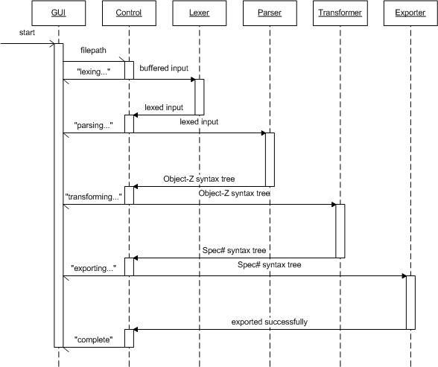

Figure 3.4.1: Basic data flow through high-level system

3.5 Component Design

The second stage of design in the top-down approach, after the system architecture, is the high-level design of the constituent components. The exploratory nature of this project meant that the initial designs for the components had to be relatively flexible and, therefore, abstract. The system design was also not taken to a level lower than component design, for the same reason.

3.5.1 Lexer and Parser

As was noted during background research for the project, there exist numerous automated lexer and parser generators in the majority of programming languages (see Section 2.5). In keeping with the reuse design principle and because the area of interest in the project is the mapping between Object-Z and Spec# rather than the lexing and parsing of Object-Z, it was decided that a parser generator would be used to produce the Lexer and Parser components. The decision of which parser generator to use, and, therefore, the design for the Lexer and Parser components, was deemed largely language-dependent and part of the exploratory work to be carried out during the project. As such, the decision is detailed in Section 4.4. Although delaying the decision to a later stage may initially thought to have a large impact on the design of other components, it should be noted that their designs are equally abstract and flexible so the impact of the choice on initial designs is negligible.

A decision that was taken at this stage was not to use or extend the CZT framework (described in Section 2.3.1) as too much time would be required to fully understand its current functionality and implementation in order to be able to successfully extend it. The lexer and parser functionality of the current CZT framework is but a minor sub-system. Therefore, locating and understanding its implementation would be time-consuming and extending it with the functionality required for this project would only add to the cumbersome nature of the framework.

3.5.2 Control

The Control component is the simplest and smallest part of the system because its only functionality is to connect the functionality of all the other components together. However, this also means that it is crucial to the operation of the system. Another result of its functionality is that it is highly dependent on the other components and, therefore, its implementation may change frequently due to changes elsewhere. However, the simplicity of the component means that changes will be quick and easy to implement.

3.5.3 Transformer

The Transformer component is the part of the system that implements the core of the system and this project. It will perform the mapping of Object-Z to Spec# by transforming the CST representation of an Object-Z specification that is produced by the Parser component into an AST representation of a Spec# program, whilst also performing any refinement required to produce method bodies from the method contracts in the Spec# program, for which its necessity is explained in Section 3.7. Since the mapping and refinement are the main exploratory work, very little design can be detailed initially. However, it is clear that it will be necessary to traverse the Object-Z CST in order to carry out the transformation. Although any form of traversal, pre-, post- or in-order, would be adequate, post-order traversal was judged the most appropriate for the exploratory work (see Figure 3.5.1 for an example of post-order traversal of a tree). This is because, in contradiction to the initial design, a bottom-up approach would simplify the exploratory work since it allows for work to be concentrated on sub-sections of the overall grammar in order to ensure the correctness and soundness of the mapping for that sub-section, without introduction of the complexity of other sub-sections.
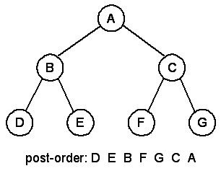
Figure 3.5.1: Post-order traversal example

3.5.4 SyntaxTree

The SyntaxTree component is a collection of classes that can be combined to form an object structure known as an AST to represent a Spec# program. It can be assumed, at this initial design stage, that the classes will represent features of a Spec# program, such as a class or a method, but no concrete design can be given since these classes are dependent on the mapping that forms the main exploratory work in the project.

3.5.5 Exporter

The Exporter component is responsible for exporting the AST representation of a Spec# program. In this case, the desired output is a Spec# (.ssc) file in the same directory as the input file, with the same root name as the input file. However, it was decided that, if feasible, a more flexible, abstract approach would be beneficial in terms of extensibility and program code clarity. Therefore the design for the exporter component follows the Visitor Pattern. It is intended to allow operations on nodes in a tree structure that do not alter the object structure to be separated from the object structure. This impacts on the design of many classes in the SyntaxTree component as all nodes in the AST must accept the visitor and call the operation of the visitor appropriate to the node’s type. In this way a visitor can be implemented that produces the desired textual output. It would be straightforward to produce additional visitors that, for example, exported the Spec# AST in different forms or that carried out analysis on the AST for testing purposes.

Figure 3.5.2 shows the abstract design for the two classes in the Exporter component and indicates the extensibility of the design. An interface class, Visitor, defines the methods all implementations of a visitor for the Spec# AST must include, while the second class, Exporter, is the implementation whose functionality will result in the desired output.
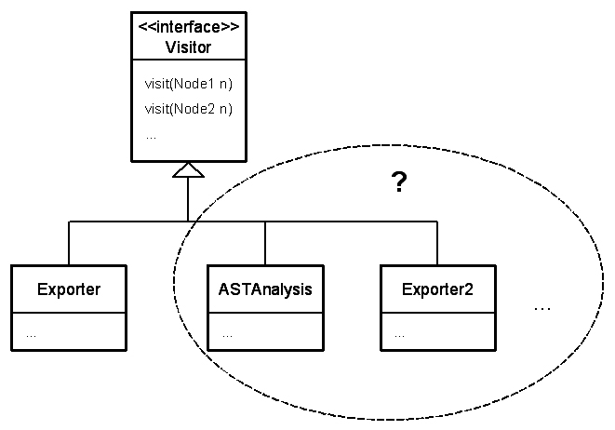
Figure 3.5.2: Exporter Component design, with extensibility indicated

3.5.6 GUI

The nature of the system means that a GUI is nominally not necessary since the user does not interact with the system any more than to indicate the input file. As such, a command-line interface would suffice. On the other hand, a GUI, however simple or unnecessary, vastly improves the user-friendliness of a system, especially as the majority of computer users nowadays have no experience of command-line interfaces. A GUI prototype for the system is shown in figure 3.5.3.

GUI Features, as indicated in Figure 3.5.3:
A – Used to enter the full path of the input file, or the full path can be selected by browsing to find the input file’s location by use of B to open G.
B – Clicking this button opens G, allowing the input file to be selected.
C – Indicates the output file, a file with the same root name as the input file but with the Spec# .ssc extension.
D – When an input file is selected, clicking this button initiates the systems primary functionality.
E – A status display; indicates which stage of the process is currently being carried out and whether errors have occurred.
F – The standard Windows minimise, full-screen and close buttons.
G – The standard Windows file-selection interface, customised to allow only the selection of files with the Latex .tex extension (see Section 4.3 for explanation)

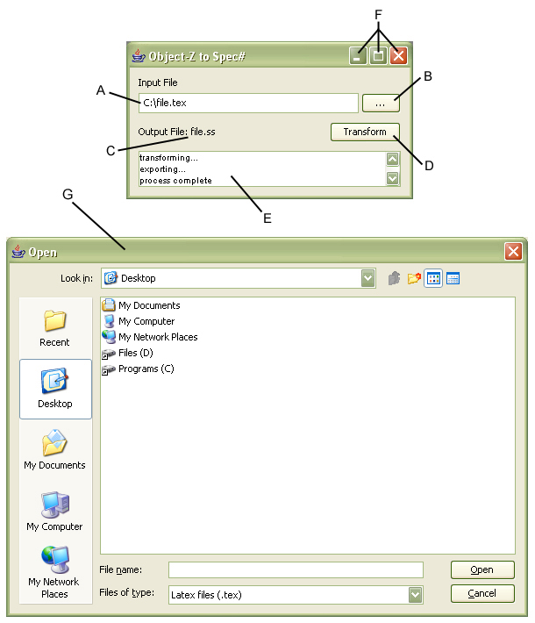
Figure 3.5.3: GUI design

3.6 Grammars

As detailed in Section 1.4, input grammars for the basic and intermediate deliverables must be defined. The grammars form subsets of the whole Object-Z grammar and the mapping between Object-Z and Spec# created during the exploratory work is based on these input grammars. The production rules of the grammars are defined abstractly in Sections 3.6.1 and 3.6.2. The syntax defines the grammars top-down, with only the productions for the capitalised non-terminals given, since the meanings of non-capitalised non-terminals and terminals are self-evident. Figure 3.6.1 clarifies the abbreviations used for the capitalised non-terminals in the abstract grammars for the basic and intermediate deliverables. The symbols * and ? stand for ‘none or more’ and ‘none or one’ respectively.

Abbreviation | Object-Z Feature
Specification | Object-Z Specification
ClassDec | Class Declaration
VisList | Visibility List
AxDef | Axiomatic Definition
State | State Schema
Init | Initial Schema
OpSch | Operational Schema
OpExpDef | Operational Expression
VarDec | Variable Declaration
SecVars | Secondary Variables
Figure 3.6.1: Abstract grammar abbreviations

3.6.1 Grammar for Basic Deliverables

The basic deliverables required a grammar representing a very basic subset of the whole Object-Z grammar. It is the minimal grammar with which a meaningful, if simplistic and artificial, Object-Z specification can be given. An abstract representation of the input grammar for the basic deliverables is given in Figure 3.6.2, with the explicit grammar given in Appendix C.
Specification | → |  | ClassDec*
ClassDec | → |  | AxDef? State? Init Op*
AxDef | → |  | VarDec* Predicate*
State | → |  | VarDec* Predicate*
Init | → |  | Predicate*
Op | → |  | deltaList VarDec* Predicate*
VarDec | → |  | nameList type
Predicate | → |  | name = Exp
 |  | | | name inequality Exp
 |  | | | true
 |  | | | false
 |  | | | ( Predicate )
Exp | → |  | Exp infix Exp
 |  | | | Prefix Exp
 |  | | | name
 |  | | | integer
Figure 3.6.2: Abstract grammar for basic deliverables
With this grammar, an example Object-Z specification was created that could later be used to test and demonstrate the functionality of the system. The example is a simplistic specification of a credit-card system where a card initially has an overdraft of 1000, an initial balance of 0 and capabilities only to withdraw, deposit and withdraw all available funds. It can be seen in Figure 3.6.3.
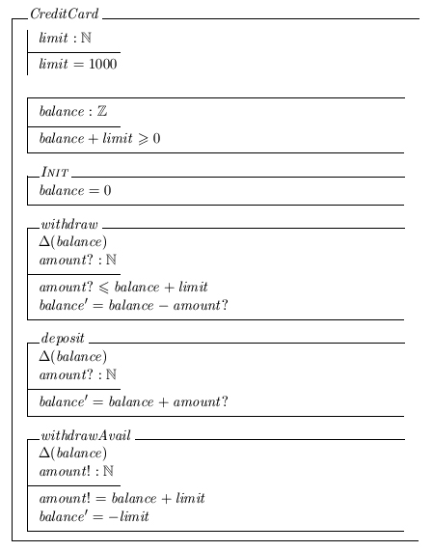
Figure 3.6.3: Object-Z specification example for basic deliverables

3.6.2 Grammar for Intermediate Deliverables

The intermediate deliverables required the grammar defined for the basic deliverables to be extended in order to extend the subset of Object-Z that could be handled by the system. The grammar was extended in several different places. The option of a visibility list was included, as well as the option of declaring secondary variables in the state schema. Two production rules for predicates were added: membership and non-membership. However, the main extension was with regard to operations, so that they could be either an operational schema or an operational expression, where an operation is defined in terms of other operations. The operational operators for sequential composition, conjunction, choice composition and parallel composition were introduced, as well as the ability to promote operations – defining an operation in a class in terms of an operation of a variable of that class. An abstract representation of the input grammar for the intermediate deliverables is given in Figure 3.6.4, with the explicit grammar given in Appendix D.

With this grammar, an example Object-Z specification was created that could later be used to test and demonstrate the functionality of the system. The example is an extension to the example used for the basic deliverables. Two operations were added to the CreditCard class from the basic deliverables: an operation that outputs the funds available and an extra withdraw operation that outputs the funds left after the withdrawal. The example specification also includes a rather artificial second class that holds two credit-cards, allowing withdrawals from the first card, transfers from the first to the second card, withdrawals that could come from either card, the transfer of all funds on the first card to the second and the replacement of the first card. The example Object-Z specification for the intermediate deliverables is shown in Figure 3.6.5.
Specification | → |  | ClassDec*
ClassDec | → |  | VisList? AxDef? State? Init Op*
VisList | → |  | nameList
AxDef | → |  | VarDec* Predicate*
State | → |  | VarDec* SecVars? Predicate*
Init | → |  | Predicate*
Op | → |  | OpSch
 |  | | | OpExpDef
OpSch | → |  | deltaList VarDec* Predicate*
OpExpDef | → |  | name OpExp
OpExp | → |  | name . name
 |  | | | name name
 |  | | | name name
 |  | | | name name
VarDec | → |  | nameList type
 |  | | | nameList className
SecVars | → |  | VarDec*
Predicate | → |  | name = Exp
 |  | | | name inequality Exp
 |  | | | name List
 |  | | | name List
 |  | | | true
 |  | | | false
 |  | | | ( Predicate )
Exp | → |  | Exp infix Exp
 |  | | | prefix Exp
 |  | | | name
 |  | | | integer
List | → |  | name*
 |  | | | integer*
Figure 3.6.4: Abstract grammar for intermediate deliverables
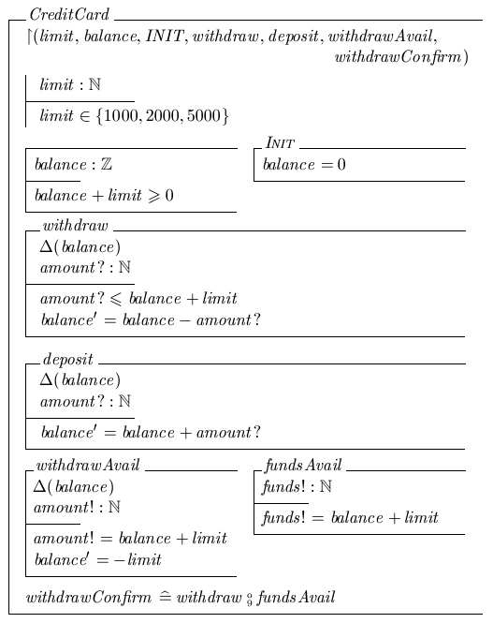
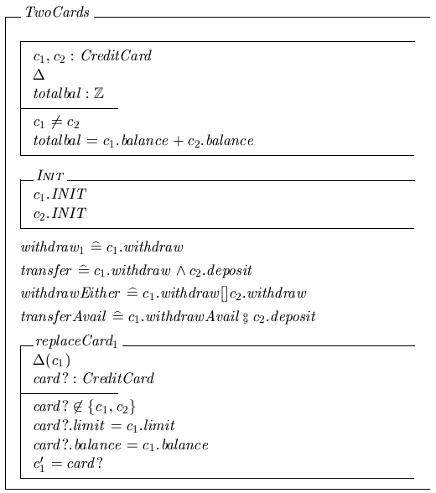
Figure 3.6.5: Object-Z specification example for intermediate deliverables
3.7 Language Incompatibilities

Several incompatibilities between Object-Z and Spec# were identified during the early stages of the project. For example, Object-Z allows multiple inheritance but Spec# has no support for this. However, if a limit is placed on the input, in this example so that multiple inheritance is not possible, many of these incompatibilities can be overcome. Section 4.8 gives details of system limitations and restrictions.

Ignoring these minor incompatibilities in features, there is also a fundamental difference between Object-Z and Spec# that has more impact. As explained in Section 2.3, Object-Z specifications are state-model specifications of systems, whereas Spec# is a real-time programming language. There are two major consequences of this difference. First, object instantiation does not occur in Object-Z, yet it is vital to Spec# programming. Therefore, a method of object instantiation must be derived from an Object-Z specification. As explained in Section 2.3, if the predicates in the initial schema and the object invariants of an Object-Z class schema all hold then the model is said to be in its initial configuration. It was decided that within this project, the instantiation of a Spec# object must result in that object being in a state equivalent to its Object-Z initial configuration.

The major second consequence of the state-model versus real-time difference between Object-Z and Spec# is that the predicates in the operational schemas of an Object-Z specification form only the method contract for that operation. The actual functionality that fulfils these method contracts is not detailed. Although method contracts are a feature of Spec# as well, functionality to fulfil the method contracts is also necessary. It is possible to produce the functionality based on the method contracts, a process known as program refinement. This process forms a key part of the project and is detailed in Section 4.6.

3.8 Chapter Summary

Chapter 3 has described the design decisions regarding principles and approach (Section 3.2) and has specified the design in as much detail as possible before the commencement of exploratory work (Sections 3.3, 3.4 and 3.5). The Object-Z grammars for the basic and intermediate deliverables have been detailed (Section 3.6) and the incompatibilities between Object-Z and Spec# have been discussed (Section 3.7).

Chapter 4: Implementation and Exploratory Work

4.1 Chapter Introduction

The initial design presented in Chapter 3 describes an object-oriented system and, therefore, the choice of programming languages for implementation was restricted to object-oriented programming languages. In order to adhere to the high-level nature of the project the use of C++ was dismissed due to its low-level nature. As a result, consideration was given to two high-level, object-oriented programming languages: Java and C#. The flexibility regarding tools and the existing familiarity with Java were the decisive factors. Therefore, all implementation was carried out using Java 1.5.0_06 and the Eclipse [EclNet] development environment.

The rest of Chapter 4 discusses all the decisions taken regarding the implementation and the results of the exploratory work carried out, such as the mapping produced and the limitations imposed on the system.

4.2 Configuration Management

Configuration management covers the managerial processes required to track a development build. Many software tools exist to assist aspects the processes such as revision and release control. Due to the exploratory nature of the project the most important configuration management processes to carry out are revision and change control. Revision control is primarily concerned with ensuring that previous versions of files are not lost, thereby allowing straightforward recovery of old versions of files. Change control involves the procedures that manage how changes are incorporated into a file. Revision and change control are essential because backtracking to a previous state of the project could be necessary at any point. Therefore, configuration management software tools were used for revision and change control throughout the project, both for program source code and documentation. Revision and change control facilities are present in all configuration management software tools so the decision of which tool to use was decided based on various other factors, such as user-friendliness. The tools used during this project are detailed below.

4.2.1 Microsoft Visual SourceSafe

Microsoft Visual SourceSafe [SouNet] is distributed as part of the Microsoft Visual Studio development environment and is a graphical configuration management system. SourceSafe’s WIMP interface provides a clear project-oriented overview of the files in its system. It can handle any type of file but is particularly suited to ASCII text files, and is therefore ideal for the revision and change control required by this project for the program source code. SourceSafe was chosen for its simple, yet powerful, interface and because it is integrated with development environment required for Spec#. However, the version used formed part of the Visual Studio .NET 2005 Beta 2 trail release, so when the Beta trial period terminated half-way through the project SourceSafe could no longer be used for configuration management.

4.2.2 Eclipse

When the Beta trail period for SourceSafe terminated (see above), it was decided that the CVS (Concurrent Versions System) [CVSNet] repository provided by the Eclipse development environment [EclNet] would be sufficient configuration management for the purposes of this project. The choice was dictated primarily because the Eclipse development environment was already being used as a programming environment for the project and, therefore, using additional tools provided by the environment would be straightforward.

4.3 Input Syntax

The relatively graphical nature of Object-Z means that creating a specification on a computer by drawing the graphical elements manually is time-consuming and cumbersome. Fortunately, three different representations of Z exist that are designed explicitly for computer use and are all supported by CZT (see Section 2.3.1): Unicode, XML and LaTeX’s oz package. However, within the scope of this project it is only feasible for the system to support one input syntax. CZT’s tools are built up primarily around the XML form of Z. However, as detailed in Section 3.5.1, it had already been decided that the CZT framework would not be involved in the project and, therefore, this possible reason for opting to use the XML representation was not relevant. Instead, the LaTeX representation for Object-Z was chosen as the input syntax for the system because its use is already more widespread than the other two and it is clear and straightforward.

LaTeX [LatNet] is a typesetting system designed specifically with the production of technical and scientific documentation in mind and is “the de facto standard for the communication and publication of scientific documents” [LatNet]. Its ASCII input syntax consists of a combination of control sequences (recognisable by the starting \ symbol) and characters, which are then transformed into a document format specified by the control sequences. Using this method it is possible to produce the graphical Object-Z notation, as exemplified in Figures 2.3.1, 3.6.3 and 3.6.5, from an ASCII text file. In accordance with the basic and intermediate objectives of illustrating the transformations implemented by the system for the current project, example Object-Z specifications were detailed in Sections 3.6.1 and 3.6.2. The LaTeX representations, and therefore concrete inputs, for these examples can be found in Appendices F and G for the basic and intermediate deliverable examples respectively.

4.4 Parser Generator

As documented in Section 2.5.1, it was identified that the use of an automated parser generator would facilitate the implementation of the system prescribed by this project, tying in loosely with the design principle of reuse explained in Section 3.2.2. The parser generator used for the current project is SableCC [SabNet] and is detailed below. It was chosen because it produces compilers in the Java programming language – consistent with the programming language adopted for the implementation (see Section 4.1) – that follow the bottom-up approach, thereby allowing the input grammar to be defined more naturally (see Section 2.5.1). Additionally, it also generates classes to assist in the manipulation of the syntax trees the parser outputs and, therefore, sets up a framework from which the transformation functionality, the focus of the project, can be built.

4.4.1 SableCC

SableCC [SabNet] is an “object-oriented framework that generators compilers in the Java programming language” [Gag98]. It was created explicitly for Java, and, therefore, takes advantage of Java-specific features, such as its type system, with key object-oriented techniques, such as modularisation and extensibility, in mind. The result is that it can be used to produce “highly modular, AST-based, object-oriented compilers” [Gag98]. Although it was designed as a tool to aide the implementation of compilers, the only complete functionality that is generated is lexing and parsing, the two phases of compiler design relevant to this project. The modularisation the SableCC generated code introduces results in a clear separation between the human-written and machine-generated code. This results in the core functionality produced by the exploratory work involved in this project, the actual transformation, to be minimally dependent on the lexer and parser, as was defined in the initial design (see Section 3.3).
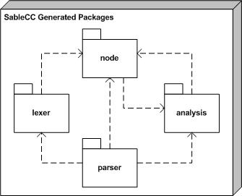

Figure 4.4.1: SableCC generated packages overview

Figure 4.4.1 identifies the structure of the code automatically produced by the SableCC tool. The packages have few inter-dependencies, i.e. are loosely coupled, and rigidly follow the design principle of encapsulation. Therefore, the generated code’s design is consistent with the design principles adopted in the non-generated system components (see Section 3.2.2). Here follows a brief description of the SableCC generated packages:
Lexer – Contains the functionality that performs lexical analysis of the input file.
Node – Contains the classes that can be combined to form an AST representation of the input file.
Parser – Produces an AST representation of a lexed input file using the classes contained in the Node package.
Analysis – Contains frameworks for depth-first and reversed depth-first tree-walking functionality following the visitor pattern (Section 3.5.5 includes a brief explanation of the visitor pattern).

4.5 Mapping

The mapping from Object-Z to Spec# is the central focus of the exploratory work involved in this project. It must maintain the logic of the original Object-Z specification whilst being sufficiently generic to allow flexibility within input specifications. The following sections abstractly present the automated mapping conceived that was subsequently implemented, along with the refinement process (see Section 4.6) to form the Transform component of the system (see Sections 3.3 and 3.5.3). The rational for these mappings is given in Section 5.3.2.

4.5.1 Class Schema, including Axiomatic Definition and State Schema

Figure 4.5.1 illustrates the mapping of class schemas, axiomatic definitions and state schemas. An Object-Z class schema maps directly to a Spec# class with the same name.
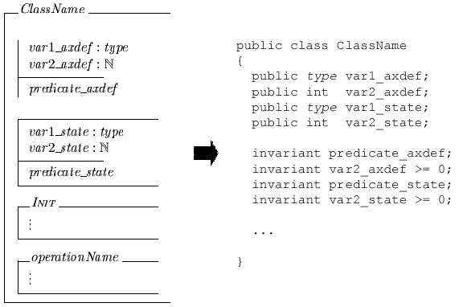
Figure 4.5.1: Class schema, axiomatic definition and state schema mapping
As explained in Section 2.3, axiomatic definitions declare global constants. These global constants are mapped to Spec# by declaring them as a variables and introducing object invariants that ensure their values remain constant. This is done by mapping the declarations and predicates in an axiomatic definition to Spec# variable declarations and object invariants respectively. An additional Spec# object invariant is introduced if the declaration is of natural number type that ensures the variable remains non-negative.

A state schema introduces global variables and constraints on those variables to an Object-Z specification (see Section 2.3). These declarations and predicates can be mapped directly to Spec# variable declarations and object invariants respectively. As with axiomatic definitions, declarations of variables of natural number type require a Spec# object invariant insuring the variables non-negativity in addition to declaration of the variable as integer type.

4.5.2 Initial Schema

It was identified in Section 3.7 that object-instantiation does not occur in Object-Z but is vital to Spec# and, therefore, object-instantiation in the form of a constructor must be introduced into the Spec# output of the system. Section 3.7 also detailed that it was decided that the functionality of an object’s constructor will result in that object being in a state equivalent to its Object-Z initial configuration. For this reason and because post-conditions of a Spec# constructor and any of its class’ object invariants must hold by the end of execution of that constructor, the predicates of an initial schema of an Object-Z class schema are mapped directly to post-conditions of that class’ Spec# constructor. This way any functionality required to instantiate a Spec# object so that it is in the initial configuration, as defined by its Object-Z specification, can be deduced in the refinement stage of the transformation. Figure 4.5.2 details the mapping of an initial schema.
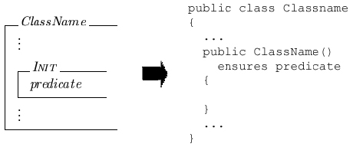
Figure 4.5.2: Initial schema mapping

4.5.3 Operational Schema

The mapping of an Object-Z operational schema to a Spec# method is relatively straightforward because logically equivalent constructs exist in both languages: The name of the operational schema maps to the name of the method; The variables in the delta list of an operational schema map to frame conditions of a Spec# method; Any Object-Z input variables map to parameters of a method; An Object-Z output variable maps to a return variable for a Spec# method (see Section 4.8 for the restriction required regarding Object-Z output variables) and a declaration of that variable in the method body; Any standard Object-Z variables map to variable declarations in the method body; predicates where the variable name on the left-hand side of the equality, inequality, membership or non-membership ends in the ! or ‘ symbols map to post-conditions and predicates where the variable name on the left-hand side of the equality or inequality ends in the ? symbol map to pre-conditions. If an operational schema does not have any output variables then the method it is mapped to will have return type void. When Object-Z predicates containing an output variable are mapped, the output variable’s name is changed to the result keyword. Any declarations of natural number type require additional condition ensuring their non-negativity to be introduced to the Spec# method in addition to declaring them as a variable of integer type. The condition is added to the pre-conditions of the method if the variable declaration is of an Object-Z input variable and the condition is added to the post-conditions if it is an output variable that is declared.

Figure 4.5.3 shows an example of the mapping of an Object-Z operational schema to a Spec# method. Note that the Spec# method appears as it exists before refinement is carried out and, therefore, does not include any functionality to move the object from a state in which the pre-conditions hold to a state in which the post-conditions hold. The refinement process is detailed in Section 4.6.
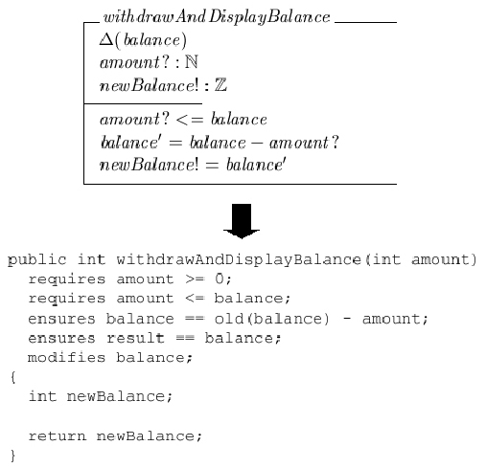
Figure 4.5.3: Operational schema mapping example

4.5.4 Operation Promotion

The mapping of an operational expression that is operation promotion is dependent on the operation that is being promoted, so the mapping of the operation promotion is dependent on the mapping of the operational schema. Therefore, the Spec# method that results from the mapping of the operation promotion, x, is derived primarily from the Spec# method produced from the operation that is being promoted, y. Any parameters of y are introduced as parameters of x and the return type and return variable, if there is one, of y are also introduced to x. The final stage of the mapping is to introduce a method call to y to the body of x that assigns its result to the output variable, if there is one. Figure 4.5.4 shows an example of the mapping of operation promotion.
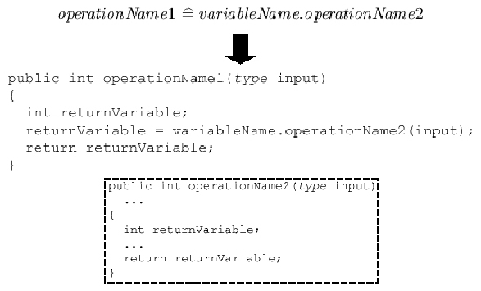
Figure 4.5.4: Operation promotion mapping example

4.5.5 Operation Compositions

As with operation promotion, the Spec# method that is mapped from the Object-Z operational expression is largely derived from the methods mapped from the expression’s constituent operations. The operational schemas of these operations can take many different forms, with any number of input variables of various types and an output variable of various types (see Section 3.7 for details of the restrictions imposed). This results in slightly altered forms of the mappings depending on the number and types of these variables, but the overall structure of the mapping is identical and these structures are presented below.

Sequential Composition

The sequential composition operator indicates the output variables of one operational schema are passed as the inputs to the following operational schema, if the base names of the output variables and the input variables match. This is mapped to Spec# by declaring a local variable to store the output of a call to the method mapped from the first operation, according to the order of the Object-Z operational expression. The variable is subsequently used as the argument in a call to the method mapped from the operational schema of the second operation. Any parameters of the method mapped from the first operational schema are introduced as parameters of the method mapped from the operational expression, and if the operational schema of the second operation has a return variable then it is also introduced to the method mapped from the operational expression. Figure 4.5.5 show an example of the mapping of sequential composition.
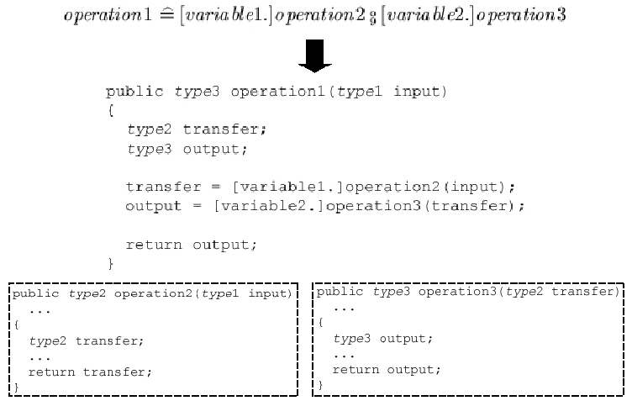
Figure 4.5.5: Sequential composition mapping example

Conjunction Operator

An operational expression defined using the conjunction operator is mapped to a method that calls the methods mapped from the constituent operations with the same arguments. The order of the methods called is left-to-right according to the order of the operations from which they were mapped that form the operational expression. The mapping of operational expressions defined using the conjunction operator is limited and these limitations are detailed in Section 4.8. An example of the mapping of the conjunction operator is given in Figure 4.5.6.
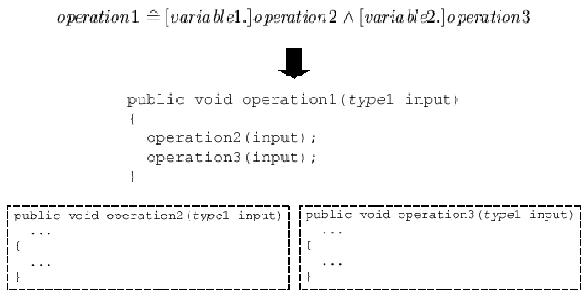
Figure 4.5.6: Conjunction operator mapping example
Choice Operator

As with other operation composition operators, the mapping of an operational expression defined using the choice operator involves a method whose functionality calls the methods mapped from the constituent operations. However, conditional blocks are introduced so that a choice is made between the two methods mapped from the constituent operational schemas. The conditional blocks are ordered according to the left-to-right occurrence of the constituent operations in the operational expression, with the body of each block consisting of a call to the method mapped from the operational schemas of the respective constituent operation. The condition on each block comprises of the pre-conditions of the method called in the block’s body. Therefore, if the pre-conditions of the method mapped from the first constituent operation are satisfied then it is called, but if they are not satisfied then the pre-conditions of the method mapped from the second constituent operation are tested and, if satisfied, this method is called. If the operational schemas of the constituent operations have input variables then these are introduced as parameters of the method mapped from the operational expression and are passed as arguments in the method calls. Additionally, occurrences of the input variable in the conditions of the blocks are replaced by the parameter of the method mapped from the operational expression. If the constituent operational schemas have an output variable then it is introduced as the return variable of the method mapped from the operational expression. Figure 4.5.7 shows an example of the mapping of operational expressions defined using the choice operator. Note that the [input2/input] notation signifies that any occurrence of the variable input in the expression is replaced by the variable input2.
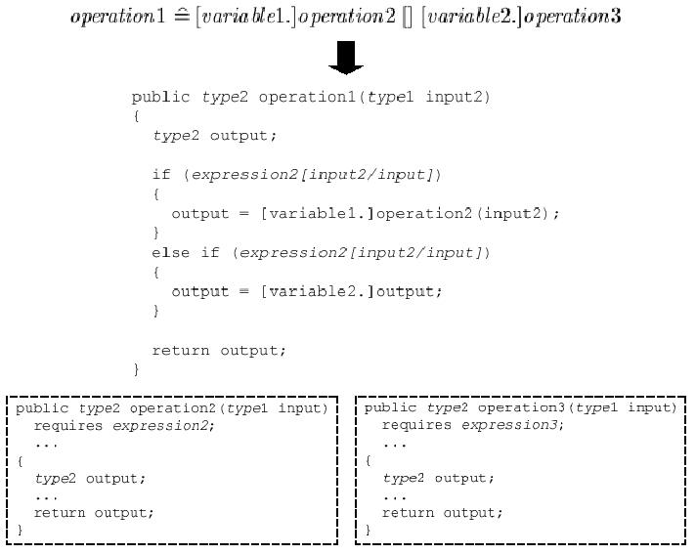
Figure 4.5.7: Choice operator mapping example

4.5.6 Visibility List

The visibility list as a whole, if present, does not map directly to Spec#. However, its logic is mapped to Spec# in the form of access modifiers (private, public, etc). If no visibility list is present in an Object-Z class schema then all variables and methods in the corresponding Spec# method are public. On the other hand, if a visibility list is present in an Object-Z class schema then the mappings of any variables or operations not included in the list are marked as private.

4.5.7 Predicates

As dictated by the grammars presented in Section 3.6, predicates can take the form of the true or false expressions, an expression involving equality or inequality or a membership or non-membership expression. All true and false expressions are ignored in the mapping as they will either hold trivially or never hold respectively.

Equality and Inequality

Expressions involving equality or inequality are mapped directly to identical Spec# expression, with only the symbols representing equality or inequality being replaced by the equivalent Spec# symbol. Figure 4.5.8 shows the equivalent equality and inequality symbols for Object-Z and Spec#.
Object-Z Symbol | Spec# Symbol
= | ==
≠ | !=
> | >
≥ | >=
< | <
≤ | <=
Figure 4.5.8: Object-Z and Spec# equality and inequality symbols
Membership and Non-Membership

A membership expression maps to a disjunction of Spec# equality expressions. Figure 4.5.9 shows the mapping of an example membership predicate. On the other hand, a non-membership expression maps to a conjunction of inequality expressions, as exemplified in Figure 4.5.10.
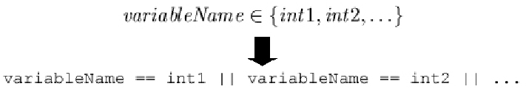
Figure 4.5.9: Membership mapping example
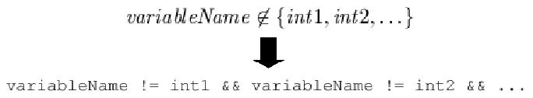
Figure 4.5.10: Non-Membership mapping example

4.6 Refinement

The mapping from Object-Z to Spec#, see Section 4.5, results in Spec# constructors and methods without any functionality, only method contracts, arguments and return types. Only the mapping of compositional operations in Object-Z introduces functionality to their respective Spec# method. However, for the Spec# method contracts of the constructor and methods to hold, functionality has to be introduced in the form of a method body. This is done by refinement, a process of deducing instructions in order to satisfy the method contract.

In the implementation produced for this project method refinement is based exclusively on the post-conditions in the method contract. However, the refinement of constructors is not based exclusively on its post-conditions. It is necessary for a constructor to also incorporate functionality that ensures the object invariants hold, since the invariants of an object must hold from the end of the constructor’s execution, its instantiation (see Section 3.7), until the object’s deletion. The reasoning behind this approach to the refinement is given and justified in Section 5.3.

4.6.1 Methods

The only post-condition in a method’s contract that results in refinement to the method is a post-condition of the form “variable == expression”, where expression is any number of variables with prefix and/or infix operators combining them, e.g. “variable1 = variable2 + variable3 – variable4”. A post-condition of this form results in an assignment statement of the form “variable = expression;” being added to the method’s body. No refinement results from inequality post-conditions, since these are ensured by the Spec#’s runtime checks.

4.6.2 Constructors

The automated refinement carried out on constructors is first performed using the constructor’s post-conditions and then its class’ object invariants. First the post-conditions are scanned for any instances of expressions of the form “variable.INIT”. These expressions are interpreted as the instantiation of that variable and, therefore, result in a statement assigning a new instance of variable’s class type. If the constructor of variable’s class type has parameters then these are introduced as parameters of this constructor and those values are passed as arguments to the instantiation of variable. The post-condition containing the expression of the form “variable.INIT” is subsequently removed from the constructor’s list of post-conditions as it is not a valid Spec# expression. However, since variable is of a class type it is also of non-null type (see Section 3.5.6) and this has consequences on the constructor’s instructions. Variable will not be readable in the constructor because all Spec# constructors are “delayed” by default, i.e. no statements in the constructor’s body, besides instantiation, can involve variable. To make variable readable in the constructor it is necessary to introduce the NotDelayed attribute. However, non-null fields must be instantiated before the base constructor call, which is no longer the case because of the introduction of the NotDelayed attribute. To resolve this issue it is necessary to explicitly call the base constructor after the instantiation of the non-null variables using the “base();” statement. For clarification of the refinement described here, see Figure 4.6.1. The next step of the refinement using the constructor’s post-conditions is to perform the same refinement using them as occurs using the post-conditions of a method. This is described above, in Section 4.6.1.

The second stage of the constructor refinement is performed using the object invariants of the constructor’s class. As with the refinement using the post-conditions of methods and constructors, object invariant expressions of the form “variable == expression” result in an assignment statement of the form “variable = expressions;” being added to the constructor body. However, unlike with the refinement on post-conditions, this is not the only form of expression that results in a statement being added to the body; membership and non-membership object invariant expressions also provoke refinement. They result in a parameter being added to the constructor of the same type as the variable, with this parameter being assigned to the variable in the constructor body. This phase of the refinement is exemplified in Figure 4.6.2.

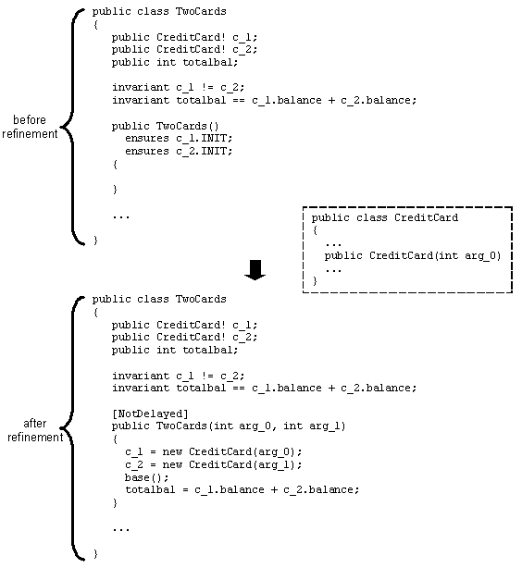
Figure 4.6.1: Example of the constructor refinement involving non-null variable instantiation

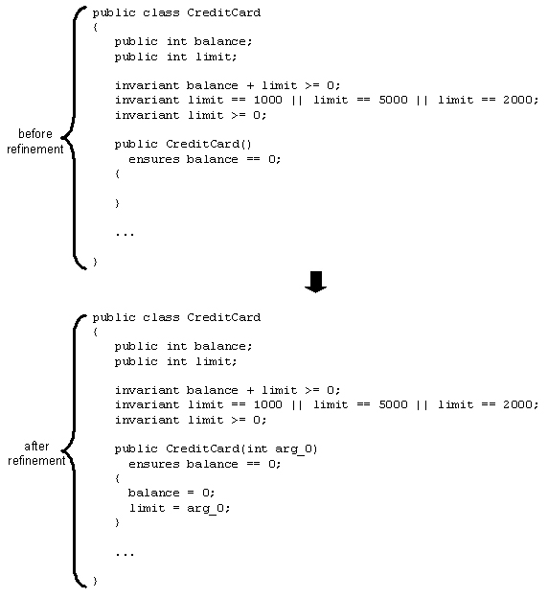
Figure 4.6.2: Example of the constructor refinement involving a membership object invariant expression

4.7 Examples

The basic and intermediate objectives detailed in Section 1.4 include illustrating the transformations at both the basic and intermediate deliverables levels using examples. The Object-Z specifications that form the basis for the transformation examples are shown in Figures 3.6.3 and 3.6.5 for the basic and intermediate deliverables levels respectively, with the concrete inputs representing those Object-Z specifications given in Appendices F and G respectively. Sections 4.7.1 and 4.7.2 present the output of the system to complete the illustration of the transformation using these two examples.

4.7.1 Example for Basic Deliverables

The input given in Appendix F, representing the Object-Z specification detailed in Figure 3.6.3, is transformed using the mapping and refinement presented above (see Sections 4.5 and 4.6) into the output shown in Figure 4.7.1 by the system created for this project.

public class CreditCard
{
public int balance;
public int limit;

invariant balance + limit >= 0;
invariant limit == 1000;
invariant limit >= 0;

public CreditCard()
ensures balance == 0;
{
balance = 0;
limit = 1000;
}

public void withdraw(int amount)
requires amount >= 0;
requires amount <= balance + limit;
ensures balance == old(balance) - amount;
modifies balance;
{
balance = balance - amount;
}
public void deposit(int amount)
requires amount >= 0;
ensures balance == old(balance) + amount;
modifies balance;
{
balance = balance + amount;
}

public int withdrawAvail()
ensures result >= 0;
ensures result == balance + limit;
ensures balance == -limit;
modifies balance;
{
int amount;

amount = balance + limit;
balance = -limit;
return amount;
}
}

Figure 4.7.1: System output for example for basic deliverables

4.7.2 Example for Intermediate Deliverables

The input given in Appendix G, representing the Object-Z specification detailed in Figure 3.6.5, is transformed using the mapping and refinement presented above (see Sections 4.5 and 4.6) into the output shown in Figure 4.7.2 by the system created for this project.
public class CreditCard
{
public int balance;
public int limit;

invariant balance + limit >= 0;
invariant limit == 1000 || limit == 5000 || limit == 2000;
invariant limit >= 0;

public CreditCard(int arg_0)
ensures balance == 0;
{
balance = 0;
limit = arg_0;
}

public void withdraw(int amount)
requires amount >= 0;
requires amount <= balance + limit;
ensures balance == old(balance) - amount;
modifies balance;
{
balance = balance - amount;
}

public void deposit(int amount)
requires amount >= 0;
ensures balance == old(balance) + amount;
modifies balance;
{
balance = balance + amount;
}

public int withdrawAvail()
ensures result >= 0;
ensures result == old(balance) + limit;
ensures balance == -limit;
modifies balance;
{
int amount;

amount = balance + limit;
balance = -limit;
return amount;
}
}

public class TwoCards
{
public CreditCard! c_1;
public CreditCard! c_2;
public int totalbal;

invariant c_1 != c_2;
invariant totalbal == c_1.balance + c_2.balance;

[NotDelayed]
public TwoCards(int arg_0, int arg_1)
{
c_1 = new CreditCard(arg_0);
c_2 = new CreditCard(arg_1);
base();
totalbal = c_1.balance + c_2.balance;
}

public void withdraw_1(int amount)
{
c_1.withdraw(amount);
}

public void transfer(int amount)
{
c_1.withdraw(amount);
c_2.deposit(amount);
}

public void withdrawEither(int amount)
{
if ((amount >= 0) && (amount <= c_1.balance + c_1.limit))
{
c_1.withdraw(amount);
}
else if ((amount >= 0) && (amount <= c_2.balance + c_2.limit))
{
c_2.withdraw(amount);
}
}

public void transferAvail()
{
int amount;

amount = c_1.withdrawAvail();
c_2.deposit(amount);
}

public void replaceCard_1(CreditCard! card)
requires card != c_1 && card != c_2;
requires card.limit == c_1.limit;
requires card.balance == c_1.balance;
ensures c_1 == card;
modifies c_1;
{
c_1 = card;
}
}

Figure 4.7.2: System output for example for intermediate deliverables

4.8 System Limits and Restrictions

In Section 3.7 a number of incompatibilities between the Object-Z and Spec# languages were identified. These incompatibilities are overcome in the system implemented for this project by prescribing restrictions that are placed on the input Object-Z specifications and detailing the limitations of the system. Several language incompatibilities, such as multiple inheritance, are eliminated by the restricted Object-Z input grammars detailed in Section 3.6. The grammars also introduce the restriction that an operational expression can only be defined in terms of two operational schemas combined by one operator and they restrict the allowable set of predicates. A restriction must also be placed on the concrete syntax of the input file because the LaTeX system often allows different control sequences to signify specific characters. The control sequences recognised by the system implemented for this project are given in Appendix E.

Operational schemas in input specifications may only have one output variable. This is because Spec# methods, to which operational schemas are mapped (see above), can only have a single return value and any approach to return multiple return values using a single data structure introduces complexities that could cloud the comprehensibility of the mapping.

The implementation of the mapping of operational expressions defined using the conjunction operator is limited in that only part of the logic implied by the conjunction operator is mapped: only the input variables of the constituent operational schemas are conjoined, not the output variables. Note that this can result in the Spec# output not correlating with the intended logic of the Object-Z input specification.

The system implemented for the current project contains several user-friendliness limitations. The implemented error handling results in the termination of the transformation process at the first error recognised. This can result in no output, or half-completed output. Additionally, the error indicated by error messages is not always easily understandable. Another limitation is that the user cannot decide the name or location of the file that will hold the output of the transformation. These system limitations are identified as areas for further work in Section 6.4.

4.9 Chapter Summary

Chapter 4 has detailed the implementation of this project’s system and the results of the exploratory work undertaken. The choice of programming language, Java 1.5.0_06, has been justified (Section 4.1), the configuration management tools used have been identified (Section 4.2), the concrete input syntax for the system has been defined (Section 4.3) and the parser generator used in the implementation has been specified. The results of the focus of this project, the mapping and refinement, have been detailed and explained (Sections 4.6 and 4.7 respectively) and the limitations of and the restrictions on the system have been identified (Section 4.8).

Chapter 5: Evaluation

5.1 Chapter Introduction

The aim of Chapter 5 is to critically evaluate the results of the exploratory work of this project and the system produced, including the soundness of the mapping and refinement produced and the output of the system. Additionally, the progress of the work will be considered and compared to the original project plan, highlighting any issues that arose. All the evaluation will be carried out objectively and in terms of the project objectives detailed in Section 1.4.

5.2 Soundness of Mapping

The mapping of Object-Z to Spec# (see Section 4.5) will be evaluated in terms of soundness, i.e. is the logic of the Spec# program code produced a logical consequence of the logic of the Object-Z specification from which it was mapped. Therefore, in the following sections the logic implied by each of the Object-Z features permitted by the grammars outlined in Section 3.6 will be compared to the logic implied by the Spec# program code mapped from it.

5.2.1 Class Schema

An Object-Z class schema represents the logical structure of a real world entity. In an object-oriented environment such a logical structure is known as a class. A class schema has no logical implication other than introducing this structure. A Spec# class implies the same logical structure and, therefore, the mapping of an Object-Z class schema to a Spec# class is sound.

5.2.2 Axiomatic Definition

An Object-Z axiomatic definition is used to declare global constants. Its declarations establish variables and their types, while its predicates introduce constraints on the values of the declared variables. Although Spec# also features the concept of global constants, they are not logically equivalent to the logic of axiomatic definitions because they cannot be used in method contracts, where as Object-Z constants can occur in operational schema predicates. For this reason, the declarations and predicates in an axiomatic definition are mapped to Spec# variable declarations and object invariants respectively, rather than to Spec# constants. The predicates constrain the value of the variable declared and this logic is similar to that of a Spec# variable declaration and object invariant, as the object invariant constrains the value of the variable in this instance and object invariants must be made to hold by the end of the constructor, thereby ensuring the variable’s value will be set by the time the object is instantiated. The difference in logic is that with this approach in Spec# it is still feasible for the value of the variable to be changed within the constraints of the object invariant. However, assuming that the Object-Z specification is logically sound, there will be no operational schemas including predicates that suggest a change in value for the constants declared and, therefore, the refinement process will not introduce any Spec# functionality that would result in a change of value to the variable mapped from the Object-Z constant. Therefore, the mapping is sound. Additionally, the mapping of variables declared of natural number type is sound because, by definition, a natural number is a non-negative integer so declaring a variable as an integer and introducing an object invariant ensuring its non-negativity is logically equivalent.

5.2.3 State Schema

The declarations and predicates in a state schema are mapped to Spec# variable declarations and object invariants respectively. This mapping is sound because a state schema’s declarations introduce global variables, as do Spec# variable declarations, and its predicates constrain the possible values of those variables, as do the Spec# object invariants to which they are mapped.

5.2.4 Initial Schema

An initial schema’s predicates are conjoined with the class’ invariants to define the initial condition, which if satisfied by an object’s state imply the object is in its initial configuration. In Section 3.7 the object-instantiation incompatibility between Object-Z and Spec# is detailed, with the solution that the result of a Spec# constructor must be an object in its initial configuration as defined by the Object-Z class schema from which the object’s class was mapped. With this decision in mind, the mapping of initial schemas is logically sound. This is because an initial schema’s predicates are mapped to post-conditions of the Spec# class’ constructor and the post-conditions of a Spec# constructor must be satisfied by the end of the constructor’s functionality, i.e. when an object is instantiated. Therefore, the logical role of an initial schema’s predicates in the initial configuration is consistent with the logic role of their mapping.

5.2.5 Operational Schema

For clarity and completeness, the evaluation of the mapping of operational schemas will be broken into the constituent elements of an operational schema. An operational schema is a logical structure and its mapping to a Spec# method is therefore sound because a method, similarly, has no implication beyond introducing a logical structure. The delta list of an operational schema is a list of the global variables whose values are subject to change by the operation. Each of the variables in a delta list is introduced as a frame condition in the Spec# mapping of the operational schema, and, since frame conditions define which global variables of the method can be modified by the method’s functionality, the mapping of delta lists is logically sound. The next element of an operational schema is the introduction of any communication variables, i.e. input and output variables. Section 4.8 explains the limit placed on operational schemas (only one output variable is permitted). Input variables in Object-Z and parameters in Spec# both imply that a value of a specific type is being passed to an operation or method, and, therefore, are logically equivalent. Similarly, Object-Z output variables and Spec# return variables imply a value of a specific type is passed as the result of an operation or method, and, therefore, are also logically equivalent. A complexity can arise in that Spec# does not support the natural number type. However, introducing a pre-condition, in the case of an input variable, or a post-condition, in the case of an output variable, ensuring the non-negativity of an integer type parameter or return variable respectively results in a logically equivalent type. Therefore, the mapping of the communication variables of an operational schema is sound.

The final element of operational schemas is the predicates. The grammars defined in Section 3.6 restrict the possible predicates it is only the mapping of these predicates that is considered. A predicate of an operational schema is mapped to a pre- or post-condition of the method mapped from the operational schema, depending on the variables on the variables involved in the left-hand side of the predicate. The predicates involving input variables on the left-hand side imply some constraint on the value of an input, i.e. a condition that must be satisfied for the operation to execute. These predicates are mapped to pre-conditions because pre-conditions have the same logical implication that they must be hold for execution of the method to be possible. Predicates involving output or primed (changed) variables on the left-hand side constrain the state after completion of an operation and, therefore, the mapping of these predicates to post-conditions maintains this logical implication since post-conditions must be satisfied by the completion of a method’s functionality.

It has been shown that the mappings of all the constituent elements of operational schemas are sound and, therefore, it can be concluded that the overall mapping of operational schemas is sound.

5.2.6 Operation Promotion

The logic implied by an operational expression defined by operation promotion is that the operation being promoted is applied to the object variable promoting it. Therefore, the promoted operation will require all the input variables defined in its operational schema and will output the value of the output variable defined in its operational schema. This is logically equivalent to the Spec# program code mapped from operation promotion, since the mapped method has any parameters implied by the operational schema’s input variables, a return value implied by the operational schema’s output variable and a call to the method mapped from the promoted operation. Therefore, the mapping of operation promotion is sound.

5.2.7 Sequential Composition

The behaviour implied by an operational expression defined using sequential composition is that any input and output variables of the operational schemas of the constituent operations with the same base name are equated, allowing inter-object communication. However, sequential composition also implies that the communication is hidden from the environment, i.e. the communication is internalised between the constituent operations. The mapping of the sequential composition operator implements this implied functionality, with the difference that communication proceeds through public local variables in the method mapped from the operational expression rather than directly between the methods mapped from the constituent operations. Despite this non-hidden method of communication, the Spec# programming system will result in the local variables being limited to the scope of the method. This means they are only visible to the environment for the relatively short duration of the method and, therefore, are essentially hidden by their scope. As a result of this, although the mapping is not logically equivalent, it can be considered sufficiently sound.

5.2.8 Conjunction Operator

Operational expressions defined using the conjunction operator imply that the input variables of the constituent operations with the same are equated, as are the output variables. This means that the same values should be passed for any inputs with the same names to all the constituent operations and any outputs with the same names should contain the same values. The Spec# program code produced from the mapping of the conjunction operator implements only half this logic, as only inputs are equated, not outputs. This means that the logic of the conjunction operator that is mapped is sound, but because not all the logic is mapped the overall mapping of the conjunction operator is not sound.

5.2.9 Choice Operator

The understanding of an operational expression defined using the choice operator is: if neither constituent operation is applicable then neither is the operational expression; if only one of the constituent operations is applicable then that operation is applied; if both constituent operations are applicable then either of the operations is applied (an operation is applicable if its pre-conditions are satisfied). The mapping of an operational expression defined using the choice operator results in similar, but not equivalent, logic. The mapping is such that the method mapped from the operational expression will always be applicable, but that its functionality will not change the state of the object if neither of the methods mapped from the constituent operations is applicable. The conditional blocks are created so that if the left-most constituent operation is applicable then its mapping will be called, without any consideration of the other constituent operation. Only if the first constituent operation is not applicable is the second considered. If it is applicable then its mapping is called, otherwise no further statements are executed. Therefore, the mapping of the choice operator is sound because Spec# program code produced is a refinement of the logic implied by the choice operator.

5.2.10 Visibility List

The visibility list of a class schema lists the variables and operations that are visible to the environment and if one is not present in a class schema then they are all implicitly visible. This logic is equivalent to that implied by the public and private access modifiers in Spec# since the public access modifier denotes that a variable or method is visible to the environment, while the private access modifier denotes the opposite. Therefore, the mapping of visibility lists is sound.

5.2.11 Equality and Inequality

The soundness of the mapping equality and inequality predicates primitively evident, since equality and the various inequalities are mapped to logically identical expressions.

5.2.12 Membership and Non-Membership

The grammars defined in Section 3.6 restrict membership and non-membership to being defined in terms of a finite set of concrete integers or names. In the case of membership this implies that the variable is equal to at least one of the concrete elements of the set, while non-membership implies the variable is not equal to any of the elements. This logic is implemented explicitly by the Spec# program code produced by the mapping and, therefore, the mapping is sound.

5.3 Soundness of Refinement

The refinement of the output of the mapping stage (see Section 4.6) will be evaluated in terms of its soundness, i.e. do the statements introduced to the method and constructor bodies logically follow from the method contracts and object invariants. Therefore, after evaluating the soundness of the overall approach used for the refinement, the refinement processes for methods and constructors will be evaluated separately.

The refinement produced within this project is based exclusively on post-conditions for methods. The reasoning behind this is that the Spec# runtime checks will ensure that any pre-conditions of a method hold prior to that method’s execution, so it can be assumed that the only purpose of a method’s functionality is to move the system state from that defined by its pre-conditions to the system state defined by its post-conditions. The refinement of constructors produced within this project bases itself on their post-conditions and their class’ object invariants. This is because it was decided that execution of the constructor would result in an object in the initial configuration as defined by the Object-Z class schema from which its class was mapped (see Section 3.7), and this is defined in terms of constructor post-conditions and object invariants because they must be satisfied by the end of execution of the constructor. Therefore, the overall approach to the refinement within this project is sound.

5.3.1 Methods

The only refinement within methods is that assignment statements are introduced into their body for every equality expression in their post-conditions. This refinement is sound because assignment forces equality between the expressions on either side of the assignment symbol, which is what equality post-conditions are indicating will be the case by the end of the method’s functionality.

5.3.2 Constructors

The first stage of the constructor refinement, that which is based on a constructor’s post-conditions, introduces statements for every equality expression and every expression of the form “variable.INIT”. The soundness of the assignment statements introduced for every equality expression is justified by the same argument as given above, in Section 5.3.1. For every expression of the form “variable.INIT” a statement assigning a new instance of variable’s class type to variable is introduced and the post-condition with that expression is removed. The soundness of this refinement is derived from the Object-Z logic implied by the expression, since the expression is meaningless in Spec#. The Object-Z implied logic is that variable will be set to its initial configuration and, therefore, in Spec# this is equated to assigning a new instance of variable’s class type to variable because a newly instantiated object must be in a state equivalent to the initial configuration of the Object-Z class schema from which its class was mapped (see Section 3.7). The additional “base()” statement and NotDelayed attribute are Spec# consequences of instantiation statements in the constructor. Therefore, the refinement of expressions of the form “variable.INIT” is sound.

The refinement of object invariants containing equality expressions is sound, using the same justification presented in Section 5.3.1. The refinement of membership and non-membership expressions in the object invariants is the introduction of a parameter whose value is subsequently assigned to the variable in the membership or non-membership expression. The runtime checks will ensure that, if the membership or non-membership expression is not satisfied at the end of execution of the constructor by the value assigned to its variable, an exception will be thrown. Therefore, the refinement of membership and non-membership object invariants is sound.

5.4 Output

The Spec# output produced by the system will be evaluated both in terms of its semantics and its clarity and understandability. The semantics will be evaluated by documenting the results of using the Boogie verification tool on the Spec# outputs of the examples created to show the transformation performed by the system (see Sections 3.6, 4.3 and 4.7).

5.4.1 Verification

The automated verification of the Spec# outputs of the system using Boogie was identified as an advanced deliverable in Section 1.4. However, due to extensive difficulties regarding the Spec# programming system, detailed in section 5.5, the “Boogie verification” task was dropped so that the project would not overrun its deadline. Therefore, the Spec# outputs produced by the system that form part of the examples illustrating the transformation process were not verified using the Boogie automated verification tool and the semantics of the system output have not been evaluated.

5.4.2 Clarity and Understandability

The clarity and understandability of a piece of program code is dependent on a large number of factors and is often relatively subjective. However, several objective factors can be considered. Clear, appropriately-named variables, classes and methods are an important factor in the understandability of program code. The Spec# variables, classes and methods introduced by the mapping are mapped directly from the variables, class schemas and operations in the input Object-Z specification and their use is not altered, e.g. input variables become parameters. Therefore, the understandability of the program code produced by the system that derives from the code’s variable, class and method names is largely dependent on the understandability of the original Object-Z specification induced by its variable, class schema and operation names. The only exception is the names of the variables introduced as parameters for any constructors. Their names will always be of the form “arg_n”, where n is some integer number. However, the system cannot introduce more appropriate variable names for these parameters since that requires an understanding of the Object-Z input.

Good and appropriate comments in program code can often clarify the semantics of a program, by explaining logic or concepts in natural language where it is not necessarily directly apparent from the code. The Spec# program code produced by the system implemented for this project does not include any comments. This is because good and appropriate commenting requires an understanding of the semantics of the specific program. Because this project’s system is implemented so as to produce generalised transformation nothing can be assumed of the input specification, implemented functionality that infers the semantics of the program so as to be able to introduce appropriate comments into the program code is outwith the scope of the project.

The appropriate use of parentheses and indentation in program code is regularly taught as “good programming practice” because it clarifies the structure of a program. The Spec# program code produced by the system implemented for this project follows the standard parentheses and indentation conventions of encapsulating the body of all class, method and conditional blocks in parentheses with the body indented. This results in clearly structured program code, thereby vastly improving its clarity and understandability.

5.5 Project Plan

The project proceeded in the cyclic, evolutionary fashion described in the original project plan (see Section 1.5.1). However, this meant that when a problem was encountered in the very early stages that was not resolved until very late on in the project it had a big impact on the progress of the project as a whole, resulting in many of the tasks being pushed back in the schedule, with a large knock-on effect.

The problem surrounded all aspects of the Spec# element of the project, including the initial “learn Spec#” task, because the correct version of Microsoft Visual Studio [VisNet] required for the available version of the Spec# plug-in was unobtainable. Initially this was because the available Spec# plug-in was for the full release of Visual Studio, while the available Visual Studio was only in the tail-end of its Beta 2 trail period. When the trial period terminated, several months passed before an academic version of Visual Studio was obtained that did not conflict with the available Spec# plug-in. It should be noted that no other development environment currently exists that supports the Spec# programming system so no alternative approach was possible. Furthermore, because Spec# is a new programming system still in development, only limited documentation is available. The combined result of these factors was that the detailed understanding of Spec# required for the successful progress of the project was not achieved until the very final stages of the project.

In addition to the knock-on effect of the issues regarding Spec#, several of the tasks overran their predicted length as detailed in the original project plan. The original project plan, as noted in Section 1.5.1, was designed with sufficient flexibility so that a need for extra time to be spent on a task would not result in insufficient time to complete the project. However, the delay and difficulties resulting from the issues with Spec# far outweighed the allowance for slip in the original project plan. Therefore, it was decided that the “Boogie verification” task, an advanced deliverable, would have to be sacrificed in order to meet the project deadline without compromising other areas of the project. A Gantt Chart depicting the actual progress of the project is given in Appendix B.

5.6 Chapter Summary

Chapter 5 has evaluated the key aspects of the current project: the results of the exploratory work, the output produced by the system implemented for the project and the project plan. The results of the exploratory work were evaluated in terms of the soundness of the mapping (Section 5.2) and the refinement (Section 5.3). The evaluation of the output produced by the system implemented for the project was in terms of semantics and clarity and understandability (Section 5.4). Finally, the project progress was evaluated against the original project plan (Section 5.5).

Chapter 6: Conclusion

6.1 Chapter Introduction

Chapter 6 summarises the work carried out throughout the current project. It demonstrates the satisfaction of the project objectives and identifies areas in which further work on the project could focus, before briefly presenting an overview of the entire project.

6.2 Satisfaction of Objectives

6.2.1 Satisfaction of Basic Objectives

The basic objectives, as defined in Section 1.4, state that a system should be created that transforms Object-Z specifications consisting of a core sub-set of Object-Z features into Spec# program code and that these transformations should be illustrated using examples. The core sub-set of Object-Z features is defined in terms of a grammar, given in Section 3.6.1, with the mapping and refinement implemented in the system that transforms those features are presented in Sections 4.5 and 4.6. The illustrative example is given in stages throughout this document. The Object-Z specification is shown in Figure 3.6.3, the concrete input in Appendix F and the result of the transformation is given in Section 4.7.1. Therefore, the basic objectives have been fully satisfied by the work performed as part of this project.

6.2.2 Satisfaction of Intermediate Objectives

The intermediate objectives, as defined in Section 1.4, require the sub-set of Object-Z features that can be handled by the transformation system to be extended and this extended sub-set if Object-Z features to be illustrated using more advanced examples than those used to illustrate the basic objectives level transformation. The extended sub-set of Object-Z features is defined in terms of a grammar, given in Section 3.6.2, with the mapping and refinement implemented in the transformation system presented in Sections 4.5 and 4.6. The illustrative example is given in stages throughout this document. The Object-Z specification is shown in Figure 3.6.5, the concrete input in Appendix G and the result of the transformation is given in Section 4.7.2. Therefore, the intermediate objectives have been fully satisfied by the work performed as part of this project.

6.2.3 Satisfaction of Advanced Objectives

The advanced objectives, as defined in Section 1.4, require the building of a graphical user interface for the system, the verification of the system output using the Boogie verification tool and the discussion of the soundness of linking Object-Z to Spec#. The design for the graphical user interface is presented in Section 3.5.6. The soundness of linking Object-Z to Spec# is discussed briefly throughout this document, but, primarily, the discussion is centred on the soundness of the mapping produced in Section 5.2. As identified in Section 5.4.1 and explained in Section 5.5, the output of the system was not verified using the Boogie verification tool. Therefore, the advanced objectives were largely satisfied by the work performed as part of this project, but not fully.
6.3 Further Work

The primary focus of further work for this project would be to further extend the subset of Object-Z features that can be handled by the system. This would require additional and more sophisticated mapping and refinement to be devised, that could subsequently be implemented to extend the existing system. The scope for further work in this area is extensive since the current work has only covered a small, core subset of Object-Z. The mapping created for this project could also be altered so as to maintain its soundness whilst producing a more generalised mapping of Object-Z.

The verification of the system’s output would also be an area for extensive further work, partly due to this not being carried out in this project. Initially, manual instigation of verification of the system’s output using Boogie could be carried out. Later on, however, integration of automated verification into the existing system would greatly improve the motivation behind the project. Another focus within this area of further work would be to improve the transformation implemented in the system based on the results of the verification of the system’s output.

A final area for further work is that of user-friendliness, as highlighted in Section 4.8. The error handling could be improved so as to allow for degraded execution in the face of errors, rather than no further execution after the recognition of an error. The error messages could also be improved so that any errors are identified more accurately, possibly with solution suggestions. Finally, the GUI could be extended to allow the user to select the output file, or a new, web-based GUI could be produced for the system so that it can become truly platform-independent and more widespread.

6.4 Project Summary

Overall the project can be considered a success. A sub-set of the formal specification language Object-Z was linked to the newly developed programming system Spec# through a transformation system incorporating a mapping from Object-Z to Spec# followed by refinement of the Spec# methods and constructors. Unfortunately, the element of the project that formed the major motivation behind the project, the use of the Spec# automated verification tool Boogie to verify the transformed Object-Z specifications, was not achieved due to time constraints resulting from extensive unforeseen difficulties with the Spec# programming system and development environment. However, a foundation for further research into this project’s topic has been produced in the form of sound mapping and refinement from Object-Z to Spec#. The areas of the project in which further work can be carried out are numerous and the scope of further research within all of these areas is vast. Therefore, despite not all objectives being completed, the overall project can be considered a success.

6.5 Chapter Summary

Chapter 6 has summarised the work carried out for this project. The satisfaction of the project objectives was demonstrated (Section 6.2) and areas on which further work in the project could focus were identified (Section 6.3). Finally, an overview of the entire project was presented (see Section 6.4).

References

Books and Journals

[Bar04] Barnett M, Rustan K, Leino M and Schulte W (2004). The Spec# Programming System: An Overview. Microsoft Research, Manuscript KRML 136.

[Ber94] Bergmann S (1994). Compiler Design: Theory, Tools and Examples. Wm. C. Brown.

[Bol87] Bolognesi T and Brinksma E (1987). Introduction to the ISO specification language LOTOS. Computer Networks, 14(1), 25-29.

[Duk95] Duke R, Rose G and Smith G (1995). Object-Z: A specification language advocated for the description of standards. Computer Standards and Interfaces, 17(1995), 511-533.

[Duk00] Duke R and Rose G (2000). Formal Object-Oriented Specification Using Object-Z. Macmillan Press.

[Gag98] Gagnon E (1998). SableCC, An Object-Oriented Compiler Framework. MSc thesis, McGill University.

[Gut77] Guttag J (1977). Abstract data types and the development of data structures. Comm. ACM, 20(6), 296-405.

[Gut85] Guttag J, Horning A, et al. (1985). The Larch family of specification languages. IEEE Software, 2(5), 24-36.

[Gut93] Guttag J, Horning A, et al. (1993). Larch: Languages and Tools for Formal Specification. Spring-Verlag.

[Hal90] Hall A (1990). Seven myths of formal methods. IEEE Software, 7(5), 11-20.

[Hoa85] Hoare C A R (1985). Communicating Sequential Processes. Prentice-Hall.

[Jon86] Jones C B (1986). Systematic Software Development Using VDM. Prentice-Hall.

[Kim99] Kim S K and Carrington D (1999). Formalizing the UML class diagram with Object-Z. The Unified Modelling Language, 1723(1999), 83-98.

[Kio97] Kion D B K (1997). Compiler Technology: Tools, Translators and Language Implementation. Kluwer Academic.

[Mat04] Matousek T (2004). The Spec# Programming System. Seminar, Charles University.

[Mia02] Miao H K, Liu L and Li L (2002). Formalizing UML models with Object-Z. Formal Methods and Software Engineering, Proceedings, 2495(2002), 523-534.

[MOD95] Ministry of Defence (1995). The Procurement of Safety Critical Software (Revised Edition). UK Ministry of Defence, Procurement Executive.

[Smi00] Smith G (2000). The Object-Z Specification Language. Kluwer Academic.

[Sno04] Snook C F and Harrison R (2004). Experimental comparison of the comprehensibility of a Z specification and its Java implementation. Information and Software Technology, 46(2004), 955-971.

[Som01] Sommerville I (2001). Software Engineering (6th Edition). Addison Wesley.

[Spi92] Spivey J M (1992). The Z Notation: A Reference Manual (2nd Edition). Prentice-Hall.

Websites

[BisNet] Free Software Foundation (2006). Bison, Available from http://www.gnu.org/software/bison/ [Accessed: 09/04/06].

[CVSNet] Price D R and Ximbiotic (2005). CVS – Concurrent Versions System, Available from http://www.nongnu.org/cvs/ [Accessed: 13/04/06].

[CZTNet] The Community Z Tools Project (2005). CZT Community Z Tools, Available from http://czt.sourceforge.net/ [Accessed: 09/04/06].

[EclNet] The Eclipse Foundation (2006). Eclipse, Available from http://www.eclipse.org/ [Accessed: 13/04/06].

[GraNet] Cederberg P (2005). Grammatica :: Parser Generator, Available from http://grammatica.percederberg.net/index.html [Accessed: 09/04/06].

[JavNet] Java.net (2006). JavaCC, Available from https://javacc.dev.java.net/ [Accessed: 09/04/06].

[LatNet] LaTeX (2006). LaTeX – A document preparation system, Available from http://www.latex-project.org/ [Accessed: 14/04/06].

[MarNet] Martin A P (2001). Proposal: Community Z Tools Project (CZT), Available from http://web.comlab.ox.ac.uk/oucl/work/andrew.martin/CZT/proposal.html [Accessed: 09/04/06].

[SabNet] SableCC (2006). SableCC: Java Parser Generator, Available from http://sablecc.org [Accessed: 09/04/06].

[SouNet] Microsoft (2006). Microsoft Visual SourceSafe 6.0, Available from http://msdn.microsoft.com/vstudio/previous/ssafe/ [Accessed: 13/04/06].

[SpeNet] Microsoft Research (2006). Spec#, Available from http://research.microsoft.com/specsharp/ [Accessed: 09/04/06].

[VisNet] Microsoft (2006). Microsoft Visual Studio 2005, Available from http://msdn.microsoft.com/vstudio/ [Accessed: 13/04/06].

Bibliography

Morgan C (1998). Programming from Specifications (2nd Edition). Prentice Hall.

Roberts A (?). Getting to Grips with LaTeX, Available from http://www.andy-roberts.net/misc/latex/ [Accessed: 13/04/06].

Wilkins D R (1995). Getting Started with LaTeX (2nd Edition), Available from http://www.maths.tcd.ie/~dwilkins/LaTeXPrimer/ [Accessed 13/04/06].

Appendices

Appendix A: Original Project Plan Gantt Chart

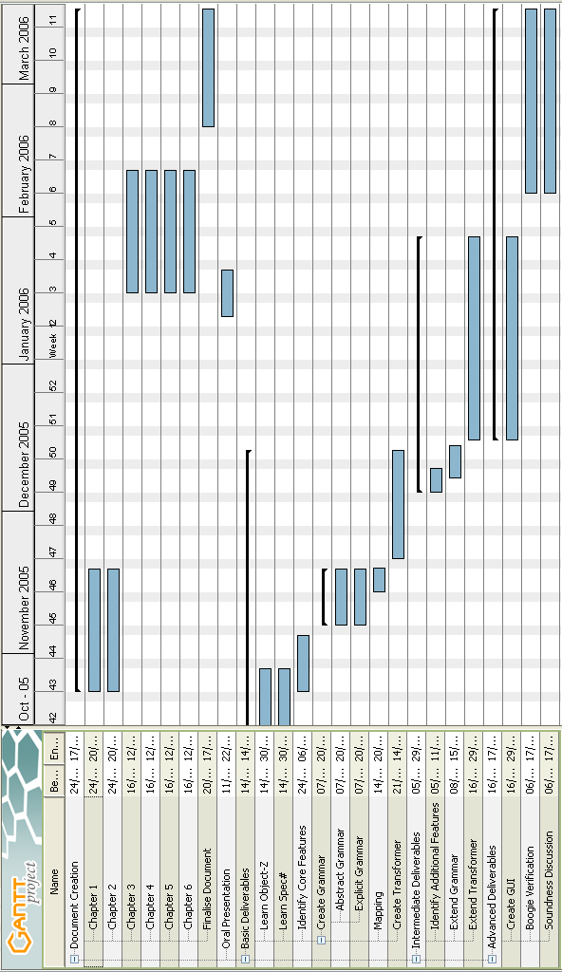
Figure A.A.1: Original project plan Gantt chart
Appendix B: Final Project Progress Gantt Chart

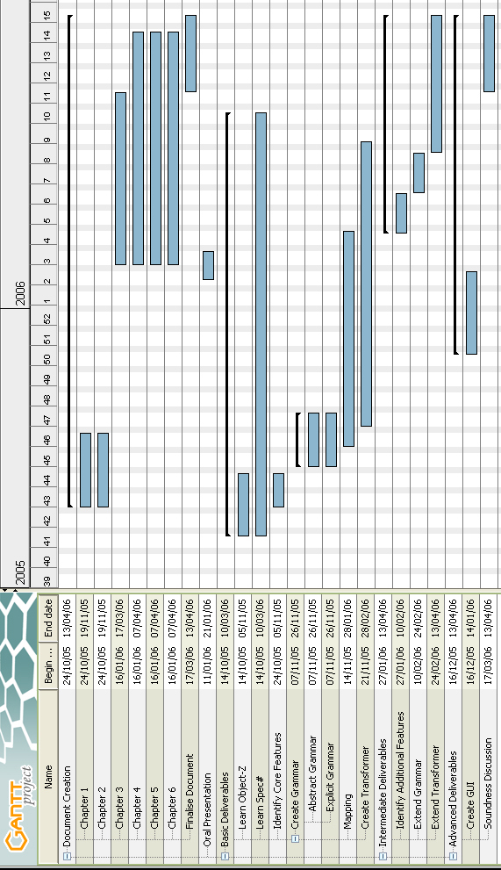
Figure A.B.1: Final project plan Gantt chart

Appendix C: Explicit Grammar for Basic Deliverables

Package mapper;

Helpers
digit = ['0' .. '9'];

Tokens
begin = '\begin';
st = '\ST';
end = '\end';
document = '{document}';
classdef = '{class}';
axdef = '{axdef}';
statedef = '{state}';
initdef = '{init}';
opdef = '{op}';

zproject = '\zproject';
delta = '\Delta';
natclass = '\nat';
intclass = '\integer';
geq = ('\geqslant' | '\geq');
leq = ('\leqslant' | '\leq');
member = '\mem';
notmember = '\nem';
sdef = '\sdef';
fcmp = '\fcmp';
zbreak = '\zbreak';
true = 'true';
false = 'false';
newline = '\\';

lbrace = '{';
rbrace = '}';
reallbrace = '\{';
realrbrace = '\}';
lsquare = '[';
rsquare = ']';
lparen = '(';
rparen = ')';
parallel = '||';
wedge = '\wedge';
comma = ',';
semicolon = ';';
colon = ':';
equals = '=';
notequals = '\not=';
plus = '+';
minus = '-';

id = (['a'..'z'] | ['A'..'Z']) (['a'..'z'] | '_' | ['A'..'Z'] | (digit) | '?' | '!' | ''' | '.')*;
integer = (digit)+;

whitespace = (10 | 13 | 9 | ' ')+;
beginsidebyside = '\begin{sidebyside}';
endsidebyside = '\end{sidebyside} \\';
nextside = '\nextside';

Ignored Tokens
whitespace,
beginsidebyside,
endsidebyside,
nextside;

Productions
spec
= begin [docopen]:document
classdec*
end [docclose]:document;

classdec
= begin [classopen]:classdef
lbrace [classid]:id rbrace
axdefsch?
statesch?
initsch
opsch*
end [classclose]:classdef newline?;

axdefsch
= begin [axdefopen]:axdef
declarationlist
st
predicatelist
end [axdefclose]:axdef newline?;

statesch
= begin [stateopen]:statedef
[primvars]:declarationlist
st
[classinvar]:predicatelist
end [stateclose]:statedef newline?;

initsch
= begin [initopen]:initdef
predicatelist
end [initclose]:initdef newline?;

opsch
= begin [opopen]:opdef
lbrace [opid]:id rbrace
deltalist?
declarationlist
st
predicatelist
end [opclose]:opdef newline?;

deltalist
= delta lparen namelist rparen newline?;

namelist
= {list} id namerest*
| {nothing} ;
namerest
= comma id;

declarationlist
= {list} declaration declarationsrest* newline?
| {nothing} ;
declarationsrest
= newline declaration;
declaration
= namelist colon type;

type
= {nat} natclass
| {int} intclass
| {class} id
;

predicatelist
= {list} predicate predicaterest*
| {nothing} ;
predicaterest
= newline predicate;
predicate
= {exp} expression
| {true} true
| {false} false
| {paren} lparen predicate rparen
;

expression
= expa;
expa
= {equals} expa equals expb
| {notequals} expa notequals expb
| {leq} expa leq expb
| {geq} expa geq expb
| {on} expb
;
expb
= {plus} expb plus expc
| {minus} expb minus expc
| {on} expc
;
expc
= {minus} minus expc
| {on} primary_exp
;
primary_exp
= {id} id
| {int} integer
;

Appendix D: Explicit Grammar for Intermediate Deliverables

Helpers
digit = ['0' .. '9'];

Tokens
begin = '\begin';
st = '\ST';
end = '\end';
document = '{document}';
classdef = '{class}';
axdef = '{axdef}';
statedef = '{state}';
initdef = '{init}';
opdef = '{op}';

zproject = '\zproject';
delta = '\Delta';
natclass = '\nat';
intclass = '\integer';
geq = ('\geqslant' | '\geq');
leq = ('\leqslant' | '\leq');
member = '\mem';
notmember = '\nem';
sdef = '\sdef';
fcmp = '\fcmp';
zbreak = '\zbreak';
true = 'true';
false = 'false';
newline = '\\';

lbrace = '{';
rbrace = '}';
reallbrace = '\{';
realrbrace = '\}';
lsquare = '[';
rsquare = ']';
lparen = '(';
rparen = ')';
parallel = '||';
wedge = '\wedge';
comma = ',';
semicolon = ';';
colon = ':';
equals = '=';
notequals = '\not=';
plus = '+';
minus = '-';

id = (['a'..'z'] | ['A'..'Z']) (['a'..'z'] | '_' | ['A'..'Z'] | (digit) | '?' | '!' | ''' | '.')*;
integer = (digit)+;

whitespace = (10 | 13 | 9 | ' ')+;
beginsidebyside = '\begin{sidebyside}';
endsidebyside = '\end{sidebyside} \\';
nextside = '\nextside';

Ignored Tokens
whitespace,
beginsidebyside,
endsidebyside,
nextside;

Productions
spec
= begin [docopen]:document
classdec*
end [docclose]:document;

classdec
= begin [classopen]:classdef
lbrace [classid]:id rbrace
vislist?
axdefsch?
statesch?
initsch
op*
end [classclose]:classdef newline?;

vislist
= zproject lparen namelist rparen newline?;

axdefsch
= begin [axdefopen]:axdef
declarationlist
st
predicatelist
end [axdefclose]:axdef newline?;

statesch
= begin [stateopen]:statedef
[primvars]:declarationlist
secvars?
st
[classinvar]:predicatelist
end [stateclose]:statedef newline?;
secvars
= delta newline?
[secvars]:declarationlist;

initsch
= begin [initopen]:initdef
predicatelist
end [initclose]:initdef newline?;

op
= {opsch} opsch
| {opexp} opexp
;

opsch
= begin [opopen]:opdef
lbrace [opid]:id rbrace
deltalist?
declarationlist
st
predicatelist
end [opclose]:opdef newline?;

opexp
= {simple} zbreak [opid]:id sdef [first]:id newline?
| {fcmp} zbreak [opid]:id sdef [first]:id fcmp [second]:id newline?
| {conj} zbreak [opid]:id sdef [first]:id wedge [second]:id newline?
| {choice} zbreak [opid]:id sdef [first]:id lsquare rsquare [second]:id newline?
| {parallel} zbreak [opid]:id sdef [first]:id parallel [second]:id newline?
;

deltalist
= delta lparen namelist rparen newline?;

list
= {int} intlist
| {name} namelist
;

namelist
= {list} id namerest*
| {nothing} ;
namerest
= comma id;

intlist
= {list} integer intrest*
| {nothing} ;
intrest
= comma integer;

declarationlist
= {list} declaration declarationsrest* newline?
| {nothing} ;
declarationsrest
= newline declaration;
declaration
= namelist colon type;

type
= {nat} natclass
| {int} intclass
| {class} id
;

predicatelist
= {list} predicate predicaterest*
| {nothing} ;
predicaterest
= newline predicate;
predicate
= {exp} expression
| {member} id member reallbrace list realrbrace
| {notmember} id notmember reallbrace list realrbrace
| {true} true
| {false} false
| {paren} lparen predicate rparen
;

expression
= expa;
expa
= {equals} expa equals expb
| {notequals} expa notequals expb
| {leq} expa leq expb
| {geq} expa geq expb
| {on} expb
;
expb
= {plus} expb plus expc
| {minus} expb minus expc
| {on} expc
;
expc
= {minus} minus expc
| {on} primary_exp
;
primary_exp
= {id} id
| {int} integer
;

Appendix E: Input Syntax Symbol Table

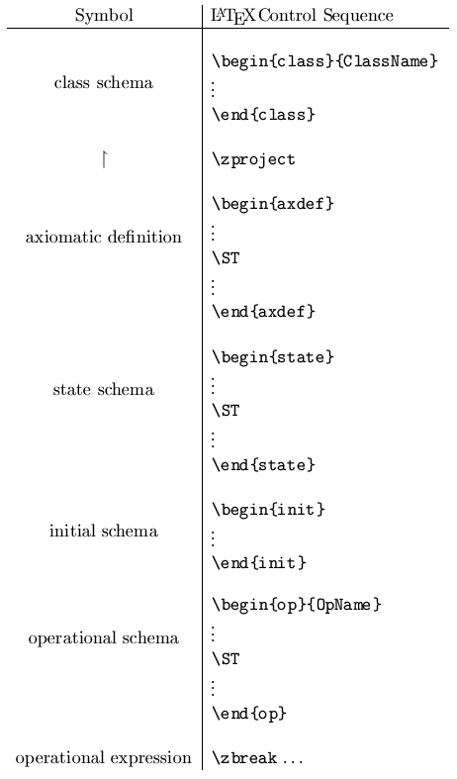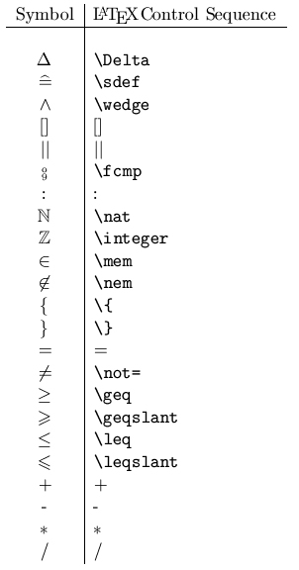

Figure A.D.1: Input syntax symbol tables

Appendix F: Concrete Input for Basic Deliverables Example

\begin{document}
\begin{class}{CreditCard}
\begin{axdef}
limit : \nat
\ST
limit = 1000
\end{axdef} \\
\begin{state}
balance : \integer
\ST
balance + limit \geqslant 0
\end{state} \\
\begin{init}
balance = 0
\end{init} \\
\begin{op}{withdraw}
\Delta (balance) \\
amount? : \nat
\ST
amount? \leqslant balance + limit \\
balance' = balance - amount?
\end{op} \\
\begin{op}{deposit}
\Delta (balance) \\
amount? : \nat
\ST
balance' = balance + amount?
\end{op} \\
\begin{op}{withdrawAvail}
\Delta (balance) \\
amount! : \nat
\ST
amount! = balance + limit \\
balance' = -limit
\end{op}
\end{class}
\end{document}

Appendix G: Concrete Input for Intermediate Deliverables Example

\begin{document}
\begin{class}{CreditCard}
\zproject (limit,balance,INIT,withdraw,deposit,withdrawAvail) \\
\begin{axdef}
limit : \nat
\ST
limit \mem \{1000,2000,5000\}
\end{axdef} \\
\begin{state}
balance : \integer
\ST
balance + limit \geqslant 0
\end{state} \\
\begin{init}
balance = 0
\end{init} \\
\begin{op}{withdraw}
\Delta (balance) \\
amount? : \nat
\ST
amount? \leqslant balance + limit \\
balance' = balance - amount?
\end{op} \\
\begin{op}{deposit}
\Delta (balance) \\
amount? : \nat
\ST
balance' = balance + amount?
\end{op} \\
\begin{op}{withdrawAvail}
\Delta (balance) \\
amount! : \nat
\ST
amount! = balance + limit \\
balance' = -limit
\end{op}
\end{class} \\

\begin{class}{TwoCards}
\begin{state}
c_1,c_2 : CreditCard \\
\Delta \\
totalbal : \integer
\ST
c_1 \not= c_2 \\
totalbal = c_1.balance + c_2.balance
\end{state} \\
\begin{init}
c_1.INIT \\
c_2.INIT
\end{init} \\
\zbreak
withdraw_1 \sdef c_1.withdraw
\zbreak
transfer \sdef c_1.withdraw \wedge c_2.deposit
\zbreak
withdrawEither \sdef c_1.withdraw [] c_2.withdraw
\zbreak
transferAvail \sdef c_1.withdrawAvail || c_2.deposit \\
\begin{op}{replaceCard_1}
\Delta (c_1) \\
card? : CreditCard
\ST
card? \nem \{c_1,c_2\} \\
card?.limit = c_1.limit \\
card?.balance = c_1.balance \\
c'_1 = card?
\end{op} \\
\end{class}
\end{document}

