Project 1: Static Foundations
Feedback for Functionary
Student: Maia Diaz (scramgledeggs) Course: CSC 436, Fall 2026 Reviewed at: a6d1f17
Repo: github.com/scramgledeggs/scramgledeggs.github.io
Submitted URL: scintillating-bavarois-7077d8.netlify.app (private) Public copy: scramgledeggs.github.io

Grade: 51 / 100
Category | Points | Earned | One line
Semantic HTML | 20 | 6 | No doctype on any page, zero h1s across four pages, one footer and no other semantic element
CSS layout | 25 | 15 | Bootstrap does the layout and that is allowed; you wrote one line of CSS, and it is an !important
Responsive design | 15 | 11 | No horizontal scroll, sidebar hides on phones; no media query of your own
JavaScript interaction | 15 | 10 | Search and game both work against a live API; failures are silent, and Check-before-Play throws
Repository and deployment | 15 | 5 | Submitted URL is private; an API key is committed to a public repo; README has no live URL
Content and polish | 10 | 4 | A real idea with a real API; zero images, two typos, no way to know when a search failed
Total | 100 | 51 | The JavaScript instincts are real. The HTML and CSS this project was testing are not here yet.

How this review was made
Your instructor reviewed this project with Claude (Anthropic's AI) as a second set of eyes. Claude cloned the repo, read all four pages, loaded the site at phone, tablet and desktop widths, ran the W3C validator on every page, searched the dictionary with a real word, an empty box and a nonsense word, played the guessing game, and read the console. Every note and every point in this document was read and approved by your instructor. Same standard, same rubric, just more time spent looking at your code than one human has in a grading week.
About this submission: you said up front that this is your final project from last semester, submitted because you ran out of time. Your instructor accepted that, once. So this review grades the site you submitted against this project's rubric, on its merits. The fact that the commit history predates the class was not held against you. Everything else in the rubric was applied the same way it was for everyone.

The short version
Your note said this would show where you are at, and it does. You can call a REST API, check the response, parse JSON, and put the result on the page. You can build a small game loop. That is real, and it is more than some people in this class attempted.
But this project was called Static Foundations for a reason. It was testing semantic HTML, hand-written layout CSS, and responsive design, and those three things are mostly absent. None of the four pages has a doctype, so every one fails the validator on line 1. None has an h1; the titles are paragraphs with a Bootstrap class that makes them big. The only semantic element on the whole site is one footer. The only CSS you wrote is a single line that forces the background color with !important. And two things that are not about skill: the URL you submitted is private, and there is a Merriam-Webster API key sitting in a public repository, which the brief specifically told you never to do.
The gap between this and a passing Project 1 is not talent. It is the skeleton. The rest of this review shows exactly where it goes.

What Claude measured
Check | Result
Submitted Netlify URL in a private window | HTTP 401, "This site is private"
Same site on GitHub Pages | HTTP 200, loads normally
Horizontal scroll at 375 / 768 / 1280 px | None at any width
W3C validator | 1 error per page, 4 pages: missing <!DOCTYPE html>
h1 elements across 4 pages | 0
Semantic elements across 4 pages | 1 (footer on the home page)
Lines of CSS you wrote | 1: body { background: #fff1cc !important; }
Media queries of your own | 0 (the sidebar hides via Bootstrap's d-none d-md-block)
Images | 0 (the one image in the repo was deleted the day before submission)
Dictionary search, "buzz" | Works: "a communication by telephone"
Dictionary search, empty box | Console error; previous answer stays on screen
Dictionary search, nonsense word | Console error; previous answer stays on screen
Guessing game | Works: word, part of speech, definition, correct and wrong answers
Clicking Check before Lets play | ReferenceError: word is not defined
API key in source | Yes, page1.html line 40 and page2.html line 66, in a public repo
README | Title, description, how to run. No live URL
Commits since the project was assigned | 2: delete an image, update README

The site at three widths
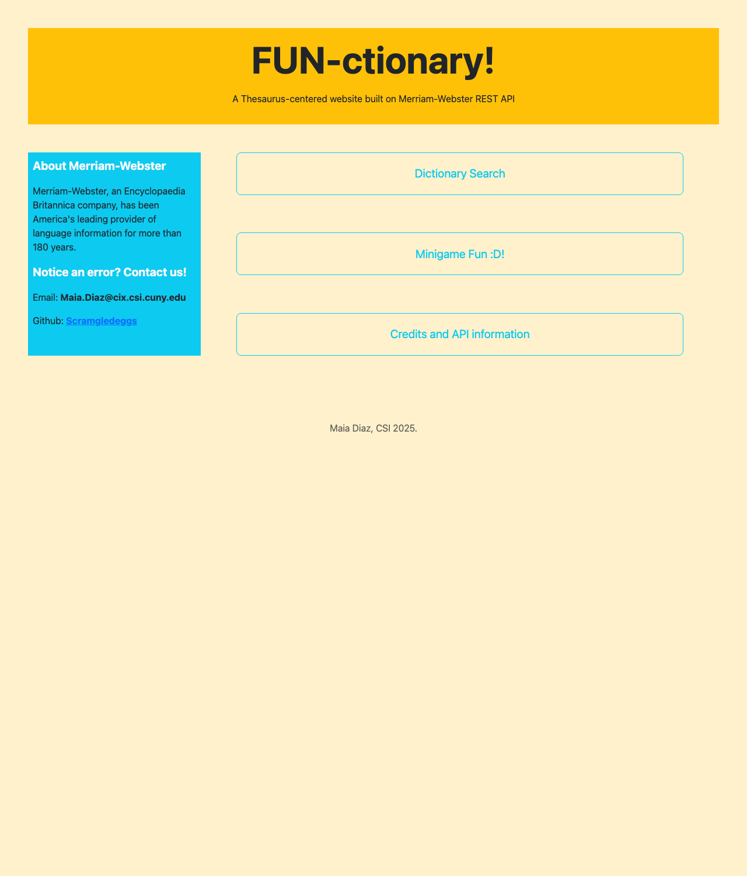
Desktop, 1280px, from the public GitHub Pages copy. Sidebar, three buttons, footer.
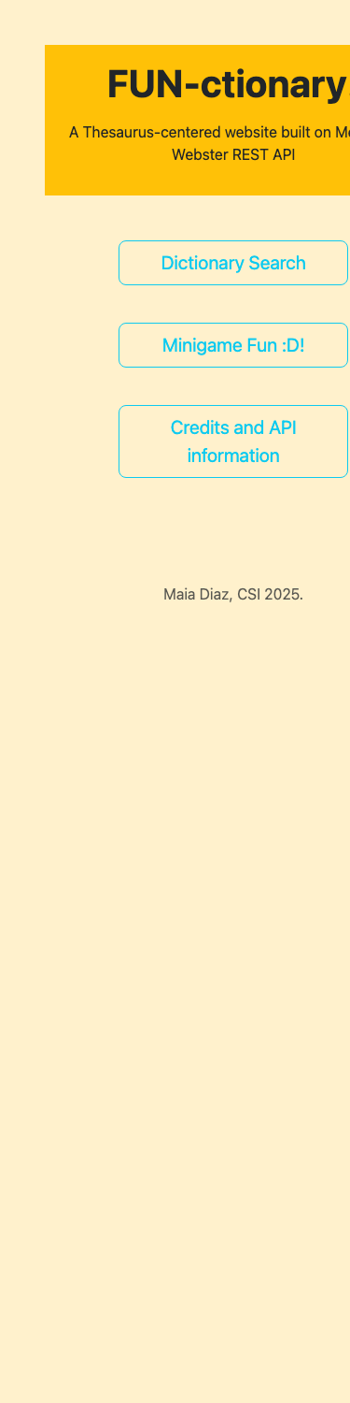  Phone, 375px. Sidebar hidden; m-5 margins squeeze the buttons. | 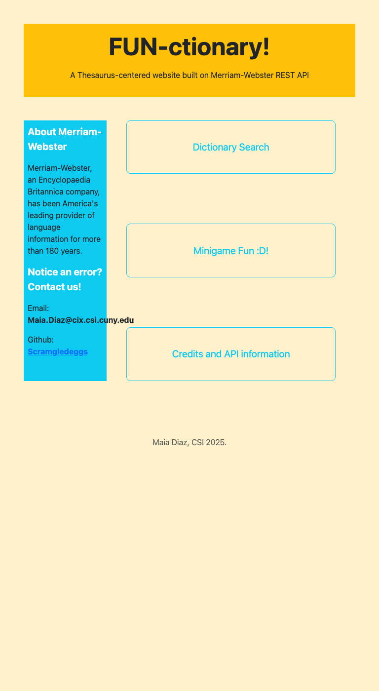  Tablet, 768px. Sidebar returns.

Semantic HTML: 6 / 20

What is working
- lang="en", a charset, a viewport tag and a title on every page. The home page has a footer. Form inputs on the search and game pages have ids and placeholders.

What to change
- No doctype. Every page starts with <html lang="en"> (index.html line 1). Without <!DOCTYPE html> on the line above it, browsers render in quirks mode and the validator stops at line 1. One line, four times.
- No h1, anywhere. "FUN-ctionary!" is <p class="display-3"> (line 16). "Thesaurus Search" and "Word Guess" are <p class="display-5">. Bootstrap's display classes are meant to go on headings; they make text look like a title without making it one. Every page needs one h1, and screen readers, search engines and the validator all count them.
- One semantic element on the site. The brief asked for at least three content sections built from header, nav, main, section, article, footer. The home page has a footer and nothing else; the other three pages have none. The yellow banner is a header. The three big buttons are a nav. The sidebar is an aside. The search form and results are main. Same Bootstrap classes, real elements underneath.
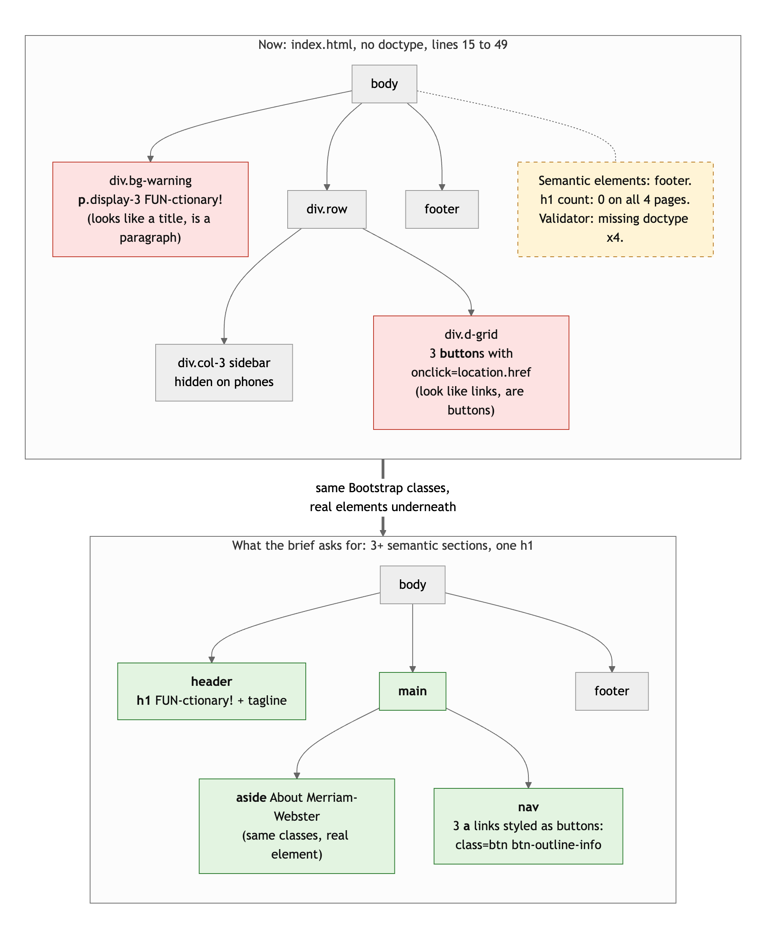
Diagram 1. The home page skeleton now (top) and with real elements under the same Bootstrap classes (bottom).
- Buttons used as links. <button onclick="location.href=..."> (lines 34 to 38) and the "Take me back!" buttons on every other page. Anything that goes to another page is an <a href>. Bootstrap's btn classes work on links, so an anchor with class="btn btn-outline-info btn-lg" looks identical, works without JavaScript, and can be opened in a new tab.
- The search "form" is not a form (page1.html lines 22 to 28). A div.form-group with an input and a button. Wrap it in <form> with a submit handler and pressing Enter works, which is what everyone does in a search box.
- Small: <style type="text/css"> is a leftover from 2005. Drop the attribute.

CSS layout: 15 / 25

What is working
- Bootstrap is doing real layout work, and Bootstrap is allowed. The home page is a flex row with a col-3 sidebar and a col-8 button column. d-grid gap-2 stacks the buttons with even spacing. The palette (cream, yellow, cyan) is consistent across all four pages.

What to change
- You wrote one line of CSS. body { background: #fff1cc !important; } (index.html line 8), repeated in each page's style block. The !important is there to beat Bootstrap's own body rule, which is a sign the fight is being lost. The brief's CSS category is about layout you author: a Flexbox or Grid rule you wrote, spacing you chose. There is not one. Even a site.css with the banner, the button column and the sidebar written out by hand would change this score more than anything else on the sheet.
- m-5 on everything. Banner, row, search box, result box, credits box: all m-5. That is not a spacing system, it is one number. On a phone m-5 is 3rem on each side, which is why the content column is so narrow at 375px.
- md-6 is not a class (line 23). Bootstrap has col-md-6; md-6 matches nothing and does nothing. Claude checked: no stylesheet defines it.
- The same style block is pasted into four pages. Move it to one style.css and link it. When you add a second rule, you will thank yourself.

Responsive design: 11 / 15

What is working
- No horizontal scroll at any width. The sidebar disappears below 768px via d-none d-md-block, and the button column takes the full width. Text wraps. Nothing breaks.

What to change
- No media query of your own. The one responsive decision on the site is Bootstrap's d-md-block. The brief asked for the layout to adapt meaningfully using media queries or intrinsic patterns you wrote. Hiding a column is the bluntest version of adapting: on a phone, the contact email and GitHub link are simply gone.
- The phone layout is cramped by m-5. At 375px, 3rem margins on both sides leave about 280px for content, and the "Credits and API information" button wraps to three lines. m-3 on small screens (m-3 m-md-5) fixes it with the tools you are already using.

JavaScript interaction: 10 / 15

What is working
- Two real features against a live API. The search (page1.html lines 35 to 55) is async/await, checks response.ok, parses JSON, and writes the definition to the page. The game (page2.html lines 41 to 81) picks a random word, fetches its part of speech and definition, and checks the guess case-insensitively. Both work; Claude searched "buzz" and got a definition, played the game and got "Correct!!!" and "wuh oh :( nope." Good instincts: try/catch, toLowerCase() on input, an early return on the correct branch.

What to change
- word is never declared. word = wordSelection[random] (page2.html line 46) creates an accidental global. Click "Check!" before "Lets play!" and the page throws ReferenceError: word is not defined. let word; at the top of the script fixes it. Same for var random: use const.
- Failures are silent, and stale. Search with an empty box and the API answers "Word is required." as plain text, response.json() throws, the catch logs to the console, and the previous definition stays on screen as if it were the answer. Search a nonsense word and the API returns a list of suggestions instead of entries, data[0].shortdef is undefined, and the same thing happens. Two console errors from ordinary use, and the user never learns anything went wrong. In the catch, write to the result element: "No definition found for that word." And check for an empty box before fetching.
- Inline onclick and innerHTML. Every handler is onclick="..." in the HTML. The pattern this class teaches is addEventListener in the script, which keeps behavior out of the markup. And innerHTML = definition inserts whatever the API sent as HTML; textContent is what you mean for plain text.
- The search box does not submit on Enter. See the form note above; a submit listener with event.preventDefault() gives you Enter for free.

Repository and deployment: 5 / 15

What is working
- The README has a title, a real description, and how to run it. The site is deployed and the GitHub Pages copy works in a private window.

What to change
- The submitted URL is private. scintillating-bavarois-7077d8.netlify.app returns 401 with "This site is private. Sign in with an invited Netlify account to view it." The brief: "Both links must work in a private or incognito browser window. If a link is broken at grading time, the project is graded on what I can see, which may be nothing." Your GitHub Pages copy is public and identical, which is why there is a grade. Turn off site protection in Netlify (Site configuration, then Access and security), and test in a private window before you submit anything again.
- An API key is committed to a public repository. key=79f6cc56-... is in page1.html line 40 and page2.html line 66. The brief says, in its own words: "Never commit secrets. If a key lands in your history, rotate it and tell me." It is a free-tier dictionary key, so the blast radius is small, but the habit is the whole point. Anyone can copy it and use up your 1,000 daily queries, and it is in every commit since December, so deleting it now does not remove it from history.
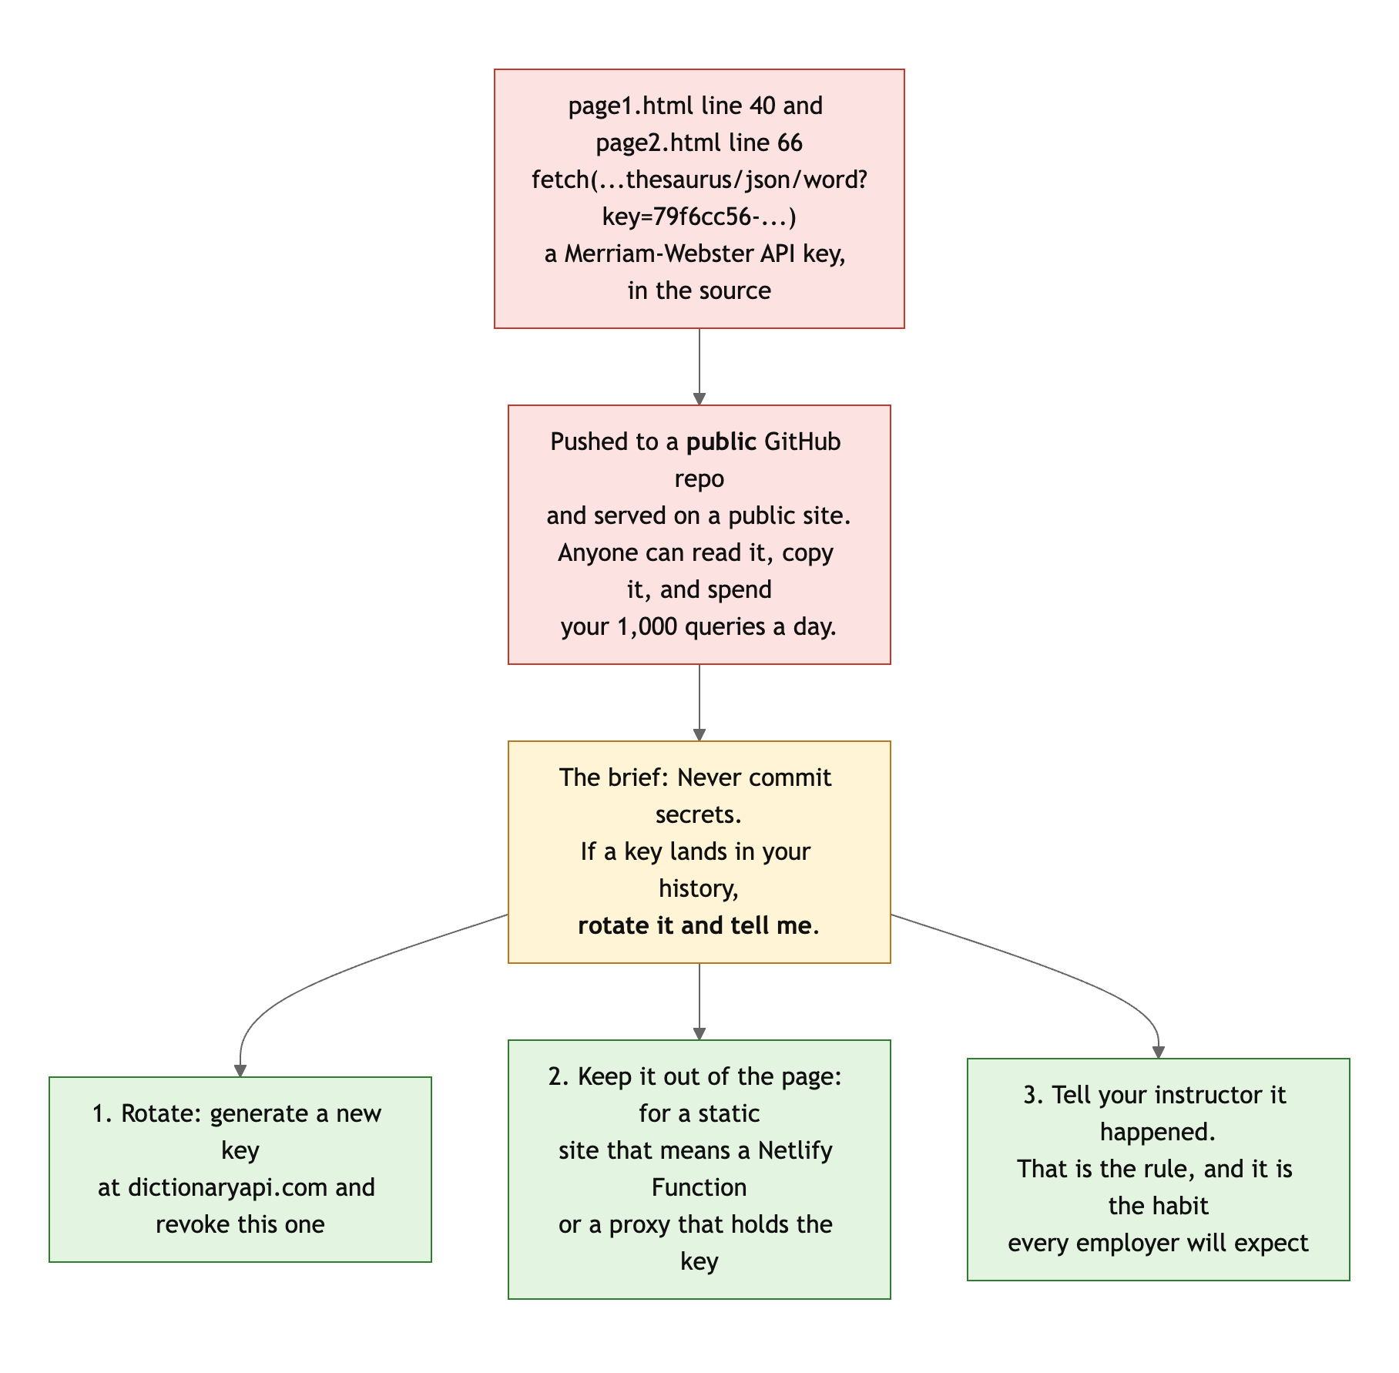
Diagram 2. Where the key is, why it matters, and the three steps the brief expects.
- README is missing the live URL, the fourth required item.
- Commit messages are GitHub's defaults. "Add files via upload," "Update index.html," "Delete ganymedeling.jpg." The timeline was not held against you, but the messages still tell a reader nothing. The brief asked for "add nav," "fix card layout."

Content and polish: 4 / 10

What is working
- A real idea, built on a real API, with a game that is actually a little fun. The voice in the copy ("Only seven words are currently in rotation, since I probably wouldn't be able to guess it otherwise!") is yours.

What to change
- Zero images. The brief asked for real text and images that fit the theme. The repo had one image, ganymedeling.jpg, and it was deleted the day before you submitted. A site about words could show a dictionary, a thesaurus page, the Merriam-Webster logo with credit. Right now it is colored boxes.
- The user cannot tell when something failed. See JavaScript. From the user's side, a bad search looks like the old answer.
- Spelling: "recieve" (page1.html line 17), "liscence" (page3.html line 26). On a dictionary site, especially.
- "Endpoints accessed: fl and shortdef" on the credits page: those are fields in the response, not endpoints. The endpoint is /references/thesaurus/json/{word}.

Your next three moves
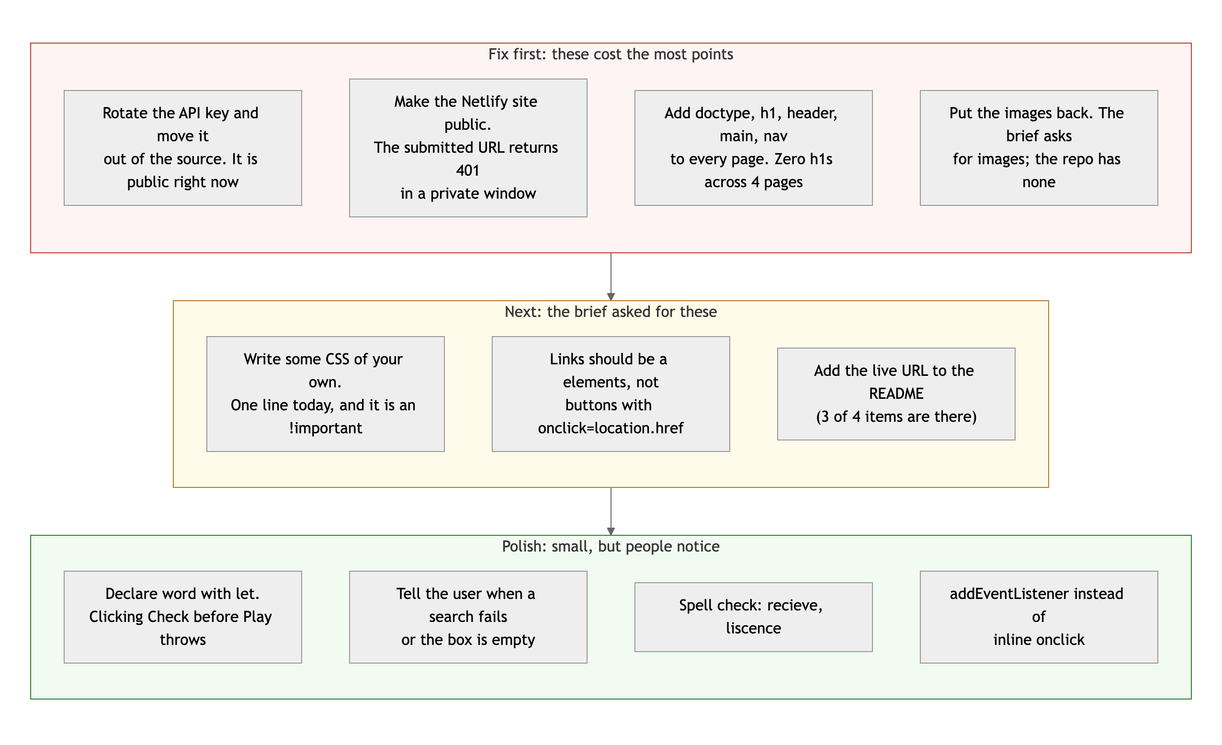
Diagram 3. Priority order. Top row first: it is where the points are.
- Rotate the key today, and make the Netlify site public. Both are ten-minute tasks, and both are things the brief said in plain words. Then tell your instructor the key was rotated.
- Give every page a skeleton. Doctype, header with an h1, nav of real links, main, footer. Same Bootstrap classes on top. An hour for four pages, and it is most of the 14 points you lost in the first category.
- Before Project 2, write one page with no Bootstrap at all. Header in Flexbox, cards in Grid, one media query, all in a CSS file you wrote. Not because Bootstrap is bad, but because this class is going to ask you to know what it is doing for you.

You were honest about what this is, and you asked to be graded on where you are at. Here is where you are at: you can make a page talk to an API. The next skill is making the page itself right, and it is a smaller step than the one you have already taken.
This review lives in a pull request on your repo. It only adds feedback files and does not touch your code. Merge it, close it, or just read it. Questions go to office hours or the Brightspace board.

