* 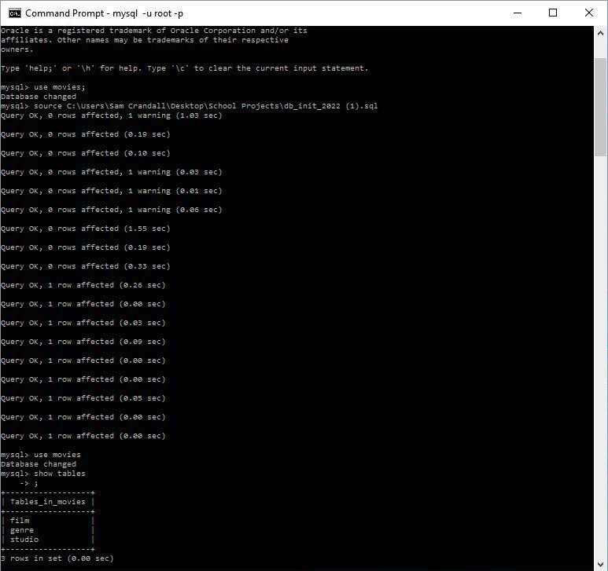CLI Script ran + show tables command:
* Python Script ran to connect to Movies DB + output:

Sam Crandall CSD310; Module 6.2 Assignment

Movies: Setup November 18th, 2022

