Sam Crandall

CSD-340; Module 1.2 Assignment

GitHub Repository Setup

January 5th, 2023

1. **GitHub Repository Link:** 
   1. [**https://github.com/scrandall93/CSD-340.git**](https://github.com/scrandall93/CSD-340.git)
2. **Screenshot of GitHub Repository:**

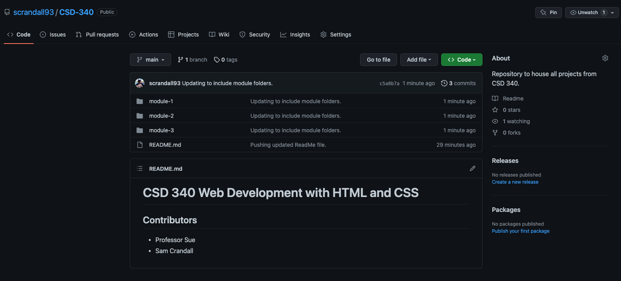

1. **Screenshot of Local Directory:**

