Sam Crandall

CSD340; Module 2.2 Assignment

Building a Web Page Exercise, Part 1

January 6th, 2023

* Link to GitHub Repository

<https://github.com/scrandall93/CSD-340.git>

* Initial validator results w/ errors

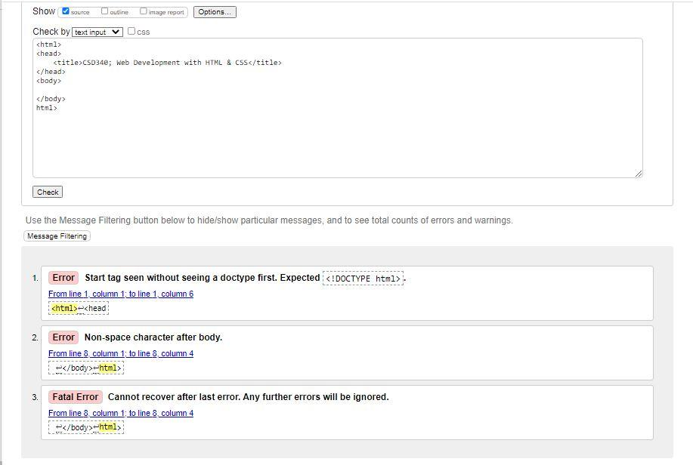

* Corrected validator results

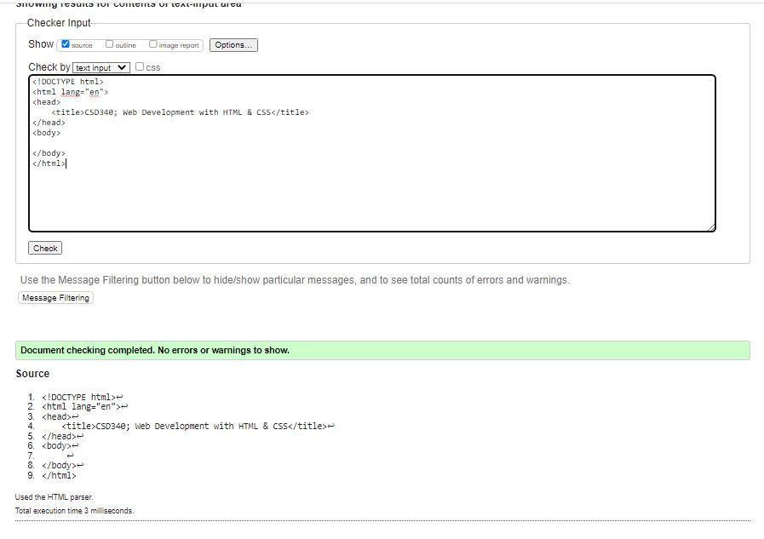

* Final validator results

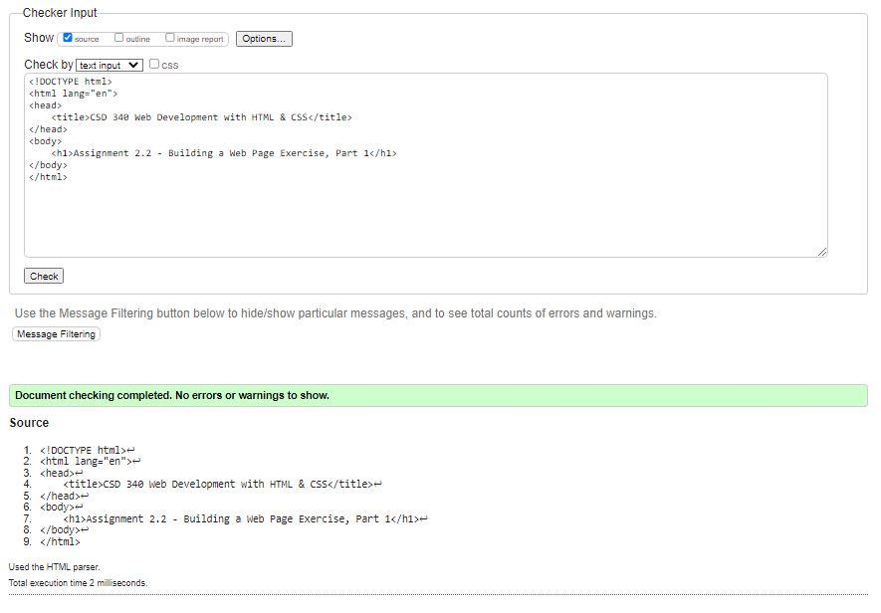

* Screenshot of file ran through Google Chrome

