Name: Faisal Ahmad

Question 1

a. number of variables: 16

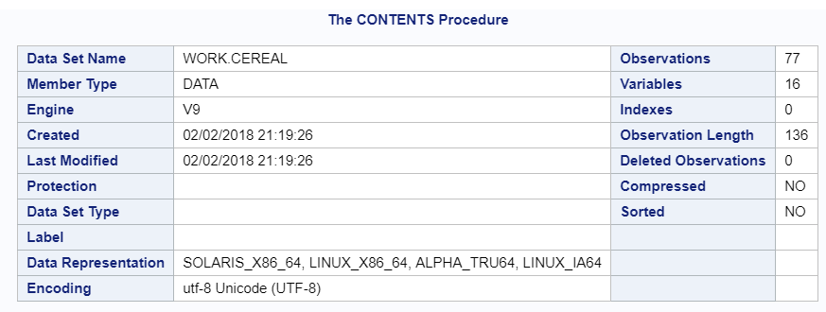

b. number of observations: 77



c.

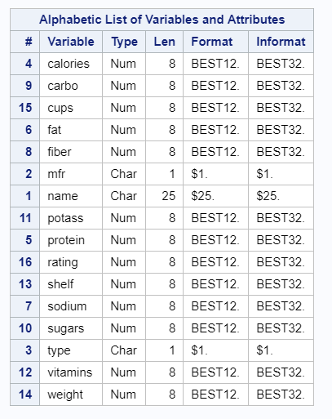

2.

a.

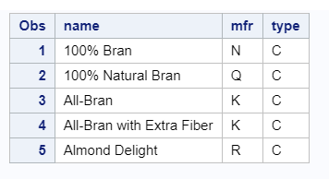

Question 3.

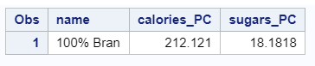

Question 4.

a.

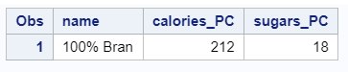

Question 5.

a.

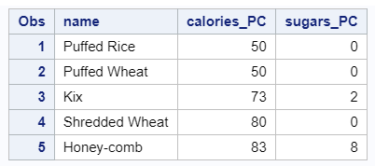

b.

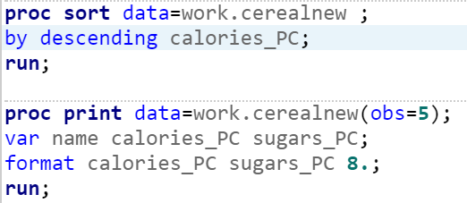

By using “sort” on “calories_PC” column, SAS sorted the whole column, since we used “by Descending” it sorted the whole column in descending order.

By printing we printed the result specifically for 5 observations of name calories_PC sugars_PC columns with only integer values.

Question 6.

a.

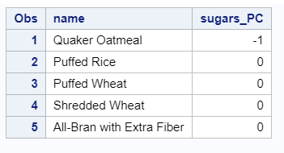

b.

Yes, after observing the value of sugars_PC=-1 in Quaker Oatmeal which in reality is impossible points us to the fact that there are some errors in data. So in order to ensure sanctity of data we need to omit the erroneous data from our dataset.

Question 8.

a.

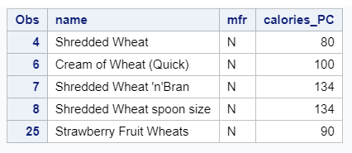

Question 9.

a.

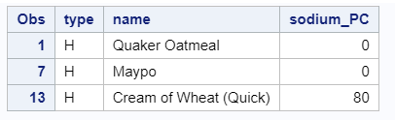

Question 10.

a.

PROC sort DATA = WORK.cerealnew;

BY descending sugars_PC;

RUN;

PROC PRINT data=work.cerealnew(obs=10);

var type name sodium_PC sugars_PC potass_PC;  
format sugars_PC sodium_PC potass_PC 8.;  
run;

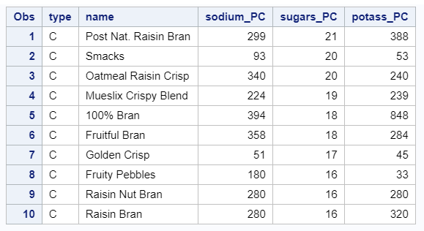

PROC sort DATA = WORK.cerealnew;  
BY sugars_PC;  
RUN;  
PROC PRINT data=work.cerealnew(obs=10);  
var type name sodium_PC sugars_PC potass_PC;  
format sugars_PC sodium_PC potass_PC 8.;  
run;

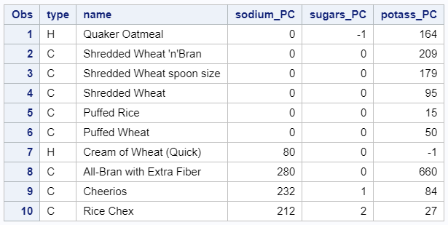

We can see for high value of sugar there is direct relationship between sodium content vs potassium content, meaning if sodium content is high comparatively potassium content is also high.

While on observing the sugar less data we mostly observed an inverse relationship between the two. That is if sodium content is low correspondingly potassium content is high