THIS PROTECTIVE EQUIPMENT
MUST BE WORN
IN THIS AREA
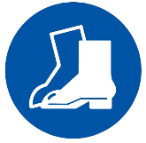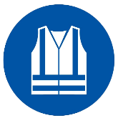

P.P.E Requirements
- Long sleeve and long pants cotton clothing
- Hearing Protection
- Eye protection
- Steel capped footwear
- High visibility clothing

STEP 1 | STEP 2
 | 
Remove the four M4 retaining screws from the front housing. | Lift the heat module clear, keeping the ribbon cable attached.
STEP 3 | STEP 4
 | 
Disconnect the ribbon cable at the board connector. | Inspect the thermal pad for damage or displacement.

