**SOFTWARE REQUIREMENTS SPECIFICATION (SRS)**



**Prepared By:**

**Liwanag, Jasper B.**

**Panganiban, Jherico T.**

**Rom, Ivan Clyde M.**

**Tarnate, Halley A.**

**Tiaga, Ellen Joyn-**

|  |
| --- |
| **Document Sign-off** |

|  |  |
| --- | --- |
| **Developers** | **Reviewers** |
| **Jasper Liwanag**  **Project Manager** | **Cherry Ann Carpiso**  **Reviewer, Class Adviser** |
|  |  |
|  |  |
| **JherichoPanganiban**  **Assistant Project Manager** |  |
|  |  |
|  |  |
| **Halley Tarnate**  **Developer** |  |
|  |  |
|  |  |
| **Ellen Joy Tiaga**  **Developer** |  |
|  |  |
|  |  |
| **Ivan Clyde Rom**  **Developer** |  |
|  |  |
|  |  |

**Revision History**

|  |  |  |  |
| --- | --- | --- | --- |
| **Name** | **Date** | **Reason For Changes / Comments** | **Version** |
| UBCPDOSRVRS | 09/12/16 | * Added content to Chapters 1 and 2 | V 0.1 |
| UBCPDOSRVRS | 9/22/16 | * Added content to Chapter 3.1 * Updated Chapters 1.3 and 1.4 | V 0.2 |
| UBCPDOSRVRS | 9/23/16 | * Added content to Chapters to 4.1. | V 0.3 |
| UBCPDOSRVRS | 9/24/16 | * Added content to Chapters 3.1.2, 3.1.3, 3.1.4, 3.1.5, and 3.1.6 * Added content to Chapters 3.2 and 3.3 * Added content to Chapters to 4.1 | V 0.4 |
| UBCPDOSRVRS | 9/25/16 | * Revised Chapter 2.2 * Added content to Chapters 3.1.7 and 3.1.8 * Added content to Chapter 4.1 | V 0.5 |
| UBCPDOSRVRS | 10/27/16 | * Revised Chapter 1.3 and 4.1 * Added content to Chapter 4.1 | V 0.6 |
| UBCPDOSRVRS | 10/28/16 | * Revised and added content to Chapter 4.1 | V 0.7 |
| UBCPDOSRVRS | 11/1/16 | * Added content to Appendix B | V 0.8 |
| UBCPDOSRVRS | 11/4/16 | * Added content to Appendix A * Revised content to Appendix B | V 0.9 |
| UPCPDOSRVRS | 11/11/16 | * Revised content to Appendix B | V 0.10 |
| UBCPDOSRVRS | 11/19/16 | * Grammatical revision of content to Chapters 1, 2, and 3 | V 0.11 |
| UBCDOSRVRS | 11/21/16 | * Grammatical revision of System Profile Chapters 1 and 2 | V 0.12 |
| UBCPDOSRVRS | 11/23/16 | * Revised System Profile Chapter 3 * Revised Chapter 1.2 * Revised Appendix A | V 0.13 |
| UBCPDOSRVRS | 11/24/16 | * Revised Appendix B * Revised Chapter 4 | V 0.14 |
| UBCPDOSRVRS | 11/26/16 | * Revised Appendix A | V 0.15 |
| UBCPDOSRVRS | 11/30/16 | * Final Revisions | V 0.16 |

**Table of Contents**

1. Introduction 7

1.1 Purpose 7

1.2 Scope 7

1.3 Definitions, Acronyms, and Abbreviations. 8

1.4 References 9

1.5 Overview 9

2. Business Description 10

2.1 Business Description 10

2.2 Business Objectives 10

2.3 Stakeholder Profile 11

3. The Overall Description 14

3.1 Product Perspective 14

3.1.1 System Interfaces 14

3.1.2 Interfaces 14

3.1.3 Hardware Interfaces 14

3.1.4 Software Interfaces 14

3.1.5 Communication Interfaces 15

3.1.6 Memory Constraints 15

3.1.7 Operations 15

3.1.8 Site Adaptation Requirements 15

3.2 Product Functions 16

3.3 User Characteristics 17

3.4Assumptions and Dependencies 18

3.5 Apportioning of Requirements. 19

3.6 Business Description 19

4. Specific Requirements 20

4.1 Functional Requirements 20

4.1.1 UBCPDOSRVRS – UC01 (User Login) 20

4.1.2 UBCPDOSRVRS – UC02 (Logout) 21

4.1.3 UBCPDOSRVRS – UC03 (Create User Account) 21

4.1.4 UBCPDOSRVRS – UC04 (Search Records) 23

4.1.5 UBCPDOSRVRS – UC05 (View User Profile) 24

4.1.6 UBCPDOSRVRS – UC06 (View Own User Profile) 25

4.1.7 UBCPDOSRVRS – UC07 (Update User Account) 25

4.1.8 UBCPDOSRVRS – UC08 (Request for Maintenance) 27

4.1.9 UBCPDOSRVRS – UC09 (Reservation of Venue) 28

4.1.10 UBCPDOSRVRS – UC10 (Link Records) 29

4.1.11 UBCPDOSRVRS – UC11 (Forgot Password) 31

4.1.12 UBCPDOSRVRS – UC12 (Add/Edit Form Status) 31

4.1.13 UBCPDOSRVRS – UC13 (Validate Staff User Account) 32

4.1.14 UBCPDOSRVRS – UC14 (Confirm Request Form) 33

Appendices 35

Appendix A: Graphical User Interface(GUI) 35

A.1 User Login 35

A.2Create User Account 35

A.3 Search Reports 36

A.4 View User Account 37

A.5 View Own User Account 37

A.6 Update User Account 37

A.7 Scheduling of Maintenance 38

A.8 Reservation of Venue 39

A.9 Link Records 40

A.10 Forgot Password 41

A.11 Add/Edit Form Status 41

A.12Validate Staff Account 42

A.13 Confirm Request Form 42

Appendix B: Table of Fields (TOF) 43

B.1 User Login 43

B.2 Create User Account 43

B.3 Search Reports 44

B.4 Update User Account 45

B.5 Request for Maintenance 45

B.6 Reservation of Venue 46

B.7 Link Records 47

B.8 Forgot Password 48

B.9 Add/Edit Form Status 48

Appendix C: THE SYSTEM PROFILE 49

Appendix D: MINUTES OF THE MEETING 62

Appendix E: GANTT CHART 84

Appendix F: DEVELOPMENT TEAM’S PICTURES 86

Appendix G: Development Team’s Testimonials 88

Appendix H: Curriculum Vitae 93

# INTRODUCTION

## 1.1 Purpose

The main goal of this SRS document is to give a background of the history, initialization, and development of the management system. This document explains the process of information between its users and the system.

## 1.2 Scope

The Service Requisition and Venue Reservation System (SRVRS), is created for the University of Baguio’s Campus Planning and Development Office. It is a system with the purpose of making requisition of service from the maintenance office, with multiple or large scale buildings under its supervision, simple and efficient in terms of time and tracking.

The SRVRS provides the users with the following services:

* Tracking of job requests and services and venue reservation within the user’s company, in terms of clients, procedures completed, time, and status of the job.
* Viewing of the previous reports and the status of current requests.
* Providing official verification from the organization staff.
* Editing and commenting of reports.
* Listing of people involved in the service.

The SRVRS is allowed to be used by the following:

* Members of the organization.
* Clients within the University or under a separate organization.

The levels of accessibility of the system vary depending on the user:

* All members of the organization – Permitted to view and create their own reports.
* Organization’s secretary and other higher position members – Permitted to view, comment, verify, and create reports.
* Maintenance Manager – Overall maintenance of the database, files, and the program itself.
* Administrator – is responsible for supervising the system in terms of management and security.

## 1.3 Definitions, Acronyms, and Abbreviations.

**Definitions:**

* Summary Report – information about the service in terms of what service and the status of the service.
* Reservation Form – a document to be filled by clients in order to reserve a facility within the University, requiring the CPDO’s approval in order for the client to be able to handle the facility under their supervision.
* Maintenance Form – a document to be filled by clients in order for the CPDO to work on a maintenance job within the university.
* Verification – confirmation of both Reservation and/or Maintenance forms from the CPDO Staff in order to start the client’s requests.

**Acronyms:**

* CPDO – Campus Planning and Development Office
* UB – University of Baguio
* GUI – Graphical User Interface
* IDE – Integrated Development Environment
* SQL – Structured Query Language
* DB - Database

**Abbreviations:**

* App – Application

## 1.4 References

Unpublished References:

* Payoyo, C. et. al. (2013). Inmates Profiling and Monitoring System – Male Dormitory. University of Baguio, Philippines.
* Baguilat, K. et. al. (2015). Landslide Monitoring and Reportng System. University of Baguio, Philippines.
* Calpito, F. et. al. (2013). Architecture and Engineering Material Cost Estimation System. University of Baguio, Philippines.

## 1.5 Overview

The following two chapters of this document will explain the business and overall development of the system. The second chapter explains the business’ general overview and objectives. It also explains how the business’ stakeholders would interact with the system.

Chapter three will cover the overall development of the system in terms of interfaces and overview of the development of system’s purpose and interactions with its users.

# BUSINESS DESCRIPTION

## 2.1 Business Description

The Campus Planning and Development Office (CPDO) of the University of Baguio became a crucial part of the University for its Administration of the university’s overall maintenance. It also takes part with most of the University’s services with other organizations that are not directly linked with the university.

## 2.2 Business Objectives

The CPDO aims to:

* Manage effectively and efficiently the physical facilities of the University of Baguio.
* Actualize infrastructure programs and physical needs of the various units;
* Provide infrastructure plans for future growth and expansion of the campus;
* Perform various repairs in a timely manner; and
* Maintain the aesthetic appearance of the University.

The SRVRS can support the CPDO by improving the rate of how the organization handles jobs and requests. The system allows clients to make requests to the CPDO without the need for both parties to physically meet, as the system would guide the client in the creation of their request, leaving the CPDO to verify and manage their request without any problem in vital details of the request. Upon application, the CPDO would be able to handle multiple requests due how easy the information is shared and accessed.

## 2.3 Stakeholder Profile

|  |  |
| --- | --- |
| **Representative** | Abaya, Bernard |
| **Description** | Director, CPDO |
| **Type** | Interviewee, High Position Member |
| **Responsibilities** | Assists in the development of UBCPDO-SRVRS by providing information about the current organization’s system |
| **Involvement** | Supervises and confirms CPDO’s jobs and requests. |
| **Deliverables** | UBCPDO-SRVRS System Profile  UBCPDO-SRVRS SRS |
| **Comments / Issues** |  |

|  |  |
| --- | --- |
| **Representative** | ChirstoreySemangan |
| **Description** | CPDO Secretary |
| **Type** | High Position Member |
| **Responsibilities** | Responsible for approving requests for the CPDO alongside with the CPDO Director. |
| **Involvement** | Supervises and confirms CPDO’s jobs and requests. |
| **Deliverables** | UBCPDO-SRVRS System Profile  UBCPDO-SRVRS SRS |
| **Comments / Issues** |  |

|  |  |
| --- | --- |
| **Representative** | Alejandro Aspuria Jr.  Roger Aspuria  Lou Dario |
| **Description** | CPDO Staff Members |
| **Type** | High Position Members |
| **Responsibilities** | Does client requests that have the approval of the CPDO Director and Secretary |
| **Involvement** | Does the completion of approved client requests |
| **Deliverables** | UBCPDO-SRVRS System Profile  UBCPDO-SRVRS SRS |
| **Comments / Issues** |  |

|  |  |
| --- | --- |
| **Representative** | Liwanag, Jasper |
| **Description** | Project Manager |
| **Type** | Requirements Analyst  System Developer |
| **Responsibilities** | Leads in the development of the system, assigns tasks to fellow developers while aiding them in their roles for development. |
| **Involvement** | Supports the development of the system with the other System Developers. |
| **Deliverables** | UBCPDO-SRVRS System Profile  UBCPDO-SRVRS SRS |
| **Comments / Issues** |  |

|  |  |
| --- | --- |
| **Representative** | Panganiban,Jherico |
| **Description** | Assistant Project Manager |
| **Type** | Requirements Analyst  System Developer |
| **Responsibilities** | Assists the development of the system, helps the project manager to assign tasks to fellow developers while aiding them in their roles for development. |
| **Involvement** | Supports the development of the system with the other System Developers. |
| **Deliverables** | UBCPDO-SRVRS System Profile  UBCPDO-SRVRS SRS |
| **Comments / Issues** |  |

|  |  |
| --- | --- |
| **Representative** | Tarnate, Halley  Tiaga, Ellen Joy  Rom, Ivan Clyde |
| **Description** | Team Member |
| **Type** | Requirements Analyst  System Developer |
| **Responsibilities** | Perform data gathering and requirement specification. Development of the system. |
| **Involvement** | Supports the development of the system with the other System Developers. |
| **Deliverables** | UBCPDO-SRVRS System Profile  UBCPDO-SRVRS SRS |
| **Comments / Issues** |  |

|  |  |
| --- | --- |
| **Representative** | Carpiso, Cherry Ann |
| **Description** | Reviewer, Class Adviser |
| **Type** | Project Reviewer, Panelist |
| **Responsibilities** | System Analysis and Development |
| **Involvement** | Review team output and provide recommendations and suggestions based on the output. |
| **Deliverables** | UBCPDO-SRVRS System Profile  UBCPDO-SRVRS SRS |
| **Comments / Issues** |  |

# 

# 3. THE OVERALL DESCRIPTION

## 3.1 Product Perspective

The SRVRS is made to automate the current manual system for accepting, tracking, and updating forms and reports needed from maintenance and venue reservation services. It provides simple but efficient monitoring and tracking of all current and previous services, in addition to quicker contact with the organization’s stakeholders via the internet.

### 3.1.1 System Interfaces

The SRVRS does not have any specific system interfaces required.

### 3.1.2 Interfaces

Users can interact between with the system will via the GUI, which will be developed by system developers.

### 3.1.3 Hardware Interfaces

The SRVRS does not require any specific hardware interface.

### 3.1.4 Software Interfaces

The system developer used the following software application in the development of the Information System:

* Microsoft Visual Studio 2010 – Provides the IDE that the system developers will need to create and support the system’s GUI.
* Microsoft Access 2010 – Supports the development of the Information System’s database.
* Windows XP and Windows 7 – The target operating systems that can support the use of the Information System.

### 3.1.5 Communications Interfaces

The SRVRS will be able to accept virtual forms from the users, specifically the clients of the organization, in response the system staff would be able to access the form and act accordingly. In addition, the form will be saved into the database.

### 3.1.6 Memory Constraints

The SRVRS does not have any required memory constraints.

### 3.1.7 Operations

The UBCPDO-SRVRS would be operational on a daily basis; however, client end-users are only permitted to access the system from 8:00 AM to 6:00 PM, as the CPDO are only permitted to accept request forms at this time. The only exception where the SRVRS would not be operational is during system maintenance or power outages as CPDO cannot handle their electrical services within that time as well as most of the equipment available are unusable during a power outage.

### 3.1.8 Site Adaptation Requirements

The UBCPDO-SRVRS would require a web server for its deployment. This can be accomplished through allocating a portion of the existing servers of University of Baguio or through the use of a third party hosting provider.

The SRVRS database for accounts and reports must be preemptively entered into the system before development. In order to make way for new information coming into the system as well as making the system functional for the existing members of the organization.

## 3.2 Product Functions

| Functionality | Description |
| --- | --- |
| **Account Creation** | Allows the user to create their accounts before they can fully use the SRVRS |
| **Account Log-in** | Allows the user to log-in/log-out their respective accounts and fully access the SRVRS. |
| **Viewing of Account Information** | Allows the Admin to view the information that the staff and users have given |
| **Reserving of Venue** | Allows the user to add/reserve a date for a given activity whether internal or external |
| **Scheduling of Maintenance** | Allows the user to schedule a job request |
| **Form Archiving** | Allows the admin to archive past or current job request records |
| **Add/Edit Form Status** | Allows the user to add or editthe current status of a form |
| **Generate Summary Report** | Allows the user to have a Summary report on the system |
| **Account Recovery** | Allows the user to reactivate their respective accounts in case of account loss |
| **Search Reports** | Allows the user to search for a previous forms and documents |

## 3.3 User Characteristics

|  |  |  |
| --- | --- | --- |
| **User** | **Description** | **Functions** |
| Administrator | Administrator  (Access Level 3) | * Edit user account information * Delete user account * Update user account * Add/Edit completed form status * Account login * Account logout * View user profiles * Account Recovery * Create user account * View User Account * View records * Search records * Link records * View Own User Account * Validate staff User Account |
| Maintenance Manager | User  (Access Level 3) | * Account login * Account logout * Create user account * Update user account * Account recovery * Add/Edit completed form status * View user profiles * View records * Search records * Link records * View User Accounts * View Own User Account * Validate staff User Account |
| CPDO Staff | User  (Access Level 2) | * Account login * Account logout * Add/Edit completed form status * Create user account * Update user account * View user profiles * View records * Search records * Link records * View User Account * View Own Use Account * Account Recovery * Validate staff User Account |
| Client | End-user  (Access Level 1) | * Account login * Account logout * Add Reservation Form * Add Maintenance Form * CreateClientUser Account * View Own User Account * Update User Account * View Own Use Account * Scheduling of Maintenance * Reserving of Venue * Account Recovery |

## 3.4 Constraints

The following are the current limitations of the SRVRS system:

* Only the Administrator has full access to all of the functions of the system.
* Users without a working user account cannot access the system.
* The user account’s access levels are strictly observed.

## 3.5 Assumptions and Dependencies

The following assumptions and dependencies are as follows:

* An administrator account has been preemptively made by the developers.
* The level of accessibility of the user will vary depending on the user’s login information.
* The system requires reliable internet connection in order for it to be accessed.

## 3.6 Apportioning of Requirements.

The apportioning of the requirements of the SRVRS are as follows:

**Phase I:** Information Management of archived documents and forms.

**Phase II:** Information Management of reports

**Phase III:** Archiving and backing up forms, documents, and reports

**Phase IV:** Adjustments to the security and accessibly of the system.

# 4. SPECIFIC REQUIREMENTS

## 4.1 Functional Requirements

**4.1.1 UBCPDOSRVRS-UC01 (User Login)**

|  |  |  |
| --- | --- | --- |
| UBCPDOSRVRS-UC01 | User Login | |
| **Description** | This allows users to access the system under their credentials. | |
| **Actor** | Clients, CPDO Staff, Maintenance Manager, Administrator | |
| **Trigger** | The user is required to login. | |
| **Pre-condition** | 1. Login Page is displayed 2. Users must have a registered account | |
| **Post-condition** | The user will be logged into the system and able to access its features. | |
| **Basic flow** | **Actor Action** | **System Response** |
| **Step 1:**User inputs username and password  **Step 2:**User submits the inputted information | **Step 3:**The information is being verified and validated  **Step 4:**Access to the system is granted |
| **Alternate Flow** | **Step 3.3:**  Return to step 1 | **Step 3.1:**Fields contain invalid information  **Step 3.2:**Informs the user about the invalidated fields |
| **Assumptions** | The user account is not currently logged in within the same computer | |
| **Business Rules** | All users are required to have a user account to access the system’s features. | |
| **Field Validations** | **B.1** User Login | |
| **Author** | Liwanag, Jasper B. | |
| **Date** | September 23, 2016  November 23, 2016 | |

**4.1.2 UBCPDOSRVRS-UC02 (Logout)**

|  |  |  |
| --- | --- | --- |
| UBCPDOSRVRS-UC02 | Logout | |
| **Description** | This allows the user to exit the system. | |
| **Actor** | Clients, CPDO Staff, Maintenance Manager, Administrator | |
| **Trigger** | The user wants to exit the system. | |
| **Pre-condition** | The user is logged in the system. | |
| **Postcondition** | The user will be logged out of the system. | |
| **Basic flow** | **Actor Action** | **System Response** |
| **Step 1:**User selects logout  **Step 3:**User verifies logout | **Step 2:**Prompts the user to verify/confirm logout  **Step 4:**Back to login page |
| **Alternate Flow** | **Step 3.1:** User cancels logout | **Step 3.2:** Resume to previous page |
| **Includes** | **4.1.1** UBCPDOSRVRS-UC01(Client User Login)  **4.1.2** UBCPDOSRVRS-UC02(Staff User Login) | |
| **Author** | Liwanag, Jasper B. | |
| **Date** | September 23, 2016  October 28, 2016  November 23, 2016 | |

**4.1.3 UBCDPOSRVRS-UC03(Create User Account)**

|  |  |  |
| --- | --- | --- |
| UBCPDOSRVRS-UC03 | Create User Account | |
| **Description** | This allows the client to create a user account for the system. | |
| **Actor** | Clients, CPDO Staff, Maintenance Manager, Administrator | |
| **Trigger** | The system requires the user to have a user account | |
| **Pre-condition** | 1. Registration page is displayed 2. The user account currently does not exist in the system | |
| **Postcondition** | User will have a user account to access the system. | |
| **Basic flow** | **Actor Action** | **System Response** |
| **Step 1:** User inputs user account registration information  **Step 2:** User submits the information  **Step 5:** User affirms registration | **Step 3:** The information is being verified and validated  **Step 4:** Prompts the user to confirm to complete the registration  **Step 6:** User account will be created and added to the database  **Step 7:** Informs the user that the registration has been completed |
| **Alternate Flow** | **Step 3.3:**  Return to step 1 | **Step 3.1:**Fields contain invalid information  **Step 3.2:**  Informs the user about the invalidated fields |
| **Assumptions** | * The user account information does not match with one currently within the system * The appropriate Access Level will be granted to the user depending on what type of account they have created * Accounts that require Access Level 2 or 3 will automatically be deactivated until the account has been approved by the CPDO Staff or Administrator | |
| **Business Rules** | * Students, faculty members, university officers and employees are eligible to call for the CPDO’s services. * Private institutions and government agencies must send a Request Letter to UB President along with the registration | |
| **Field Validations** | **B.2** Create User Account | |
| **Author** | Liwanag, Jasper B. | |
| **Date** | September 24, 2016  October 28, 2016  November 23, 2016 | |

**4.1.4 UBCDPOSRVRS-UC04 (Search Records)**

|  |  |  |
| --- | --- | --- |
| UBCPDOSRVRS-UC04 | Search Records | |
| **Description** | It allows the user to locate a specific record in the system. | |
| **Actor** | Client, CPDO Staff, Maintenance Manager, Administrator | |
| **Trigger** | The user needs to search for a record | |
| **Pre-condition** | 1. The user is currently logged in 2. The main form is displayed | |
| **Postcondition** | The system presents the user information matching the user’s requirements | |
| **Basic flow** | **Actor Action** | **System Response** |
| **Step 1:** Enters the search information | **Step 2:** Searches for matching information  **Step 3:** Displays related information |
| **Alternate Flow** | **Step 2.3:** Return to Step 1 | **Step 2.1:** Search information does not match any of the records  **Step 2.2:** Displays nothing |
| **Includes** | **4.1.2** UBCPDOSRVRS-UC02(User Login) | |
| **Assumptions** | The system will search a record based on the following:   * Location Name * Client Name * Staff Name * Date Created * Date Last Modified | |
| **Field Validations** | **B.3** Search Records | |
| **Author** | Liwanag, Jasper B. | |
| **Date** | September 24,2016  October 28,2016  November 24,2016 | |

**4.1.5 UBCDPOSRVRS-UC05 (View User Profile)**

|  |  |  |
| --- | --- | --- |
| UBCPDOSRVRS-UC05 | View User Profile | |
| **Description** | This allows the user to view a user account within the system. | |
| **Actor** | CPDO Staff, Maintenance Manager, Administrator | |
| **Trigger** | The user needs to view a user’s account information | |
| **Pre-condition** | 1. User is currently logged in. 2. The user Account being viewed currently exists within the system. 3. The main form is displayed. | |
| **Postcondition** | The user can see the selected user account information | |
| **Basic flow** | **Actor Action** | **System Response** |
| **Step 1:** User selects the user account name on the searched records | **Step 2:** User account information is displayed |
| **Alternate Flow** |  |  |
| **Includes** | **4.1.1** UBCPDOSRVRS-UC01 (User Login)  **4.1.6**UBCPDOSRVRS-UC04 (Search Records) | |
| **Assumptions** | The User can view the following on the account:   * Name * Email Address * Button to edit password * Sent Forms * Action History | |
| **Author** | Liwanag, Jasper B. | |
| **Date** | September 24, 2016  October 28, 2016  November 24, 2016 | |

**4.1.6 UBCDPOSRVRS-UC06 (View Own User Profile)**

|  |  |  |
| --- | --- | --- |
| UBCPDOSRVRS-UC06 | View Own User Account | |
| **Description** | This allows the user to view their own user account within the system. | |
| **Actor** | Clients, CPDO Staff, Maintenance Manager, Administrator | |
| **Trigger** | The user needs to view a user’s own account information | |
| **Pre-condition** | 1. User is currently logged in. 2. The main form is displayed. | |
| **Postcondition** | The user can see their own user account information | |
| **Basic flow** | **Actor Action** | **System Response** |
| **Step 1:** User selects Profile | **Step 2:** User’s own User Profile Information is displayed |
| **Alternate Flow** |  |  |
| **Includes** | **4.1.1** UBCPDOSRVRS-UC01 (User Login) | |
| **Assumptions** | The User can view the following on their account:   * Name * Email Address * Button to edit password * Sent Forms | |
| **Author** | Liwanag, Jasper B. | |
| **Date** | October 28, 2016  November 24, 2016 | |

**4.1.7 UBCDPOSRVRS-UC07 (Update User Account)**

|  |  |  |
| --- | --- | --- |
| UBCPDOSRVRS-UC07 | Update User Account | |
| **Description** | This allows the user to replace information of a user account with recent and relevant information. | |
| **Actor** | Client, CPDO Staff, Maintenance Manager, Administrator | |
| **Trigger** | Information within an account needs to be updated. | |
| **Pre-condition** | 1. User is logged in 2. User account currently exists in the system 3. User Account Information form is displayed | |
| **Postcondition** | 1. User has successfully updated the account 2. Account history has been updated | |
| **Basic flow** | **Actor Action** | **System Response** |
| **Step 1:** User chooses to update user account  **Step 3:** User replaces the information  **Step 4:** User submits information  **Step 7:** User selects affirms changes | **Step 2:** Allows the user to edit information  **Step 5:** The information is being verified and validated  **Step 6:** Prompts the user to confirm changes  **Step 8:** Saves changes to user account |
| **Alternate Flow** | **Step 4.1:** User cancels changes in the user account form  **Step 5.3:** Return to Step 3 | **Step 4.2:**Information remains unchanged  **Step 5.1:**  Fields contains invalid information  **Step 5.2:**  Informs the user about the invalid fields |
| **Includes** | **4.1.5**UBCPDOSRVRS-UC05(View User Account)  **4.1.6**UBCPDOSRVRS-UC06(View Own User Account) | |
| **Assumptions** | Account Password and Connected E-mail are enabled with Access Level 1. Other information are only enabled with Access Level 2 and 3. | |
| **Business Rules** | CPDO can change information of user accounts if such change is needed during transaction | |
| **Field Validations** | **B.4** Update User Account | |
| **Author** | Liwanag, Jasper B. | |
| **Date** | September 24, 2016  November 24, 2016 | |

**4.1.8 UBCDPOSRVRS-UC08 (Request for Maintenance)**

|  |  |  |
| --- | --- | --- |
| UBCPDOSRVRS-UC08 | Request for Maintenance | |
| **Description** | Allows the user to schedule a job request to the CPDO for approval | |
| **Actor** | Clients | |
| **Trigger** | The user needs to schedule a job request | |
| **Pre-condition** | 1.User is logged in  2.Job Request Form is open | |
| **Post condition** | User successfully sends a job request to the CPDO for approval | |
| **Basic flow** | **Actor Action** | **System Response** |
| **Step 1:** Enters request information  **Step 2:** User submits request form  **Step 4:** Saves the request information. | **Step 3:** The information is being verified and validated  **Step 5:** Prompts the user that the request is submitted |
| **Alternate Flow** | **Step 3.3:** Return to Step 1 | **Step 3.1:**Fields contain invalid information  **Step 3.2:** Informs the user about the invalidated fields |
| **Business Rules** | * Job request must within campus facilities only * Job request must have been approved by the head of the department * Only the members of the university are permitted to submit a job request to the CPDO | |
| **Field Validations** | **B.5** Request for Maintenance | |
| **Author** | Panganiban, Jherico T.  Rom, Ivan M.  Tarnate, Halley A.  Tiaga, Ellen Joy B.  Liwanag, Jasper B. | |
| **Date** | September 24, 2016  October 28, 2016 | |

**4.1.09 UBCDPOSRVRS-UC09 (Reservation of Venue)**

|  |  |  |  |
| --- | --- | --- | --- |
| UBCPDOSRVRS-UC09 | Reservation of Venue | | |
| **Description** | Allows the user to reserve a venue/facility within the university | | |
| **Actor** | Clients, CPDO Staff, Administrator | | |
| **Trigger** | The user needs to reserve a venue/facility or validate existing Reservation Form | | |
| **Pre-condition** | 1. User is logged in  2. Reservation Form is open | | |
| **Post condition** | User successfully sent a Reservation Form to the CPDO Staff for approval | | |
| **Basic flow** | **Actor Action** | **System Response** |
| **Step 1:** User fills up required fields.  **Step 2:** User submits the information  **Step 5:** User affirms the request | **Step 3:** The information is being validated  **Step 4:** Alerts user that all fields are valid and submission of the form is possible  **Step 6:** Sends Request Form to the CPDO Staff for approval  **Step 7:** Display the Request Form |
| **Alternate Flow** | **Step 3.3:** Return to Step 1  **Step 7.1:** User selects Affirm Request  **Step 7.3:** User gives response | **Step 3.1:** Fields contain invalid information  **Step 3.2:** Informs the user about the invalid fields  **Step 7.2:** Prompts user to Confirm or Deny the request  **Step 7.4:** System informs both parties about the request | |
| **Business Rules** | * All requirements needed must be finalized one week before scheduled activity. * Requested activity must be included in the University’s calendar of activities, if not, it should be tentatively reserved two weeks before the scheduled activity approved by the Dean/Director/Heads of Offices. * Private institutions and government agency clients must send a Request Letter to the UB President. * Request to use any facilities should be duly endorsed and approved by the President for accommodation of the event. | | |
| **Field Validations** | **B.6** Reservation of Venue | | |
| **Author** | Panganiban, Jherico T.  Rom, Ivan M.  Tarnate, Halley A.  Tiaga, Ellen Joy B.  Liwanag, Jasper B. | | |
| **Date** | September 24, 2016  October 28, 2016  November 24, 2016 | | |

**4.1.10 UBCDPOSRVRS-UC10 (Link Records)**

|  |  |  |  |
| --- | --- | --- | --- |
| UBCPDOSRVRS-UC10 | Link Records | | |
| **Description** | Allows the user to attach a link to another record for easy access | | |
| **Actor** | CPDO Director, CPDO Secretary, CPDO Staff, Administrator | | |
| **Trigger** | The user needs to link one or more records. | | |
| **Pre-condition** | 1. User is logged in 2. Record Form is opened. | | |
| **Post condition** | User successfully linked the record. | | |
| **Basic flow** | **Actor Action** | **System Response** |
| **Step 1:** User selects Attach Related Records  **Step 3:** User selects records to be attached  **Step 4:** User saves changes | **Step 2:** System shows displays all records  **Step 4:** System adds links onto the current report  **Step 5:** System alerts user that changes have been completed |
| **Alternate Flow** | **Step 3.1:** User searches for a specific record using the search bar  **Step 3.2:** User selects OK to confirm the search | **Step 3.3:** System displays possible search results | |
| **Includes** | **4.1.4**UBCPDOSRVRS-UC04(Search Records) | | |
| **Assumptions** | * Records without search will display the most recent records first | | |
| **Business Rules** | * The CPDO can only link records if those records have been made the same client. * Disapproved or Denied forms made by the same client can be linked to the form as well | | |
| **Field Validations** | **B.7** Link Records | | |
| **Author** | Panganiban, Jherico T.  Rom, Ivan Clyde M.  Tarnate, Halley A.  Tiaga, Ellen Joy B. | | |
| **Date** | September 25, 2016  November 24, 2016 | | |

**4.1.11 UBCDPOSRVRS-UC11 (Forgot Password)**

|  |  |  |  |
| --- | --- | --- | --- |
| UBCPDOSRVRS-UC11 | Forgot Password | | |
| **Description** | Allows the user to reactivate their respective accounts in case of account loss. | | |
| **Actor** | Client, CPDO Staff, CPDO Director, Administrator | | |
| **Trigger** | The user need to recover an account | | |
| **Pre-condition** | 1.The user has an existing account.  2.The user needs to have an email.  3. Login Form is displayed | | |
| **Post condition** | The user regains access to their user account | | |
| **Basic flow** | **Actor Action** | **System Response** |
| **Step 1:** The user selects “Forgot Password”  **Step 3:** User inputs username | **Step 2:** System asks user for account username  **Step 4:** Confirmation to reset password will be sent to the attached account’s e-mail address |
| **Alternate Flow** |  |  | |
| **Assumptions** | * The e-mail will inform the user that the password has been reset to “1”. | | |
| **Field Validations** | **B.8** Forgot Password | | |
| **Author** | Panganiban, Jherico T.  Rom, Ivan Clyde M.  Tarnate, Halley A.  Tiaga, Ellen Joy B.  Liwanag, Jasper B. | | |
| **Date** | September 25, 2016  October 28, 2016 | | |

**4.1.12 UBCDPOSRVRS-UC12 (Add/Edit Form Status)**

|  |  |  |
| --- | --- | --- |
| UBCPDOSRVRS-UC12 | Add/Edit Form Status | |
| **Description** | This allows the user to add or change the form status | |
| **Actor** | CPDO Staff, Maintenance Manager, Administrator | |
| **Trigger** | The user needs to change the form status | |
| **Pre-condition** | 1. User is currently logged in. 2. User is Record Form is displayed | |
| **Postcondition** | The user changed the form status | |
| **Basic flow** | **Actor Action** | **System Response** |
| **Step 1:** User selects Change Status  **Step 3:** User selects one of the options from the drop down box  **Step 4:** User affirms changes | **Step 2:** Drop down box for Status will be enabled  **Step 5:** System changes the form status to the one selected |
| **Alternate Flow** |  |  |
| **Includes** | **4.1.4**UBCPDO-SRVRS-UC04 (Search Records) | |
| **Assumptions** |  | |
| **Business Rules** | * Changes in form status is permitted if the client fails to meet the requirements post-approval of the form | |
| **Field Validations** | **B.9** Add/Edit Form Status | |
| **Author** | Liwanag, Jasper B. | |
| **Date** | September 25, 2016  October 28, 2016  November 26, 2016 | |

**4.1.13 UBCDPOSRVRS-UC13 (Validate Staff User Account)**

|  |  |  |
| --- | --- | --- |
| UBCPDOSRVRS-UC13 | Validate Staff User Account | |
| **Description** | This allows the user to activate a Staff User Account for use. | |
| **Actor** | CPDO Staff, Maintenance Manager, Administrator | |
| **Trigger** | The user needs to activate a created Staff User Account | |
| **Pre-condition** | 1. User is currently logged in. 2. User is currently viewing the Accounts Maintenance Form. | |
| **Postcondition** | The user has activated a Staff User Account for use | |
| **Basic flow** | **Actor Action** | **System Response** |
| **Step 1:** User selects on a registered account  **Step 3:** User selects Activate Account | **Step 2:** System shows registered account information  **Step 4:** System permits the account in the system  **Step 5:** Informs user that the process has been completed |
| **Alternate Flow** |  |  |
| **Includes** | **4.1.1** UBCPDOSRVRS-UC01 (User Login)  **4.1.3**UBCPDOSRVRS-UC03 (Create User Account) | |
| **Business Rules** | * New Staff Accounts can only be approved if the CPDO Director has given his approval on the registration of the account * The account must belong to a current CPDO Staff member. | |
| **Author** | Liwanag, Jasper B. | |
| **Date** | October 28, 2016  November 24, 2016 | |

**4.1.14 UBCDPOSRVRS-UC14 (Confirm Request Form)**

|  |  |  |
| --- | --- | --- |
| UBCPDOSRVRS-UC14 | Confirm Request Form | |
| **Description** | This allows the user to validate a client’s Job Request/Reservation Form | |
| **Actor** | CPDO Staff, Maintenance Manager, Administrator | |
| **Trigger** | The user needs to approve a Job Request/Reservation Form | |
| **Pre-condition** | 1. User is currently logged in. 2. User is currently viewing the Requests Form. | |
| **Postcondition** | The user has approval from the CPDO to push through with the request | |
| **Basic flow** | **Actor Action** | **System Response** |
| **Step 1:** User selects one request form  **Step 3:** User selects Confirm Request | **Step 2:** System displays form information  **Step 4:** System applies changes to form and informs the client and the user that the request has been approved. |
| **Alternate Flow** | **Step 3.1:** User selects Deny Request | **Step 3.2:** System informs the client and the user that the request has been denied |
| **Includes** | **4.1.08** UBCPDOSRVRS-UC08 (Scheduling of Maintenance)  **4.1.09**UBCPDOSRVRS-UC09 (Reservation of Venue) | |
| **Assumptions** | * The forms have successfully been submitted by the client * The CPDO Director must verify the request before it will be approved by the CPDO. | |
| **Business Rules** | Requested activity for the venue must be included in the University’s calendar of activities, if not, it should be tentatively reserved two weeks before the scheduled activity approved by the Dean/Director/Heads of Offices. | |
| **Author** | Liwanag, Jasper B. | |
| **Date** | October 28, 2016 | |

**Appendix A: Graphical User Interface (GUI)**

**A.1. User Login**



**A.2. Create User Account**

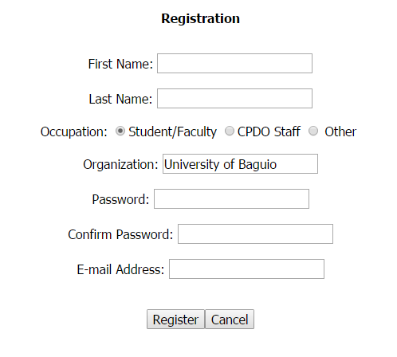

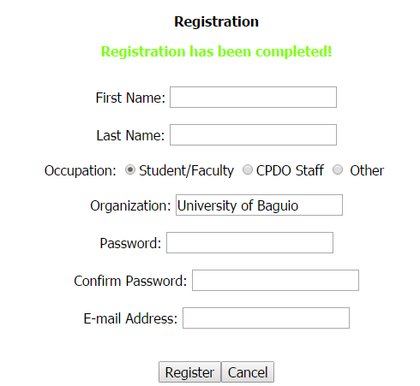

**A.3. Search Reports**

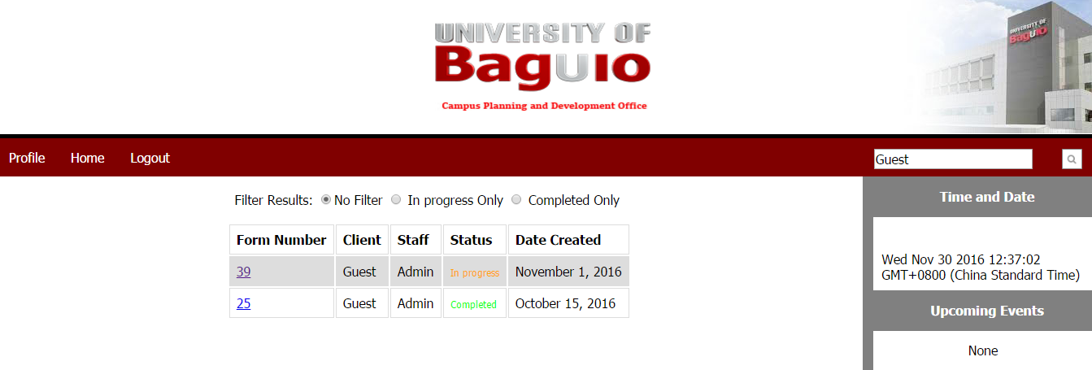

**A.4. View User Account**

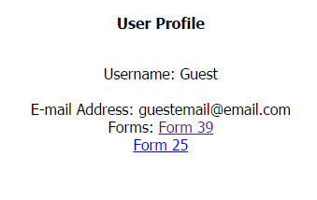

**A.5. View Own User Account**

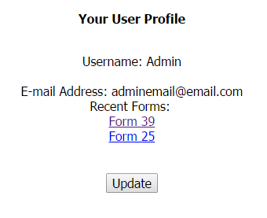

**A.6. Update User Account**

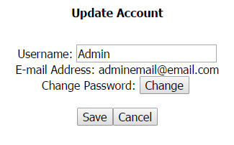

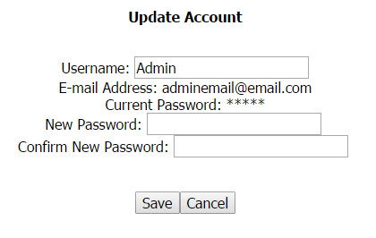

**A.7. Scheduling of Maintenance**

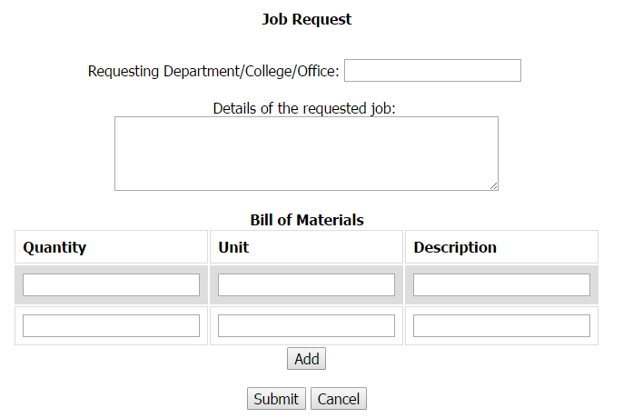

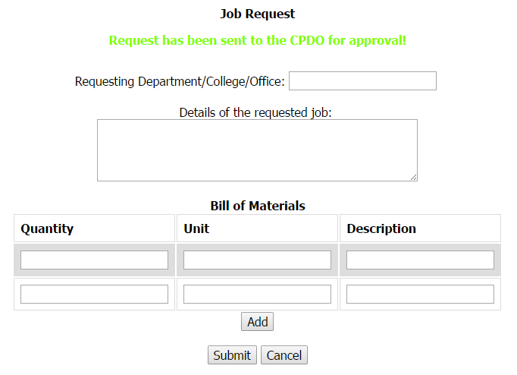

**A.8. Reservation of Venue**

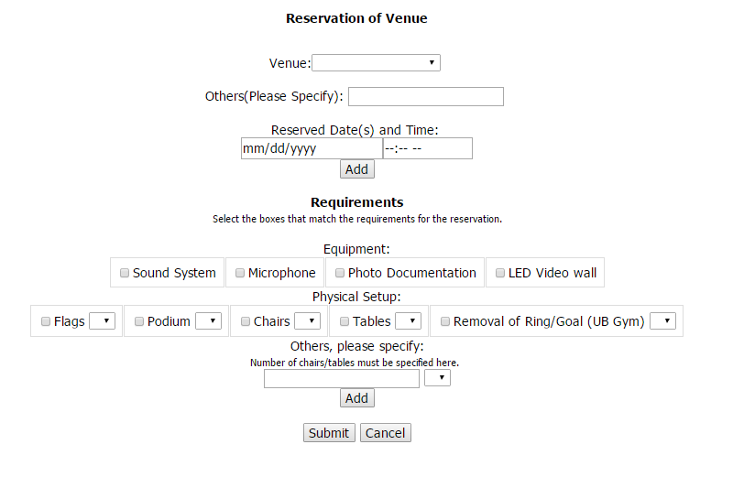

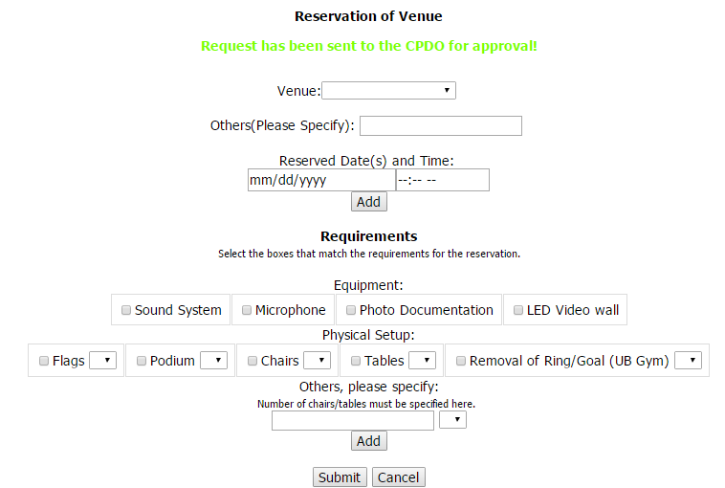

**A.9. Link Records**

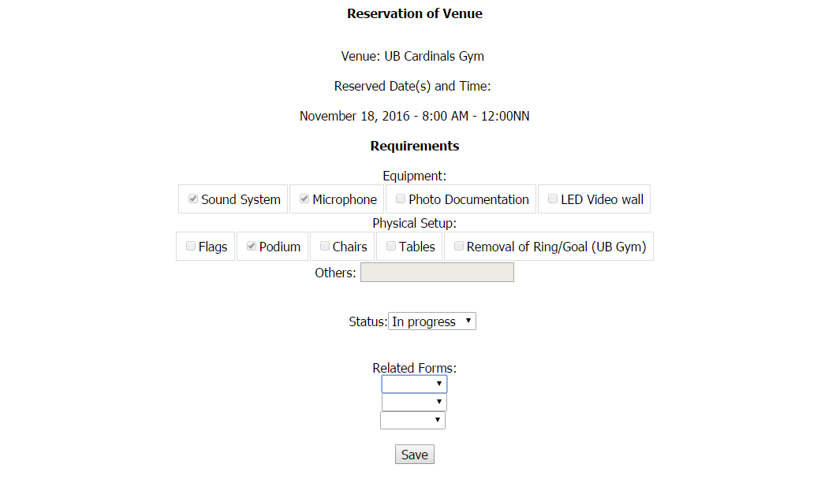

**A.10. Forgot Password**

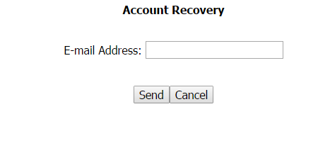

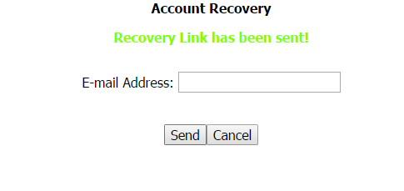

**A.11. Add/Edit Form Status**

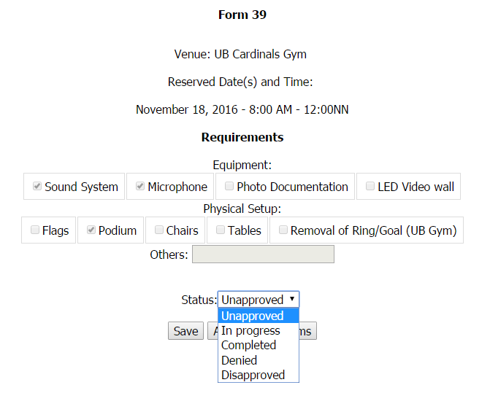

**A.12.Validate Staff User Account**

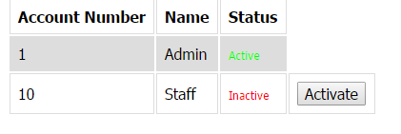

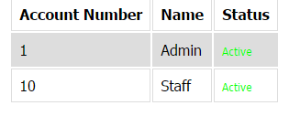

**A.13.Confirm Request Form**

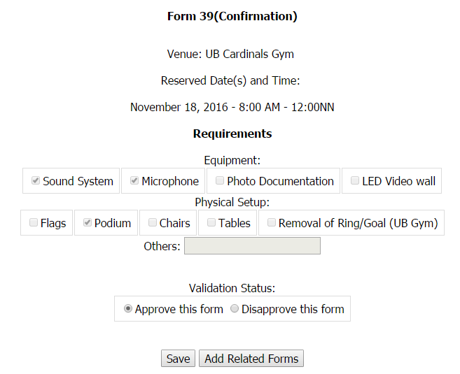

**Appendix B: Table of Fields (TOF)**

**B.1 User Login**

|  |  |  |  |  |  |  |  |  |
| --- | --- | --- | --- | --- | --- | --- | --- | --- |
| Fields | Type | Domain Constraints | Required Fields | Other considerations | User Who Edit the Contents of the field | | | |
| Administrator | Maintenance Manager | CPDO staff | Client |
| User name | Text | A-9;a-z;  0-9;  Min=5  Max = 20  Characters | Required |  | X | X | X | X |
| Password | Text | A-9;a-z;  0-9;  Min=5  Max = 20  Characters | Required |  | X | X | X | X |

**B.2 Create User Account**

|  |  |  |  |  |  |  |  |  |
| --- | --- | --- | --- | --- | --- | --- | --- | --- |
| Fields | Type | Domain Constraints | Required Fields | Other considerations | User Who Edit the Contents of the field | | | |
| Administrator | Maintenance Manager | CPDO staff | Client |
| First Name | Text | A-9;a-z;  0-9;  Min=5  Max = 20  Characters | Required |  | X | X | X | X |
| Last Name | Text | A-9;a-z;  0-9;  Min=5  Max = 20  Characters | Required |  | X | X | X | X |
| Occupa-tion | Boolean | Student/  Faculty  CPDO Staff  Other | Required |  | X | X | X | X |
| Organiza-tion | Text/Number | A-9; a-z; 0-9; min=10  max=40  characters | Required | “University of Baguio” will be automatically be placed when Student/Faculty or CPDO Staff is selected |  |  |  | X |
| Password | Text | A-9;a-z;  0-9;  Min=5  Max = 20  Characters | Required |  | X | X | X | X |
| Confirm Password | Text | A-9;a-z;  0-9;  Min=5  Max = 20  Characters | Required |  | X | X | X | X |
| E-mail address | Text | A-9; a-z; 0-9; min=10  max=40  characters | Required |  | X | X | X | X |

**B.3 Search Records**

|  |  |  |  |  |  |  |  |  |
| --- | --- | --- | --- | --- | --- | --- | --- | --- |
| Fields | Type | Domain Constraints | Required Fields | Other considerations | User Who Edit the Contents of the field | | | |
| Administrator | Maintenance Manager | CPDO staff | Client |
| Search Field | Text | A-9;a-z;  0-9;  min=5  max = 20  characters | Required |  | X | X | X | X |
| Filter | Boolean | No Filter  In progress Only  Completed Only | Required |  | X | X | X | X |

**B.4 Update User Account**

|  |  |  |  |  |  |  |  |  |
| --- | --- | --- | --- | --- | --- | --- | --- | --- |
| Fields | Type | Domain Constraints | Required Fields | Other considerations | User Who Edit the Contents of the field | | | |
| Administrator | Maintenance Manager | CPDO staff | Client |
| Username | Text | A-9;a-z;  0-9;  min=5  max = 20  characters | Optional |  | X | X | X | X |
| Current Password | Text | A-9;a-z;  0-9;  min=5  max = 20  characters | Required |  | X | X | X | X |
| New password | Text | A-9; a-z; 0-9; min=5 max=20 characters | Optional |  | X | X | X | X |
| Confirm new password | Text | A-9; a-z; 0-9; min-5 max=20 characters | Optional | Required if New password field is not null | X | X | X | X |
| E-mail address | Text | A-9; a-z; 0-9; min=10 max=40 characters | Optional | Previous value is displayed; must not be null is modified | X | X | X | X |

**B.5 Request for Maintenance**

|  |  |  |  |  |  |  |  |  |
| --- | --- | --- | --- | --- | --- | --- | --- | --- |
| Fields | Type | Domain Constraints | Required Fields | Other considerations | User Who Edit the Contents of the field | | | |
| Administrator | Maintenance Manager | CPDO staff | Client |
| Requester | Text/ Number | A-9;a-z;  0-9;  min=5  max = 25  characters | Required |  |  |  |  | X |
| Details | Text/  Number | A-9;a-z;  0-9;  min=3  max = 200  characters | Required |  |  |  |  | X |
| Quantity | Number | 0-9; min=1 max=6 characters | Required |  |  |  |  | X |
| Unit | Text/  Number | A-9;a-z;  0-9;  min=3  max = 15  characters | Required |  |  |  |  | X |
| Description | Text/  Number | A-9;a-z;  0-9;  min=3  max = 40  characters | Required |  |  |  |  | X |

**B.6 Reservation of Venue**

|  |  |  |  |  |  |  |  |  |
| --- | --- | --- | --- | --- | --- | --- | --- | --- |
| Fields | Type | Domain Constraints | Required Fields | Other considerations | User Who Edit the Contents of the field | | | |
| Administrator | Maintenance Manager | CPDO staff | Client |
| Venue | Boolean | -UB Gym  -Centennial Hall  -Audio Visual Room  -AMS Hall  -RCB Dome | Required |  |  |  |  | X |
| Other  Venue | Text | A-9; a-z; 0-9; min=5 max=40 characters | Optional |  |  |  |  |  |
| Rental Date | Date | MM/DD/YY | Required |  |  |  |  | X |
| Time | Time | Hr:Min | Required |  |  |  |  | X |
| Equipment | Boolean | -Sound System  -Microphone  -Photo Documentation  -LED Video Wall | Required |  |  |  |  | X |
| Physical Setup | Boolean | -Flags  -Podium  -Chairs  -Tables  -Removal of Ring/Goal | Required |  |  |  |  | X |
| Number of Items | Boolean | Varies | Required | -Number varies depending how many is available |  |  |  | X |
| Other Equipment | Text | A-9; a-z; 0-9; min=5 max=40 characters | Optional |  |  |  |  | X |

**B.7 Link Records**

|  |  |  |  |  |  |  |  |  |
| --- | --- | --- | --- | --- | --- | --- | --- | --- |
| Fields | Type | Domain Constraints | Required Fields | Other considerations | User Who Edit the Contents of the field | | | |
| Administrator | Maintenance Manager | CPDO staff | Client |
| Related Forms | Boolean | All Completed Forms | Required |  | X | X | X |  |

**B.8Forgot Password**

|  |  |  |  |  |  |  |  |  |
| --- | --- | --- | --- | --- | --- | --- | --- | --- |
| Fields | Type | Domain Constraints | Required Fields | Other considerations | User Who Edit the Contents of the field | | | |
| Administrator | Maintenance Manager | CPDO staff | Client |
| E-mail address | Text | A-9;a-z;  0-9;  Min=5  Max = 40  Characters | Required |  | X | X | X | X |

**B.9Add/Edit Form Status**

|  |  |  |  |  |  |  |  |  |
| --- | --- | --- | --- | --- | --- | --- | --- | --- |
| Fields | Type | Domain Constraints | Required Fields | Other considerations | User Who Edit the Contents of the field | | | |
| Administrator | Maintenance Manager | CPDO staff | Client |
| Status | Boolean | -Unapproved  -In progress  -Completed  -Denied  Disapproved | Required |  | X | X | X |  |

**THE SYSTEM PROFILE**



**UB Campus Planning and Development Office Service Requisition and Venue Reservation UB Campus Planning and Development Office Service Requisition and Venue Reservation System**

**Prepared By:**

**Liwanag, Jasper B.**

**Panganiban, Jherico T.**

**Rom, Ivan Clyde M.**

**Tarnate, Halley A.**

**Tiaga, Ellen Joy B.-**

# Contents

1. ABOUT THE COMPANY 51

1.1 History 51

1.2 Information System History 51

1.3 Organizational Chart 52

1.4 Positions 52

1.5 Services Offered 53

2. The Information System 54

2.1 Processes 54

2.2 Source Documents 54

2.3 Reports 55

2.4 Policies 55

2.5 Table of Information System Details 57

2.6 Suggestions and Recommendations 58

2.7 Flowchart of the existing system 59

# ABOUT THE COMPANY

## 1.1 History

Rosa C. Bautista and husband Dr. Fernando G. Bautista founded this educational institution on August 8, 1948. University of Baguio strived hard to provide competitive environment to students. After several years, the institution introduced new curriculums and degree programs to serve more youths in the city until CHED granted level II and level III accreditation status to some of the undergraduate and graduate programs of the school in 2007.

After the 1990 earthquake, the university was left in ruins. The Campus Planning and Development Office was then established with the goal to reconstruct the ruined facilities and make sure that the university is ready to educate students once again. The CPDO was first handled by Antonio A. Bautista. It was then handled by Engr. Wilfredo Antonio and then passed on to Arch. Johnny Rios, then to Mr. Lou Dario. The CPDO was then given authority to Engr. Bernard Z. Abaya in 2015 who is still the director heading the office at present time.

## 1.2 Information System History

Since the CPDO is established, the only way to process information is through forms. They paper forms which is not viable to last. They search for paper documents compiled in a folder which requires inefficient manpower for advancements in technology today. The CPDO is still manually processing information and is need of a better information system to make actions more immediate.

## 

## 1.3 Organizational Chart

## Positions

**1.4.1 Vice President for Administration**

Atty. Rommel Ayson is currently the overlooking supervisor of CPDO and other offices in the University of Baguio.

**1.4.2 CPDO Director**

Engr. Bernard Abaya governs the staff and makes the decisions in maintaining the facilities of the university. He overlooks the smooth flow of operation of the office.

**1.4.3 CPDO Staff**

The CPDO staff members, Alejandro Aspuria Jr., Roger Aspuria, and Lou Dario, takes care of the documents going through the office. They are also responsible for documenting and processing the transactions and information inside the department.

**1.4.4 CPDO Secretary**

ChirstoreySemangan is the CPDO Secretary and Safety Officer. He checks the reports of the clients and is also accountable for a CPDO Personal Field Report.

## 1.5 Services Offered

**1.5.1 Maintenance of the Facilities**

* The CDPO are responsible for the maintenance of the facilities and equipments in the university. It is in-charge of making sure the university is safe both for the students and the employees.

**1.5.2 Design for New Facilities**

* The CPDO is liable with designing new facilities to make sure that it is disaster proof.

**1.5.3 Safety within the Campus**

* The CPDO are accountable for checking the electrical wirings, plumbing and carpentry around the campus.

**1.5.4 Waste Management**

* The CPDO is in-charge of the waste segregation and recycling of garbage.

**1.5.5 Reservation of Facilities**

* The CPDO is responsible for the reservation of venues and equipment. They make sure that a venue is safe from harm both inside and outside. And they also secure the equipment is fully functional.

# The Information System

## 2.1 Processes

**2.1.1 Maintenance**

* A job request will be filed if there is a problem with the facilities inside the university. The job request will be logged and given a control number. It will be signed by the CPDO Director and then checked by the maintenance group. It will be sent to Asset Management Department for inventory checking and then schedule.

**2.1.2 Reservation of venues**

* If the reservation is made by school faculty or students, it will be processed for the reservation request’s approval. The CPDO staff must check the venue and equipment before the approval of the reservation, if no other issues arise in the process.
* If the reservation is made out of school, it will be processed for both parties to come to terms. The CPDO must negotiate the price of the venue, which it will be approved by the Vice President of Administration and the Finance Department.

## 2.2 Source Documents

**2.2.1 Job Request Form**

* A form filed when a there is a problem in the facilities or equipment around the university.

**2.2.2 Materials Request Form**

* It is a form used to request the materials that are denoted in the Job Request Form.

**2.2.3. A Requisition Slip (Non-Consumables)**

* A form used to ask for non-consumable materials like; curtains, tables, chairs etc.

**2.2.4. B Requisition Slip (Consumables)**

* A form used to ask for consumable materials like; paint, varnish, electrical tape, etc.

**2.2.5 CPDO Personal Field Report**

* A form describing the observation of a place, people or events.

**2.2.6 Overtime Application Form**

* A form used to inform that the work being processed is in need of overtime. It is usually filed 2 days prior to the date of overtime.

**2.2.7 Reservation Form**

* A form used to reserve a place/venue for an event or equipment (mostly for CPDO staff).

## 2.3 Reports

**2.3.1 Job Request Completion**

The CPDO documents all of the Job Requests done or in idle and what are the materials needed in the request.

**2.3.2 Utility Expenses Report**

The CPDO handles the expenses of the university like the electricity and water expenses.

**2.3.3 Project Monitoring**

The CPDO are submitting the project report they made to the VP for Administration and to the president.

## 2.4 Policies

**2.4.1 General Policies**

* A Request Form must be passed to the CPDO before any event could occur within the school’s large facilities such as the gym or swimming pool.
* Reservation of equipment is only viable for CDPO Staff. Equipment is only for maintenance.
* All requirements needed must be finalized one week before scheduled activity.
* Installing heavy structures on the floor of the reserved venue is not allowed.
* Use of pyrotechnics, explosive devices, and flammable substances is strictly prohibited.
* During the activity, applicant should ensure that house protocols for safety, security and health measures are being observed, otherwise, the next request for venue with the same applicant will not be endorsed.

**2.4.2 Job Request Policies**

* All Employees and members of University of Baguio can make requests with the signature of their immediate Dean, Principal, Director and Head of office.
* All repairs concerning carpentry, electrical and plumbing should be requested through Job Request Form and to be passed to the Campus Planning Development Office.
* Requisition Slip must be forwarded every Monday or 1st working day of week, from 8:00AM to 12:00NN and 1:00PM to 4:00PM only.
* Requisition Slips for water and gas refills are exempted from the former policy.
* All containers, such as bottles, cartridges, and the like, must be returned to the CPDO.

**2.4.3 Internal Venue Reservation Policies**

* Requested activity must be included in the University’s calendar of activities, if not, it should be tentatively reserved two weeks before the scheduled activity approved by the Dean/Director/Heads of Offices.
* Students, faculty members, university officers and employees are eligible to apply for the CPDO venue reservation.
* Applicant shall coordinate needed physical set-up to the respective Technical Committees two days before the usage of the venue once the Request Form has approved by the CPDO Director.
* Applicant shall coordinate needed physical set-up to the respective Technical Committees two days before the usage of the venue
* All student activities must process pre-activity request for the endorsement of the school dean and the approval of the activity by the Vice President of Academic Affairs, before the approval of the venue.

**2.4.3 External Venue Reservation Policies**

* Private institutions and government agencies must send a Request Letter to the University of Baguio President.
* Request to use any facilities should be duly endorsed and approved by the President for accommodation of the event.
* Upon submission of the accomplished reservation form not later than one week before the activity, a 50% down payment shall be collected to the applicant.
* 50% down payment should be made upon submission of reservation form to the CPDO. Full payment of the reservation fee, together with PHP 5000.00 bond, should be settled two days before the event. Otherwise, the reservation will be cancelled.

## 2.5 Table of Information System Details

|  |  |  |  |  |
| --- | --- | --- | --- | --- |
| **User/**  **Position** | **Source Document /Fields** | **Process** | **Output Report/ Fields** | **Policies** |
| Vice President of the Administration | Overtime application form | The Overtime application form needs to be signed by the Vice President for Administration to be approved. | Project Monitoring | External Venue Reservation |
| CPDO Director | Job Request  Form | The director needs to sign and approve of the Job Requested. | Job Request Completion | Job Request  Internal Venue Reservation  External Venue Reservation |
| CPDO Staff | Requisition Form  Material Request Form | CPDO Staff are required to fill up a requisition slip/ Material Request Form | Utility Expenses Report | Job Request  Internal Venue Reservation  External Venue Reservation |
| CPDO Secretary | Reservation of Venues  CPDO Personal Field Report | He is responsible for the management of reservations.  He is the one that goes to places to report activities that need actions. | Job Request Completion  Utility Expenses Report  Project Monitoring | Internal Venue Reservation  External Venue Reservation |

**2.6 Suggestions and Recommendations**

* The proposed system currently does not cover all of the services of the CPDO, only servicing to the documentation of Maintenance and Reservation services.
* Constant updates on the system on thepreset existing venues and rental equipment on the system are a requirement.
* All system updates must be made on Sundays in order for it to not interfere with upcoming requests coming into the system

**2.7 Flowchart of the existing system**

**2.7.1 Internal Reservation of Venue**

Client CPDO Staff CPDO Director

CPDO gives the client Job Request Form to be accomplished

Client makes a request to the CPDO

The CPDO staff will cancel the request

CPDO Director approves the request

Yes

No

Yes

No

The venue will be under the supervision of the client during the requested time.

Did the client meet with the technical

committee?

Did the client meet the requirements?

**2.7.2 External Reservation of Venue**

Client CPDO Staff CPDO Director President

Are all requirements followed?

Yes

No

CPDO cancels the reservation.

Yes

Request will be approved and be processed by the CPDO.

No

Clients must make another letter

No

Staff inspects the request letter.

Yes

No

Has the rental fee been paid within two weeks?

Are all requirements followed?

Client pays the down payment.

Client receives an approved reservation letter to be filled out.

The venue will be under the supervision of the client during the requested time.

Does the letter follow requirements?

Request will not be approved.

The request letter will be given to the director for approval.

Yes

Client makes a request letter to the President.

**2.7.3 Job Request Process**

Client CPDO Staff CPDO Director

Yes

Does the request require materials?

No

Yes

Clients must make another letter

Client must process the materials needed.

Staff inspects the request letter.

Does the letter follow requirements?

No

CPDO will start working on the request.

Yes

Request will be checked and inspected for the appropriate action.

Client sends a Job Request form to the CPDO

**Appendix D: Minutes of Meeting**

**MINUTES OF THE MEETING**

**Date/Time** : August 8, 2016/9:00-10:00am

**Venue** : F214

**Attendees** : Jasper B. Liwanag

Jherico T. Panganiban

Ivan Clyde M. Rom

Halley A. Tarnate

Ellen Joy B. Tiaga

**Subject** : Discussion of Ideas

**Agenda**

1. Suggestion of topics.

**Record of Significant Discussion**

|  |  |
| --- | --- |
| **#** | **Discussion Item** |
| 1 | Suggested topics:   1. Petition Monitoring system 2. UB student Organization Monitoring System |

**Prepared by:**

Halley A. Tarnate

Jherico T. Panganiban

**MINUTES OF THE MEETING**

**Date/Time** : August 10, 2016/9:00-10:00am

**Venue** : F214

**Attendees** : Jasper B. Liwanag

Jherico T. Panganiban

Ivan Clyde M. Rom

Halley A. Tarnate

Ellen Joy B. Tiaga

**Subject** : Discussion of Ideas

**Agenda**

1. Consultation of proposed topics

2.Assigning the roles

**Record of Significant Discussion**

|  |  |
| --- | --- |
| **#** | **Discussion Item** |
| 1 | Topics:   1. Petition and Dissolving Subjects Monitoring System 2. UB student Organization Monitoring System |
| 2 | Roles Assigned:  Leader: Jasper B. Liwanag  System Analysts: Ivan Clyde M. Rom  Ellen Joy B. Tiaga  Documentation: Jherico T. Panganiban  Halley A. Tarnate  Public Relations: Jherico T. Panganiban |
|  |  |

**Prepared by:**

Halley A. Tarnate

Jherico T. Panganiban

**MINUTES OF THE MEETING**

**Date/Time** : August 12, 2016/9:00-10:00am

**Venue** : F214

**Attendees** : Jasper B. Liwanag

Jherico T. Panganiban

Ivan Clyde M. Rom

Halley A. Tarnate

Ellen Joy B. Tiaga

**Subject** : Approval of the first Topic

**Agenda**

1. Consultation of topics

2.Approval of Topics

**Record of Significant Discussion**

|  |  |
| --- | --- |
| **#** | **Discussion Item** |
| 1 | Topics:   1. Petition and Dissolving Subjects Monitoring System 2. UB student Organization Monitoring System |
| 2 | Petition and Dissolving Subjects Monitoring System rejected |
|  |  |

**Prepared by:**

Halley A. Tarnate

Jherico T. Panganiban

**MINUTES OF THE MEETING**

**Date/Time** : August 15, 2016/9:00-10:00am

**Venue** : F214

**Attendees** : Jasper B. Liwanag

Jherico T. Panganiban

Ivan Clyde M. Rom

Halley A. Tarnate

Ellen Joy B. Tiaga

**Subject** : Finalizing the Revised topic

**Agenda**

1. Consultation of topics

2.Approval of Topics

**Record of Significant Discussion**

|  |  |
| --- | --- |
| **#** | **Discussion Item** |
| 1 | Topics:   1. Petition and Dissolving Subjects Monitoring System 2. UB student Organization Monitoring System |
| 2 | Petition and Dissolving Subjects Monitoring System rejected |
| 3 | Topic Revised to Management of Services within UB |

**Prepared by:**

Halley A. Tarnate

Jherico T. Panganiban

**MINUTES OF THE MEETING**

**Date/Time** : August 17, 2016/ 9:00-10:00

**Venue** : F214/Asset Management Department

**Attendees** : Jasper B. Liwanag

Jherico T. Panganiban

Ivan Clyde M. Rom

Halley A. Tarnate

Ellen Joy B. Tiaga

**Subject** : Asset Management Head/Director

**Agenda**

1. Asking questions from Asset Management Department

2. Revision of Topic

**Record of Significant Discussion**

|  |  |
| --- | --- |
| **#** | **Discussion Item** |
| 1 | Things to Ask:   1. Position 2. Complete Name |
| 2 | Topic Changed to Requisition of Services in the Campus Planning Development Office |

**Prepared by:**

Halley A. Tarnate

Jherico T. Panganiban

**MINUTES OF THE MEETING**

**Date/Time** : August 18, 2016 /12:00-2:00

/5:00-6:00

**Venue** : F214/Asset Management Department

**Attendees** : Jherico T. Panganiban

Ivan Clyde M. Rom

Halley A. Tarnate

Ellen Joy B. Tiaga

**Subject** : Request Letter Approval and Interview

**Agenda**

1. Request Letter be Signed by the Dean

2. Interview with Engr. Bernard Z. Abaya

**Record of Significant Discussion**

|  |  |
| --- | --- |
| **#** | **Discussion Item** |
| 1 | Let the Request Letter to Interview be signed by the Dean for approval. |
| 2 | Official Interview with Engr. Bernard Z. Abaya in the CPDO Office |

**Prepared by:**

Halley A. Tarnate

Jherico T. Panganiban

**MINUTES OF THE MEETING**

**Date/Time** : August 19, 2016 /9:00-10:00

/2:00-3:00

**Venue** : F214/Asset Management Department

**Attendees** : Jasper B. Liwanag

Jherico T. Panganiban

Ivan Clyde M. Rom

Halley A. Tarnate

Ellen Joy B. Tiaga

**Subject** : Finalization Of Topic And Interview

**Agenda**

1. Finalization of the topic title

2. Follow-up interview with Engr. Bernard Z. Abaya

**Record of Significant Discussion**

|  |  |
| --- | --- |
| **#** | **Discussion Item** |
| 1 | The final title for the System Profile is The Requisition of Services of the Campus Planning Department Office |
| 2 | Follow-up interview of Engr. Bernard Z. Abaya to clarify the information recorded. |

**Prepared by:**

Halley A. Tarnate

Jherico T. Panganiban

**MINUTES OF THE MEETING**

**Date/Time** : August 20, 2016 /12-:00-2:00

**Venue** : WiFi Area (F Buliding)

**Attendees** : Jherico T. Panganiban

Ivan Clyde M. Rom

Halley A. Tarnate

Ellen Joy B. Tiaga

**Subject** : Documentation

**Agenda**

1.Completion of System Profile

**Record of Significant Discussion**

|  |  |
| --- | --- |
| **#** | **Discussion Item** |
| 1 | Documentation of Information about the System. |

**Prepared by:**

Halley A. Tarnate

Jherico T. Panganiban

**MINUTES OF THE MEETING**

**Date/Time** : August 21, 2016/ 9:00-11:00PM

**Venue** : Facebook Groupchat

**Attendees** : Jasper B. Liwanag

Jherico T. Panganiban

Ivan Clyde M. Rom

Halley A. Tarnate

Ellen Joy B. Tiaga

**Subject** : Asset Management Head/Director

**Agenda**

1. Arranging of topic

**Record of Significant Discussion**

|  |  |
| --- | --- |
| **#** | **Discussion Item** |
| 1 | Topic is being reviewed and arranged. |

Jherico T. Panganiban

**Prepared by:**

Halley A. Tarnate

**MINUTES OF THE MEETING**

**Date/Time** : August 26, 2016/ 9:00-10:00

**Venue** : F214/Facebook Groupchat

**Attendees** : Jasper B. Liwanag

Jherico T. Panganiban

Ivan Clyde M. Rom

Halley A. Tarnate

Ellen Joy B. Tiaga

**Subject** : Documentation

**Agenda**

1. Completion of System Profile

**Record of Significant Discussion**

|  |  |
| --- | --- |
| **#** | **Discussion Item** |
| 1 | Completing the System flow chart |

**Prepared by:**

Jherico T. Panganiban

Halley A. Tarnate

**MINUTES OF THE MEETING**

**Date/Time** : September 2, 2016/ 9:00-10:00

**Venue** : F214/Facebook Groupchat

**Attendees** : Jasper B. Liwanag

Jherico T. Panganiban

Ivan Clyde M. Rom

Halley A. Tarnate

Ellen Joy B. Tiaga

**Subject** : Documentation

**Agenda**

1. Completion of System Profile

**Record of Significant Discussion**

|  |  |
| --- | --- |
| **#** | **Discussion Item** |
| 1 | Documentation of information about the system |

**Prepared by:**

Jherico T. Panganiban

Halley A. Tarnate

**MINUTES OF THE MEETING**

**Date/Time** : September 5, 2016

**Venue** : Facebook Groupchat

**Attendees** : Jasper B. Liwanag

Jherico T. Panganiban

Ivan Clyde M. Rom

Halley A. Tarnate

Ellen Joy B. Tiaga

**Subject** : Revision

**Agenda**

1. Revision of topic

**Record of Significant Discussion**

|  |  |
| --- | --- |
| **#** | **Discussion Item** |
| 1 | Topic changed to University of Baguio Campus Planning and Development Office Service Requisition and Venue Reservation System |

**Prepared by:**

Jherico T. Panganiban

Halley A. Tarnate

**MINUTES OF THE MEETING**

**Date/Time** : September 11, 2016/ 9:00-11:00

**Venue** : F214/Facebook Groupchat

**Attendees** : Jasper B. Liwanag

Jherico T. Panganiban

Ivan Clyde M. Rom

Halley A. Tarnate

Ellen Joy B. Tiaga

**Subject** : Documentation

**Agenda**

1. Completing the System Profile

**Record of Significant Discussion**

|  |  |
| --- | --- |
| **#** | **Discussion Item** |
| 1 | Documentation of information about the system profile |

**Prepared by:**

Jherico T. Panganiban

Halley A. Tarnate

**MINUTES OF THE MEETING**

**Date/Time** : September 17, 2016

**Venue** : Facebook Groupchat

**Attendees** : Jasper B. Liwanag

Jherico T. Panganiban

Ivan Clyde M. Rom

Halley A. Tarnate

Ellen Joy B. Tiaga

**Subject** : Documentation

**Agenda**

1. Completing the System Profile

**Record of Significant Discussion**

|  |  |
| --- | --- |
| **#** | **Discussion Item** |
| 1 | Completion of SRS, Vision ,Mission, and Objective |

**Prepared by:**

Jherico T. Panganiban

Halley A. Tarnate

**MINUTES OF THE MEETING**

**Date/Time** : September 25, 2016

**Venue** : Irisan Baguio City

Facebook Groupchat

**Attendees** : Jherico T. Panganiban

Ivan Clyde M. Rom

Halley A. Tarnate

Ellen Joy B. Tiaga

**Subject** : Documentation

**Agenda**

1. Completing the Use Cases

**Record of Significant Discussion**

|  |  |
| --- | --- |
| **#** | **Discussion Item** |
| 1 | Completing information about the Use Cases |

**Prepared by:**

Jherico T. Panganiban

Halley A. Tarnate

**MINUTES OF THE MEETING**

**Date/Time** : October 17, 2016

**Venue** : Facebook Groupchat

**Attendees** : Jasper B. Liwanag

Jherico T. Panganiban

Ivan Clyde M. Rom

Halley A. Tarnate

Ellen Joy B. Tiaga

**Subject** : Documentation

**Agenda**

1. Completing the System Profile

**Record of Significant Discussion**

|  |  |
| --- | --- |
| **#** | **Discussion Item** |
| 1 | Documentation of information about the system profile. |

**Prepared by:**

Jherico T. Panganiban

Halley A. Tarnate

**MINUTES OF THE MEETING**

**Date/Time** : October 26, 2016

**Venue** : Facebook Groupchat

**Attendees** : Jasper B. Liwanag

Jherico T. Panganiban

Ivan Clyde M. Rom

Halley A. Tarnate

Ellen Joy B. Tiaga

**Subject** : Documentation

**Agenda**

1. Completing the System Profile

**Record of Significant Discussion**

|  |  |
| --- | --- |
| **#** | **Discussion Item** |
| 1 | Documentation of information about the system profile and revising few use cases |

**Prepared by:**

Jherico T. Panganiban

Halley A. Tarnate

**MINUTES OF THE MEETING**

**Date/Time** : October 27, 2016

**Venue** : Facebook Groupchat

**Attendees** : Jasper B. Liwanag

Jherico T. Panganiban

Ivan Clyde M. Rom

Halley A. Tarnate

Ellen Joy B. Tiaga

**Subject** : Documentation

**Agenda**

1. Updating the System Profile

**Record of Significant Discussion**

|  |  |
| --- | --- |
| **#** | **Discussion Item** |
| 1 | Updating some of the use cases, business rules and Field Validations. |

**Prepared by:**

Jherico T. Panganiban

Halley A. Tarnate

**MINUTES OF THE MEETING**

**Date/Time** : October 28, 2016

**Venue** : University of Baguio Library

**Attendees** : Jasper B. Liwanag

Jherico T. Panganiban

Ivan Clyde M. Rom

Halley A. Tarnate

Ellen Joy B. Tiaga

**Subject** : Documentation

**Agenda**

1. Updating the System Profile

**Record of Significant Discussion**

|  |  |
| --- | --- |
| **#** | **Discussion Item** |
| 1 | Updating information about the System Profile. |

**Prepared by:**

Jherico T. Panganiban

Halley A. Tarnate

**MINUTES OF THE MEETING**

**Date/Time** : November 2, 2016

**Venue** : F214/9:00-10:00

**Attendees** : Jasper B. Liwanag

Jherico T. Panganiban

Ivan Clyde M. Rom

Halley A. Tarnate

Ellen Joy B. Tiaga

**Subject** : Documentation

**Agenda**

1. Updating the System Profile

**Record of Significant Discussion**

|  |  |
| --- | --- |
| **#** | **Discussion Item** |
| 1 | Updating information about the System Profile. |

**Prepared by:**

Jherico T. Panganiban

Halley A. Tarnate

**MINUTES OF THE MEETING**

**Date/Time** : November 8, 2016

**Venue** : F214/9:00-10:00

**Attendees** : Jasper B. Liwanag

Jherico T. Panganiban

Ivan Clyde M. Rom

Halley A. Tarnate

Ellen Joy B. Tiaga

**Subject** : Documentation

**Agenda**

1. Finalization

**Record of Significant Discussion**

|  |  |
| --- | --- |
| **#** | **Discussion Item** |
| 1 | Finalizing information about the System Profile. |

**Prepared by:**

Jherico T. Panganiban

Halley A. Tarnate

**MINUTES OF THE MEETING**

**Date/Time** : November 27, 2016

**Venue** : Facebook Groupchat

**Attendees** : Jasper B. Liwanag

Jherico T. Panganiban

Ivan Clyde M. Rom

Halley A. Tarnate

Ellen Joy B. Tiaga

**Subject** : Documentation

**Agenda**

1. Updating the System Profile

**Record of Significant Discussion**

|  |  |
| --- | --- |
| **#** | **Discussion Item** |
| 1 | Updating and finalizing information about the System Profile. |

**Prepared by:**

Jherico T. Panganiban

Halley A. Tarnate

**Appendix E: Gantt Chart**

**PROPOSED GANTT CHART**

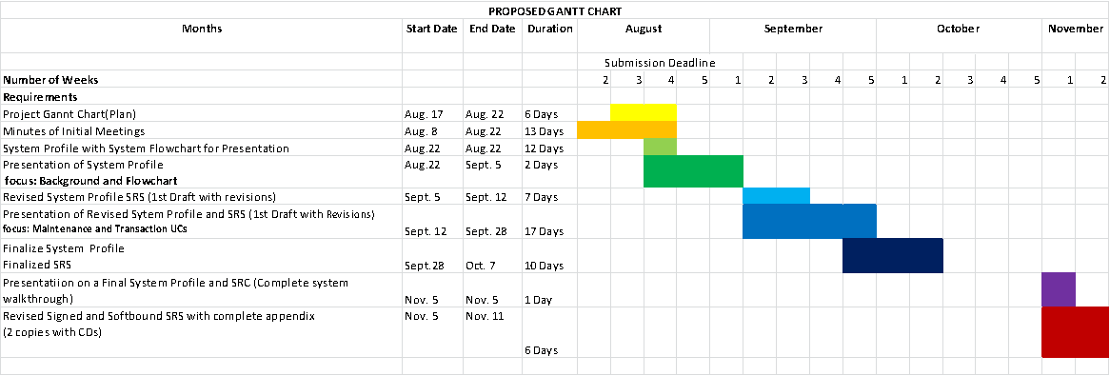

**ACTUAL GANTT CHART**

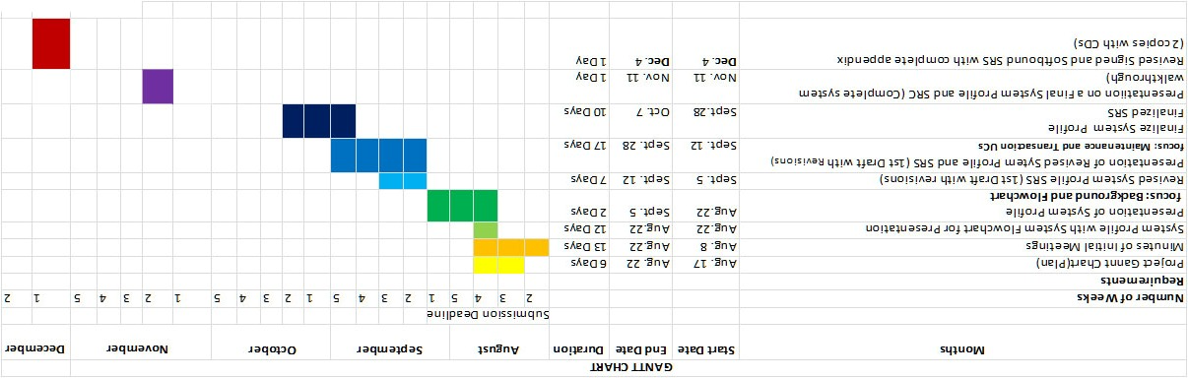

**Appendix F: Development Team’s Pictures**

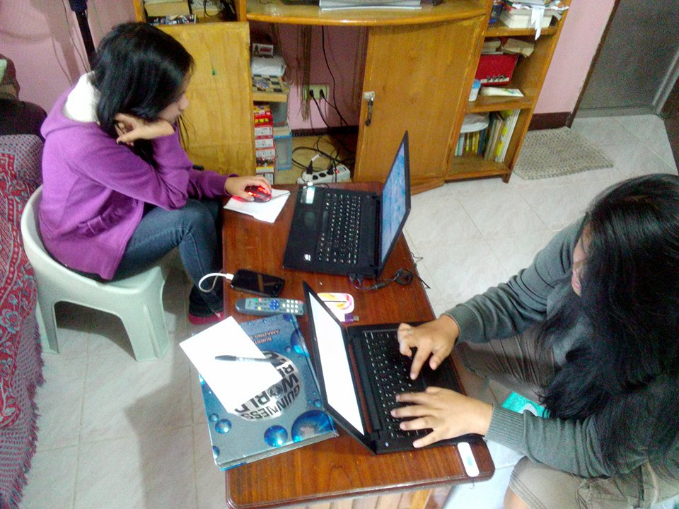

Creation of the System Profile by the team

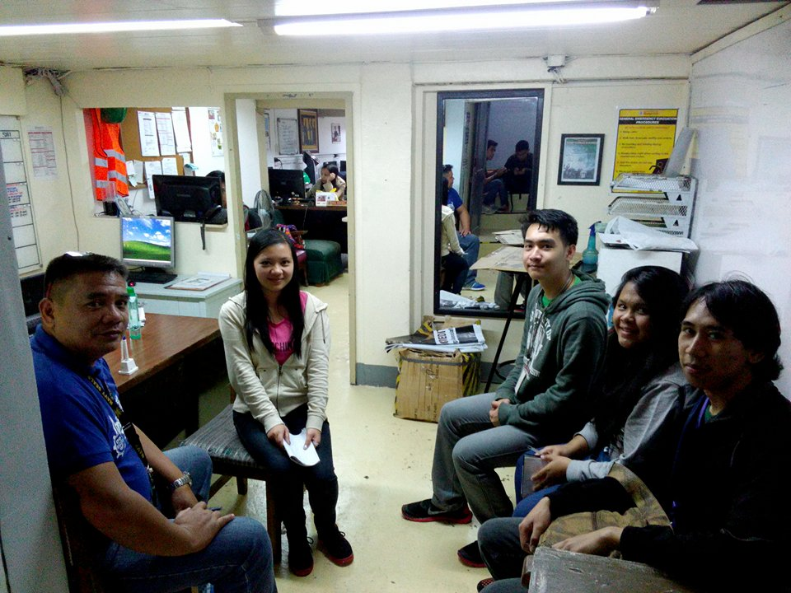

Post Interview with the CPDO Director, Bernard Abaya

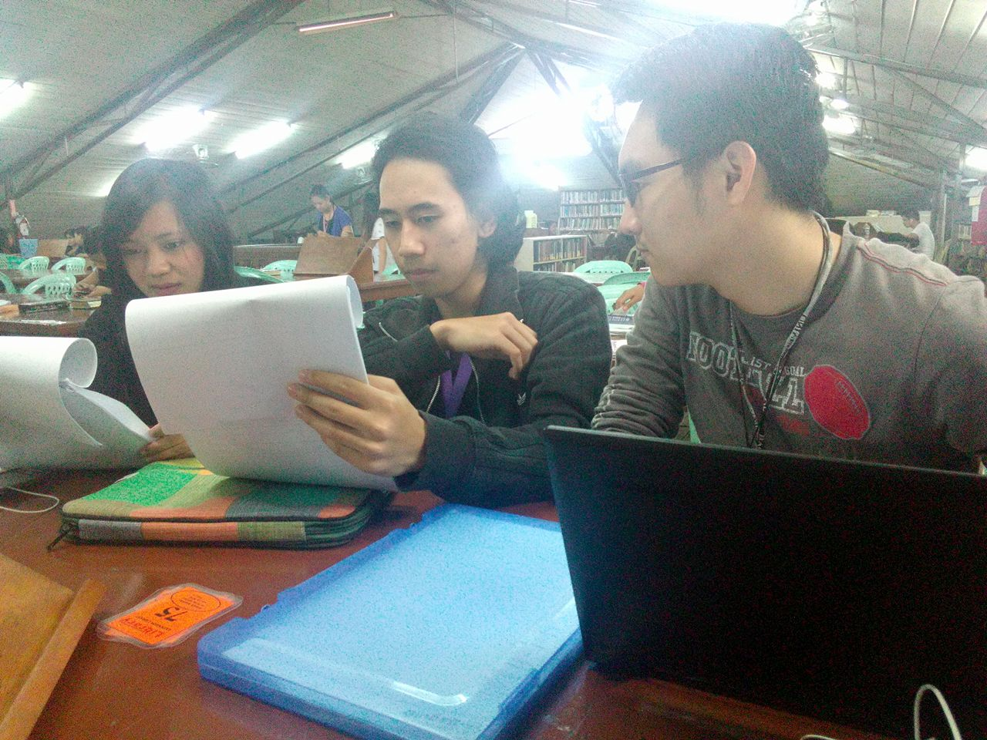

Revision of the System Profile and Software Requirements Specification

**Appendix G: Development Team’s Testimonials**

“Developments”

There were a lot of things going through my mind when I took up this subject, mostly fear over how difficult the subject is according to my friends. Other than that, I still don’t know what to expect from this subject. First day, I ended the way with classmates, no one who I talked or worked with prior to this subject so it was still a large step from what I was used to (being with friends or going solo).

I’ll go straight to the point and admit that it was a massive snowball going downhill fast. I was assigned to be the leader of the group, a position that I hate being put in since I feel like everything about the project is on my shoulders. It was difficult, whether it was me having other priorities or our team was not on the same idea as I expected. It’s not as simple as just assigning the workload amongst the group and everything goes smoothly. Keeping everything on watch constantly was basically required, and I was required to step in whenever something goes wrong. It was extremely exhausting and tiring.

In the end, after days of placing insane amounts of effort on our papers and seeing our score go up from First Grading to Midterms to Finals feels worth it. It’s definitely a wild ride to experience and I’m glad that I took it because I feel like I’ve improved as a person in terms of schoolwork and around others.

-Jasper Liwanag

“Stress + Anxiety – Happiness = SAD”

When I enrolled this subject, I thought it would just be pure class discussion. I didn’t really expect that we were going to make an information system. I just heard from some of my friends that there will be interviews so I was really surprised. But at least it’s a group work (Yeah!!).

When starting the project, everyone is still nice to each other. We were really a GROUP, but that didn’t last long. It all started with a snide remark, then everything went down. Even though they don’t say it, I know that my group mates still have a little grudge with each other. But the even through all that, we still managed to pass our requirements. That would be the best thing that happed for me. That there is still teamwork even though the group is divided.

There so many things that happened during the past months, but I still enjoyed working with these guys. I still learned a lot in discussions, even though stress is always by my side. Thank you to the best teacher for understanding and helping us work together. I hope that we graduate together though.

-Jherico Panganiban

“SAD”

As I entered this subject, I didn’t expect that majority of the outputs will depend on teamwork and cooperation, I was surprised and nervous at the same time because cooperating in a group is my Achilles heel, since I’m shy and unsociable I always prefer to work alone. But by that time, I had no choice but to join a group, and I was lucky that my current group mates dragged me to their group. I experienced many things with them, arguments, misunderstandings, and there is this one time that we got to the point where everything got personal but in the end of the day we fixed it as a team. The rules are simple, work hard, have fun, no drama and don’t take it to heart. Just like what Patrick Lencioni said, "Teamwork begins by building trust. And the only way to do that is to overcome our need for invulnerability". This will be an unforgettable memory in my college life.

-Halley Tarnate

“Achilles’ heel”

When I enrolled in System Analysis and Design, I don’t know that this was a pure thesis subject. And I really thought that it was an easy subject and then everything changed. We started to talk about it all the time up to the point that we needed to have an overtime just to finish the papers on time. It was tough yet fun because we are getting to know each other’s personality, interests and skills.

Sometimes things got rough that we have a misunderstanding with each other. But, of course we managed to fix the flaws, do it all again and understand each other’s opinion.

The subject teaches me to give an extra effort, time and be responsible at all time.

* Ellen Joy Tiaga

“SAD but enjoyable experience”

I didn’t really expect this subject to be like this. Taking this subject gave me unforgettable experience. At first, when I learned what this subject all about, I was asking myself if I can do it. I don’t really have a choice but to pass this subject. When our professor asked us to group ourselves, I was lucky that one of my friends picked me. I knew the three of them except for this one guy. I don’t even know him but it seems that one of my group mates know him. Well, I don’t really care if I don’t know him. What I really care is that if I am able to help them because for unknown reasons, I tends to work alone. I am not the kind person who likes group works.

Sometimes, there are cases that my group mates misunderstand each other. But from my observation, they are like fighting each other. Even if my group mates are like that, they tried to keep that anger to themselves. I really enjoyed this subject, not because my group mates are fighting each other but because this subject taught me many things. This subject helps me to improve myself. I also learned a lot of things in this subject like UNITY. Working together as a group is a good thing. Like helping each other, care for each other.

In this subject, we experienced a lot of things, like having a fun while we are revising our documents and when we are presenting while our classmates is watching.

-Ivan Clyde M. Rom

**Appendix H: Curriculum Vitae**



**Jasper B. Liwanag**

493B Youngland St., Camp7, Kennon Rd.,

Baguio City

**Personal Data:**

Date of Birth: June 6, 1998

Sex: Male Citizenship: Filipino Civil Status: Single

Language Spoken: English, Filipino

Religious Affiliation: Roman Catholic

**Education:**

**Tertiary:**

University of Baguio

Gen. Luna Rd., Baguio City

Bachelor of Science in Information Technology

**Secondary:**

University of Baguio Science High School

Gen. Luna Rd., Baguio City

**Primary:**

University of Baguio Laboratory Elementary School

Happy Glen Loop, Baguio City

**Skills:**

-HTML, CSS, and Javascript

-C Programming

-Java Programming

-Photoshop Editing

-Video Editing

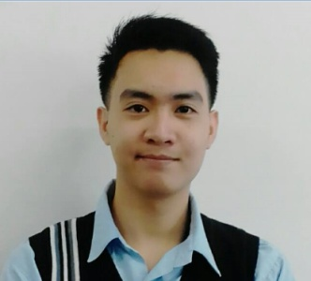**Jherico T. Panganiban**

#172 Bayoya Street, Brgy. San Vicente

Baguio City

**Personal Data:**

Contact No.: +639469809197

Date of Birth: September 2, 1997

Sex: Male

Citizenship: Filipino

Civil Status: Single

Language Spoken: Filipino, English, Ilocano

Religious Affiliation: None

**Education:**

**Tertiary:**

University of Baguio (2014-Present)

Gen. Luna Rd., Baguio City

Bachelor of Science in Information Technology

Informatics Institute (2013-2014)

Lower Bonifacio, Baguio City

Bachelor of Science in Information Technology

**Secondary:**

San Vicente National High School

Brgy. San vicente, Baguio City

**Primary:**

San Vicente Elementary School

Brgy. San Vicente, Baguio City

**Skills:**

Programming

Web Design

Photo Editing

**Halley A. Tarnate**

#0175 Dontogan Green Valley, Baguio City

**Personal Data:**

Contact No.: +639079866287

Date of Birth: April 11,1998

Sex: Female

Citizenship: Filipino

Civil Status: Single

Language Spoken: Filipino, English

Religious Affiliation: Anglican

**Education:**

**Tertiary:**

University of Baguio (2014-Present)

Gen. Luna Rd., Baguio City

Bachelor of Science in Information Technology

**Secondary:**

Baguio City National High School Main Campus

(2010-2004)

Governor Pack Road

**Primary:**

Dontogan Elementary School (2004-2010)

Green Valley, Baguio City

**Skills:**

Computer Literate

Photo Editing

Animation

Web Development

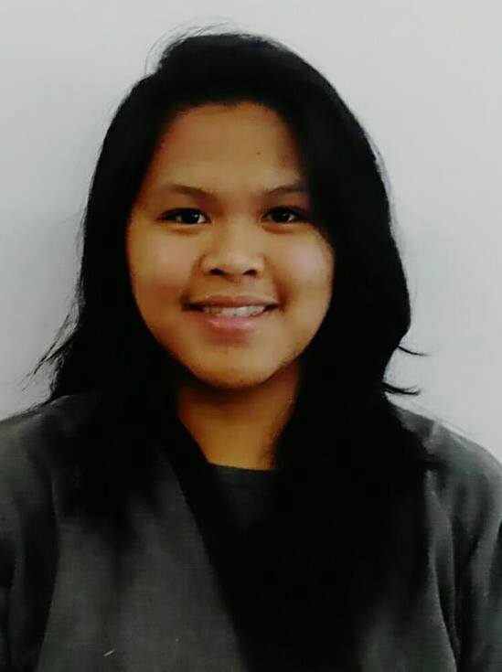

**Ellen Joy B. Tiaga**

#23 AsinExtension, Baguio City

**Personal Data:**

Contact No.: +639156274264

Date of Birth: November 27, 1997

Sex: Female

Citizenship: Filipino

Civil Status: Single

Language Spoken: Filipino, English

Religious Affiliation: Catholic

**Education:**

**Tertiary:**

University of Baguio (2014-Present)

Gen. Luna Rd., Baguio City

Bachelor of Science in Information Technology

**Secondary:**

Pines City National High School (2010-2004)

Palma St., Baguio City

**Primary:**

Baguio Central Elementary School (2004-2010)

F. Yandoc St., Baguio City

**Skills:**

Computer Literate

Photo Editing

Business Analysis

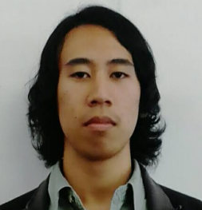**Ivan Clyde M. Rom**

#118-B Talco Compound SitioBilis,

Sto.Tomas Central

Baguio City

**Personal Data:**

Contact No.: +639298139364

Date of Birth: February 3, 1998

Sex: Male

Citizenship: Filipino

Civil Status: Single

Language Spoken: Filipino, English, Ilocano

Religious Affiliation: None

**Education:**

**Tertiary:**

University of Baguio (2014-Present)

Gen. Luna Rd., Baguio City

Bachelor of Science in Information Technology

**Secondary:**

Baguio City National High School

Gov. Pack road, Baguio City

**Primary:**

Dontogan Elementary School

Km.6 DontoganGreenvalley, Baguio City

**Skills:**

Programming

Web Design

Photo Editing