**SOFTWARE DESIGN DOCUMENT (SDD)**



Agyinasare Leadership College – Library Monitoring System

**Version 0.5**

**Prepared By:**

**Fernando, Jekeri Anton**

**Garcia, John Peter**

**Raga-as, Terence Ralph**

|  |
| --- |
| Document Sign-off |

|  |  |
| --- | --- |
| Team Members | Panel Members |
| Raga-as, Terence Ralph  Project Manager | Mrs. Erna-Kristi Martinez  Adviser |
| De Guzman, Angeline  Member  Fernando, Jekeri  Member  Garcia, John Peter  Member | Ms. Divine Aguilar  Database Reviewer  Ms. Hydi Toyeng  Code Reviewer |

Revision History

|  |  |  |  |
| --- | --- | --- | --- |
| Name | Date | Reason For Changes / Comments | Version |
| ALC-LMS | 01/26/18 | Changed the front page, included table of contents and change minor errors in SDD. | 0.1 |
| ALC-LMS | 01/29/18 | Included the Architecture style, Data Design and revised parts of SDD. | 0.2 |
| ALC-LMS | 02/05/18 | Revised Introduction, Design Consideration, Architecture Style and Data Design | 0.3 |
| ALC-LMS | 03/04/18 | Revised Introduction, Design Consideration, Architecture and Data Design | 0.4 |
| ALC-LMS | 04/02/18 | Updated the Risk and Volatile areas, Data Design | 0.5 |

**Table of Contents**

**Contents**

**1.** **Introduction 5**

1.1. System Overview 5

1.2. Scope 5

1.3. Document Overview 6

**2.** **Design Consideration 7**

2.1. Assumptions and Dependencies 7

*2.1.1.* *Assumptions 7*

*2.1.2.* *Dependencies 7*

2.2. Drivers and Constraints 8

*2.2.1 Drivers 8*

*2.2.2 Constraints 8*

2.3. System Environment 9

*2.3.1 Hardware Requirements 9*

*2.3.2 Software Requirements 9*

2.4. Risk and Volatile Areas – 10

**3.** **Architecture 11**

3.1 Design Pattern 11

***3.1.1 Deployment*** *12*

**3.2 Program Structure** 13

1. **Introduction** 
   1. System Overview

The software design document will be used as a guide or reference for future use and modifications of the system.

The software design document provides the information about the ALC-LMS’ characteristics and functionalities. The document also provides information about the test modules of the system.

The software design document gives the detailed description of both functional and non-functional requirements in the form of list, tables, paragraphs and graphical representations.

* 1. Scope

The document discusses about the ALC-LMS’ capabilities. The document also discusses about the architecture and data design of the regarding the test modules of the system.

The ALC Library Monitoring System can:

* Manage records
* Monitor books
* Manage accounts

ALC Library Monitoring System is a computerized system that can be used to effectively and efficiently manage specific library tasks and reports.

* 1. Document Overview

The document is divided into 7 major sections:

Section 1: Introduction – provides an overview of the Software Design Document and the scope of the document.

Section 2: Design Consideration – provides the assumptions and dependencies in the context of design; drivers and constraints; hardware and software requirements and the risk and volatile areas, if applicable.

Section 3: Architecture – shows the architectural style and program structure of the system.

Section 4: Data Design – developers shall refer to this section for database model and schema.

Section 5: User Interfaces – provides the user interfaces and discusses the events and actions.

Section 6: Report Design – provides the narrative overview of the reports that can be generated from the system and the layout of each report.

Section 7: Definitions, acronyms and abbreviations – provides definitions of all terms, acronyms and abbreviations needed for the SDD.

1. **Design Consideration** 
   1. Assumptions and Dependencies
      1. Assumptions

* There will be no changes for the requirements of the system.
* The performance of each project member will be consistent and efficient throughout the process. With the use of the right tools, for example; Time management, maturity etc., it can be done.
* The assigned jobs for the project members must be balanced accordingly based from their skill set.
  + 1. Dependencies
* The team should decide on the system architecture
* A data model should be designed and defined before creating the fields in the database and in the interface.
* The functionalities for each users must be identified in order to build the user interface for the different access levels.
* In order to construct, access, and test the system, the team must use a personal computer.
  1. Drivers and Constraints

2.2.1 Drivers

* The creation of account is done through authorized personnel, which is the librarian, to secure their account.
* Accessing functionalities of the system can be done by logging with a valid ID number and password.
* Account and book records can only be accessed by the administrator.
* Browsing and checking available books can be done 24/7 except when there is a server maintenance.

2.2.2. Constraints

* The ALC-LMS may only be opened using a browser on any platform.
* The ALC-LMS is only limited to ALC students and employees.
* The ALC-LMS cannot be used without an internet connection.
* Database capacity must be at least 500 GB.
  1. System Environment

2.3.1. Hardware Requirements

|  |  |  |
| --- | --- | --- |
| **System Environment** | **Hardware** | **Specifications** |
| Development Environment | Personal Computer | CPU: Intel® Core™ i5-5200U CPU @ 2.70GHz  RAM: 4.0GB  Storage: 1 TB Hard disk drive |
| Deployment Environment | Personal Computer | CPU: Intel® Core™ i7-7700HQ CPU @ 2.80GHz  RAM:4.0GB  Storage: 1 TB Hard disk drive |

2.3.2. Software Requirements

|  |  |
| --- | --- |
| **System Environment** | **Software** |
| Development Platform | Windows 10 |
| Deployment Platform | Windows XP, Windows 7, Windows 8, Windows 10 |
| Integrated Development Environment IDE | PHP Storm |
| Database Management System (DBMS) Software | MySQLite |
| Programming Language | PHP |
| Markup Language | HTML |
| Cross-platform Web Server Solution Stack Package | XAMPP |

* 1. Risk and Volatile Areas –

The Risk and Volatile areas of the ALC-LMS would be:

* When multiple users access the same data within the system at the same time, it can cause the system to slow down.
* Other users can access other account because of the default password.

1. **Architecture**

3.1 Design Pattern

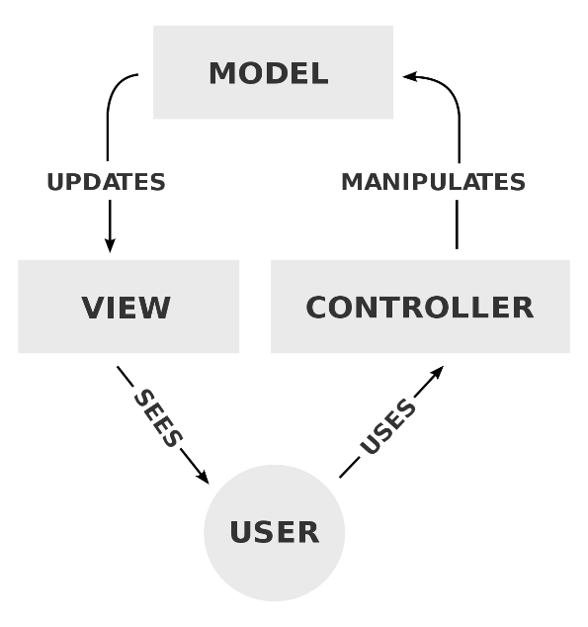

Model View Controller

The Agyinasare Leadership College – Library Monitoring System will be using Model View Controller as design. The model contains the database of the application. It is where the maintenance manager updates the design and data of the application. The View is where the website design will be seen by the users of the application. The controller is responsible for manipulating data and it is the brain of the application. The controller decides what the user's input was, how the model needs to change as a result of that input, and which resulting view should be used.

3.1.1 Deployment

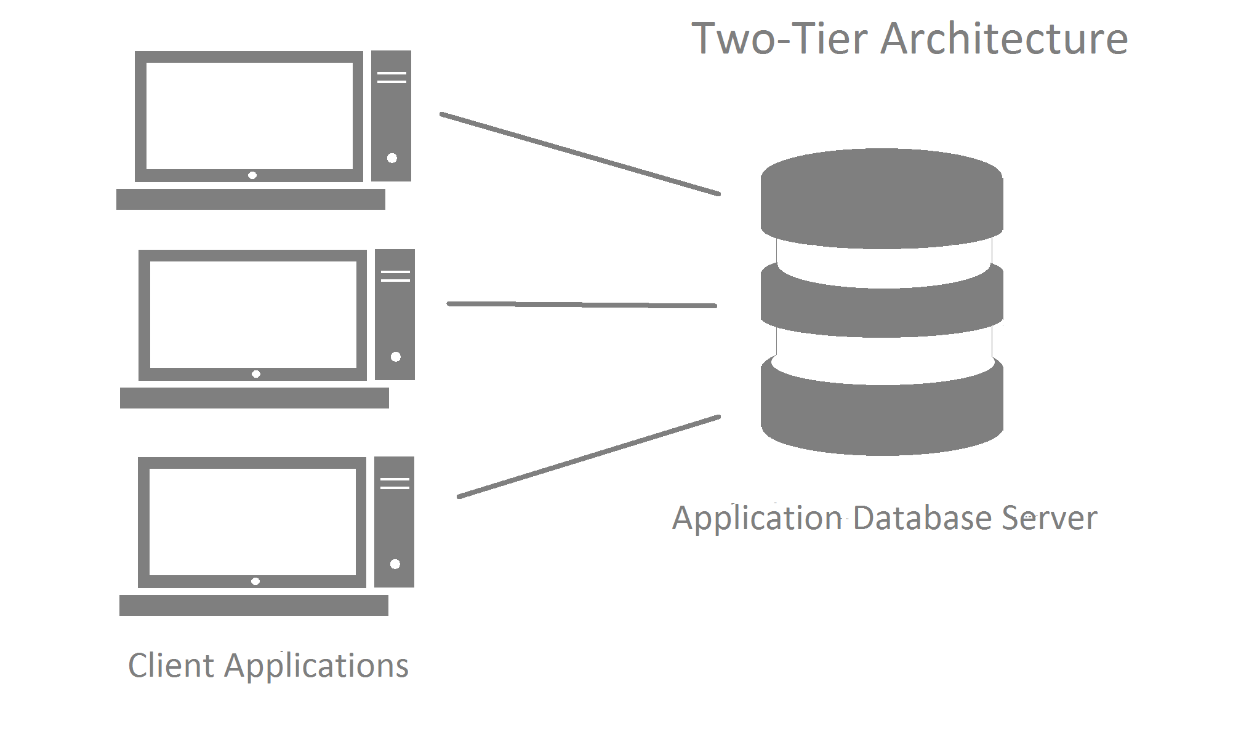

The ALC-LMS will utilize two-tier architecture because of higher security, centralized data access and ease of maintenance. The Server will be responsible for the ALC-LMS’s website design and will display information that is related to function of the system. The data source or database tier will be responsible for storing such information and data for ALC.

3.1.2 Structure

The ALC-LMS will user Object-Oriented Architectural Style because of highly cohesive, extensible, testable, reusable and easy to understand. The OO-AS communicate through interfaces by calling methods or accessing properties. In this architectural style, it uses metadata used map formats that hold data structure. Objects in here can also be inherited and can manipulate update and maintenance faster than any other architectural style.

3.2 Program Structure

3.2.1 Administrator View

* Generate Book List

Reports

* Log-in
* Log-out
* Change Password
* Forgot Password (Email and Contact)

Utilities

Library Monitoring System

* Private messaging
* Post Announcements
* Book Monitoring
* View Announcements
* View posted books
* User Accounts Management
* Create Account
* Edit Account Details
* View Account
* View User/s Information
* Search
* Send Message
* Books
* Update
* Archive
* Unarchive
* Add
* Search
* View Book List
* Message/Announcement

Account Maintenance

Transactions

3.2.2 User View

* Generate Book List

Reports

* Log-in
* Log-out
* Change Password
* Forgot Password (Email and Contact)

Library Monitoring System

Utilities

* View Announcements
* View posted books
* View borrowed books
* View returned books

Transactions

Account Maintenance

* User Accounts
* Edit Account Details
* View Account
* Books
* View Book Details
* Read Book
* Search
* Message/Announcement
* View
* Delete Messages

**4. Data Design**

4.1 Database Model

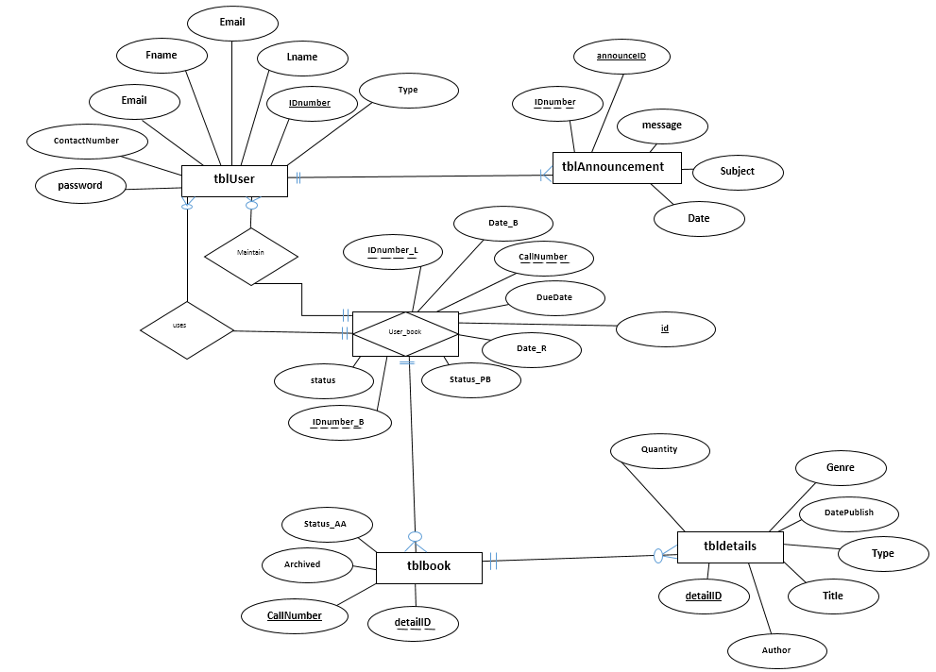

4.2 Database Schema

4.2.1 <User>

|  |  |  |  |  |  |
| --- | --- | --- | --- | --- | --- |
| Fields | Type | Size | Domain Constraint | Description | Mandatory |
| IDnumber | varchar | 15 | 0-9 | ID Number of the user. Use to login at the system. ID number will be the primary key | Yes |
| Password | Varchar | 50 | a-z; A-Z; 0-9 | Password of the User | Yes |
| FirstName | Varchar | 50 | A-Z with a-z; Min:2 | First Name of the librarian | Yes |
| LastName | Varchar | 50 | A-Z with a-z; Min:2 | Last name of the librarian | Yes |
| ContactNumber | Varchar | 13 | 0-9 with +; (; )  Min:11 | Contact Information of the user | Yes |
| EmailAddress | Varchar | 50 | 0-9; A-Z; a-z; @; . | Email Address of the user | Yes |
| Type | Enum | 1 | 0 or 1 | Contains the access level of the user.  Ex: 1 is user(student, employee) and 0 is for admin | yes |

4.2.2 <Book>

|  |  |  |  |  |  |
| --- | --- | --- | --- | --- | --- |
| Fields | Type | Size | Domain Constraint | Description | Mandatory |
| BookID | int | 15 | 0-9 | IDnumber of the user. Use to login at the system | Yes |
| CallNumber | Varchar | 50 | a-z; A-Z; 0-9 | Password of the User | Yes |
| Author | Varchar | 50 | A-Z with a-z; Min:2 | First Name of the librarian | Yes |
| Edition | Varchar | 50 | A-Z with a-z; Min:2 | Last name of the librarian | Yes |
| Genre | Varchar | 13 | 0-9 with +; (; )  Min:11 | Contact Information of the user | Yes |
| Title | Varchar | 50 | 0-9; A-Z; a-z; @; . | Email Address of the user | Yes |
| Status | Varchar | 20 | a-z;A-Z | It defines if the book is available or borrowed | yes |
| Date | Date | 50 | Mm/dd/yy | Date added in the system | yes |
| DatePublished | Date | 50 | Mm/dd/yy | Date of publishing of the book | yes |

4.2.3 <Announcement>

|  |  |  |  |  |  |
| --- | --- | --- | --- | --- | --- |
| Fields | Type | Size | Domain Constraint | Description | Mandatory |
| announceID | int | 15 | 0-9 | Primary key for announcement | Yes |
| Date | Date | 50 | Mm/dd/yy | Date of the announce post | Yes |
| Subject | Varchar | 50 | A-Z with a-z; Min:2 | Subject of the announcement | Yes |
| Message | Varchar | 50 | A-Z with a-z; Min:2 | Contains the message of the announcement | Yes |
| IDnumber | Varchar | 15 | 0-9 with +; (; )  Min:11 | Id number of the user(Foreign key) | Yes |

4.2.4 <User_Book>

|  |  |  |  |  |  |
| --- | --- | --- | --- | --- | --- |
| Fields | Type | Size | Domain Constraint | Description | Mandatory |
| DateLate | Date | 15 | Mm/dd/yy | Date | Yes |
| BookID | int | 15 | 0-9 | Primary key of Book | Yes |
| IDnumber | Varchar | 15 | A-Z with a-z; Min:2 | Primary key of user | Yes |
| DateBorrow | Date | 15 | Mm/dd/yy | Specify the date borrowed in the system | Yes |
| DateReturned | Date | 15 | Mm/dd/yy | Specify the date returned in the system | Yes |

**5. User Interface**

5.1.1.Home Page for all users

This page provides initial access for all users.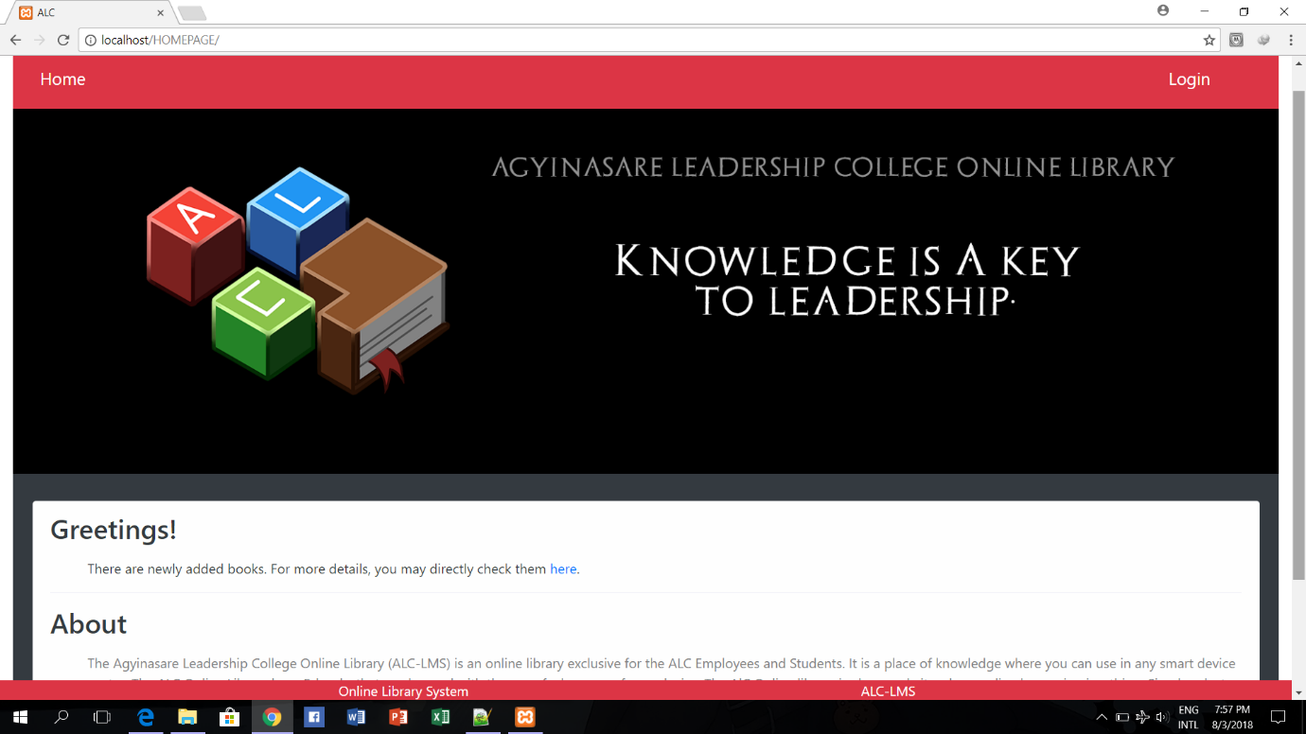

|  |  |  |  |
| --- | --- | --- | --- |
| **Task** | **Object** | **Event** | **Event Details** |
| Selects Home Button | btn_home | onClick | The system refreshes the page and redirects to the same page |
| Clicks Login Button | btn_login | onClick | The system redirects the view to the Login Page |

5.1.2. Login Page

This page allows users to login their account.

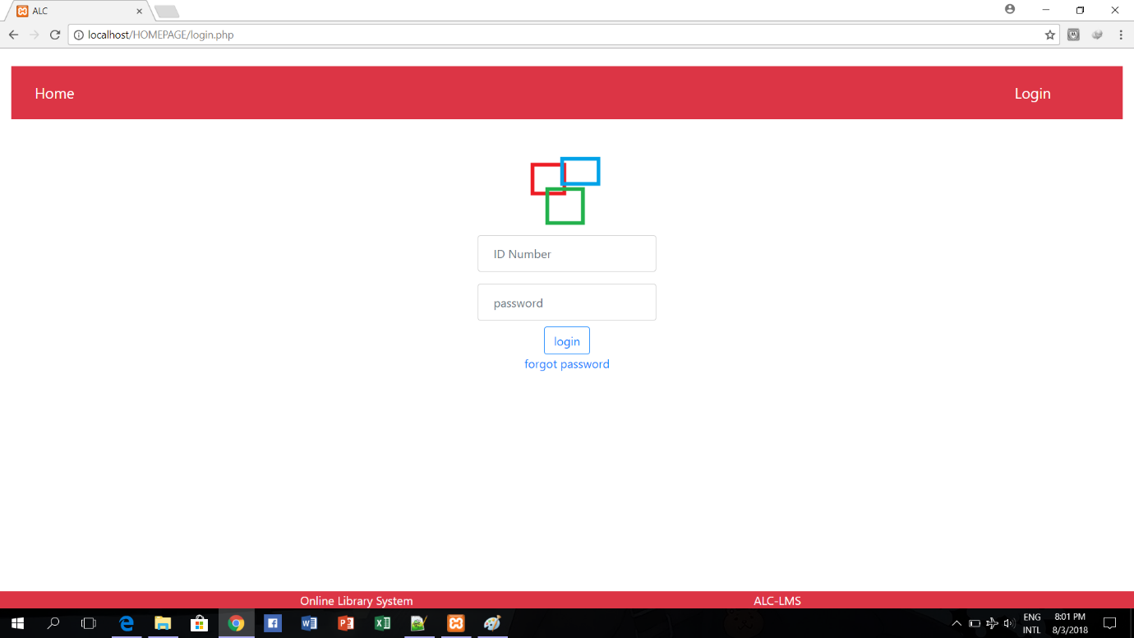

|  |  |  |  |
| --- | --- | --- | --- |
| **Task** | **Object** | **Event** | **Event Details** |
| Selects Home Button | lnkHome | onClick | The system refreshes the page and redirects to the same page |
| Enters ID number | txt_idnum | None | None |
| Enters password | txt_pwd | None | None |
| Clicks login button | btn_login | onClick | The system validates the information entered by the user;  The system checks if there are missing fields during submission;  The system checks if the if the account exist in the database and verifies if the user role is admin or user;  Redirects user to the user or admin home page. |
| Selects forgot password | Lnk_forgotpwd | onClick | Redirects user to the Forgot Password page |

5.1.3. Forgot Password

This page will let the user choose where to send the verification.

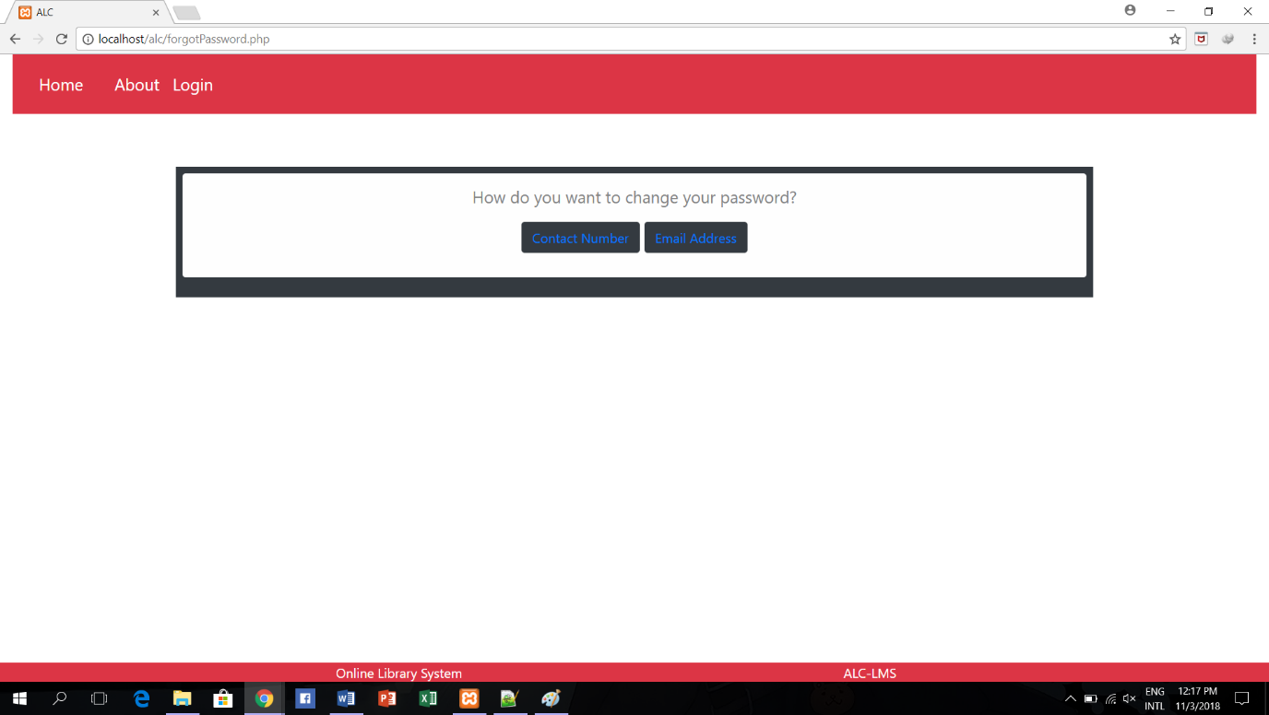

|  |  |  |  |
| --- | --- | --- | --- |
| **Task** | **Object** | **Event** | **Event Details** |
| Selects Home Button | lnkHome | onClick | The system refreshes the page and redirects to the same page |
| Clicks login button | btn_login | onClick | Redirects user to the user or admin home page. |
| Selects Contact Number | btn_contactNum | onClick | Redirects user to the Input Contact Number page. |
| Selects Email Address | btn_emailAddress | onClick | Redirects user to the Input Email Address |

5.1.3.1. Input Contact Number

This page let the user enter his/her contact number for the verification code.

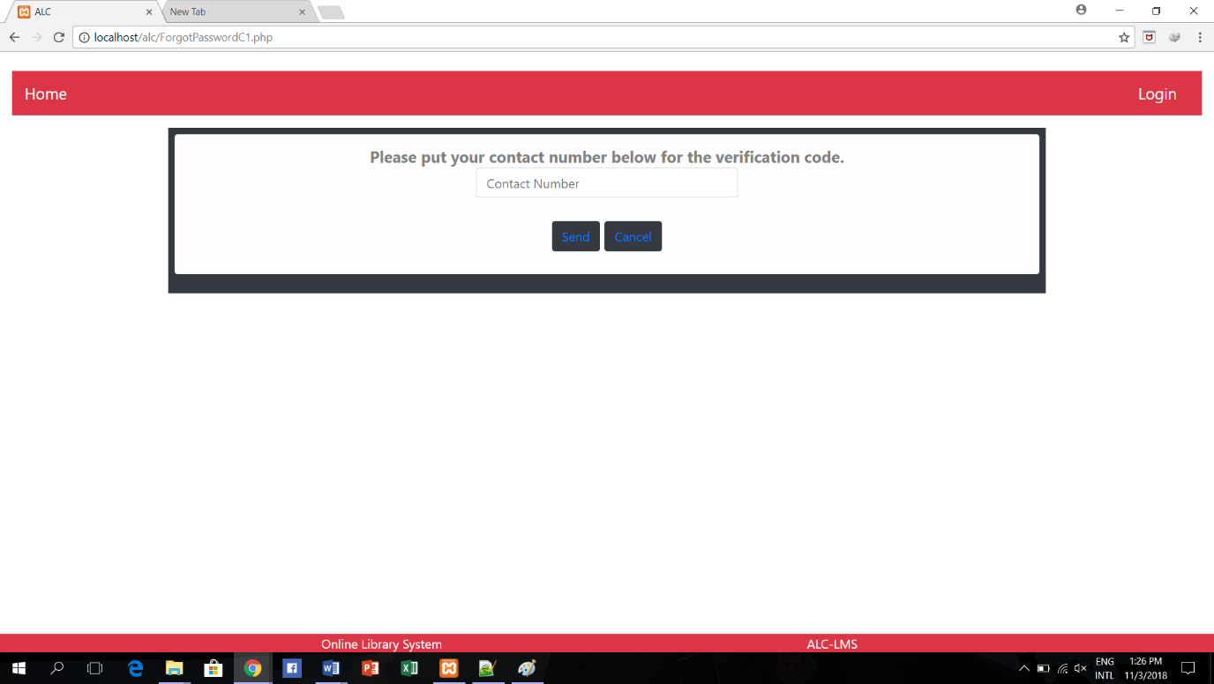

|  |  |  |  |
| --- | --- | --- | --- |
| **Task** | **Object** | **Event** | **Event Details** |
| Selects Home Button | lnkHome | onClick | The system refreshes the page and redirects to the same page |
| Clicks login button | btn_login | onClick | Redirects user to the user or admin home page. |
| Enters contact Number | txt_contactNum | none | none |
| Clicks Send | Btn_send | onClick | The system will validate the contact number if it is registered and will send the verification code to it.  Redirects user to the Verification of Password Code page. |
| Clicks Cancel | Btn_cancel | onClick | Redirects to the Forgot Password Page. |

5.1.3.2. Input Email Address

This page let the user enter his/her email address for the verification code.

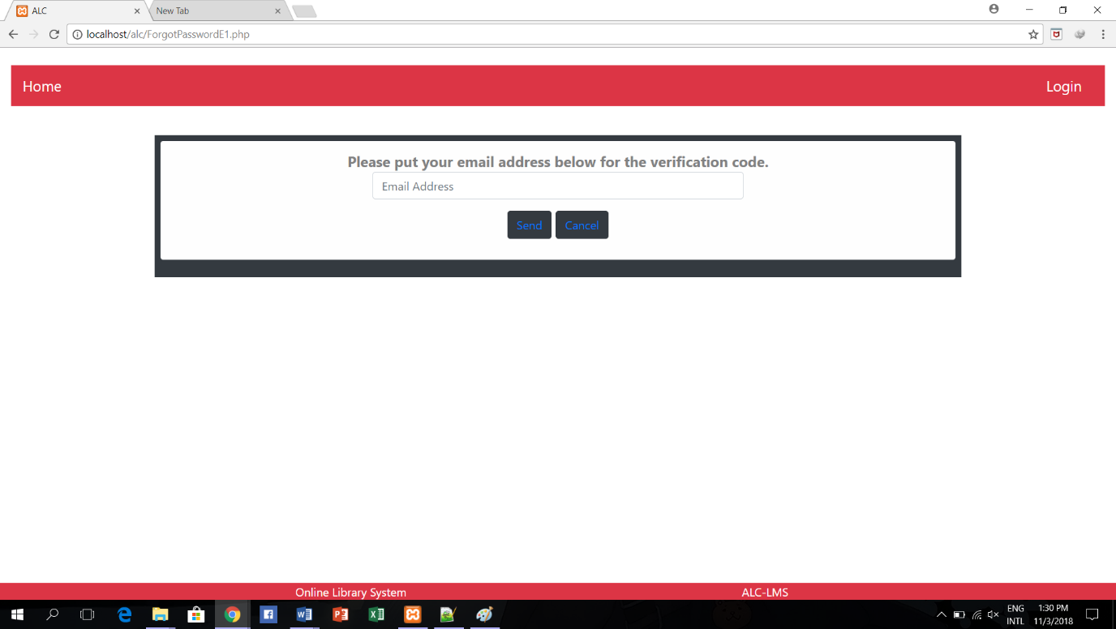

|  |  |  |  |  |  |  |
| --- | --- | --- | --- | --- | --- | --- |
| **Task** | **Object** | | | **Event** | | **Event Details** |
| Selects Home Button | lnkHome | | | onClick | | The system refreshes the page and redirects to the same page |
| Clicks login button | btn_login | | | onClick | | Redirects user to the user or admin home page. |
| Enters Email Address | txt_emailAddress | | | none | | none |
| Clicks Send | | Btn_send | onClick | | The system will validate the email address if it is registered and will send the verification code to it.  Redirects user to the Verification of Password Code page. | |
| Clicks Cancel | | Btn_cancel | onClick | | Redirects to the Forgot Password Page. | |

5.1.3.3. Verification of Password Code

This page will allow the user to input his/her new password along with the verification code.

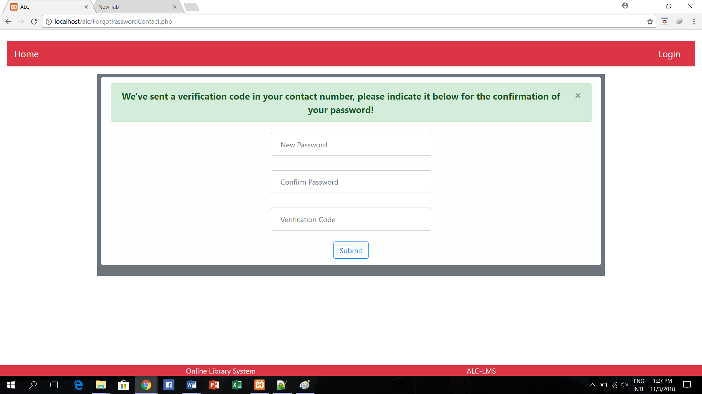

|  |  |  |  |
| --- | --- | --- | --- |
| **Task** | **Object** | **Event** | **Event Details** |
| Selects Home Button | lnkHome | onClick | The system refreshes the page and redirects to the same page |
| Clicks login button | btn_login | onClick | Redirects user to the user or admin home page. |
| Enters New Password | txt_newPassword | none | none |
| Enters Confirm Password | txt_confirmPassword | none | none |
| Enters Verification Code | txt_verificationCode | none | none |
| Clicks submit | btn_submit | onClick | The system will check if the new password and confirm password is the same.  The system will check if the verification code is authentic. |

5.1.4. Home Page (Administrator)This page is the administrator’s home page where the administrator can navigate to different administrative pages that he or she can access.

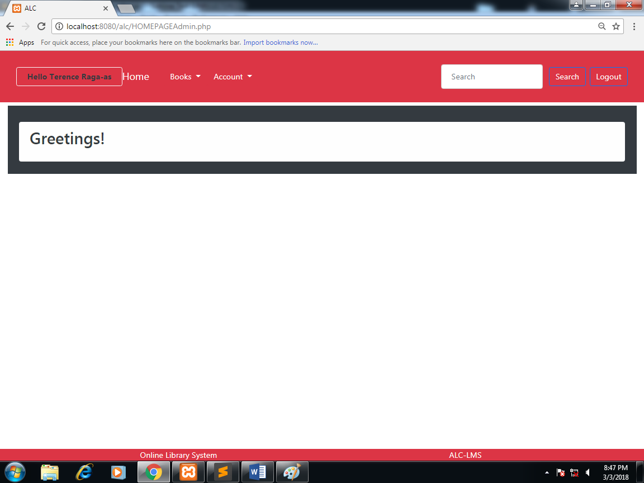

|  |  |  |  |
| --- | --- | --- | --- |
| **Task** | **Object** | **Event** | **Event Details** |
| Selects Home button | btn_home | onClick | Refreshes the page and redirects administrator to the same page. |
| Selects Books Button | btn_books | onClick | Drops down a menu that contains a link to the Book List, Book Archive, and Add Book pages. |
| Selects Book List link | lnk_book_list | onClick | Redirects the administrator to the Book List page. |
| Selects Book Archive | lnk_book_arch | onClick | Redirects the administrator to the Book Archive page. |
| Selects Add Book | lnk_add_book | onClick | Redirects the administrator to the Add Book Page. |
| Selects Account | btn_account | onClick | Drops down a menu which contains User Account Creation, Account Information, View User Profile, Post Announcement and Messages pages. |
| Selects User Account Creation | lnk_account_creation | onClick | Redirects page to User Account Creation page. |
| Selects Account Information | lnk_account_information | onClick | Redirects page to Account Information page. |
| Selects View User Profile | lnk_view_profile | onClick | Redirects page to View User Profile page. |
| Selects Post Announcement | lnk_post_announcement | onClick | Redirects page to Post Announcement page. |
| Selects Messages | lnk_post_messages | onClick | Redirects page to Messages page. |
| Selects Logout | btn_logout | onClick | Logs out the administrator and redirects page to the Index page. |

5.1.4.1.Book List (Administrator)

This page is where the administrator can view the list of books in the system.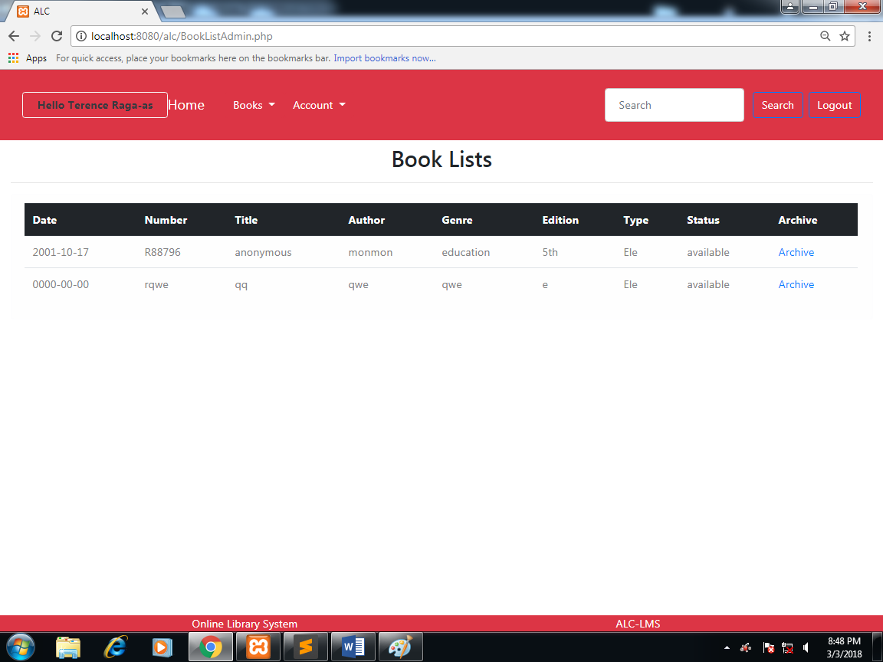

|  |  |  |  |
| --- | --- | --- | --- |
| **Task** | **Object** | **Event** | **Event Details** |
| Selects Home Button | btn_home | onClick | Redirects administrator to the administrator home page. |
| Selects Books Button | btn_books | onClick | Drops down a menu that contains a link to the Book List, Book Archive, and Add Book pages. |
| Selects Book List link | lnk_book_list | onClick | Redirects the administrator to the Book List page. |
| Selects Book Archive | lnk_book_arch | onClick | Redirects the administrator to the Book Archive page. |
| Selects Add Book | lnk_add_book | onClick | Redirects the administrator to the Add Book Page. |
| Selects Account | btn_account | onClick | Drops down a menu which contains User Account Creation, Account Information, View User Profile, Post Announcement and Messages pages. |
| Selects User Account Creation | lnk_account_creation | onClick | Redirects page to User Account Creation page. |
| Selects Account Information | lnk_account_information | onClick | Redirects page to Account Information page. |
| Selects View User Profile | lnk_view_profile | onClick | Redirects page to View User Profile page. |
| Selects Post Announcement | lnk_post_announcement | onClick | Redirects page to Post Announcement page. |
| Selects Messages | lnk_post_messages | onClick | Redirects page to Messages page. |
| Selects Logout | btn_logout | onClick | Logs out the administrator and redirects page to the Index page. |
| Selects Archive | lnk_archive | onClick | Archives the data of the book to the Archived Books page. |

5.1.4.2. Archived Books (Administrator)This page allows the administrator to view the books archive in the system.

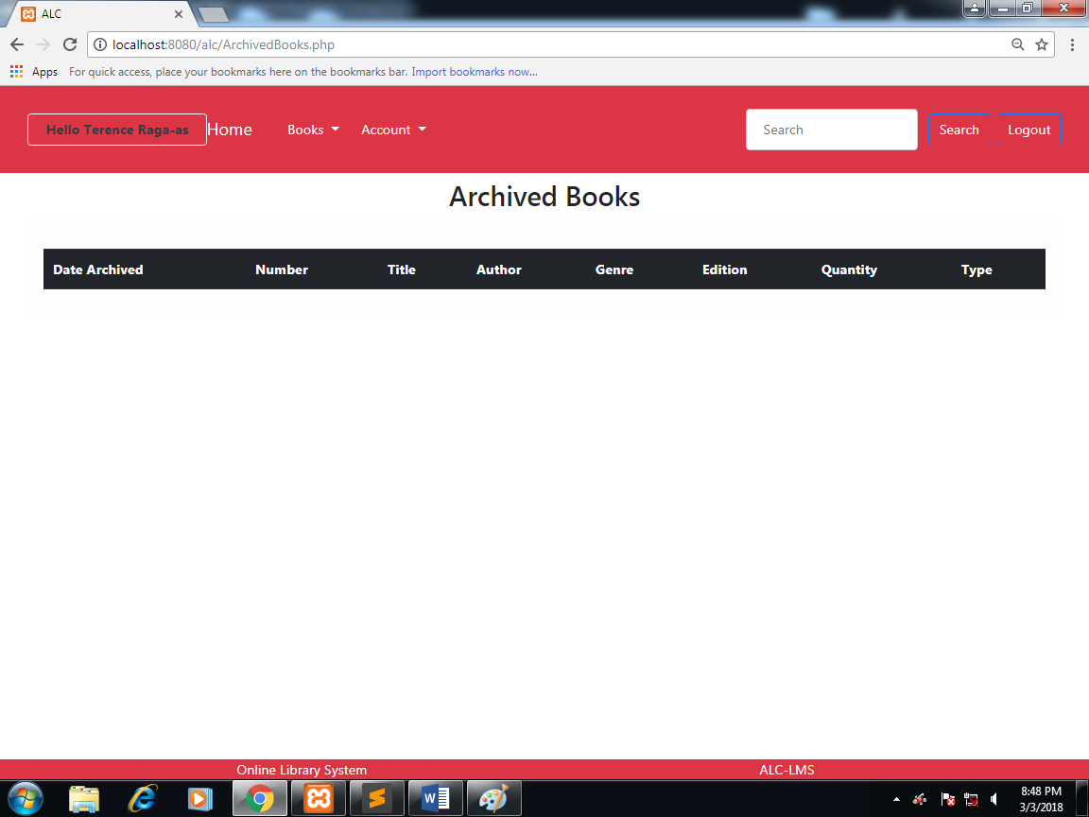

|  |  |  |  |
| --- | --- | --- | --- |
| **Task** | **Object** | **Event** | **Event Details** |
| Selects Home Button | btn_home | onClick | Redirects administrator to the administrator home page. |
| Selects Books Button | btn_books | onClick | Drops down a menu that contains a link to the Book List, Book Archive, and Add Book pages. |
| Selects Book List link | lnk_book_list | onClick | Redirects the administrator to the Book List page. |
| Selects Book Archive | lnk_book_arch | onClick | Redirects the administrator to the Book Archive page. |
| Selects Add Book | lnk_add_book | onClick | Redirects the administrator to the Add Book Page. |
| Selects Account | btn_account | onClick | Drops down a menu which contains User Account Creation, Account Information, View User Profile, Post Announcement and Messages pages. |
| Selects User Account Creation | lnk_account_creation | onClick | Redirects page to User Account Creation page. |
| Selects Account Information | lnk_account_information | onClick | Redirects page to Account Information page. |
| Selects View User Profile | lnk_view_profile | onClick | Redirects page to View User Profile page. |
| Selects Post Announcement | lnk_post_announcement | onClick | Redirects page to Post Announcement page. |
| Selects Messages | lnk_post_messages | onClick | Redirects page to Messages page. |
| Selects Logout | btn_logout | onClick | Logs out the administrator and redirects page to the Index page. |

5.1.4.3. Add Book (Administrator)This page allows the administrator to add book/s in the system.

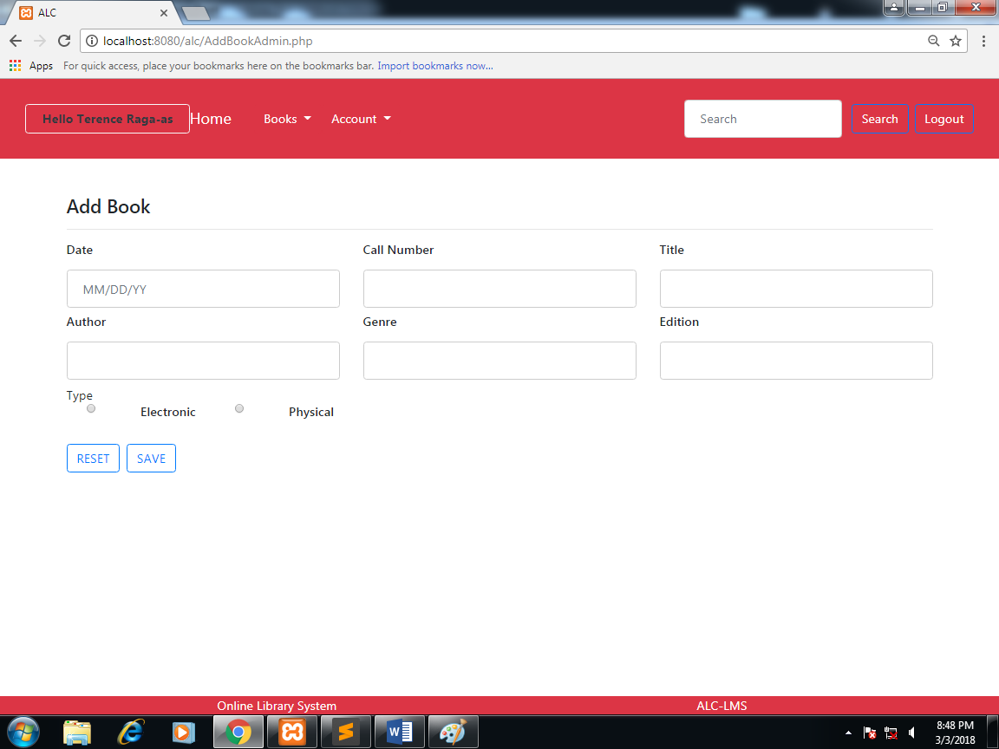

|  |  |  |  |
| --- | --- | --- | --- |
| **Task** | **Object** | **Event** | **Event Details** |
| Selects Home Button | btn_home | onClick | Redirects administrator to the administrator home page. |
| Selects Books Button | btn_books | onClick | Drops down a menu that contains a link to the Book List, Book Archive, and Add Book pages. |
| Selects Book List link | lnk_book_list | onClick | Redirects the administrator to the Book List page. |
| Selects Book Archive | lnk_book_arch | onClick | Redirects the administrator to the Book Archive page. |
| Selects Add Book | lnk_add_book | onClick | Redirects the administrator to the Add Book Page. |
| Selects Account | btn_account | onClick | Drops down a menu which contains User Account Creation, Account Information, View User Profile, Post Announcement and Messages pages. |
| Selects User Account Creation | lnk_account_creation | onClick | Redirects page to User Account Creation page. |
| Selects Account Information | lnk_account_information | onClick | Redirects page to Account Information page. |
| Selects View User Profile | lnk_view_profile | onClick | Redirects page to View User Profile page. |
| Selects Post Announcement | lnk_post_announcement | onClick | Redirects page to Post Announcement page. |
| Enters the book title | txt_title | none | none |
| Enters the book author | txt_author | none | none |
| Enters the book Date added | txt_dateAdded | none | none |
| Enters the book Call Number | txt_callNumber | none | none |
| Enters Genre | txt_genre | none | none |
| Enters the book Edition | txt_edition | none | none |
| Selects Electronic | rbtn_electronic | none | none |
| Selects Physical | rbtn_physical | none | none |
| Selects the save button | btn_save | onClick | The system will save the information to the systems database. |
| Selects the reset button | btn_reset | onClick | Clears all the fields. |

5.1.4.4. Account Information(Administrator)

This page allows the user to view his or her account information.

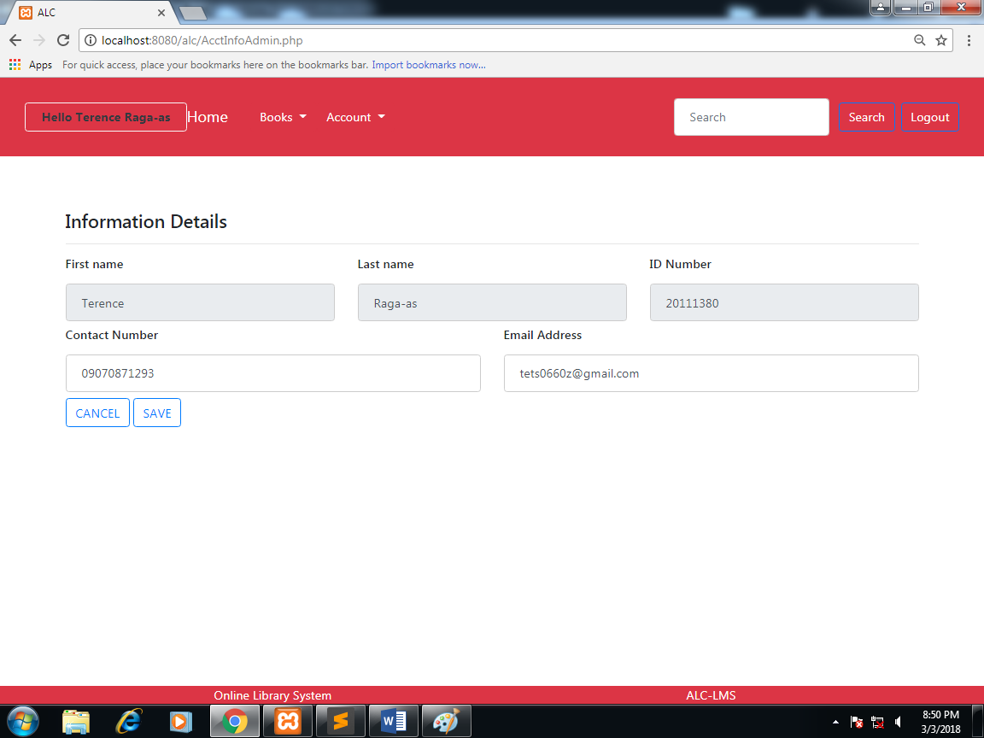

|  |  |  |  |
| --- | --- | --- | --- |
| **Task** | **Object** | **Event** | **Event Details** |
| Selects Home button | btn_home | onClick | Refreshes the page and redirects administrator to the same page. |
| Selects Books Button | btn_books | onClick | Drops down a menu that contains a link to the Book List, Book Archive, and Add Book pages. |
| Selects Book List link | lnk_book_list | onClick | Redirects the administrator to the Book List page. |
| Selects Book Archive | lnk_book_arch | onClick | Redirects the administrator to the Book Archive page. |
| Selects Add Book | lnk_add_book | onClick | Redirects the administrator to the Add Book Page. |
| Selects Account | btn_account | onClick | Drops down a menu which contains User Account Creation, Account Information, View User Profile, Post Announcement and Messages pages. |
| Selects User Account Creation | lnk_account_creation | onClick | Redirects page to User Account Creation page. |
| Selects Account Information | lnk_account_information | onClick | Redirects page to Account Information page. |
| Selects View User Profile | lnk_view_profile | onClick | Redirects page to View User Profile page. |
| Selects Post Announcement | lnk_post_announcement | onClick | Redirects page to Post Announcement page. |
| Selects Messages | lnk_post_messages | onClick | Redirects page to Messages page. |
| Selects Logout | btn_logout | onClick | Logs out the administrator and redirects page to the Index page. |
| Edits the contact number | txt_contactNumber | None | none |
| Edits the Email Address | txt_emailAddress | None | none |
| Clicks the save button | btn_save | onClick | The system will replace the current email address and contact number with the new email address and contact number. |
| Clicks the cancel button | btn_cancel | onClick | Cancels the changes in the email address and contact number. |

5.1.4.5. Account Creation Page(Administrator)

This page allows the administrator to create an account for the user.

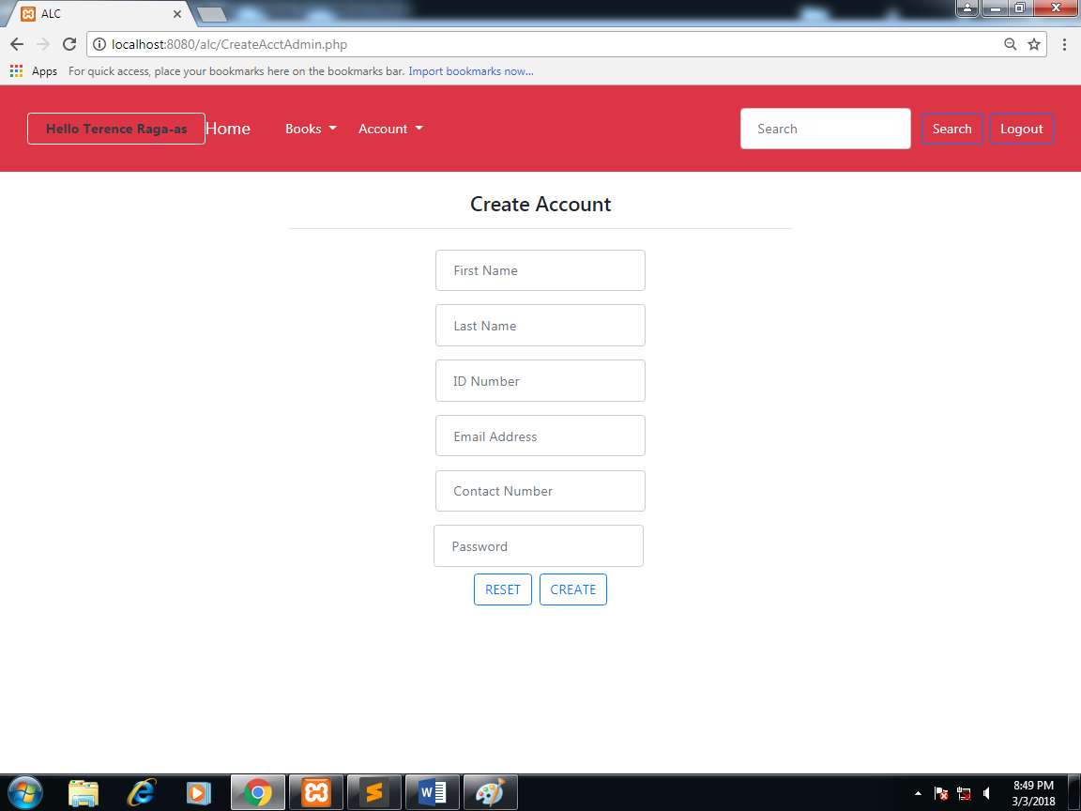

|  |  |  |  |
| --- | --- | --- | --- |
| **Task** | **Object** | **Event** | **Event Details** |
| Selects Home button | btn_home | onClick | Refreshes the page and redirects administrator to the same page. |
| Selects Books Button | btn_books | onClick | Drops down a menu that contains a link to the Book List, Book Archive, and Add Book pages. |
| Selects Book List link | lnk_book_list | onClick | Redirects the administrator to the Book List page. |
| Selects Book Archive | lnk_book_arch | onClick | Redirects the administrator to the Book Archive page. |
| Selects Add Book | lnk_add_book | onClick | Redirects the administrator to the Add Book Page. |
| Selects Account | btn_account | onClick | Drops down a menu which contains User Account Creation, Account Information, View User Profile, Post Announcement and Messages pages. |
| Selects User Account Creation | lnk_account_creation | onClick | Redirects page to User Account Creation page. |
| Selects Account Information | lnk_account_information | onClick | Redirects page to Account Information page. |
| Selects View User Profile | lnk_view_profile | onClick | Redirects page to View User Profile page. |
| Selects Post Announcement | lnk_post_announcement | onClick | Redirects page to Post Announcement page. |
| Selects Messages | lnk_post_messages | onClick | Redirects page to Messages page. |
| Selects Logout | btn_logout | onClick | Logs out the administrator and redirects page to the Index page. |
| Enters the first name | txt_firstname | None | None |
| Enters the last name | txt_lastname | None | None |
| Enters the ID number | txt_idNum | None | None |
| Enters the Email Address | txt_emailAddress | None | None |
| Enters the Contact Number | txt_contactNumber | None | None |
| Enters the password | txt_password | None | none |
| Clicks the save button | btn_save | onClick | The system will register the information in the database. |
| Clicks the reset button | btn_reset | onClick | Clears the fields. |

5.1.4.6. Posting of Announcement(Administrator)

This page allows the administrator to post an announcement.

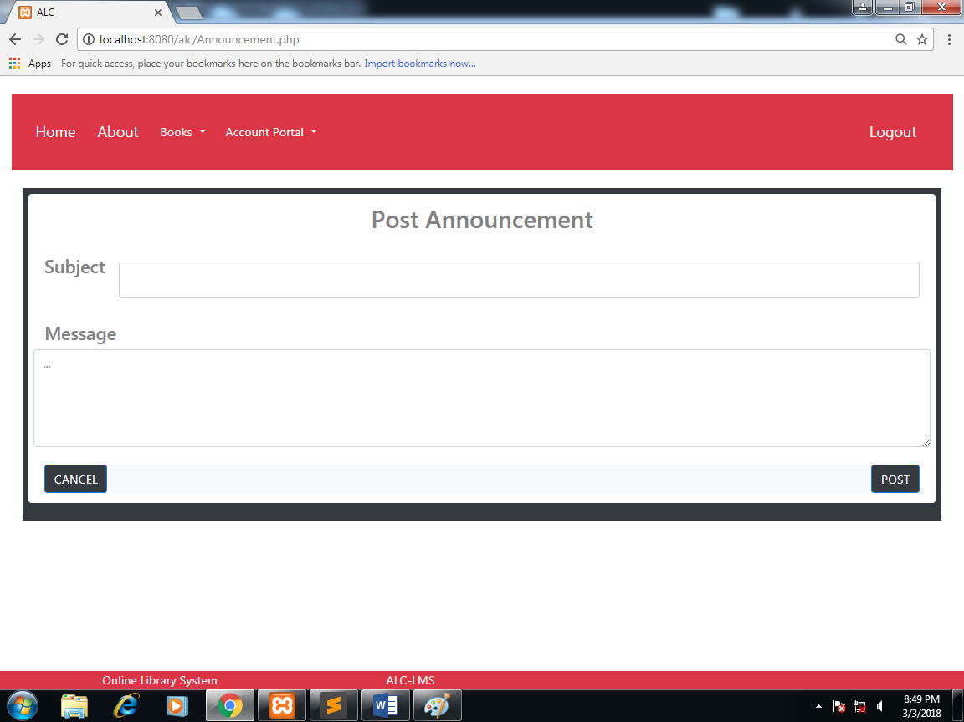

|  |  |  |  |
| --- | --- | --- | --- |
| **Task** | **Object** | **Event** | **Event Details** |
| Selects Home button | btn_home | onClick | Refreshes the page and redirects administrator to the same page. |
| Selects Books Button | btn_books | onClick | Drops down a menu that contains a link to the Book List, Book Archive, and Add Book pages. |
| Selects Book List link | lnk_book_list | onClick | Redirects the administrator to the Book List page. |
| Selects Book Archive | lnk_book_arch | onClick | Redirects the administrator to the Book Archive page. |
| Selects Add Book | lnk_add_book | onClick | Redirects the administrator to the Add Book Page. |
| Selects Account | btn_account | onClick | Drops down a menu which contains User Account Creation, Account Information, View User Profile, Post Announcement and Messages pages. |
| Selects User Account Creation | lnk_account_creation | onClick | Redirects page to User Account Creation page. |
| Selects Account Information | lnk_account_information | onClick | Redirects page to Account Information page. |
| Selects View User Profile | lnk_view_profile | onClick | Redirects page to View User Profile page. |
| Selects Post Announcement | lnk_post_announcement | onClick | Redirects page to Post Announcement page. |
| Selects Messages | lnk_post_messages | onClick | Redirects page to Messages page. |
| Selects Logout | btn_logout | onClick | Logs out the administrator and redirects page to the Index page. |
| Enters the subject regarding the post | txt_subj | none | none |
| Enters the message | txt_message | none | none |
| Clicks the post button | btn_button | onClick | The system will post the announcement. |
| Clicks the cancel button | btn_cancel | onClick | Clears the fields. |

5.1.4.7. Messages Page(Administrator)

This page allows the administrator to view messages.

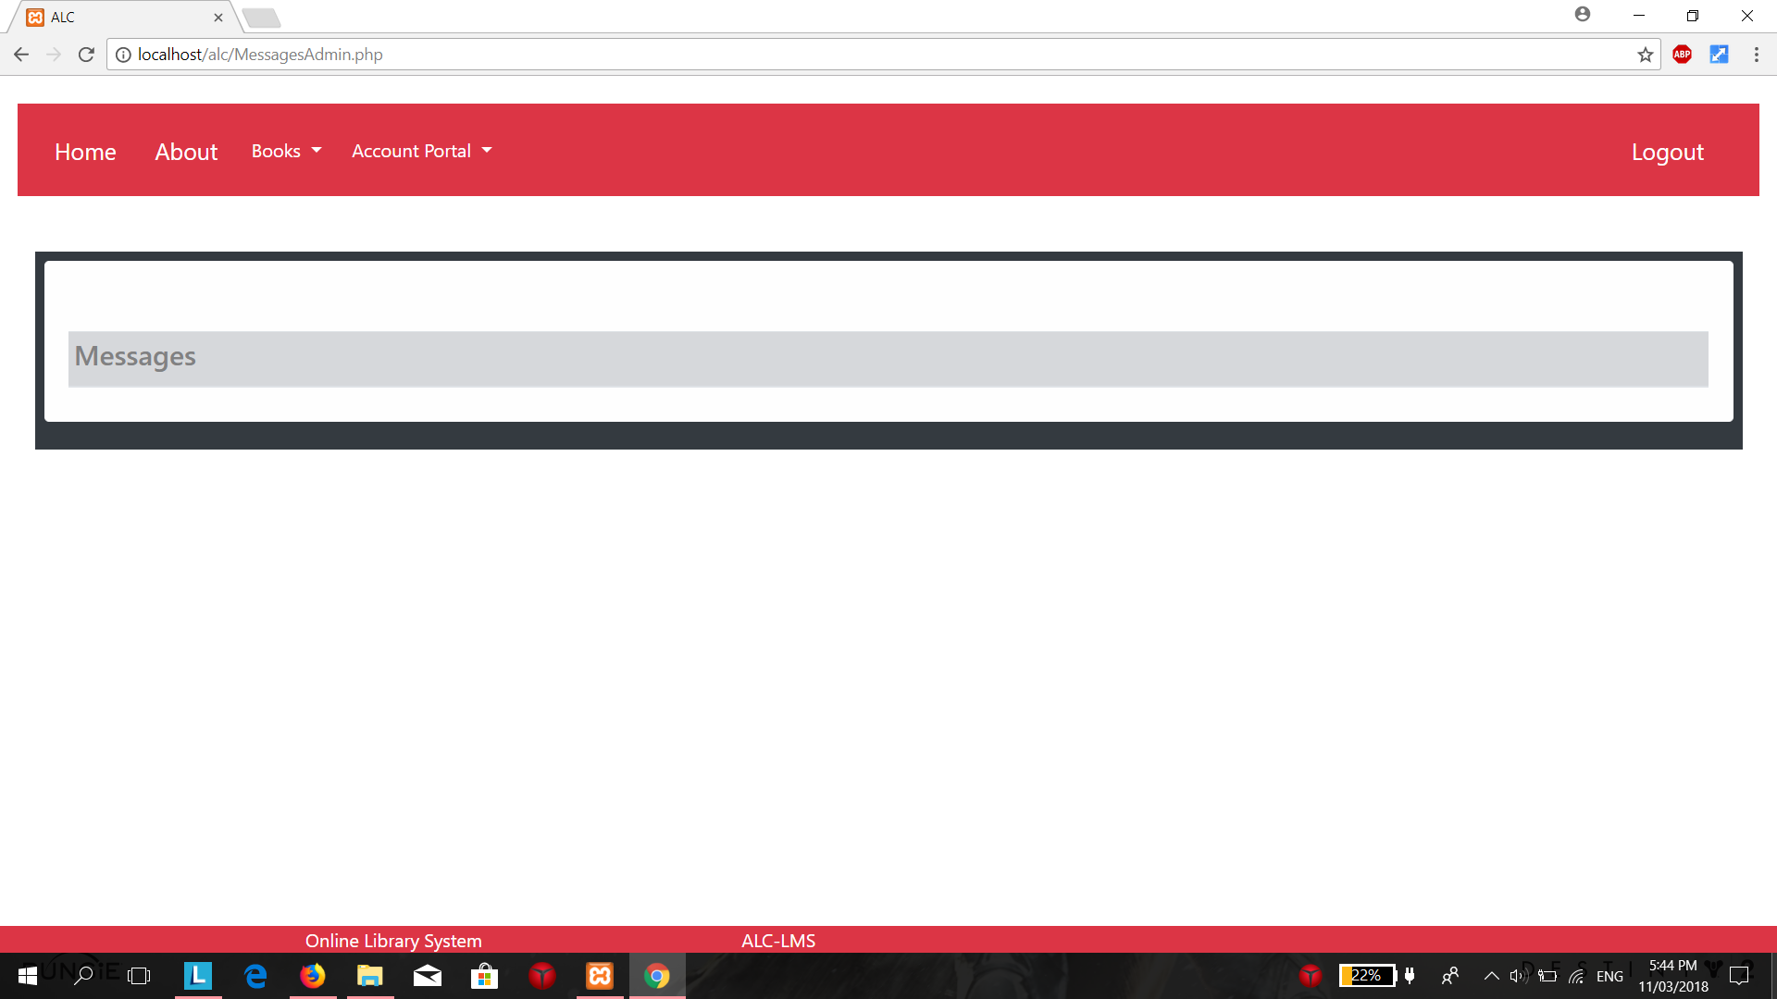

|  |  |  |  |
| --- | --- | --- | --- |
| **Task** | **Object** | **Event** | **Event Details** |
| Selects Home button | btn_home | onClick | Refreshes the page and redirects administrator to the same page. |
| Selects Books Button | btn_books | onClick | Drops down a menu that contains a link to the Book List, Book Archive, and Add Book pages. |
| Selects Book List link | lnk_book_list | onClick | Redirects the administrator to the Book List page. |
| Selects Book Archive | lnk_book_arch | onClick | Redirects the administrator to the Book Archive page. |
| Selects Add Book | lnk_add_book | onClick | Redirects the administrator to the Add Book Page. |
| Selects Account | btn_account | onClick | Drops down a menu which contains User Account Creation, Account Information, View User Profile, Post Announcement and Messages pages. |
| Selects User Account Creation | lnk_account_creation | onClick | Redirects page to User Account Creation page. |
| Selects Account Information | lnk_account_information | onClick | Redirects page to Account Information page. |
| Selects View User Profile | lnk_view_profile | onClick | Redirects page to View User Profile page. |
| Selects Post Announcement | lnk_post_announcement | onClick | Redirects page to Post Announcement page. |
| Selects Messages | lnk_post_messages | onClick | Redirects page to Messages page. |
| Selects Logout | btn_logout | onClick | Logs out the administrator and redirects page to the Index page. |

5.1.5. Home Page (User)

This page is the user’s home page where the user can navigate to different pages that he or she can access.

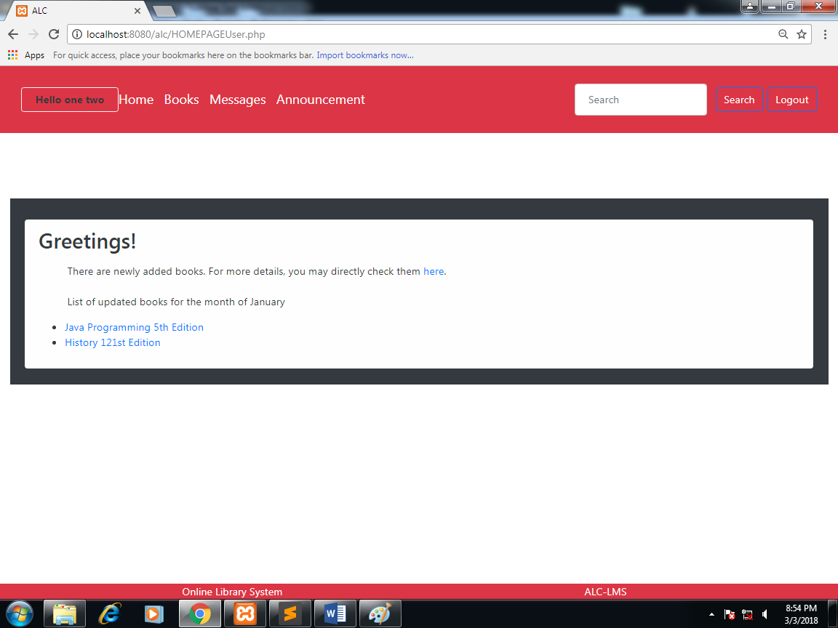

|  |  |  |  |
| --- | --- | --- | --- |
| **Task** | **Object** | **Event** | **Event Details** |
| Selects Home button | btn_home | onClick | Refreshes the page and redirects administrator to the same page. |
| Selects Books Button | btn_books | onClick | The page will be redirected to the Book Lists page. |
| Selects messages | btn_messages | onClick | The page will be redirected to the Messages page. |
| Selects Announcement | btn_announcement | onClick | The page will be redirected to the Announcement page. |
| Selects Logout | btn_logout | onClick | Logs out the administrator and redirects page to the Index page. |

5.1.5.1. Books Page(User)

This page allows the user view available books.

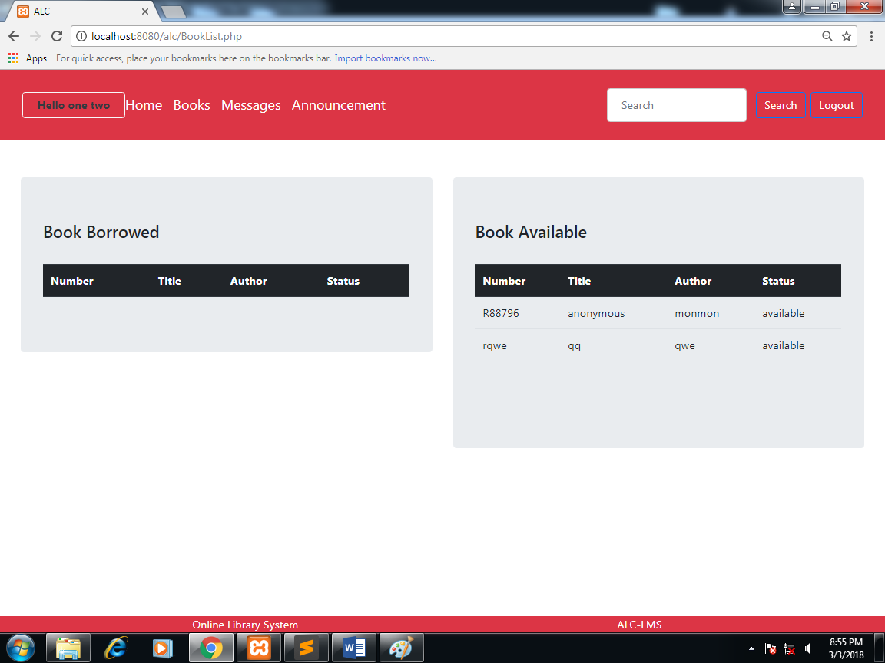

|  |  |  |  |
| --- | --- | --- | --- |
| **Task** | **Object** | **Event** | **Event Details** |
| Selects Home button | btn_home | onClick | Refreshes the page and redirects administrator to the same page. |
| Selects Books Button | btn_books | onClick | The page will be redirected to the Book Lists page. |
| Selects messages | btn_messages | onClick | The page will be redirected to the Messages page. |
| Selects Announcement | btn_announcement | onClick | The page will be redirected to the Announcement page. |
| Selects Logout | btn_logout | onClick | Logs out the administrator and redirects page to the Index page. |

**5.1.5.2. Account Information(User)**

This allows the user to view his or her account information.

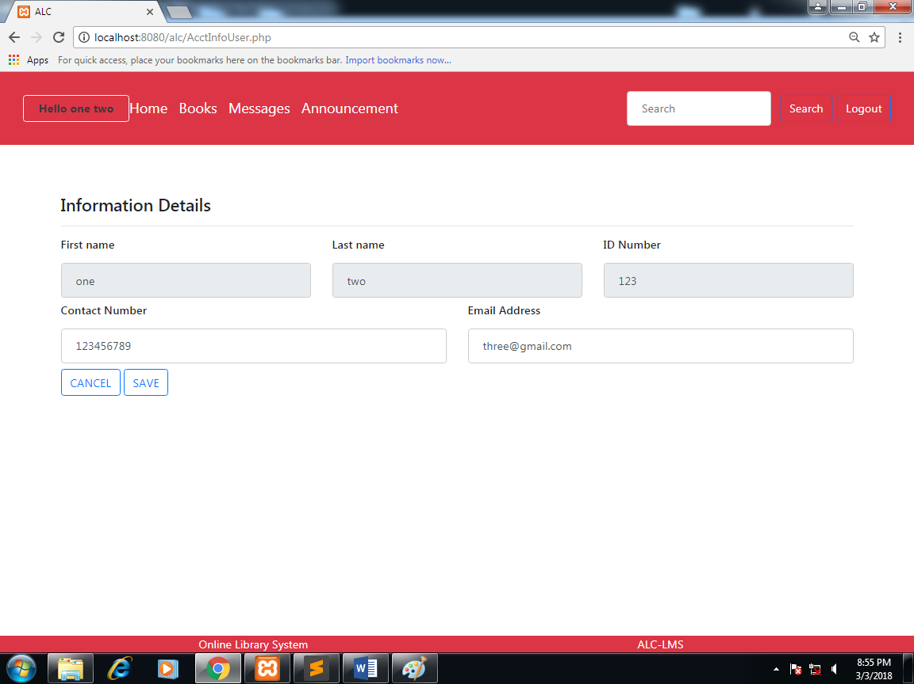

|  |  |  |  |
| --- | --- | --- | --- |
| **Task** | **Object** | **Event** | **Event Details** |
| Selects Home button | btn_home | onClick | Refreshes the page and redirects administrator to the same page. |
| Selects Books Button | btn_books | onClick | The page will be redirected to the Book Lists page. |
| Selects messages | btn_messages | onClick | The page will be redirected to the Messages page. |
| Selects Announcement | btn_announcement | onClick | The page will be redirected to the Announcement page. |
| Selects Logout | btn_logout | onClick | Logs out the administrator and redirects page to the Index page. |
| Edits the contact number | txt_contactNumber | None | none |
| Edits the Email Address | txt_emailAddress | None | none |
| Clicks the save button | btn_save | onClick | The system will replace the current email address and contact number with the new email address and contact number. |
| Clicks the cancel button | btn_cancel | onClick | Cancels the changes in the email address and contact number. |

**6. Report Design**

6.1. Generate/Print Borrowed Book List

This report is generated by the Administrator. It contains the details the books borrowed.  
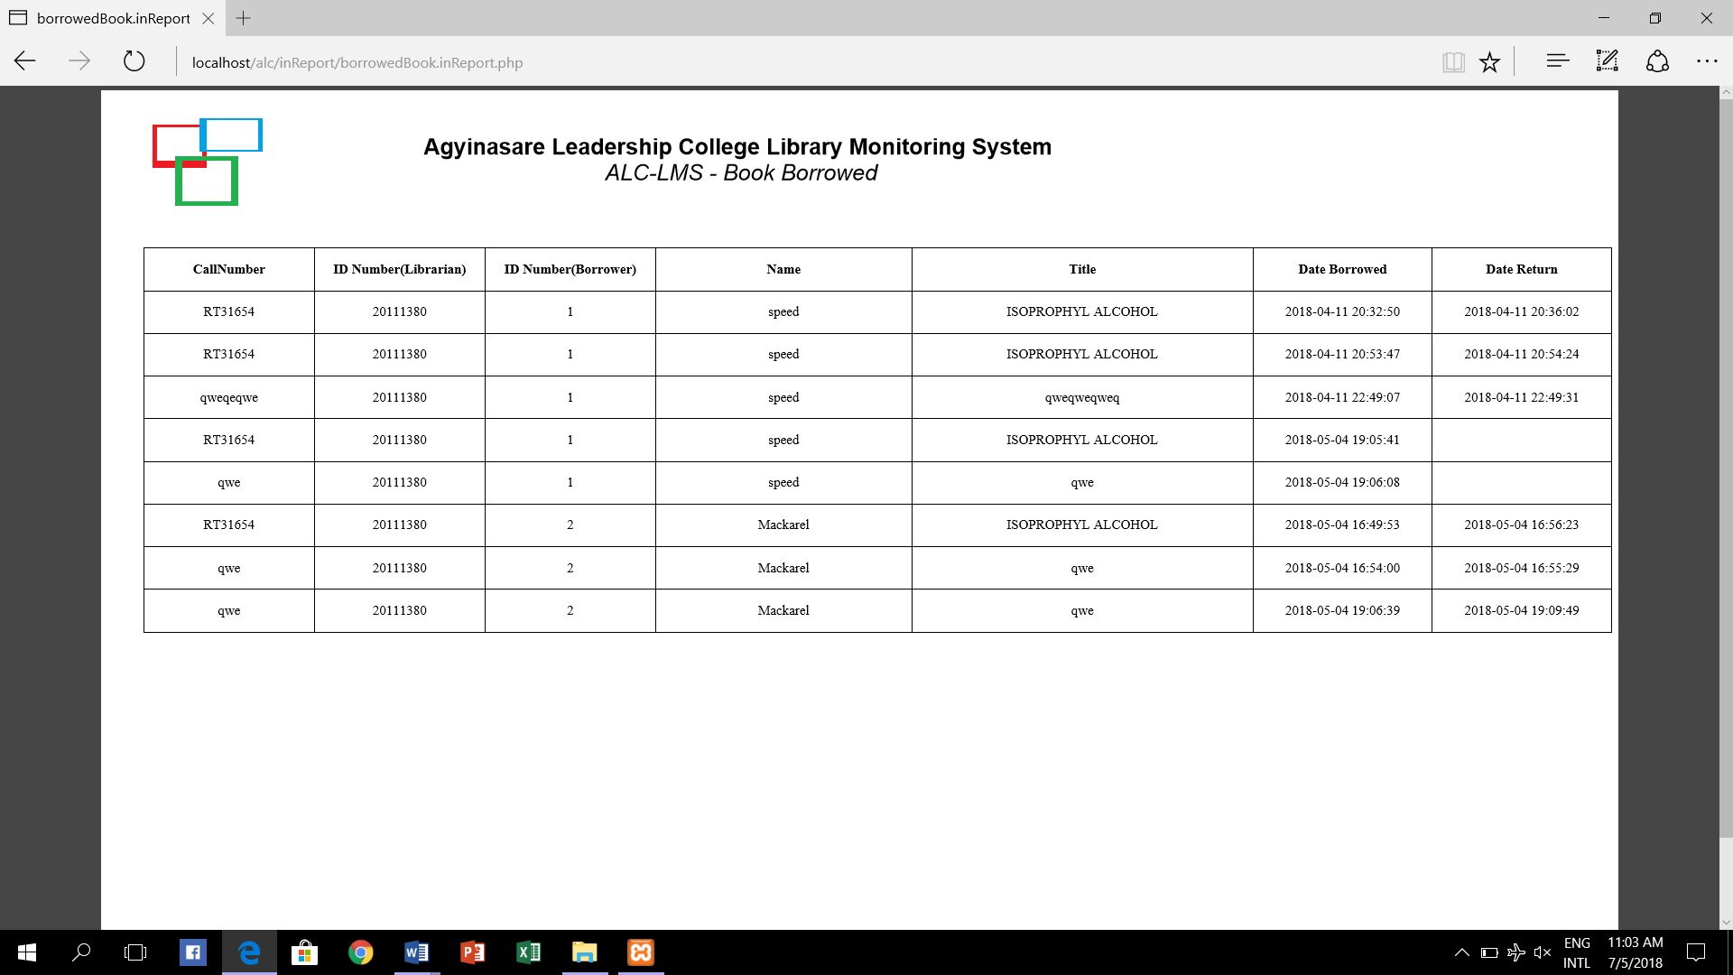

**7. Definitions, Acronyms, and Abbreviations** - provide definitions of all terms, acronyms and abbreviations needed for the SDD.

* ALC-LMS – Agyinasare Leadership College – Library Monitoring System
* ID – Identification of a user
* CPU – Central Processing Unit of a computer.
* RAM – Random Access Memory of a computer.
* HTML – Hypertext Mark-up Languange.
* MVC – Model View Controller.
* Two-Tier Architecture – a client-server system architecture.