Mini project web

For Independent Contractors

# Group members

*Mohamed Yassine Mathlouthi

*Yassine Nermi

*Hsan ouselati

*Aziz Kbaier

## The Objective

* Need #1: conceptualization of a website
* Need #2: developing the website's front-end
* Need #3: developing the website's backend

# website discrption

|  |  |
| --- | --- |
| Raised hand with solid fill | Our website is called bloggy and it is about publishing and reading blogs. Users can visit our website to read a blog on a given topic. So, through our platform, you may respond to blogs, share content, and, of course, establish an account that asks you for information and has identification to show it's you. |

# conception

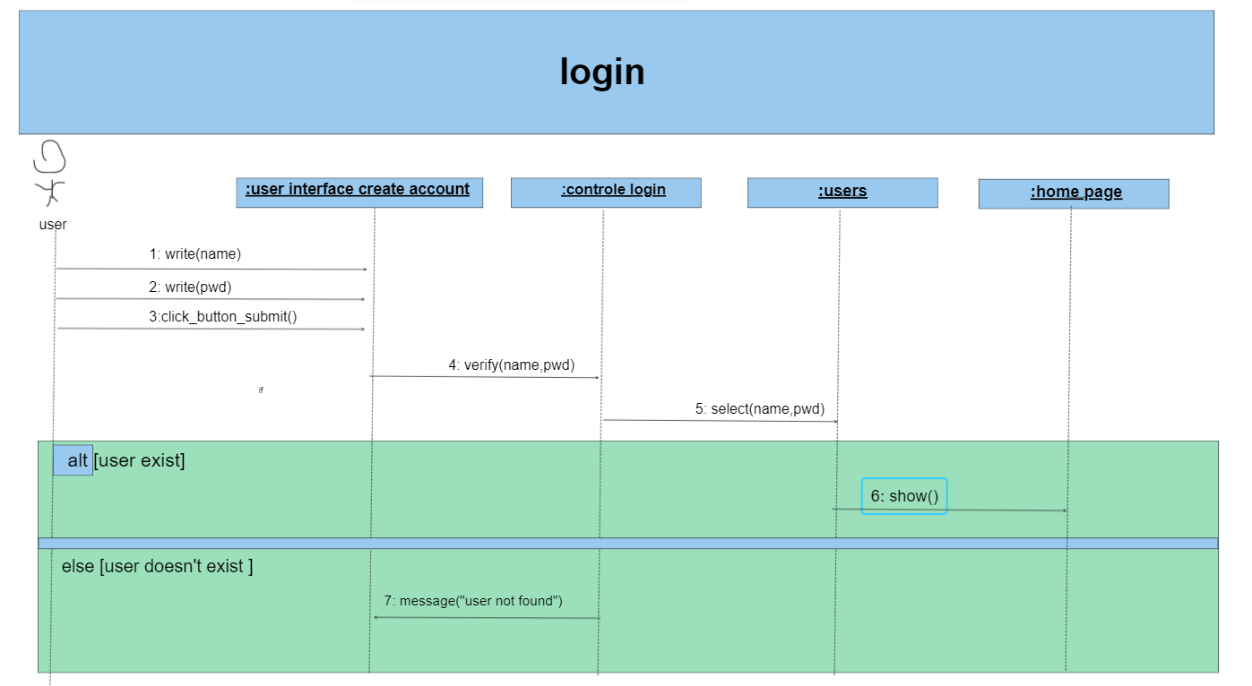

# conception login case

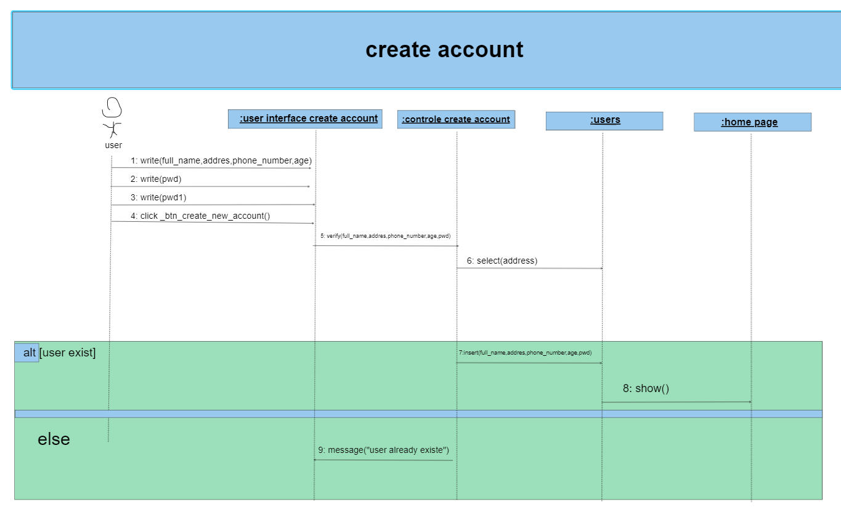

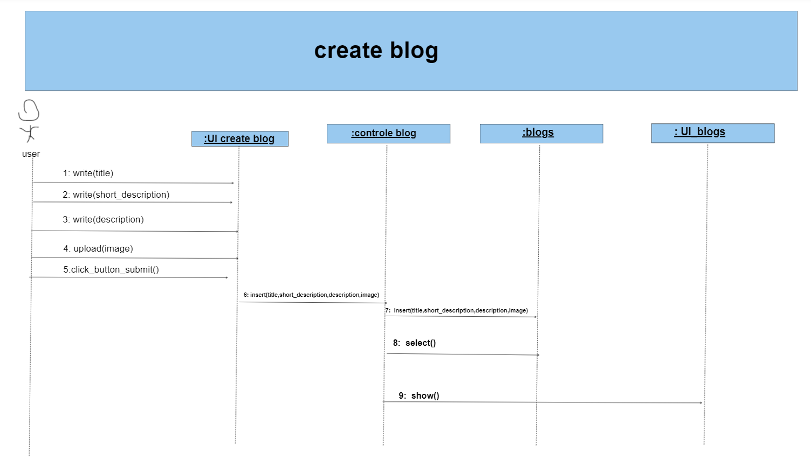

# conception creating log case

# conception delete case

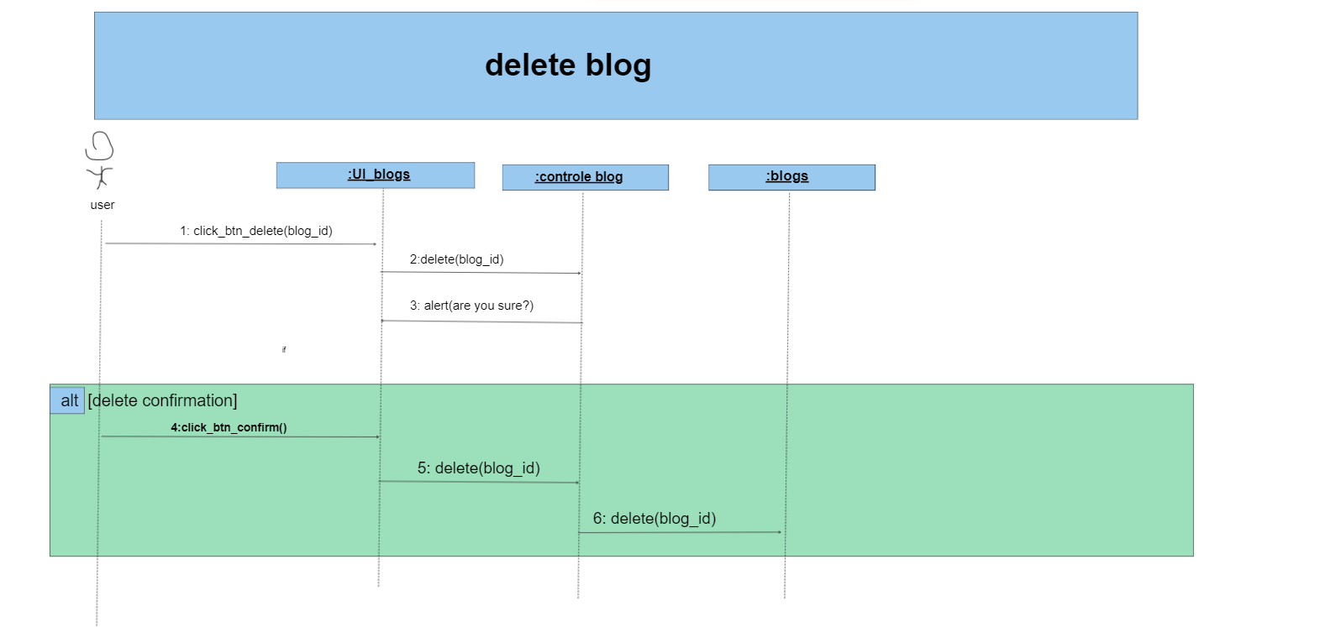

# conception modify case

