Warranty Report

Customer Vitobello
Engine model Peugeot
Engine serial number 4H03 0526908
Warranty complaint: oil consumption, 6 litres per 2,000 km.
*turbocharger replaced.
Identification markings: photos 01–02.
Thermo marker: slightly activated.
Condition found:
- damage to bearings, photos 04–05–06,
- damage to crankshaft, photos 07–08,
- damage to camshaft bearings and camshaft, photos 09–10–11–12,
- damage to rockers and tappets, photo 13,
- latent damage to pistons, photo 14,
- end gap of oil control rings 0.6 mm, photo 15,
- end gap of oil scraper rings 1.2 mm, photo 16,
- end gap of compression rings 0.6 mm,
- cylinders polished/glazed and within tolerance, video clip.
Explanation: the listed damages occurred due to insufficient oil quantity as a result of excessive oil consumption, failure to withdraw the vehicle from use in a timely manner, and improper handling of the vehicle.
The problem has been identified in the excessive end gap of the piston rings, which is defined by the manufacturer (obviously inadequate), and in the surface texture (roughness) of the honing pattern.
Given that the replacement of the turbocharger is mentioned, the condition of the oil vapour separator, DPF and catalytic converter remains unknown, all of which can significantly contribute to engine restriction and forced migration of oil into the combustion chamber.
Conclusion: there are quite a few uncertainties regarding this warranty claim, but in order to maintain good partnership relations, your warranty claim will be accepted.
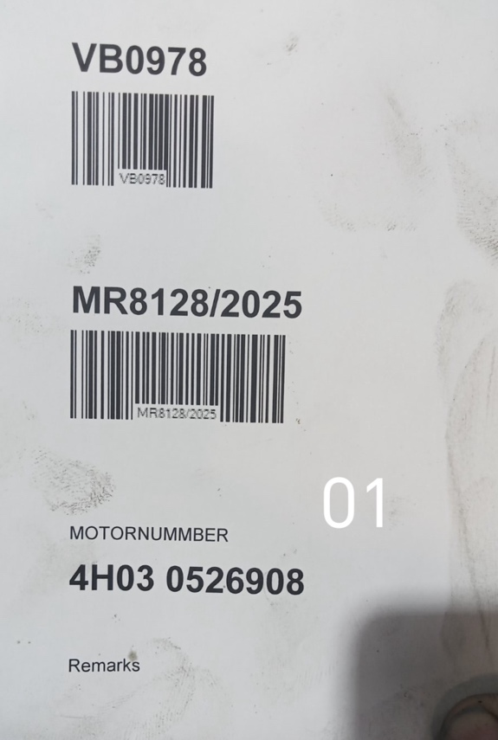 | 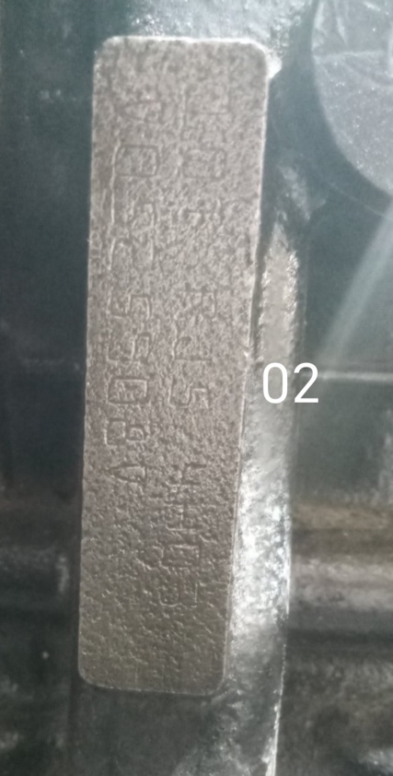
Picture 1 | Picture 2
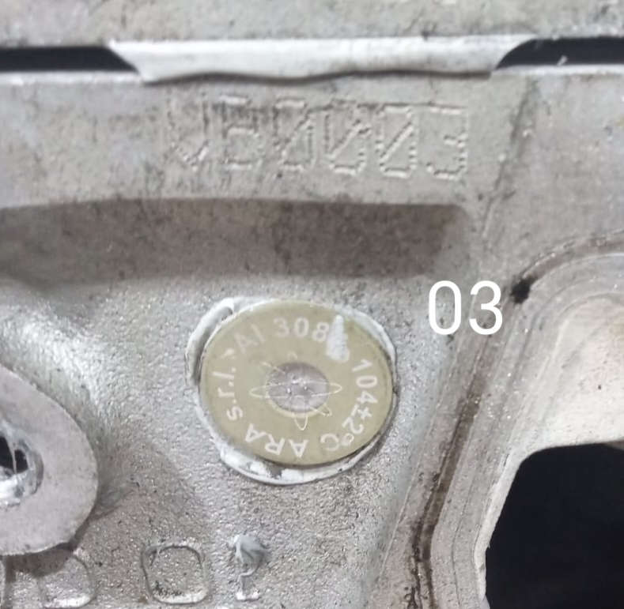 | 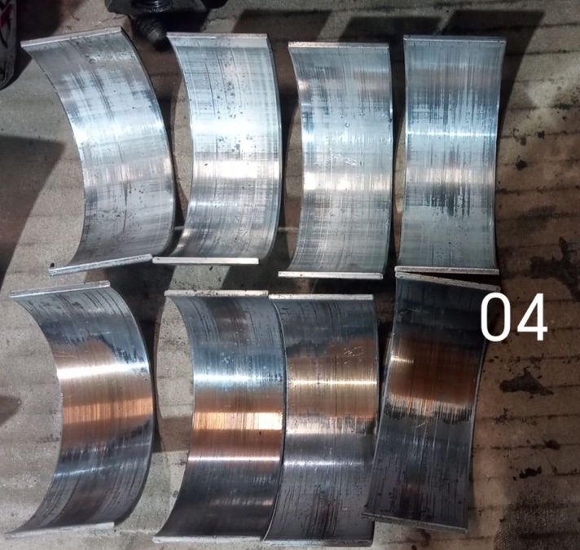
Picture 3 | Picture 4
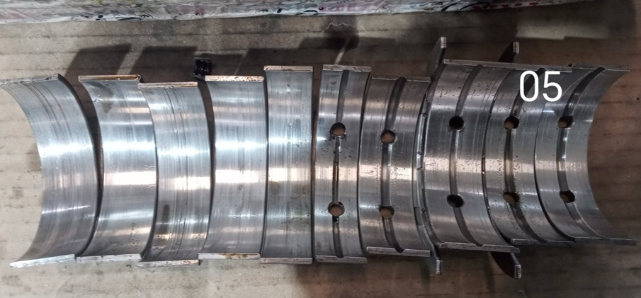 | 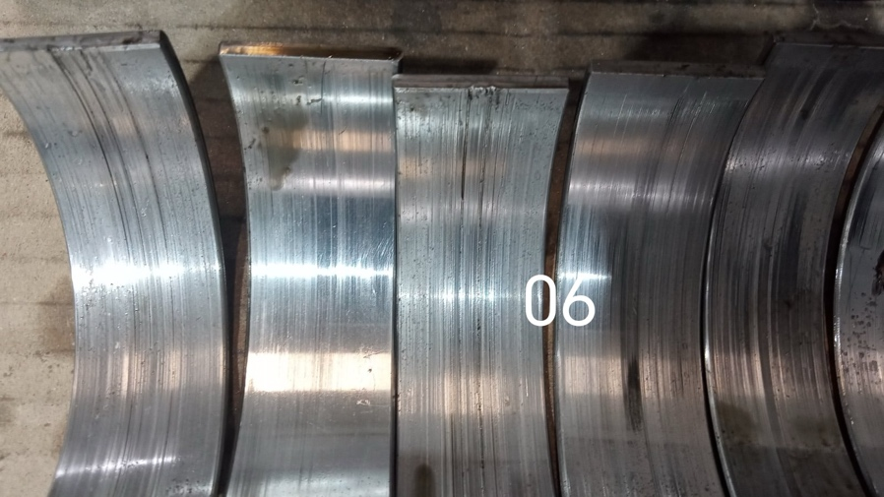
Picture 5 | Picture 6
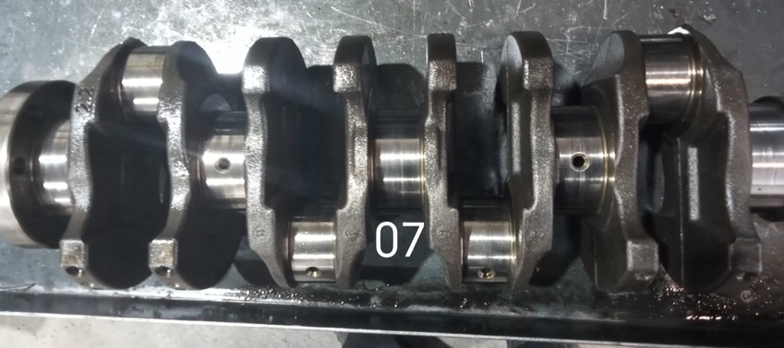 | 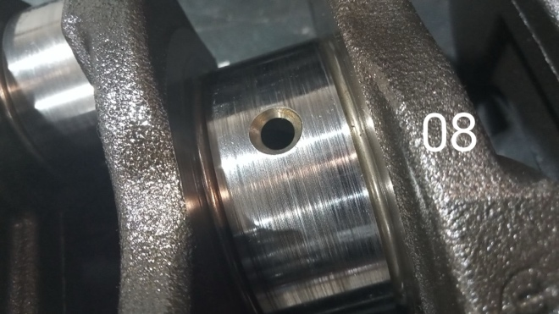
Picture 7 | Picture 8
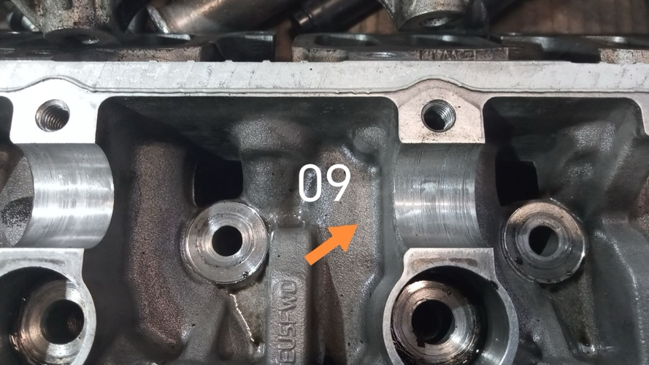 | 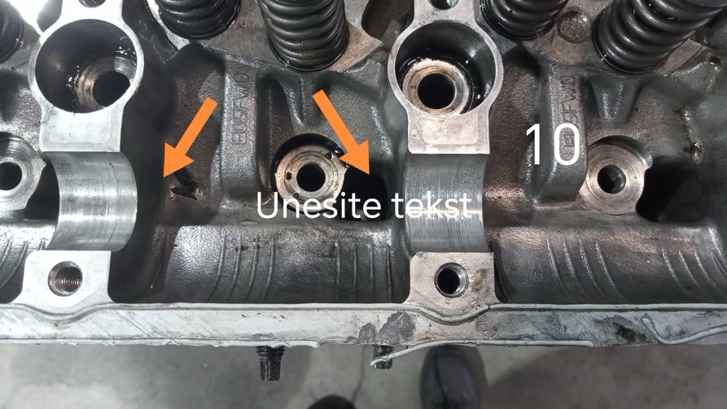
Picture 9 | Picture 10
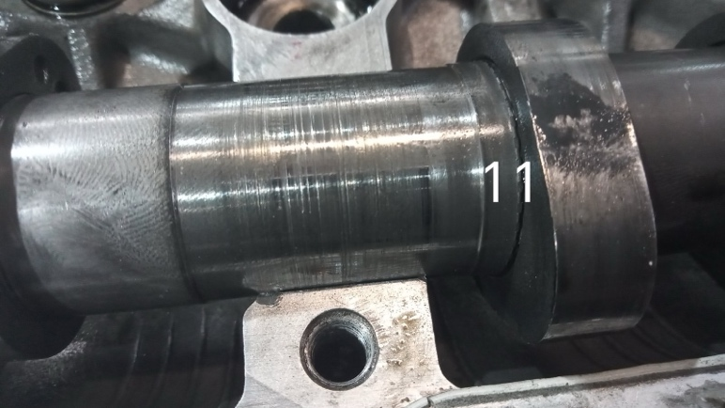 | 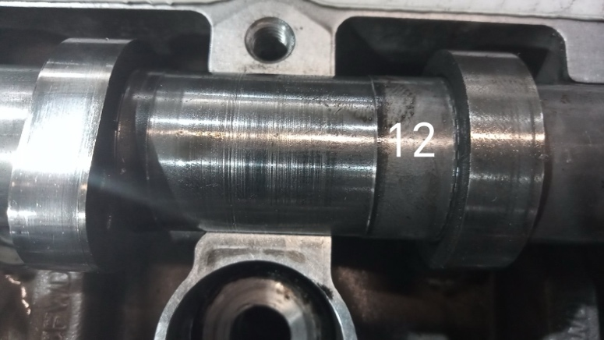
Picture 11 | Picture 12
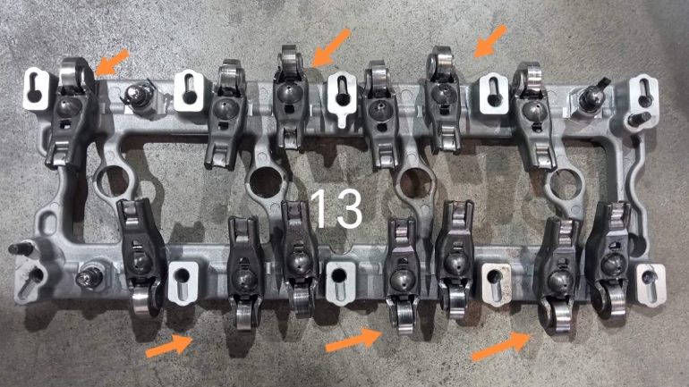 | 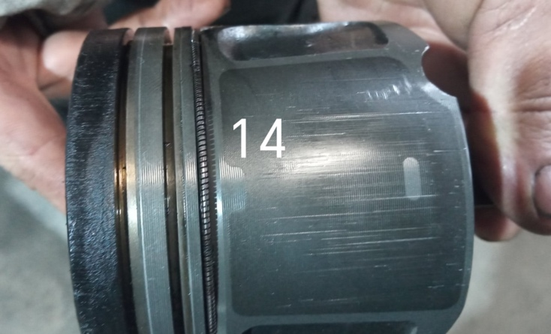
Picture 13 | Picture 14
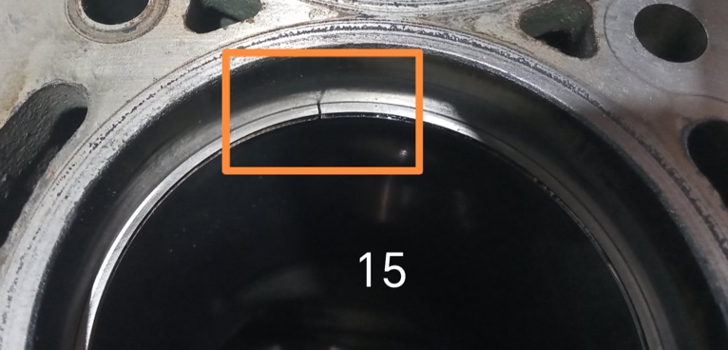 | 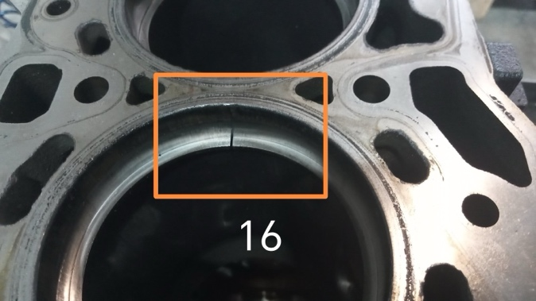
Picture 15 | Picture 16
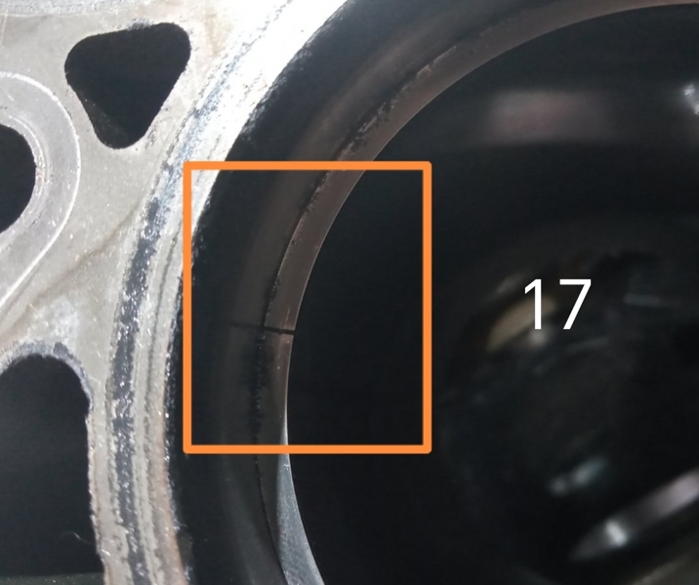
Picture 17
Kind regards,
Dragan Todorović
Technical Support – MRE

