# CASE WITH TWO LAR INPUT ARGUMENTS (A,B)

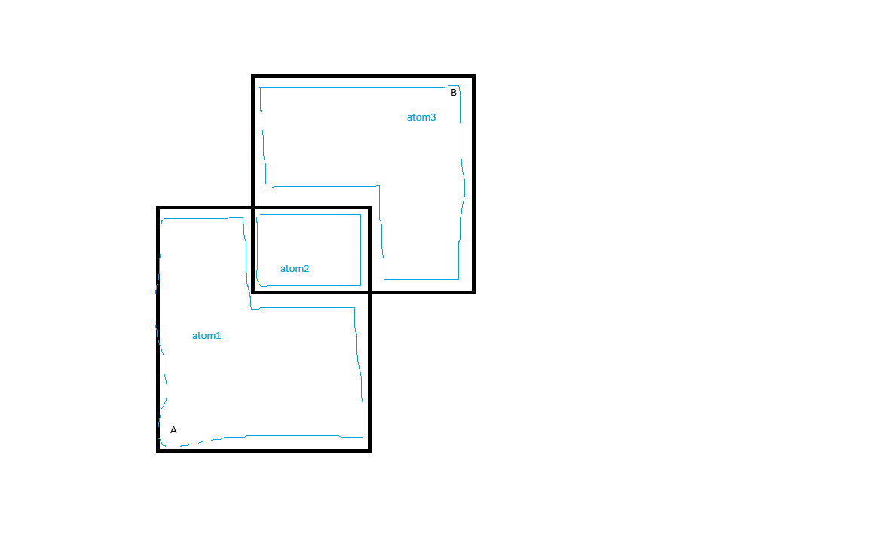

**UNION(A,B)**

|  |  |  |  |
| --- | --- | --- | --- |
|  | **A** | **B** | **Result** |
| Atom1 | 1 | 0 | **1 (==1 | 0)** |
| Atom2 | 1 | 1 | **1 (==1 | 1)** |
| Atom3 | 0 | 1 | **1 (==0 | 1)** |

function Union(v::AbstractArray)

return any(v)

en

@assert(Union([false, false])==false)

@assert(Union([true, false])==true)

@assert(Union([true, true])==true)

@assert(Union([false, true])==true)

**NOTE: Result is needed to know if an atom will be included in the boolean operation, or must be excluded**

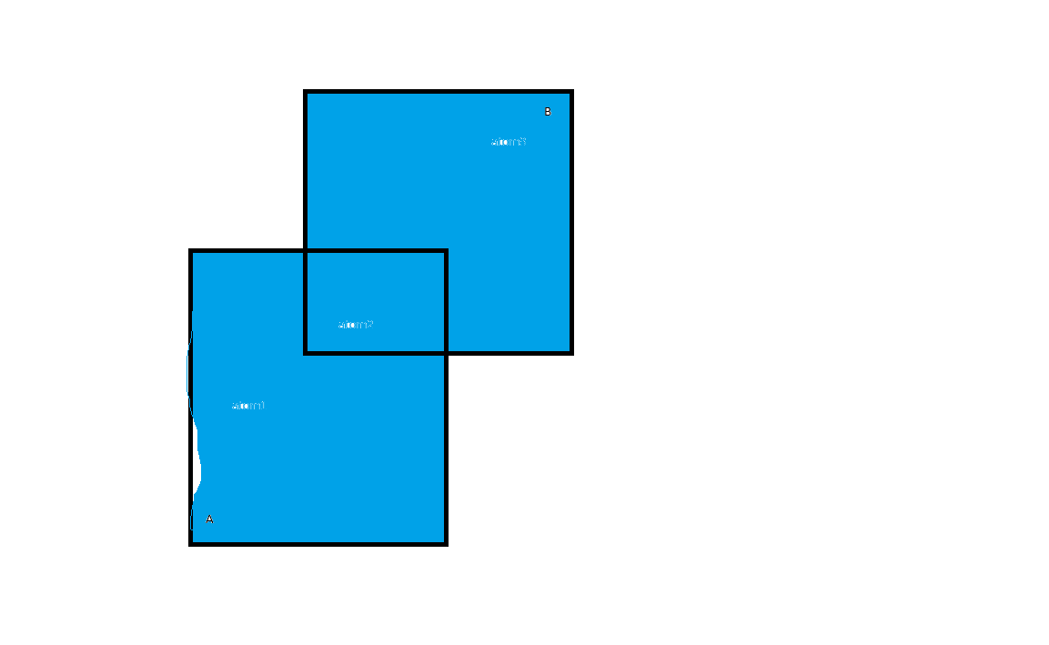

**INTERSECTION(A,B)**

|  |  |  |  |
| --- | --- | --- | --- |
|  | **A** | **B** | **Result** |
| Atom1 | 1 | 0 | **0 (==1 & 0)** |
| Atom2 | 1 | 1 | **1 (==1 & 1)** |
| Atom3 | 0 | 1 | **0 (== 0 & 1)** |

function Intersection(v::AbstractArray)

return all(v)

end

@assert(Intersection ([false, false])==false)

@assert(Intersection ([true, false])==false)

@assert(Intersection ([true, true])==true)

@assert(Intersection ([false, true])==false)

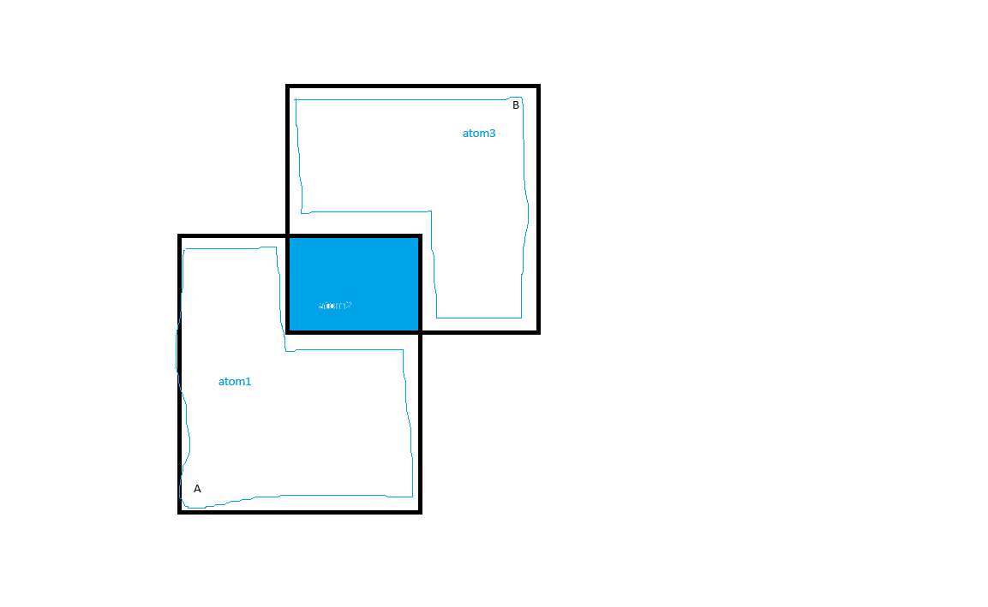

**DIFFERENCE(A,B) == A-B**

|  |  |  |  |
| --- | --- | --- | --- |
|  | **A** | **B** | **Result** |
| Atom1 | 1 | 0 | **1 (==1-0)** |
| Atom2 | 1 | 1 | **0 (==1-1)** |
| Atom3 | 0 | 1 | **0 (==0-1)** |

function Difference(v::AbstractArray)

return v[1] && !any(v[2:end])

end

@assert(Difference ([false, false])==false)

@assert(Difference ([true, false])==true)

@assert(Difference ([true, true])==false)

@assert(Difference ([false, true])==false)

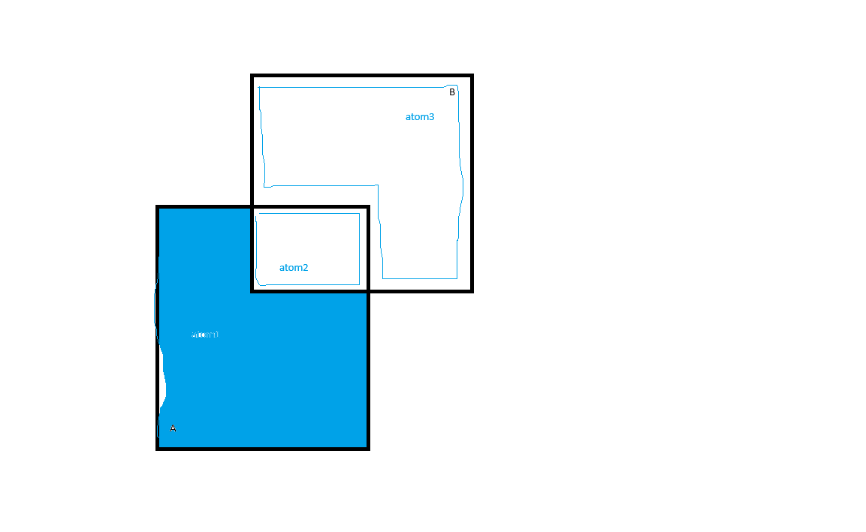

**XOR(A,B)**

|  |  |  |  |
| --- | --- | --- | --- |
|  | **A** | **B** | **Result** |
| Atom1 | 1 | 0 | **1 (==1 ⊻ 0)** |
| Atom2 | 1 | 1 | **0 (==1⊻1)** |
| Atom3 | 0 | 1 | **1 (==0⊻1)** |

function Xor(v::AbstractArray)

return (length([it for it in v if it]) % 2)==1

end

@assert(Xor ([false, false])==false)

@assert(Xor ([true, false])==true)

@assert(Xor ([true, true])==false)

@assert(Xor ([false, false])== true)

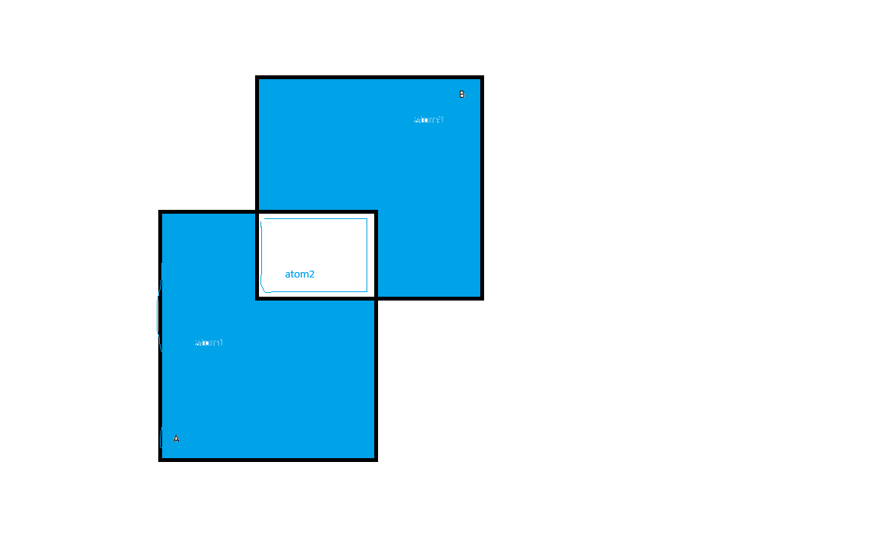

# CASE WITH 3 LAR INPUT ARGUMENTS (A,B,C)

**UNION(A,B,C)**

|  |  |  |  |  |
| --- | --- | --- | --- | --- |
|  | **A** | **B** | **C** | **Result** |
| Atom1 | 1 | 0 | 0 | **1 (==1 | 0 | 0)** |
| Atom2 | 1 | 1 | 0 | **1** |
| Atom3 | 0 | 1 | 0 | **1** |
| Atom4 | 1 | 0 | 1 | **1** |
| Atom5 | 1 | 1 | 1 | **1** |
| Atom6 | 0 | 1 | 1 | **1** |
| Atom7 | 0 | 0 | 1 | **1** |

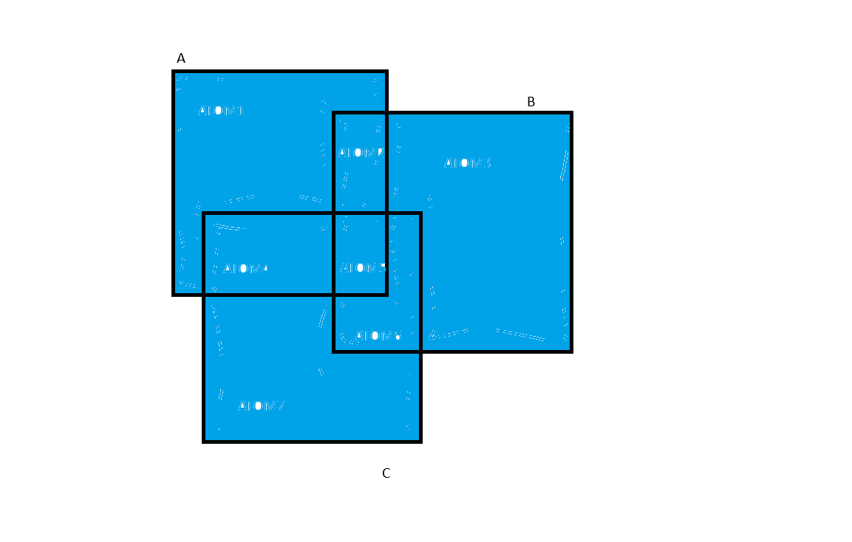

**INTERSECTION(A,B,C)**

|  |  |  |  |  |
| --- | --- | --- | --- | --- |
|  | **A** | **B** | **C** | **Result** |
| Atom1 | 1 | 0 | 0 | **0** |
| Atom2 | 1 | 1 | 0 | **0** |
| Atom3 | 0 | 1 | 0 | **0** |
| Atom4 | 1 | 0 | 1 | **0** |
| Atom5 | 1 | 1 | 1 | **1** |
| Atom6 | 0 | 1 | 1 | **0** |
| Atom7 | 0 | 0 | 1 | **0** |

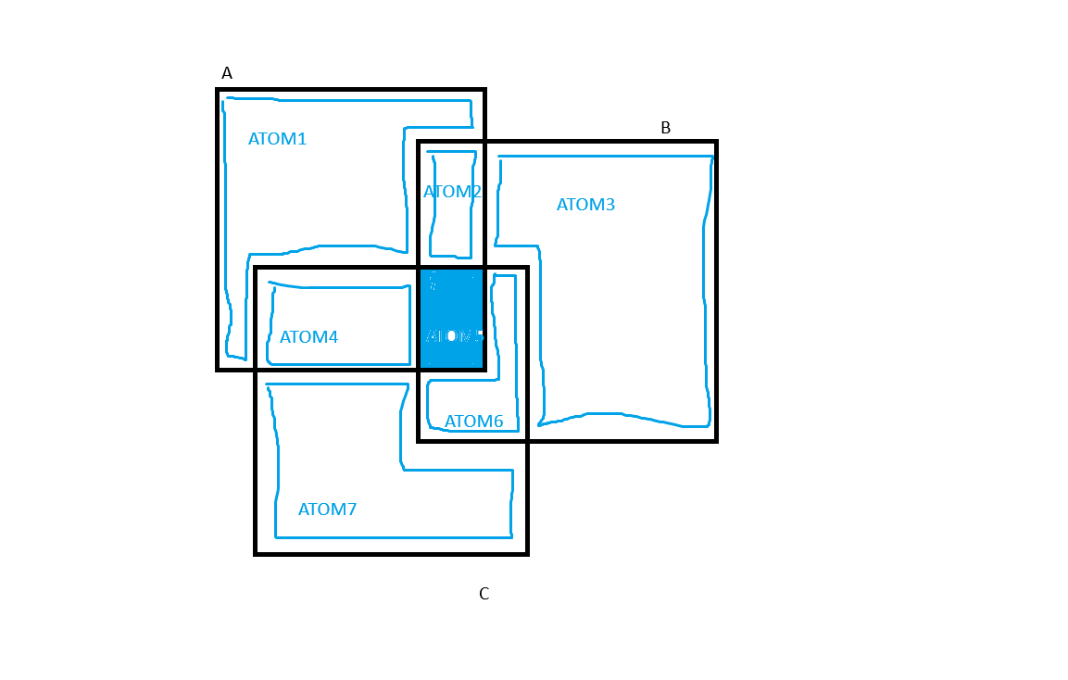

**DIFFERENCE(A,B,C)==A-(B UNION C)**

|  |  |  |  |  |
| --- | --- | --- | --- | --- |
|  | **A** | **B** | **C** | **Result** |
| Atom1 | 1 | 0 | 0 | **1** |
| Atom2 | 1 | 1 | 0 | **0** |
| Atom3 | 0 | 1 | 0 | **0** |
| Atom4 | 1 | 0 | 1 | **0** |
| Atom5 | 1 | 1 | 1 | **0** |
| Atom6 | 0 | 1 | 1 | **0** |
| Atom7 | 0 | 0 | 1 | **0** |

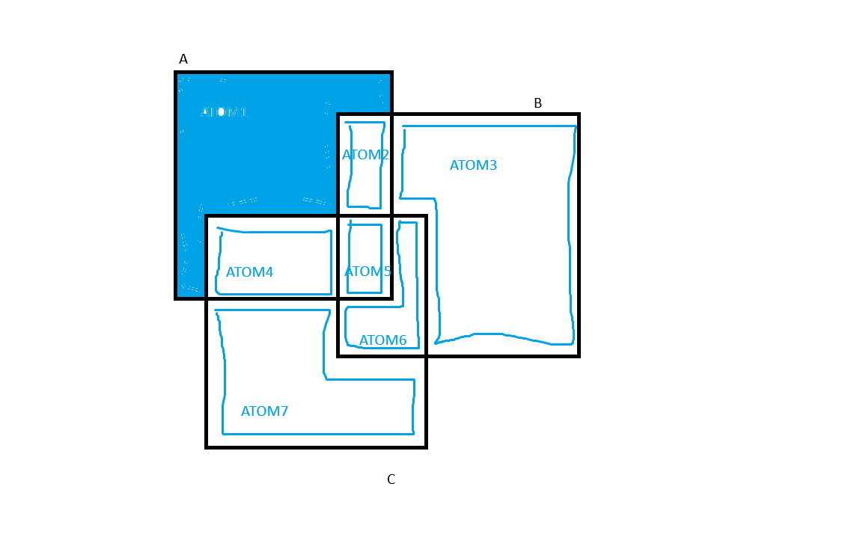

**XOR(A,B,C)**

|  |  |  |  |  |
| --- | --- | --- | --- | --- |
|  | **A** | **B** | **C** | **Result** |
| Atom1 | 1 | 0 | 0 | **1** |
| Atom2 | 1 | 1 | 0 | **0** |
| Atom3 | 0 | 1 | 0 | **1** |
| Atom4 | 1 | 0 | 1 | **0** |
| Atom5 | 1 | 1 | 1 | **1** |
| Atom6 | 0 | 1 | 1 | **0** |
| Atom7 | 0 | 0 | 1 | **1** |
|  |  |  |  |  |

