

**Automated Water Filling  
MachineEmbedded Systems Course**

**Supervisor: Dr. Belal Sababha**

**Fall 2022-2023**

**Done by:**

**Abdullah Mitwalley (20190048)**

**Mohammad Ali Alhaddar (20190068)**

**Mohammad Qasem (20190568)**

**Abstract**

The automatic filling water cup embedded system is a device that uses advanced technology to provide an efficient and convenient way to dispense water. It is designed with sensors, a microcontroller and a pump that automatically fills a cup with water when placed on top of it. The system can be programmed to dispense a specific amount of water, making it a convenient and accurate way to measure out water for different purposes. This system can be integrated into a larger system such as a vending machine or water dispenser, making it even more convenient for users. The device is designed to be energy-efficient, easy to use and maintain, making it an ideal solution for a wide range of applications.

**Introduction**

An automatic filling water cup embedded system is a sophisticated device that utilizes cutting-edge technology to provide a convenient and efficient way to dispense water. The system is designed with a microcontroller, which serves as the brain of the device, and a series of sensors that detect the presence of any disposable cup. Once a cup is placed a designed cup holder of the device, the user choose his choice from (Full, half, quarter, manual) the sensors send a signal to the microcontroller which then activates the pump to fill the cup with water. The system can be programmed to dispense a specific amount of water, making it a convenient and accurate way to measure out water for different purposes.

* 1. **Hardware components**

Components that were used in this project are:

**-PIC Microcontroller(16F877A)**

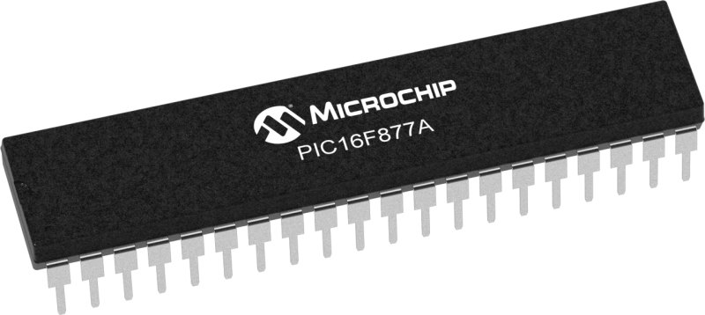

Figure (1.1) PIC 16f877a

**-Ultrasonic Sensor**

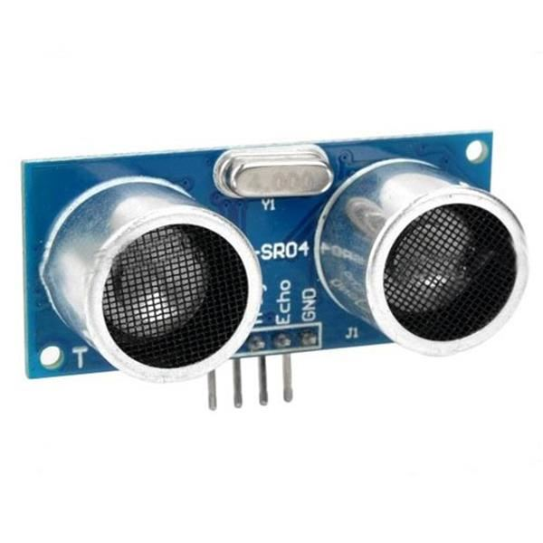

Figure (1.2) Ultrasonic Sensor

**-LCD display**

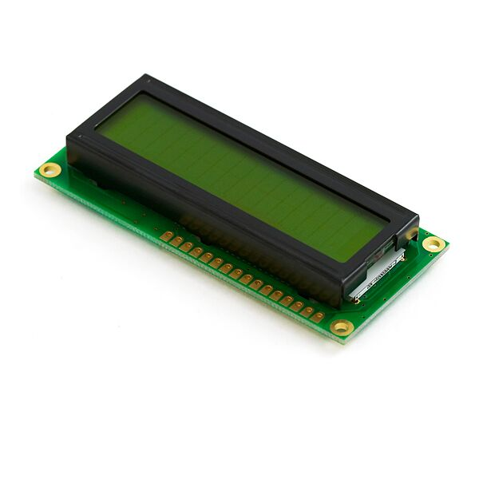

Figure (1.3) LCD display

**-voltage regulator**

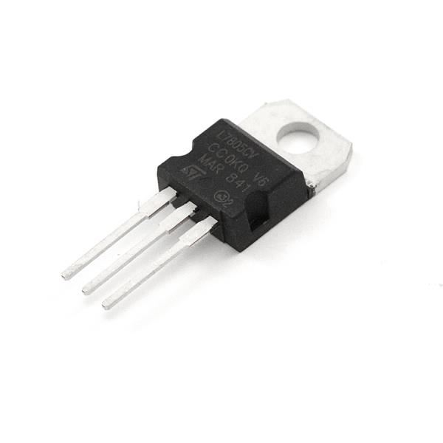

Figure (1.4) voltage regulator

**- 5v water pump**

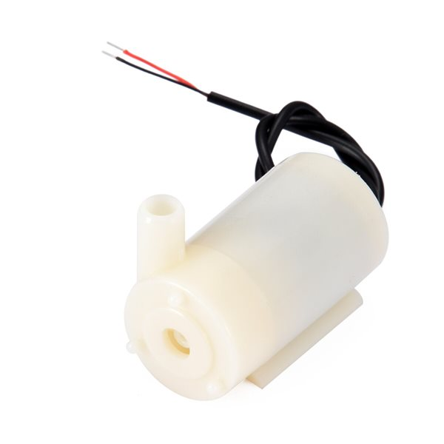

Figure (1.5) water pump

**-Tupe**

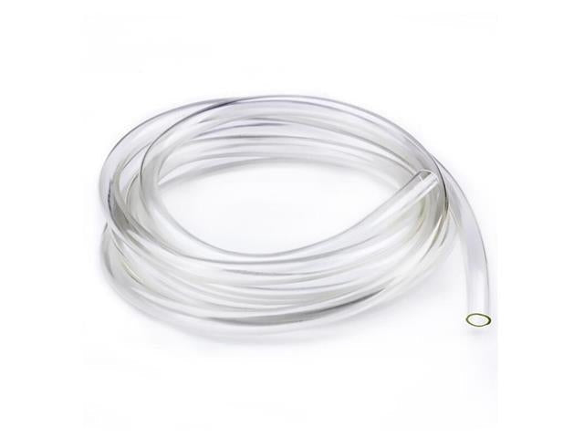

Figure (1.6) Tupe

**-Push Buttons**

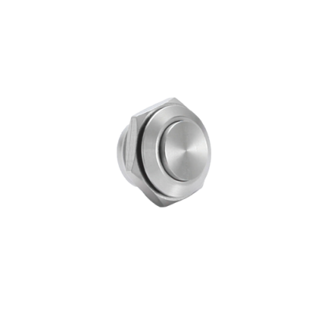

Figure (1.7) Push Buttons

**-Relay module 5V 1CH**

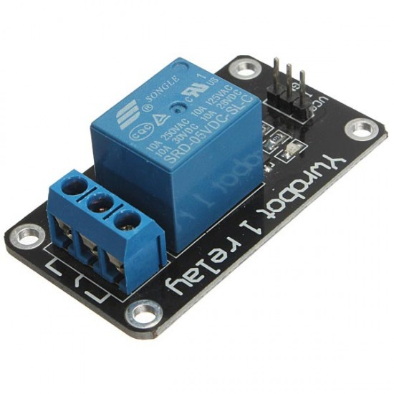

Figure (1.8) Relay

**-potentiometer**

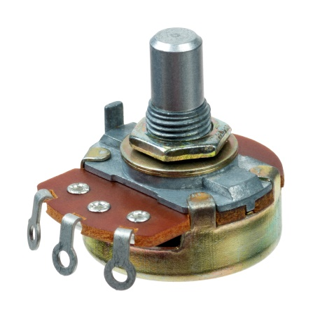

Figure (1.8) potentiometer

**2.1 Project Flow Chart & Design**

**-Flowchart**

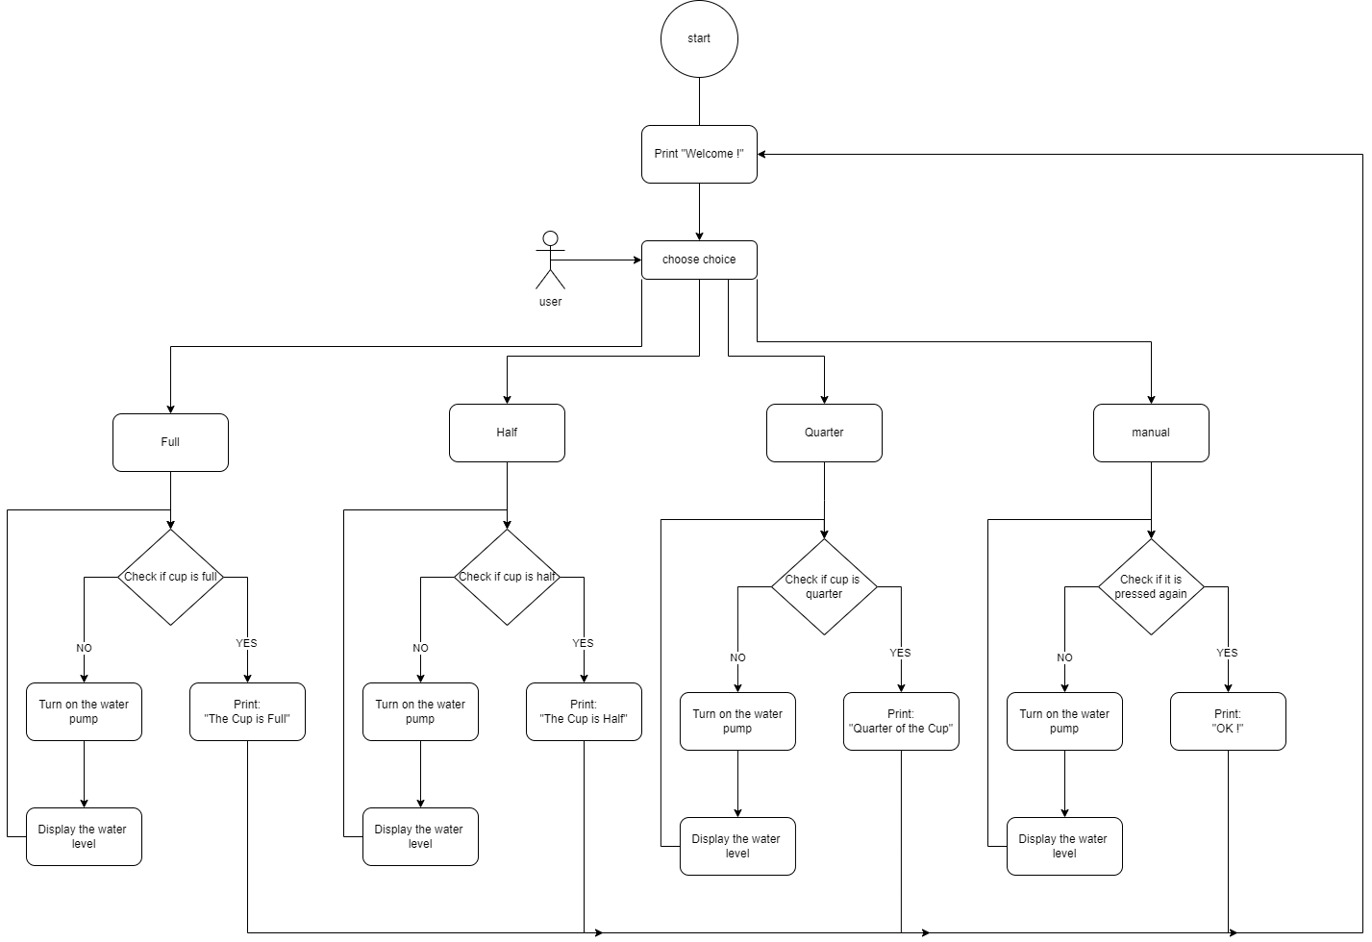

**-Circuit Design**

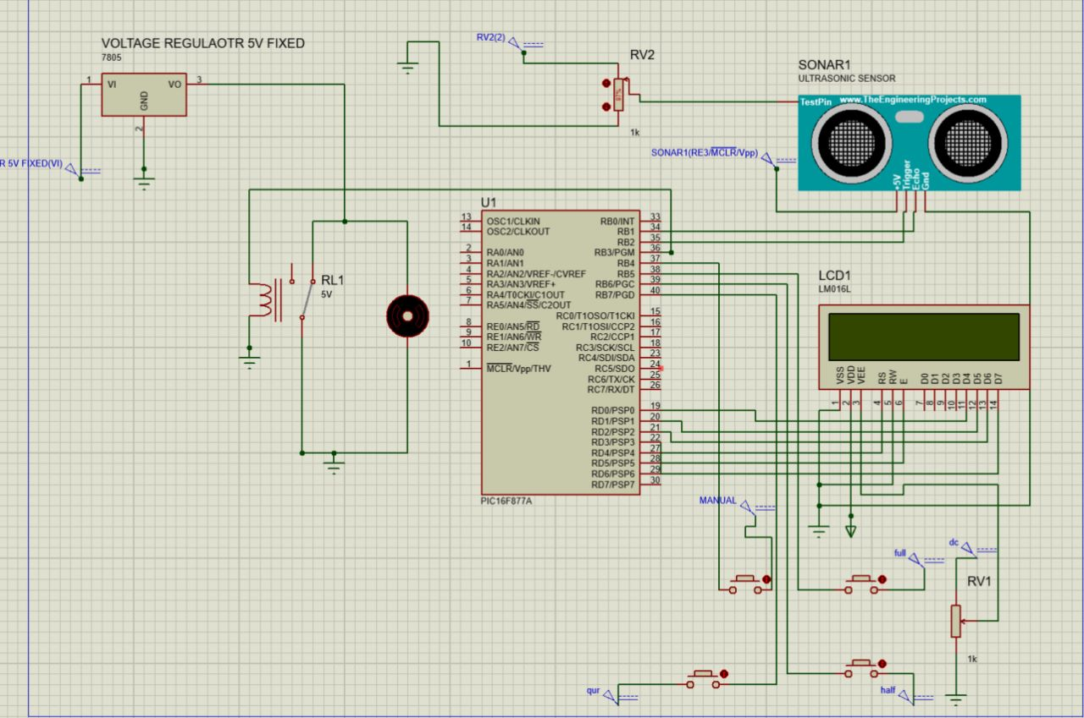

**-Mechanical Design**

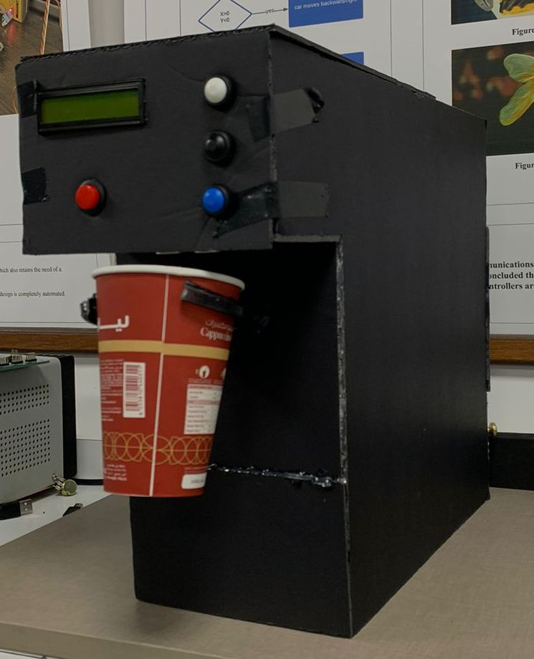

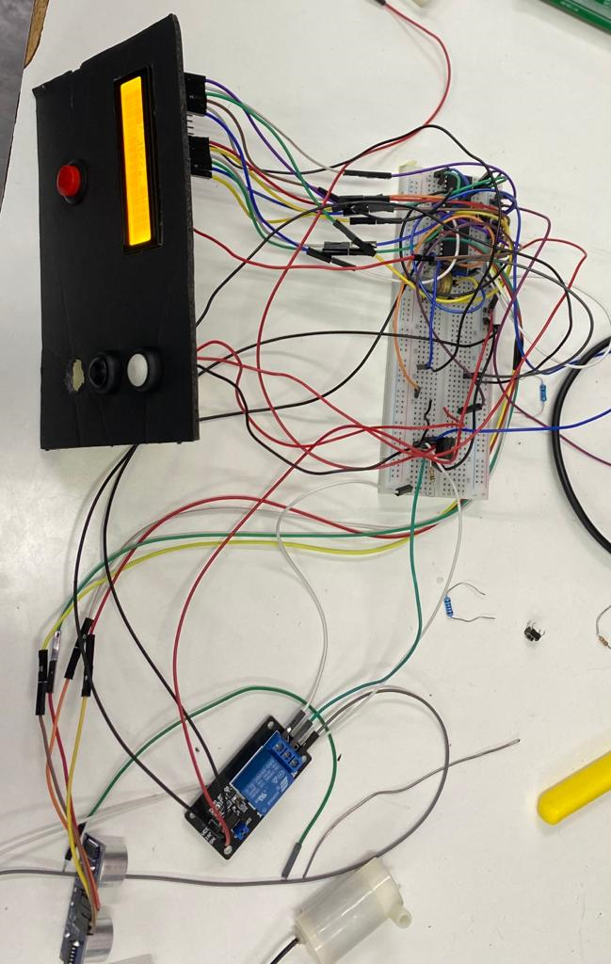

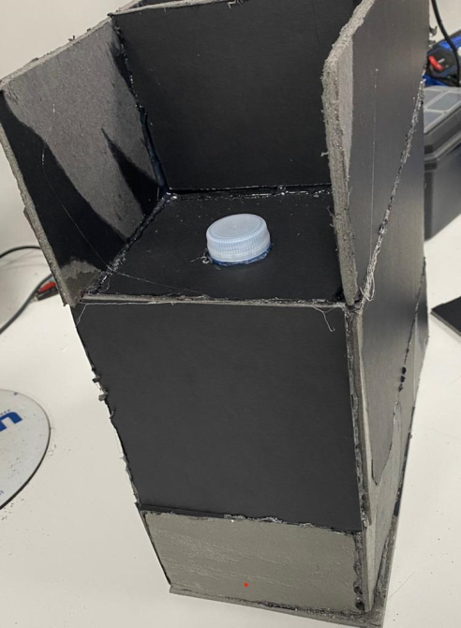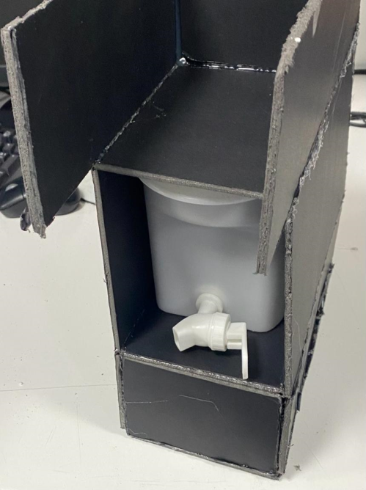

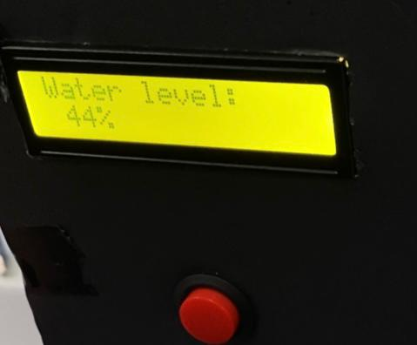

**Problems and Recommendations**

We encountered a few issues while working on this project that we should note:

* Sensor malfunction: Sensors are critical to the functioning of the system, and a malfunction in any of the sensors could cause the system to stop working or dispense water inaccurately.
* Power supply issues: Power supply issues such as voltage fluctuations or power outages could cause the system to shut down or malfunction.
* Having a hard time using the relay without a voltage regulator.
* So many wires so we didn’t know where is the problem.

We believe that including the following suggestion into the work in the future could be beneficial:

* It’s easier to reconnect the wires than find the problem among the complicity of it.
* Regularly clean the pump to prevent debris from clogging the system.
* Regularly check and maintain the sensors to ensure they are functioning properly.

**Conclusion**

The automatic filling water cups embedded system is a device that utilizes various components to automatically fill any disposable size cups with water. The ultrasonic sensor is used to detect the presence of a cup, the LCD display is used to show the status of the system, the DC water pump is responsible for pumping water, the relay is used to control the power to the pump, the voltage regulator is used to regulate the voltage supplied to the system, and the press buttons are used to manually control the system.

This feature makes it more versatile and can be used in multiple scenarios, such as in offices, homes, or public places. This system is also very versatile and can be used in a variety of settings. It is a great solution for anyone looking for a convenient and efficient way to dispense water.