**Explicit Intent:**

**First Layout file:** Activitymain.xml

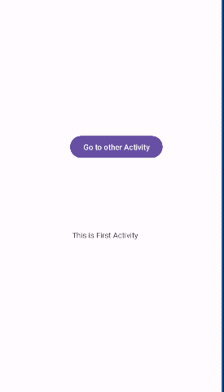

**Main Activity.java (for layout 1)**

package com.example.myapplicationint;  
  
import androidx.appcompat.app.AppCompatActivity;  
  
import android.os.Bundle;  
import android.widget.Button;  
import android.content.Intent;  
import android.view.View.OnClickListener;  
import android.view.Menu;  
import android.view.View;  
  
  
public class MainActivity extends AppCompatActivity {  
Button b;  
 @Override  
 protected void onCreate(Bundle savedInstanceState) {  
 super.onCreate(savedInstanceState);  
 setContentView(R.layout.*activity_main*);  
 Button b = (Button) findViewById(R.id.*button*);  
  
 b.setOnClickListener(new OnClickListener() {  
 public void onClick(View view) {  
 // Intent is used to move from home activity to other activity  
 Intent i = new Intent(MainActivity.this, MainActivity2.class);  
 startActivity(i);  
 }  
 });  
  
 }  
 }

Now create the Second Layout file as follows

Go to **res** click on **new r**ight click on **activity** and select **Empty activity as shown below**



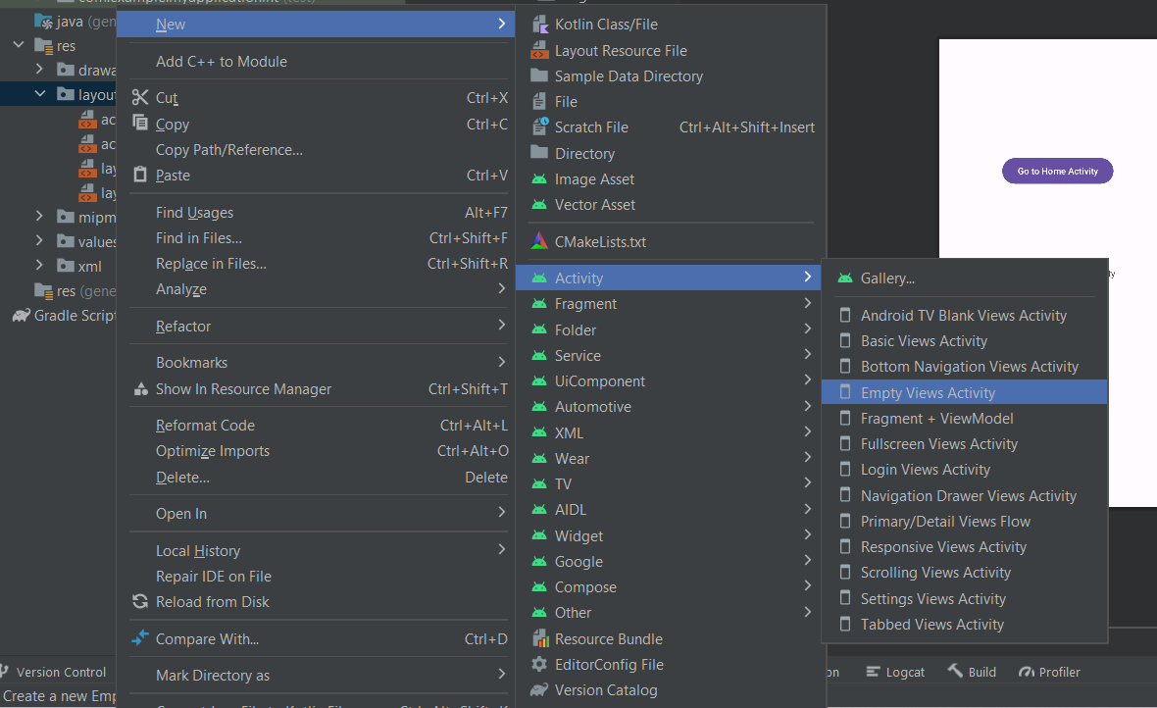

**Second Layout file:**

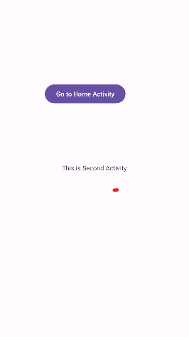

**Main Activity2.java (for layout )**

package com.example.myapplicationint;  
  
import androidx.appcompat.app.AppCompatActivity;  
  
import android.os.Bundle;  
import android.widget.Button;  
import android.content.Intent;  
import android.view.View.OnClickListener;  
import android.view.Menu;  
import android.view.View;  
  
  
public class MainActivity2 extends AppCompatActivity {  
Button b2;  
 @Override  
 protected void onCreate(Bundle savedInstanceState) {  
 super.onCreate(savedInstanceState);  
 setContentView(R.layout.*activity_main2*);  
 Button b2 = (Button) findViewById(R.id.*button2*);  
 b2.setOnClickListener(new View.OnClickListener() {  
 public void onClick(View view) {  
 // Intent is used to move from other activity to home activity  
 Intent intent = new Intent(getApplicationContext(), MainActivity.class);  
 startActivity(intent);  
 }  
 });  
  
 }  
}

**Implicit Intent**

<?xml version="1.0" encoding="utf-8"?>  
<androidx.constraintlayout.widget.ConstraintLayout xmlns:android="http://schemas.android.com/apk/res/android"  
 xmlns:app="http://schemas.android.com/apk/res-auto"  
 xmlns:tools="http://schemas.android.com/tools"  
 android:layout_width="match_parent"  
 android:layout_height="match_parent"  
 tools:context=".MainActivity">  
  
 <EditText  
 android:id="@+id/editTextText"  
 android:layout_width="wrap_content"  
 android:layout_height="wrap_content"  
 android:ems="10"  
 android:inputType="text"  
 android:text="Name"  
 tools:ignore="MissingConstraints,TouchTargetSizeCheck"  
 tools:layout_editor_absoluteX="58dp"  
 tools:layout_editor_absoluteY="223dp" />  
  
 <Button  
 android:id="@+id/button"  
 android:layout_width="wrap_content"  
 android:layout_height="wrap_content"  
 android:text="Button"  
 tools:layout_editor_absoluteX="99dp"  
 tools:layout_editor_absoluteY="417dp"  
 android:gravity="bottom"  
 app:layout_constraintTop_toBottomOf="@+id/editTextText"  
 tools:ignore="MissingConstraints" />  
</androidx.constraintlayout.widget.ConstraintLayout>

**Activity.java**

package com.example.myapplicationimp;  
  
import androidx.appcompat.app.AppCompatActivity;  
  
import android.os.Bundle;  
import android.widget.Button;  
import android.widget.EditText;  
import android.net.Uri;  
import android.view.View;  
import android.content.Intent;  
  
public class MainActivity extends AppCompatActivity {  
EditText e;  
Button b;  
 @Override  
 protected void onCreate(Bundle savedInstanceState) {  
 super.onCreate(savedInstanceState);  
 setContentView(R.layout.*activity_main*);  
 e = findViewById(R.id.*editTextText*);  
 b = findViewById(R.id.*button*);  
  
 b.setOnClickListener(new View.OnClickListener() {  
 @Override  
 public void onClick(View view) {  
 String url = e.getText().toString();  
 Intent intent = new Intent(Intent.*ACTION_VIEW*, Uri.*parse*(url));  
 startActivity(intent);  
  
 }  
 });  
 }  
}