Abstract
This thesis presents Warene, an AI-powered mobile assistive system designed to support blind and low-vision users through real-time computer vision, audio feedback, and haptic cues. The system addresses critical gaps in existing assistive technologies, particularly for users in the Middle East and North Africa region. By integrating state-of-the-art deep learning architectures including YOLOv8 for real-time object detection and Large Multimodal Models for semantic understanding, Warene provides comprehensive assistance for both indoor and outdoor environments. The system features indoor object detection with distance estimation, in-hand object recognition, currency identification, outdoor obstacle detection, traffic light recognition, document reading with question-answering capabilities, and emergency safety features. Unlike existing solutions that rely heavily on cloud processing, Warene emphasizes privacy-preserving local AI while maintaining high accuracy and low latency. The application is developed using Flutter for cross-platform compatibility and incorporates Arabic language support, addressing the linguistic and cultural needs of users in the Arab world.

List of Abbreviations
AI | Artificial Intelligence
API | Application Programming Interface
COCO | Common Objects in Context
CPU | Central Processing Unit
CV | Computer Vision
GAN | Generative Adversarial Network
GPU | Graphics Processing Unit
LF-VQA | Long-Form Visual Question Answering
LMM | Large Multimodal Models
MENA | Middle East and North Africa
OCR | Optical Character Recognition
RAM | Random Access Memory
TTS | Text-to-Speech
VQA | Visual Question Answering
WHO | World Health Organization
YOLO | You Only Look Once

Introduction
This chapter introduces the project, provides background context, defines the problem, and outlines the objectives and significance of the Warene assistive system for visually impaired users.

Background of the Study
This project focuses on assistive technology for blind and low-vision users using computer vision, Optical Character Recognition (OCR), audio, and haptic feedback. Smartphones now include powerful cameras, sensors, and on-device AI capabilities. These capabilities create an opportunity to deliver real-time environmental awareness without specialized hardware.
Vision-impaired users face daily barriers both indoors and outdoors. Objects, obstacles, text, and signals are often inaccessible without assistance. Human assistance is not always available, and traditional aids do not provide contextual understanding.
Current assistive applications handle isolated tasks. Many focus only on OCR or basic object detection. They lack context awareness, struggle in cluttered environments, and often overwhelm users with unnecessary information. There is a gap in integrated systems that combine object detection, text understanding, safety alerts, and directional feedback. Few systems filter information based on user intent or risk, and privacy handling remains limited.
This study addresses the need for a unified mobile system that delivers accurate, timely, and safe assistance tailored to real-world situations. By leveraging modern deep learning architectures and mobile computing capabilities, the proposed system aims to significantly improve independence and safety for visually impaired individuals.

Problem Statement
Blind and low-vision users lack a single reliable mobile system that provides real-time contextual understanding of their surroundings. Existing solutions handle isolated functions and fail in complex environments. They do not prioritize safety-critical information and offer limited privacy control. This results in reduced independence and increased risk during daily activities.

Aim and Objectives

General Aim
The general aim of this project is to build a mobile assistive system that supports blind and low-vision users through real-time vision, audio, and haptic feedback. The system seeks to improve safety, independence, and access to information in both indoor and outdoor spaces.

Specific Objectives
The specific objectives of this project are:
- Detect indoor objects and estimate distance with high accuracy.
- Detect the object held in the user’s hand with low false detection rate.
- Read currency and identify value quickly.
- Detect outdoor obstacles and traffic lights with real-time response with very low latency.
- Read text and answer user questions from documents with correct intent recognition.
- Trigger danger mode and emergency call very quickly.

Scope of the Project

Included Features
The following features are included in the scope of this project:
- Indoor object detection, brand recognition, and in-hand detection.
- Outdoor object detection, obstacle awareness, and object finding.
- OCR for documents, signs, and labels.
- Inegrating LMM-based question answering.
- Audio cues and haptic alerts.
- Emergency call and danger mode activation.

Excluded Features
The following aspects are excluded from the scope of this project:
- Hardware Manufacturing: The project focuses on a software-based mobile application. It does not include the development or sale of custom wearable hardware (such as smart glasses).

Constraints
The project is subject to the following constraints:

Data Constraints
- Limited availability of labeled datasets for in-hand detection, brand recognition, and currency.
- Dataset bias toward common objects and environments.
- Language and currency coverage restricted to selected regions.

Hardware Constraints
- Mobile phone CPU, GPU, and memory limitations.
- Camera resolution and low-light performance vary across devices.
- Battery consumption restricts continuous real-time processing.

Time Constraints
- Fixed academic timeline limits model training and optimization cycles.
- Restricted time for large-scale user testing.
- Limited duration for dataset collection and annotation.

Significance of the Project

Beneficiaries
The project benefits multiple stakeholders:
- Blind and low-vision users: Gain independence in daily activities.
- Caregivers: Gain safety assurance for their dependents.
- Researchers: Gain access to a modular assistive vision system for further study.
- Organizations: Gain a deployable accessibility tool for their constituents.

Potential Impact
The potential impact of this project includes:
- Reduces daily dependency on human assistance.
- Combines vision, language, audio, and haptics in one integrated system.
- Focuses on context filtering to reduce cognitive noise.
- Helps blind individuals perform daily tasks with greater ease and confidence.

Project Methodology

Development Approach
The project follows an iterative Agile development approach with the following characteristics:
- Incremental feature delivery with regular milestones.
- Continuous testing after each module integration.
- User-centered design with feedback-driven refinement.

Key Technologies and Tools
The following technologies and tools are employed in the development:
- Deep learning models for object detection and OCR.
- Mobile frameworks for on-device inference.
- Text recognition and assistant LMM models.
- Audio output and vibration APIs for feedback.
- Smartphone camera, microphone, and motion sensors.

Project Organization
This thesis is organized as follows:
- Chapter One: Introduces the project, presents the problem statement, defines the aim and objectives, and outlines the scope.
- Chapter Two: Provides a literature review of assistive vision systems, object detection, OCR, and audio feedback technologies.
- Chapter Three: Presents the system analysis and design, including models, datasets, and design decisions.

Literature Review

Introduction
Visual impairment constitutes a profound global challenge that significantly restricts individual independence, mobility, and access to information. The World Health Organization estimates a substantial prevalence of blindness and vision impairment, with a disproportionate burden falling on developing regions. In the Middle East and North Africa (MENA), and specifically in Egypt, these challenges are exacerbated by a scarcity of assistive technologies that are culturally and linguistically tailored to the local population.
While the market for assistive technology has expanded with solutions utilizing Artificial Intelligence (AI) and Computer Vision (CV), the majority of these tools are designed with a “Western-centric” focus. They often lack robust support for the Arabic language, fail to recognize region-specific entities such as local currency or products, and frequently compromise user privacy by relying on cloud-based processing.
This project, Warene, proposes a novel, comprehensive mobile application designed to bridge these specific accessibility gaps. By integrating state-of-the-art 2025 AI architectures—combining real-time AI processing for safety with Large Multimodal Models (LMMs) for semantic understanding—Warene aims to empower visually impaired users in the Arab world with a reliable, localized, and privacy-preserving assistive tool.

Review of Related Systems and Studies
The domain of assistive technology for the visually impaired is characterized by a mix of commercial mobile applications and academic research targeting specific computer vision problems. A critical review of these systems highlights both the progress made and the significant limitations that persist.

Analysis of Commercial Assistive Applications
Several prominent mobile applications currently serve the visually impaired community. However, a detailed analysis reveals deficiencies in accuracy, localization, and usability, particularly for users in the MENA region.

Microsoft Seeing AI (2017)
As one of the earliest comprehensive AI tools, Seeing AI provides diverse channels for reading text and describing scenes. Despite its popularity, the application frequently suffers from inaccurate object recognition in complex, cluttered environments. Users often report receiving overwhelming descriptions where the system narrates insignificant details rather than prioritizing safety-critical information, leading to cognitive overload. Furthermore, its language support is primarily optimized for English, with limited efficacy for Arabic dialects.

Google Lookout (2019)
Google Lookout utilizes camera input to identify objects and text. However, its accessibility is severely limited by its exclusivity to the Android ecosystem, leaving iOS users unsupported. The application has been criticized for instability, with frequent crashes disrupting the user experience. It is also notably battery-intensive, as the continuous requirement for camera streaming and AI processing rapidly depletes device power. A significant concern is privacy, as the system often relies on sending images to Google’s servers for processing, which poses risks when scanning sensitive personal documents.

Envision AI (2018)
Envision AI is widely regarded for its text recognition capabilities. However, it lacks effective localization for non-Western regions. It struggles to identify culture-specific items, such as local Egyptian products or currency, limiting its utility for daily independence in Egypt. Additionally, it relies on older computer vision models that do not match the speed and semantic understanding of current state-of-the-art architectures.

E3rafli by Vodafone (2017)
Developed specifically for the Egyptian market, E3rafli attempts to address the linguistic gap. However, its functionality is limited compared to global competitors. While it offers a native Arabic interface, it is primarily effective only for color detection and currency recognition. Its capabilities in general object detection, scene understanding, and document reading are inaccurate, rendering it insufficient as a standalone tool for independent living.

Comparative Analysis
Table 2.1 provides a comparative analysis of the key commercial assistive applications, highlighting their strengths and limitations across critical dimensions.
Comparison of Commercial Assistive Applications
Application | Year | Platform | Arabic Support | Processing | Key Limitations
Microsoft Seeing AI | 2017 | iOS only | Limited | Cloud-based | Inaccurate in clutter; cognitive overload
Google Lookout | 2019 | Android only | Limited | Cloud-based | Frequent crashes; high battery usage; privacy concerns
Envision AI | 2018 | iOS & Android | Weak | Hybrid | Poor localization; outdated CV models
E3rafli (Vodafone) | 2017 | Android only | Native | Local | Limited features; inaccurate object detection

Review of Academic Research
Academic literature provides the theoretical foundation for addressing the technical limitations observed in commercial applications. Recent studies have specifically focused on optimizing artificial intelligence for mobile deployment, enhancing localization capabilities, and ensuring user privacy.

Image Quality and Interactive Visual Question Answering (VQA)
A persistent challenge in assistive CV is that blind users often capture images that are blurry, poorly framed, or obscured. Recent research by Huh et al. (2024) addresses this by proposing “Long-Form Visual Question Answering” (LF-VQA). Their study demonstrates that visually impaired users derive significantly more value from an interactive model—where they can ask follow-up questions to clarify ambiguous images—rather than receiving static, generic captions . This validates the necessity of moving beyond simple image description to interactive dialogue systems.

Arabic Optical Character Recognition (OCR)
Standard OCR engines, while proficient in Latin scripts, often degrade in performance when processing Arabic due to its cursive, context-dependent nature. Ayadi et al. (2025) explored this issue, proposing specialized architectures such as optimized Generative Adversarial Networks (GANs) to enhance Arabic Text Recognition for the visually impaired . Their findings confirm that generic, multi-language models often fail to capture the nuances of Arabic calligraphy and handwriting, necessitating dedicated, localized OCR solutions for reliable accessibility.

Localized Currency Recognition
Financial independence is a key goal for visually impaired individuals. However, global models frequently fail to recognize local banknotes, particularly when they are old or crumpled. Ghanem et al. (2025) developed a deep learning system specifically for Recognizing Egyptian Currency, utilizing a custom dataset of local notes . The study showed that localized training data significantly outperforms general-purpose models, underscoring the importance of region-specific modules in assistive applications.

Real-Time Obstacle Detection (Safety)
For outdoor navigation, low latency is critical to prevent accidents. Research by Wang et al. (2024) introduced “YOLO-OD,” a modified YOLO (You Only Look Once) architecture optimized for detecting outdoor obstacles like curbstones and poles . Their work proves that single-stage detectors offer the optimal balance of speed and accuracy for mobile devices, enabling real-time safety alerts that heavier, cloud-dependent models cannot provide.

Indoor Navigation and Structural Recognition
Navigating indoor environments requires the identification of specific structural elements rather than just generic objects. A comparative study by Wojtowicz (2025) evaluated the performance of YOLOv8 in assistive Mixed Reality applications . The research confirmed that YOLOv8 maintains superior precision in detecting indoor classes such as doors, stairs, and empty seats, validating its suitability for the “Indoor Mode” of a navigation aid.

Privacy-Preserving Computer Vision
The reliance on cloud processing in existing applications exposes users to privacy risks. Martin & Moon (2025) proposed a “Privacy-Preserving Image Captioning” framework that utilizes partial encryption and local detection to redact sensitive visual data (such as faces or text) on the device before any transmission occurs . This supports the implementation of an On-Device Privacy Guard, ensuring that sensitive user data is filtered locally.

Research Gap and Summary
A systematic review of the existing literature and commercial landscape reveals a “Fragmented Ecosystem” in assistive technology. While individual solutions exist for specific tasks—such as object detection or text reading—there is a critical lack of integrated, culturally aware, and privacy-centric systems. Specifically, the current state-of-the-art fails to address four fundamental dimensions:

The Geo-Linguistic Disparity (The Localization Gap)
Existing research and commercial products exhibit a strong “Western-centric” bias. Global applications like Microsoft Seeing AI and Envision AI are optimized for Latin scripts and Western environments. There is a distinct absence of robust solutions that address the specific linguistic and environmental context of the Middle East.
- Linguistic Void: Current systems struggle with the morphological complexity of the Arabic language, particularly in unconstrained “scene text” scenarios.
- Cultural Blindness: Generic object detectors are trained on global datasets (like COCO) and fail to recognize region-specific entities essential for daily independence in regions like North Africa and the Middle East.

The Obsolescence of Legacy Computer Vision Models
A significant portion of the available assistive tools relies on computer vision architectures dating back to the 2017–2020 era. These legacy systems present a critical Performance-Accuracy Trade-off:
- Latency Issues: Older cloud-dependent models introduce dangerous latency in navigation scenarios.
- Semantic Limitations: Pre-2023 models typically provide simple “tagging” without understanding context. There is a gap in utilizing Next-Generation 2025 Architectures like YOLOv8/v10 and LMMs.

The Privacy-Utility Paradox
Reviewing the literature highlights a forced compromise for visually impaired users: they must currently choose between high capability (Cloud AI) and data privacy (Offline Tools).
- Most high-accuracy applications require streaming unrestricted video feeds to third-party servers.
- There is a notable research gap in the implementation of “Privacy-Preserving” with On-Device Redaction.

Lack of Interactive Contextual Awareness
Finally, existing literature establishes that blind users prefer Interactive Visual Question Answering (VQA) over static image captioning. Current applications largely function as one-way communication tools. There is a lack of conversational assistive agents that allow users to interrogate their environment naturally.
In conclusion, while the individual components for a superior system exist in isolation within recent research, no single platform effectively integrates Localized Arabic AI, Real-Time Safety, and Privacy-Preserving Architectures into a unified mobile solution. Warene is proposed specifically to fill this multi-dimensional gap.

Summary of Existing Technologies
To bridge the identified research gaps, this project leverages a suite of modern technologies, frameworks, and platforms. This section summarizes the key technological enablers that facilitate the development of a responsive, localized, and privacy-aware assistive application.

Cross Platform Mobile-Based Frameworks
Modern assistive applications increasingly rely on cross-platform frameworks to ensure broad accessibility. Flutter has emerged as a leading framework, offering high-performance rendering and seamless integration with native device features on both iOS and Android. It allows for the direct embedding of lightweight Machine Learning engines (such as TensorFlow Lite or PyTorch Mobile) for local AI processing.

Real-Time Object Detection Architectures (YOLO)
The industry standard for real-time detection has shifted to single-stage detectors, specifically the YOLO (You Only Look Once) family. YOLOv8 represents the state-of-the-art, offering a unique balance of inference speed and accuracy. It is capable of detecting dynamic obstacles, traffic lights, and indoor structures in milliseconds, critical for the project’s “Safety Mode.”

Large Multimodal Models (LMMs)
The emergence of LMMs, such as OpenAI’s GPT-4 Vision, has revolutionized Visual Question Answering (VQA). Unlike traditional image captioning, LMMs can analyze visual input with deep semantic understanding, allowing users to ask natural language questions about a scene and receive context-aware answers.

On-Device OCR Engines
For reliable document reading, modern on-device OCR engines like Google ML Kit and EasyOCR have become essential. These platforms utilize deep learning to recognize text in multiple languages, including Arabic, directly on the smartphone, maintaining data privacy and working without internet connectivity.

Hybrid Cloud-Local Architectures
Current best practices advocate for a Hybrid Approach. This processes latency-sensitive data (obstacle detection) using lightweight models, while offloading complex tasks (scene analysis) to the “Cloud,” effectively balancing performance, battery life, and capability.

System Analysis and Design

System Overview and Proposed Concept
The system overview described in this chapter outlines the architecture and functionality of the AI-powered solution developed to assist visually impaired individuals in navigating both indoor and outdoor environments. The proposed system leverages advanced artificial intelligence techniques, including computer vision, optical character recognition (OCR), object detection, and scene understanding, to analyze visual data captured through a camera-enabled device in real time.
The core of the system is built upon a robust AI model trained to recognize obstacles, read text from the surrounding environment, and identify key objects and landmarks that are essential for safe and independent movement.
Once the AI model is trained and optimized for performance, it is integrated into a user-friendly application designed specifically for visually impaired users. The application serves as the main interaction platform, providing audio and haptic feedback to convey meaningful information to the user. The AI model processes visual inputs, extracts relevant information such as text, objects, or navigation cues, and delivers clear and timely guidance to help the user understand their surroundings.
This integration enhances the user’s ability to move safely and confidently in complex environments, such as streets, buildings, and public spaces. By automating environment perception and information delivery, the system reduces dependence on external assistance and improves overall accessibility.
The system model discussed in this chapter focuses on the interaction between the AI components and the application, the flow of data from image capture to user feedback, and how the generated insights are utilized to support real-time decision-making for visually impaired users.

Functional Requirements
The functional requirements of the Warene system are categorized into four main areas of assistance:

Indoor Assistance
- Indoor Object Detection: The system shall detect indoor objects and estimate distance from them.
- In-Hand Detection: The system shall detect specifically the object that is in the hand of the user, as to not get confused by other objects in the environment.
- Brand Detector: The system shall identify product brands indoors.
- Currency Reader: The system shall detect and read currency denominations.
- Privacy Mode: The system shall detect sensitive data without speaking it aloud.
- Saved Items: The system shall identify user-owned items using stored reference images.

Outdoor Assistance
- Outdoor Object Detection: The system shall detect cars, bicycles, and other outdoor obstacles.
- Outdoor Object Finder: The system shall locate ATMs, benches, trash cans, and other helpful outdoor items.
- Outdoor Reader: The system shall quickly read shop names, billboards, and street signs.
- Traffic Light Status: The system shall detect traffic light colors for crossing guidance.

OCR Features
- Read Document: The system shall read documents, menus, books, and labels.
- QA Mode: Instead of just reading a document word for word, the system shall allow users to ask questions about it to get specific responses.
- Danger Word Alerts: The system shall notify users when dangerous keywords appear, such as “Wet Floor,” “Danger,” or “Caution.”

Audio and Haptics Service
- Danger Mode: The system shall enable danger mode using voice command, gesture, or phone shake.
- Emergency Auto Call: The system shall automatically call the user’s emergency contact in danger mode.
- Emergency Auto Location: The system shall send the current location of the user to their emergency contact in danger mode.
- Directional Audio: The system shall provide left or right ear cues to indicate object direction.

Non-Functional Requirements
The non-functional requirements define the quality attributes of the Warene system:
- Performance: The system shall provide real-time processing with minimal delay.
- Accessibility: The system shall offer full control using voice or simple gestures.
- Privacy: Local processing is preferred to ensure data protection.
- Reliability: The system must function in various indoor and outdoor lighting conditions.
- Usability: The system shall provide clear and consistent audio feedback with spatial cues.
- Scalability: The system shall support future expansion and improved AI models.
- Security: The system shall protect user data and stored personal images.
- Power Efficiency: The system shall reduce battery consumption during continuous operation.

System Environment
The proposed system is developed using a combination of modern hardware capabilities and advanced software technologies to ensure efficient, accurate, and real-time assistance for visually impaired users.

Hardware Environment

User Mobile Device (Target Platform)
A modern smartphone capable of running AI-powered applications.

Processor (CPU)
A multi-core processor (octa-core 2.0 GHz or higher recommended) to support real-time image processing and AI inference.

Memory (RAM)
A minimum of 2 GB RAM is required, while 4 GB or more is recommended for smooth execution of deep learning models such as YOLO v8 and PyTorch-based frameworks.

Camera
A high-definition rear camera used for capturing images and video streams necessary for object detection, text recognition, and currency identification.

Sensors
Built-in sensors such as an accelerometer and gyroscope are utilized to enhance spatial awareness and provide navigation-related feedback.

Connectivity
An active internet connection (Wi-Fi or 4G/5G) is required for cloud-based services, including advanced scene understanding and text-to-speech processing.

Software Environment

AI and Machine Learning Frameworks

PyTorch & OpenCV:
Used for real-time object detection, color recognition, and localized currency identification.

YOLO v8:
Employed as the primary deep learning architecture for fast and accurate object detection in both indoor and outdoor environments.

Text Recognition (OCR)

EasyOCR & Google ML Kit:
Used for recognizing English and Arabic text from signs, labels, and printed materials.

OpenAI GPT-4 with Vision:
Utilized for advanced scene understanding, complex text interpretation, and enhanced Arabic OCR tasks.

Voice and Audio Processing

Google Cloud Text-to-Speech (TTS):
Provides natural and clear audio feedback to guide users and describe their surroundings.

Whisper AI:
Used for accurate speech-to-text processing, enabling voice commands and user interaction.

Application Development Environment

Flutter (Dart):
Used to develop a cross-platform mobile application compatible with both Android and iOS devices, ensuring accessibility and consistent user experience.

System Architecture
The system architecture illustrates the high-level design of the Warene application, showing how different components interact to provide assistive functionality to the user. Figure 3.1 presents the overall system architecture.
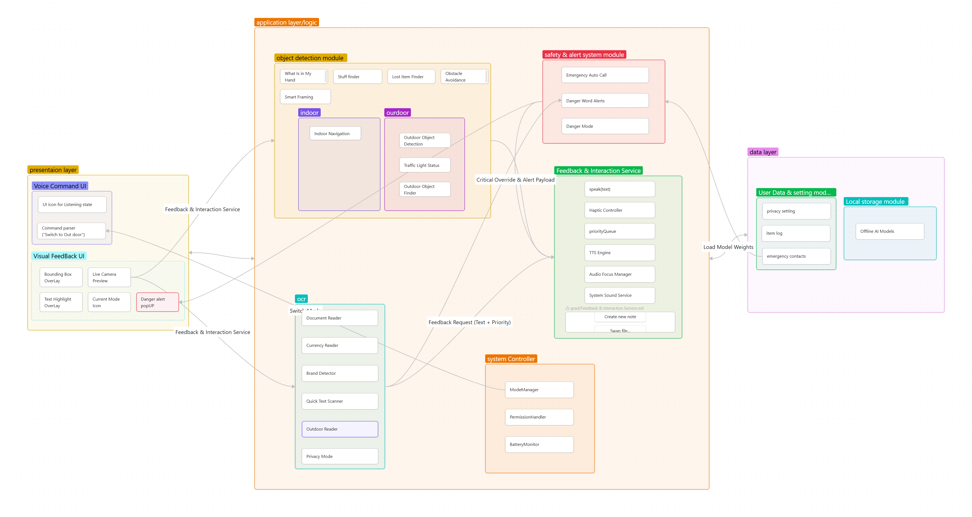
System Architecture Diagram

Class Diagram
The class diagram presented in Figure 3.2 illustrates the structural design of the Warene system, depicting the key classes, their attributes, methods, and the relationships between them. The diagram captures the core components of the application, including the user interface controllers, AI processing modules, service classes for object detection, OCR, and audio feedback, as well as data models for storing user preferences and detected objects. The relationships shown—such as associations, compositions, and inheritances—demonstrate how the system components collaborate to deliver seamless assistive functionality. This object-oriented design ensures modularity, maintainability, and scalability, allowing for future enhancements and the integration of additional AI models.
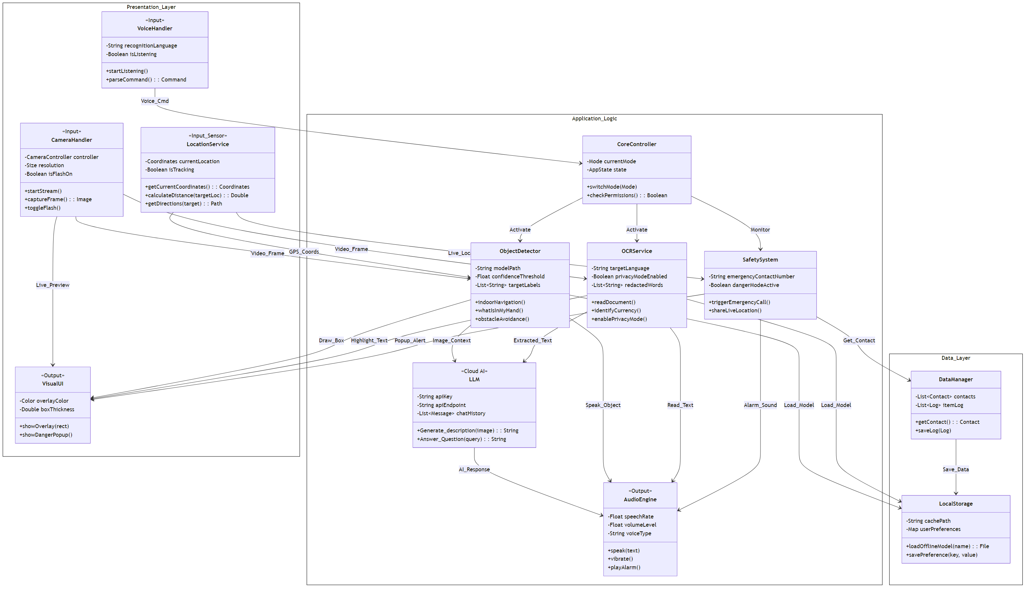
Class Diagram

Use Case Diagram
The use case diagram illustrates the interactions between the user and the Warene system, showing the various functionalities available to visually impaired users. Figure 3.3 presents the system use cases.
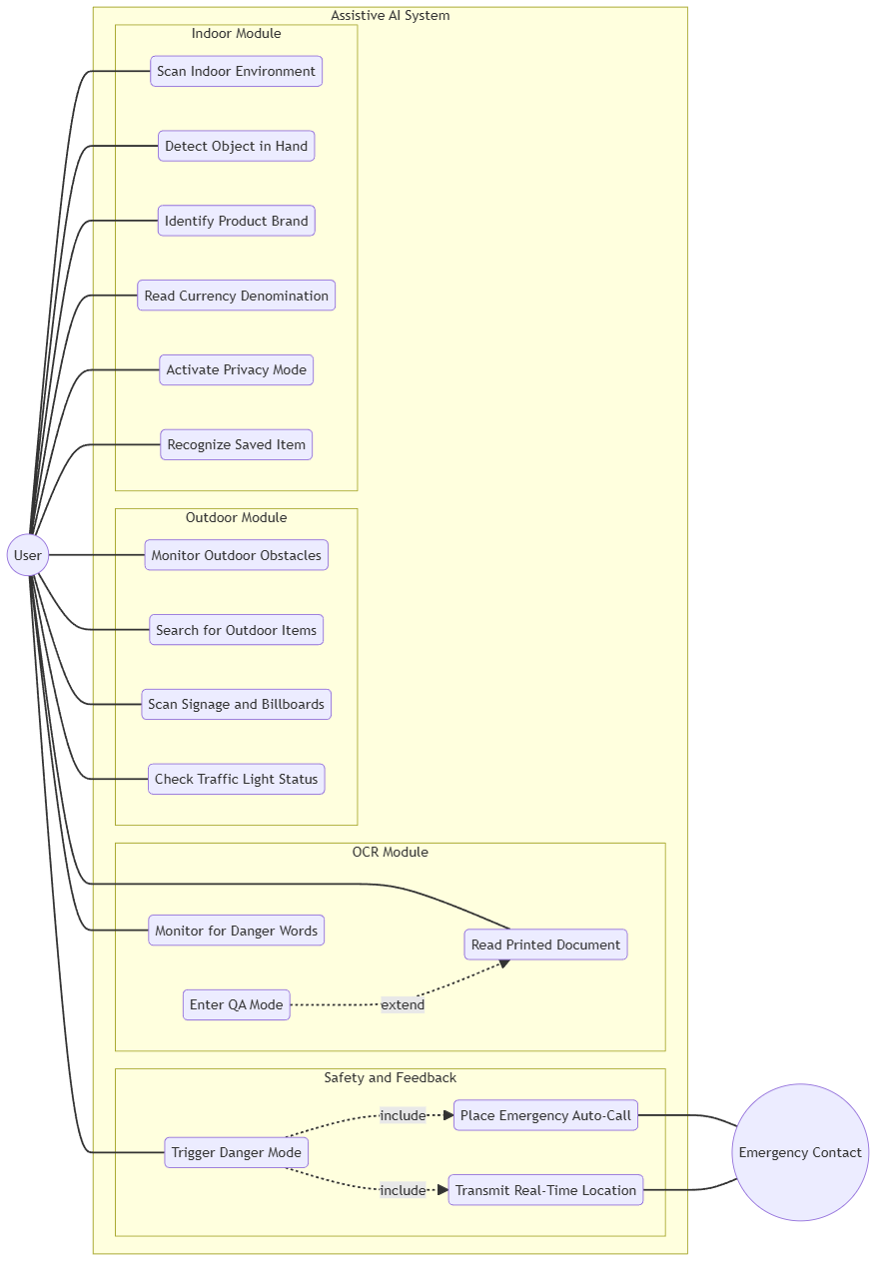
Use Case Diagram

Sequence Diagrams
The following sequence diagrams illustrate the flow of interactions for the key features of the Warene system.

General Flow Diagrams
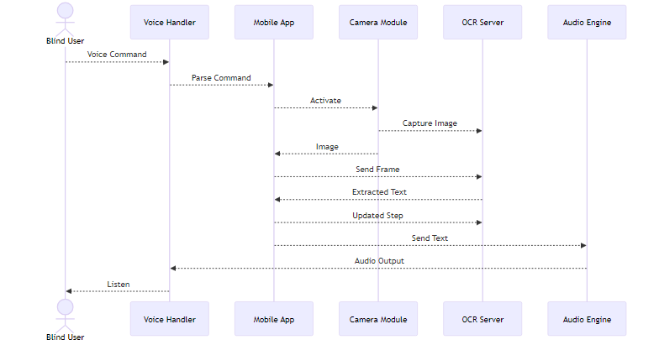
General Flow 1: OCR Processing
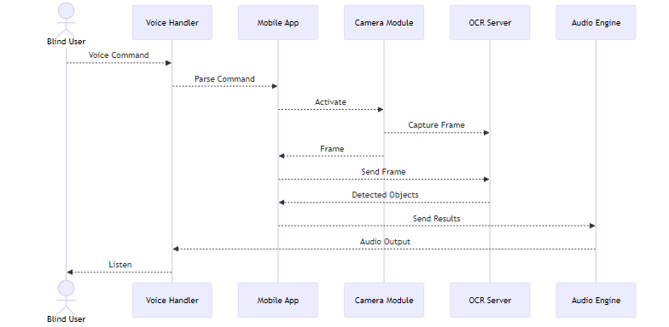
General Flow 2: Object Detection Processing
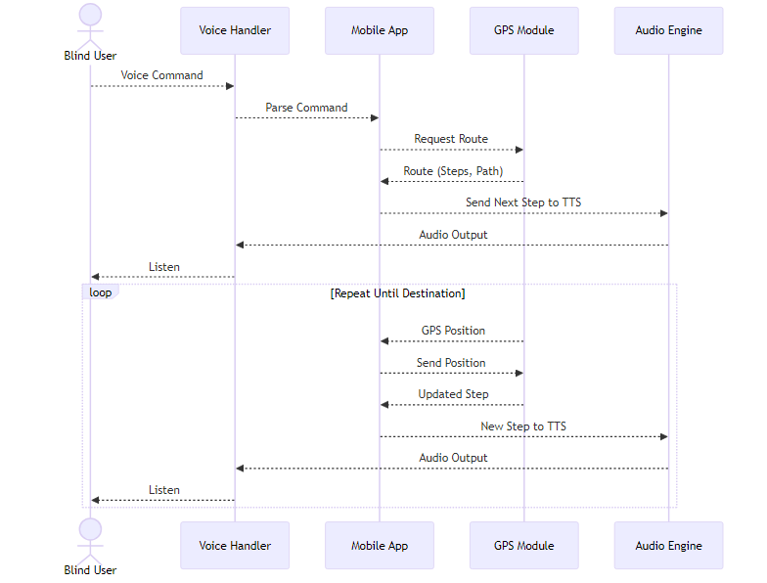
General Flow 3: Navigation Processing

Indoor Features
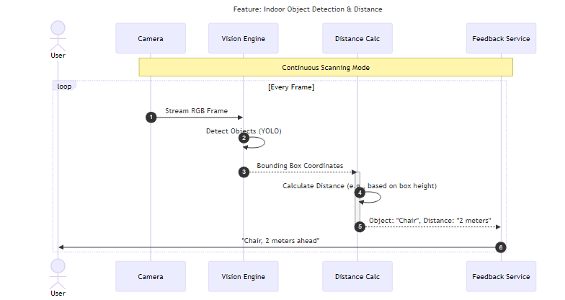
Sequence Diagram: Indoor Object Detection and Distance Estimation
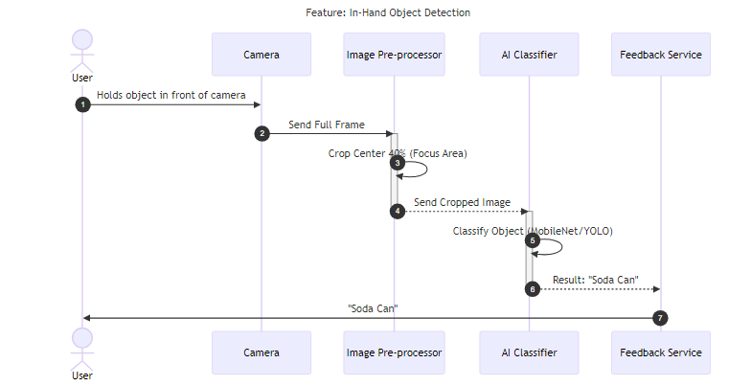
Sequence Diagram: In-Hand Object Detection
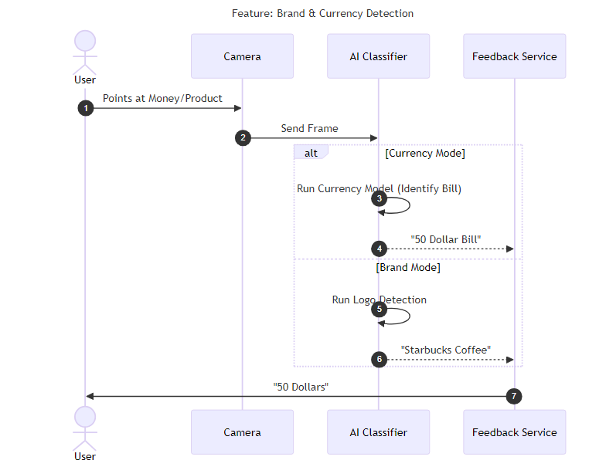
Sequence Diagram: Brand and Currency Detection
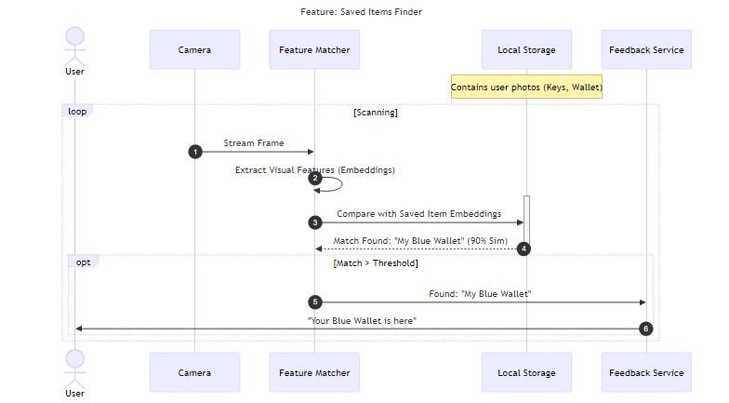
Sequence Diagram: Saved Items Finder

Outdoor Features
Sequence Diagram: Outdoor Object Detection
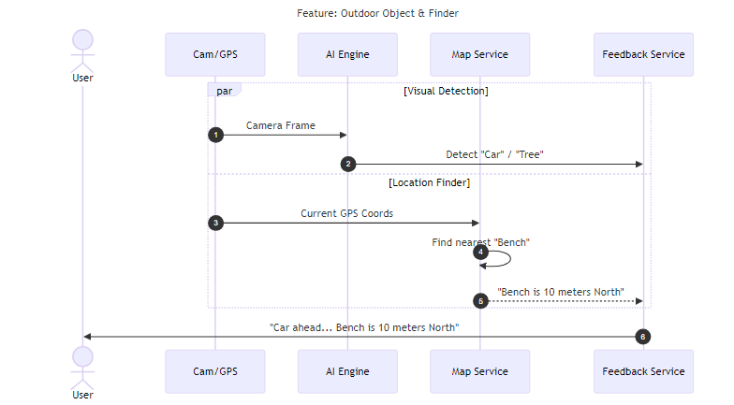
Sequence Diagram: Outdoor Object Finder
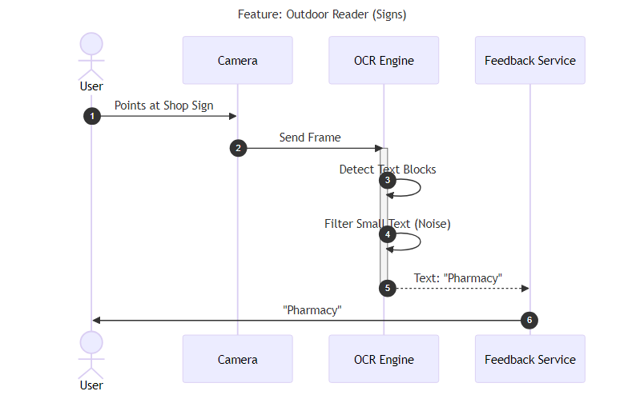
Sequence Diagram: Outdoor Reader for Signs
Sequence Diagram: Outdoor Navigation
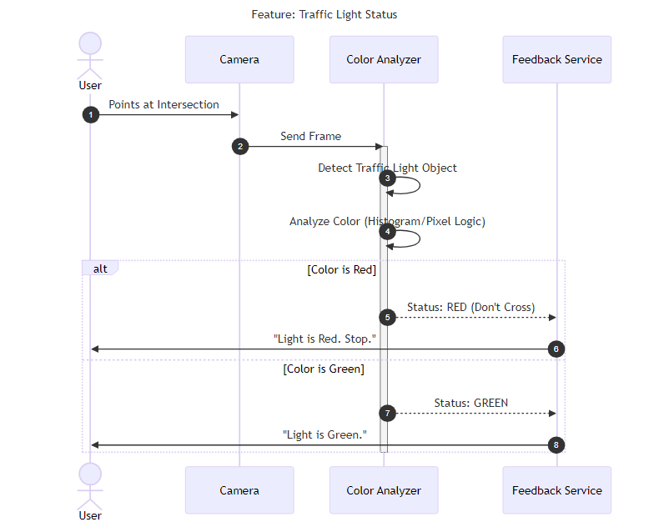
Sequence Diagram: Traffic Light Status Detection

OCR Features
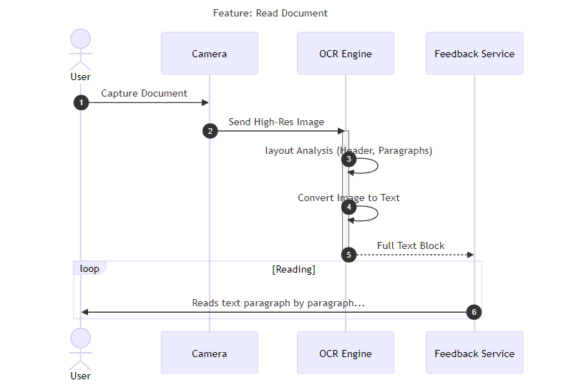
Sequence Diagram: Read Document
Sequence Diagram: Read Document (Alternative Flow)
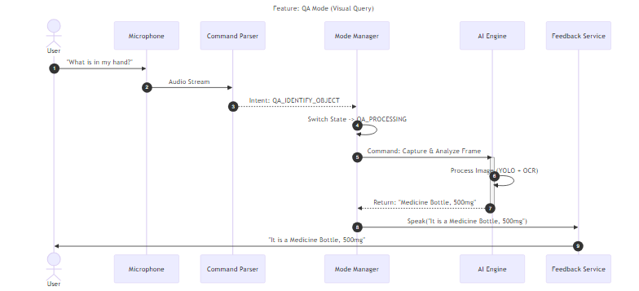
Sequence Diagram: QA Mode (Visual Query)
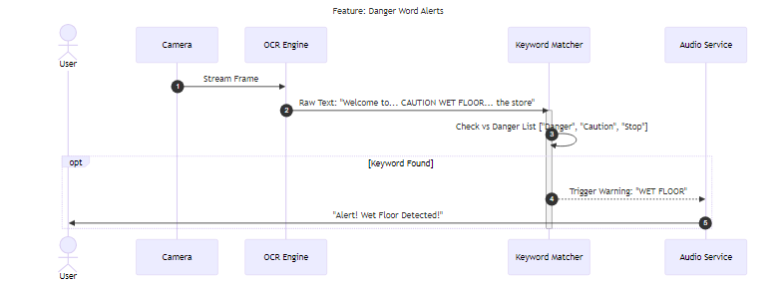
Sequence Diagram: Danger Word Alerts

Safety and Emergency Features
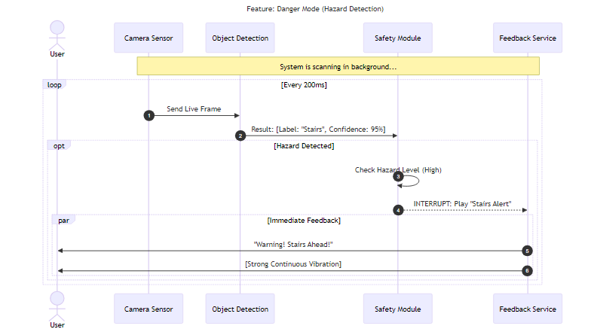
Sequence Diagram: Danger Mode (Hazard Detection)
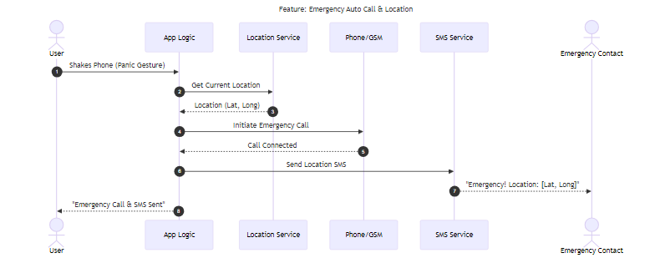
Sequence Diagram: Emergency Auto Call and Location Sharing
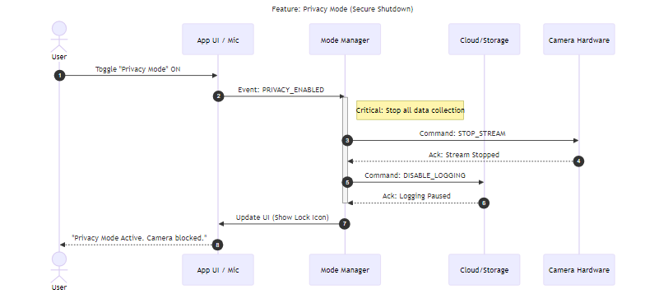
Sequence Diagram: Privacy Mode (Secure Shutdown)

Audio and Haptics Features
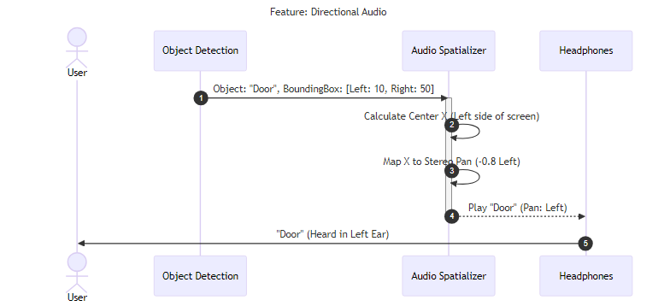
Sequence Diagram: Directional Audio

ERD Diagram
The Entity-Relationship Diagram (ERD) presented in Figure 3.24 illustrates the database schema and data model of the Warene system. The diagram depicts the core entities required to store user information, system preferences, detected objects, saved items, emergency contacts, and usage history. The relationships between these entities—such as one-to-many and many-to-many associations—demonstrate how data flows and persists throughout the application lifecycle. This relational design ensures efficient data storage, quick retrieval of user-specific information, and maintains the integrity of personal data such as saved item references and emergency contact details. The ERD serves as the foundation for implementing a robust and scalable database structure that supports all functional requirements of the assistive system.
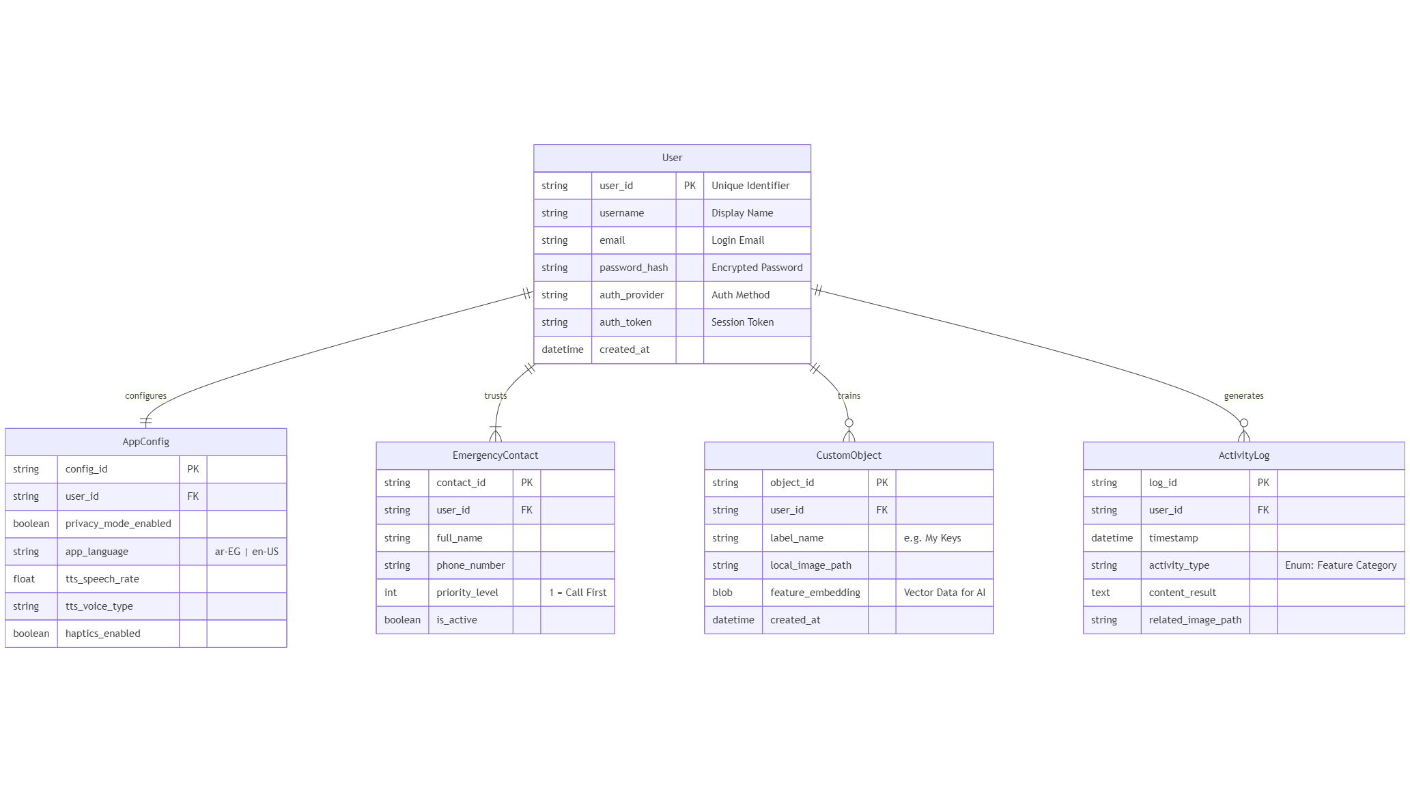
Entity-Relationship Diagram

Bibliography:
M. Huh et al., “Long-Form Answers to Visual Questions from Blind and Low Vision People,” arXiv preprint arXiv:2408.06303, 2024. [Online]. Available: https://arxiv.org/abs/2408.06303
M. Ayadi et al., “Empowering Accessibility in Handwritten Arabic Text Recognition for Visually Impaired Individuals through Optimized Generative Adversarial Network (GAN) model,” Journal of Disability Research, vol. 4, no. 1, 2025. [Online]. Available: https://www.scienceopen.com/hosted-document?doi=10.57197/JDR-2024-0110
A. M. Ghanem, H. A. Youness, M. Wahba, and H. M. Abdelaal, “Recognizing Egyptian currency for people with visual impairment using deep learning models,” Scientific Reports, vol. 15, no. 1, 2025. [Online]. Available: https://www.researchgate.net/publication/396095205
W. Wang et al., “YOLO-OD: Obstacle Detection for Visually Impaired Navigation Assistance,” Sensors, vol. 24, no. 23, p. 7621, 2024. [Online]. Available: https://www.mdpi.com/1424-8220/24/23/7621
K. Wojtowicz, “The Impact of YOLOv8 and YOLOv9 Neural Network Architectures on the Quality and Speed of Object Detection in Assistive VR/MR Applications for Visually Impaired Users,” European Research Studies Journal, vol. 28, no. 4, pp. 1044–1057, 2025. [Online]. Available: https://ersj.eu/journal/4157
A. D. Martin and I. Moon, “Privacy-Preserving Image Captioning with Partial Encryption and Deep Learning,” Mathematics, vol. 13, no. 4, p. 554, 2025. [Online]. Available: https://www.mdpi.com/2227-7390/13/4/554

