Crate Management

Description:
This module is to manage the crates used in Warehouse and Hub’s. Every crate consists of two status (s): a) Status and b) Transaction Status

Status:
This one describes the physical status of the crate

Transaction Status:
This one describes the current position of the crate

Below chart explains the stages in both the Status and Transaction Status and the database representation [screenshot 1].

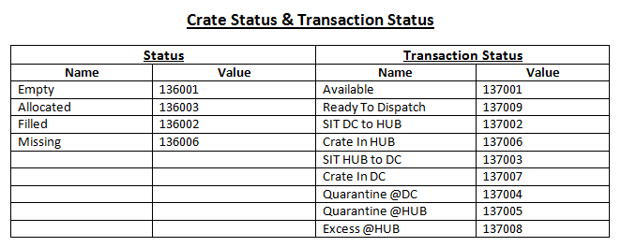
[screenshot 1]

As per order status the transaction status will be updated to the crate. The flow of the crate is according to the order status.

Crate Dashboard:

There is a dashboard (Portal Home => Inventory => Crate Dashboard) to check the current position of the crates. Here in this dashboard the details of the crate [screenshot 2] like Crate Code, current Status, Transaction Status, The DC Name to which warehouse the crate belongs to, The Last Order Id to which the crate is associated, The Last Order Code, The Last Order Code, Picker Name, Delivery Executive Name and an Action button to see the Product details [screenshot 3] like Product Title, Mrp and Quantity.
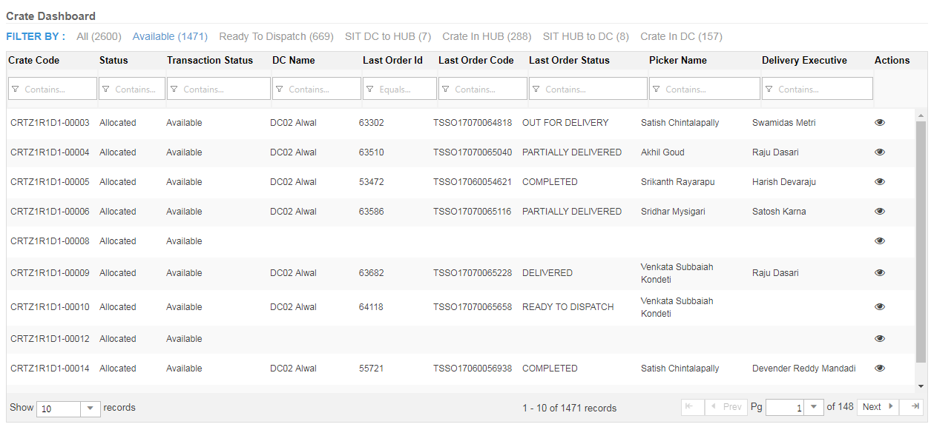
[screenshot 2]

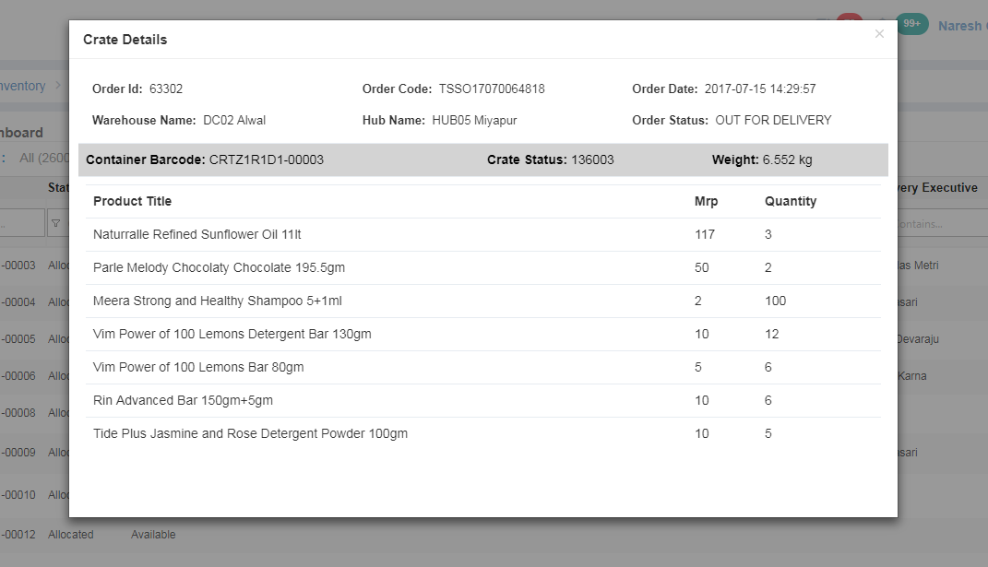
[screenshot 3]

Flow:

According to the crate status and transaction status the flow of the crate is explained as below:

Check for Crate Availability:

Picker scans the crate (App Home (Left Menu) => Picker => Pending => Order Details => Order List Items) and checks whether the crate is available to assign for an order, if the crate status and transaction status are Empty and Available respectively then the crate can be assigned to an order or else an alert will be thrown to scan other crate [screenshot 4].

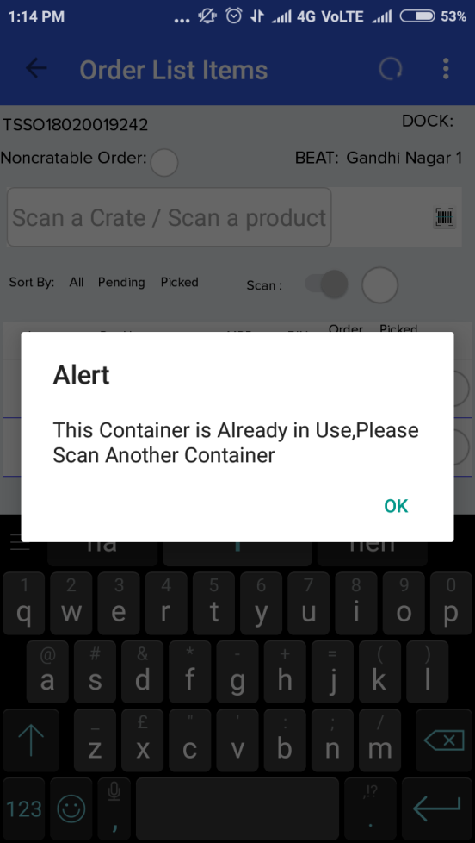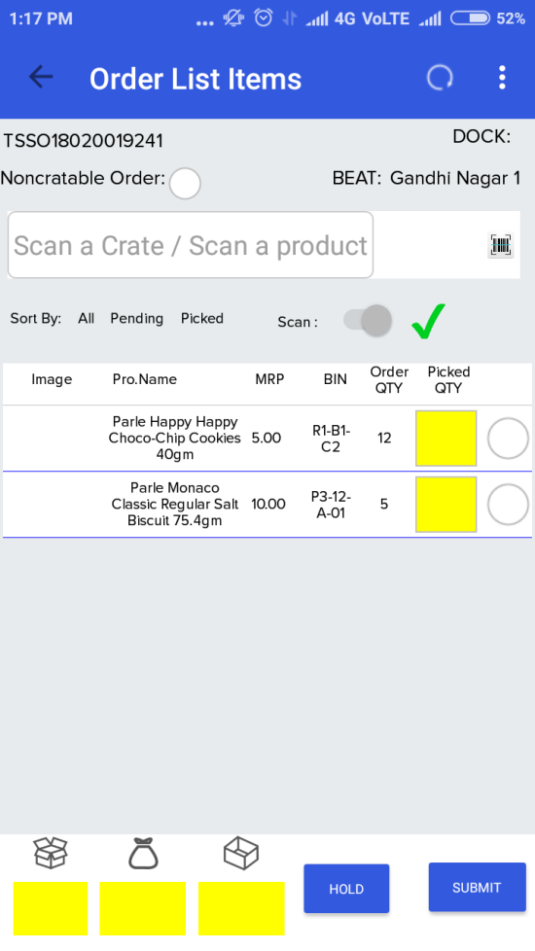
[screenshot 4] [screenshot 5]

Crate Allocation:

Upon scanning the available crate (App Home (Left Menu) => Picker => Pending => Order Details => Order List Items), status of the crate will be updated to Allocated. Now the picker can place the products of a particular order and the crate is associated to that order after the submission [screenshot 5].

Filled and Ready For Dispatch:

Upon submission (App Home (Left Menu) => Picker => Pending => Order Details => Order List Items) the crate status and transaction status will be updated to Filled and Ready For Dispatch respectively [screenshot 6].

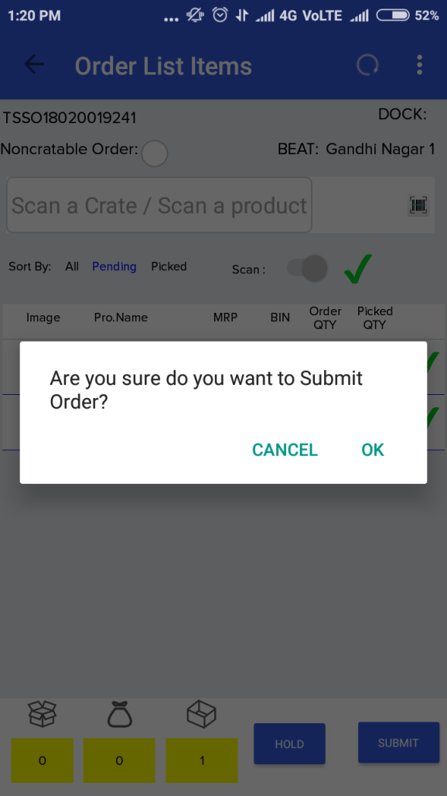
[screenshot 6]

SIT DC To HUB:

Now the crates are pushed for verification [screenshot 7], after completion of the verification the crate (s) transaction status will be update to SIT DC to HUB (App Home (Left Menu) => SIT Orders) [screenshot 8].

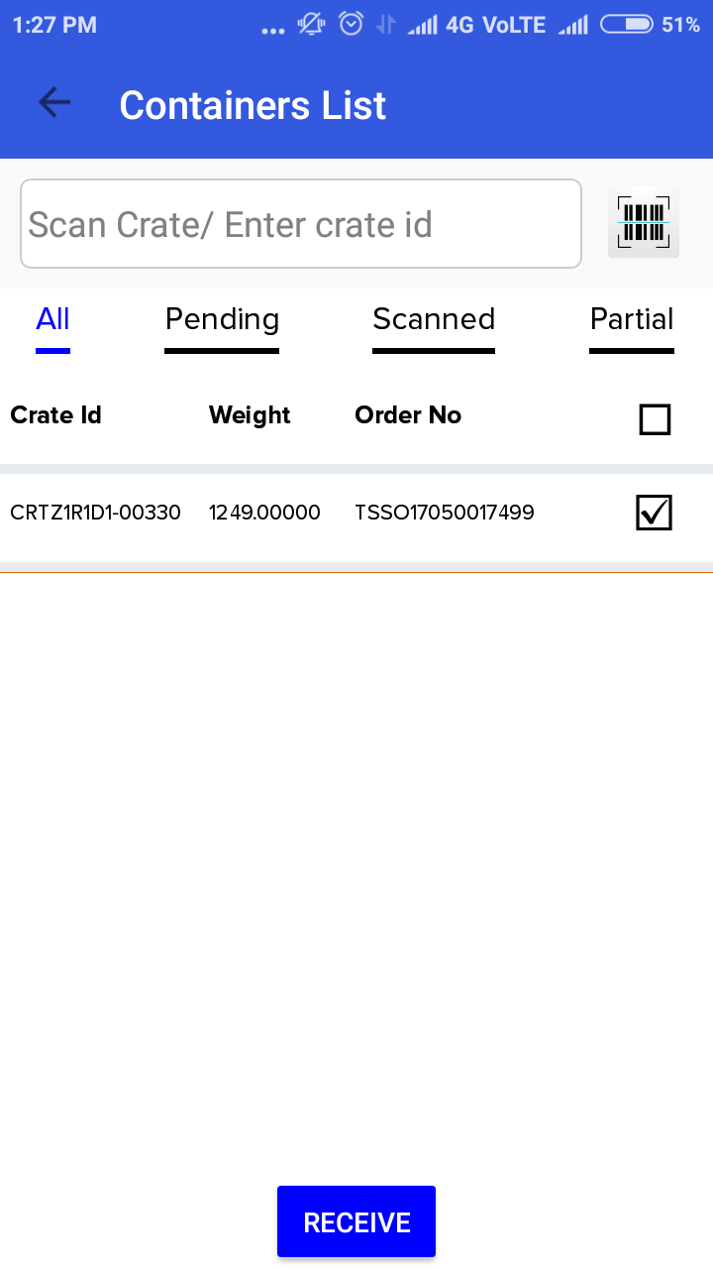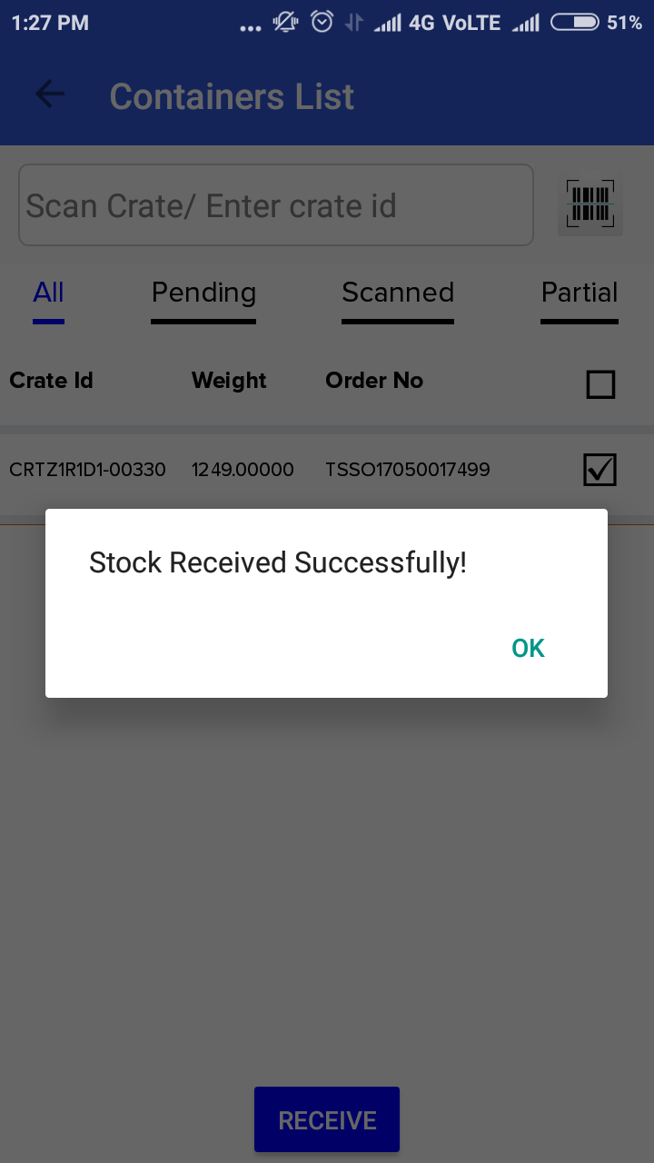
[screenshot 7] [screenshot 8]

Crate In HUB:

Now the crates are moved to respective HUB’s. In HUB the HUB Incharge will receive the crates by scanning each crate (App Home (Left Menu) => SIH Orders). Upon scanning the crate, transaction status will be updated to Crate In HUB.

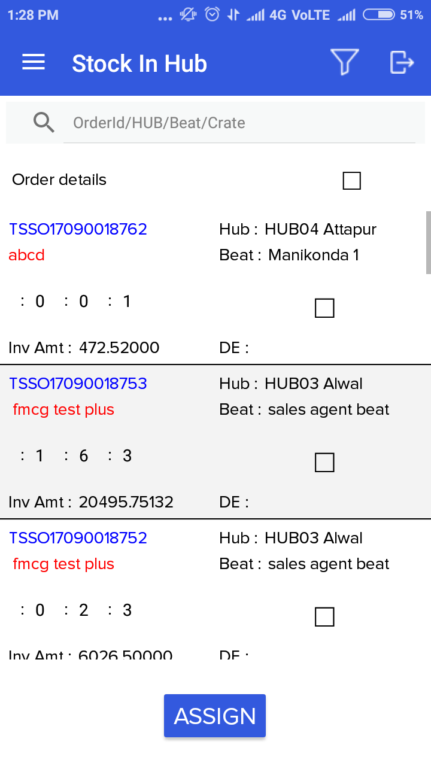
[screenshot 9]

Out For Delivery:

The crates (Order) will be sent out for delivery (App Home (Left Menu) => Delivery => Pending => Order Details => DEL Sheet => Click on OUT FOR) [screenshot 10], here the crates (order) will have three different stages as below:
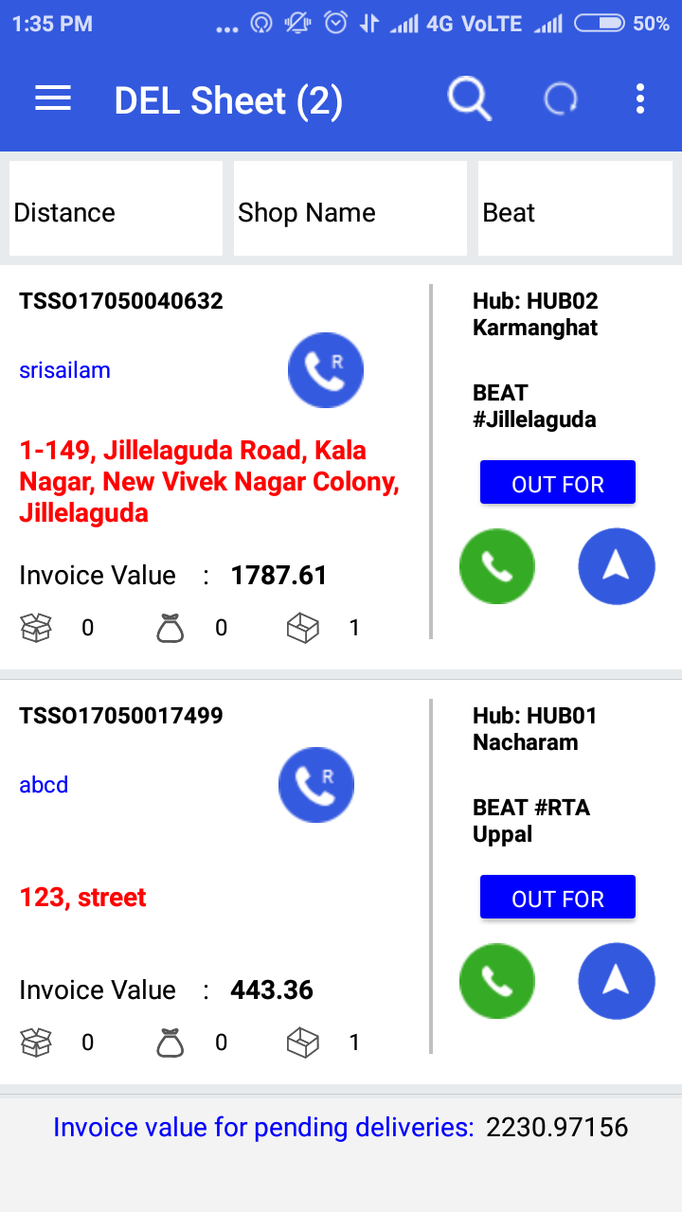
[screenshot 10]

- Delivered:

If the order is fully delivered (App Home (Left Menu) => Delivery => Pending => Order Details => DEL Sheet => Click on DELIVER) [screenshot 11] [screenshot 12] then the crate status will be updated to Empty and the transaction status will remain same Crate In HUB.

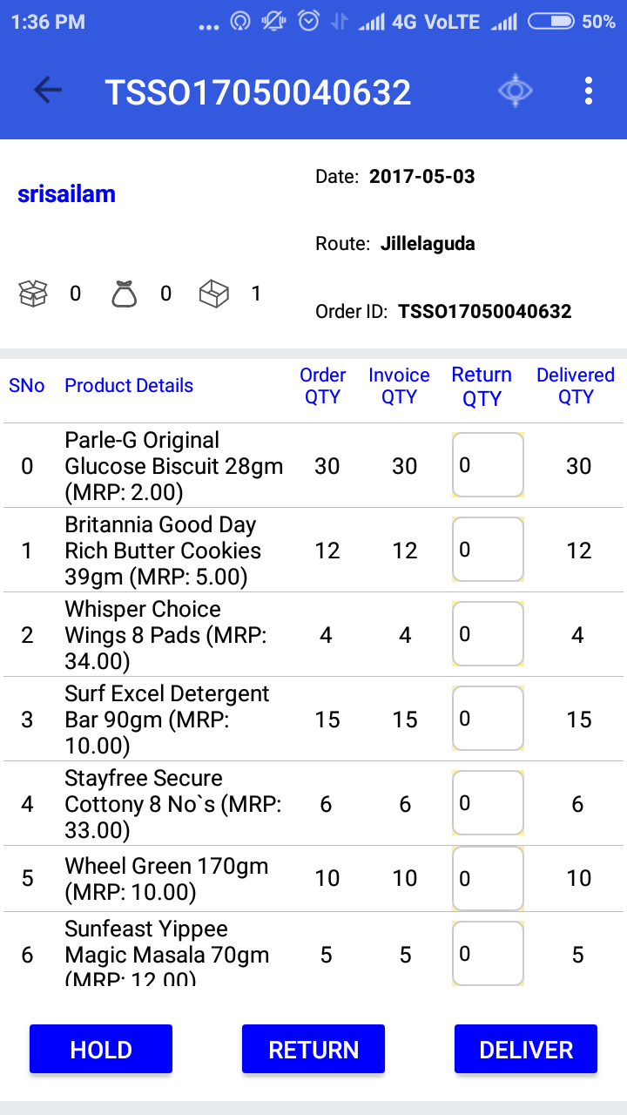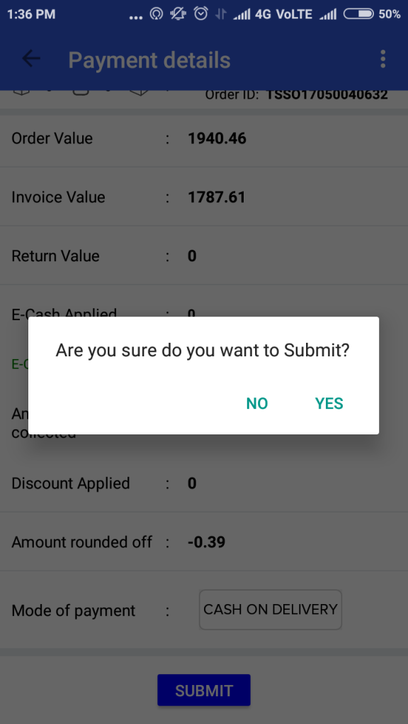
[screenshot 11] [screenshot 12]

- Partially Delivered:

If the order was partially delivered then the crate status and transaction status will be remain same as Filled and Crate In HUB respectively. The entries for partial delivery will be entered and clicks on deliver button (App Home (Left Menu) => Delivery => Pending => Order Details => DEL Sheet => Click on DELIVER). Here we are not changing the status of the crate.

- Returned:

If the order is returned then here also the Partially Delivered scenario is applicable. For return orders (App Home (Left Menu) => Delivery => Pending => Order Details => DEL Sheet => Click on RETURN) the delivery executive will click RETURN button.

SIT HUB To DC:

After Out For Delivery, the crates (order) will be returned to HUB. Now these crates should be sent back to DC. For this the HUB manager (App Home (Left Menu) => Orders => RAH DEL Orders) will scan all the crates (orders) either the delivered or partially delivered or returned orders. Upon scanning the crate the transaction status will be updated to SIT HUB TO DC and the crates will be sent back to DC through vehicles.
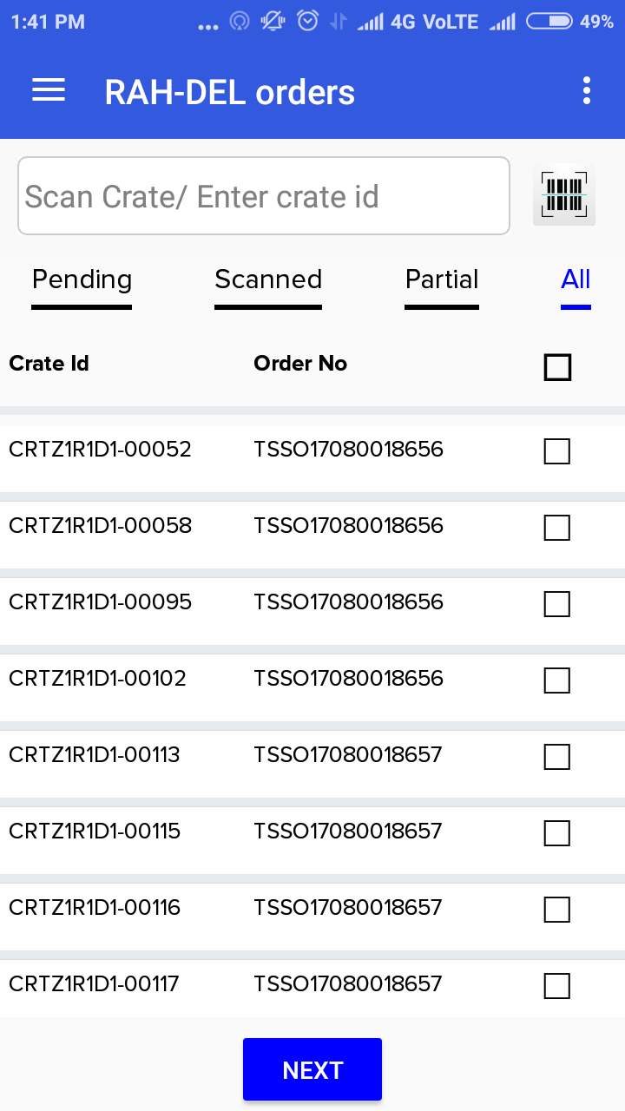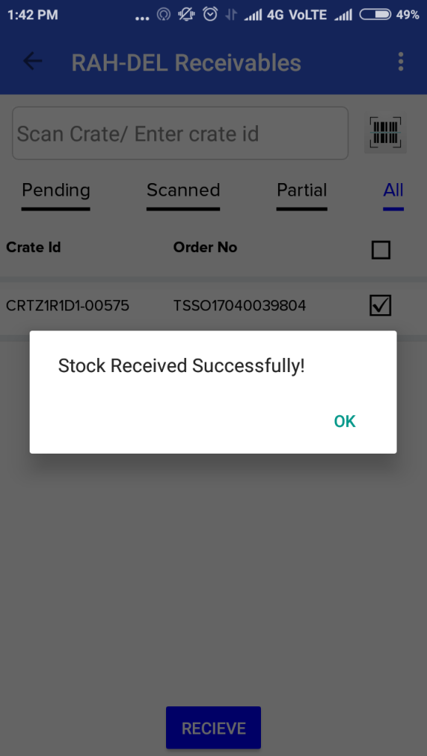
[screenshot 13] [screenshot 14]

Crate In DC:

After reaching the crates to DC, the DC manager (App Home (Left Menu) => Order => RAH-DEL SIT HUB-DC) will receive [screenshot 15] the crates by scanning them. Here the crates (order) will have three different stages as below:
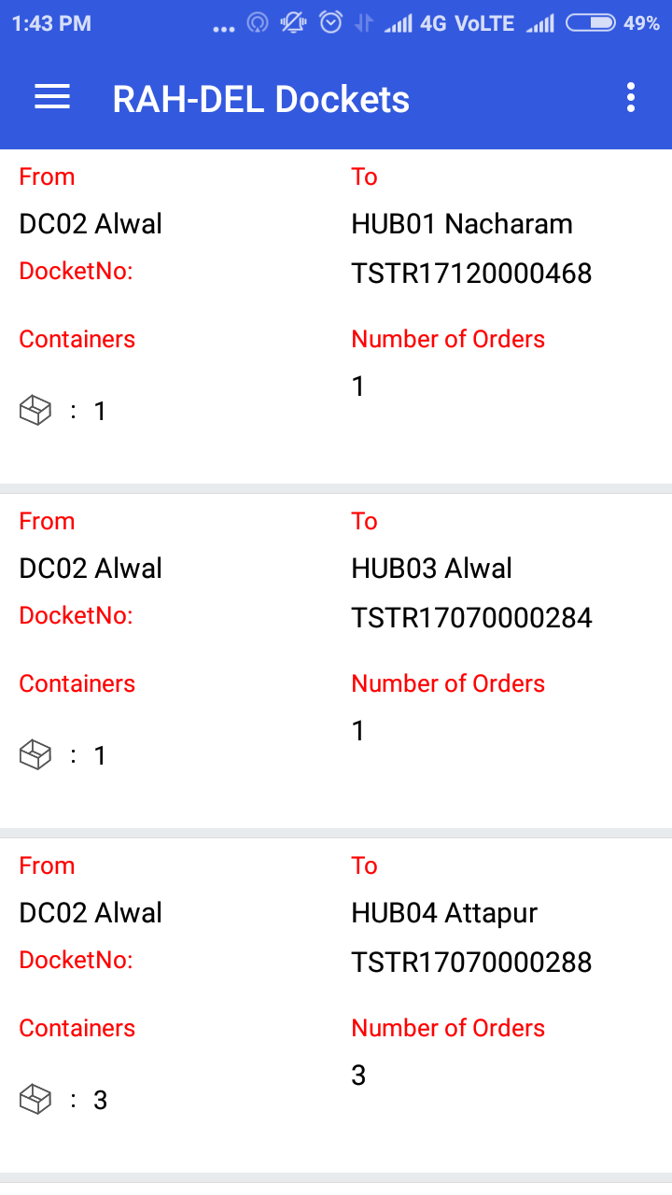
[screenshot 15]

- Delivered:

If the order is fully delivered then the crate transaction status will be updated to Available.

- Partially Delivered:

If the order was partially delivered then the crate status will be remain same as Filled and transaction status will be updated as Crate In DC. These crates will be moved for replenishment [screenshot 16]. In replenishment process the status and transaction status will be updated as Empty and Available respectively.

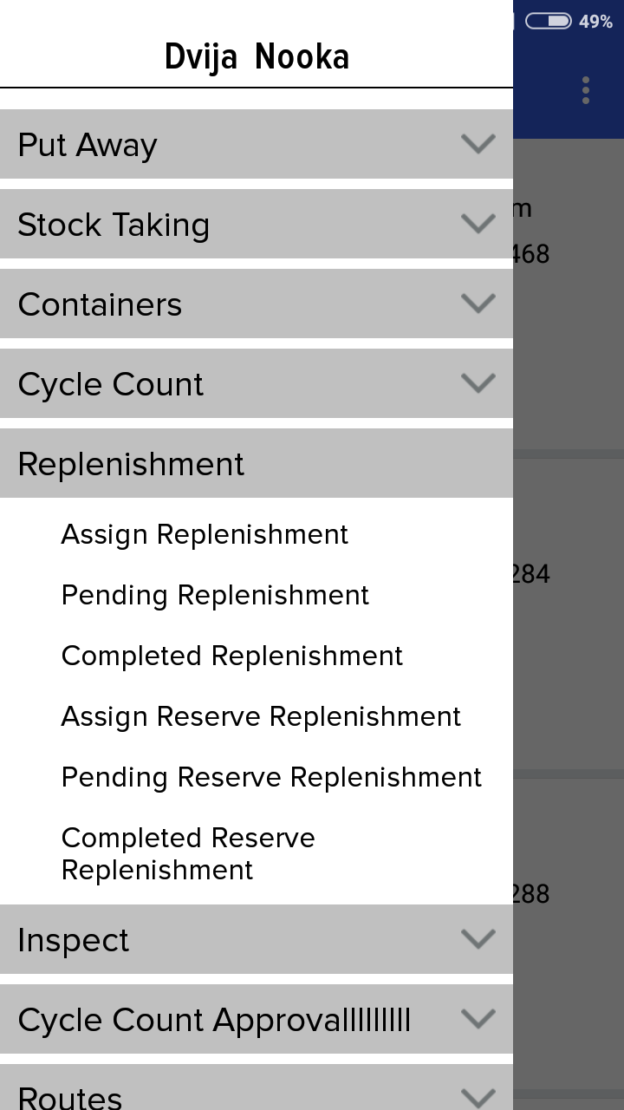
[screenshot 16]

- Returned:

If the order is returned then here also the Partially Delivered scenario is applicable.

