Tax Module

This module consists two processes:

- Tax Class Creation

- Tax Class Mapping with a Product

Tax Class Creation:

Tax classes can be created in two ways:

- Through Form (Grid Action)

- Through Excel Sheet upload

Through Form (Grid Action):

To create a new tax class user can select the state from the Tax Classes Grid. Upon clicking the plus button in action column ​[screenshot 1]​, a pop will open with required fields to create a new tax class ​[screenshot 2]​.
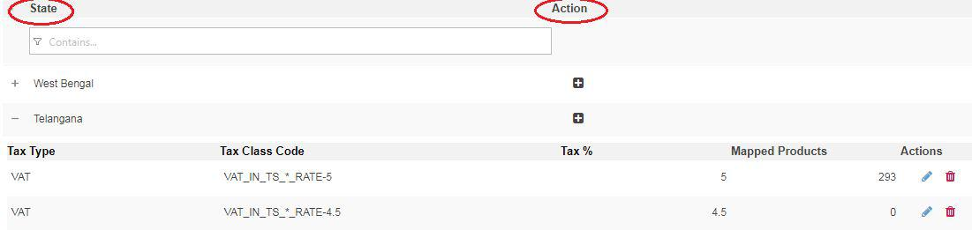

[screenshot 1]

By filling the required fields a Tax Class Code will be generated automatically based on the previous fields selection ​[screenshot 2]​.

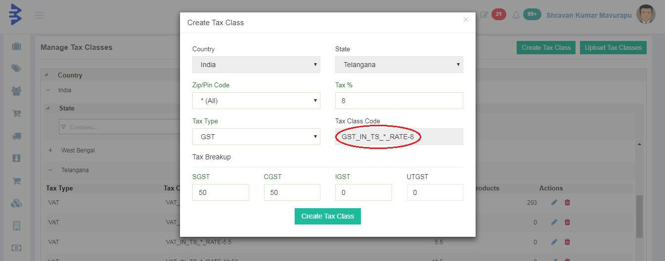

[screenshot 2]

Duplicate Tax Class can not not be created, an error will be thrown upon creating so.

Updation and deletion of the Tax Class can be done in the same screen [screenshot​ 1].​

Through Excel Sheet Upload:

New tax classes can also be created through the excel sheet upload. A button named “Upload Tac Classes” is there at the right top to upload the excel sheet ​[screenshot 3]​.
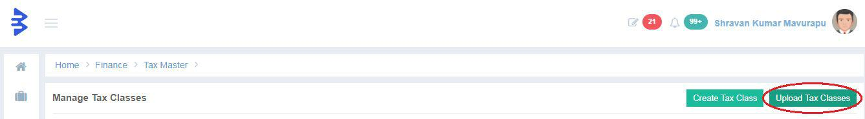

[screenshot 3]

A predefined template is available to create new tax classes ​[screenshot 4]​. After downloading ​[screenshot 5]​the template file you can fill the required fields to create multiple new tax classes for different states by uploading the same template.
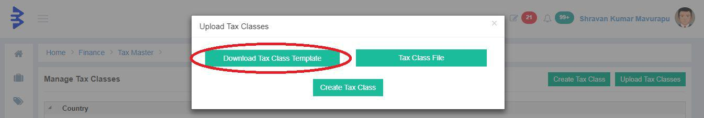

[screenshot 4]

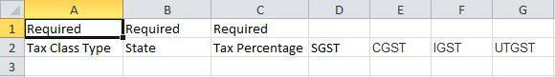

[screenshot 5]

Tax Class Mapping with a Product:

Every product has a tax, this mapping can be done using the Product Tax Mapping grid. This grid consists all active products and state wise tax classes mapped with the each product. Upon clicking the action button a pop up with Product, HSN and Tax Type details are shown [screenshot 6]​.
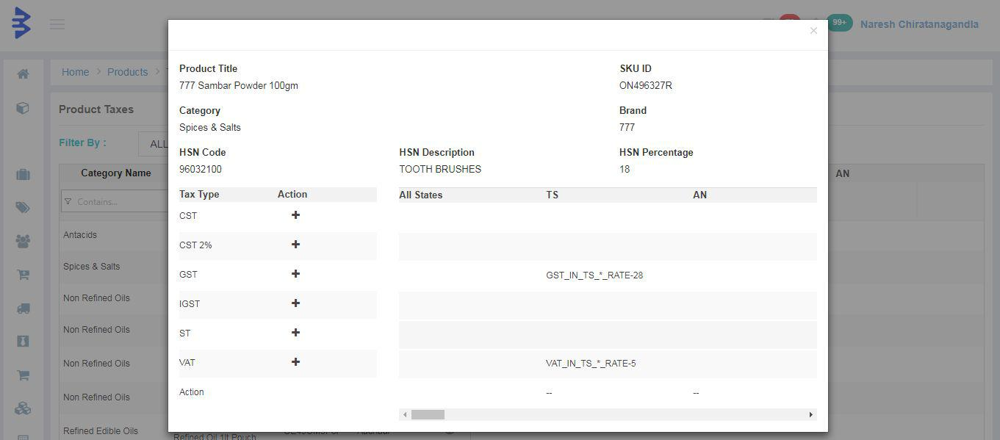

[screenshot 6]

Against each Tax Type there is an action button as shown in ​[screenshot 6]​, upon clicking the plus icon a new pop up with HSN Details and required fields to map the tax class with product are shown ​[screenshot 7]​. Without the HSN details a product can not be mapped with any tax class. If the HSN details are not mapped to any product, we can add those details here using the link ​“Click for HSN Info”​.

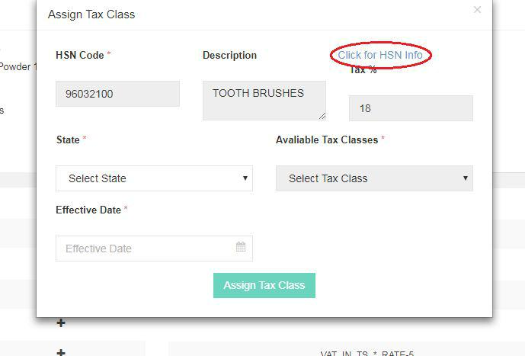

[screenshot 7]

Upon selecting the State, Available Tax Classes and Effective Date and submitting, the selected tax class is mapped with that product. Here same product cannot map tax classes with the same effective date for a particular state.

After mapping the tax class to a particular product, the Approval Workflow takes place by creating a ticket and assign the same according to the defined role in Approval Workflow. After approval the mapped tax % will be applied to that product from the date mentioned in the Effective Date while selling the product.

Edit Product:

The tax class can be mapped with a product in Product module also. Here we developed a component to reuse the same code in multiple places.

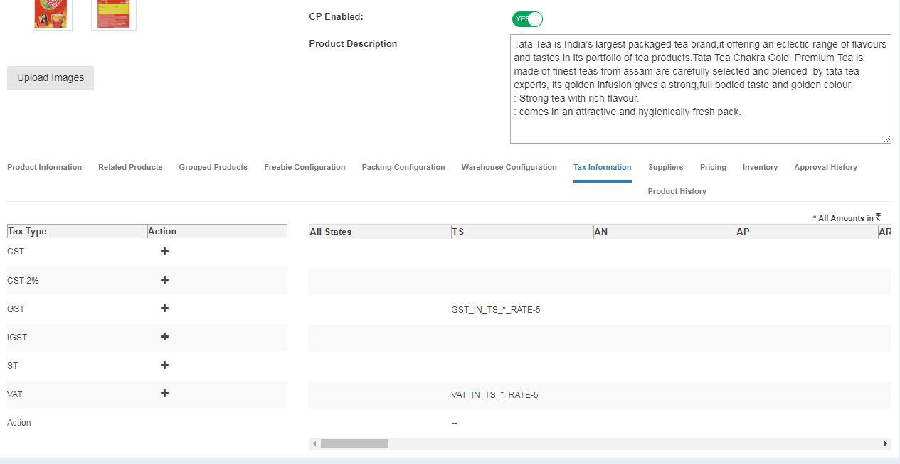

[screenshot 8]

