# Auto-Indent

Purchase Indent is an internal company document used in the purchasing process to authorize the requisition of materials prior to initiating a purchase order. At Ebutor we use Indents to create PO (Purchase Orders), Indent help purchasing team to create accurate and faster PO’s.

At Ebutor we create indents based on manufacturers. Creation of Indent starts from Di-Mi-Ci report (DiMiCi report forecasts requirement of inventory for number of days), So once user upload Di-Mi-Ci report to system, system process it and group data based on “manufacturer”, later it creates separate indents for each manufacturer. This full process called “Auto - Indent”.

## Generate Indents

Below are the steps to create auto-indents:

**Screen 1:**

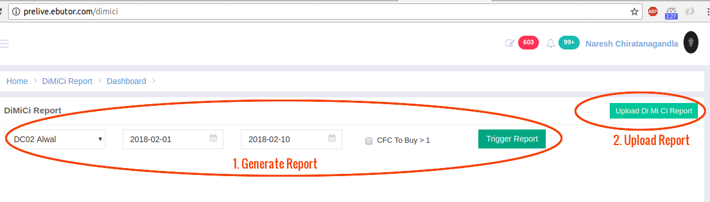

**Screen 2:**

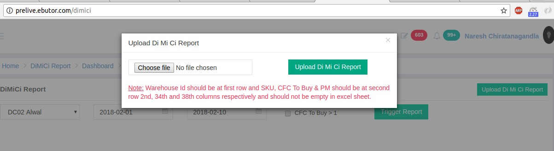

**Screen 3:**

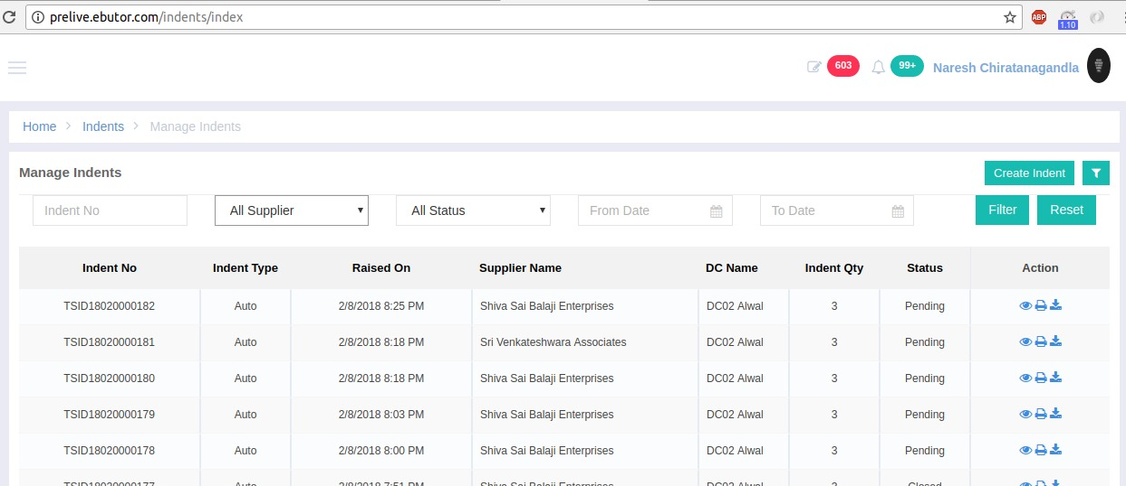

1. Login to portal.ebutor.com, go to left menu, select “Reports”, find “DiMiCi Report” and click on it.
2. Report page will appear as screen 1.
3. To generate DiMiCi report, select warehouse and dates, click on “Trigger Report”.
4. User will receive report at his email (it will take ~1-15 mins based on date range selected).
5. Once received report at mail, user can upload same report.
6. Click on “Upload report” as shown in screen 1.
7. Pop-up will appear as screen 2, select report file and click on upload button.
8. Above steps will generate Indents.
9. To check created indent, Go to left menu, select “Purchases”, Click on “Indents” from sub-menu.
10. Page will appear as Screen 3. It will contain a grid with all created Indents.

## 

## Edit Indents

User need to select “Suppliers” for newly created indents (only indents with supplier would be visible at PO page). User also can edit indent values, follow below steps:

**Screen 1:**

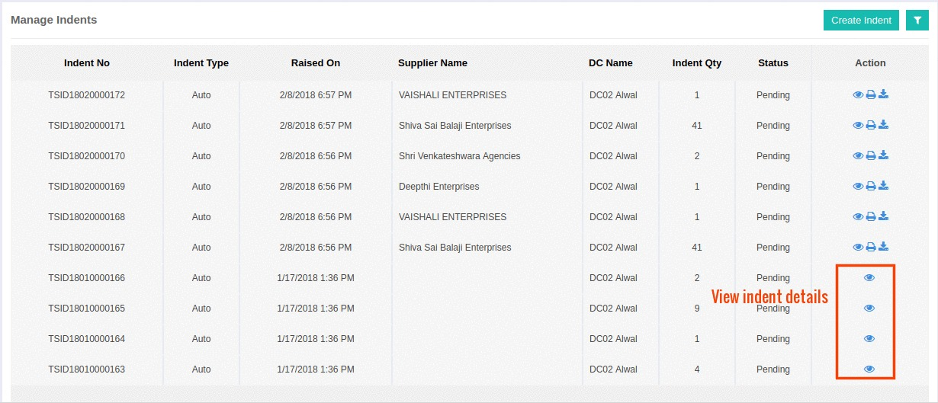

**Screen 2:**

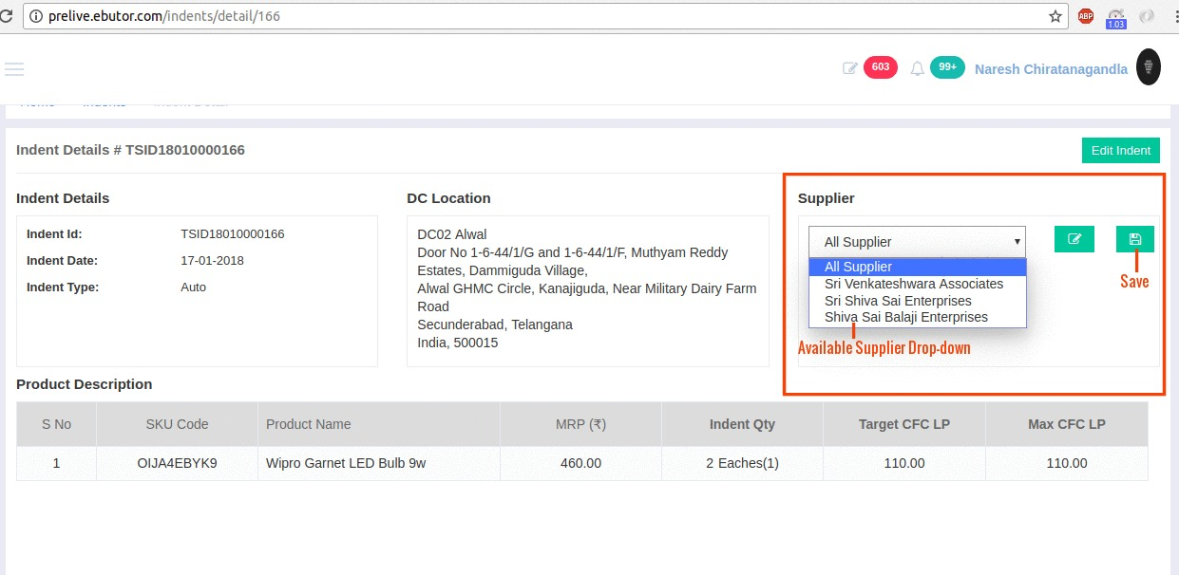

**Screen 3:**

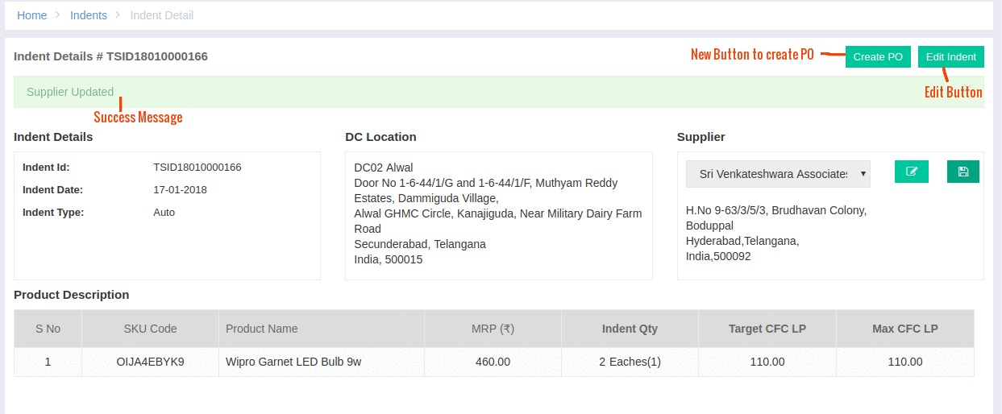

**Screen 4:**

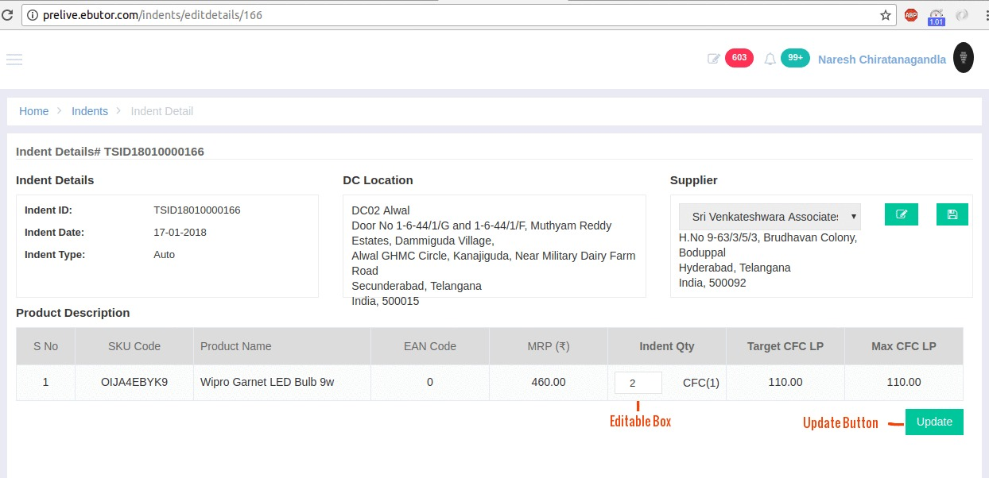

1. To see created indents, Go to left menu, select “Purchases”, Click on “Indents” from sub-menu.
2. Page will appear as Screen 1. It will contain a grid with all created Indents.
3. Click on “View” button to open Indent Details as shown in Screen 1.
4. It will open indent details page as screen 2.
5. To update “Supplier”, select supplier from drop down and hit save button (Screen 2).
6. User will see Success Message after submission (Screen 3).
7. To edit Indent click on “Edit Button” as shown in Screen 3.
8. It will open page in edit mode, and user can edit “Indent Qty” as shown in Screen 4.
9. After change user needs to hit on “update” button (Screen 4).
10. Success message will display after successful process.

## Code Flow

Code flow to create Indents includes following important stages:

While uploading DiMiCi report call goes to below URL:

**URl: /dimici/uploadreport**

**File: /app/Modules/DiMiCiReport/Controllers/DimiciController.php**

**Function: uploadAction()**

1. **uploadAction** function further calls **readExcel4indent()** function which is in same file.
2. **readExcel4indent() :** This function reads uploaded excel and based on manufacturer collects products in multidimensional array. So output by this function is a multidimensional array which is having **manufacturerID** as index.
3. Further output from **readExcel4indent()** will go as input to **createIndent()** function at same file.
4. **createIndent() :** This function further read arrays based on manufacturers, and call to function down the line **saveIndent()** & **saveIndentProducts()**.
5. **saveIndent() :** Function create Indent entry to “**gds_orders_indent**” table.
6. **saveIndentProducts() :** Function create entries for Indent products at “**gds_orders_indent_products**” table. Which also carries **Indent_id** generated by last function.

Other options like edit, delete print etc are in Indent Modules. All these are very basic functions.

**Indent module path: /app/Modules/indent**

**Tables : gds_orders_indent, gds_orders_indent_products**