# PICKING

This topic includes follwoing steps:

1. Picklist generation - Feature available at WEB/APP
2. Picking Process - Feature available at APP

## Picklist Generation:

Picklist generation process containes follwoing points:

1. Assignment of orders to Pickers
2. Check available Bin-Inventory
3. Auto cancellation

### Assignment of orders to Pickers

Assignment of orders to pickers process can be done from both Web/App sides.

**Discription:**

User selects “Open Orders” and assigns it to pickers, once assignment is successful order status changed to “Picklist Generated”. This feature is available at both Web & App ends.

Below are the process for Web & App:

**Web:**

Screen 1:

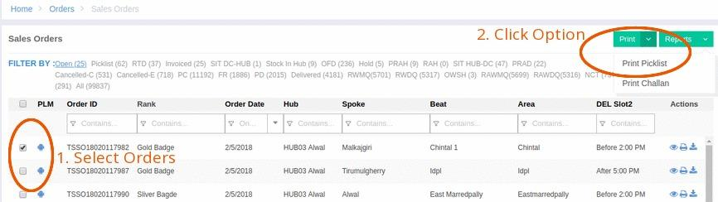

Screen 2:

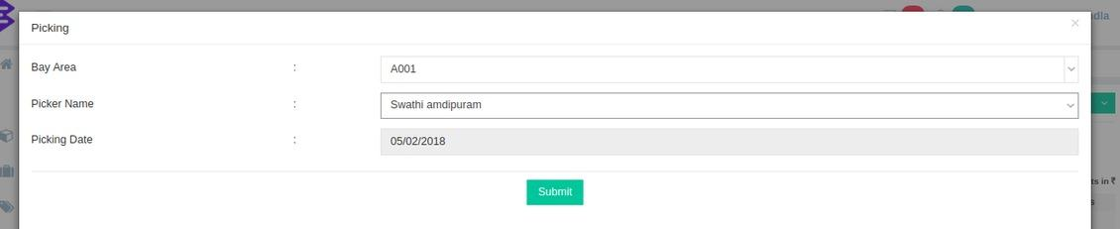

To generate picklist user needs to follow below steps:

1. Go to Sales Order page.
2. Selcet “Open” tab.
3. Select order as shown in screen 1 above.
4. Click on “Print Picklist” option (upper side right corner of page) from submenu.
5. After click, one pop-up will come as screen 2.
6. Select “Bay Area” & “Picker Name”, hit on Submit button.

**Mobile:**

Screen 1 Screen 2

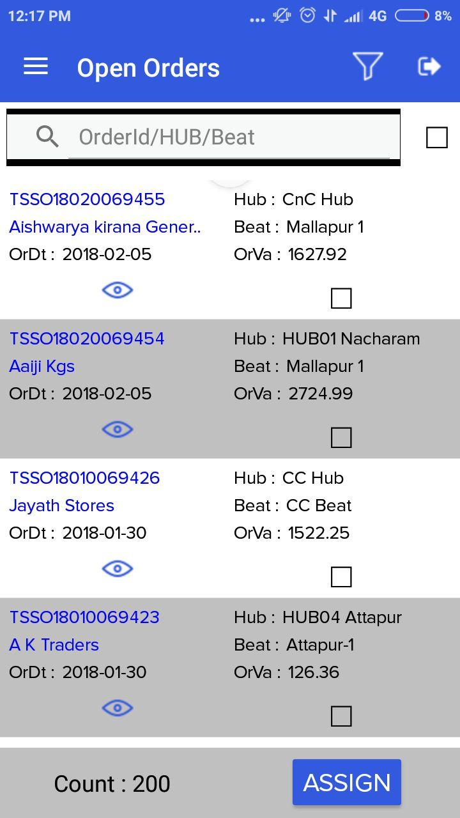 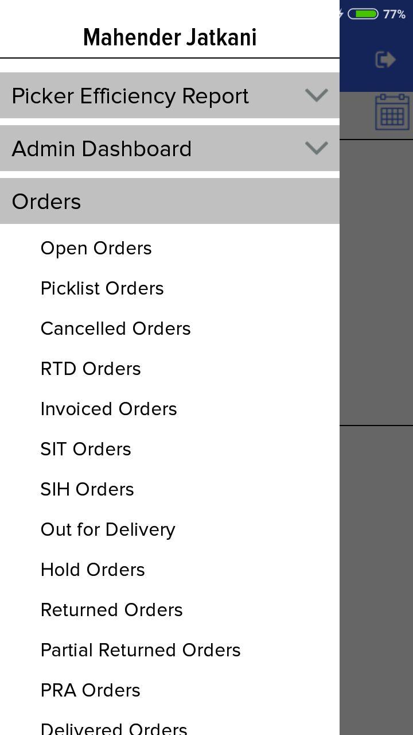

Screen 3 Screen 4

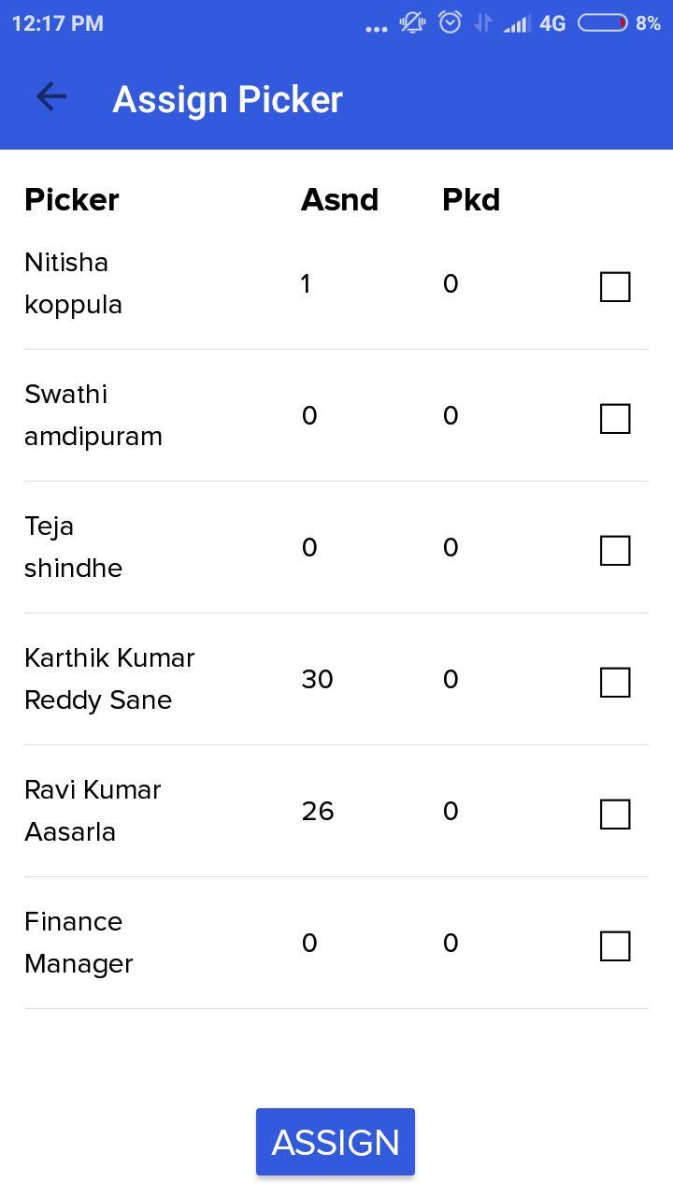 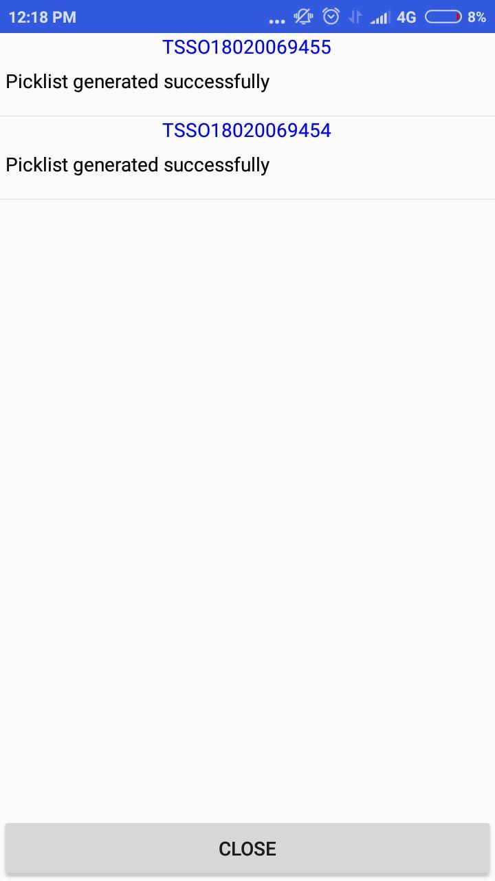

To generate picklist from mobile app, follow below steps:

1. Go to Order side menu (Screen 1)
2. Tap on Open Orders, select one or more orders, tap Assign (Screen 2)
3. Select pickers and tap on Assign (Screen 3)
4. Next page will display success/failure message (Screen 4)

### Check available Bin-Inventory

While user submit picker assignment from Web or App, our system will check following conditions:

* 1. Ordered products should have bin configured.
  2. Bin for ordered product should have sufficient inventory.
  3. Bin inventory should be sufficient enough to fulfill ordered product ESU.

### Auto cancellation

Once above conditions (one or more) are failed, system will auto cancel items. Folowing are some more conditions for auto-cancle :

1. If ESU is not present at bin, system will cancle pending ESU qty.
2. If main item got cancelled, accordingly freebie needs to cancle as well.
3. If freebie got cancle, accordingly main items also needs to cancle.

### Code Flow

Web:

Once user clicks on submit link from pop-up it triggers addresses:

URL: /salesorders/savepicklist

Filepath: /Code/app/Modules/Orders/Controllers/OrdersController@savePicklistAction

APP:

Once user tap on Assign button, it triggers below API:

API Details:<https://docs.google.com/document/d/1SHdMz8StrKr4Ug0fyXq820bEkasSqyLm4P-FqGmk_bM/edit?usp=sharing#heading=h.23zya7fon5kz>

Filepath: /Code/app/Modules/Cpmanager/Controllers/AssignOrderController@assignOrderToPickerAction

## Picking Process:

Picking process can be done trough APP only. Please follow below screens and steps to understand flow:

Screen 1: Screen 2:

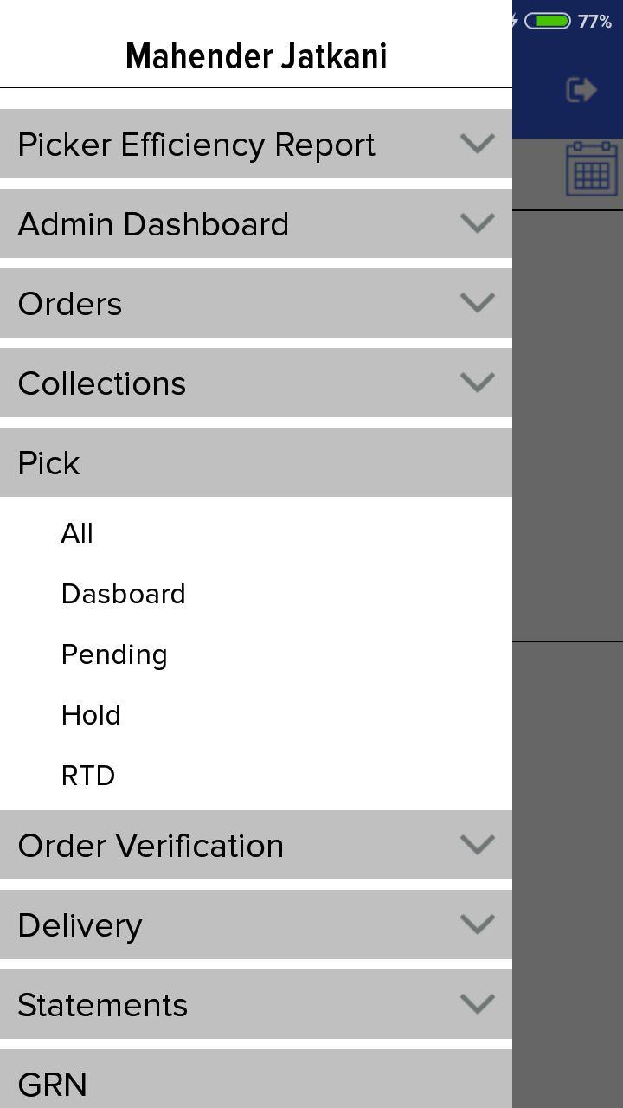 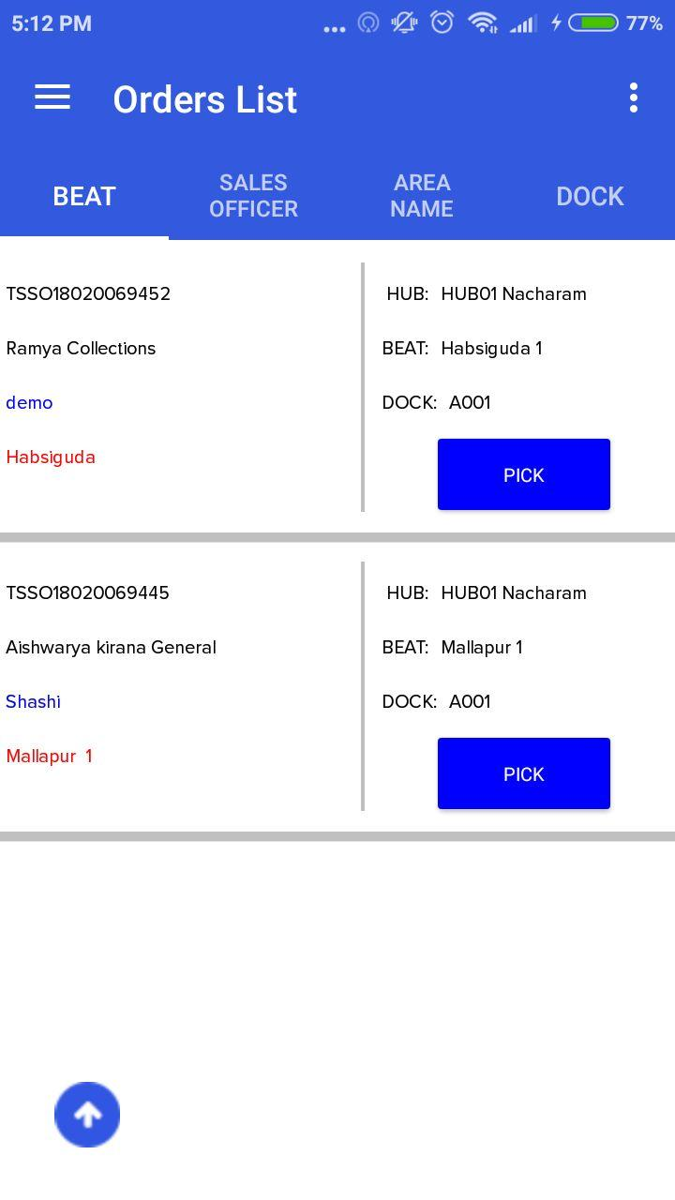

Screen 3: Screen 4: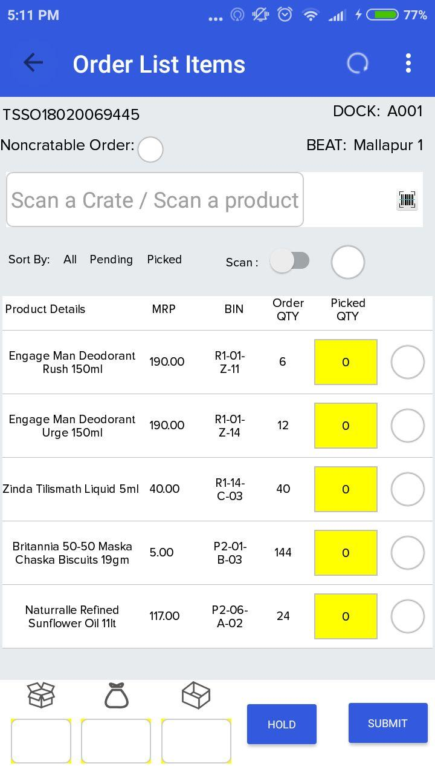 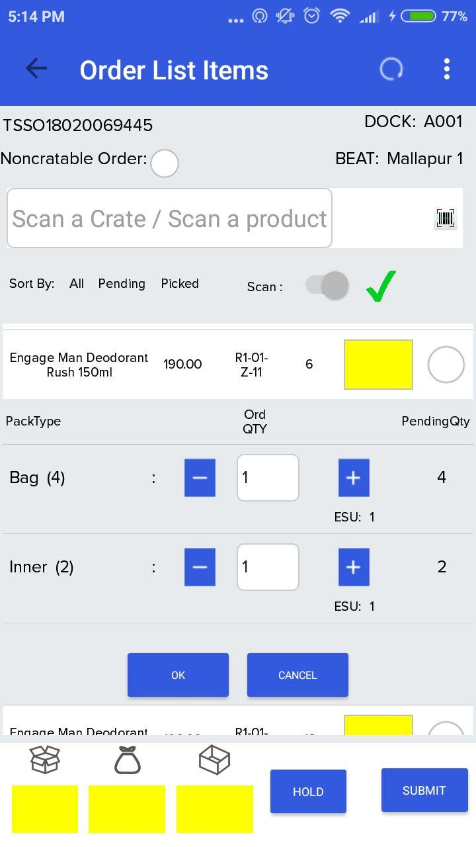

Screen 5: Screen 6: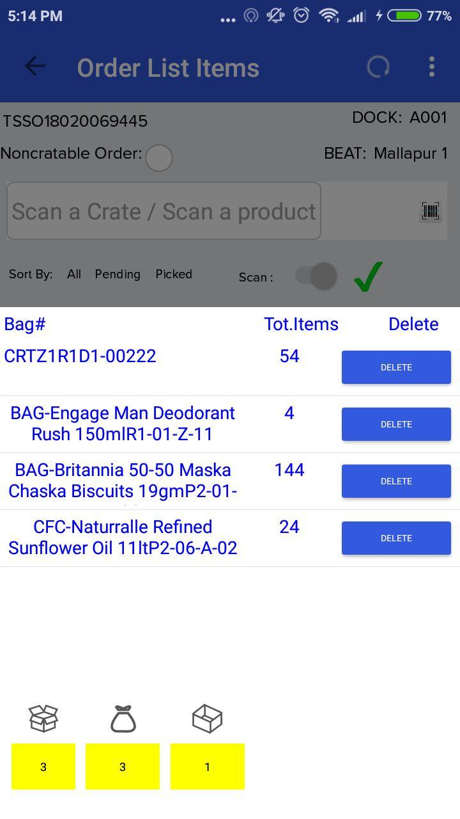 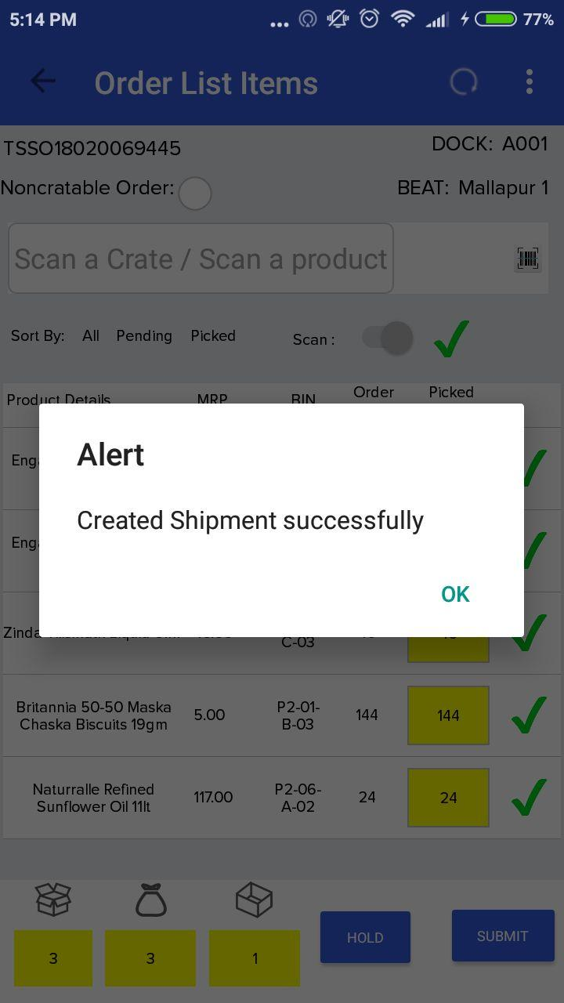

Picker needs to follow below steps:

1. Login to APP, go to left menu, tap on “Pick”(Screen 1).
2. Tap on “Pending” (Screen 1).
3. Pending picking list will display on next page (Screen 2).
4. Tap on “Pick” button to order detail page.
5. Next page will display order products/qty/bins (Screen 3).
6. Scan some empty crate to start picking.
7. Tap on products to expand it (Screen 4).
8. Provide exact picking qty by tapping on (+/-) button(Screen 4).
9. Repeate step 7-8 for all products to complete picking.
10. To see summary of picked items, tab on images at bottom of page (Screen 5).
11. Tab on submit button at bottom to complete picking.
12. Confirmation message will display, after submittion (Screen 6).

Below are some conditions pickers needs to take care of:

1. Picker should enable scanning if he tries to pick with containers(present we are following the procedure)
2. After scanning picker cannot pick any item, unless the entire order is non-cratable order.
3. We are displaying a checkbox if it is a non-cratable order(in this case picker can pick item without scanning a crate).
4. Picker can pick partially or can ignore any item depending on available qty for him while picking at DC. In such case remaining qty will get auto cancle.
5. Picker can delete container in any case required and can scan again , repick items.
6. Picker can cancel entire order by submitting without picking any item.
7. In any case either item cancel/order cancel picker should provide reason for mandatory.
8. Picker can hold any order anytime and can pick order afterwards.
9. Picker will loose the information if he jumps back to the previous page(orderlistpage) without keeping that order in hold.
10. All containers that are used in the process of picking that particular order are updated to filled state.

### API's used under picking process

**API 1: getPickOrderList**

Description: To get list of pending orders for picking

API Details:<https://docs.google.com/document/d/1SHdMz8StrKr4Ug0fyXq820bEkasSqyLm4P-FqGmk_bM/edit?usp=sharing#heading=h.ffbh2buyay3r>

**API 2: getpicklistdetails**

Description: To get details of order.

API Details:<https://docs.google.com/document/d/1SHdMz8StrKr4Ug0fyXq820bEkasSqyLm4P-FqGmk_bM/edit?usp=sharing#heading=h.hd0wtw5o1pqt>

**API 3: checkcontainer**

Description: Check whether Crate is Empty and Available or not.

API Details:<https://docs.google.com/document/d/1SHdMz8StrKr4Ug0fyXq820bEkasSqyLm4P-FqGmk_bM/edit?usp=sharing#heading=h.7xaim7t90gs9>

**API 4: setcratestatus**

Description: To make crate filled after picking

API Details:<https://docs.google.com/document/d/1SHdMz8StrKr4Ug0fyXq820bEkasSqyLm4P-FqGmk_bM/edit?usp=sharing#heading=h.jogqzygp6qkm>

**API 5: insertMobileApiLog**

Description: To insert mobile logs before submitting picking

API Details:<https://docs.google.com/document/d/1SHdMz8StrKr4Ug0fyXq820bEkasSqyLm4P-FqGmk_bM/edit?usp=sharing#heading=h.cr365t2isz2e>

**API 6: saveContainerData**

Description: Submit picking data from mobile, it will update many tables and change Order status to “RTD”

API Details:<https://docs.google.com/document/d/1SHdMz8StrKr4Ug0fyXq820bEkasSqyLm4P-FqGmk_bM/edit?usp=sharing#heading=h.rquwasz6v4qb>

**API 7: updatecontainer**

Description: To update crate status to “Empty”

API Details:<https://docs.google.com/document/d/1SHdMz8StrKr4Ug0fyXq820bEkasSqyLm4P-FqGmk_bM/edit?usp=sharing#heading=h.bhl9gfxgkizq>

**API 8: getRtdOrdersData**

Description: To display all RTD orders(unassigned) ready for verification

API Details:<https://docs.google.com/document/d/1SHdMz8StrKr4Ug0fyXq820bEkasSqyLm4P-FqGmk_bM/edit?usp=sharing#heading=h.mrj88hb5name>