# Verification

**Description**: At verification(checking) process, checker needs to check all picked items by picker. So that we would be confirmed that we are sending correct items with correct qty to customers. Verification process helps to reduce returns initiated by customer because of incorrect delivered items.

Screens related to verification process:

Screen 1: Screen 2: 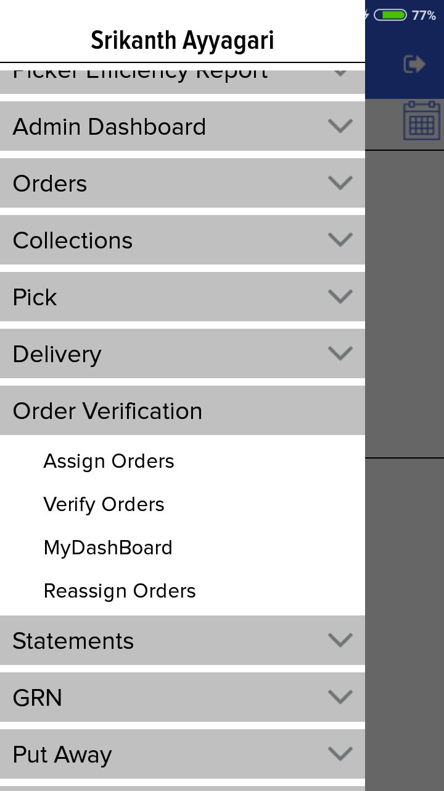 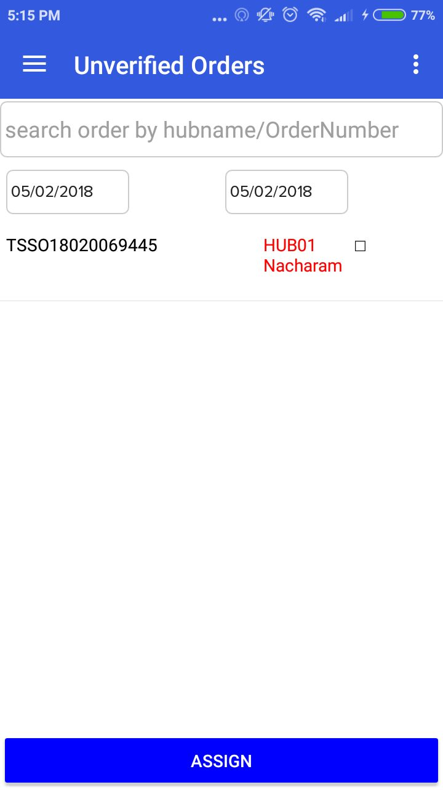

Screen 3: Screen 4:

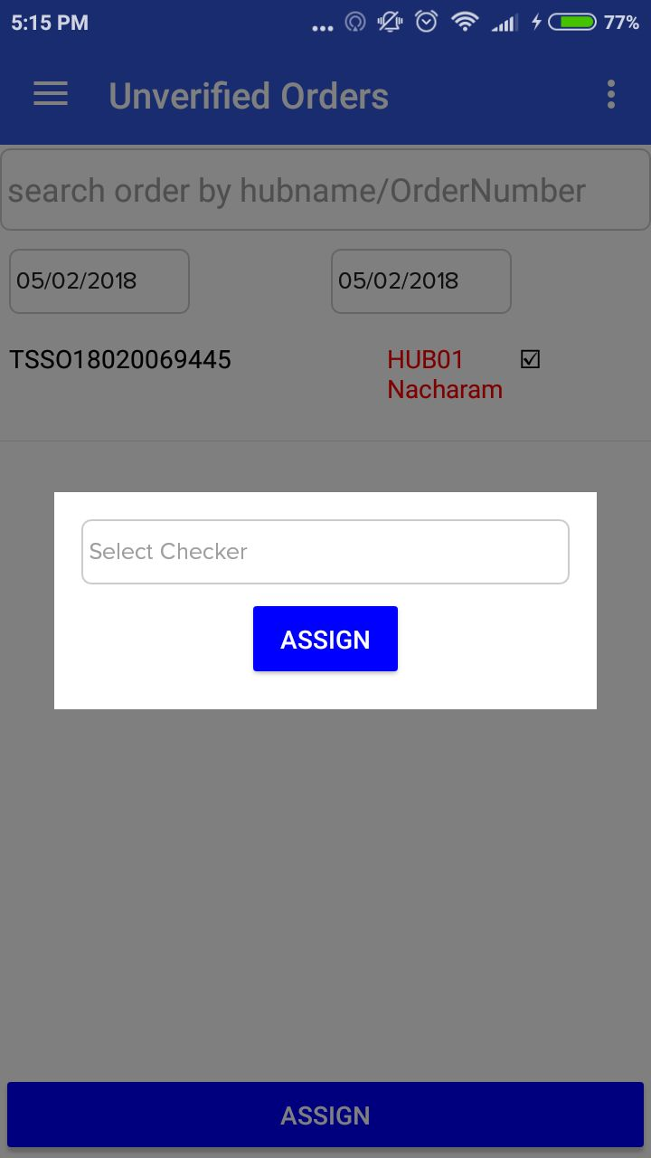 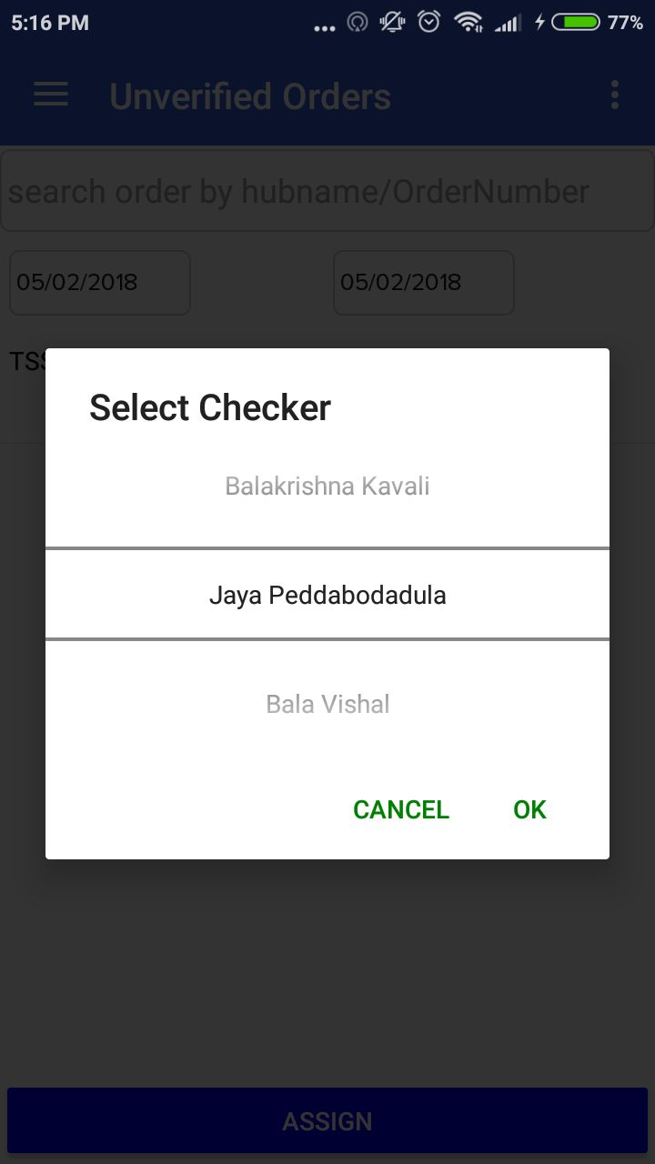

Screen 5: Screen 6:

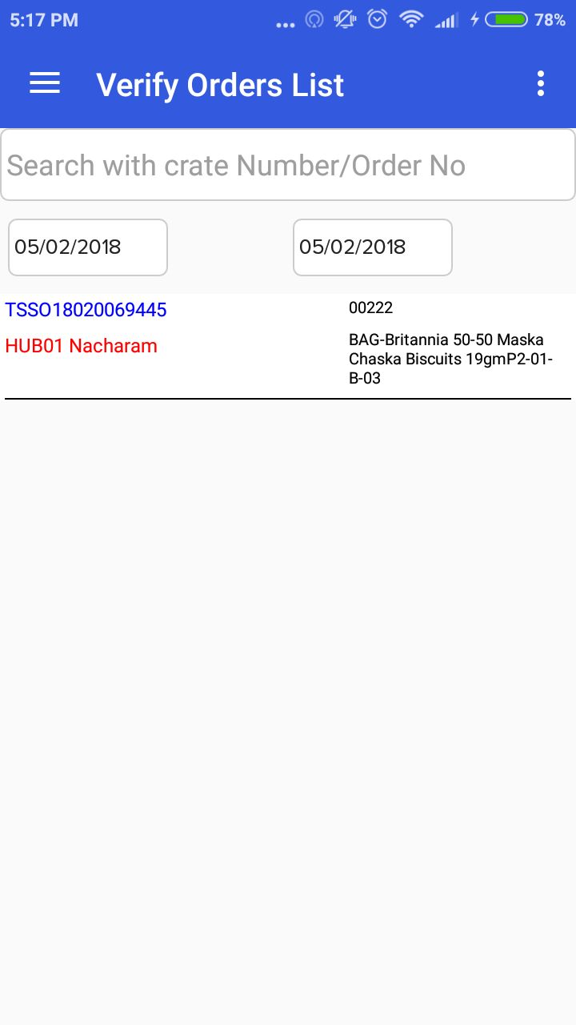 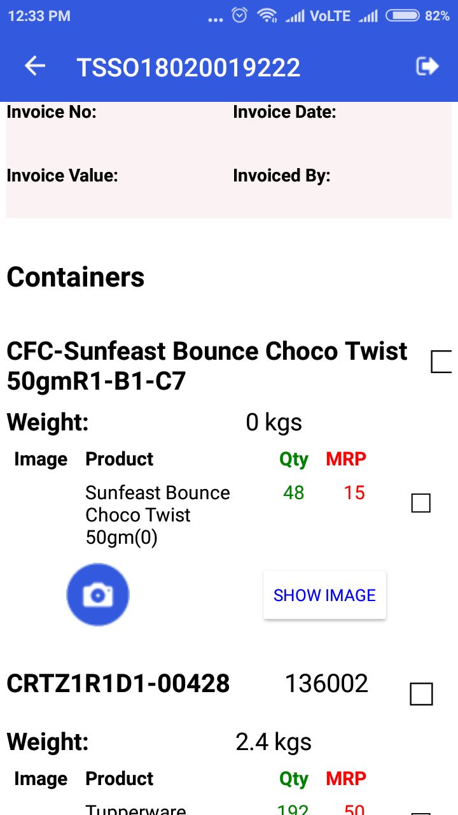

Screen 7: Screen 8:

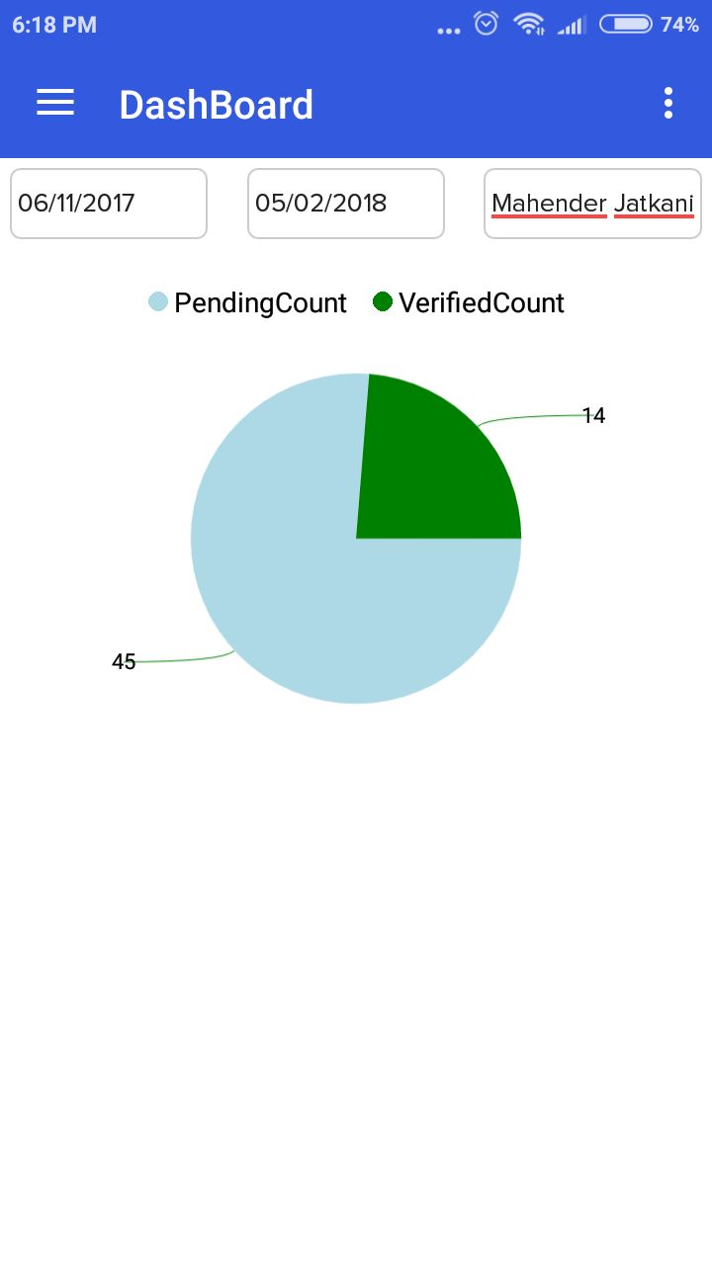 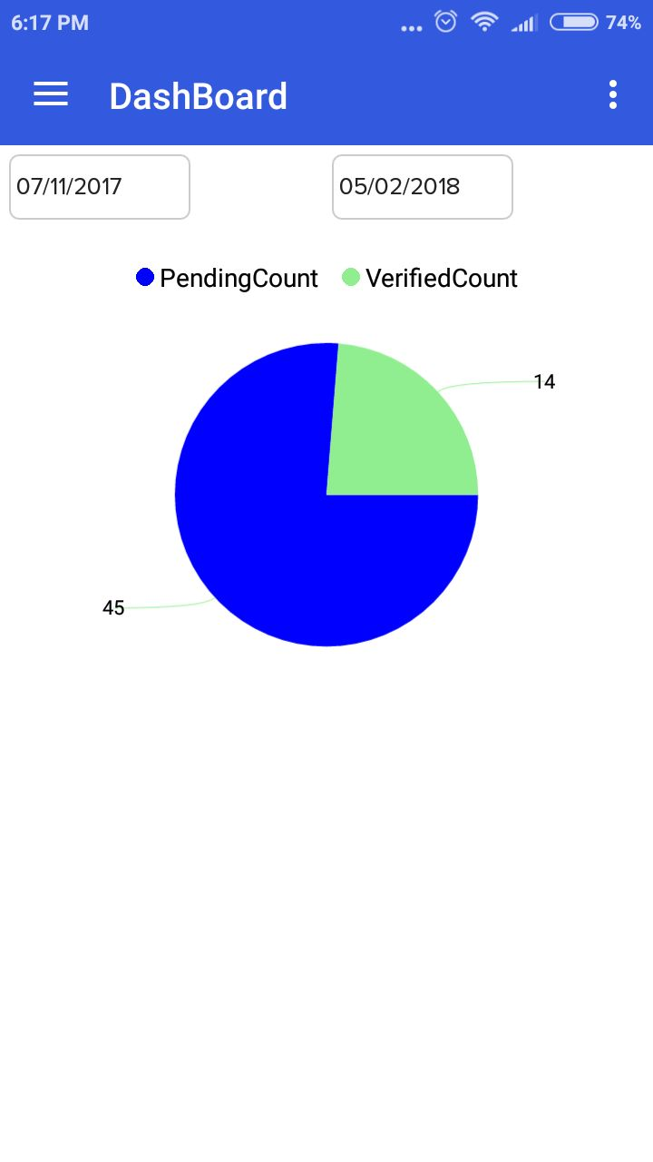

Follow below steps to assign RTD orders to checker:

1. User needs to login at LP APP.
2. Go to left menu, tap on “Order verification”, tap on “Assign Orders” (Screen 1)
3. Next screen will display list of unverified orders (Screen 2).
4. Select orders by checking checkboxes, click on “Assign” (Screen 3).
5. Pop-up will come, where you can give checker name (Screen 3).
6. Select a checker to assign with selected orders (Screen 4).
7. Successful message will be displayed.
8. Manager can see Verified/Pending status on dashboard (Screen 7).

Checker needs to follow below steps to process verification:

1. Checker needs to login on LP APP.
2. Go to left menu, tap in “Order Verification”, tap on “Verify Orders” (Screen 1).
3. Order details page will display, it will include product details of order (Screen 2).
4. Checker needs to take picture (by clicking on Camera Icon) of product he is checking.
5. Checker needs to tick each verified products.
6. After all products got verified, click on “Submit”.
7. Confirmation message will display.
8. Personal dashboard for Checker, to see pending and verified orders (Screen 8)

API’s used for Verification process:

**API 1: getRtdOrdersData**

Description: To get list of RTD orders for verification

API Details: <https://docs.google.com/document/d/1SHdMz8StrKr4Ug0fyXq820bEkasSqyLm4P-FqGmk_bM/edit?usp=sharing#heading=h.mrj88hb5name>

**API 2: getCheckersList**

Description: To get list of Checkers.

API Details:

<https://docs.google.com/document/d/1SHdMz8StrKr4Ug0fyXq820bEkasSqyLm4P-FqGmk_bM/edit?usp=sharing#heading=h.22x7f2fbswoh>

**API 3: assignOrdersForChecker**

Description: To assign orders to checker.

API Details: <https://docs.google.com/document/d/1SHdMz8StrKr4Ug0fyXq820bEkasSqyLm4P-FqGmk_bM/edit?usp=sharing#heading=h.9cq4g8icj8l3>

**API 4: getAssignedVerificationList**

Description: To get rtd orders(assigned orders) for re-assigning to a checker

API Details: <https://docs.google.com/document/d/1SHdMz8StrKr4Ug0fyXq820bEkasSqyLm4P-FqGmk_bM/edit?usp=sharing#heading=h.10x1sb5oktkg>

**API 5: getpendingVerification**

Description: To get list of pending orders for verification based on checker

API Details: <https://docs.google.com/document/d/1SHdMz8StrKr4Ug0fyXq820bEkasSqyLm4P-FqGmk_bM/edit?usp=sharing#heading=h.6y28fdgjd2e0>

**API 6: getCrateDetails**

Description: To get detail about order related to crate

API Details: <https://docs.google.com/document/d/1SHdMz8StrKr4Ug0fyXq820bEkasSqyLm4P-FqGmk_bM/edit?usp=sharing#heading=h.19yttbq4zds9>

**API 7: getWrongPickedProducts**

Description: To check whether any wring item got picked or not

API Details: <https://docs.google.com/document/d/1SHdMz8StrKr4Ug0fyXq820bEkasSqyLm4P-FqGmk_bM/edit?usp=sharing#heading=h.19yttbq4zds9>

**API 8: saveCrateVerification**

Description: To check whether any wring item got picked or not

API Details: <https://docs.google.com/document/d/1SHdMz8StrKr4Ug0fyXq820bEkasSqyLm4P-FqGmk_bM/edit?usp=sharing#heading=h.dimft59tfzg2>