PENETRATION TESTING REPORT
FOOTPRINTING, OSINT & NETWORK SCANNING PHASES
W2-PM1 to W2-PM5 | CYBERSECURITY | NETWORKWALKS
PENTESTER NAME | Kings Ojore Ojorumi
BATCH | B083-Networkwalks
DATE | 14 - 17 September 2026
MODULE / WEEK TASK COMPLETED | W2-PM1 (Footprinting With Multiple Tools)  W2-PM2 (Footprinting With GHDB)  W2-PM3 (Footprinting With Maltego)  W2-PM4 (Footprinting With theHarvester)  W2-PM5 (Zenmap Scanning)
TARGET | 1. networkwalks.com (with authorized permission)  2. My own local LAN network (10.0.0.10/24)
PERMISSION | Yes
PHASES | Phase 1: OSINT / Passive Recon (WHOIS, WhatWeb, DNSRecon, theHarvester, Maltego)  Phase 2: DNS Reconnaissance (nslookup, dnsrecon)  Phase 3: Active Web Recon (WhatWeb, curl -i, wafw00f)  Phase 4: Search Engine Hacking (GHDB)  Phase 5: Network Scanning (Zenmap - local LAN)

1. Liability Disclaimer
All activities documented in this report were performed exclusively on systems and devices for which I had obtained explicit written authorization, or on devices/systems that I personally own. This material is provided strictly for educational and research purposes.
Nothing in this document should be used to violate any applicable law. The instructor, the authors, and Networkwalks bear no responsibility for how this knowledge is used — every individual is solely accountable for their own actions. Misuse of these techniques may result in criminal prosecution, substantial fines, loss of employment, and a permanent criminal record. In most jurisdictions, unauthorized access to a computer system constitutes a criminal offense, regardless of whether any damage occurs.

2. Introduction
This report covers Week 2 of my Cybersecurity & Ethical Hacking internship at Networkwalks. It documents footprinting and OSINT activity performed against the networkwalks.com domain (with explicit authorized permission), and network discovery scanning performed against my own local LAN using Zenmap.
The work spans five practical modules: multi-tool footprinting (WHOIS, WhatWeb, nslookup, curl, dnsrecon), Google Hacking Database (GHDB) search-engine reconnaissance, OSINT graphing with Maltego, email/subdomain harvesting with theHarvester, and local network host discovery with Zenmap.
All commands against networkwalks.com were run in Kali Linux. Maltego was run on a separate Kali session. The Zenmap scan was performed from a Windows 10 VM against my own local LAN subnet. Every step below includes the exact command used, the result observed, a screenshot as evidence, and a short note on why the finding matters from an attacker's point of view.

3. Tools Used
The table below lists each tool used in this report and its purpose.
Kali Linux & Windows 10 (VirtualBox) | Operating systems used for reconnaissance and scanning activities
WHOIS | Find domain registration details (registrar, dates, name servers, registrant privacy status)
WhatWeb | Fingerprint web technologies (CMS, plugins, server, IP, headers)
nslookup | Resolve the domain name to its IP address using DNS
curl -i | Read the raw HTTP response headers of the website
wafw00f | Detect whether a Web Application Firewall protects the site
dnsrecon | Enumerate DNS records (SOA, NS, MX, TXT/SPF, SRV) and DNS server software
Google Hacking Database (GHDB) | Search-engine dorking to locate exposed devices/files indexed by Google
Maltego | Graph-based OSINT correlation (domain → associated email addresses, infrastructure)
theHarvester | Harvest emails, subdomains and hosts from public/search-engine sources
Zenmap (Nmap GUI) | Scan the local subnet to find live hosts, IPs and MAC addresses
Windows ipconfig | Identify local IP address, subnet mask and default gateway

4. Activities Performed

4.1 Footprinting & Reconnaissance — networkwalks.com
With authorized permission from Networkwalks, I performed OSINT and footprinting against the networkwalks.com domain using WHOIS, WhatWeb, nslookup, curl, wafw00f and dnsrecon.

4.2 Search Engine Hacking (GHDB)
As part of the search-engine hacking module, I used Google Hacking Database (GHDB) dorks to demonstrate how search-engine indexing can expose (a) unsecured, internet-facing security camera interfaces and (b) publicly indexed downloadable files — in this case, mathematics eBooks in PDF format. This activity targeted content already indexed by Google, was passive (query-only, no login attempts or interaction with any discovered device/server), and none of the discovered systems belong to networkwalks.com or fall within the authorized test scope for that domain.

1 | http://68.115.218.130:32479/multi.html | inurl:/multi.html intitle:webcam
2 | http://139.64.168.120:8080/ | intitle:"webcamXP" inurl:8080
3 | http://109.233.191.130:8080/ | intitle:"webcamxp" "Flash JPEG Stream"
4 | http://myfishcam.homedns.org:444/ | intitle:"webcamxp" "Flash JPEG Stream"
5 | http://109.206.96.249:8080/ | intitle:"webcamXP 5" inurl:8080 'Live'
6 | http://99.114.240.169:8080/ | inurl:/multi.html intitle:webcam
7 | http://87.149.209.173:8080/ | intitle:"webcamXP 5" inurl:8080 'Live'
8 | http://184.57.102.6:5400/ | intitle:"webcamXP 5" inurl:8080 'Live'
9 | http://184.57.102.6:5800/ | intitle:"webcamXP 5" inurl:8080 'Live'
10 | http://75.149.26.30:1024/ | intitle:"webcamXP 5" -download
No credentials were found, requested or used for any of the above — all ten interfaces were reachable without authentication, which is itself the finding.

1 | https://mathweb.ucsd.edu/~jverstra/Math180A-Lecture21.pdf
2 | http://erewhon.superkuh.com/library/Math/A Concise Introduction to Mathematical Logic_ 3rd ed_ Wolfgang Rautenberg_ 2009.pdf
3 | https://web.eecs.umich.edu/~fessler/book/a-math.pdf
4 | https://isidore.co/CalibreLibrary/Klein, Felix/Elementary Mathematics from a Higher Standpoint_ Volume I_ Arithmetic, Algebra, Analysis (6600)/
5 | https://education.giakonda.org.uk/Maths/Additional_Mathematics__Pure_and_Applied.pdf
6 | https://www.caltecacademy.com/notes/s.3/O Level Math Book 1.pdf
7 | https://educasia.org/wp-content/uploads/Maths-1-Numbers-SB.pdf
8 | https://www.aetkin.com/files/Math 150 Calculus I/Advanced Calculus Textbook/Calculus 1 textbook.pdf
9 | http://erewhon.superkuh.com/library/Math/Introduction to Mathematical Physics_ Michael T Vaughn_ 2007.pdf
10 | https://www.math.ucdavis.edu/~tjlewis/teaching/MAT17material/books/book_LEK/M103Fulltext.pdf
No username or password was required for any of these files — all were retrievable directly from open directory listings, indicating the hosting servers had directory browsing enabled and/or the files were not access-controlled.

4.3 OSINT Correlation with Maltego
I used Maltego (Desktop 4.13.0) to graph OSINT relationships starting from the networkwalks.com Domain entity. Running the "To Email Addresses [Search Engine]" transform against the domain returned the associated email address info@networkwalks.com, confirming the same contact address surfaced independently by WhatWeb. This demonstrates how a single domain entity can be pivoted into related infrastructure and personnel/contact information using chained transforms.

4.4 Email & Subdomain Harvesting with theHarvester
This module was a separate practice task and was deliberately run against microsoft.com rather than networkwalks.com, to practice theHarvester's syntax and source options on a large, well-known domain. An initial run without the required -d flag returned a usage error, confirming the correct syntax. A run with the Baidu source (theHarvester -d microsoft.com -l 1000 -b baidu) completed successfully but returned no IPs, emails, people or hosts for that source. A broader run using all sources (theHarvester -d microsoft.com -l 50 -b all) executed, but the majority of premium sources (bevigil, Bitbucket, bufferoverun, BuiltWith, Brave Search, Censys, etc.) failed due to missing API keys, which is expected on a default Kali installation without paid/free-tier API keys configured.
Key takeaway: theHarvester's usefulness depends heavily on having valid API keys configured for its data sources. This exercise confirmed correct command syntax and demonstrated the tool's behaviour when sources are unavailable. As a next step, this module could be re-run with API keys configured, and/or pointed at networkwalks.com, to attempt actual email/subdomain harvesting against the authorized target.

4.5 Network Scanning with Zenmap
For the final activity, I used Zenmap to perform host discovery on my own local network from a Windows 10 VM. I first ran ipconfig, which identified my local IPv4 address as 10.0.0.10 on subnet mask 255.255.255.0 with default gateway 10.0.0.1.

- 10.0.0.1 — MAC 52:55:0A:00:00:01 (vendor unknown) — default gateway
- 10.0.0.2 — MAC 08:00:27:8A:35:D2 (Oracle VirtualBox virtual NIC)
- 10.0.0.3 — MAC 52:55:0A:00:00:03 (vendor unknown)
- 10.0.0.10 — the scanning host itself (no MAC reported for local interface)
After completing the scan, I opened the Topology tab, enabled the legend to confirm the marker meanings (green = host with fewer than 3 open ports; dashed lines = no traceroute information available), and reviewed the resulting star topology showing all discovered hosts connecting through the local host.

5. Risk Analysis / Impact
Based on the information collected during the footprinting, OSINT and network scanning activities, I identified the following potential risks.
1 | Web technology and plugin versions exposed | WhatWeb and curl identified WordPress 7.1, WP Download Manager 3.3.58, and the "Really Simple Security" plugin via the X-Redirect-By header | Attackers can target known vulnerabilities for the specific CMS/plugin versions in use | ● Medium
2 | Server IP address identifiable | nslookup and WhatWeb both resolved 192.232.216.135 | Provides a direct target for network-layer scanning/enumeration | ● Low
3 | HTTP technical information exposed | curl -i returned server banner, security-plugin name, and a session cookie tied to WP Download Manager | Assists technology fingerprinting and targeted exploitation of the identified plugin | ● Medium
4 | WAF vendor identifiable | wafw00f identified ModSecurity (SpiderLabs) | Reveals the security architecture, which can help an attacker select known WAF-evasion techniques | ● Low
5 | DNS infrastructure and mail routing exposed | dnsrecon identified NS/SOA/MX/SPF/SRV records and BIND version 9.16.23-RH on both name servers | Builds a broader infrastructure/hosting profile and reveals the DNS server software version | ● Medium
6 | Contact email address discoverable via OSINT | WhatWeb and Maltego's "To Email Addresses" transform both surfaced info@networkwalks.com | Usable as a target for phishing or social-engineering campaigns | ● Low
7 | Multiple live hosts visible on the local network | Zenmap ping scan identified 4 live hosts (10.0.0.1, .2, .3, .10) with MAC addresses for 3 of them | Unknown or unauthorized devices could be present on the network if any host is not accounted for | ● Medium
8 | theHarvester practice task limited by missing API keys | Deliberate practice run against microsoft.com; most sources under -b all failed due to missing API keys on the default Kali install | Not a networkwalks.com finding — illustrates that OSINT tool coverage is incomplete without proper API key configuration | N/A
9 | Unauthenticated live security cameras discoverable via search-engine dorking (general internet exposure, not networkwalks.com) | 10 internet-facing webcam interfaces located via GHDB dorks, none requiring a username or password to view | Demonstrates how easily unsecured IoT/camera devices can be found and viewed by anyone; a real-world privacy exposure for whoever owns each device | ● Critical
10 | Copyrighted/restricted files exposed via open directory listings (general internet exposure, not networkwalks.com) | 10 downloadable mathematics PDF files located via GHDB "index of" dorking, none access-controlled | Shows how misconfigured directory listings can expose files never intended for public download | ● Medium
Risk level key:
● Critical ● Medium ● Low
Note: risks #1–8 relate to the authorized networkwalks.com engagement and my own local network. Risks #9–10 were surfaced purely to demonstrate the GHDB search-engine hacking technique against the open internet in general — the exposed cameras and files are unrelated to networkwalks.com, do not fall within this engagement's scope, and no interaction beyond viewing the search results took place.
The risks above are observations from footprinting, OSINT and host-discovery exercises, not confirmed vulnerabilities.
These activities primarily involved information gathering and host discovery. No exploitation, credential testing or vulnerability validation was performed as part of these modules.
Therefore, the presence of information such as a software version, IP address, or DNS record does not by itself mean that the system is vulnerable. Further authorized security testing would be required to confirm any actual exploitable vulnerability.

6. Recommendations
Based on the observations from these activities, I recommend the following security improvements:
- Review publicly exposed technology information — regularly audit what CMS, plugin and server version information is visible via HTTP headers and fingerprinting tools such as WhatWeb.
- Suppress version-revealing headers — configure the security plugin (or web server/reverse proxy) so that the X-Redirect-By and similar headers do not disclose the specific security plugin name in use.
- Keep WordPress core, themes and plugins updated — particularly WordPress 7.1 and WP Download Manager 3.3.58, reviewed against current CVEs/security advisories.
- Review HTTP response headers — remove or minimize unnecessary technical headers/cookies that aid fingerprinting.
- Harden DNS configuration — restrict BIND version disclosure on the name servers and periodically review SPF/TXT/SRV records to ensure only required services are publicly exposed.
- Consider enabling DNSSEC — the domain currently returns unsigned DNSSEC, leaving DNS responses unauthenticated.
- Properly configure and monitor the WAF — keep ModSecurity enabled and tuned, and periodically validate it against current attack patterns.
- Limit public exposure of contact emails — consider a contact form instead of a plaintext email address to reduce phishing/harvesting exposure.
- Perform regular internal network discovery — periodically scan the local network to confirm that all live hosts and MAC addresses are accounted for.
- Investigate unknown devices — any host with an unrecognized MAC vendor discovered during scanning should be investigated and verified.
- Configure API keys for OSINT tooling — supply valid API keys for theHarvester's data sources so future engagements produce reliable, complete results.
- Perform security testing only with authorization — reconnaissance and scanning should only be performed against systems and networks where appropriate authorization has been granted.
- Disable directory browsing and enforce authentication on network-attached cameras and file servers — the GHDB exercise showed how quickly search engines index unsecured devices/files; owners of internet-facing devices should always set a strong username/password and disable default open access.

7. Conclusion
During Week 2 of my Cybersecurity & Ethical Hacking internship, I completed practical activities covering footprinting, OSINT correlation, search-engine reconnaissance and local network scanning.
In the footprinting activity, I used WHOIS, WhatWeb, nslookup, curl and dnsrecon to build a profile of networkwalks.com — confirming its hosting provider, exposed CMS/plugin versions, WAF vendor, and DNS/mail infrastructure. I supplemented this with Maltego, which independently corroborated a contact email address through a graph-based OSINT transform. As a separate practice task, I also ran theHarvester against microsoft.com to confirm correct tool syntax, which highlighted the importance of proper API key configuration for OSINT modules to return usable results.
In the network scanning activity, I used Zenmap to identify my local network configuration and discover four active hosts, along with their IP and MAC address information, and reviewed the resulting network topology.
These exercises reinforced that information gathering is a foundational part of cybersecurity work. Even before any exploitation is attempted, a significant amount can be learned about an environment by carefully analyzing publicly available information, DNS records, and HTTP responses.
I also learned that clear documentation matters: a good cybersecurity report should explain what was performed, what was discovered, what the observation means, what risk it may create, and what can be done to reduce that risk - including being transparent when a tool or technique did not produce a usable result.
Finally, all reconnaissance and scanning in this report were performed within an authorized scope, either against a domain for which explicit permission was granted, or against infrastructure I personally own.

8. Evidence Collected
8.1 WHOIS Lookup
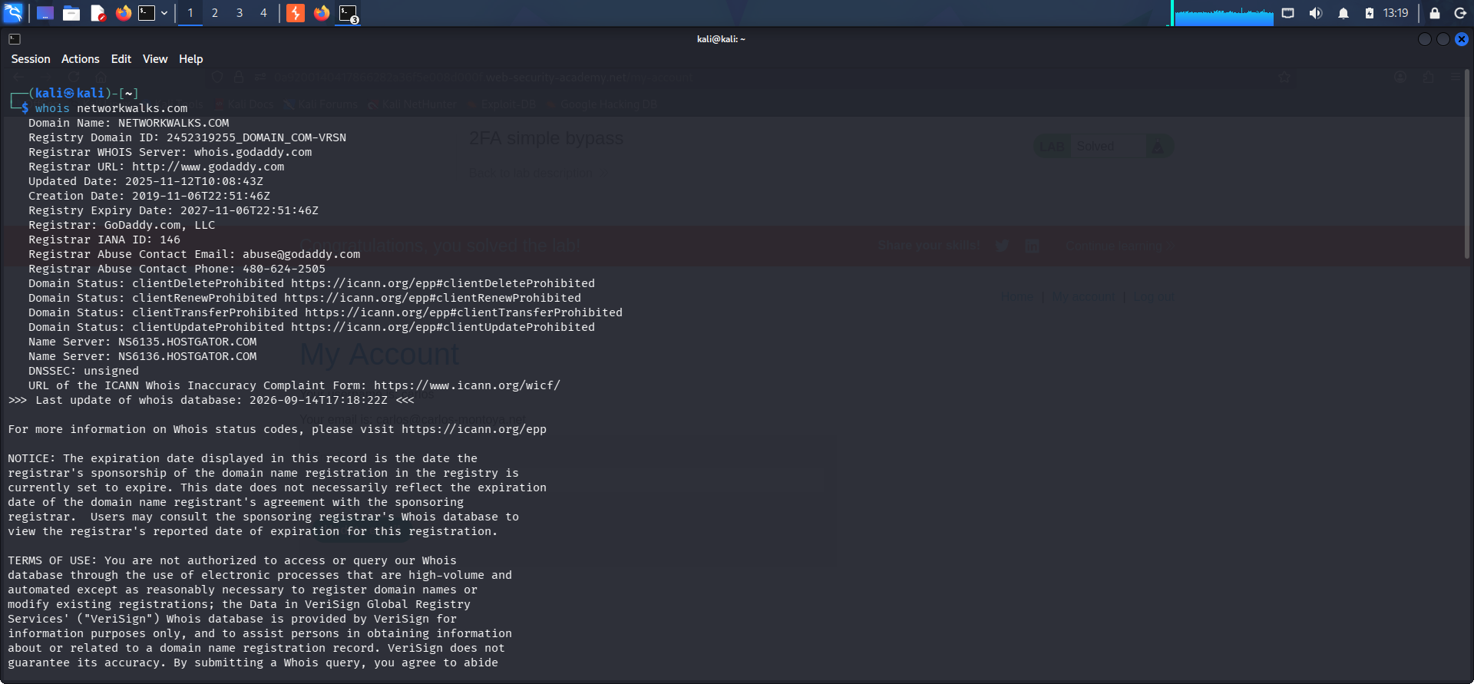
whois networkwalks.com — registrar, name server and registrant privacy details.
8.2 WhatWeb Fingerprinting
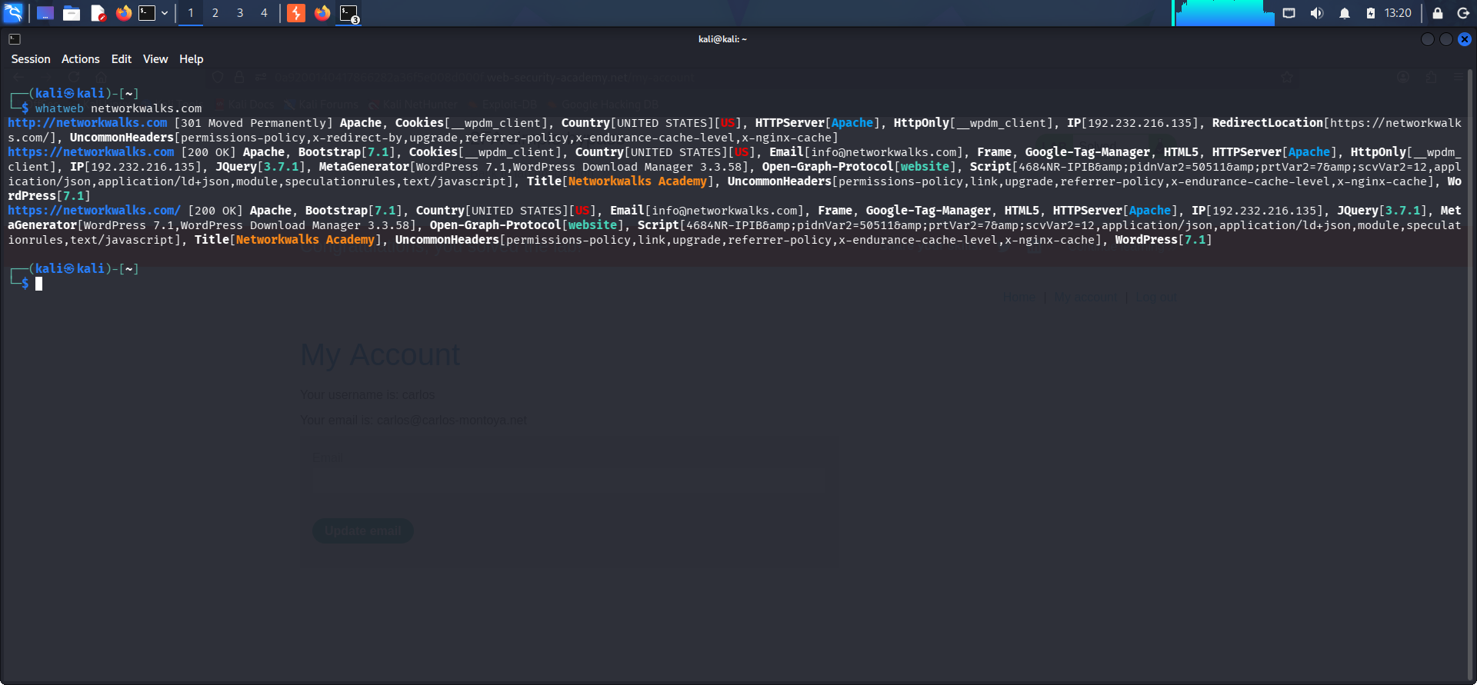
whatweb networkwalks.com — WordPress 7.1, WP Download Manager 3.3.58, Apache, IP 192.232.216.135.

8.3 Nslookup
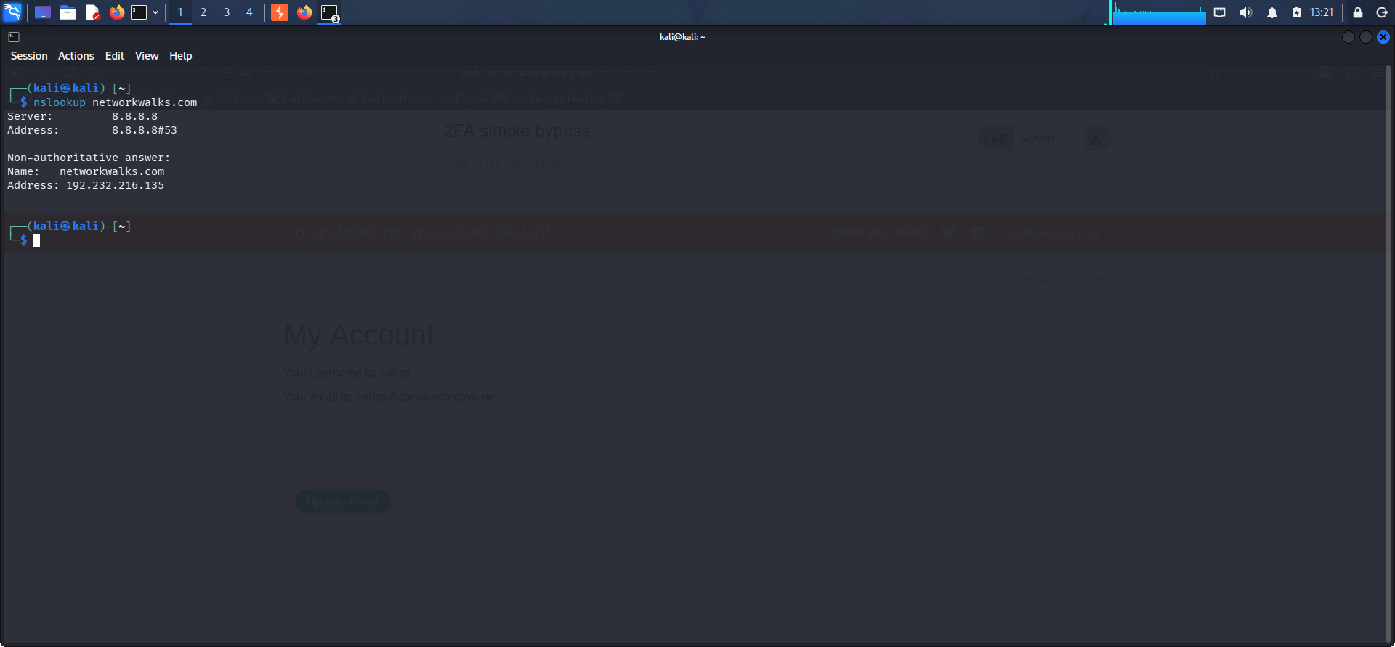
nslookup networkwalks.com — resolved to 192.232.216.135.
8.4 curl -i (HTTP Headers)
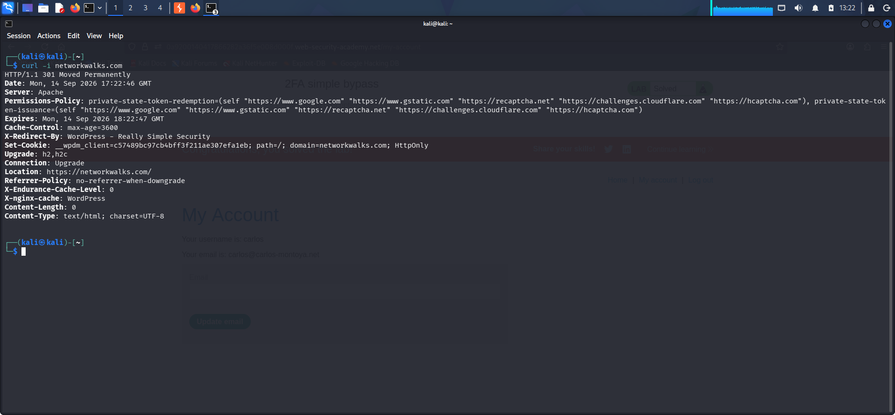
curl -i networkwalks.com — X-Redirect-By security plugin header, cookies, permissions-policy.

8.5 wafw00f (WAF Detection)
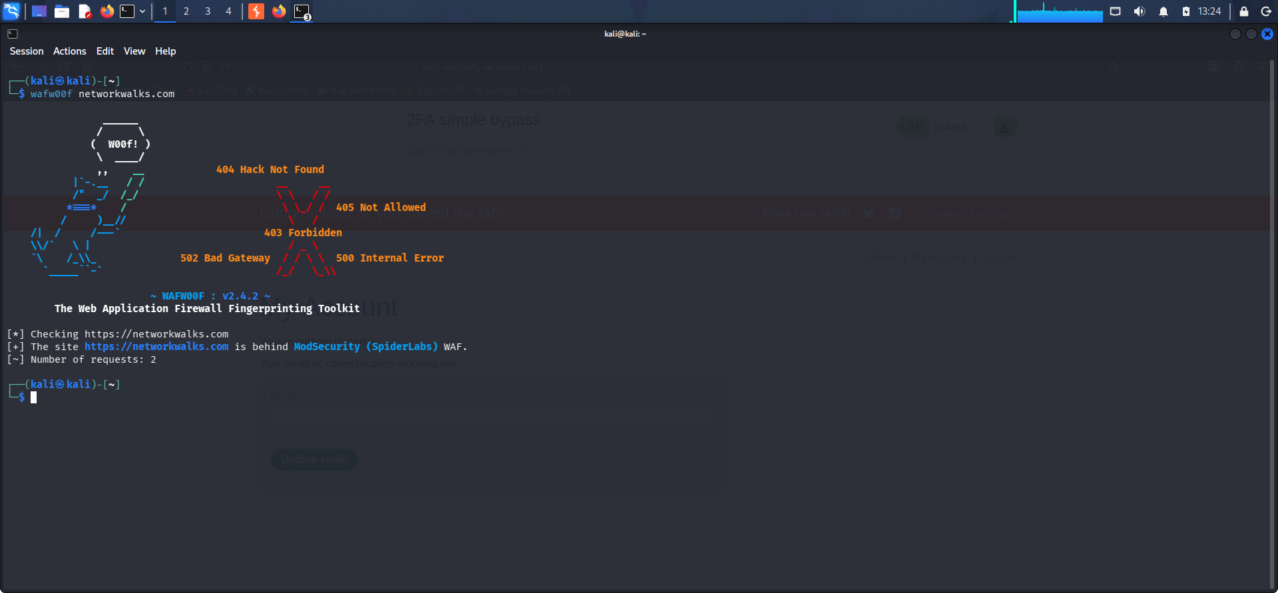
wafw00f networkwalks.com — identified ModSecurity (SpiderLabs) WAF.
8.6 DNSRecon
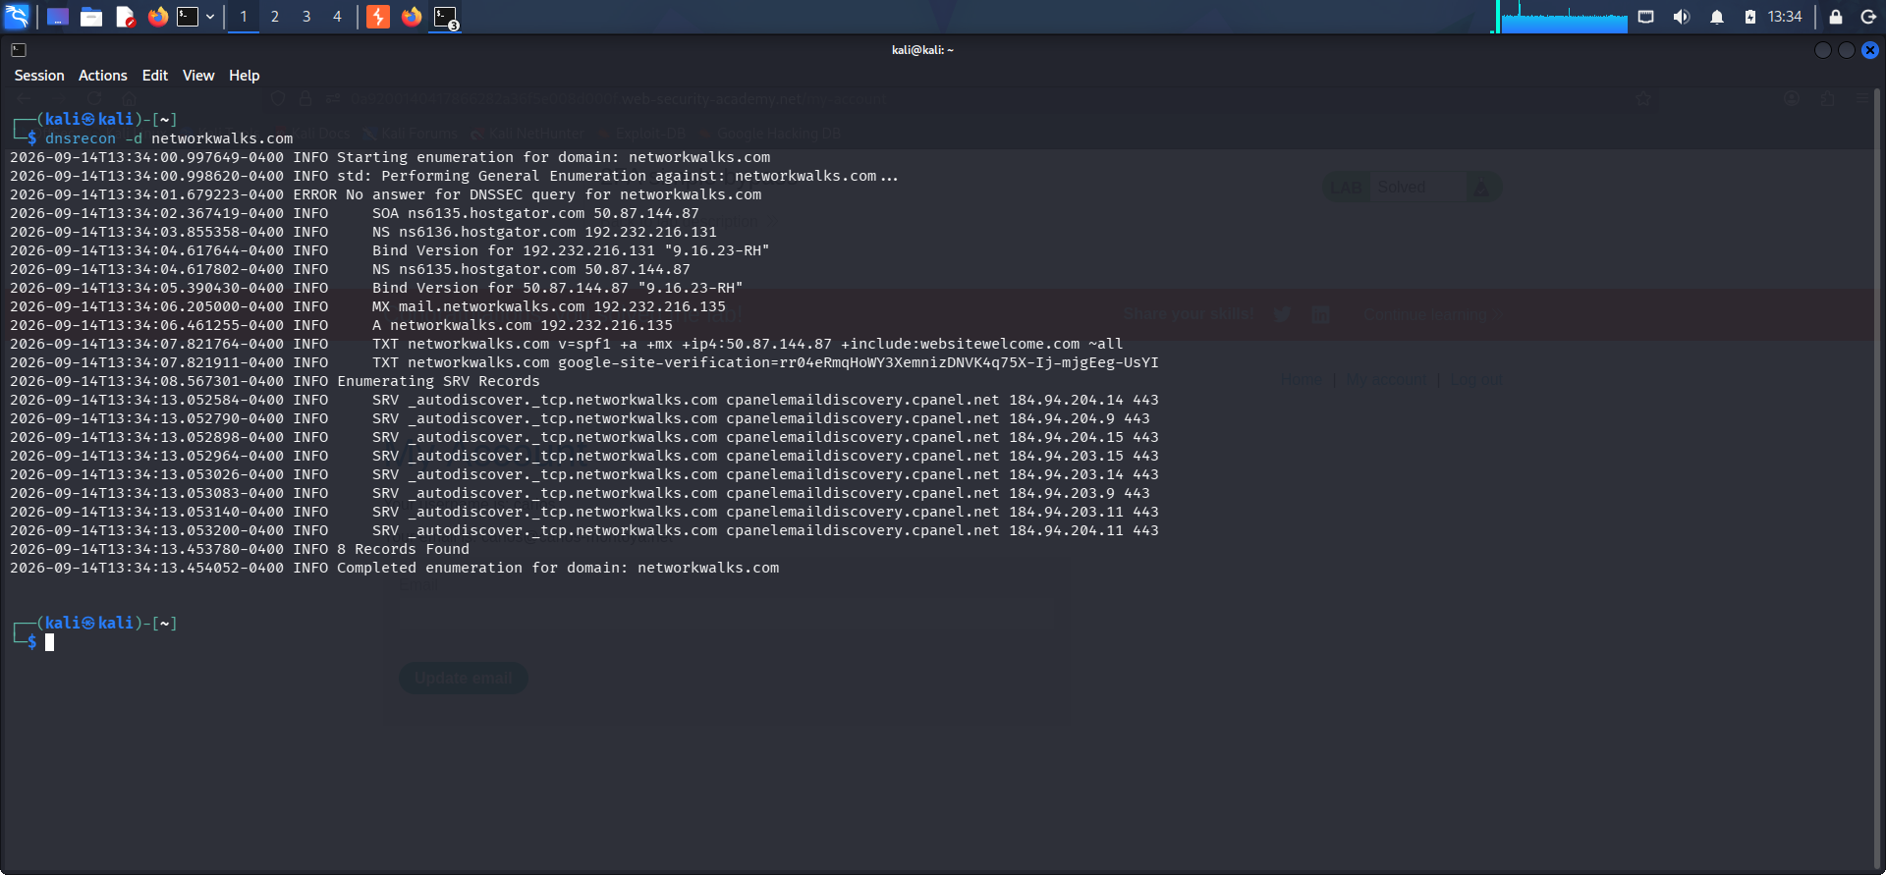
dnsrecon -d networkwalks.com — SOA/NS/MX/TXT/SRV records and BIND version disclosure.

8.7 Maltego OSINT Graph
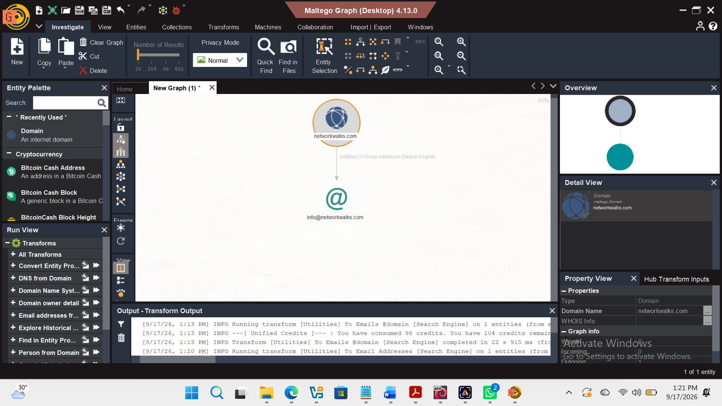
Domain → Email Addresses [Search Engine] transform surfacing info@networkwalks.com.
8.8 theHarvester (Practice Task — microsoft.com)
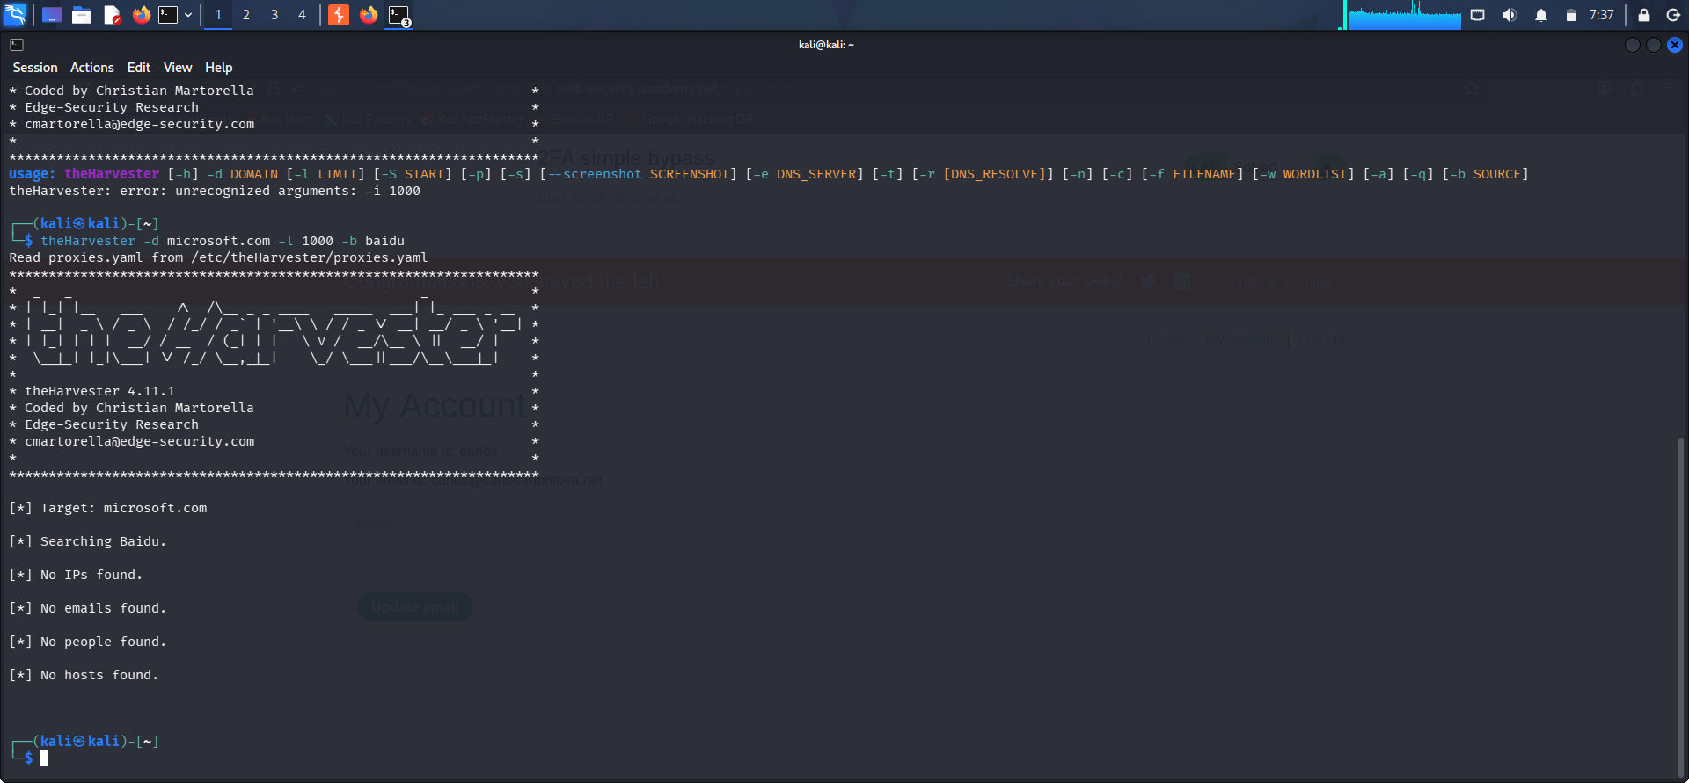
theHarvester -d microsoft.com -l 1000 -b baidu — syntax/tooling practice run; no results returned from the Baidu source for this target.

8.9 Local Network Configuration (ipconfig)
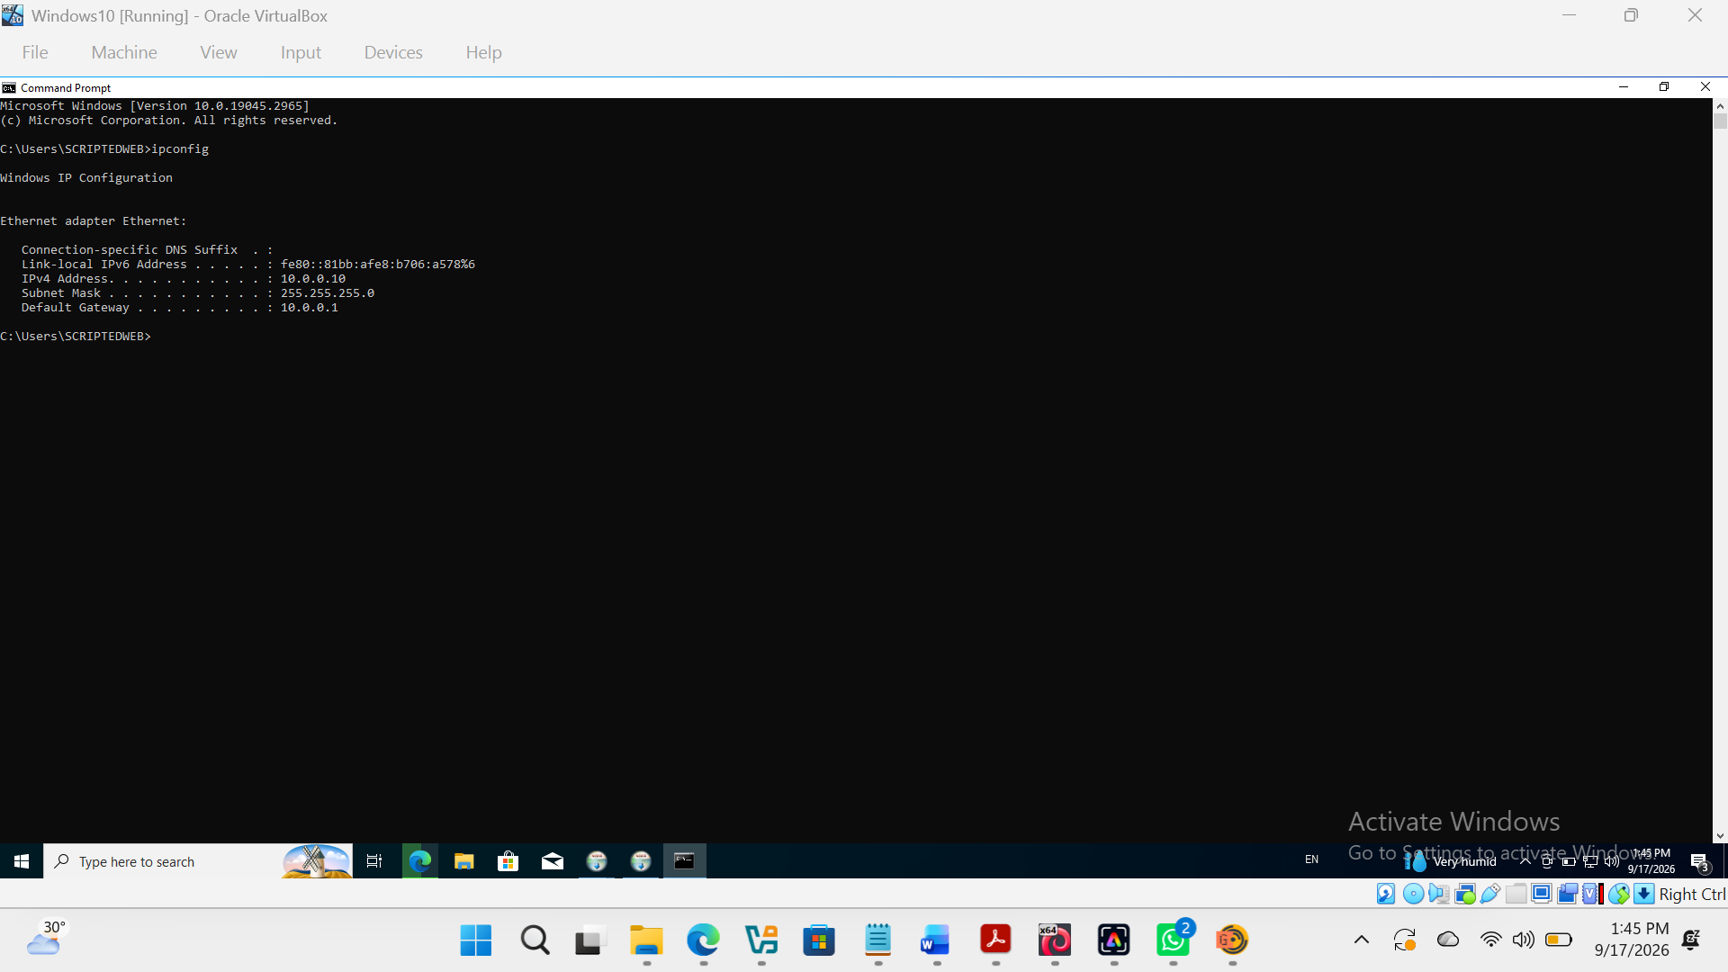
ipconfig on the Windows 10 VM — local IP 10.0.0.10, subnet 255.255.255.0, gateway 10.0.0.1.
8.10 Zenmap Ping Scan
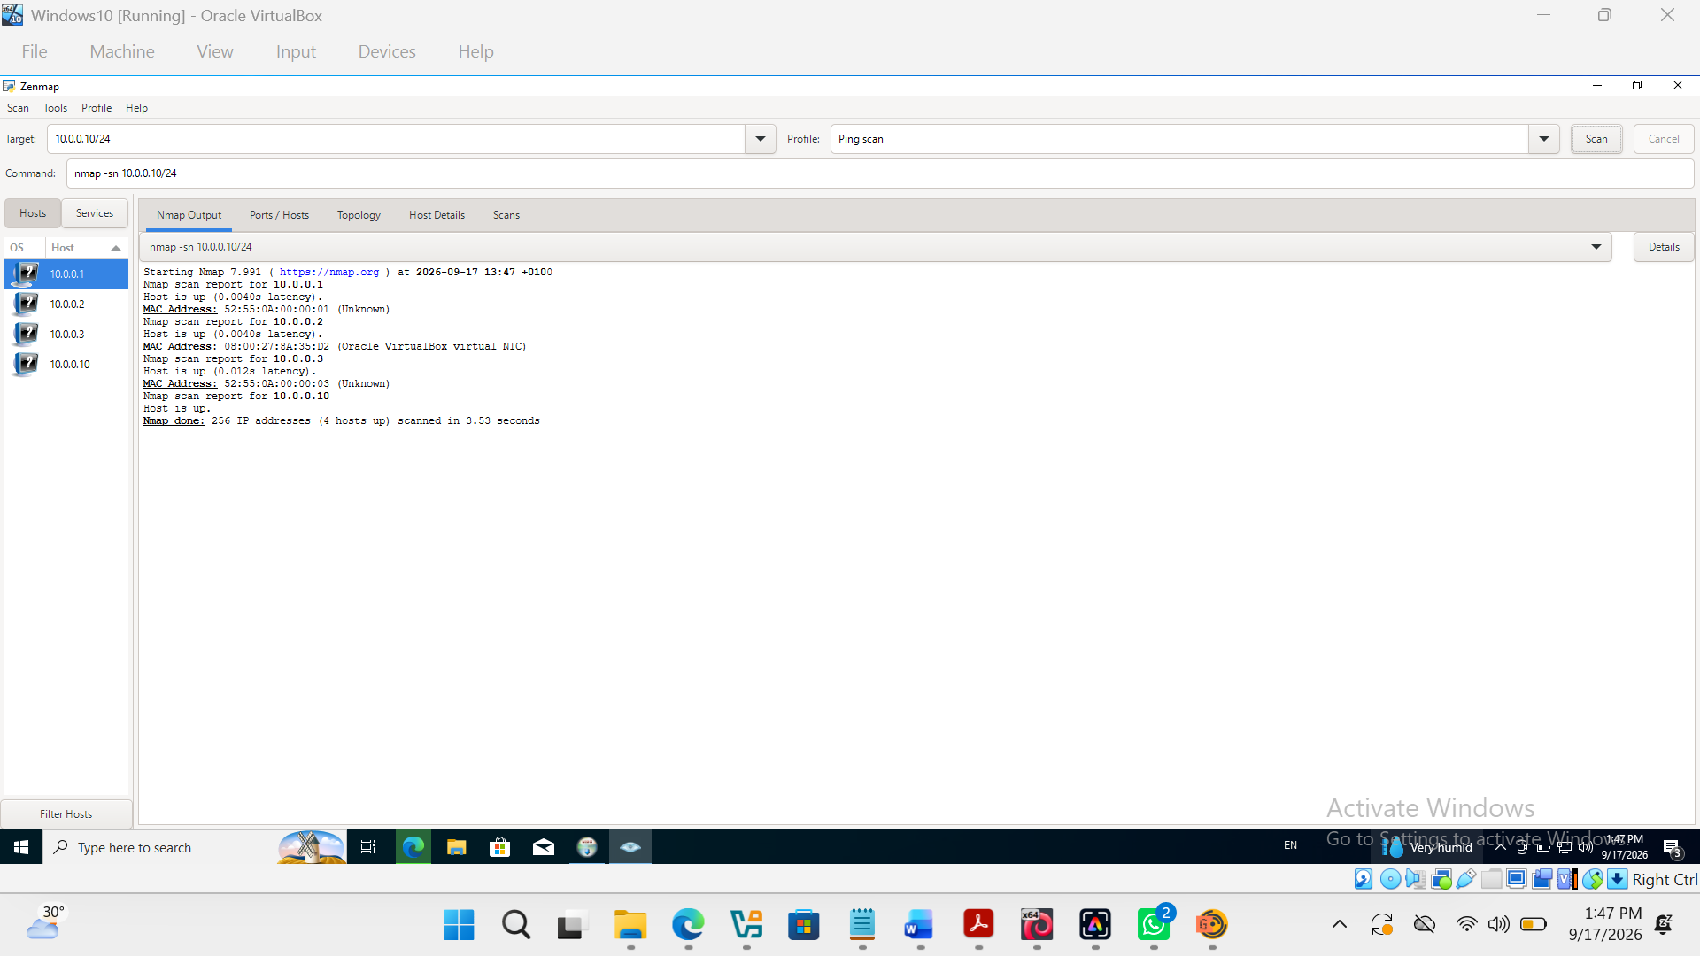
nmap -sn 10.0.0.10/24 — 4 live hosts identified with MAC addresses.
8.11 Zenmap Network Topology
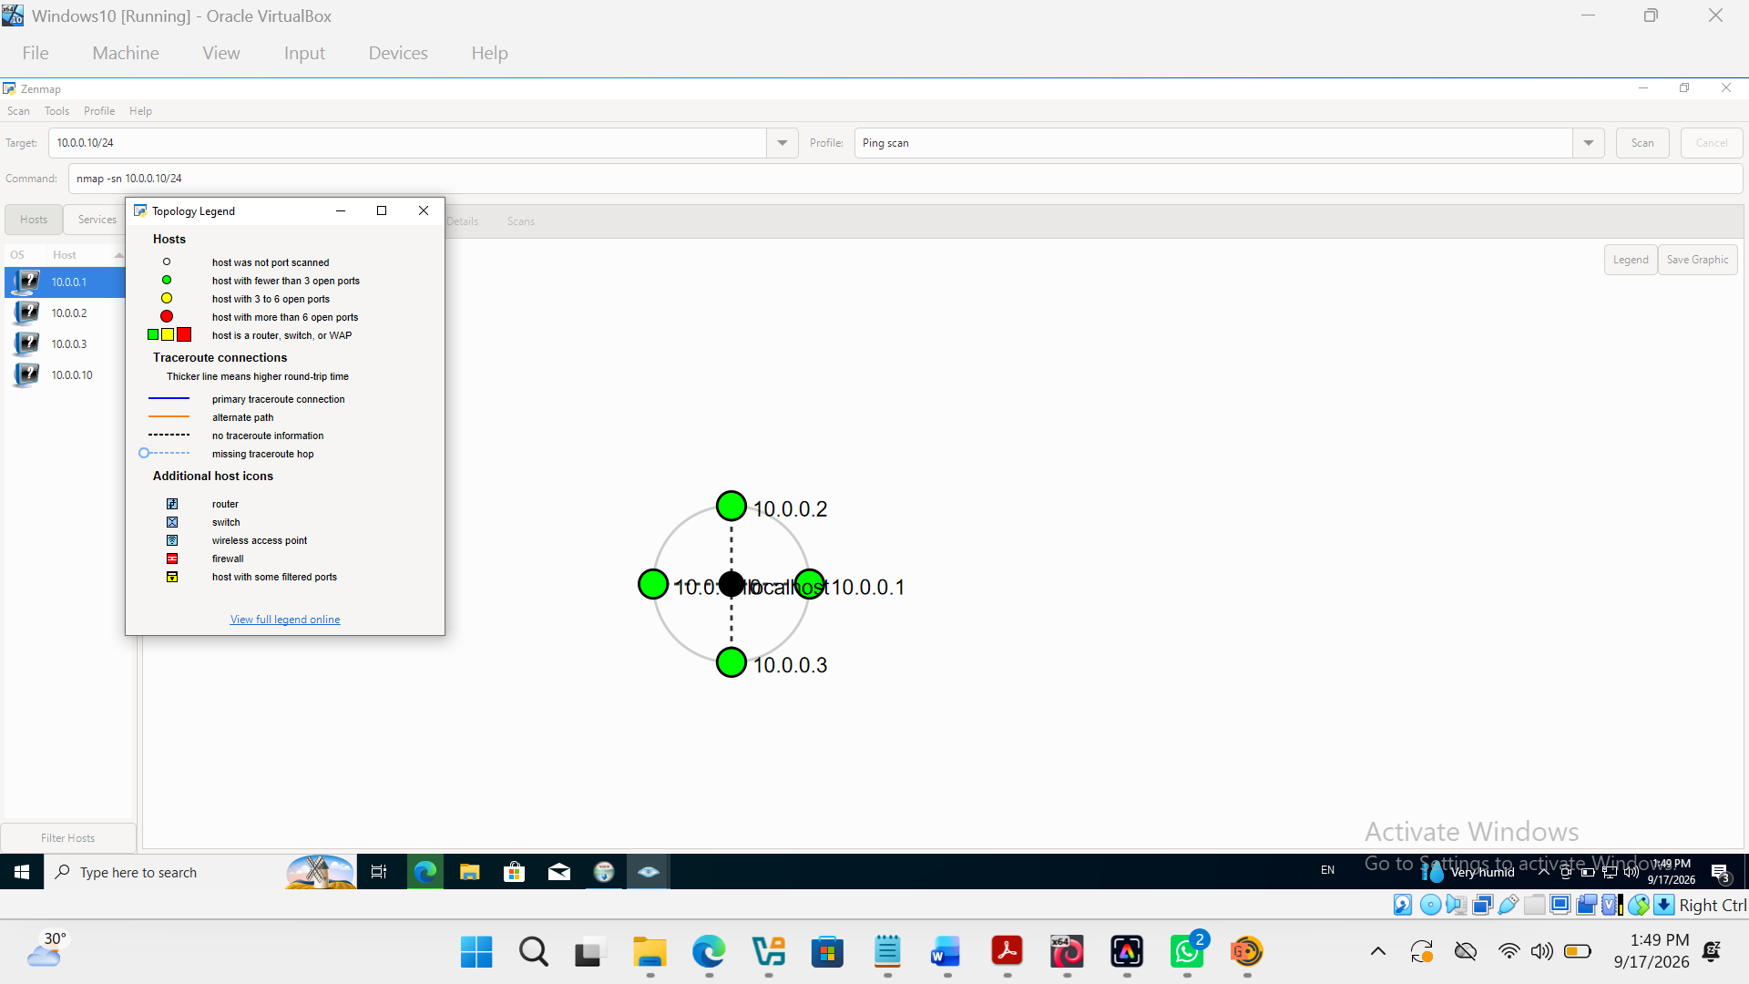
Topology view with legend enabled, showing the 4 discovered hosts in a star topology.
- End -
👤 Author
Kings Ojore Ojorumi
Cybersecurity Professional, B083-Networkwalks
📌 Project Information
Program Name: Cybersecurity Program at Networkwalks | Week: 02 | Modules: W2-PM1–W2-PM5

