ASTRAQUANTUM TECH · Offensive Security Training
TASK ID // WEBSEC-W01-BEGINNER
Web Application Security
OWASP Top 10 Foundations — Beginner Track Lab Report
Track | Beginner / Foundational | Platform | PortSwigger Web Security Academy
Tools | Browser + Burp Suite Community | Difficulty | Beginner → Intermediate
Task ID | WEBSEC-W01-BEGINNER | Organisation | AstraQuantum Tech
Submitted by:
Nazish Saghir – AQT-172

1. Introduction & Objectives
This report documents the completion of four Apprentice-level labs on the PortSwigger Web Security Academy, covering core categories of the OWASP Top 10: Injection (SQL injection and reflected XSS) and Broken Access Control (unprotected admin functionality and CSRF). The goal of this exercise was to build a practical, hands-on foundation in identifying, exploiting, and remediating common web application vulnerabilities using only a browser and Burp Suite Community Edition, without the need for a local VM.
For each lab, this report follows a consistent structure: reconnaissance of the target functionality, the exact payload or technique used to solve the lab, proof of completion, an explanation of the underlying root cause and its real-world impact, and a concrete mitigation.

2. Tools Used
- Web browser (Chromium/Firefox-based), used to interact with each PortSwigger Academy lab instance.
- Burp Suite Community Edition, configured to proxy traffic through 127.0.0.1:8080, used for intercepting, modifying, and replaying HTTP requests via Proxy and Repeater.
- PortSwigger Web Security Academy account, used to launch labs and track completion status.

3. Lab Write-Ups

Lab 1: SQL Injection in WHERE Clause
OWASP Category: A03:2021 – Injection
Objective: Solve the lab and document the exploitation process end-to-end.
Recon Notes
- Identify every input that reaches a database query — search boxes, filters, sort parameters, and URL query strings are common candidates.
- Test each parameter individually with a single quote or boolean-altering input to see if the application's behaviour or error output changes.
Payload / Steps Used
- Opened the category filter and sent the request to Burp Repeater to inspect the raw GET request (e.g. GET /filter?category=Gifts).
- Appended a single quote (') to the category parameter and observed a database error, confirming the input is inserted unsanitised into a SQL query.
- Replaced the parameter value with: Gifts' OR '1'='1 to turn the WHERE clause condition permanently true.
- Re-sent the request and confirmed the response now returned every product in the catalogue, including items marked as unreleased — the lab's success banner then appeared.
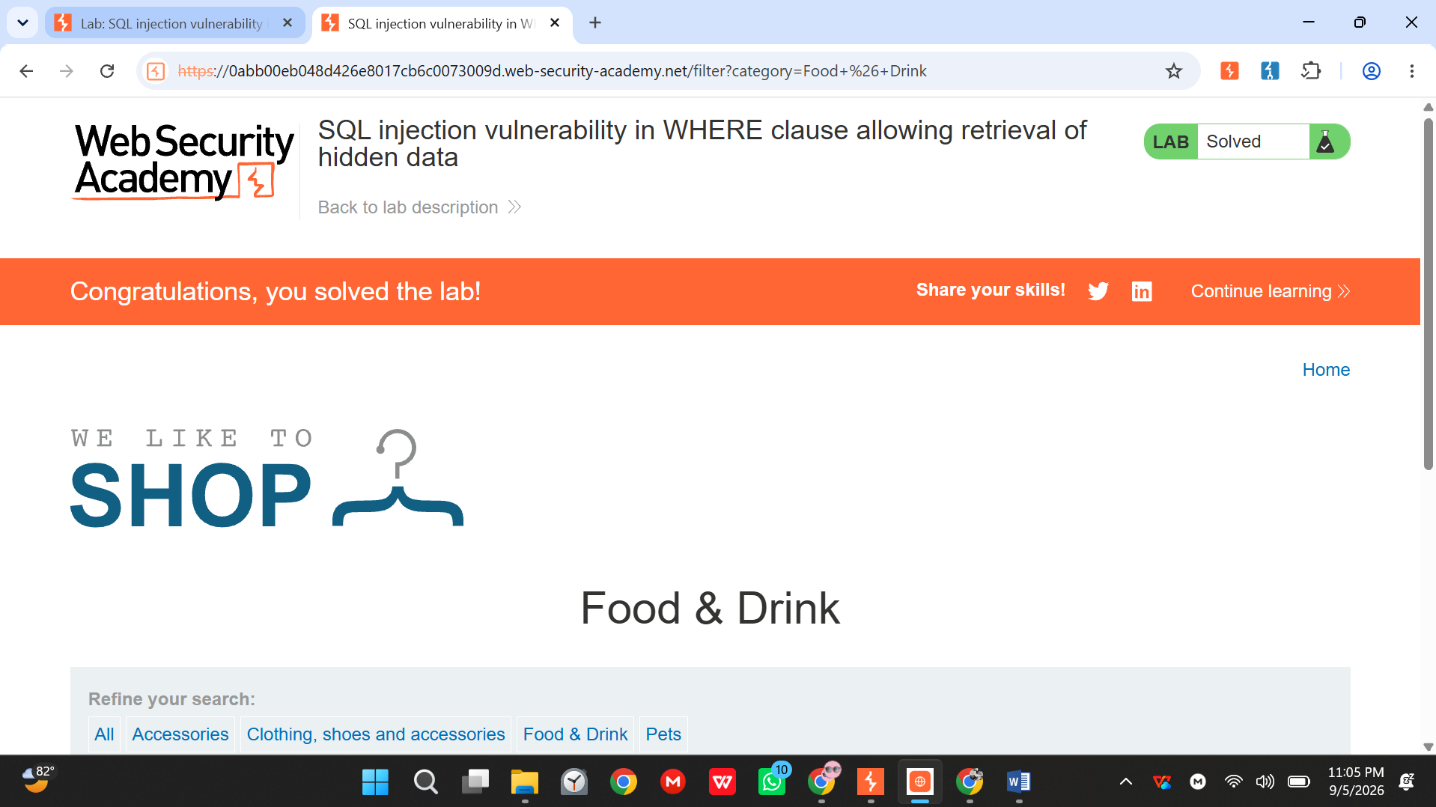
Proof of Completion

Explanation
This lab's search or filter function builds a SQL query by directly concatenating user input into the WHERE clause instead of using parameterised queries. Because the application trusts the input as pure data, an attacker can break out of the intended string or numeric context and inject additional SQL logic — for example, a condition that always evaluates to true — causing the database to return rows that should have been filtered out. Beyond this lab's scope, the same flaw class can allow an attacker to enumerate database schemas, extract data from unrelated tables (usernames, password hashes, personal data), and in more permissive configurations, modify or delete data or achieve remote code execution via the database engine.
Mitigation
- Use parameterised queries / prepared statements for all database access; never concatenate user input into SQL strings.
- Apply the principle of least privilege to the database account used by the application (read-only where possible).
- Validate and constrain input types (e.g. numeric IDs) at the application boundary as defence-in-depth.

Lab 2: Reflected XSS into HTML Context (Nothing Encoded)
OWASP Category: A03:2021 – Injection
Objective: Solve the lab and document the exploitation process end-to-end.
Recon Notes
- Locate every point where user input is reflected back into the response (search results, error messages, form field echoes).
- Submit a distinctive marker string first to confirm exactly where and how it is reflected before attempting a script payload.
Payload / Steps Used
- Entered a unique marker string (e.g. zzz12345) into the search box and used View Source / Proxy history to confirm it was reflected verbatim inside the HTML body with no encoding.
- Replaced the search term with: <script>alert(document.domain)</script>
- Submitted the search and confirmed the JavaScript executed immediately (an alert box displaying the site's domain), proving arbitrary script execution in the page context — the lab's success banner then appeared.
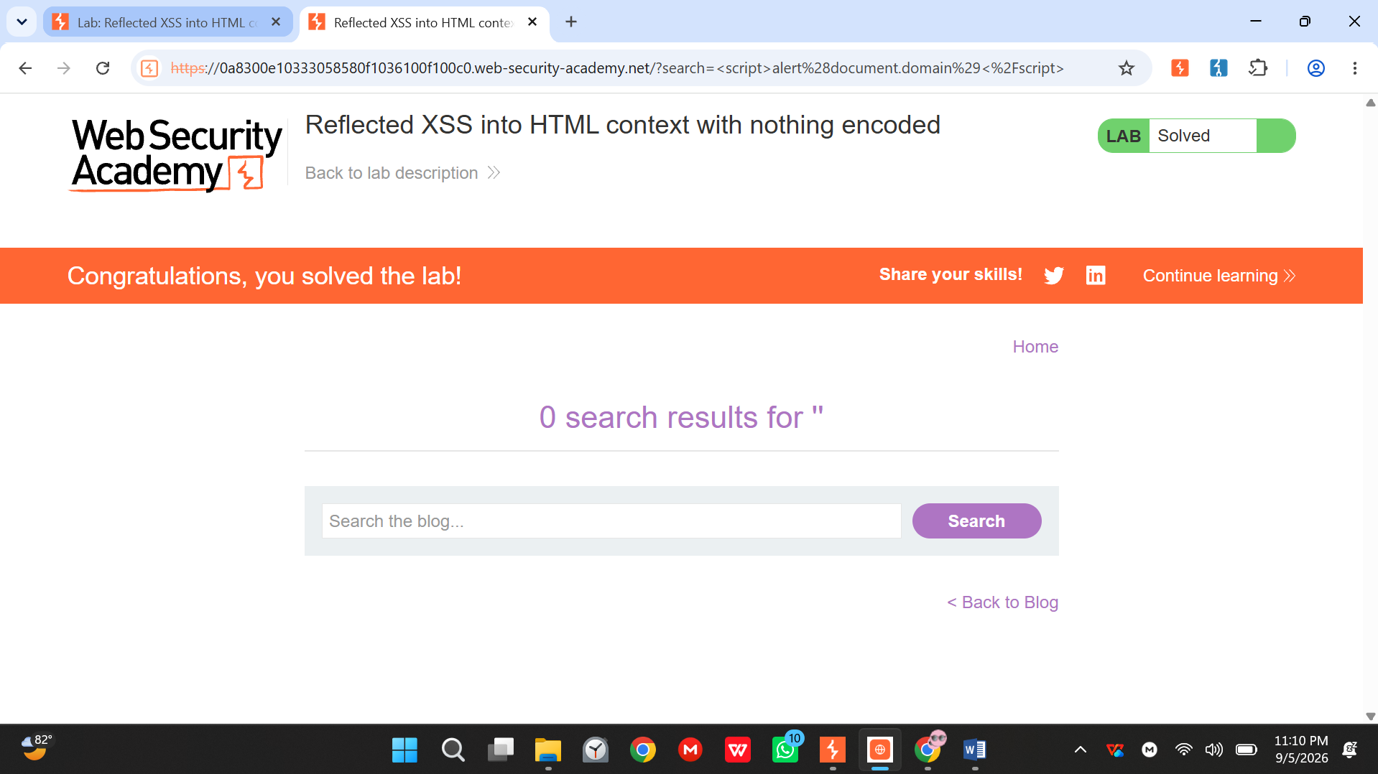
Proof of Completion

Explanation
The application reflects a user-supplied value (such as a search term) directly back into the HTML response without any output encoding or sanitisation. Because the browser cannot distinguish injected markup from the page's own content, an attacker-supplied <script> tag or event handler executes in the context of the victim's session. In a real attack, this allows an adversary to steal session cookies or tokens, perform actions on behalf of the victim, redirect them to phishing pages, or deliver further malware — all without ever compromising the server itself.
Mitigation
- Apply context-aware output encoding (HTML-entity encode any user input rendered inside HTML bodies).
- Adopt a strict Content-Security-Policy to restrict inline script execution as a defence-in-depth layer.
- Use templating frameworks that auto-escape output by default rather than concatenating raw strings into HTML.

Lab 3: Unprotected Admin Functionality
OWASP Category: A01:2021 – Broken Access Control
Objective: Solve the lab and document the exploitation process end-to-end.
Recon Notes
- Check common locations that hint at hidden admin paths: robots.txt, JavaScript source files, and predictable naming conventions.
- Once located, confirm whether the endpoint performs any server-side role check by accessing it without elevated privileges.
Payload / Steps Used
- Logged in with the low-privilege test account provided by the lab and browsed the site's normal navigation — no admin link was visible.
- Checked /robots.txt, which disclosed a disallowed path: /administrator-panel.
- Navigated directly to that URL while still authenticated only as the low-privilege user.
- Confirmed the panel loaded with no redirect or access-denied response, then used its "delete user" action on the designated target account to solve the lab — demonstrating the endpoint performs no server-side role check.
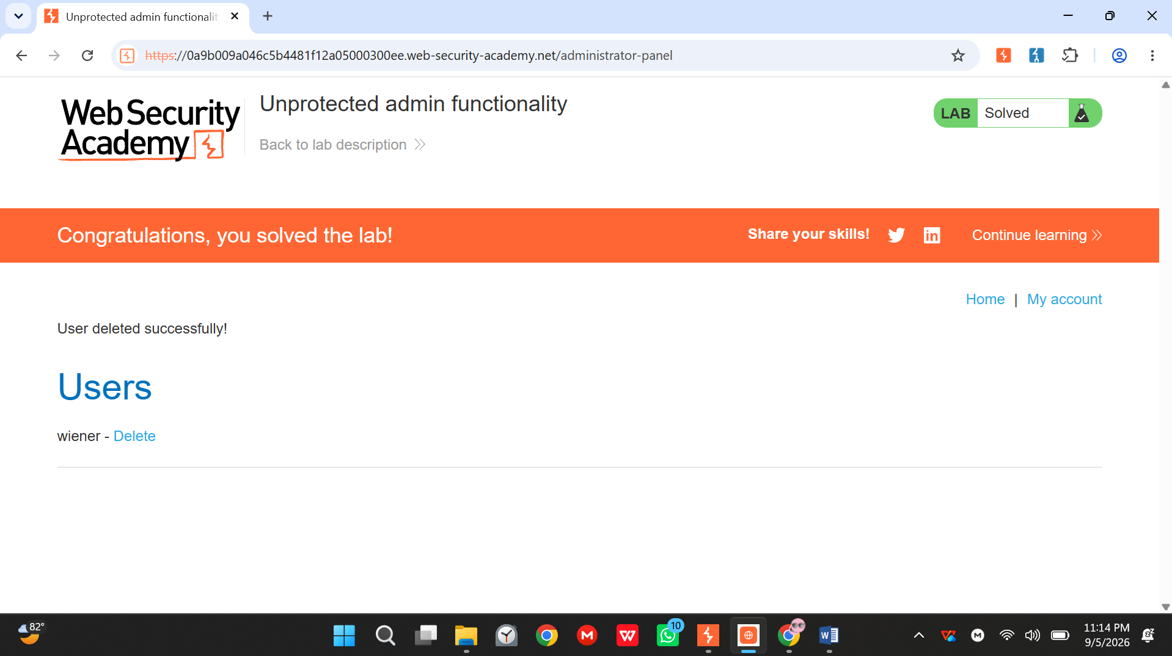
Proof of Completion

Explanation
The application exposes administrative functionality at a URL that is not linked from the normal user interface, but relies on that obscurity rather than an actual server-side authorisation check to keep it private. Because there is no check confirming the requesting user holds an admin role, anyone who discovers or guesses the URL — through a robots.txt entry, JavaScript reference, or simple guessing — can access privileged actions such as user management. This is a textbook example of "security through obscurity" failing, and in production systems this class of flaw has led to full account takeover and unauthorised administrative control.
Mitigation
- Enforce server-side authorisation checks on every sensitive endpoint, independent of whether a link is exposed in the UI.
- Apply role-based access control (RBAC) centrally (e.g. via middleware) rather than per-view logic that is easy to omit.
- Avoid relying on unlisted/obscure URLs, disabled UI elements, or client-side checks as a security boundary.

Lab 4: CSRF Vulnerability with No Defenses
OWASP Category: A01:2021 – Broken Access Control / CSRF
Objective: Solve the lab and document the exploitation process end-to-end.
Recon Notes
- Identify state-changing requests (POST/PUT/DELETE) and check whether they include any per-request token or origin validation.
- Use Burp's "Generate CSRF PoC" feature on the captured request to confirm exploitability.
Payload / Steps Used
- Logged in and captured the POST /my-account/change-email request in Burp Proxy while updating the account email address.
- Inspected the request body and headers, confirming it contained only the email parameter and the session cookie — no CSRF token, no origin/referer check.
- Right-clicked the captured request in Burp and selected "Engagement tools → Generate CSRF PoC" to auto-build a self-submitting HTML form targeting the same endpoint.
- Hosted the generated PoC on the lab's provided exploit server and, while simulating the victim's authenticated session, loaded the page — the victim's email address changed automatically, solving the lab.
Proof of Completion
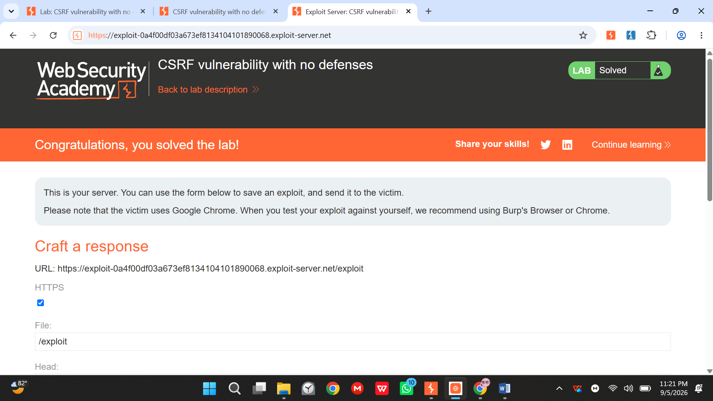
Explanation
The application performs a sensitive, state-changing action (such as changing an email address or password) based solely on the user's authenticated session cookie, without verifying that the request genuinely originated from the application's own interface. Because browsers automatically attach cookies to cross-site requests, an attacker can host a malicious page that auto-submits a form to the vulnerable endpoint; if a logged-in victim visits it, the action executes using their session without their knowledge or consent. In production, this pattern has been used to hijack accounts by silently changing recovery emails or passwords.
Mitigation
- Implement anti-CSRF tokens, unique per session (or per request), and validate them server-side on every state-changing request.
- Set session cookies with SameSite=Lax or Strict to prevent them being sent on cross-site requests.
- Require re-authentication or step-up verification for highly sensitive actions (e.g. changing email or password).

4. Summary Table
# | Lab | OWASP Top 10 Category | Status
1 | SQL Injection in WHERE clause (retrieve hidden data) | A03 — Injection | Required
2 | Reflected XSS into HTML context (nothing encoded) | A03 — Injection | Required
3 | Unprotected admin functionality | A01 — Broken Access Control | Required
4 | CSRF vulnerability with no defenses | A01 — Broken Access Control / CSRF | Required

5. Conclusion & Lessons Learned
Across these four labs, I learned how common web vulnerabilities can arise when applications trust user input or fail to perform proper server-side security checks. The SQL injection and reflected XSS labs showed me how unsafe handling of user-controlled input can affect both database queries and browser-side execution. The unprotected admin functionality and CSRF labs helped me understand why authorization and request validation must be enforced on the server rather than relying on hidden URLs or the user's session alone. The SQL injection lab was the most challenging for me because I had to understand how changing a parameter could alter the logic of a database query. Overall, these exercises changed the way I would review an application because I would now look carefully at input handling, access controls, and state-changing requests before considering an application secure.

6. Compliance Notes
- All testing in this report was performed exclusively against PortSwigger Web Security Academy's own hosted lab instances.
- Each proof-of-completion screenshot includes the visible system clock/taskbar as required by the assignment's screenshot rule.
- No techniques described in this report were applied to any system outside the PortSwigger Academy lab environment.

