ASTRAQUANTUM TECH
Cybersecurity Internship Program
WEEK 1 REPORT
TryHackMe Foundations: Operating Systems, the Web & Career Paths
Prepared by | Nazish Saghir
Role | Cybersecurity Intern
TryHackMe Profile | tryhackme.com/p/nazishsaghir16
Date | 7 August 2026

Table of Contents
Introduction 1
Room 1 — Getting Started 1
Room 2 — Careers in Cyber 3
Room 3 — HTTP in Detail 7
Room 4 — Linux Fundamentals Part 1 11
Room 5 — Windows Fundamentals 1 15
Week 1 Summary 21

Introduction
This report documents my progress through the Week 1 TryHackMe rooms assigned as part of the AstraQuantum Tech cybersecurity internship. Each section below covers one room: the objective, what I learned, key concepts and commands, supporting screenshots, and a short reflection. This structure is repeated for every room so the report stays consistent and easy to review.
I have also followed the lead instructor's TryHackMe profile (muhammadxahmed) as required, so my activity and progress can be tracked for upcoming CTF team selection.

Room 1 — Getting Started
Room Link | tryhackme.com/room/gettingstarted
Objective | Learn how to navigate the TryHackMe platform and get started with your first steps.

What I Learned
This room introduced the TryHackMe platform itself — how rooms, tasks, and answer boxes work, and how progress is tracked (the room completion bar at the top of the page). It also walked through the different learning paths TryHackMe offers, including Jr Penetration Tester and Pre Security, which gave me a clearer picture of the skill tracks available going forward.
The practical part of the room used a mock social media site called “BFFs” to teach basic web reconnaissance. The goal was to find a hidden admin panel and log into it using nothing but information exposed in the page itself — no scanning tools required.

Key Concepts / Commands
- Viewing page source in the browser (right-click → View Page Source) to inspect the raw HTML sent by a server.
- HTML comments begin with <!-- and end with -->, and can accidentally leak developer notes, hidden URLs, or leftover credentials.
- Directory/endpoint discovery: a hidden admin route (/test-admin) was found inside an HTML comment rather than through any tool.
- Default credentials as a security weakness — the admin portal accepted the well-known default login admin:admin, since the developer had never changed it.
- Basic post-login recon: once inside the admin panel, checking what data is exposed (e.g. a list of registered users) is itself part of the assessment.

Task Answers / Findings
Item | Finding / Answer
Hidden admin page | /test-admin
Working credentials | admin:admin
Registered users found | 3 (peterpan, asmith, jane)

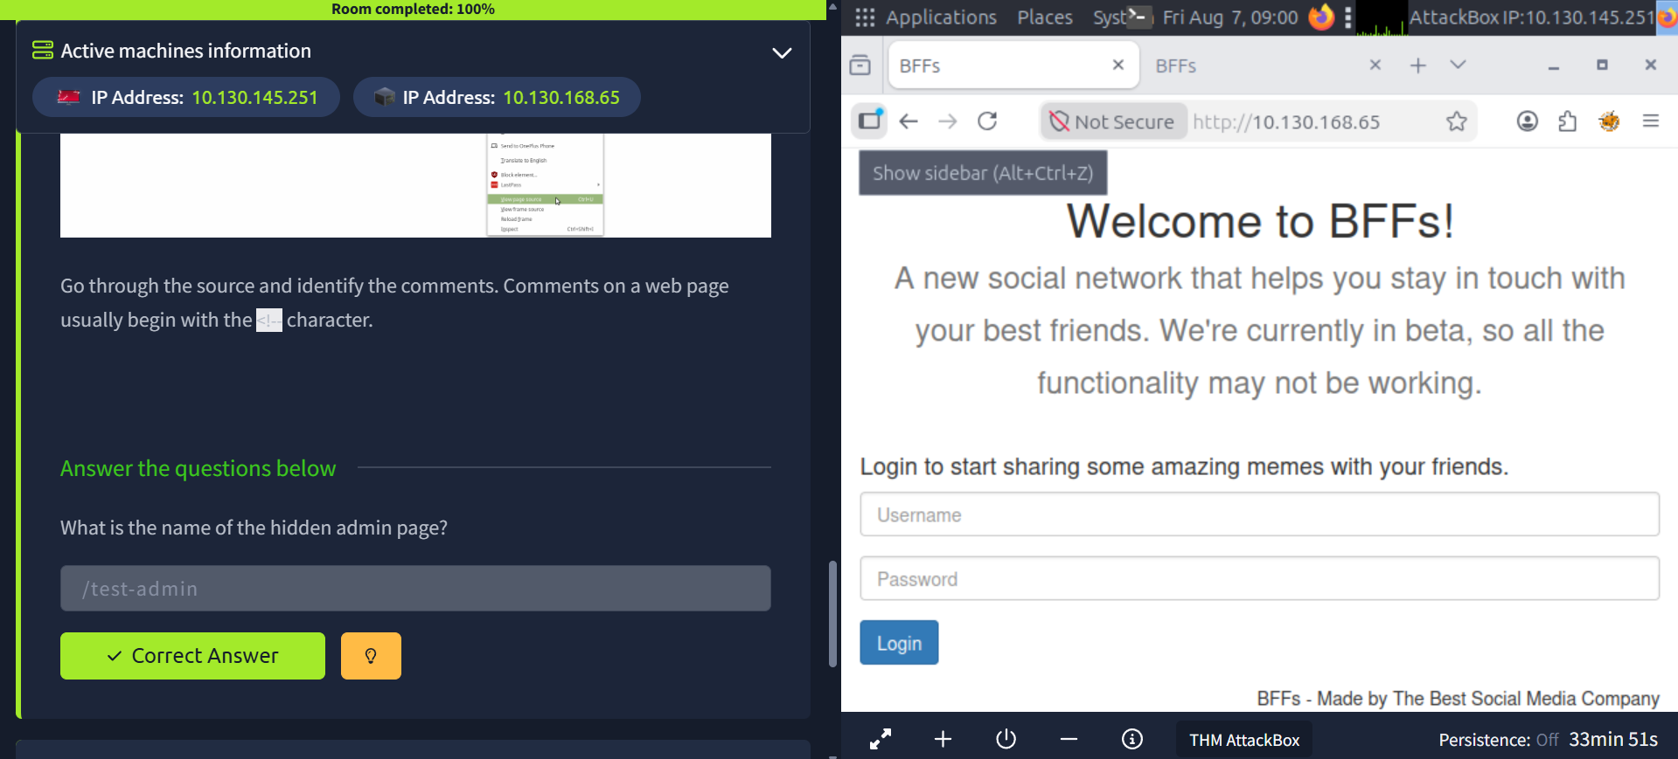
Fig. 1 — BFFs homepage login screen and the task prompt asking for the name of the hidden admin page, found via an HTML comment in the page source.

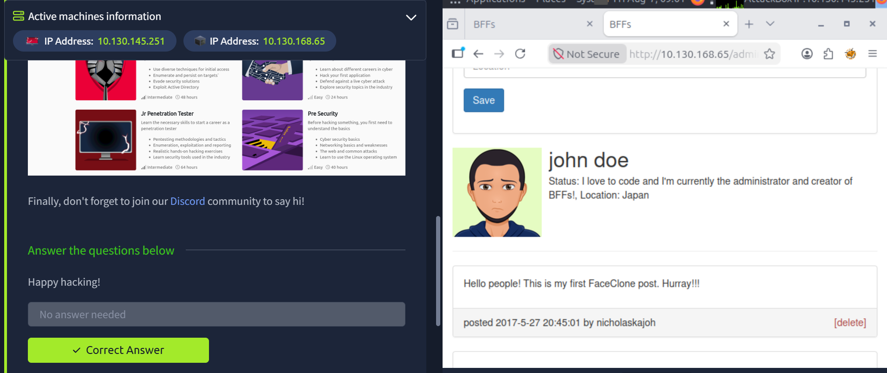
Fig. 2 — Successfully logged into the admin portal after navigating to the discovered /test-admin route.

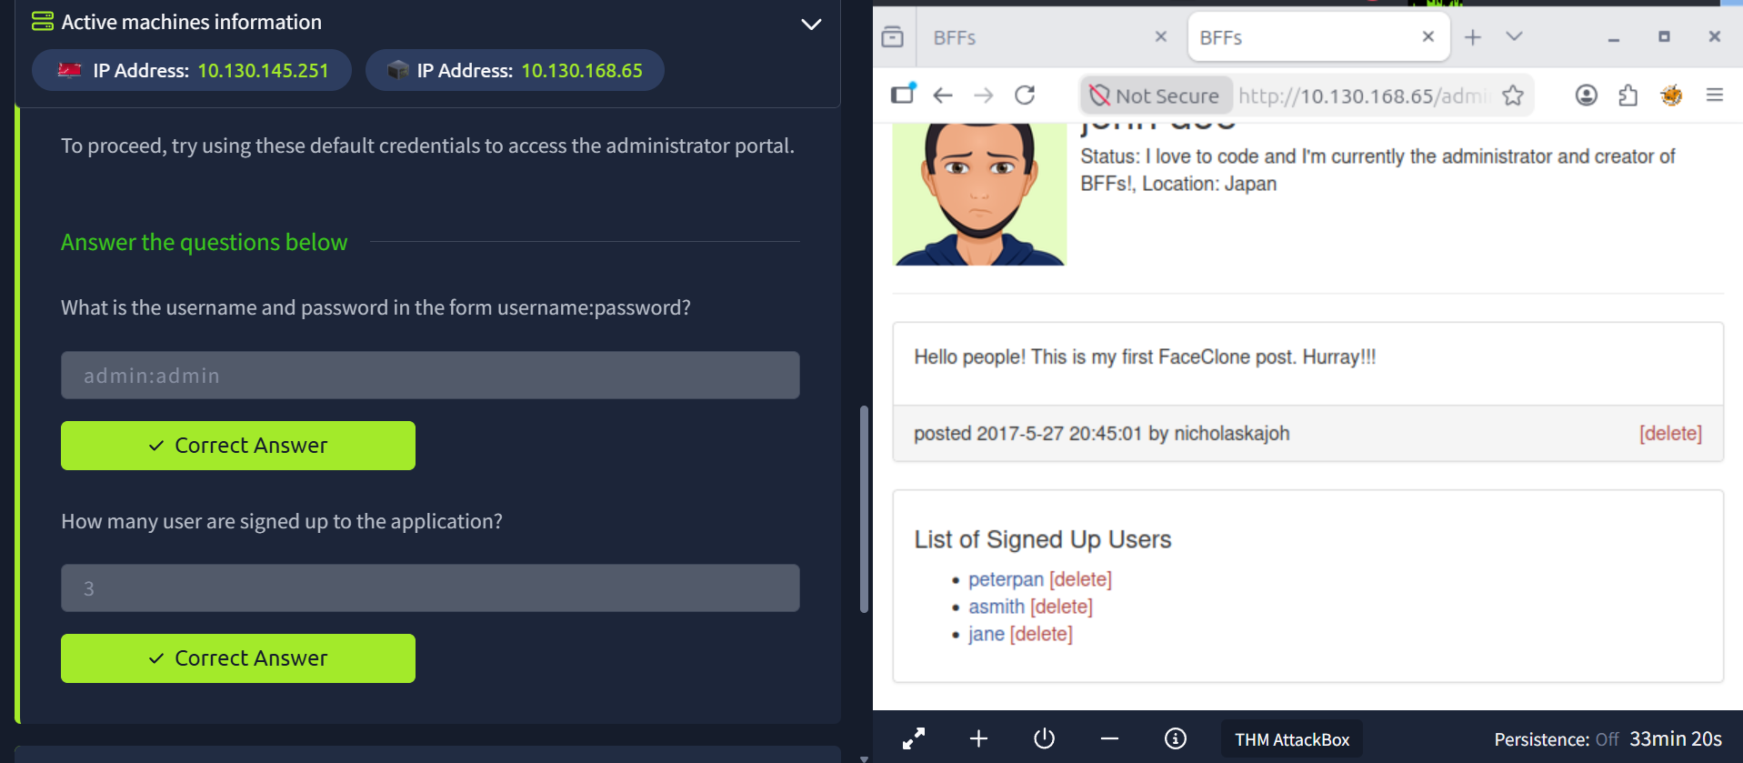
Fig. 3 — Confirmed the default credentials (admin:admin) and viewed the full list of signed-up users from inside the admin panel.

Reflection
This room was a good reminder that a lot of real-world vulnerabilities aren't about writing exploit code — they come from developers leaving comments or default credentials in production. Reading the page source before touching any automated tool should be step one of any web assessment. I completed the room at 100% and answered both required questions correctly.

Room 2 — Careers in Cyber
Room Link | tryhackme.com/room/careersincyber
Objective | Explore different career domains in cybersecurity to find where your passion lies.

What I Learned
This room walked through why cyber security is worth pursuing as a career and then helped narrow down which specific role actually fits. It's structured as six short tasks: three make the case for the field (opportunity, pay, and impact), two explain how varied the roles actually are, and the last is an interactive quiz that maps your instincts to a real job title.
Task 1 (The Open Door) made the point that cyber security doesn't require a computer science degree — millions of roles sit unfilled, and people move in from backgrounds like healthcare, finance, law enforcement, and teaching. Task 2 (What It Pays) reinforced that entry-level pay is competitive and that certifications, not a four-year degree, are often enough to get in. Task 3 (The Bigger Picture) shifted focus to why the work matters: cyber professionals protect hospitals, power grids, banks, and factories, not just “tech companies.”
Task 4 (Find Your Place) broke down that cyber security covers 50+ recognised roles — some people think like attackers (penetration testers), some work like detectives after an incident (incident responders), some do real-time defence (SOC analysts), and others research how threats evolve (threat intelligence). Task 5 (Your Starting Point) tied it together: the field keeps expanding as new technology (AI, cloud, connected healthcare, digital banking) creates new roles, and people rarely stay in one lane — they grow into others. Task 6 (Launch Careers Quiz) was the practical part — an interactive quiz that takes your answers about how you think and work, and matches you to a specific cyber security role.

Key Concepts / Takeaways
- Cyber security spans 50+ recognised roles, not one single job — e.g. penetration tester, SOC analyst, threat intelligence researcher, incident responder, security engineer.
- No mandatory degree or years-long licence is required to enter the field; certifications and hands-on practice can get you to a well-paying role faster than traditional paths like law or medicine.
- Different roles suit different ways of thinking: offensive (attacker mindset), investigative (post-incident detective work), real-time defensive (cat-and-mouse monitoring), or research-driven (studying how threats evolve).
- The impact of the field is real-world and physical, not just digital — cyber defence failures can shut down hospitals, banks, and power grids.
- My careers quiz result was Security Analyst — a role focused on designing and improving security measures, reviewing and testing company networks, and producing reports that help engineers prevent attacks.

Quiz Result: Security Analyst
According to the room's Careers in Cyber Quiz, my profile matches a Security Analyst. Core responsibilities for this role include working with different teams to review and improve an organisation's cyber security, producing regular reports on network safety and how issues were fixed, and developing security plans that incorporate research on new attack techniques and defensive measures.

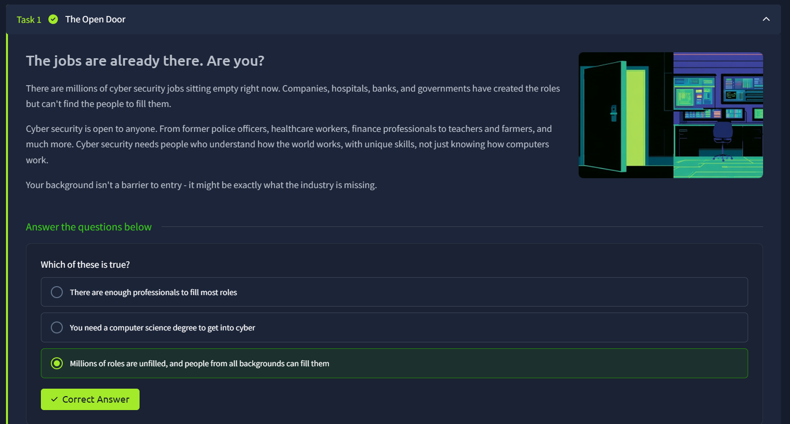
Fig. 1 — Task 1: The Open Door — millions of cyber security roles are unfilled and open to people from any background.

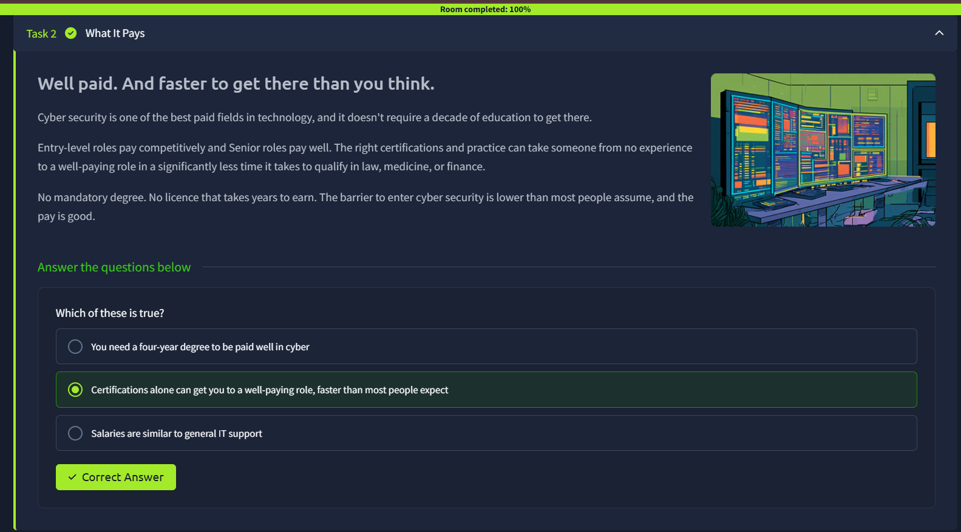
Fig. 2 — Task 2: What It Pays — entry-level roles pay competitively and don't require a four-year degree.

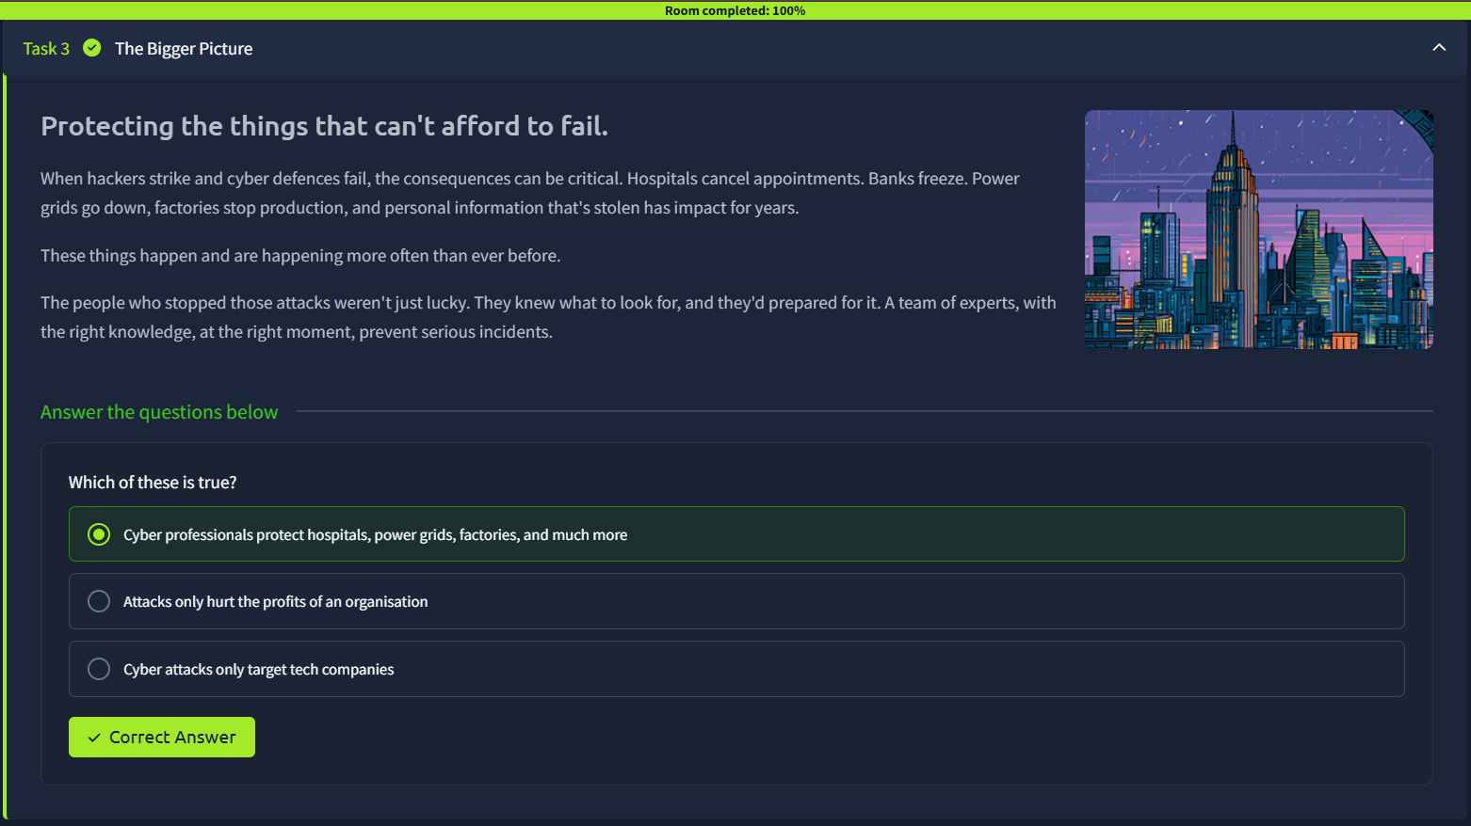
Fig. 3 — Task 3: The Bigger Picture — cyber professionals protect hospitals, power grids, banks, and factories.

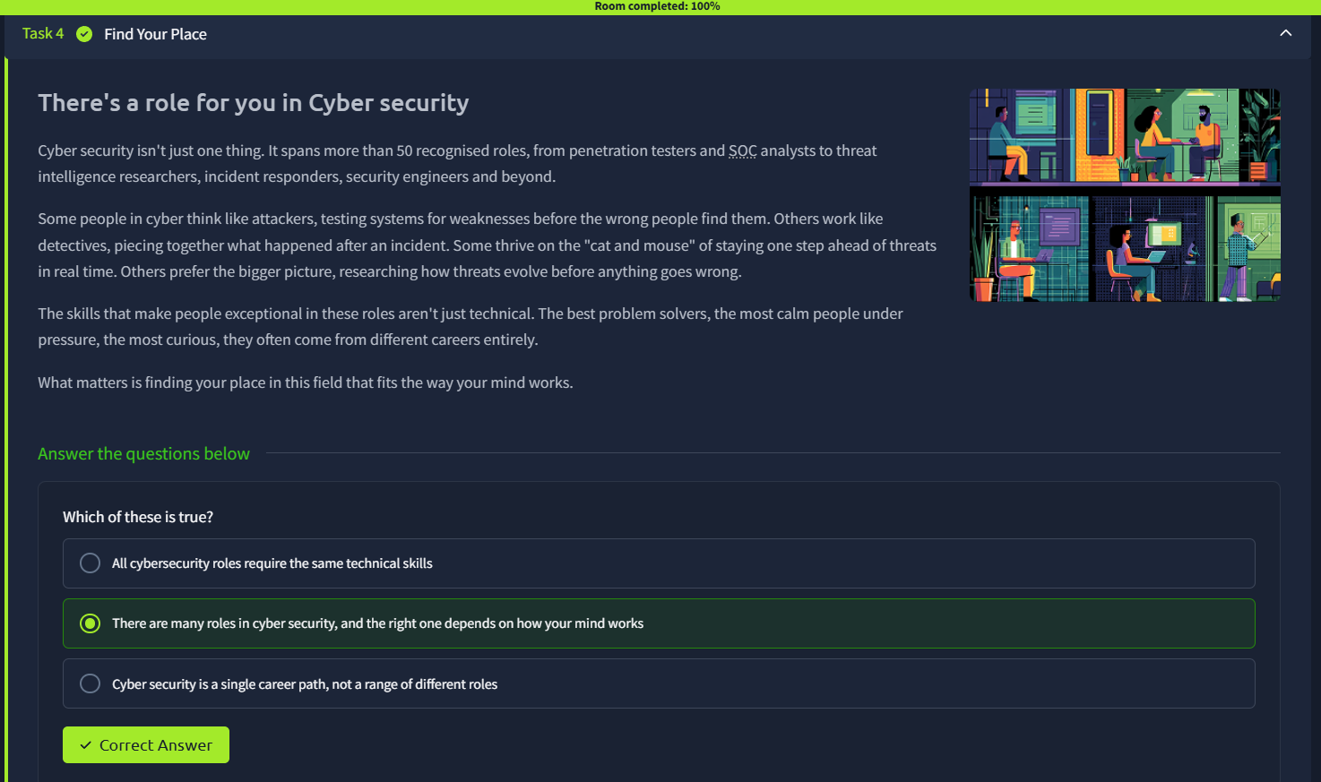
Fig. 4 — Task 4: Find Your Place — cyber security spans 50+ roles suited to different ways of thinking.

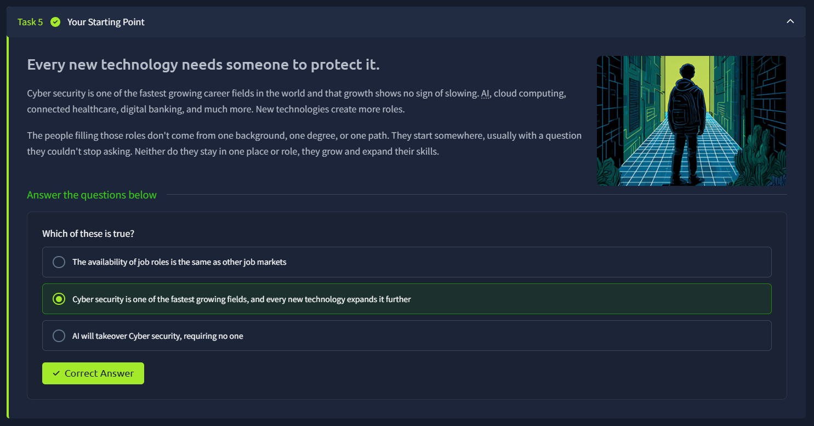
Fig. 5 — Task 5: Your Starting Point — new technology keeps expanding the field and creating new roles.

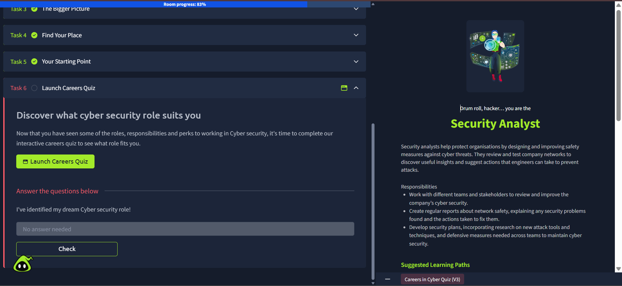
Fig. 6 — Task 6: Careers Quiz completed — matched to the Security Analyst role, with its responsibilities and suggested learning paths.

Reflection
This room was less technical and more about orientation — it reframed cyber security as a field with many entry points rather than one narrow path. Getting matched to Security Analyst on the quiz lines up well with the kind of work I've been doing already: reviewing systems, documenting findings, and communicating them clearly, which is essentially what this report itself has been about. I completed the room at 100% and answered all six questions correctly.

Room 3 — HTTP in Detail
Room Link | tryhackme.com/room/httpindetail
Objective | Understand how the web works under the hood by diving into HTTP requests, responses, and headers.

What I Learned
This room went a level deeper than the earlier rooms by unpacking exactly what happens on the wire every time a browser talks to a web server. Rather than just using the web, the tasks broke a request and response down into their component parts — the request line, the response status line, and the headers riding along with each — and then had me identify specific headers and status codes from real (if simulated) HTTP traffic.
The Cookies task built on this by showing a raw server response containing a Set-Cookie header and a personalised login page, illustrating how a website remembers a logged-in user between requests without asking them to log in again on every page. The follow-up Common Headers task then covered the wider set of headers a request or response can carry — things like Cache-Control, Content-Type and Content-Encoding — and asked me to match a header to its purpose.
The HTTP Response Codes task covered how servers signal success or failure using three-digit status codes, grouped by their leading digit (2xx success, 4xx client error, 5xx server error), and asked me to pick the right code for different scenarios — creating a resource, hitting a missing page, a server/database outage, and an unauthenticated request.
The room finished with Task 7, Making Requests — a hands-on emulator where I had to actually construct GET, DELETE, PUT and POST requests (setting URI parameters, body parameters and a username/password) against a fake site, rather than just answering questions about them. Each correctly-formed request returned a THM{...} flag, which tied the whole room together: by that point I was reading and writing raw HTTP requests instead of just recognising their parts.

Key Concepts / Headers
- Set-Cookie (response header) — tells the browser to store a piece of data (a cookie) and send it back automatically on every future request to that site; this is how sites keep a user “logged in” without re-authenticating on each page.
- Cache-Control (response header) — tells the browser how long it can reuse a cached copy of the response before it needs to request it again.
- Content-Type (response header) — tells the client what kind of data is being returned (HTML, CSS, JavaScript, an image, a PDF, etc.) so the browser knows how to process it.
- Content-Encoding (response header) — states what compression method (if any) was used to shrink the response before sending it over the network.
- User-Agent (request header) — tells the web server what browser/client is making the request.
- Host (request header) — tells the web server which website/domain is being requested, which matters when one server hosts several sites.
- HTTP response codes are grouped by their first digit: 2xx = success (e.g. 201 Created), 4xx = client-side error (e.g. 404 Not Found, 401 Unauthorized), 5xx = server-side error (e.g. 503 Service Unavailable).
- HTTP methods used in the Making Requests task: GET (retrieve data), DELETE (remove a resource), PUT (update a resource), and POST (submit data, e.g. logging in with a username and password).
- URI parameters (e.g. ?id=1) and body parameters are two different places a request can carry data — the emulator's gear button was used to set each one for the right request type.

Task Answers / Findings
Item | Finding / Answer
Header that saves cookies to the browser | Set-Cookie
Header identifying the browser in use | User-Agent
Header describing returned data type | Content-Type
Header naming the requested website | Host
Code for creating a new resource | 201
Code for a missing page | 404
Code for a database/server outage | 503
Code for an unauthenticated request | 401
GET /room | THM{YOU'RE_IN_THE_ROOM}
GET /blog?id=1 | THM{YOU_FOUND_THE_BLOG}
DELETE /user/1 | THM{USER_IS_DELETED}
PUT /user/2 (username=admin) | THM{USER_HAS_UPDATED}
POST /login (thm / letmein) | THM{HTTP_REQUEST_MASTER}

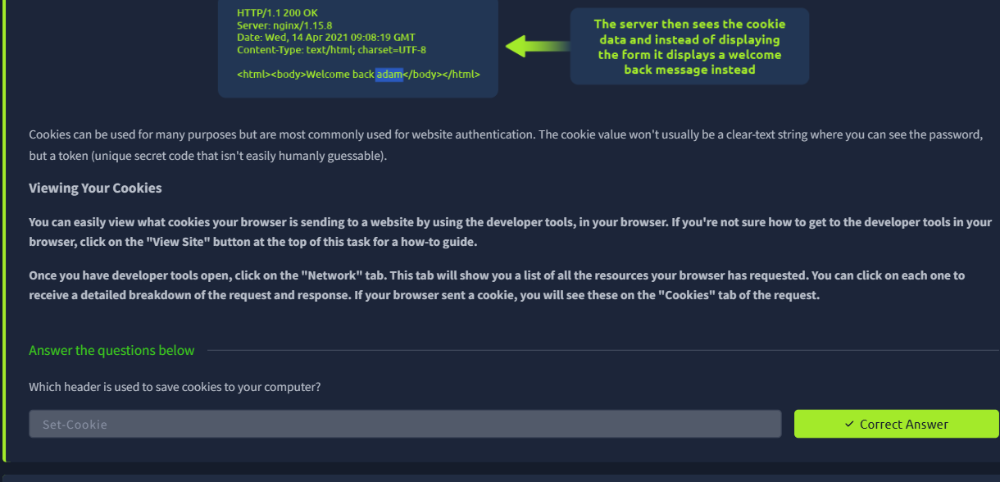
Fig. 1 — The Cookies task: viewing a raw HTTP response with a Set-Cookie header, and identifying it as the header used to save cookies to the browser.

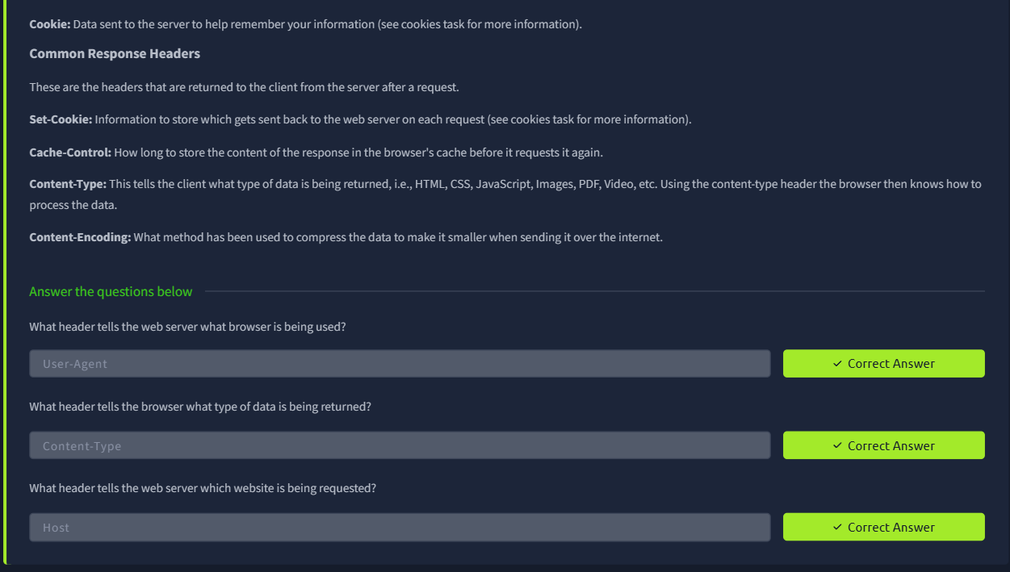
Fig. 2 — Common Headers task: definitions of Set-Cookie, Cache-Control, Content-Type and Content-Encoding, correctly matched to User-Agent, Content-Type and Host.

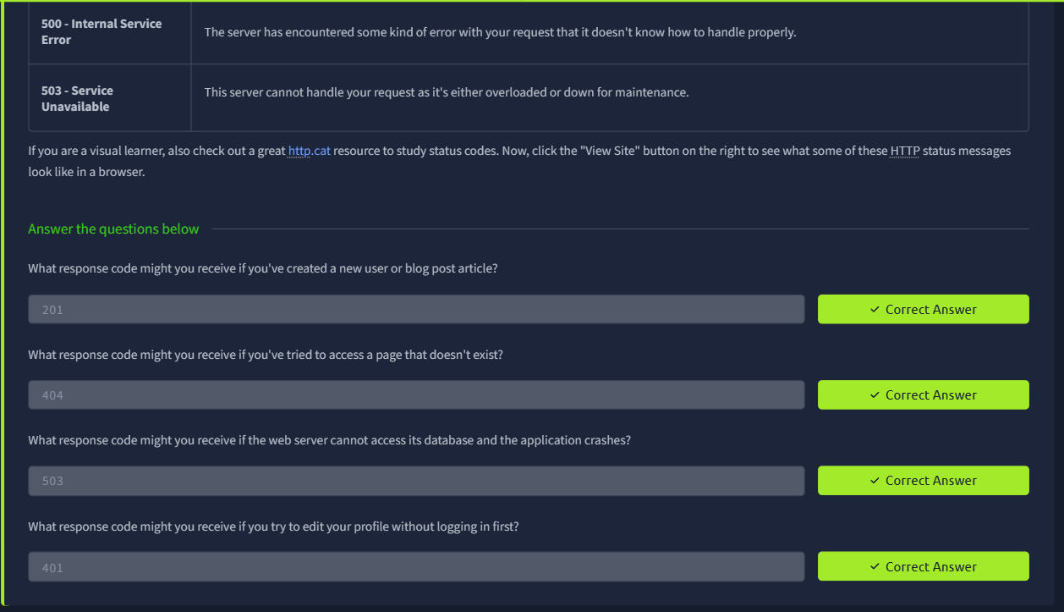
Fig. 3 — HTTP Response Codes task: matching 201, 404, 503 and 401 to their scenarios.

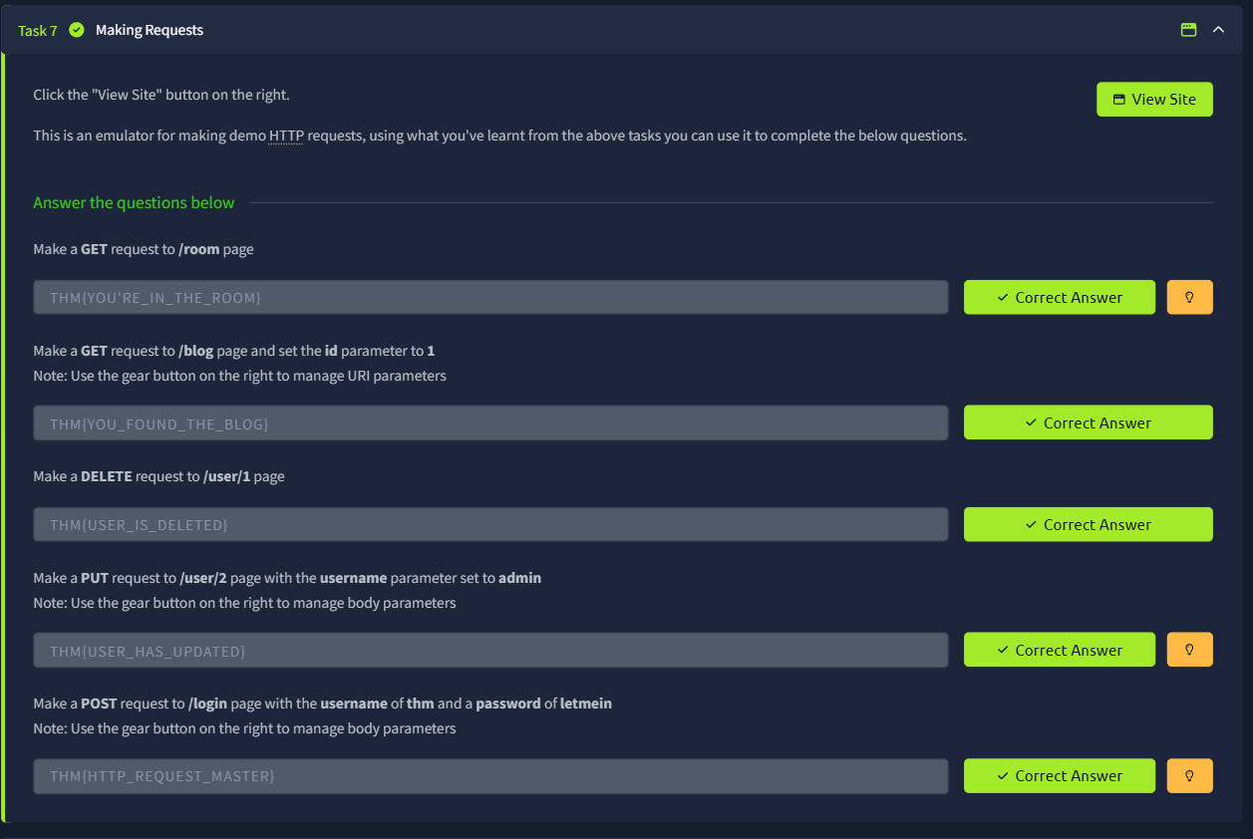
Fig. 4 — Task 7 (Making Requests): using the request emulator to send GET, DELETE, PUT and POST requests and retrieve all five flags, completing the room.

Reflection
This room made HTTP feel far less abstract — headers stopped being a list of names to memorise and became things I could point to in an actual response and explain the purpose of, and status codes became a quick way to reason about what went wrong (or right) without needing to see the server logs. Task 7 was the most useful part: constructing GET, DELETE, PUT and POST requests by hand in the emulator is much closer to what I'll actually be doing when testing real endpoints later in the internship. I completed the room at 100% and answered all required questions correctly.

Room 4 — Linux Fundamentals Part 1
Room Link | tryhackme.com/room/linuxfundamentalspart1
Objective | Learn the fundamentals of Linux by running essential commands on an interactive terminal — logging in, navigating the filesystem, reading files, and combining commands.

What I Learned
This room deployed an in-browser Ubuntu Linux machine and walked through the first commands anyone needs to work in a Linux terminal. The room started with basic identity and output commands, moved on to navigating the filesystem and reading file contents, and finished by combining commands together with operators and using grep to search a log file for a hidden flag.
The first task after deploying the machine covered two commands: whoami, which prints the currently logged-in user (tryhackme), and echo, which prints text back to the terminal. I tested both directly — whoami returned tryhackme, and echo commands printed the exact text passed to them.
The next task covered moving around the filesystem. Running ls in the home directory listed one file (access.log) and four folders (folder1–folder4). I used cd to enter each folder and ls to check its contents, and cd ~ / cd /home/tryhackme to jump back home. Only folder1 contained a file — passwords.txt — which I read with cat and found the contents to be password123. I also confirmed the same file could be located with find -name passwords.txt, and that grep "password123" passwords.txt correctly matched the line.
The last part of the room covered combining commands: the && operator, which runs a second command only after the first one finishes successfully, and output redirection with > and >>. I tested this by running echo "test" > thm, which created a new file called thm containing the word test, then echo "hey" >> thm, which added a second line without erasing the first. Finally, I used grep "THM" access.log to search the log file in the home directory for any line containing "THM", which surfaced a fake HTTP access-log entry containing the flag THM{ACCESS}.

Key Concepts / Commands
- whoami — prints the username of the currently logged-in account.
- echo "text" — prints text to the terminal; also used to write text into files.
- ls — lists the files and folders in the current directory.
- cd foldername / cd ~ / cd /home/tryhackme — changes the current directory; cd ~ or cd with no path returns to the home directory.
- cat filename — prints the full contents of a file to the terminal.
- find -name filename — searches the current directory tree for a file by name.
- grep "pattern" filename — searches a file line by line for text matching the given pattern.
- && — a logical AND operator that runs the second command only if the first command completes successfully.
- > — redirects a command's output into a file, overwriting the file's existing contents.
- >> — redirects a command's output into a file, appending to the end without overwriting existing contents.

Task Answers / Findings
Item | Finding / Answer
Command to find the current user | whoami
Command to output text | echo
Folders found with ls | 4
Folder containing a file | folder1
Contents read with cat | password123
Flag found with grep "THM" access.log | THM{ACCESS}
Operator that waits for the first command | &&
Redirector used to save output to a file | >

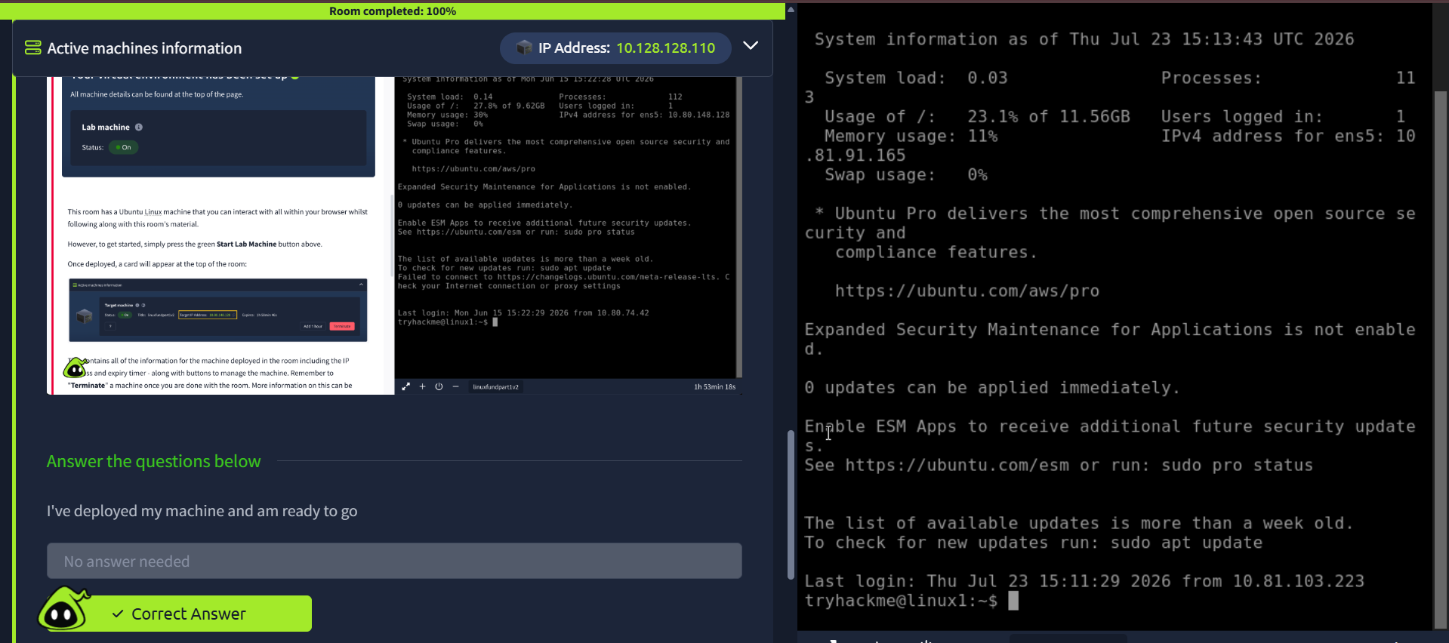
Fig. 1 — Confirming the machine had been deployed and was ready to go.

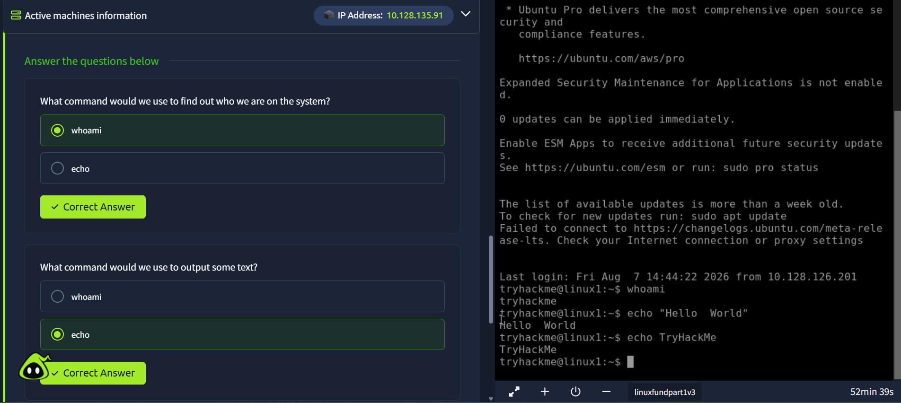
Fig. 2 — Testing whoami and echo: whoami correctly returned the logged-in user, and echo printed back both test strings exactly as entered.

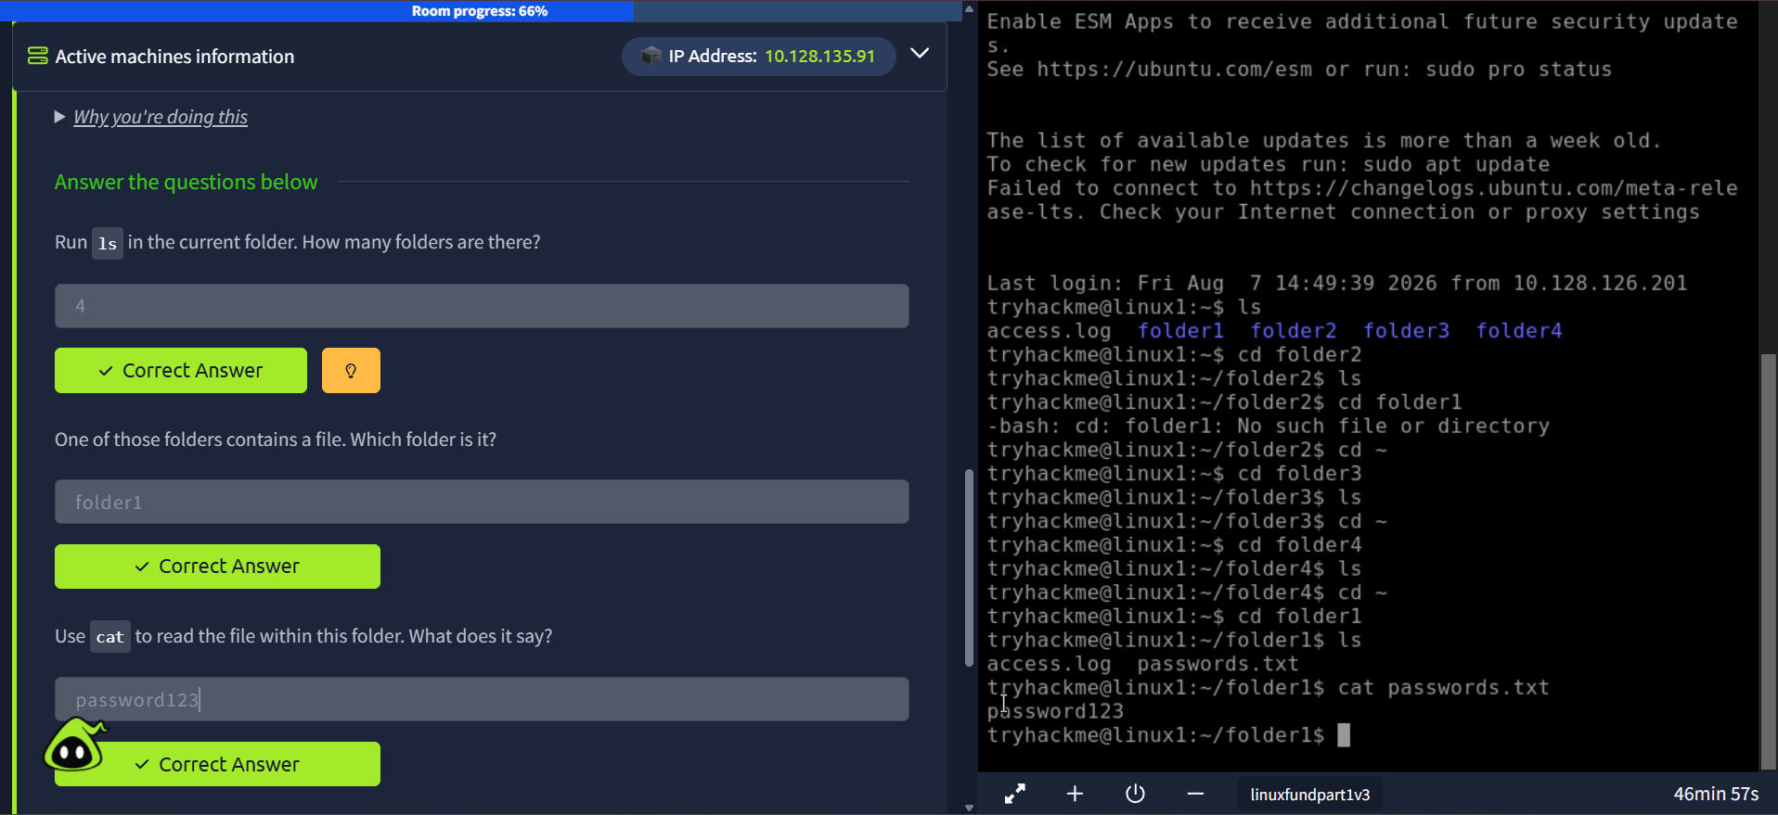
Fig. 3 — Navigating the filesystem with ls and cd: 4 folders were found, folder1 contained passwords.txt, and cat revealed the contents as password123.

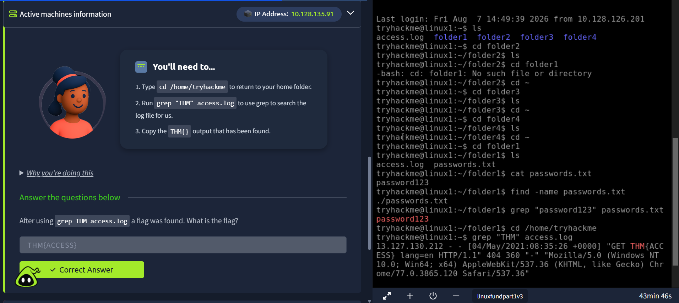
Fig. 4 — Using grep "THM" access.log to search the log file for the flag, found as THM{ACCESS} inside a fake HTTP request line.

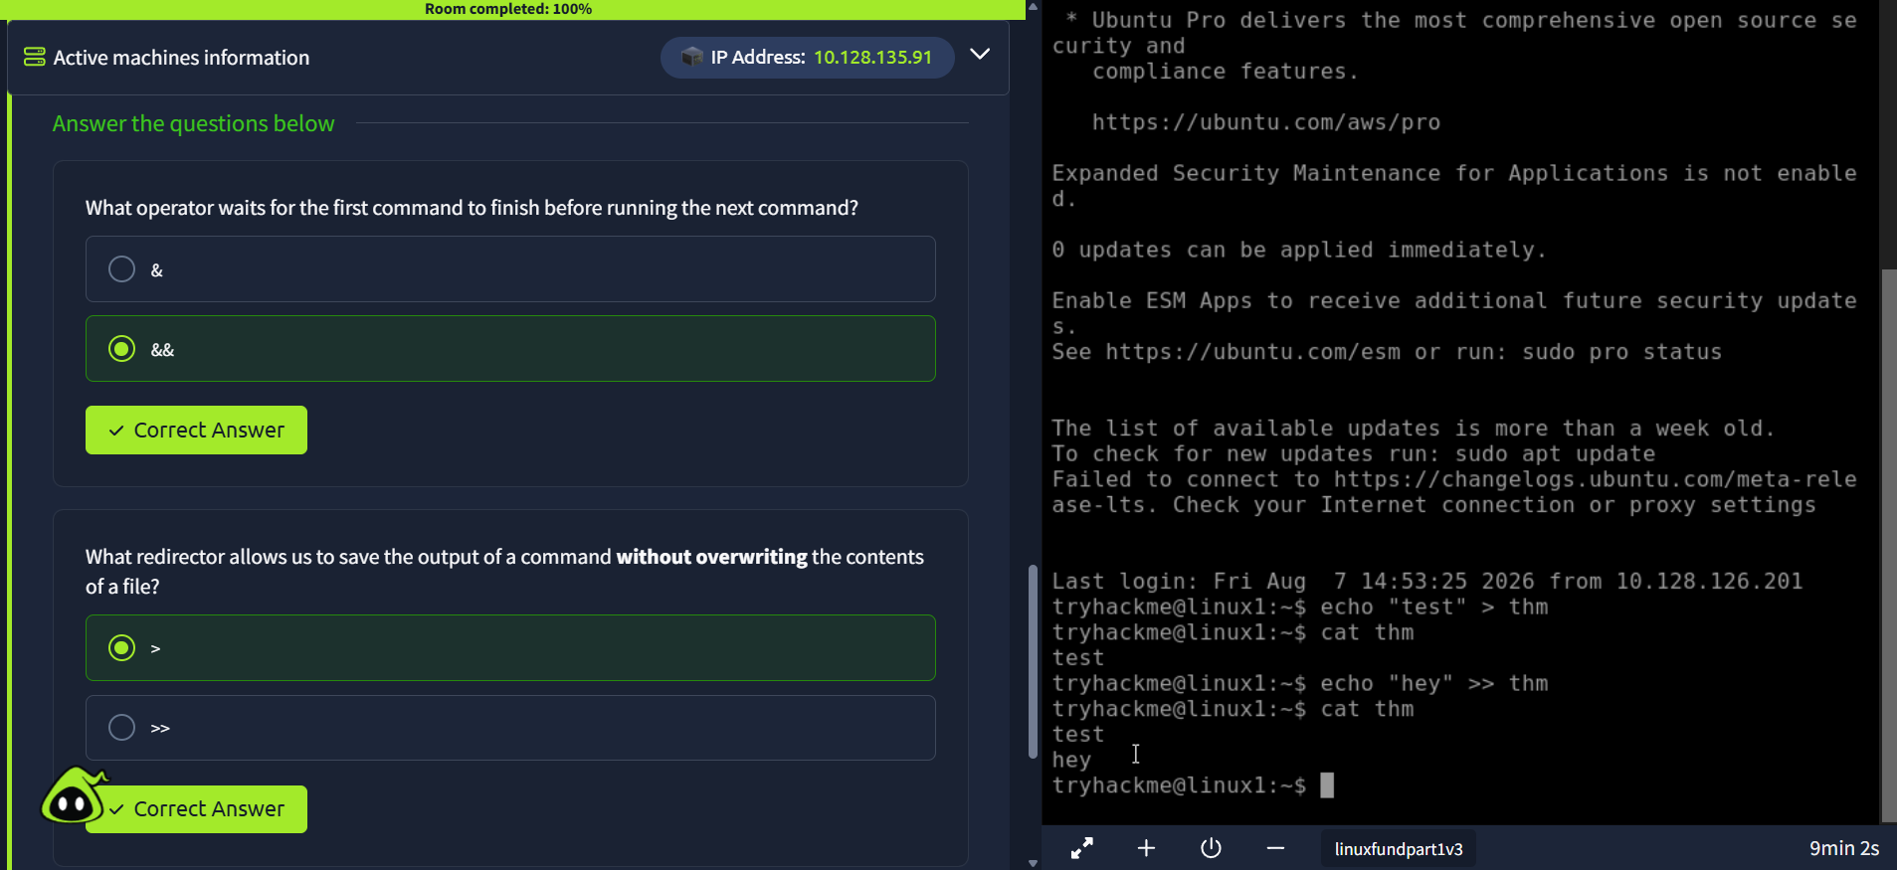
Fig. 5 — Identifying the && operator and testing output redirection with > and >> in the terminal on the right.

Reflection
This room was a solid, hands-on introduction to the Linux command line rather than a security-specific exercise, but every command covered here — navigating directories, reading files, and especially grep — is something I expect to use constantly in later, more security-focused rooms (e.g. searching log files for indicators of compromise). The distinction between > and >> was the part most worth remembering, since overwriting a file by mistake with > is an easy way to lose data during an investigation. I completed the room at 100% and answered all required questions correctly.

Room 4 Summary
Room 4 focused entirely on the Linux Fundamentals Part 1 room, building the basic command-line skills — identity commands, filesystem navigation, file reading, grep, and command/output operators — that later rooms in the Linux Fundamentals series (permissions, package management, logging) will build on.

Room 5 — Windows Fundamentals 1
Room Link | tryhackme.com/room/windowsfundamentals1
Objective | Learn the fundamentals of the Windows operating system — editions, the desktop environment, user accounts, User Account Control, Control Panel, and Task Manager.

What I Learned
This room moved from the web and Linux over to Windows, covering the operating system from the ground up: which edition is installed and why it matters, how the desktop, taskbar and notification area can be customised, where Windows keeps its critical system files, how user accounts and permissions work, and the built-in tools used to monitor and control the system day to day.
Task 1 (Windows Editions) covered the difference between Windows Home and Pro — the attached machine was actually running Windows Server 2019 Standard, and the task highlighted that BitLocker disk encryption is a Pro-only feature that isn't available on Home. The Taskbar and Notification Area task then covered how to customise which icons show in the search box, task view button, and notification area via the taskbar settings and Control Panel — my first answer for the notification-area icon ("volume icons") was wrong, and the correct answer turned out to be Action Center, a good reminder to check the exact wording Windows itself uses rather than guessing from memory.
The System32 task explained that this folder holds files critical to the OS and should never be modified or deleted carelessly, and introduced the %windir% system variable as a shortcut to the Windows installation folder. The User Accounts task had me open Local Users and Groups to inspect a second account on the machine (tryhackmebilly) — its group memberships (Remote Desktop Users, Users), the built-in Guest account used for anonymous/guest access, and the account's description field, which turned out to contain what looks like a plaintext password — a realistic example of sensitive data being left somewhere it shouldn't be.
The User Account Control (UAC) task explained the elevation prompt that appears whenever a program tries to make changes requiring administrator rights, and that the prompt automatically times out and cancels the action if no password is entered — a safeguard against malware silently gaining admin access. The Control Panel task had me switch the view to Small Icons and read down the alphabetical list to find the last entry (Windows Defender Firewall). Finally, the Task Manager task covered opening Task Manager with Ctrl+Shift+Esc, its "More details" process view, and ending unresponsive tasks.

Key Concepts / Commands
- Windows editions: Home vs Pro — Pro adds features like BitLocker drive encryption that aren't available on Home; the attached VM in this room ran Windows Server 2019 Standard.
- Ctrl+Shift+Esc — keyboard shortcut that opens Task Manager directly, without going through Ctrl+Alt+Del.
- Task Manager → More details → process list — shows every running process with live CPU and memory usage, and lets you End task on anything unresponsive.
- Control Panel view modes — switching from Category to Small icons/Large icons lists every applet alphabetically instead of grouping them.
- Taskbar/Notification Area settings — "Select which icons appear on the taskbar" and "Turn system icons on or off" control what shows next to the clock.
- %windir% — a system environment variable pointing to the Windows installation folder (usually C:\Windows).
- System32 — a protected folder inside %windir% containing files critical to the OS; accidentally deleting contents here can render Windows inoperable.
- Local Users and Groups — built-in management console for viewing/creating user accounts, group memberships, and account descriptions.
- Guest account — a built-in, disabled-by-default account intended for temporary/anonymous access to a computer.
- User Account Control (UAC) — the elevation prompt Windows shows before allowing a program to make changes that require administrator privileges.

Task Answers / Findings
Item | Finding / Answer
Pro-only encryption feature | BitLocker
Setting that hides the search box | Hidden
Extra notification-area icon | Action Center
System variable for the Windows folder | %windir%
Other user account found | tryhackmebilly
Groups for that account | Remote Desktop Users, Users
Built-in guest-access account | Guest
That account's description field | Window$Fun1!
Meaning of UAC | User Account Control
Last item in Control Panel (Small icons) | Windows Defender Firewall
Shortcut to open Task Manager | Ctrl+Shift+Esc

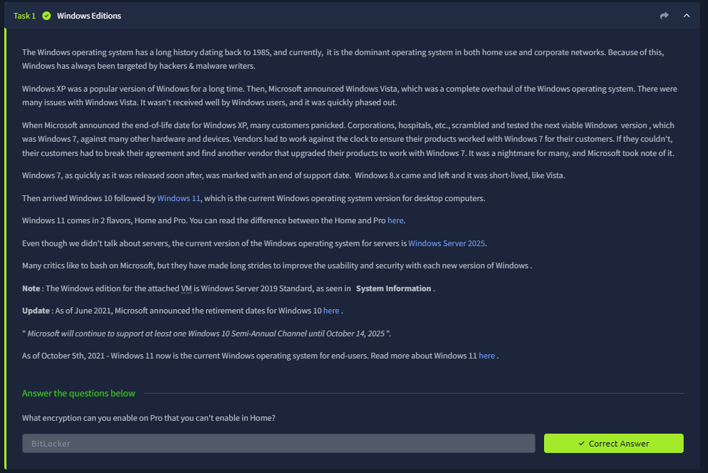
Fig. 1 — Task 1: Windows Editions — identifying BitLocker as the Pro-only encryption feature, on a VM confirmed to be running Windows Server 2019 Standard.

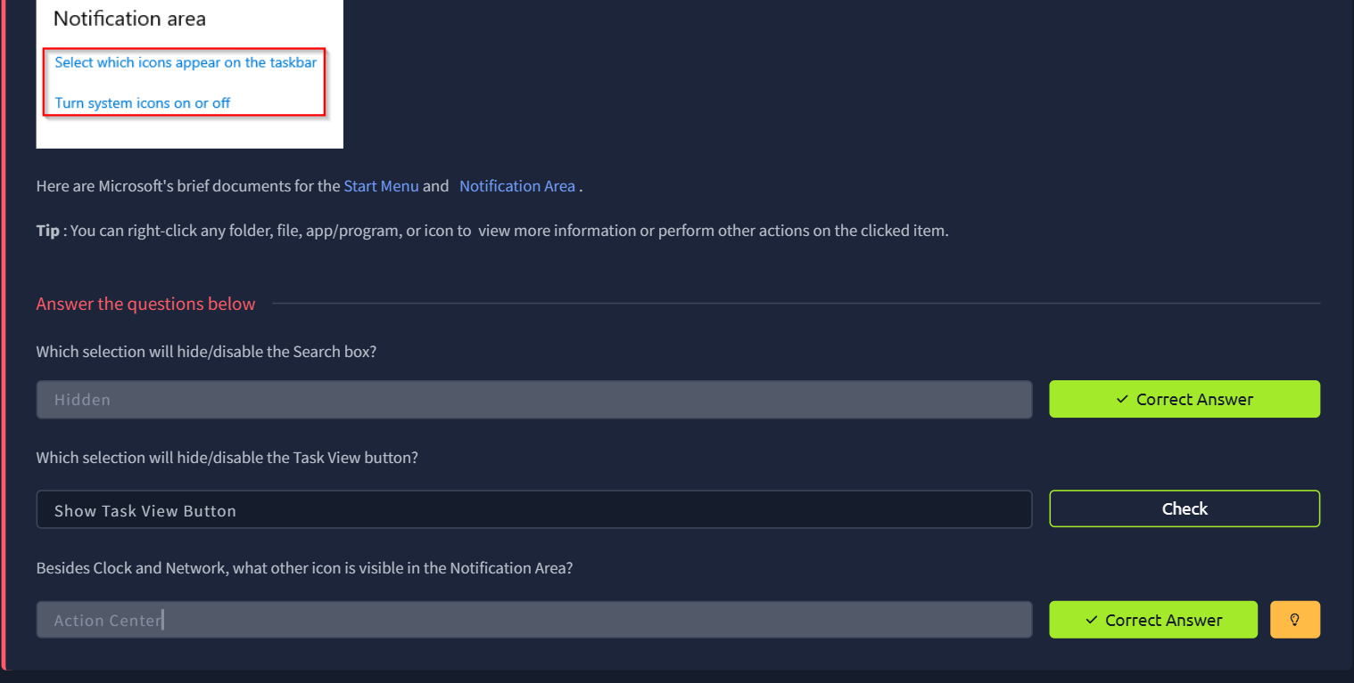
Fig. 2 — Taskbar and Notification Area: correctly identifying "Hidden" for the search box and Action Center as the extra notification-area icon.

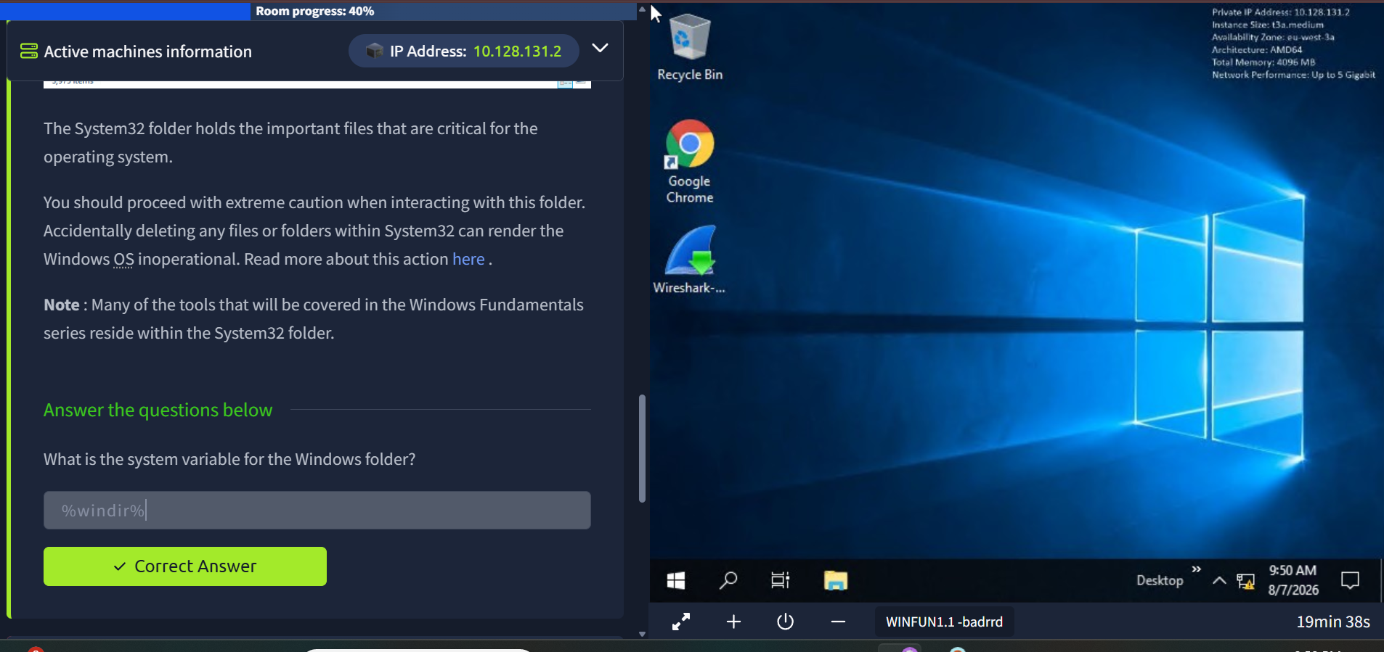
Fig. 3 — The System32 folder and the %windir% system variable, with a caution note about not deleting files from this folder.

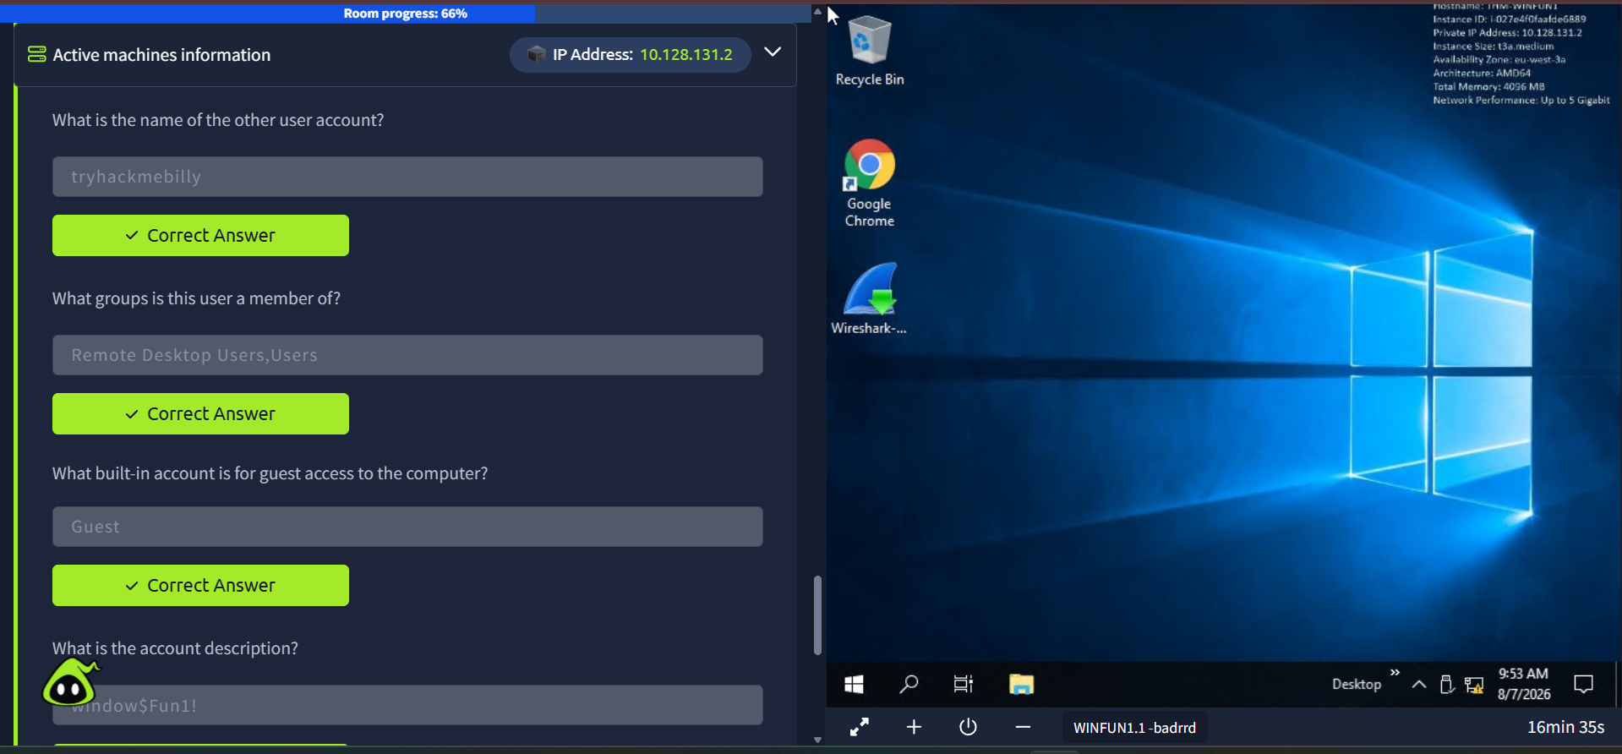
Fig. 4 — User Accounts task: the tryhackmebilly account, its groups, the built-in Guest account, and its description field.

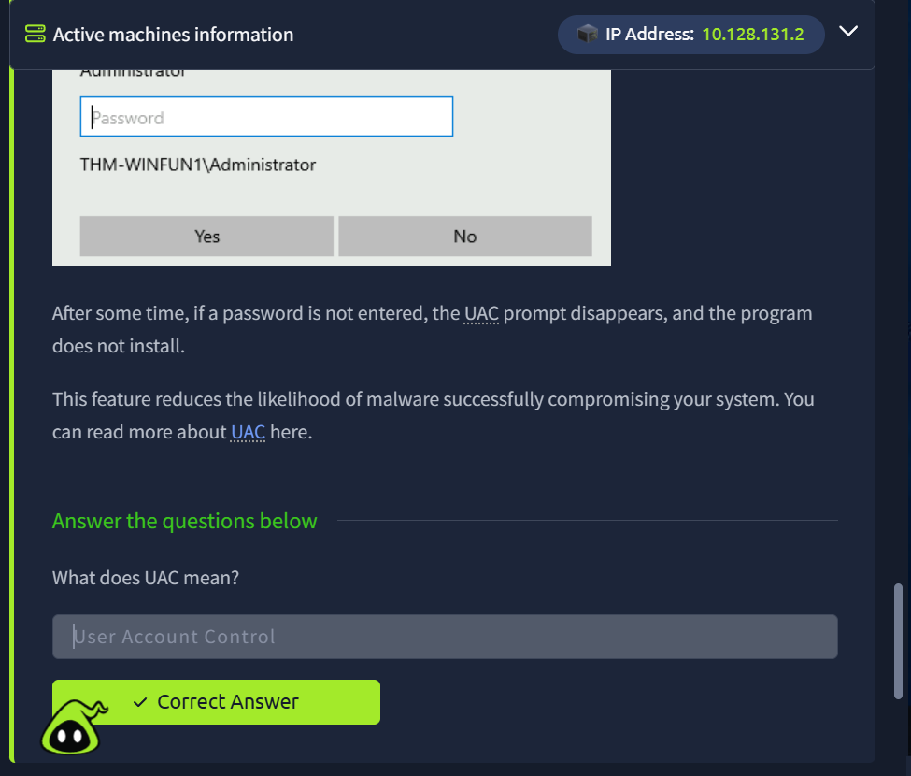
Fig. 5 — The User Account Control (UAC) elevation prompt shown before an action requiring admin rights.

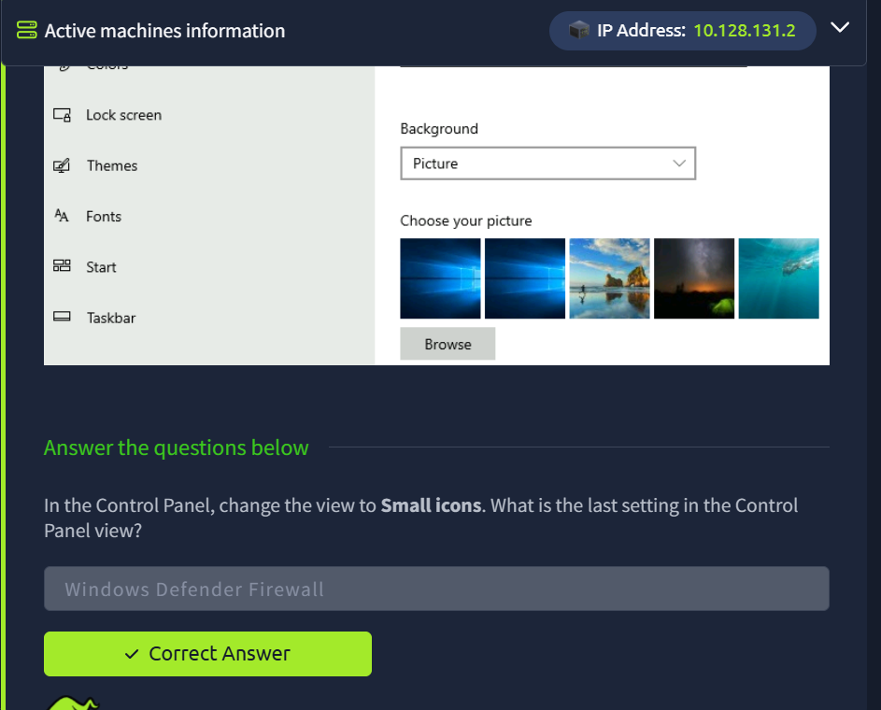
Fig. 6 — Control Panel switched to Small icons view, with Windows Defender Firewall as the last item in the alphabetical list.

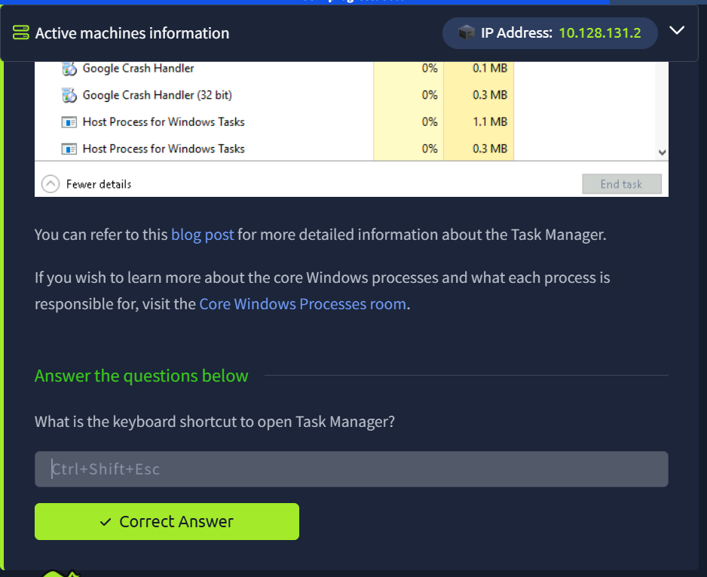
Fig. 7 — Task Manager's process list and the Ctrl+Shift+Esc shortcut used to open it directly.

Reflection
This room rounded out Week 1 by covering the Windows side of the fundamentals, mirroring the Linux Fundamentals room but for an environment I'll likely see far more of during client engagements. The description-field password on the tryhackmebilly account was the standout finding — it's exactly the kind of low-effort information disclosure that shows up in real assessments, and a reminder to check account metadata and not just usernames and group memberships when reviewing local accounts. UAC and Task Manager were more about building baseline operational familiarity than finding anything to exploit, but both are tools I'll be relying on constantly once later rooms move into actual Windows exploitation and privilege escalation. I completed the room and answered all required questions correctly, wrapping up all five rooms assigned for Week 1.

Week 1 Summary
Week 1 focused on getting comfortable with the TryHackMe platform and picking up the fundamentals needed for deeper security work — reading raw HTTP traffic, working in Linux and Windows environments, and understanding where different cybersecurity careers lead.
Item | Finding / Answer
Room 1 — Getting Started | Complete — 100%
Room 2 — Careers in Cyber | Complete — 100%
Room 3 — HTTP in Detail | Complete — 100%
Room 4 — Linux Fundamentals Part 1 | Complete — 100%
Room 5 — Windows Fundamentals 1 | Complete — 100%

All five rooms assigned for Week 1 are complete, covering the TryHackMe platform basics, raw HTTP traffic, and both Linux and Windows environments as planned.

