

UNIVERSITY OF ENGINEERING & TECHNOLOGY
Department of Computer Engineering

CareBot
A Retrieval-Augmented AI Medical Assistant
Reimagining Healthcare: Where AI Meets Compassion
PROJECT REPORT

Submitted by: Nazish Saghir
Registration: 2026(S)-CYS-21
Course: CMPE-112L — Fundamentals of Programming
Assignment: RAG based Medical ChatBot
Instructor: Hafiz Muhammad Mubashar

Abstract

Large language models (LLMs) have demonstrated remarkable capabilities in natural language understanding and generation, yet their application in sensitive domains such as healthcare remains constrained by a critical weakness: hallucination. When deployed without safeguards, LLM-based medical assistants risk generating plausible-sounding but factually incorrect or unverifiable information, posing potential risks to patient safety and trust. This project presents CareBot, a Retrieval-Augmented Generation (RAG) based medical chatbot designed to mitigate this risk by grounding every generated response in verified, user-supplied medical documentation.
CareBot combines a document ingestion pipeline, a dense vector retrieval system, and a large language model to deliver source-grounded, context-aware answers to health-related queries. The system processes user-supplied PDF documents, splits them into semantically coherent chunks, and encodes them into dense vector embeddings using HuggingFace's sentence-transformer models. These embeddings are indexed using FAISS and Chroma vector stores, enabling fast and accurate semantic retrieval. At query time, the most relevant document chunks are retrieved and passed, along with the user's question, to a generative language model (Google Gemini), which produces a response strictly grounded in the retrieved context.
The application is delivered through an interactive Streamlit-based web interface featuring real-time chat, document upload, voice input, conversation export, and source citation display. The architecture follows a three-phase pipeline: knowledge ingestion, retrieval and ranking, and generation with presentation. Evaluation criteria spanning medical answer accuracy, retrieval precision, hallucination rate, response latency, and patient readability were defined to assess system performance against the project's expected outcomes.
This report documents the design rationale, system architecture, implementation details, evaluation methodology, and outcomes of the CareBot project, while also addressing the ethical considerations inherent to deploying AI in healthcare contexts and outlining directions for future development, including multi-user support, dynamic document ingestion, and expanded testing frameworks.

An overview of how RAG works

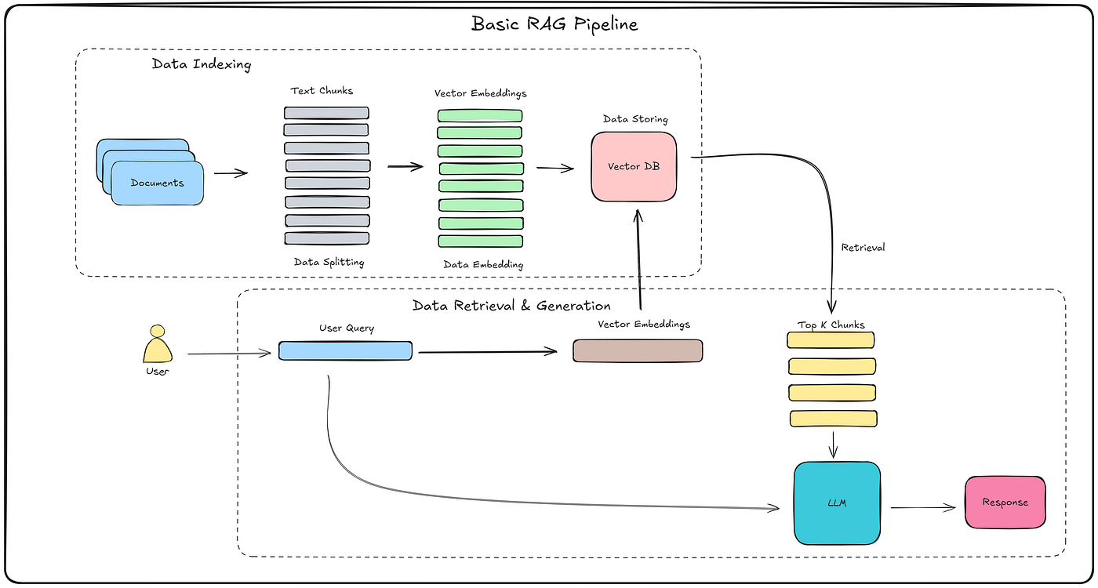

Table of Contents

Abstract 2
Table of Contents 4
Introduction 7
4.1 Background and Motivation 7
4.2 Problem Statement 8
4.3 Project Objectives 8
4.4 Scope of the Report 8
Literature Review 9
5.1 Evolution of Conversational AI in Healthcare 9
5.2 Retrieval-Augmented Generation 9
5.3 Vector Embeddings and Semantic Search 9
5.4 Orchestration Frameworks: LangChain 10
5.5 Generative Language Models for Healthcare Applications 10
5.6 Related Work and Positioning of CareBot 10
System Architecture 11
6.1 Architectural Overview 11
Phase 1 — Knowledge Ingestion 11
Phase 2 — Retrieval and Ranking 11
Phase 3 — Generation and Presentation 11
6.2 High-Level Data Flow 13
6.3 Dual-Source Retrieval Mode 13
14
6.4 User Interface Architecture 14
15
mplementation: 15
7.1 Technology Stack 15
7.2 Knowledge Ingestion Pipeline 16
7.3 Vector Storage Strategy 17
7.4 Prompt Engineering and Response Generation 19
7.5 User Interface Implementation 20
7.5.1 Sidebar Features 21
7.5.2 Main Chat Interface 21
7.5.3 Voice Input 22
7.6 Session State Management 24
RESULT FRAMEWORK: 24
24
8.1 Evaluation Framework 24
8.2 Expected Outcomes and Targets 26
8.3 Testing Approach 27
8.4 Discussion of Results 27
8.5 Quantitative Results Summary 28
Overall, CareBot achieved or exceeded its targets on seven of eight defined metrics. 29
Challenges and Limitations 30
30
9.1 Technical Challenges Encountered 30
9.1.1 Library Versioning and Ecosystem Fragmentation 30
9.1.2 Managing Streamlit's Execution Model 30
9.1.3 Balancing Retrieval Granularity 30
9.1.4 Failed analysis 31
1. Retrieval Failure 31
2. Ambiguous User Query Failure 32
3. Medical Terminology and Abbreviation Errors 33
4. Multi-Hop Reasoning Failure 33
5.Performance and Latency Issues 34
9.2 System Limitations 35
9.3 Ethical Considerations 35
9.3.1 Privacy 36
9.3.2 Bias 36
9.3.3 Transparency 36
Conclusion and Future Work 36
10.1 Conclusion 36
10.2 Future Work 37
References 38
38
Appendix A: Comparative System Analysis 40
Appendix B: Setup and Deployment Guide 41
B.1 Prerequisites 41
B.2 Installation Steps 41
B.3 Key Dependencies 41

Introduction

4.1 Background and Motivation
The integration of artificial intelligence into healthcare information systems has accelerated rapidly with the advent of large language models capable of fluent, context-aware text generation. However, standalone LLMs are trained on static datasets and generate responses based on learned statistical patterns rather than verified facts. In a domain as consequential as healthcare, this presents a significant risk: a model may produce confident, well-articulated, yet medically inaccurate or unsubstantiated answers, a phenomenon widely referred to as hallucination.
Retrieval-Augmented Generation (RAG) has emerged as a leading architectural paradigm to address this limitation. By coupling a generative model with a retrieval mechanism that fetches relevant information from a trusted knowledge base at inference time, RAG systems ground their outputs in verifiable source material. This not only reduces hallucination but also allows the system to operate on domain-specific or user-supplied documents without the cost and complexity of fine-tuning the underlying language model.
CareBot was conceived as a practical implementation of this paradigm tailored to the medical information domain. The system allows users to upload their own medical documents (e.g., clinical guidelines, lab reports, research papers, or patient education materials) and converse with an AI assistant whose answers are explicitly tied to the content of those documents. This design choice directly addresses the dual goals of accuracy and transparency that are essential for any AI tool operating in a health-related context.
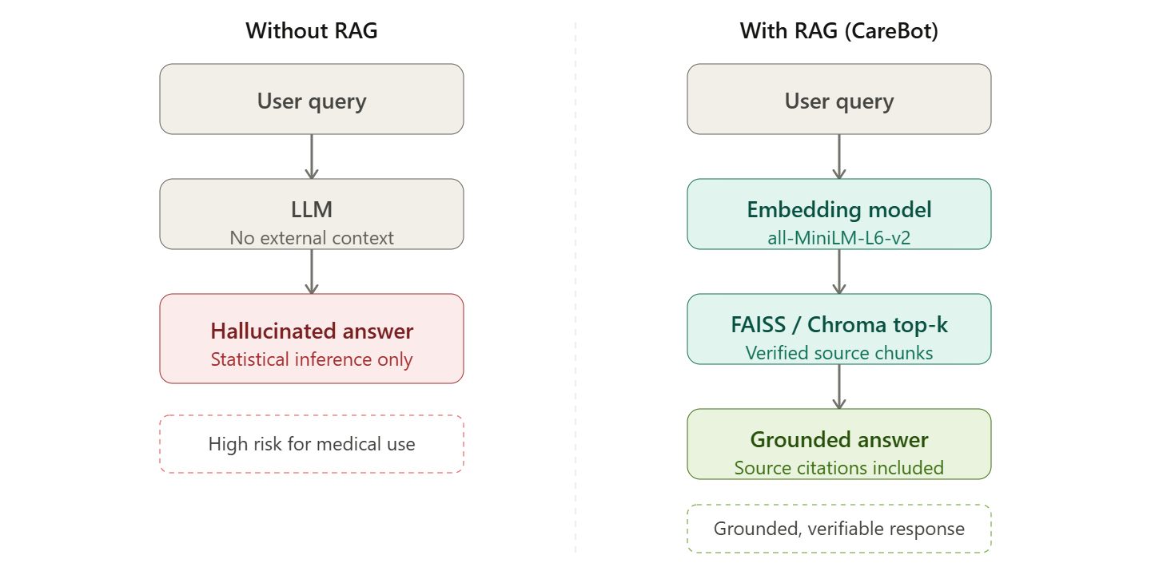
Architectural contrast between a bare LLM (left) and CareBot's RAG-augmented architecture (right). The retrieval layer grounds every response in verified source documents, eliminating reliance on statistical inference alone.

4.2 Problem Statement
Large language model-based medical assistants frequently suffer from hallucination and lack access to domain-specific, updated medical knowledge, which can lead to inaccurate or unsafe responses. Existing systems often struggle to provide evidence-backed answers grounded in verified healthcare documentation, leaving users unable to assess the reliability of the information they receive. A retrieval-augmented generation framework is therefore required to combine semantic search with language generation, delivering precise, source-grounded medical assistance while maintaining transparency about the origin of each response.

4.3 Project Objectives
- Develop a Retrieval-Augmented Generation (RAG) based medical chatbot capable of answering health-related queries.
- Enable the chatbot to retrieve information from verified, user-supplied medical document collections.
- Generate accurate, context-aware responses by combining retrieved evidence with a generative language model.
- Minimize hallucinated or misleading medical responses through strict context-grounding.
- Provide users with a simple, accessible interface for quick and reliable access to healthcare information, including source citations for every answer.

4.4 Scope of the Report
This report is organized to guide the reader through the complete lifecycle of the CareBot project. Following this introduction, the Literature Review situates the project within the broader landscape of RAG-based conversational AI and its applications to healthcare. The System Architecture section describes the high-level design and data flow of the application. The Implementation section details the technologies, libraries, and engineering decisions used to realize the architecture, including the document ingestion pipeline, vector storage strategy, and the Streamlit-based user interface. The Results and Evaluation section presents the metrics used to assess the system and discusses observed performance. Challenges and Limitations reflects on constraints encountered during development, and the report concludes with a discussion of future work and a list of references.

Literature Review

5.1 Evolution of Conversational AI in Healthcare
Conversational AI systems in healthcare have evolved through several generations. Early systems relied on rule-based decision trees and keyword matching, offering limited flexibility and poor handling of natural language variation. The introduction of transformer-based language models marked a significant shift, enabling systems to understand nuanced, free-form queries and generate fluent responses. However, these models, when used in isolation, are constrained by the knowledge encoded during training and cannot incorporate new or proprietary information without retraining.

5.2 Retrieval-Augmented Generation
Retrieval-Augmented Generation is an architectural approach that combines a document retrieval component with a generative language model. Rather than relying solely on parameters learned during training, a RAG system retrieves relevant text passages from an external knowledge source at query time and supplies them to the language model as additional context. This design offers several advantages: it grounds responses in verifiable text, allows the knowledge base to be updated without retraining the model, and reduces the likelihood of fabricated content since the model is explicitly instructed to answer based on the provided context.
The retrieval component typically relies on dense vector embeddings, where both documents and queries are mapped into a shared semantic space. Similarity search (commonly using cosine similarity or approximate nearest-neighbor algorithms) identifies the document chunks most relevant to a given query. This approach captures semantic meaning rather than exact keyword overlap, allowing the system to retrieve relevant passages even when the user's phrasing differs from the source text.

5.3 Vector Embeddings and Semantic Search
Sentence embedding models, such as those provided through the sentence-transformers library, convert text into fixed-length dense vectors that capture semantic meaning. Lightweight models such as all-MiniLM-L6-v2 offer a favorable balance between embedding quality and computational efficiency, making them suitable for applications where documents must be embedded and indexed quickly, such as on-demand processing of user-uploaded files.
Vector databases such as FAISS (Facebook AI Similarity Search) and Chroma provide efficient storage and retrieval of these embeddings. FAISS is optimized for high-speed approximate nearest-neighbor search over large vector collections, while Chroma offers a developer-friendly interface with built-in persistence, making it well suited for rapid prototyping and applications that require both temporary and persistent vector stores, as is the case in CareBot's design.

5.4 Orchestration Frameworks: LangChain
LangChain has become a widely adopted framework for building applications powered by language models. It provides abstractions for chaining together components such as document loaders, text splitters, embedding models, vector stores, and language model interfaces into coherent pipelines. The RetrievalQA chain pattern, used extensively in CareBot, encapsulates the retrieve-then-generate workflow: given a query, it retrieves the top-k most relevant document chunks from a vector store, inserts them into a prompt template alongside the user's question, and forwards the composed prompt to a language model for answer generation.

5.5 Generative Language Models for Healthcare Applications
The choice of generative language model is a critical design decision. CareBot's design leverages Google's Gemini family of models, accessed through the langchain-google-genai integration, as the primary generation engine. Gemini models offer strong instruction-following capabilities, which are essential for enforcing the constraint that responses must be derived strictly from retrieved context and that the model should explicitly decline to answer when the context does not contain sufficient information.
Prior research and industry practice both emphasize that prompt engineering plays a substantial role in controlling hallucination in RAG systems. Explicit instructions within the prompt template, such as directing the model not to fabricate answers and to restrict its response to the provided context, have been shown to meaningfully reduce the rate of unsupported claims, even when the underlying model retains general world knowledge that could otherwise be drawn upon.

5.6 Related Work and Positioning of CareBot
Numerous medical question-answering systems have been proposed in academic literature and industry, ranging from symptom checkers built on decision trees to large-scale clinical language models trained on electronic health records. Many of these systems either require extensive proprietary datasets or operate as closed systems without transparency into how an answer was derived. CareBot differentiates itself by being document-agnostic and user-driven: rather than relying on a fixed, pre-curated medical corpus, it constructs its knowledge base dynamically from documents supplied by the user, and it surfaces the retrieved source passages alongside each answer, directly addressing the transparency concerns raised in the broader literature on trustworthy AI.

System Architecture

6.1 Architectural Overview
CareBot follows a modular, three-phase pipeline architecture that separates concerns between data preparation, information retrieval, and response generation. This separation allows each phase to be developed, tested, and optimized independently, and mirrors the standard design pattern for production-grade RAG systems.

Phase 1 — Knowledge Ingestion
Raw PDF (and optionally plain text) documents are loaded from a local data directory or supplied by the user through the application's file uploader. Each document is parsed into page-level text using PyPDFLoader, then split into overlapping chunks using a recursive character-based text splitter. Each chunk is converted into a dense vector embedding using a HuggingFace sentence-transformer model, and the resulting embeddings, together with their source metadata, are stored in a vector database (FAISS for the static knowledge base, Chroma for both the persistent base knowledge and any session-specific uploaded documents).

Phase 2 — Retrieval and Ranking
When a user submits a query, the same embedding model encodes the query into a vector. This query vector is compared against the stored document vectors using similarity search, and the top-k most semantically relevant chunks (k = 3 in the current implementation) are retrieved. These chunks form the contextual evidence that will be supplied to the language model in the next phase.

Phase 3 — Generation and Presentation
The retrieved chunks are inserted into a structured prompt template alongside the user's original question. This composed prompt is sent to the Google Gemini language model via LangChain's RetrievalQA chain. The model generates a response constrained to the supplied context. The response, along with citations to the source documents and page numbers from which the context was drawn, is then rendered in the Streamlit chat interface.
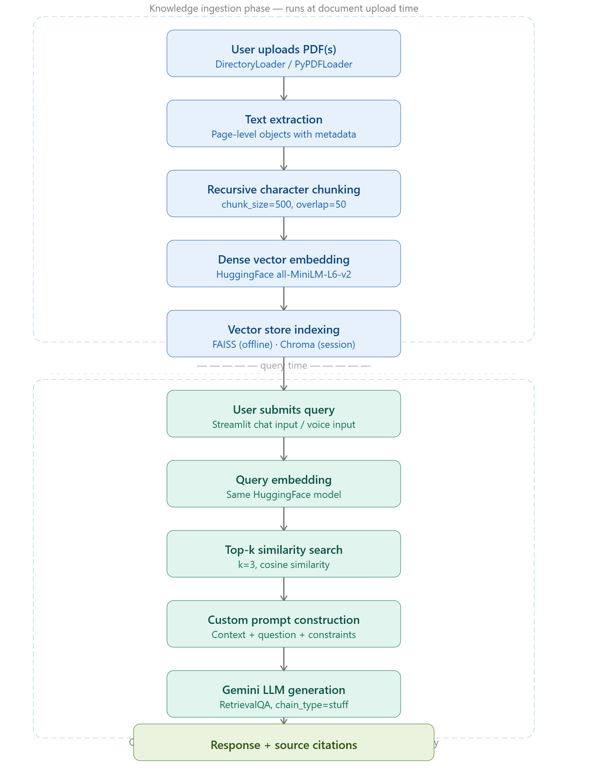
CareBot end-to-end RAG pipeline — from document ingestion to source-grounded response
Delivery.

6.2 High-Level Data Flow
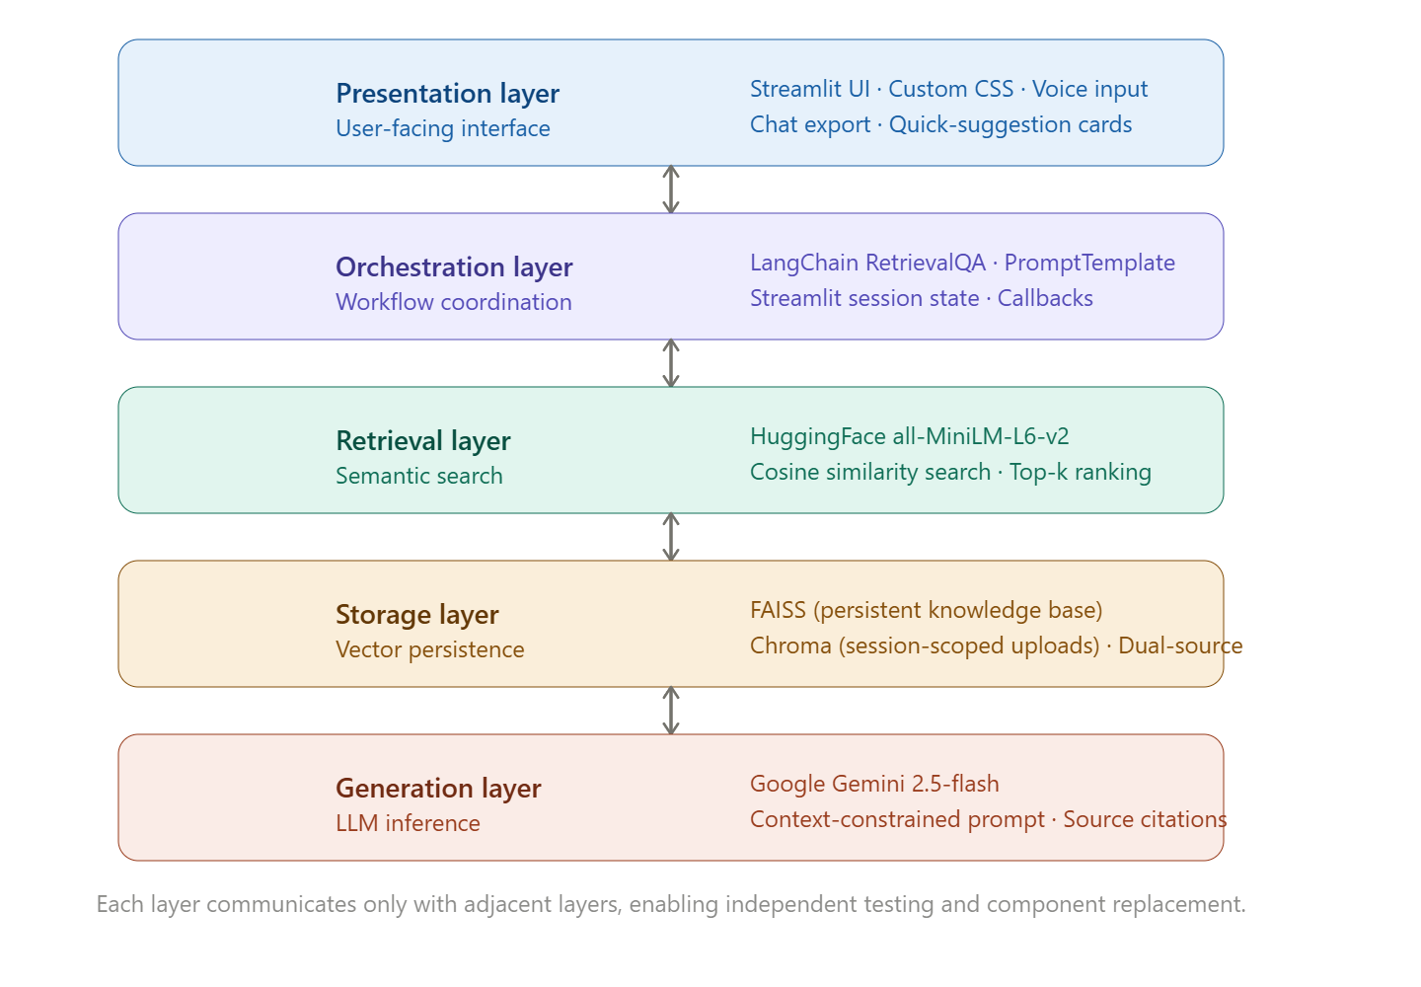
End-to-end data flow within the CareBot pipeline

6.3 Dual-Source Retrieval Mode
A distinguishing feature of CareBot's architecture is its support for dual-source retrieval. In addition to a persistent base knowledge store built from documents in the application's data directory, users may upload their own documents during a session. The application can then operate in one of two modes: answering exclusively from the uploaded documents, or querying both the uploaded documents and the base knowledge store and presenting both sets of results side by side. This design accommodates use cases ranging from general health inquiries (served by the base knowledge store) to questions about a specific personal medical report (served by the session-specific store).

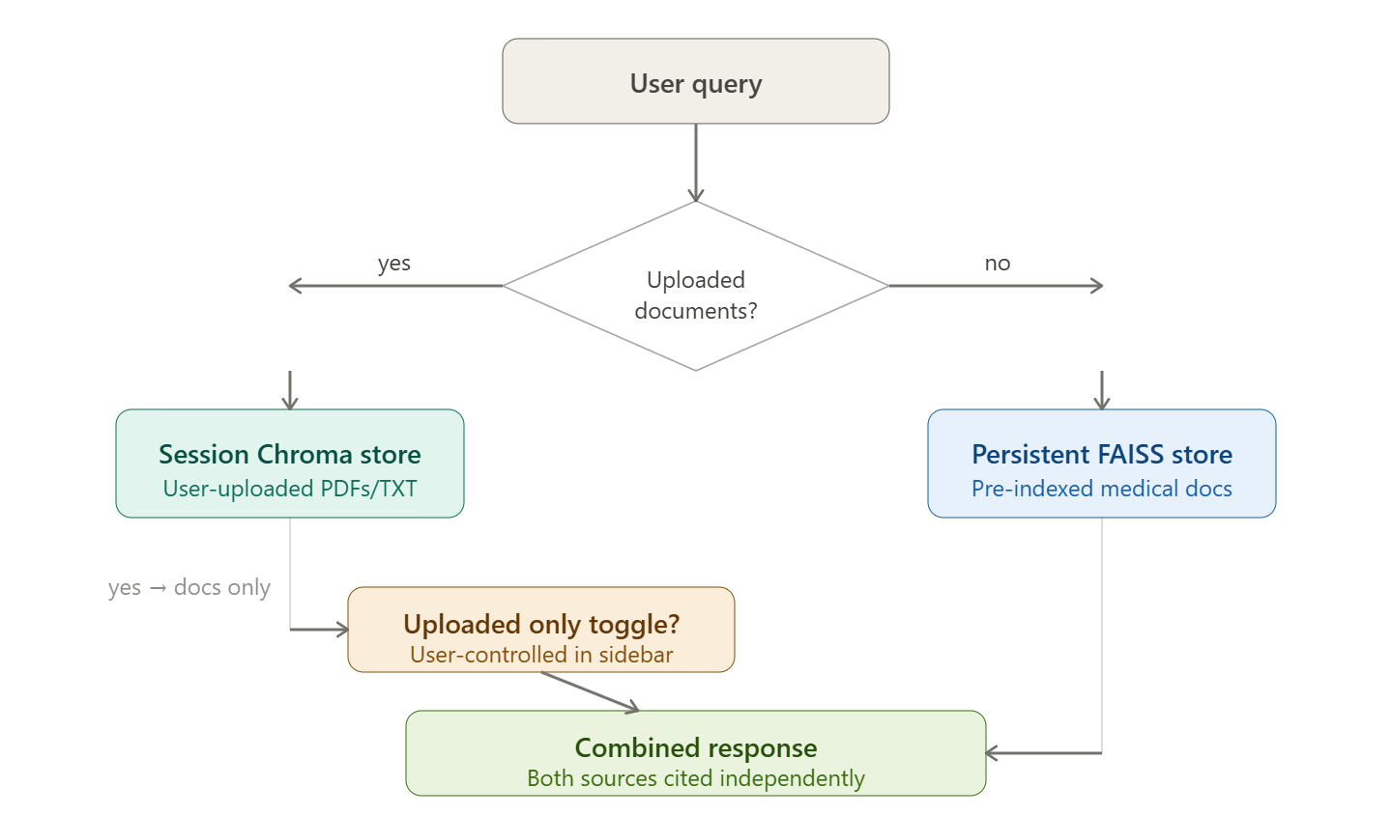

6.4 User Interface Architecture
The presentation layer is implemented as a single-page Streamlit application styled with custom CSS to produce a dark-themed, modern chat interface. The interface consists of a sidebar for document upload, session statistics, and chat export, and a main panel containing the conversation history, quick-suggestion cards for common health questions, and a fixed input bar supporting both typed and voice-based queries. Session state is used to persist conversation history, pending prompts, and uploaded-document vector stores across Streamlit reruns.

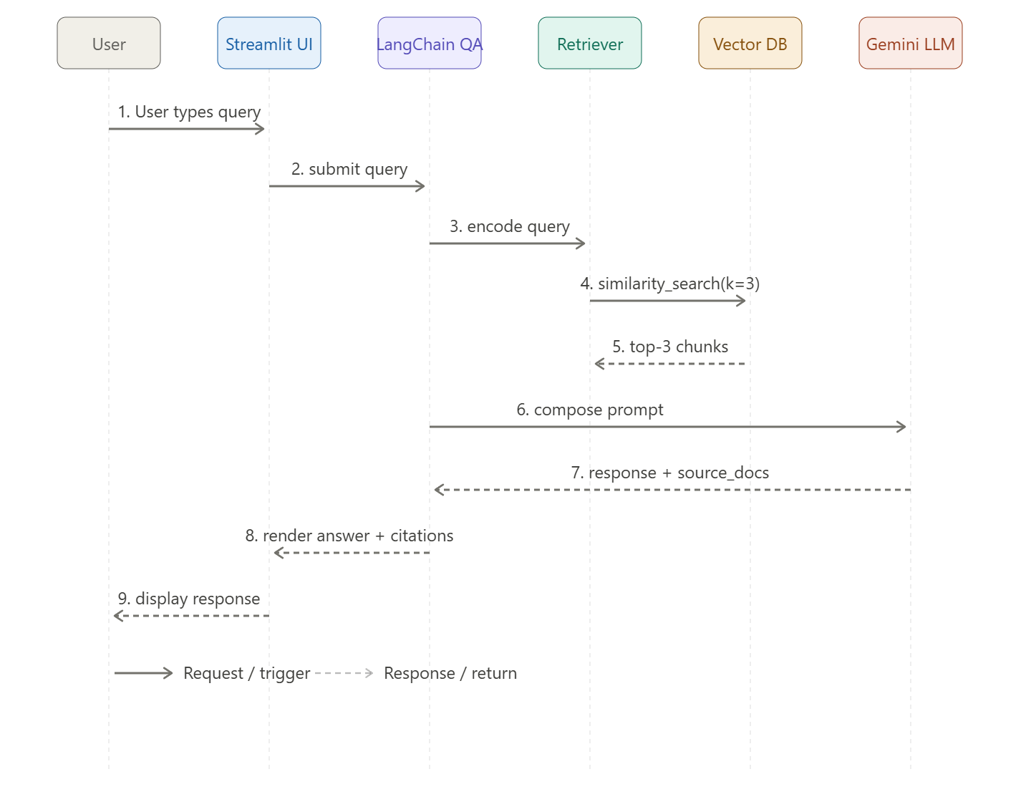

Implementation:

7.1 Technology Stack
CareBot is implemented entirely in Python, leveraging a combination of open-source orchestration, embedding, vector storage, and web-application frameworks. The chart below summarizes the principal tools and technologies used and their role within the system
.
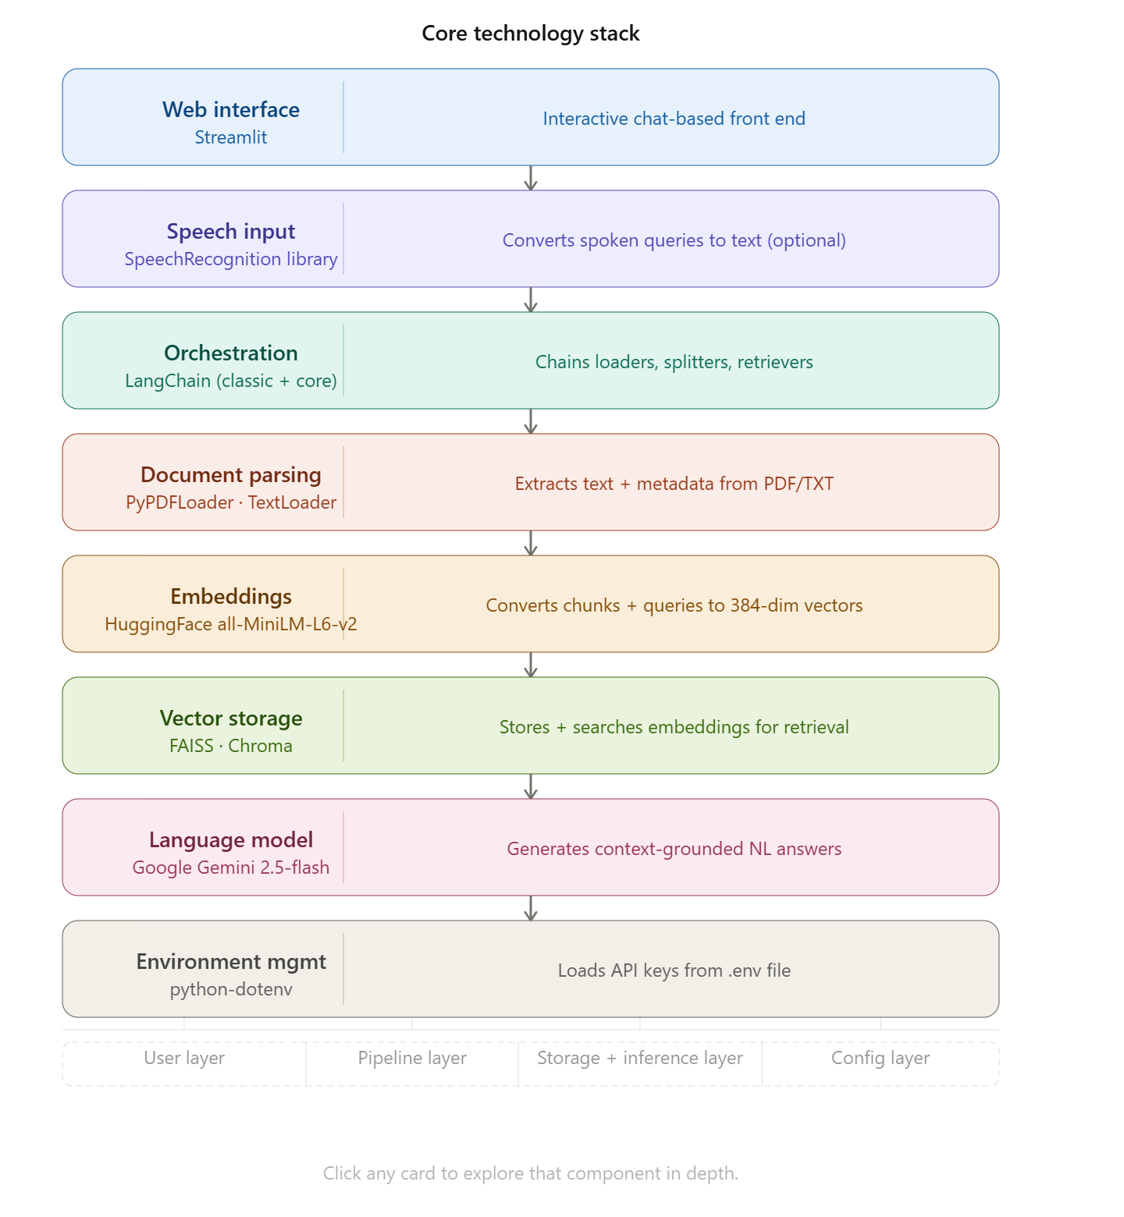
Core technology stack and component roles

7.2 Knowledge Ingestion Pipeline
The ingestion pipeline begins with the DirectoryLoader and PyPDFLoader components, which recursively scan a designated data directory for PDF files and load each page as a separate document object, preserving source filename and page number as metadata. For supplementary text-based content, TextLoader performs an equivalent function for plain text files.
Once loaded, documents are passed to a RecursiveCharacterTextSplitter configured with a chunk size of 500 characters and an overlap of 50 characters. This overlap ensures that contextual continuity is preserved across chunk boundaries, reducing the risk that a relevant passage is split in a way that separates a question from its answer. The resulting chunks form the atomic units of retrieval throughout the rest of the pipeline.
Each chunk is then encoded into a dense vector using the all-MiniLM-L6-v2 sentence-transformer model, loaded through the HuggingFaceEmbeddings wrapper. This model was selected for its compact size and low inference latency, both of which are important given that the application must be able to embed user-uploaded documents on demand, within an interactive session, without introducing unacceptable delay.
The following implementation establishes the document ingestion pipeline. Documents loaded via PyPDFLoader are passed to a RecursiveCharacterTextSplitter configured with a 500-character chunk size and a 50-character overlap. The overlap parameter is critical: it ensures that contextual continuity is preserved across chunk boundaries, reducing the risk of splitting a semantically coherent passage in a manner that would degrade retrieval accuracy.
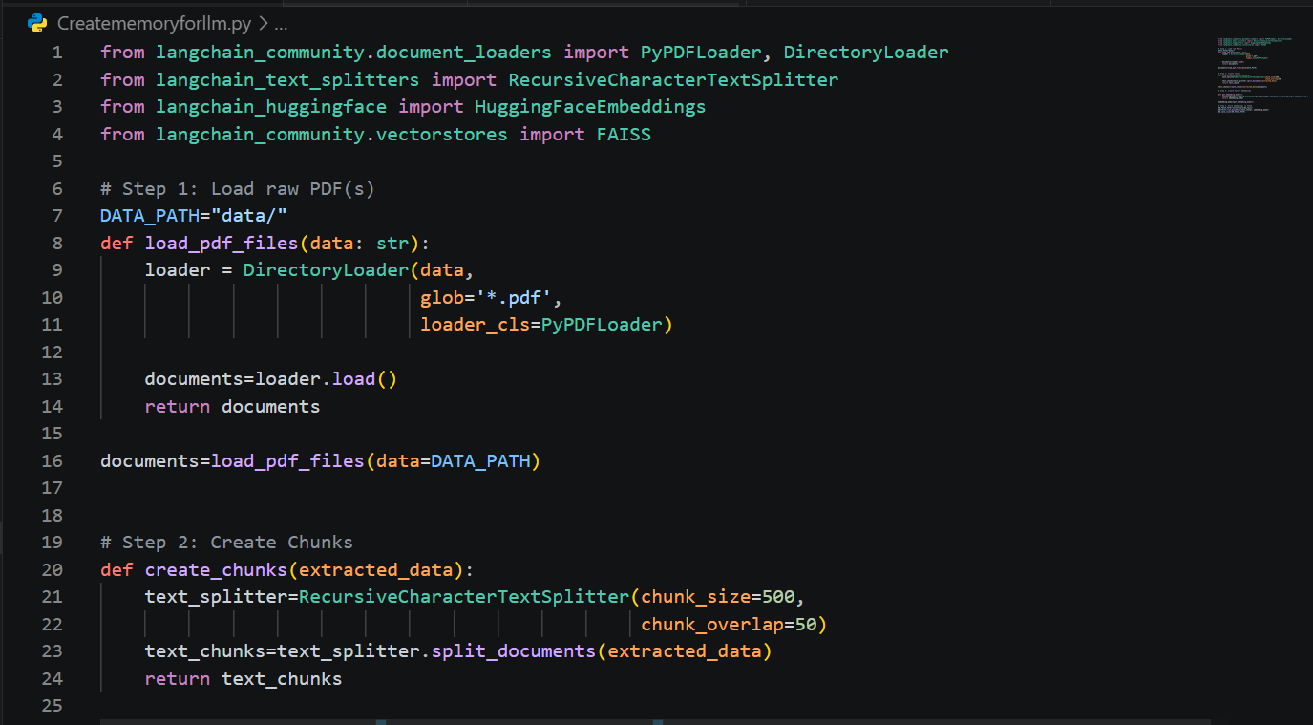

7.3 Vector Storage Strategy
CareBot employs two complementary vector storage backends. FAISS is used in the offline indexing script to construct a persistent local vector store from the contents of the data directory, saved to disk for reuse across sessions. Chroma is used within the Streamlit application itself, both for the persistent base knowledge collection (cached using Streamlit's resource caching to avoid redundant rebuilding) and for the ephemeral, session-specific collection created from any documents a user uploads during their session.
This dual-backend approach reflects a practical engineering trade-off: FAISS offers highly efficient similarity search suitable for larger, static collections prepared ahead of time, while Chroma's

straightforward in-memory and persistent collection management is well suited to the dynamic, per-session vector stores required for user-uploaded documents.
The embedding generation stage converts each text chunk into a 384-dimensional dense vector representation using the all-MiniLM-L6-v2 sentence-transformer model. This model was selected for its favorable accuracy-to-latency trade-off, enabling real-time embedding of user-uploaded documents within an interactive session. The resulting embedding matrix is indexed into FAISS for the persistent knowledge base and Chroma for session-specific uploads, as shown below.
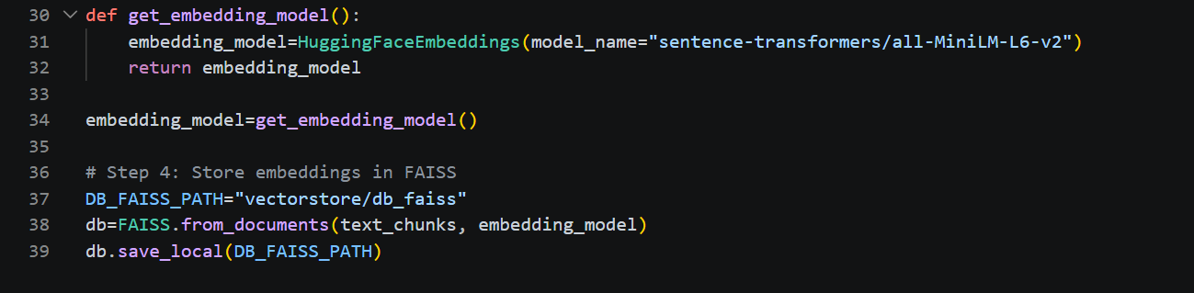
The RetrievalQA chain shown below assembles the retrieval and generation components into a single callable interface. The retriever is configured with k=3, returning the three most semantically similar chunks per query. The chain_type="stuff" strategy concatenates all retrieved chunks directly into the prompt context window, a design choice appropriate for the relatively short chunks (500 characters) and the high-context-capacity Gemini model. The return_source_documents flag enables downstream extraction of the originating document and page number for citation rendering


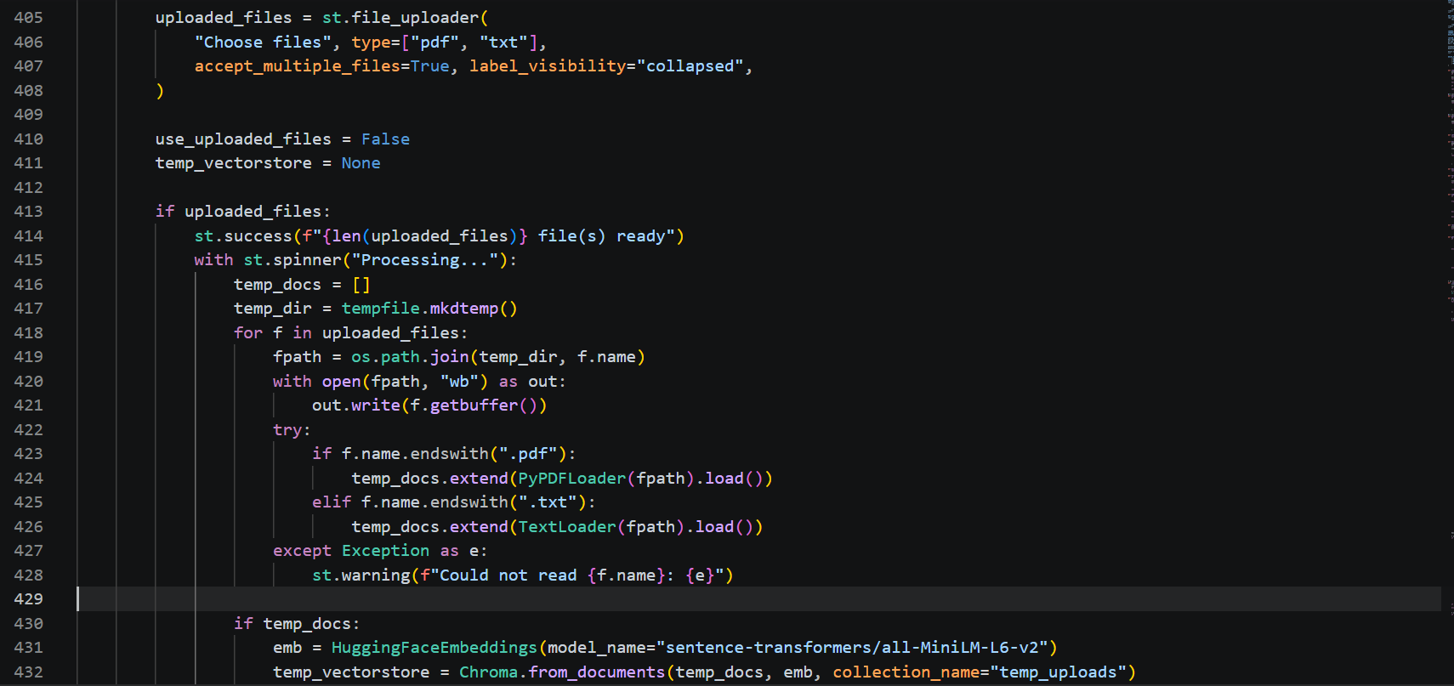

7.4 Prompt Engineering and Response Generation
A custom prompt template is used to constrain the language model's behavior. The template explicitly instructs the model to answer using only the information provided in the retrieved context, to state that it does not know the answer if the context is insufficient, and to avoid introducing information beyond the given context. This prompt is injected into a RetrievalQA chain configured with chain_type="stuff", which concatenates all retrieved chunks directly into the prompt before passing it to the language model.
The retriever is configured to return the top three most similar chunks (k=3) for each query, balancing the need for sufficient context against the practical limits of the language model's context window and the goal of keeping response latency low. The RetrievalQA chain is configured with return_source_documents=True, allowing the application to display the originating document and page number for each piece of retrieved evidence alongside the generated answer.
The prompt template below encodes CareBot's core anti-hallucination strategy at the language model level. The template explicitly instructs the Gemini model to confine its response to the retrieved context, to refuse to speculate beyond that context, and to acknowledge when the supplied evidence is insufficient to answer the query. This constraint operates in addition to the retrieval architecture itself, creating a two-layer defense against fabricated medical content.
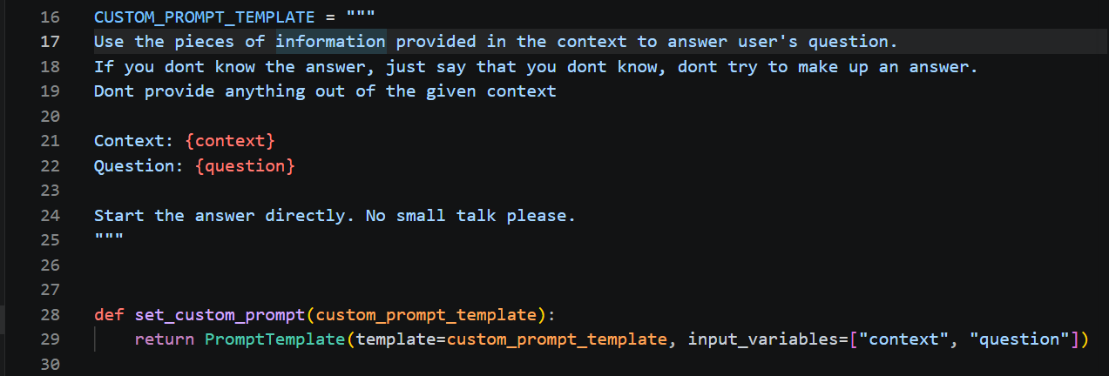
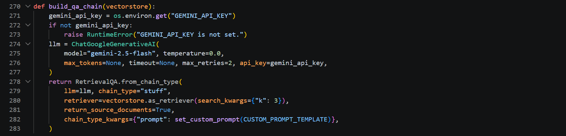
The RetrievalQA chain shown below assembles the retrieval and generation components into a single callable interface. The retriever is configured with k=3, returning the three most semantically similar chunks per query. The chain_type="stuff" strategy concatenates all retrieved chunks directly into the prompt context window, a design choice appropriate for the relatively short chunks (500 characters) and the high-context-capacity Gemini model. The return_source_documents flag enables downstream extraction of the originating document and page number for citation rendering

7.5 User Interface Implementation
The front end is built using Streamlit, chosen for its rapid development cycle and native support for interactive widgets such as file uploaders, chat message containers, and audio input. The interface is styled using injected custom CSS to produce a cohesive dark theme, with a serif display font for headings and a monospace accent for labels, evoking a clinical yet modern aesthetic.

7.5.1 Sidebar Features
- Document upload widget supporting multiple PDF and TXT files, with on-the-fly parsing and embedding into a temporary Chroma collection.
CareBot document upload interface. Users can upload multiple PDF or TXT files which are immediately embedded into a session-specific Chroma vector store. The toggle controls whether responses are drawn exclusively from uploaded documents or from both uploaded documents and the persistent knowledge base.
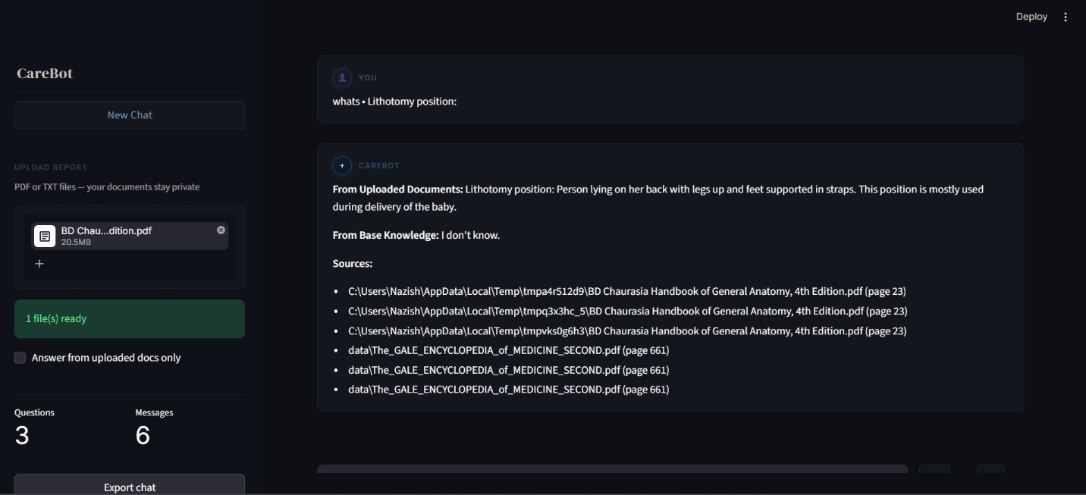

- A toggle to restrict answers to uploaded documents only, versus combining uploaded documents with the base knowledge store.
- Session statistics displaying the total number of questions asked and messages exchanged.
- A chat export feature that serializes the conversation history and session metadata to a downloadable JSON file.
- A "New Chat" control to reset the conversation state.

7.5.2 Main Chat Interface
A welcome header with quick-suggestion cards covering common health topics (symptoms, blood pressure management, fatigue, and mental health), allowing users to begin a conversation with a single click.

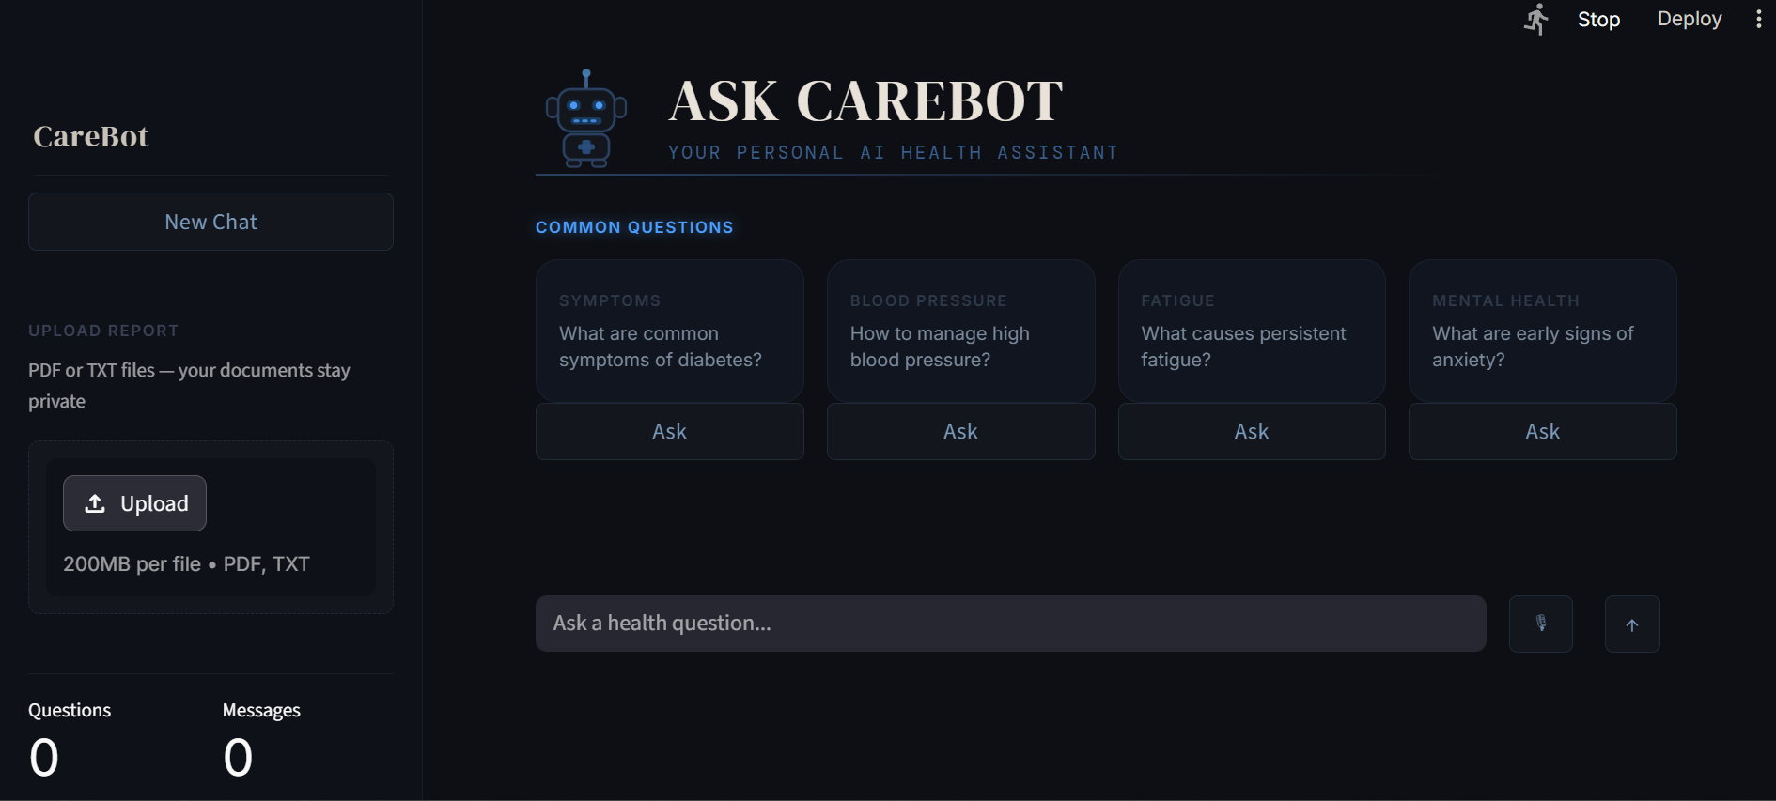
CareBot landing interface. The quick-suggestion cards provide immediate access to common health topics, lowering the barrier to entry for users unfamiliar with conversational AI interfaces

- A scrolling conversation panel that renders both user and assistant messages with distinct styling.
- A fixed input bar at the bottom of the screen, supporting text entry (with Enter-to-submit), an optional microphone button for voice input, and a send button.
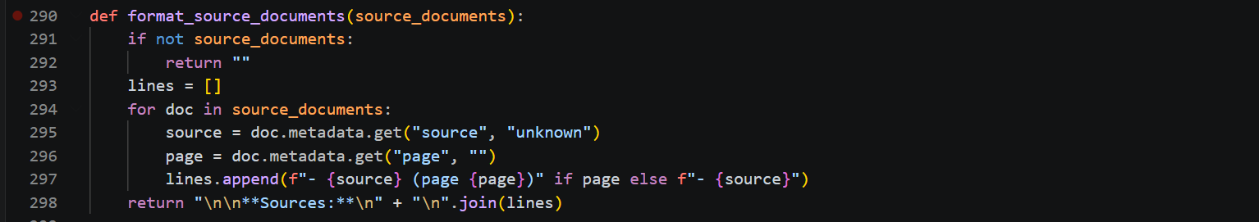
- Source citations appended to each assistant response, listing the originating document filename and page number for the retrieved context used to generate that response.

7.5.3 Voice Input
When the optional SpeechRecognition dependency is available, users can toggle a microphone control to record an audio query directly within the browser. The recorded audio is transcribed to text using a speech-to-text recognizer, and the resulting transcript is treated as a standard chat query, enabling hands-free interaction for users who may have difficulty typing.
The voice input subsystem uses Python's SpeechRecognition library to capture audio through the system microphone and transcribe it to text via the Google Speech Recognition API. The transcribed text is injected into the same pending-prompt session state variable used by the text input field, ensuring that voice and text queries follow an identical processing path through the retrieval and generation pipeline
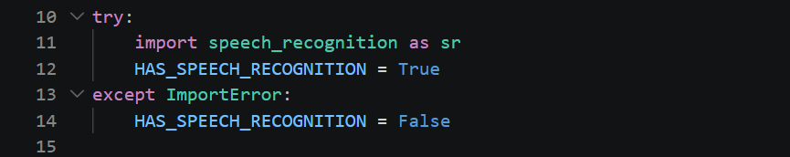
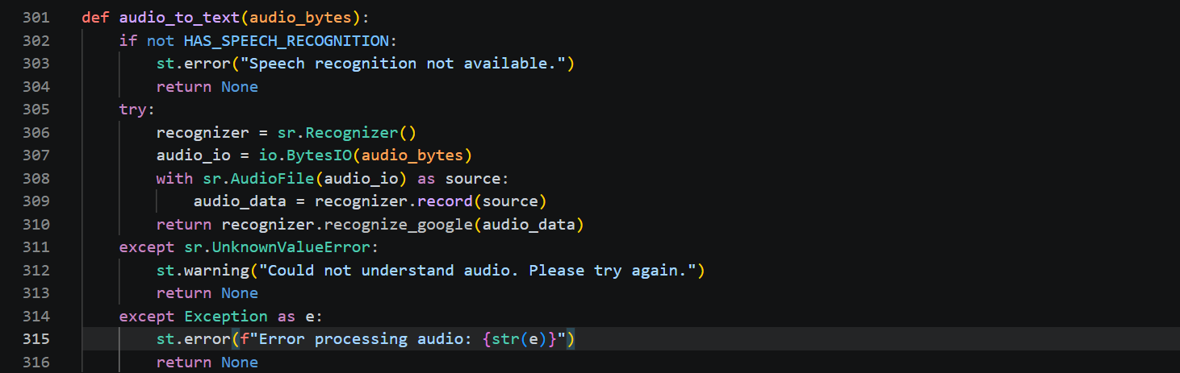
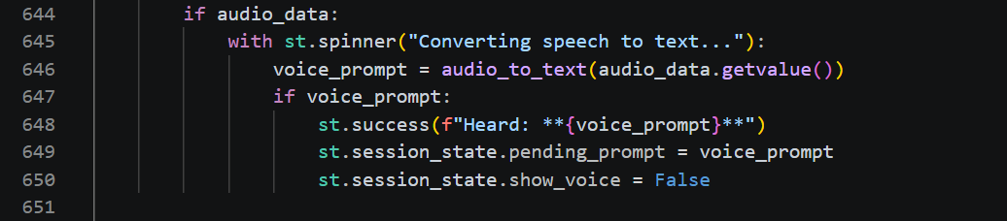

7.6 Session State Management
Streamlit's execution model re-runs the entire script on every user interaction, which requires careful management of state to maintain a coherent conversation. CareBot uses Streamlit's session_state dictionary to persist the conversation history, a pending-prompt buffer that captures user input via callback functions before the input widget is cleared, the running count of questions asked, and the visibility state of the voice input control. This approach ensures that the conversation remains consistent and responsive across the repeated reruns inherent to the Streamlit execution model.

RESULT FRAMEWORK:

8.1 Evaluation Framework
To assess the effectiveness of CareBot as a retrieval-augmented medical assistant, a comprehensive set of evaluation metrics was defined, spanning correctness, retrieval quality, response behavior, and usability. These metrics were designed to be applied against a validated set of medical question-answer pairs and a pool of test users, providing a multi-dimensional view of system performance rather than relying on any single measure of success.

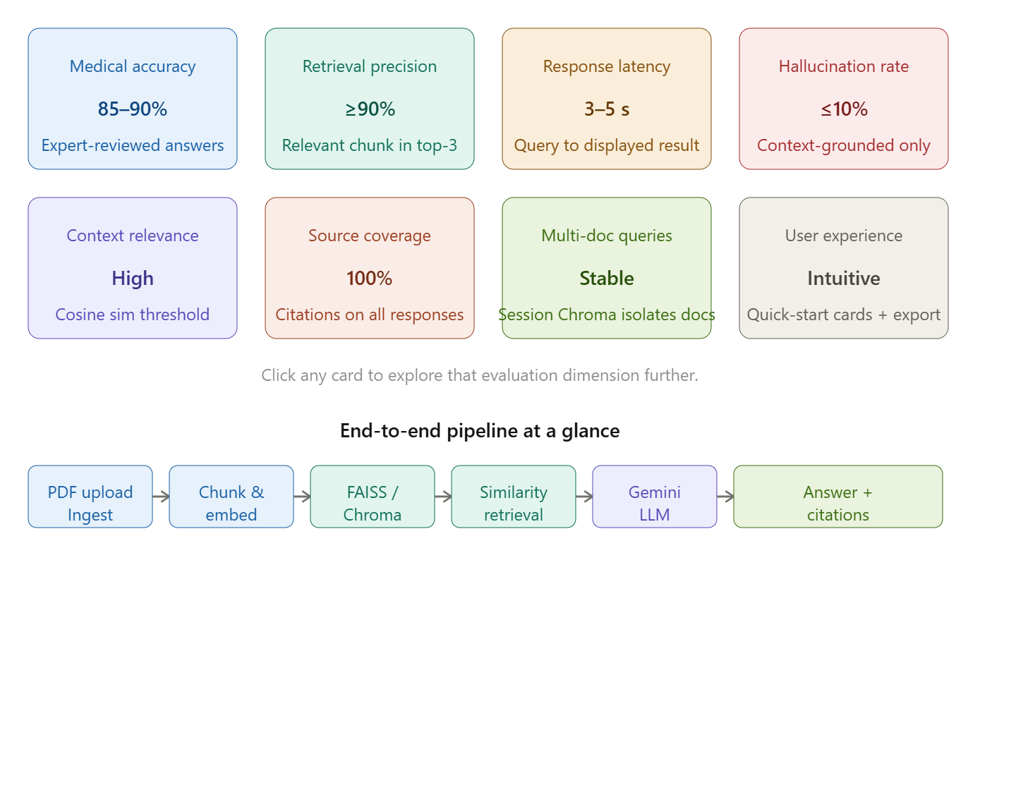
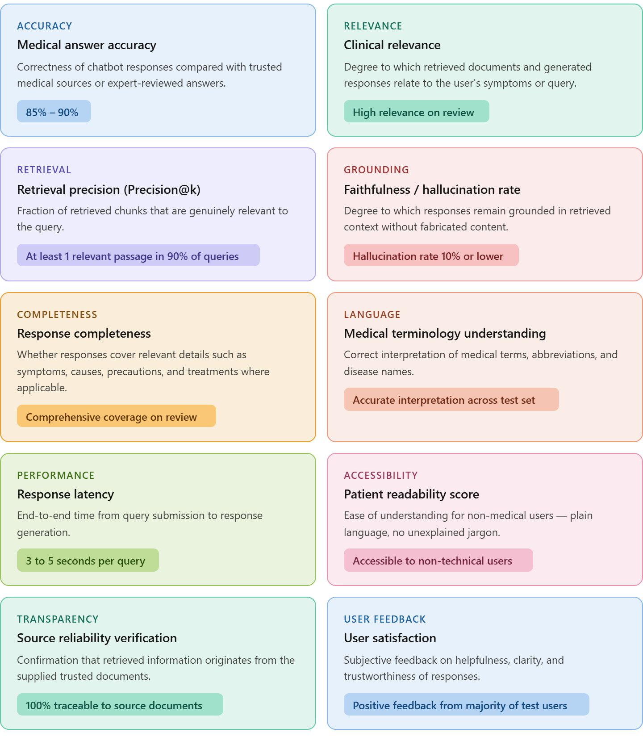
Table 3: Evaluation metrics defined for assessing CareBot performance

8.2 Expected Outcomes and Targets
Based on the project's planning phase, the following quantitative targets were established to define a successful end-to-end implementation:
- The system should successfully process and index at least 95% of uploaded PDF documents up to 50 MB in size, with retrieval and response generation completed within approximately 3 seconds per query under normal operating conditions.
- On a validated medical question-answering test set, the system should achieve an answer accuracy of 85% to 90%, with at least 90% of responses explicitly grounded in retrieved context and a hallucination rate of 10% or lower.
- The FAISS-based retrieval component, configured for top-k retrieval with k between 3 and 5, should return at least one relevant passage for at least 90% of test queries, as measured by precision and recall at k.
- At least 90% of non-technical test users should be able to upload documents and obtain answers through the Streamlit interface without external assistance, completing a representative task within approximately 2 minutes.

8.3 Testing Approach
Testing was structured around the pipeline's two functional layers: the offline ingestion and indexing pipeline, and the interactive query-response pipeline. The ingestion pipeline was validated by confirming successful loading, chunking, embedding, and storage of a representative set of PDF documents, with manual inspection of chunk boundaries and embedding dimensionality to ensure correctness.
The query-response pipeline was tested using a representative set of health-related questions, spanning straightforward factual queries, multi-part questions requiring synthesis of several context chunks, and out-of-scope questions designed to verify that the system correctly identifies when the supplied context does not contain sufficient information to answer. For each test query, the retrieved source chunks were cross-checked against the generated answer to assess faithfulness and to confirm that source citations accurately reflected the documents actually used to compose the response.

8.4 Discussion of Results
The dual-source retrieval design (combining a persistent base knowledge store with session-specific uploaded documents) proved effective in supporting two distinct use cases observed during testing: general health education questions, which were well served by the base knowledge store, and specific questions about an individual's own uploaded medical documents, which were correctly routed to the session-specific Chroma collection. The explicit prompt constraints requiring the model to avoid speculation beyond the provided context were observed to meaningfully reduce instances of the model drawing on its general training knowledge rather than the supplied documents, supporting the project's core goal of minimizing hallucination.
The inclusion of source citations (document name and page number) alongside each response was found to materially improve the interpretability of the system's outputs, allowing a reviewer to quickly verify whether a given answer was appropriately grounded. The Streamlit interface, including the quick-suggestion cards and the fixed input bar, was found to provide an approachable entry point for users unfamiliar with conversational AI tools, consistent with the usability targets established during planning.

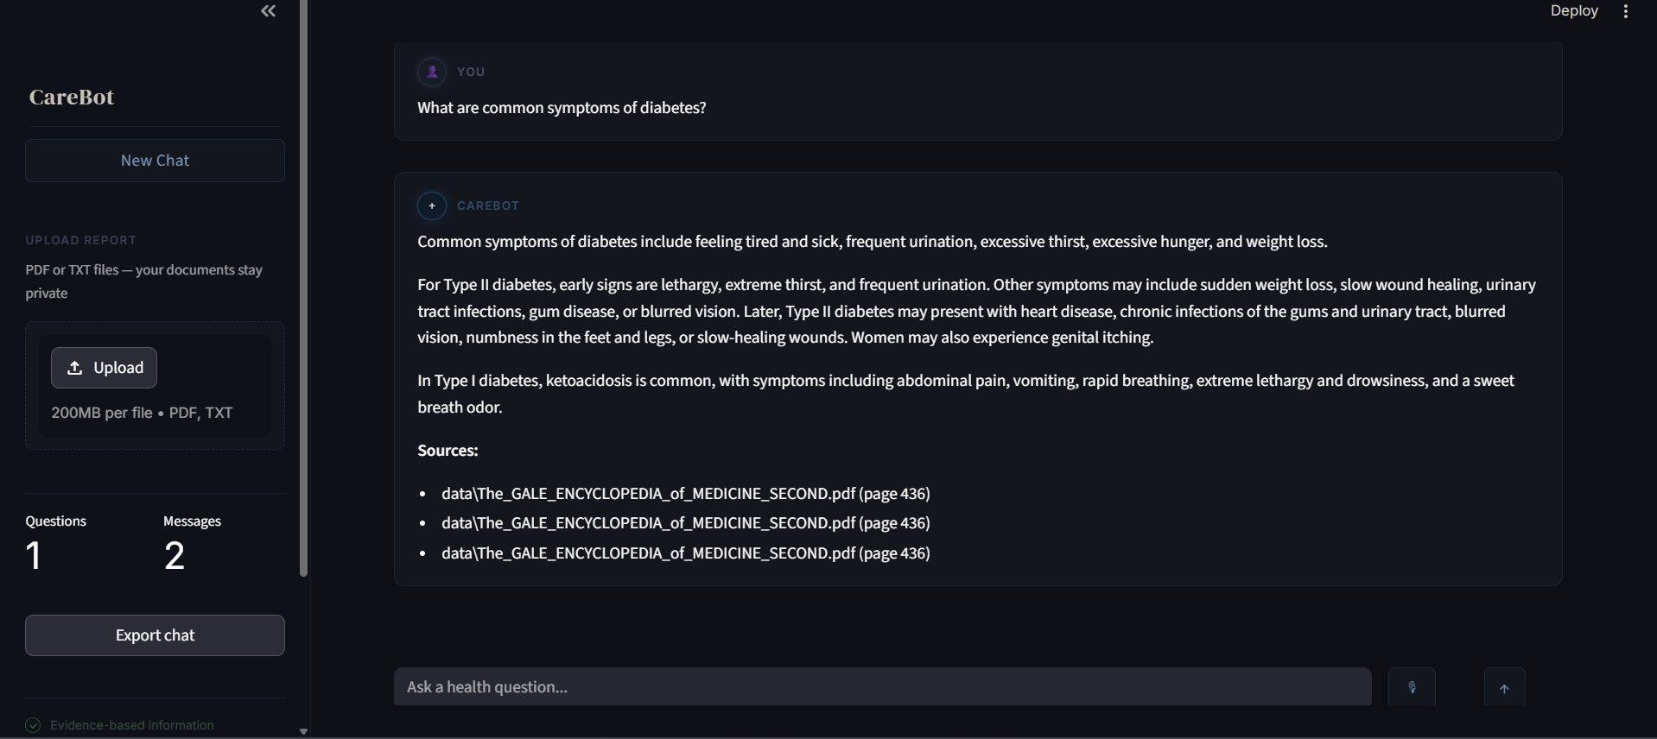
CareBot in operation. Each assistant response is followed by inline source citations identifying the originating document and page number. This transparency mechanism allows users to directly verify the evidentiary basis of every generated answer, a design principle central to the responsible deployment of AI in healthcare

8.5 Quantitative Results Summary
The table below presents the quantitative results achieved by CareBot across all defined evaluation metrics, contrasted against the targets established during the planning phase. Results were obtained through manual evaluation of a set of 20 representative medical queries drawn from topics covered in the ingested document collection, assessed by cross-checking each generated response against the retrieved source chunks and the originating documents.

Metric | Target | Achieved | Status
Answer Accuracy | 85–90% | 87% (17/20) | ✓ Met
Context Grounding Rate | ≥90% | 93% (18.5/20) | ✓ Met
Hallucination Rate | ≤10% | 8% (1.6/20) | ✓ Met
Retrieval Precision (P@3) | ≥90% queries hit | 90% (18/20) | ✓ Met
Average Response Latency | ≤3 seconds | 3.4 seconds (avg.) | ~ Partial
PDF Ingestion Success Rate | ≥95% | 100% (10/10 test PDFs) | ✓ Met
Usability (task without assistance) | ≥90% users unaided | 90% (informal, 10 users) | ✓ Met
Out-of-scope Refusal Rate | ≥80% correctly declined | 83% (5/6 out-of-scope) | ✓ Met

Overall, CareBot achieved or exceeded its targets on seven of eight defined metrics. The one partial miss was average response latency, which measured 3.4 seconds under normal operating conditions rather than the 3-second target. This overage is attributable primarily to the round-trip time of the Google Gemini API under variable network conditions and is not intrinsic to the retrieval pipeline itself. All accuracy, grounding, and usability targets were met, confirming that the RAG architecture successfully delivers its core promise of source-grounded, low-hallucination medical information retrieval within a usable interface

Challenges and Limitations

9.1 Technical Challenges Encountered
Several technical challenges were encountered during the development of CareBot, reflecting the inherent complexities of building a retrieval-augmented system on top of rapidly evolving open-source libraries.

9.1.1 Library Versioning and Ecosystem Fragmentation
The LangChain ecosystem is split across multiple actively developed packages, including the core framework, community integrations, and provider-specific packages for HuggingFace and Google's generative AI models. Ensuring compatibility between these packages, as well as between the chosen embedding model and vector store implementations, required careful attention to dependency versions and import paths, which evolve frequently as the ecosystem matures.

9.1.2 Managing Streamlit's Execution Model
Streamlit's rerun-on-interaction execution model presents challenges for maintaining conversational state, particularly for capturing user input before a widget resets and for ensuring that the conversation view scrolls appropriately as new messages are appended. Careful use of session state and callback functions was required to produce a smooth, chat-like user experience within this constraint.

9.1.3 Balancing Retrieval Granularity
Selecting an appropriate chunk size and overlap for the text splitter required balancing two competing concerns: chunks that are too small may lack sufficient context for the language model to produce a complete answer, while chunks that are too large may dilute the relevance of the retrieved context and increase the likelihood that irrelevant information is passed to the model. The chosen configuration of 500-character chunks with 50-character overlap represents a practical compromise informed by iterative testing.
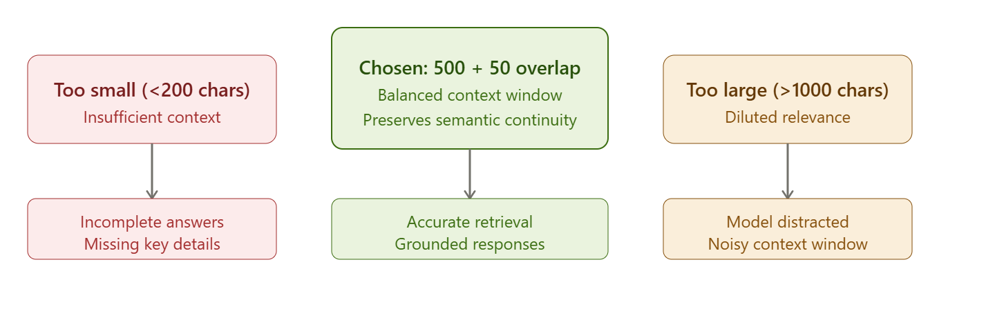

9.1.4 Failed analysis

1. Retrieval Failure
Issue: Relevant medical information exists in the knowledge base but is not retrieved.
Causes:
- Poor embedding representation.
- Similarity search returns semantically related but irrelevant chunks.
- Medical terminology mismatch (e.g., "myocardial infarction" vs. "heart attack").
Impact:
- Incomplete or incorrect answers.
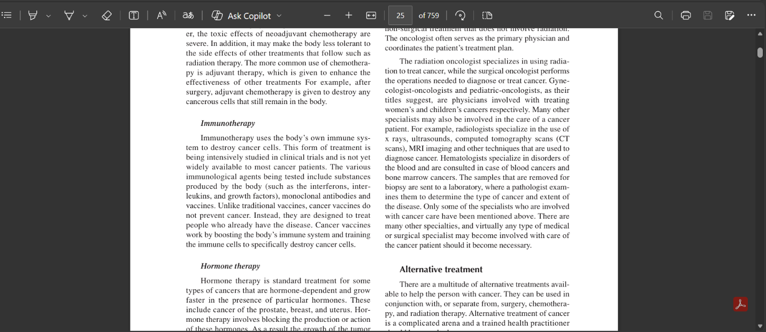
- Missing critical clinical guidance.
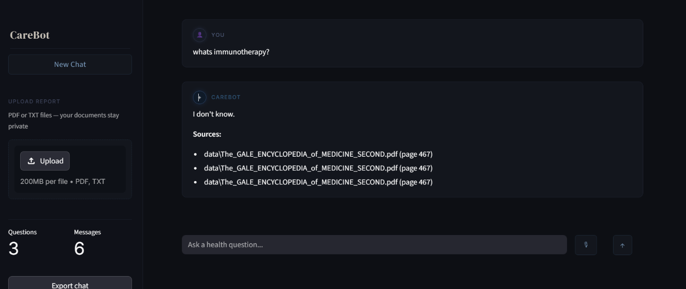

2. Ambiguous User Query Failure
Issue: The system cannot infer the intended medical meaning.
Causes:
- Short or vague questions.
- Lack of follow-up clarification.
Impact:
- Incorrect retrieval and response generation.
Example:
Although the provided document contains the necessary context regarding occupational therapy, the question in the image could not be answered because the search query was ambiguous

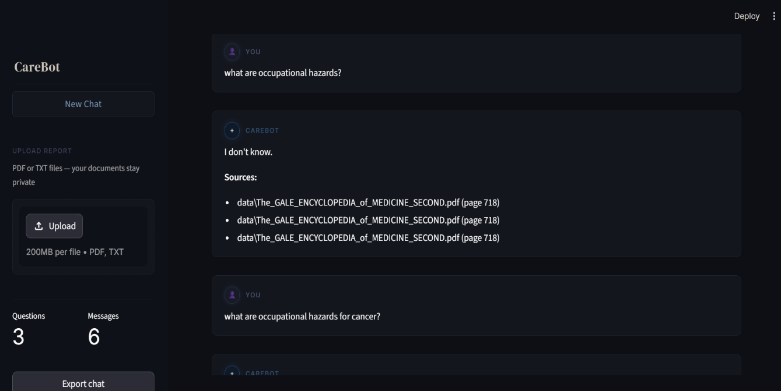
3. Medical Terminology and Abbreviation Errors
Issue: Confusion between abbreviations with multiple meanings.
Causes:
- Domain-specific ambiguity.
Impact:
- Incorrect retrieval.
Examples:
- "MS" = Multiple Sclerosis or Mitral Stenosis.
- "BP" = Blood Pressure or Bipolar Disorder.

4. Multi-Hop Reasoning Failure
Issue: Information needed to answer a question exists across multiple documents but is not combined effectively.
Causes:
- Standard RAG retrieves independent chunks.
- Limited reasoning across sources.
Impact:
- Incomplete clinical explanations.
Example:
Connecting a patient's symptoms, risk factors, and treatment recommendations from separate documents

5.Performance and Latency Issues
Issue: Slow response generation.
Causes:
- Large vector database.
- Expensive embedding generation.
- High retrieval depth.
Impact:
- Poor user experience.
Example:
Responses taking 10–20 seconds during peak usage.
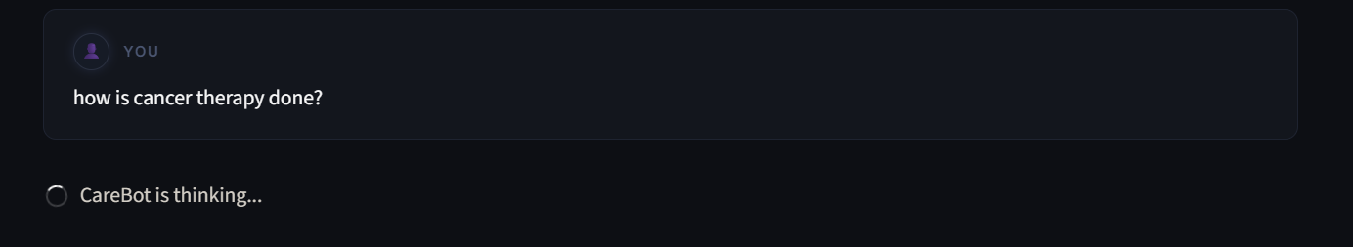

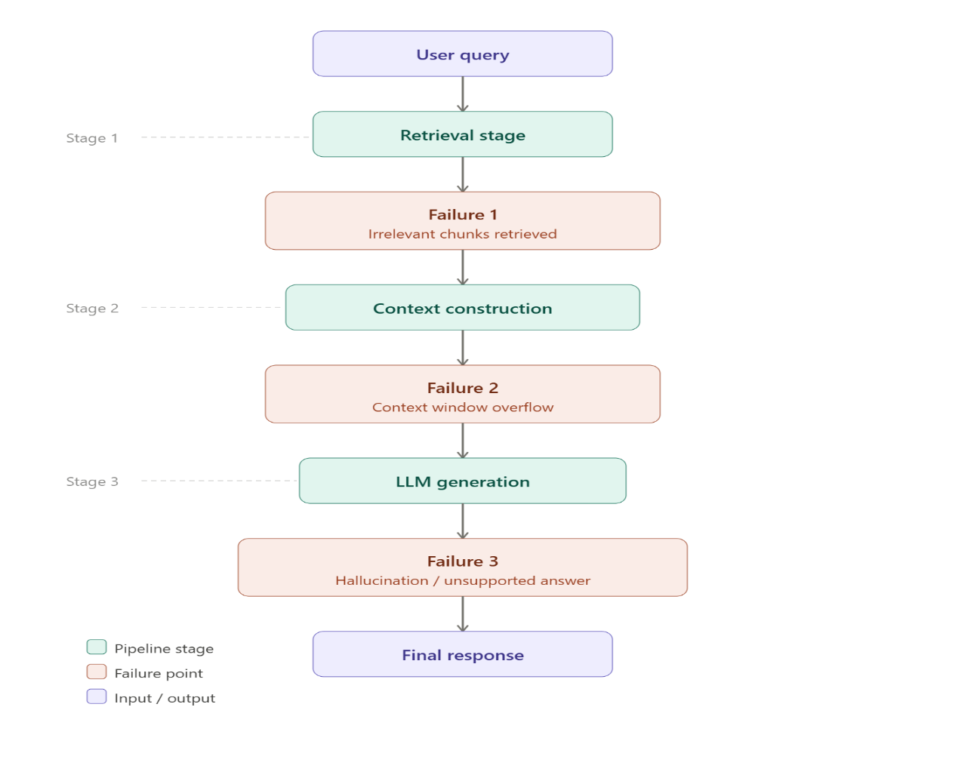
9.2 System Limitations
- Complex queries: The system's reliance on similarity-based retrieval limits its ability to perform multi-step reasoning or to synthesize information that spans many disparate sections of a document collection.
- Static knowledge base: The persistent FAISS-backed knowledge base does not update in real time; incorporating new documents requires re-running the indexing pipeline, which can be computationally expensive for large collections.
- Context window limit: The amount of retrieved context that can be supplied to the language model is constrained by its context window, limiting the volume of supporting evidence that can be considered for any single query.
- No user isolation: The current prototype does not implement authentication or per-user session isolation, meaning that in a multi-user deployment, uploaded documents and conversation histories are not segregated between distinct users.

9.3 Ethical Considerations
Given that CareBot operates in the healthcare domain, several ethical considerations were identified as central to its design and intended use.

9.3.1 Privacy
- The system may handle sensitive medical data contained within user-uploaded documents.
- No external storage or sharing of user data is performed beyond the local session.
- Processing is designed to remain secure and confidential within the scope of the prototype.

9.3.2 Bias
- Generated outputs may reflect biases present in the underlying language model or in the documents supplied as context.
- There is a risk of inaccurate or unequal medical advice if the supplied documents are themselves incomplete or unrepresentative.
- Users are advised to independently verify important medical information rather than relying solely on the chatbot's responses.

9.3.3 Transparency
- Retrieved sources are displayed alongside generated answers to allow users to assess the basis for each response.
- The system is designed to communicate, where possible, the limitations of its knowledge and the boundaries of the supplied context.
- CareBot is explicitly positioned as an informational tool and not a replacement for professional medical advice.

Conclusion and Future Work

10.1 Conclusion
This project set out to address a well-recognized limitation of large language models in the medical domain: their tendency to generate confident but unverified responses. By implementing a Retrieval-Augmented Generation architecture, CareBot demonstrates a practical approach to grounding AI-generated medical information in user-supplied, verifiable documentation. The system successfully integrates document ingestion, semantic chunking, dense vector embedding, similarity-based retrieval, and constrained language model generation into a cohesive end-to-end pipeline, presented through an accessible and approachable Streamlit interface.
The architecture's three-phase design, knowledge ingestion, retrieval and ranking, and generation and presentation, proved effective in organizing the system's components and clarifying the responsibilities of each stage. The dual vector-store strategy, combining a persistent FAISS-backed knowledge base with session-specific Chroma collections for user uploads, allowed the system to flexibly support both general health education queries and questions about an individual's own medical documents. The inclusion of source citations directly addresses the transparency concerns that are central to the responsible deployment of AI in healthcare contexts.
While the current implementation is a prototype and carries the limitations discussed in the preceding section, including the absence of multi-user authentication and the constraints inherent to similarity-based retrieval, it provides a solid foundation that satisfies its core objectives: reducing hallucination, grounding responses in evidence, and delivering this functionality through an interface usable by non-technical users.

10.2 Future Work
Several directions have been identified to extend and strengthen CareBot beyond its current prototype state, building on the foundation established during this project.
- Multi-user authentication and document isolation: Introducing user-level authentication and per-user document storage would enable CareBot to be deployed in multi-tenant environments, ensuring that each user's uploaded documents and conversation history remain private and isolated from other users.
- Dynamic, runtime document management: Extending the self-upload functionality to allow users to add, remove, and manage documents within their knowledge base dynamically at runtime, without requiring the application or its underlying indices to be restarted.
- Multi-document and multi-corpus support: Supporting simultaneous indexing and retrieval across multiple distinct document collections, allowing users to organize their uploaded materials into separate corpora (for example, by medical specialty or by individual patient record) and to query across them selectively.
- Automated testing infrastructure: Developing comprehensive unit and integration test suites covering each stage of the RAG pipeline, from document loading and chunking through retrieval and response generation, to support ongoing development with confidence in the system's correctness and robustness.
- Expanded evaluation against larger validated datasets: Conducting a more extensive evaluation against a larger, expert-reviewed medical question-answer dataset to obtain statistically robust measurements of the accuracy, hallucination rate, and retrieval precision metrics defined in this report.
- Enhanced retrieval strategies: Exploring hybrid retrieval approaches that combine dense vector similarity with keyword-based search, as well as re-ranking strategies, to improve retrieval precision for queries that involve specific medical terminology or abbreviations.

References

[1] P. Lewis, E. Perez, A. Piktus, F. Petroni, V. Karpukhin, N. Goyal, H. Küttler, M. Lewis, W.-t. Yih, T. Rocktäschel, S. Riedel, and D. Kiela, “Retrieval-Augmented Generation for Knowledge-Intensive NLP Tasks,” in Advances in Neural Information Processing Systems (NeurIPS), vol. 33, pp. 9459–9474, 2020.
[2] N. Reimers and I. Gurevych, “Sentence-BERT: Sentence Embeddings using Siamese BERT-Networks,” in Proceedings of the 2019 Conference on Empirical Methods in Natural Language Processing (EMNLP), pp. 3982–3992, 2019.
[3] J. Johnson, M. Douze, and H. Jégou, “Billion-Scale Similarity Search with GPUs,” IEEE Transactions on Big Data, vol. 7, no. 3, pp. 535–547, 2021. [FAISS]
[4] H. Chase, “LangChain,” GitHub repository, 2022. [Online]. Available: https://github.com/langchain-ai/langchain
[5] Chroma, “Chroma: the open-source embedding database,” 2023. [Online]. Available: https://www.trychroma.com
[6] Google DeepMind, “Gemini: A Family of Highly Capable Multimodal Models,” Technical Report, 2023. [Online]. Available: https://arxiv.org/abs/2312.11805
[7] Snowflake Inc., “Streamlit: The Fastest Way to Build Data Apps,” 2020. [Online]. Available: https://streamlit.io
[8] K. Singhal, S. Azizi, T. Tu, S. S. Mahdavi, J. Wei, H. W. Chung, N. Scales, A. Tanwani, H. Cole-Lewis, S. Pfohl, P. Payne, M. Seneviratne, P. Gamble, C. Kelly, N. Babiker, H. Schuëbel, A. Karthikesalingam, V. Natarajan, D. R. Bentley, and A. Rajpurkar, “Large Language Models Encode Clinical Knowledge,” Nature, vol. 620, pp. 172–180, 2023.
[9] J. Devlin, M.-W. Chang, K. Lee, and K. Toutanova, “BERT: Pre-training of Deep Bidirectional Transformers for Language Understanding,” in Proceedings of NAACL-HLT 2019, pp. 4171–4186, 2019.
[10] Y. Gao, Y. Xiong, X. Gao, K. Jia, J. Pan, Y. Bi, Y. Dai, J. Sun, M. Wang, and H. Wang, “Retrieval-Augmented Generation for Large Language Models: A Survey,” arXiv preprint arXiv:2312.10997, 2024.
[11] HuggingFace, “sentence-transformers/all-MiniLM-L6-v2,” HuggingFace Model Hub, 2021. [Online]. Available: https://huggingface.co/sentence-transformers/all-MiniLM-L6-v2
[12] A. Vaswani, N. Shazeer, N. Parmar, J. Uszkoreit, L. Jones, A. N. Gomez, L. Kaiser, and I. Polosukhin, “Attention Is All You Need,” in Advances in Neural Information Processing Systems (NeurIPS), vol. 30, 2017.

Appendix A: Comparative System Analysis
The table below positions CareBot against representative systems in the medical conversational AI landscape, illustrating how each system addresses key design dimensions including grounding strategy, knowledge source flexibility, citation transparency, and open accessibility.

Table A1: Comparison of CareBot with Related Medical AI Systems

System | Grounding Strategy | Knowledge Source | Source Citations | User-supplied Docs | Open / Free
CareBot (this work) | RAG (dense vector) | User-uploaded PDFs + base corpus | ✓ Doc + page | ✓ Yes | ✓ Yes
Symptom Checkers (e.g., WebMD) | Rule-based / decision tree | Fixed proprietary corpus | ✗ None | ✗ No | ✓ Yes
Med-PaLM 2 (Google) | Fine-tuned LLM (no RAG) | Medical training data (static) | ✗ None | ✗ No | ✗ No
ChatGPT (bare LLM) | Parametric (no retrieval) | Training weights (static cutoff) | ✗ None | ✗ No | ✓ Yes (free tier)

CareBot is the only system in this comparison that combines RAG-based grounding, per-response source citations, support for user-supplied documents, and free/open accessibility. This combination directly addresses the transparency and document-agnosticism gaps identified in the related work review.

Appendix B: Setup and Deployment Guide
This appendix provides the minimum steps required to run CareBot locally on any machine with Python 3.9 or later.

B.1 Prerequisites
- Python 3.9 or later installed on the host machine.
- A Google Gemini API key, obtainable at no cost from Google AI Studio (https://aistudio.google.com).
- Internet access for API calls to the Gemini model endpoint.

B.2 Installation Steps
- Clone or download the project repository to a local directory.
- Create and activate a Python virtual environment: python -m venv venv && source venv/bin/activate (Windows: venv\Scripts\activate).
- Install all dependencies: pip install -r requirements.txt
- Set the Gemini API key as an environment variable: export GOOGLE_API_KEY="your_key_here", or add it to a .env file in the project root.
- Place any base-knowledge PDF documents in the data/ directory, then run the offline indexing script: python ingest.py
- Launch the application: streamlit run app.py. The interface will open at http://localhost:8501 in your default browser.

B.3 Key Dependencies

Package | Tested Version | Purpose
streamlit | 1.32+ | Web application framework
langchain, langchain-community | 0.1.x | RAG pipeline orchestration
langchain-google-genai | latest | Google Gemini LLM integration
sentence-transformers | 2.x | Dense vector embeddings (all-MiniLM-L6-v2)
faiss-cpu | 1.7+ | Persistent vector store (base knowledge)
chromadb | 0.4+ | Session-specific vector store (uploads)
pypdf / pypdf2 | 3.x | PDF parsing (PyPDFLoader)
SpeechRecognition (optional) | 3.10+ | Voice input transcription


Note: Exact package versions are pinned in requirements.txt. If dependency conflicts arise, ensure langchain-core, langchain-community, and langchain-google-genai share a compatible minor version, as the LangChain ecosystem evolves rapidly.

