Coursework Cover Sheet
Students should complete the input fields contained in this form and attach it in front of your formal assessment submission. All fields within this form are required. Please ensure that check boxes and radio buttons are appropriately selected. The last three questions are just for you to personally consider.
Department and assessment information:
Assessment title: The impact of social media marketing on the buying behavior of college and university students in the United Kingdom
Course Title: Enter the Course Title here
Module Title: Enter the Module Title here
Module Code: Enter the Module code here
Year of Study: 2026
Student Number: Ayesha Anwar

Academic Misconduct / Plagiarism Declaration
By attaching this front cover sheet to my assessment I confirm and declare that I am the sole author of this work, except where otherwise acknowledged by appropriate referencing and citation, and that I have taken all reasonable skill and care to ensure that no other person has been able, or allowed, to copy this work in either paper or electronic form, and that prior to submission I have read, understood and followed the University regulations as outlined in the Academic Integrity Policy and Procedure for Academic Misconduct
Have you checked the following? This will help your assessment achievement.
I have applied the learning outcomes for this module ☐
I have checked for Academic Integrity via Turn-it-in ☐
I have used references in accordance with instructions in the Assessment Brief ☐
I have proofread my work for spelling, grammar and punctuation. ☐
I have checked that the word count/size of this submission accords with the guidance provided in the Assessment Brief ☐
I have followed the guidance in the Assessment Brief and have not made inappropriate use of AI to boost my grade unfairly ☐
List any AI tools used (including assistive tools such as Grammarly) Click or tap here to enter text.
Please provide details of how you have used AI tools, including examples such as screenshots of prompts and the output which have been generated Click or tap here to enter text.
Well-being
We wish to support any student who is experiencing mitigating circumstances which prevents students from performing to the best of their ability when completing or submitting assignments. If you are experiencing such circumstances, then you may apply for Mitigating Circumstances. Wherever possible this must be done prior to handing in your assignment.
Do you need to apply for mitigating circumstances for this assignment Please select Yes / No
Please refer to the Mitigating Circumstances Policy
Questions you may wish to consider:
- Have I allowed sufficient time to prepare this assessment?
- Have I reflected on previous feedback and made improvements in accordance with advice?
- What grade am I expecting?

Acknowledgements
I would like to show my gratitude to my supervisor for his immense help and support. He encouraged me and guided me with his constructive feedback and this pushed me to complete the research with enthusiasm. I would also like toe extend my heartfelt thanks to the participants for their time and effort and also to my family and friends for their support and encouragement in completing this dissertation.
Abstract
The appearance of social networks led to the significant change in the communication between firms and their clients, which became one of the factors that affect the choice of consumers, especially youth. The effect of the social network usage on the purchase behavior of college/university students living in the UK will be considered in the present paper. The quantitative approach has been chosen for studying the issue at hand. In addition, the structured online survey was selected as a method for collecting the primary data. The data were obtained by the means of convenience sampling technique and contained responses of 60 respondents. The collected data have been analyzed by using the descriptive statistics techniques. The main variables in the current study include the use of social media, the effect of advertisements and influencers on consumer decisions, purchase intentions and effectiveness of various social networks (Instagram, TikTok and Facebook). According to the results of the study, social media have a great impact on the purchase behavior of students as they provide the target audience with more information about the product. Nevertheless, the impact of advertisements, influencer recommendations and other users feedbacks is rather weak as credibility and authenticity are important for the target audience.
Keywords: Social Media Marketing, Buying Behaviour, Consumer Behaviour, Purchase Intention, College Students, University Students, Digital Marketing, Influencer Marketing, Instagram, TikTok, Facebook, United Kingdom.

Table of Contents
Chapter 1: Introduction 9
1.1 Introduction to Social Media 9
1.2 Social Media Marketing and Buying Behavior 9
1.3 Young Consumers 11
1.4 Research Gap 12
1.5 Aim 12
1.6 Objectives 12
1.7 Significance 12
1.8 Dissertation Structure 13
Chapter 2: Literature Review 14
2.1 Introduction 14
2.2 Conceptualizing Social Media Marketing 14
2.3 Consumer Buying Behaviour 16
2.4 Social Media Usage among College & University Students in the UK 17
2.5 Influence of Social Media Advertising on Buying Behaviour 19
2.6 Influencer Marketing & User Generated Content 20
2.7 Social Media Engagement & Purchase Intention 22
2.8 Platform Comparison: Instagram, TikTok &Facebook 23
2.9 Theoretical Framework 24
2.9.1 Theory of Planned Behaviour (TPB) 24
2.9.2 Source Credibility Theory 25
2.9.3 Stimulus–Organism–Response Model 26
2.10 Conceptual Framework 27
2.11 Research Gap 28
2.12 Chapter Summary 28
Chapter 3: Research Methodology 29
3.1 Introduction 29
3.2 Research Philosophy 29
3.3 Research Approach 30
3.4 Research Design 31
3.5 Research Strategy 32
3.6 Data Collection Method 33
3.7 Sampling Technique 33
3.8 Data Analysis Method 33
3.9 Reliability and Validity 34
3.10 Ethical Considerations 35
3.11 Limitations of Methodology 35
3.12 Chapter Summary 36
Chapter 4: Findings & Discussion 37
4.1 Introduction 37
4.2 Respondent Demographic Profile 37
4.3 Objective 1: Social Media Usage During Purchase Decisions 40
4.4 Objective 2: Influence of Advertisements and Influencers 42
4.5 Objective 3: Impact of Social Media Marketing on Purchase Intention 44
4.6 Objective 4: Comparison of Instagram, TikTok and Facebook 46
4.7 Summary of Findings Against Research Objectives 47
4.8 Chapter Summary 48
Chapter 5: Conclusion & Recommendations 49
5.1 Introduction 49
5.2 Conclusions Based on Research Objectives 49
5.2.1 Objective 1: Social Media Usage During Purchase Decisions 49
5.2.2 Objective 2: Influence of Advertisements and Influencers 49
5.2.3 Objective 3: Impact of Social Media Marketing on Purchase Intention 50
5.2.4 Objective 4: Comparison of Instagram, TikTok and Facebook 50
5.3 Practical Recommendations 50
5.4 Suggestions for Future Research 51
Chapter 6: Personal Reflection 52
6.1 Introduction (Why Gibbs' Reflective Cycle?) 52
6.2 Description 53
6.3 Feelings 53
6.4 Evaluation 53
6.5 Analysis 54
6.6 Conclusion 54
6.7 Action Plan 54
References 56
Appendices 66
Appendix 1: Questionnaire 66
Appendix 2: Research Project Proposal 72
Appendix 3: Ethics form 72
Appendix 4: Role of the Supervisor & the Supervisory Process 72

List of Tables
Table 1: Descriptive for objective 1 40
Table 2: Descriptive for objective 2 42
Table 3: Descriptive for objective 3 44
Table 4: Descriptive for objective 4 46

List of Figures
Figure 1: Social media usage overview 10
Figure 2: UK: social media users 2026, by generation 11
Figure 3: Structure of the dissertation 13
Figure 4: Number of social media users worldwide from 2017 to 2030 14
Figure 5: Share of Gen Z shoppers who discovered on social media and purchased it in 2023 and 2024 16
Figure 6: Distribution of social network users in the United Kingdom as of September 2024, by education 17
Figure 7: How social media is Reshaping Consumer Behaviour 19
Figure 8: Influencer marketing market size worldwide from 2015 to 2025 20
Figure 9: Technology Acceptance Model 22
Figure 10: Facebook Ads Are the Most Noticeable 23
Figure 11: Theory of Planned Behaviour 24
Figure 12: Source Credibility Theory 25
Figure 13: Stimulus–Organism–Response Model 26
Figure 14: Conceptual Framework 27
Figure 15: Types of Research philosophy 30
Figure 16: Types of Research approach 31
Figure 17: Types of Research design 32
Figure 18: Research Onion 34
Figure 19: Age of the participants 37
Figure 20: Gender of the participants 38
Figure 21: Level of the study of the participants 39
Figure 22: Frequency of the participants they use frequently 39
Figure 23: Gibbs’ Reflective Cycle 52

Chapter 1: Introduction

1.1 Introduction to Social Media
Scrolling has become an everyday activity and is considered to be an instrument which influences contemporary consumer behavior. The increase in social media has transformed the landscape of how organizations connect with their customers while promoting their goods (Jeswani, 2023). After COVID-19, social networking sites have become increasingly important for marketing and purchasing procedures. Reports suggest that there are 5.31 billion social media users all over the world, and represents more than 65% of the global population (Mahajan and Pangarkar, 2026). Users are found to spend two hours with 21 minutes per day on social networking sites. It is to be noted that Instagram, TikTok, and Facebook are some of the sites which influence the perception, preference, along with intentions of young customers. Moreover, influencer’s recommendations, with the customer reviews online, and along with tailored ads are significant in terms of consumer behavior these days. Though the previous studies have analyzed the role of social media in consumer behavior, there is relatively limited research that has directly compared the social media sites such as Instagram, TikTok and Facebook in the context of UK University students.

1.2 Social Media Marketing and Buying Behavior
Social media marketing has been considered as one of effective tools that helps in shaping the consumer buying behavior within today's technological world (Antczak, 2024). Companies which are using social media platforms such as Instagram, TikTok and Facebook for marketing their products and creating brand awareness are believed to get more success than others. As per the reports of Chaffey (2025) about 5.24 billion people use social media around the world in the year 2025 which accounts for about 63.9% of the global population. Social media content is considered as significant in the form of advertisement for endorsing influencer’s suggestions or even the consumer's personal view that helps in determining the attitude and purchase intention.
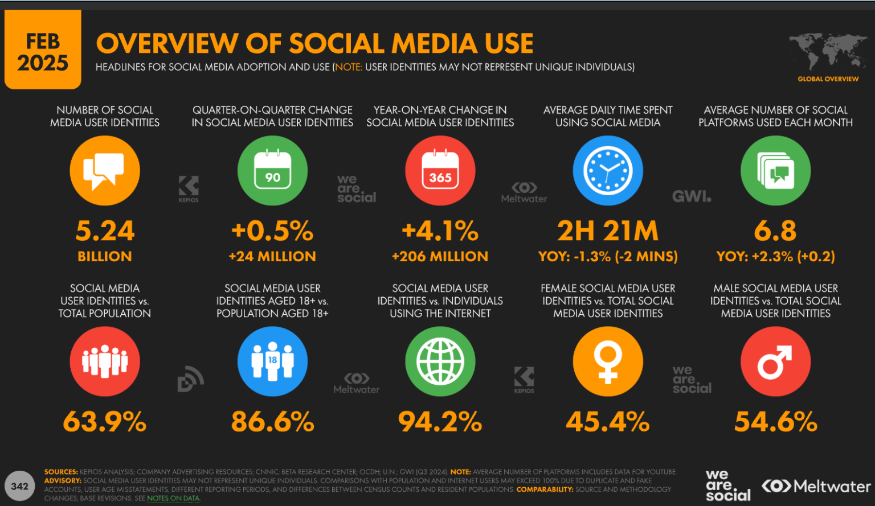
Figure 1: Social media usage overview
(Source: Chaffey, 2025)
As per recent study of Farrell, Campbell, and Sands, (2022) it has been laid down that about half of the consumers grow the tendency to purchase the product when endorsed by the influencers they follow or come across. Young consumers get highly influenced with social media as they devote a lot of time to consume content on digital media (Vázquez-Herrero et al., 2022). Thus, this study topic is highly relevant for understanding the effect of social media upon the purchase behavior that young consumers showcase.

1.3 Young Consumers
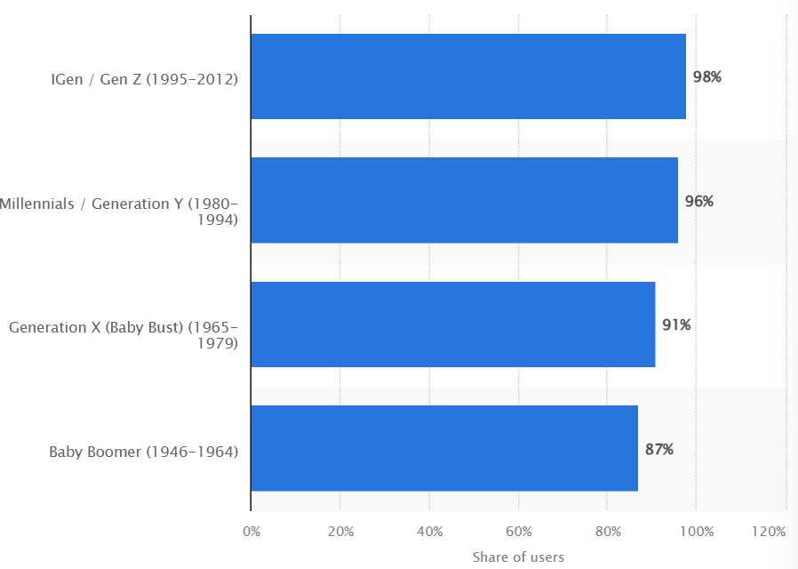
Figure 2: UK: social media users 2026, by generation
(Source: Thuy, 2026)
It has been found out through research that young consumers are those individuals who are too much engaged with social media platforms and get easily impacted by the online world. It is to be noted that the utilisation of social media platforms is mostly seen in the UK. In addition to this, research suggests that in 2026, about 98% of people who fall under the category of Gen-Z in the UK used social media platforms (Thuy, 2026). Young consumers who utilize social media too often have connections with information search, trends, accompanied by purchase intentions (Solanki, Mahaveer and Nair, 2026). Various social media platforms consisting of Instagram, TikTok, and Facebook, and young consumers are often exposed to various marketing activities with the help of advertisements and advice given by others that influences their preferences and purchase intentions. However, this influence of different social media platforms might have variation as each platform has a unique way of content format and user interactions. This depicts a need to compare each impact in a specific manner for the university students.

1.4 Research Gap
The field of social media has been growing rapidly, however there is relatively little research in this field which has examined the impact of Instagram, TikTok, and Facebook on the buying behaviors of students from colleges and universities in the UK. In the year 2024, about 5.04 billion users for the global social media, which is about 62.3% of the total world population where the Gen Zs are considered as one of the most active generations (Barbu et al., 2024). Most of the existing studies have either examined social media in a collective manner or as a single platform with relatively less attention given to compare Instagram, TikTok and Facebook within the UK higher educational context. Thus, further research is needed for understanding the platform-specific influences on the student purchasing behavior.

1.5 Aim
This study aims to evaluate the impact of social media marketing upon the purchasing behavior of young consumers studying in the UK higher education institutions with its main doc’s ion Instagram, TikTok and Facebook.

1.6 Objectives
- To explore how young consumers use social media when making purchase decisions
- To assess the influence of content such as adverts and influencers on product preferences
- To evaluate the impact that social media marketing has upon the student purchase intentions
- To compare the influence of Instagram, TikTok and Facebook upon the purchasing behavior of the UK University students

1.7 Significance
Social media marketing secured its position to be an essential part of marketing, where 5.24 billion users utilize social media from all over the world in 2025, and forms 63.9% of the total world’s population (Guttmann, 2026). It has been found out that the young generation is very much active on social media as around 60% of Generation Z spend at least four hours each day with the help of social media sites (Elkatmış, 2024). Therefore, it is necessary to interpret the impact of social media on the purchasing decisions of consumers. These findings would showcase useful insights for the businesses who are seeking to engage with the university students using social media marketing. Additionally, it would also contribute to the existing literature by comparing the influence of three major social media platforms in the UK higher educational contexts.

1.8 Dissertation Structure
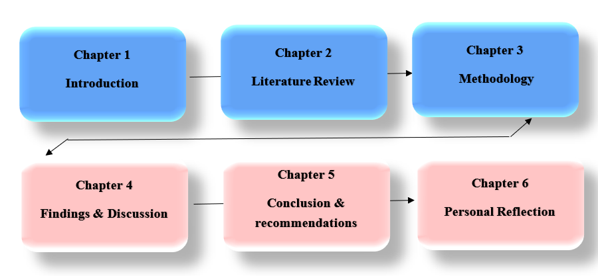
Figure 3: Structure of the dissertation
(Source: Self-created)
This dissertation has been structured into 6 segments. Starting from chapter one which targets the introduction, research gap, objective with the aim of the study. Followed by literature review is covered in chapter two and chapter 3 deals with methodology. Chapter 4 would present the research findings, chapter 5 provides the conclusion and recommendations and chapter six would present the personal reflection.

Chapter 2: Literature Review

2.1 Introduction
In this chapter, literature associated with the topic of social media marketing has been explored in the context of college and university students from the UK. Social media has become a critical tool for businesses to promote their products. The vast number of social media users made the platform attractive for promotional purposes. This literature review has explored different dimensions of social media marketing in relation to the college and university students of the UK. Also, explanations of theories have been done in the chapter to strengthen the research.

2.2 Conceptualizing Social Media Marketing
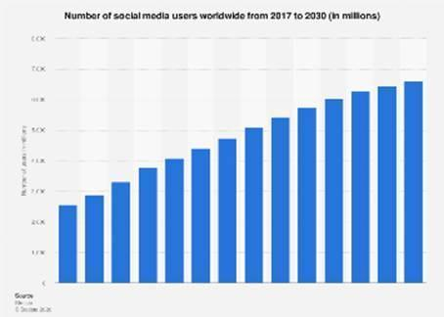
Figure 4: Number of social media users worldwide from 2017 to 2030
(Source: Statista, 2026)
In contemporary times, social media marketing has become an essential tool for businesses. The widespread uses of social media have been attractive for the businesses to promote their products and services in social media (Li et al., 2021). The concept of social media marketing involves use of social media platforms for increasing sales, building brand, and attracting website driven traffic. Through social media, businesses can connect with the customers to interact and collect their data from evaluating the effectiveness of marketing campaigns in real time. Using social media, businesses can have two-way communication with the consumers. It helps businesses to offer personalized experiences to the customers. In accordance with Statista (2026a) the number of social media users in 2025 was 5 billion which is equivalent to 63.9% of the world population. Daily uses of social media are also quite considerable for the businesses to consider the platform for marketing.
The spending of businesses on social media marketing has increased significantly in recent years. The report by Statista (2026b) shows that companies are expected to spend $338.75 billion for social media marketing in 2026. In businesses, the commonly used social media platforms include Instagram, Facebook and TikTok. Not only promotion through direct posts and media content on social media, but influencer marketing also helps businesses. Personalized and creative content can be created by the companies through collaboration with influencers. On the other hand, User Generated Content (UGC) helps businesses with organic promotion. Replies, likes, comments and review posts of customers are UGC for the businesses. However, UGC also puts businesses at risk of negative marketing impact. Negative feedback from the customers can significantly harm the brand reputation as well as sales. In regards to social media marketing, Khanom (2023) highlighted the issue of privacy and information overload. According to Peredy et al. (2024) the modern-day youth customers avoid social media marketing campaigns with potential security issues or information overload. This can remarkably reduce the efficiency of social media marketing among this segment of customers.

2.3 Consumer Buying Behaviour
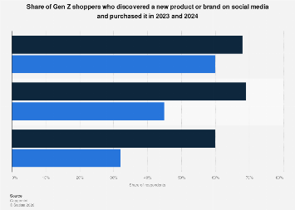
Figure 5: Share of Gen Z shoppers who discovered on social media and purchased it in 2023 and 2024
(Source: Statista, 2026)
Zhao et al (2023) defines consumer buying behavior as the decision processes and acts followed by people to buy and use products or services. In order to purchase products, customers tend to collect information and evaluate options before making the decisions. In the current business world, it has become important to understand the consumer buying behavior as massive flow of digital information is changing the purchase decision approach of customers. According to Rodrigues et al. (2021) traditional consumer decision making process was rational and systematic. However, Palalic et al. (2021) claims that the existing consumer decision making process has changed due to use of social media and large volume of digital information. Earlier, consumers used to follow a systematic approach of decision making through processes like recognition of problems, search for information, evaluation of alternatives, and purchase decisions (Hampson et al., 2021). From the recent studies, it is also understood that social media is hugely used by consumers to collect information related to products and services (Varghese and Agrawal, 2021). Customers search for peer feedback and recommendations from influencers to make their purchase decision. In accordance with Statista (2026) report more than 30% of Gen Z customers use social media as a primary platform to get information before purchasing products or services. The Gen Z customers also prefer to explore new brands by collecting information from social media which includes highly attractive visual graphics that attract young customers. Businesses use this aspect of social media by developing creative designs and media for promotion.

2.4 Social Media Usage among College & University Students in the UK
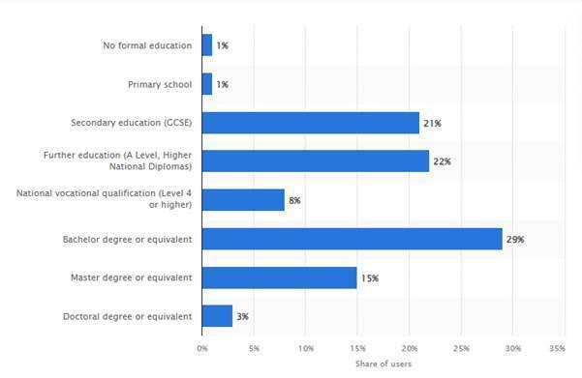
Figure 6: Distribution of social network users in the United Kingdom as of September 2024, by education
(Source: Statista, 2026d)
The uses of social media have significantly increased among the college and university students in the UK. Young students are preferring social media for sourcing information and making their purchase decisions. The young generation is highly tech savvy due to their growth and development in technology surrounding the environment (AlShawabkeh et al., 2021). This has made social media an integral part of the young generation. Social media is also influencing the shopping behavior of the segment. The use of social media among the students in Bachelor degree and master degree is 29% and 15% respectively. It includes a vast percentage of students and creates scope for businesses to promote and target the customer segment. According to Statista (2026d) report young students are highly active in social media that helps businesses to promote through networking. The students and young consumers' interest in sharing information improves the efficiency of social media marketing for the businesses (Chan, 2022). However, studies have revealed that converting youth customer’s leads into sales is quite challenging for the companies from social media. This is because the young students normally use social media for comparing products only, instead of making final purchase decisions.
Although the influence of social media on youth students is highly prevalent in the UK, its significance is also questioned by some authors. Authors like Ahmed et al. (2025) states that social media marketing often includes information overload. It leads to confusion and decision-making problems among the users. Furthermore, a tendency of doubting the social media campaign is also common among young consumers. Due to this reason, the sales from social media are often low for the businesses. However, it is also argued by the authors like Wilska et al. (2023) that social media helps in obtaining important information and making rational decisions. Although, the author reflects on the need for checking the authenticity of promotional campaigns before making any purchase decision. Hai Nguyen (2025) also identified issues like privacy and digital fatigue may become reasons for reduced social media usages among youth in coming years. Such issues can lead to reduced efficiency of social media for business promotions. In the UK, around 11% of youth prefer Facebook to purchase products from social media. Facebook marketplace has become significant for driving the sales in the UK (Yougov, 2025).

2.5 Influence of Social Media Advertising on Buying Behavior
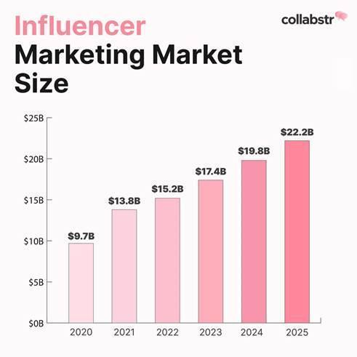
Figure 7: How social media is Reshaping Consumer Behavior
(Source: Almond Solutions, 2023)
Consumer behaviour plays the key role for businesses to develop strategies, organizational goals and marketing tactics. According to Akayleh (2021) understanding the importance of consumer behaviour has become important for organizations due to dynamic and ever-changing user interaction of social media. In the current tech driven business environment, efficient understanding of consumer behaviour in social media helps to gain competitive advantage (Alyahya et al., 2023). With the increasing online interactions in social media, it has become important for organizations to remain attuned to the customer preferences. In this regard, it is significant that consumer behaviour is highly influenced by the social media interactions in the contemporary era. Kumar (2024) states that social media works as a vast virtual market place where customers can find new products by visiting posts, reviews or recommendations. The easy accessibility and vast network make the social media platforms significant for product discovery among customers.
In modern times, influencer marketing has significant potential to influence customer preferences and buying behaviour. A significant number of social media users follow influencers. According to Lajnef (2023) the act of following influencers is preventable among youth who often try to mimic the lifestyle of influencers. Thus, influencers always have a significant influence on the purchase decision. Due to social media marketing and influencer marketing, customers also started to feel lack of engagement. Thus, it leads to influencer driven sales for the businesses.

2.6 Influencer Marketing & User Generated Content
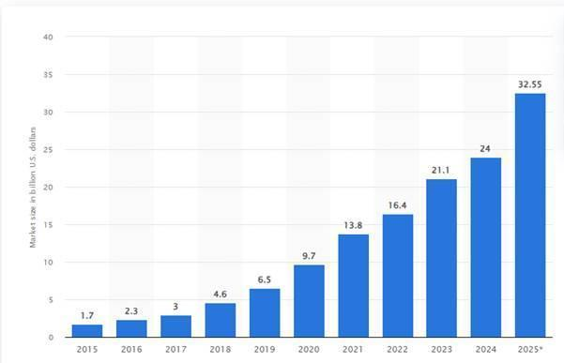
Figure 8: Influencer marketing market size worldwide from 2015 to 2025
(Source: Statista, 2026e)
Influencer marketing enables organizations to reach consumers in large numbers. The influencers with large audiences are mostly preferred by the businesses to promote their products or services. Through influencer marketing, content is created by the influencers for providing suggestions to the customers (Liu et al., 2025). It can significantly impact the purchase decision of customers. On the other hand, user generated content like review, testimonials are also effective for organizations to promote their businesses. User generated content develops a sense of authentication among the customers that can have a significant impact on the purchase decision. According to Statista (2026g) the value of the influencer marketing industry increased to $33 billion in 2025. It reflects on the steep growth of influencer marketing. This also shows higher intention among the businesses to incorporate influencer marketing for targeting the youth customers.
Theoretical implication is considerable to provide understanding of influencer marketing impact on customers. Here, the Source Credibility Theory has been considered here to perform the analysis. The theory states that the determination of persuasive power significantly depends on the credibility of information sources. Thus, consumers tend to trust credible sources of information from influencers. This is more prevalent among the young generations. It is also claimed by Venciute et al. (2023) that the young customers can have a higher tendency of purchasing a product from influencer recommendations if they have a long-term relationship with the influencers. Although, studies like Smith et al. (2023) argued that effectiveness of influencer marketing still remains an area of discussion. This is highly significant among the young customer segment who have high sensitivity to the promotional campaigns. Thus, user generated content helps in establishing a strong image of the brand among the consumers.

2.7 Social Media Engagement & Purchase Intention
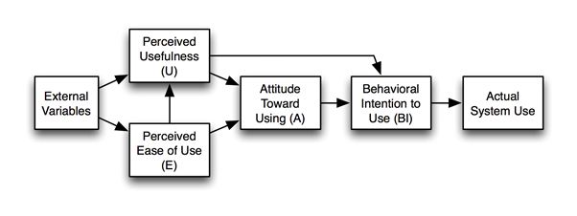
Figure 9: Technology Acceptance Model
(Source: Xue et al., 2026)
In simpler words, social media engagement influences organizations to use social media analytics. Using social media analytics, businesses can evaluate the consumer activities like post visits, like and comment on posts. These sorts of interactions are considered as the evidence of positive response from the customers in social media. According to Matin et al. (2020) the key aspect of social media is its ability of two-way communication with the users. It differentiates social media marketing from other types of traditional marketing approaches. In this regard, social media platforms play a critical role to develop strong and long-term relationships with the consumers. Bilal et al. (2021) states that development of relationships with the younger generation customers is highly significant for organizations to promote business. The social media platforms work as a mediator for the younger customers to connect with businesses and make their purchase decisions.
In order to provide an in-depth analysis of the topic, the Technology Acceptance Model can be considered. According to the Technology Acceptance Model, the usefulness of technologies can have an impact on the intentions of consumers. This reflects that the features of social media like attractive designing, creativity are significant to attract the consumers (Al-Adwan et al., 2023). Social media platforms like Instagram provide illustrated visual graphics. Such attractive graphics are significant for companies to draw the attention of the users. Other than this, social learning theory is also considerable regarding the understanding of social media engagement. The social learning theory claims that individuals tend to copy or follow the behaviour of others by observing (Zaineldeen et al., 2020). This is significant among the young generation who are hugely deviated to different social media influencers. Thus, they intended to follow the style and clothing choices of influencers. It paves the way for companies to collaborate with the influencers and promote their products among the young generation segment.

2.8 Platform Comparison: Instagram, TikTok &Facebook
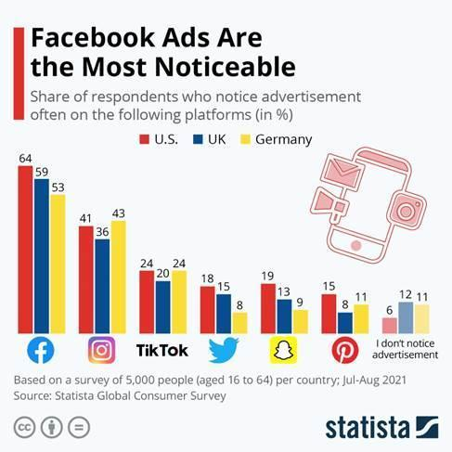
Figure 10: Facebook Ads Are the Most Noticeable
(Source: Statista, 2026f)
In the contemporary social media scenario, there are several social media platforms that businesses can use for promotional purposes. Different platforms serve different purposes for the businesses. For example, Instagram is a platform where businesses can post attractive visual graphics to draw the attention of users (Singh, 2020). The visual graphical aspect of Instagram makes the platform attractive for businesses to use in their influencer marketing. Using Instagram, businesses can collaborate with influencers to develop highly visually attractive content. On the other hand, Facebook is the most popular social media platform in the world. Facebook has a vast number of users which provides a huge customer base to the businesses (Wiese et al., 2020). Facebook marketplace is a significant feature of the platform that businesses use for promotion and sales of their products. This is highly significant for the small and medium-size businesses. Because, Facebook opens a large customer base and market for the companies to promote and sell. While TikTok is used by businesses to create short videos and showcase the authentic business approaches. Features of TikTok like Ads Manager provides options to the businesses for running targeted campaigns. It is significant for businesses to design their target market specific content.

2.9 Theoretical Framework

2.9.1 Theory of Planned Behaviour (TPB)
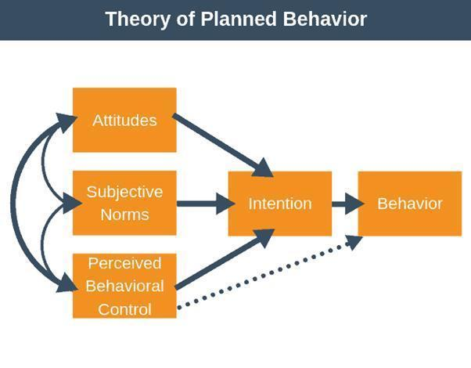
Figure 11: Theory of Planned Behavior
(Source: Conner, 2020)
According to Conner (2020) the theory of planned behaviour explores the consumer behaviour which is influenced by the critical factors such as attitude and perceived control of behaviour. In regards to social media marketing, consumer attitudes are influenced by the type of content. While the subjective norms of customers are influenced by the online communities, peer review and interactions in social media.

2.9.2 Source Credibility Theory
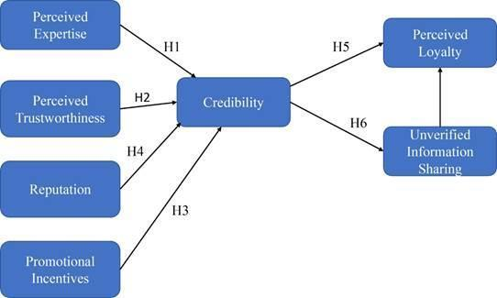
Figure 12: Source Credibility Theory
(Source: Serman and Sims, 2023)
In accordance with Serman and Sims (2023) Source credibility theory claims that effectiveness of marketing approaches depends on the credibility of information sources as well as trustworthiness among the consumers. In this regard, social media influencers have been able to develop a credible relationship with their followers. Regular posts and ensuring authenticity in social media are critical for the influencers to become effective.

2.9.3 Stimulus–Organism–Response Model
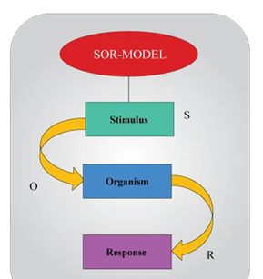
Figure 13: Stimulus–Organism–Response Model
(Source: Pan et al., 2024)
In accordance with Pan et al. (2024) Stimulus–Organism–Response Model is a psychological tool used for explaining the influence of external environment factors on human behaviour. According to the theory, external stimuli can trigger internal cognitive as well as affective evaluation within an organism. This further leads to dictating the observational behaviour or response.

2.10 Conceptual Framework
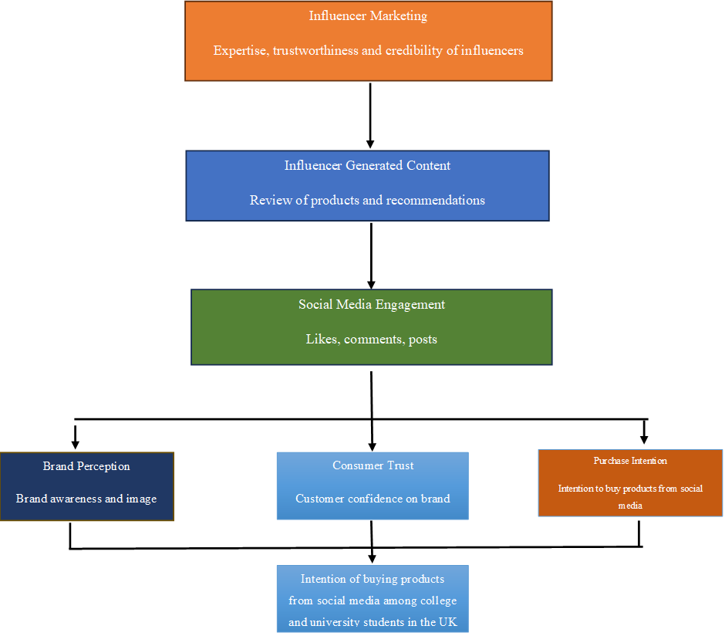
Figure 14: Conceptual Framework
(Source: Self-created)
The above conceptual framework depicts the relationship between variables in the study. Social media marketing is the independent variable that impacts on consumer behaviour, the dependent variable. In order to have an impact on dependent variables, social media marketing approaches include PR campaign, influencer marketing. The use of social media significantly helps businesses to influence buying behaviour of customers.

2.11 Research Gap
The topic of social media marketing is highly researched in academics. However, still some gaps existed in the available literature associated with social media marketing. The available studies have majorly focused on exploring the relevance of social media marketing with youth. However, the studies have significantly avoided the consideration of students in the UK. This is a significant gap in existing research which influenced the conduct of this research.

2.12 Chapter Summary
This chapter of the research has incorporated literature review on the topic. The literature review has helped in developing strong theoretical knowledge of the topic. The review of literature using existing information has helped in understanding the relevance of social media marketing in current time. Also, the chapter has explored different theories like Technology acceptance model, source credibility theory. These theories have helped to strengthen the theoretical aspects of the topic.

Chapter 3: Research Methodology

3.1 Introduction
This chapter provides the details of the research methodology adopted in studying the effect of social media marketing on the purchase decisions of students enrolled in universities in the United Kingdom. This chapter will cover such issues as philosophical assumptions, research approach, research design, research strategy, data collection, sampling procedure, data analysis, reliability and validity, ethical issues and limitations of the research methodology. Adequate justification of all research methodologies used in this research will be provided via analyzing research methodology literature.

3.2 Research Philosophy
Research philosophy implies assumptions about the acquisition, interpretation and analysis of knowledge in the course of research (Mbanaso et al., 2023). Choosing the adequate research philosophy is important as it affects the research design and the methods used for answering research questions. Such philosophies as positivism, interpretivism and pragmatism are often used in research practices. Oriented toward the objective reality and measurability, positivism contrasts interpretivism focused on subjective human experience. Therefore, the research philosophy of positivism was chosen in the present research as it helped to examine the connection between measurable social media marketing and the behavior of students associated with purchases. However, this would not result in any generalizations of the research issue. That is why positivism was regarded as the appropriate research methodology which allowed to obtain objective and statistically comparable results (Park et al., 2020).
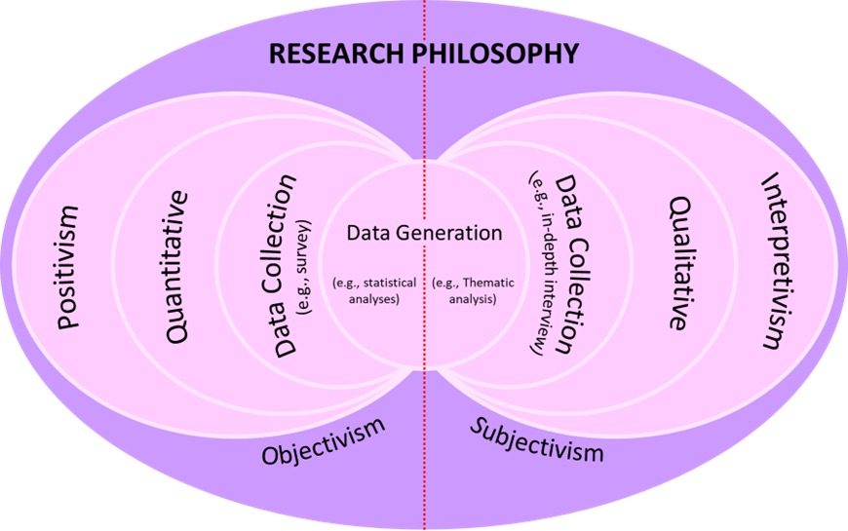
Figure 15: Types of Research philosophy
(Source: King, 2023)

3.3 Research Approach
The research approach stands for the relationship between the theoretical knowledge and empirical research conducted in the course of research (Grøndahl Glavind et al., 2023). Deductive and inductive research approaches are two major types of research approaches used in research practices (Azungah, 2018). Using observations to develop new theories, the inductive research approach contrasts the deductive research approach which implies the empirical investigation of existing theories (Robinson and Bailey Rodriguez, 2026). In the present research, the deductive research approach was chosen as it helped to examine the adequacy of the existing theories explaining the effect of social media marketing on the purchase decisions of UK students. Several theories were selected through literature review as the theoretical framework for the study. These are Theory of Planned Behavior, Source Credibility Theory and Stimulus-Organism-Response (SOR) Model. Inductive approach in research proved to be less suitable than deductive approach (Daniel and George, 2025).
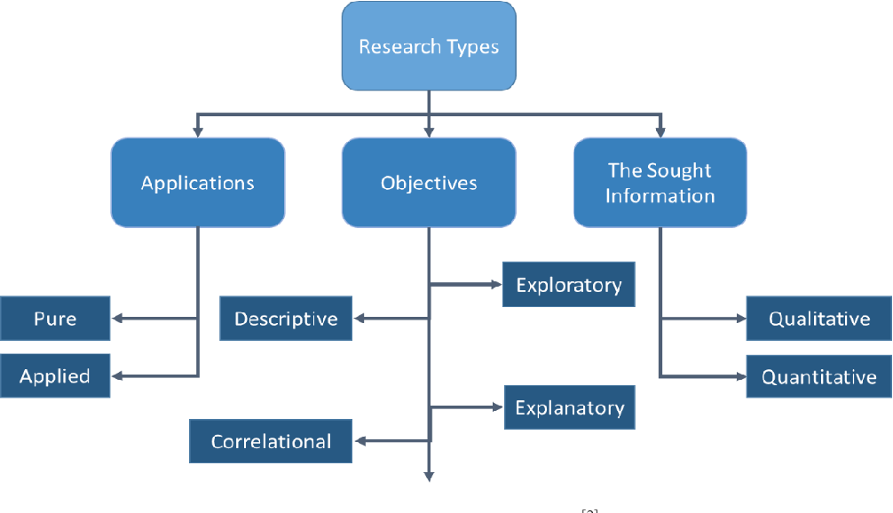
Figure 16: Types of Research approach
(Source: Taherdoost, 2022)

3.4 Research Design
The research design implies the framework which helps to conduct the data collection and analysis needed for achieving the research objectives (Slator and Hasson, 2025). The main research designs include exploratory, explanatory and descriptive research designs. Used when there is insufficient knowledge on the research issue, the exploratory research design contrasts the explanatory research design implying the investigation of cause-and-effect relationships. The descriptive research design helps to describe the features, behavior and patterns of the target population (Siedlecki, 2020). The descriptive research design was used in the present research as the primary aim of the research was to examine the effect of social media marketing on the purchasing behavior of the UK students. Though the explanatory research design could help to investigate causality, the descriptive research design was more appropriate for the research.
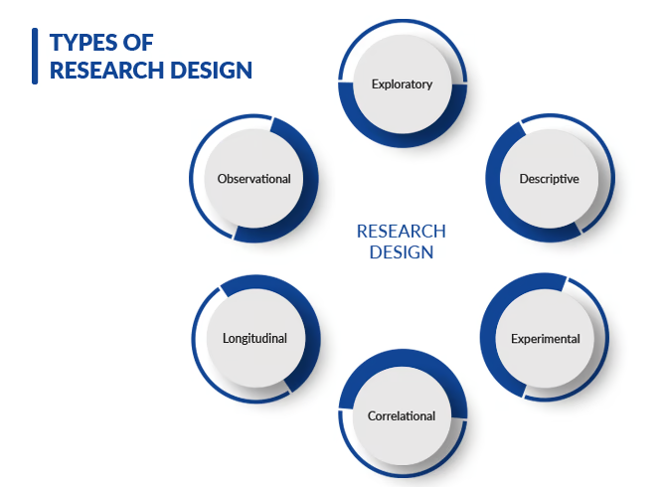
Figure 17: Types of Research design
(Source: Gertschnig, 2025)

3.5 Research Strategy
The term "research strategy" is used to refer to the general approach chosen by the researcher in order to conduct systematic collection and analysis of data (Johannesson and Perjons, 2021). Survey, case study, experiment, interview and ethnographic research are examples of the research strategies (Mitsi, 2022). The selection of the appropriate research strategy depends on research aims, research resources and type of data that will be obtained. In the current case, the survey research strategy was chosen because it enables obtaining standardized data from a large number of respondents in a short period of time. The online questionnaire was used in order to collect data from UK college and university students measuring their perceptions regarding the influence of social media marketing on their purchasing decisions. The numerical data could be obtained and subjected to statistical analysis owing to the use of the survey research strategy. Although the interview research strategy provides the richness and depth of opinions, this method would take more time and limit the number of participants (Saunders et al., 2019). Hence, the survey strategy became the most adequate in achieving research aims.

3.6 Data Collection Method
The primary data were obtained with the help of the structured online questionnaire created on the basis of Google Forms. The primary data had to be collected as the information needed in order to achieve research aims could be obtained directly from participants, who are new and up-to-date. The questionnaire consisted of two parts. The first part entailed the collection of the demographic information such as age, gender, education level and frequency of social media usage, while the second part included the close-ended statements measured with the help of the five-point Likert scale providing the answers from "Strongly Disagree" to "Strongly Agree". Such concepts as social media advertisements, influencer marketing, user-generated content, platform engagement and purchase intention were measured. Thus, the academic basis of the study was created and research results were based on empirical data.

3.7 Sampling Technique
The target population of this research consisted of college and university students studying in the UK and actively using at least one social media platform. The non-probability convenience sampling technique was used in order to recruit participants fast through university channels and online student communities. The convenience sampling was chosen and about 60 participants were recruited owing to the limitations of time and accessibility related to postgraduate research. Even though the probability sampling allows obtaining the more representative sample, it requires the sampling frame, which was not available in the current study (Sharma, 2023).

3.8 Data Analysis Method
The data were analyzed with the help of IBM SPSS Statistics and Microsoft Excel in order to conduct the statistical analysis properly. Firstly, screening was conducted in order to exclude incomplete questionnaires, duplicate entries and missing data to ensure the quality of data. Descriptive statistical techniques such as frequencies, percentages, means and standard deviations were used in order to describe the demographic information of respondents and patterns of their social media usage (Siregar, 2025). Pie and bar charts were created in order to facilitate the visualization of research results and their interpretation (Divecha et al., 2023). The comparative analysis of differences in students' perception of Instagram, TikTok and Facebook as marketing platforms was conducted in order to answer research questions. Sometimes cross-tabulation was used to reveal the relationships between demographic variables and purchasing behavior. The research results were interpreted considering the theoretical frameworks described in Chapter Two including the Theory of Planned Behaviour, Source Credibility Theory and the Stimulus–Organism–Response Model.
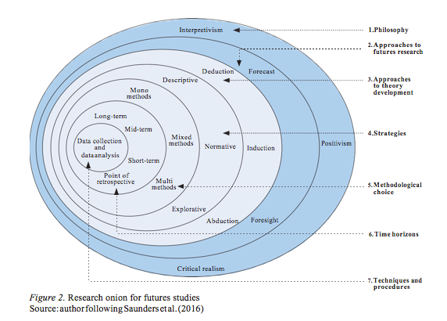
Figure 18: Research Onion
(Source: Melnikovas, 2019)

3.9 Reliability and Validity
Reliability and validity are criteria which should be used to evaluate the quality of the results. Reliability stands for the consistency of the instrument, which means that the researcher is able to produce similar results in case of repeating it in the same conditions (Sürücü, 2020). In order to increase the reliability of the research, the structured questionnaire with standardized questions and five-point Likert scale will be used; it will be created based on the examples of previous peer-reviewed studies related to the topic. Validity can be defined as the capability of the instrument to measure the construct of interest (Andersson et al., 2024). Besides, the pilot test of the questionnaire was conducted among university students to make it clear. Though self-reporting can lead to biases, using the valid measurements and consistent data collection methods will ensure the credibility of the research.

3.10 Ethical Considerations
Ethical issues were considered during the research process to ensure that it complies with the university research ethics requirements (Miteu, 2024). Ethical approval was obtained prior to the data collection process in accordance with the institutional standards (Capilli and Anastasi, 2024). The information sheet was provided to the participants, who were informed about the purpose of the study, its voluntariness and the option to decline from the participation. Informed consent was obtained and. confidentiality of the respondents was ensured by the lack of personal data collection, anonymity and confidentiality of the responses. The data was stored on the secure devices protected with the password and used for academic purposes in accordance with the UK General Data Protection Regulation (UK GDPR).

3.11 Limitations of Methodology
However, the limitations exist in relation to the application of systematic methodology approach. Firstly, convenient sampling was used, and hence, the results may not properly represent the population of college and university students of the United Kingdom. The subjects were selected not by means of randomization but according to their availability to participate in the research. Secondly, as far as cross-sectional design was used, it is not possible to identify any changes that have occurred in consumers' behavior as this type of design takes into account only one point in time (Wang and Cheng, 2020). There are several limitations related to the use of self-report questionnaires, such as social desirability and recall bias. However, the use of structured questionnaires, standardized data collection and analysis approaches will overcome the mentioned limitations.

3.12 Chapter Summary
This chapter provides the methodological approach which has been used for the investigation of the impact of social media marketing on the consumer behavior of students in the United Kingdom. Research philosophy, approach, design, strategy, data collection, sampling, data analysis, reliability, validity, ethical considerations and methodological limitations have been discussed in this chapter to provide the grounds for the discussion of the results in the next chapter.

Chapter 4: Findings & Discussion

4.1 Introduction
The results collected through questionnaire surveys conducted among 60 college/university students in the United Kingdom will be presented and analyzed in this chapter. The results will be critically analyzed based on research objectives and descriptive statistics will be used for the purpose of comparison of the results with those presented in literature and theory in Chapter Two.

4.2 Respondent Demographic Profile
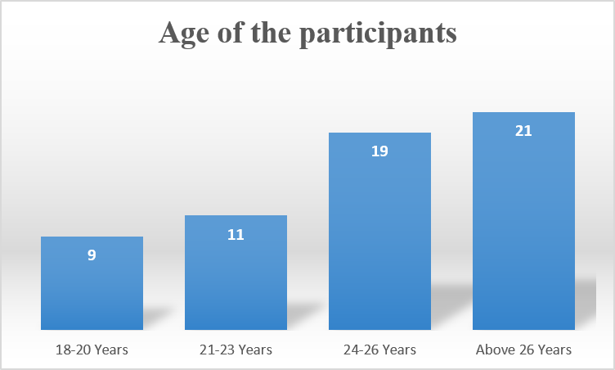
Figure 19: Age of the participants
(Source: Survey data)
It can be seen from the figure that majority of the respondents have aged 26 years or above (35%) followed by 24-26 years (31.7%). The age group of 21-23 years and 18-20 years accounts for 18.3% and 15% of the total number of respondents respectively. It can be concluded that there is some diversity of age group in the sample of the participants that are sufficiently experienced in social media in relation to purchases.
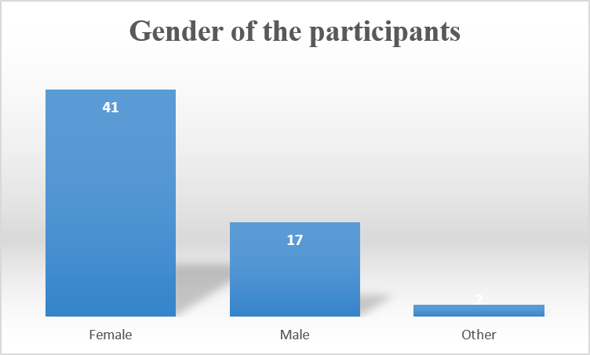
Figure 20: Gender of the participants
(Source: Survey data)
It can be seen from the above chart that majority of the respondents (41) are of female gender (68.3%) followed by male respondents (17; 28.3%) while 2 (3.4%) respondents fall under the category of "Other". It can be seen that there is sufficient diversity of gender and greater involvement of females in the sphere of social media marketing and purchasing behaviors.
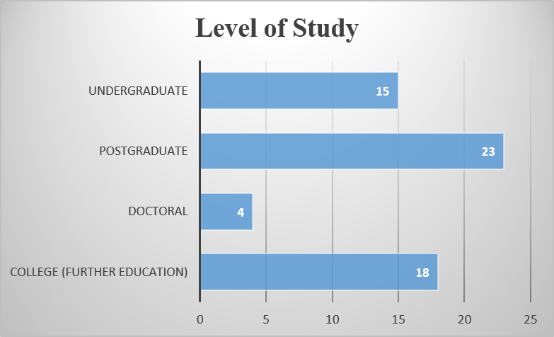
Figure 21: Level of the study of the participants
(Source: Survey data)
It can be seen from the above chart that respondents are from various educational levels with most of them being post-graduates (23) followed by college/further education (18), undergraduate (15) and doctoral (4).
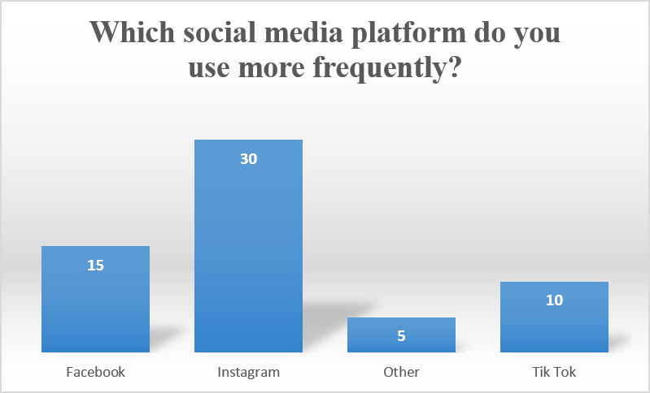
Figure 22: Frequency of the participants they use frequently
(Source: Survey data)
It can be seen from the above chart that the majority of the participants (30; 50%) prefer Instagram as the social media platform followed by Facebook (15), Tiktok (10) and other platforms (5). Thus, Instagram can be seen as the dominating social media platform used by the participants.

4.3 Objective 1: Social Media Usage During Purchase Decisions
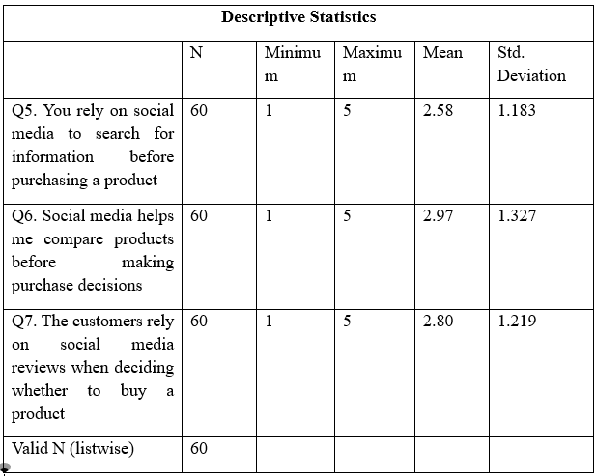
Table 1: Descriptive for objective 1
(Source: SPSS)
Analysis: Table 4.1 gives the results of the descriptive statistics in relation to social media usage by the respondents in relation to purchase decisions. From the three questions, the highest mean score has been achieved for Q6 ("Social media helps me compare products before making purchase decisions") (M = 2.97, SD = 1.327) showing the moderate usage of social media to compare products. The second question in relation to the mean scores is Q7 ("I trust consumers' social media reviews when deciding whether to buy a product") (M = 2.80, SD = 1.219). The lowest mean score has been obtained for Q5 ("I rely on social media to search for information before purchasing a product") (M = 2.58, SD = 1.183).
Discussion: It has been proved that social media significantly affects the process of consumer decision making including the product comparison before purchase. The highest mean value for product comparison supports the claims of Rodrigues et al. (2021) who suggest that the digital platform has revolutionized the traditional behavior of information searching allowing consumers to compare the alternatives quickly. Similarly, the claims of Varghese and Agrawal (2021) that consumers use social media in order to gather product information and compare competing brands before making purchase decisions have been proved in the current research. However, it should be noted that relatively low mean value for the reliance on social media in information searching shows that participants do not rely on the social media alone. It is thus different from the claims of Zhao et al. (2023) who claimed that social media has become the main source of information throughout the purchasing process.
Furthermore, the respondents showed the moderate level of trust in online consumer reviews. It means that the user-generated content may not affect the purchase decisions in all cases. This finding supports the arguments of Ahmed et al. (2025) that information overload and content credibility affect the confidence of consumers in social media information. Based on the Theory of Planned Behaviour (Conner, 2020) it can be stated that consumer purchasing decisions are not only affected by the information presented in the social media but also by the attitude, credibility of content and subjective evaluation prior to making the final purchase decision.

4.4 Objective 2: Influence of Advertisements and Influencers
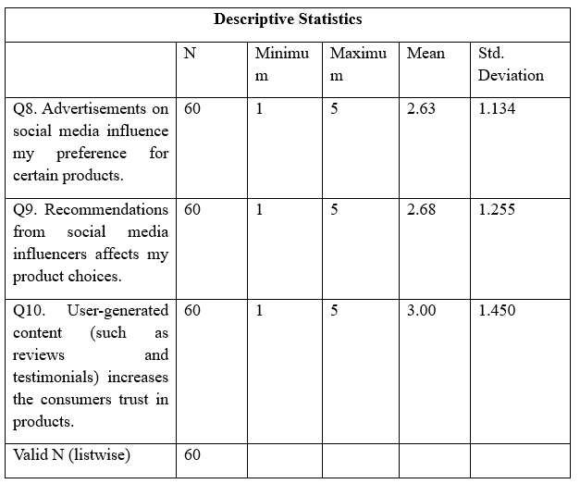
Table 2: Descriptive for objective 2
(Source: SPSS)
Analysis: The table 4 below presents the descriptive statistics with respect to the influence of advertisements and influencers on the purchasing behavior of the respondents. It has been revealed that user-generated content such as online reviews and testimonials has received the highest mean score (M = 3.00, SD = 1.450) indicating that the respondents trust in authentic customer experiences rather than in other promotional activities. The recommendations from the social media influencers got a mean score of 2.68 (SD = 1.255), while social media advertisement got the lowest mean score (M = 2.63, SD = 1.134).
Discussion: It should be pointed out that the respondents pay attention to the user generated content than social media advertisements. This finding demonstrates that authenticity has become an important determinant of consumer decision making. It is consistent with the argument of Liu et al. (2025) that customer-generated reviews and testimonials help in increasing the credibility and encourage consumers to trust in product-related information. Similarly, Venciute et al. (2023) claim that consumers tend to respond positively when the information source is perceived as credible and authentic. Relatively high mean score indicates the importance of credibility in influencing the buying behavior.
However, moderate influence of the recommendations from influencers and advertisements is inconsistent with the researches which consider influencer marketing as one of the strongest drivers of consumer purchase decision. For example, Lajnef (2023) states that young consumers follow the influencers and are greatly influenced by their product endorsements. In the same way, Farrell, Campbell and Sands (2022) claim that recommendations from influencers increase consumers' willingness to purchase products. Relatively low mean values in the current study indicate that UK college and university students have become more careful about the sponsored promotional content. This finding is consistent with the arguments of Smith et al. (2023) that over-commercialization of influencer marketing decreases consumer trust and promotional effectiveness. The results thus support the Source Credibility Theory which suggests that consumers assess the trustworthiness of the information before accepting the persuasive marketing messages. Businesses should thus focus on authentic customer engagement and cooperation with influencers rather than on traditional advertising.

4.5 Objective 3: Impact of Social Media Marketing on Purchase Intention
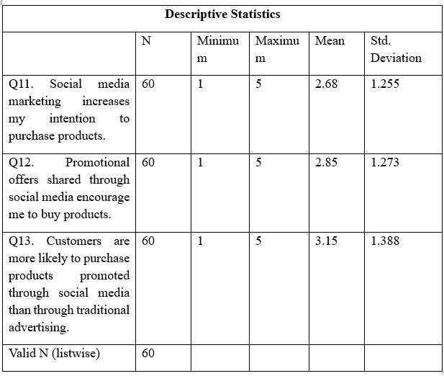
Table 3: Descriptive for objective 3
(Source: SPSS)
Analysis: Table 4.3 presents the descriptive statistics for the Objective 3 which aimed at revealing the impact of social media marketing on purchase intentions of the students. It has been found that the respondents moderately agree that social media marketing affects their purchase decisions. The highest mean value was revealed for the statement "Customers are more likely to purchase products promoted through social media than through traditional advertising" (Mean = 3.15, SD = 1.388). Promotion of offers through the social media also positively affects the purchase decisions (Mean = 2.85, SD = 1.273). At the same time, the mean value of the statement that social media marketing affects the purchase intention is 2.68 (SD = 1.255).
Discussion: It has been concluded that the social media marketing affects the purchase intentions of students, though this influence is not strong. Relatively high mean value for purchasing the products promoted through social media supports the claim of Kumar (2024) that social media serves as the virtual marketplace in which customers discover the products through advertisements, influencer content and interactions. Bilal et al. (2021) state that social media helps in building the long-term relationship between organizations and young consumers, hence increasing the purchase intentions. This can be partially supported by the current findings because the respondents confirm the influence of social media promotions; however, the levels of agreement are not high.
These findings are also consistent with the Stimulus–Organism–Response (SOR) Model presented in Chapter Two. According to Pan et al. (2024), the external marketing stimuli such as advertisements, promotional offers and social media content affect the internal cognitive and emotional responses which influence the purchasing behavior. Though the moderate mean scores indicate that the above-mentioned stimuli influence the buying intentions of students, purchase decisions are also influenced by other factors such as the quality of the product, its price and personal preferences. Furthermore, the findings of the current research are consistent with Al-Adwan et al. (2023) who stated that the consumer perceptions of the usefulness and attractiveness of social media platforms influence the behavioral intentions. These findings are inconsistent with the stronger arguments of Matin et al. (2020) that social media engagements drive purchasing behavior.

4.6 Objective 4: Comparison of Instagram, TikTok and Facebook
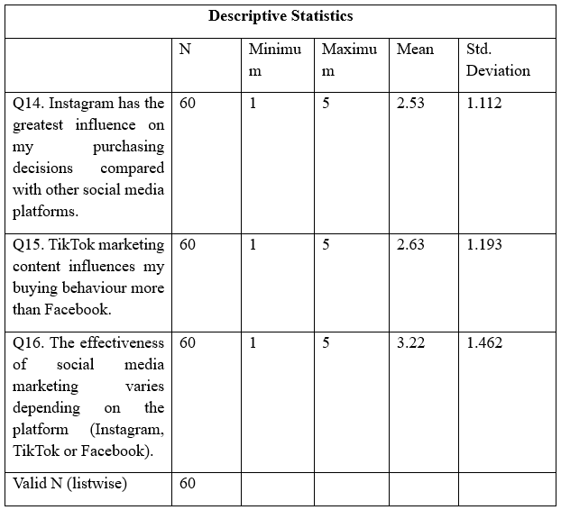
Table 4: Descriptive for objective 4
(Source: SPSS)
Analysis: Table 4 represents the descriptive statistics related to the perception of respondents regarding the usage of Instagram, TikTok, and Facebook as social media marketing platforms. The highest mean (M = 3.22; SD = 1.462) has been obtained in regard to the statement "the effectiveness of social media marketing depends on the platform". Additionally, the second highest mean score has been received in relation to the statement that TikTok has a greater impact on buyers than Facebook (M = 2.63; SD = 1.193). Also, the lowest mean score has been received in relation to the statement that Instagram has the greatest impact on purchasing decisions (M = 2.53; SD = 1.112).
Discussion: It is possible to see that the findings of the study have confirmed the hypothesis according to which students perceive differences in the impact of social media platforms on the purchasing behavior of users. Therefore, the findings prove the popular opinion that social media platforms influence consumers differently according to their features. The fact that the highest mean has been obtained in relation to platform variation proves that students do not perceive social media as similar marketing channels and evaluate them individually according to content formats and opportunities for engagement. The findings are consistent with the literature review presented in Chapter 2 where Singh (2020) claims that Instagram is effective due to high-quality visual content making it possible to use Instagram for influencer marketing. Additionally, Wiese et al. (2020) state that Facebook is convenient due to certain characteristics such as Facebook Marketplace providing easy access to a large consumer base.
However, despite the opinion of previous scholars according to which Instagram is the leading social media platform influencing purchasing decisions of consumers, the relatively low mean score of Instagram in this study proves that students do not prefer any particular platform to other platforms. The findings contradict the findings of Liu et al. (2025) and Lajnef (2023) who claim that influencer-led content of Instagram greatly influences consumers' preferences. Thus, it is possible to conclude that purchasing decisions are influenced not by the platform itself but by the quality and relevance of marketing content. Therefore, companies should use platform-specific marketing strategies targeting UK college and university students considering their preferences and content quality.

4.7 Summary of Findings Against Research Objectives
It should be mentioned that the results of the study have proved that all four research objectives have been achieved through the primary survey. Firstly, it has been found that social media has an important role in the purchasing decision-making process as students use online platforms to find information about products, compare their alternatives and customers' reviews before purchasing something. Secondly, it has been discovered that advertisements, influencer recommendations, and user-generated content have a moderate impact on the respondents' product preferences and purchasing decisions. Thirdly, the findings have proved that social media marketing positively influences purchase intention as it makes it possible to increase the awareness of products and increases the probability of thinking about the products advertised via social media. Finally, the comparison of Instagram, TikTok, and Facebook has proved that the effectiveness of social media marketing depends on different platforms as respondents understand the uniqueness of these platforms and influence consumer behavior. Overall, the results of the study have proved the research aim stating that social media marketing has a great impact on the buying behavior of college and university students in the United Kingdom.

4.8 Chapter Summary
Therefore, this chapter has analyzed the survey results in relation to the research objectives and discussed them in the context of the literature. It has been shown that social media marketing has a great impact on the purchasing behavior of students while differences among Instagram, TikTok, and Facebook prove the importance of using platform-specific marketing strategies.

Chapter 5: Conclusion & Recommendations

5.1 Introduction
In this chapter, the main findings of the study will be discussed in relation to the research objectives. The impact of social media marketing on consumer behavior of college and university students in the UK will be analyzed, as well as some recommendations and directions for future research will be provided.

5.2 Conclusions Based on Research Objectives

5.2.1 Objective 1: Social Media Usage During Purchase Decisions
It can be said that the results revealed that social media became an important element in the process of the consumer journey in connection with gathering the information before making the purchase decision. Participants noted that they used social media to gather information, compare different products and get some insights from the customers' experience. Therefore, it can be stated that social media became an integral part of the consumer journey and not just a source of entertainment anymore. The results are consistent with the results of the previous research carried out by Bilal et al. (2022) and Kumar (2022) who identified that social media are valuable information sources that decrease uncertainties and build up confidence among consumers. Thus, the first research objective has been achieved.

5.2.2 Objective 2: Influence of Advertisements and Influencers
The results revealed that the advertisement and recommendations of the influencers had medium influence on the purchase decision. Participants noted that credible influencers and customers' sincere opinions positively affected their attitudes towards the product although the content itself did not result in the purchase. The results are consistent with the Source Credibility Theory that states that credibility and expertise increase the effectiveness of the message. Besides, the results are consistent with the research carried out by Lou and Yuan (2019) and Lajnef (2023) according to which consumers are more likely to trust authentic influencers. Thus, the second research objective has been achieved.

5.2.3 Objective 3: Impact of Social Media Marketing on Purchase Intention
It can be said that the impact of social media marketing on the purchase intention is positive since social media increase the awareness about the product, stimulate the product evaluation and contribute to the purchasing of advertised products. The results are consistent with the Stimulus–Organism–Response (SOR) Model as per the marketing stimuli which brings changes in the internal evaluation of the consumer along with his behavioral response. They have been quite consistent with the research carried out by Duffett (2017) and Matin et al. (2022) as per the social media marketing affects purchase intention through increased consumer engagement. Thus, the third objective has been successfully achieved.

5.2.4 Objective 4: Comparison of Instagram, TikTok and Facebook
The comparison of the mentioned platforms helped identify that respondents had the understanding of the effectiveness of Instagram, TikTok and Facebook concerning the influence on the purchasing decisions of students. Although Instagram is still an effective platform because of the presence of visual content and influencer marketing, participants agreed that the role of TikTok and Facebook increases. Instead of the selection of only one platform, it can be stated that the effectiveness of the marketing campaign depends on the personal preferences of the user, content quality and goals of the campaign. The results partially support the findings of Singh (2020) according to which the effectiveness of Instagram was identified but are consistent with the research carried out by Wiese et al. (2020). Thus, the fourth research objective has been achieved.

5.3 Practical Recommendations
- Develop Platform-Specific Marketing Strategies
The firms that are interested in attracting the attention of the college/university students need to apply platform-specific marketing tactics and content. Furthermore, to gain social networks the firms need to adapt the marketing campaign tailored to the features of social networks. For example, visual storytelling is an effective marketing tactic in Instagram, videos in TikTok and so on.
- Collaborate with Credible Influencers
The influencers that the firms select should be credible, genuine and qualified enough in the field. In order to create trust among the consumers, the firms should consider not only the quantity of the followers of the influencers but also the influencers whose followers are similar to the target audience of the firm
- Encourage User-Generated Content
The forms are always suggested to mentor their consumers and teach them how to create user generated content including reviews, testimonials and various other data related to the product. This would make the product much more credible as well as trustworthy as it offers the social proof. Furthermore, the incentives along with motivation program might prove beneficial in attaining this goal,
- Invest in Interactive and Visual Content
The firms need to implement the interactive marketing tactics including short videos or live streaming with quizzes along with entertainment. This would attract a lot of people while elevating their knowledge and foster the buying behaviors of the consumers. As it is often seen that the students actively utilise social media, the firms need to develop visual strategies.

5.4 Suggestions for Future Research
The future research should involve larger samples in order to increase the generalizability of the results. Moreover, one can study the influence of different age groups, new social networks or conduct longitudinal studies about the effect of digital marketing trends on the purchasing behavior.

Chapter 6: Personal Reflection

6.1 Why Gibbs' Reflective Cycle?
Reflection is one of the most important aspects of academic research, since it enables researchers to reflect upon their experiences and solve problems by finding out how they can perform better in future. This reflection is based on Gibbs' Reflective Cycle (1988), which consists of six stages of reflection including description, feelings, evaluation, analysis, conclusion and action plan. Unlike traditional reflection that involves only description of one's experience, Gibbs' Reflective Cycle includes the element of critical thinking, which enables researchers to understand the reasons of some events, their influence on research projects and possible ways to improve their performance in future research.
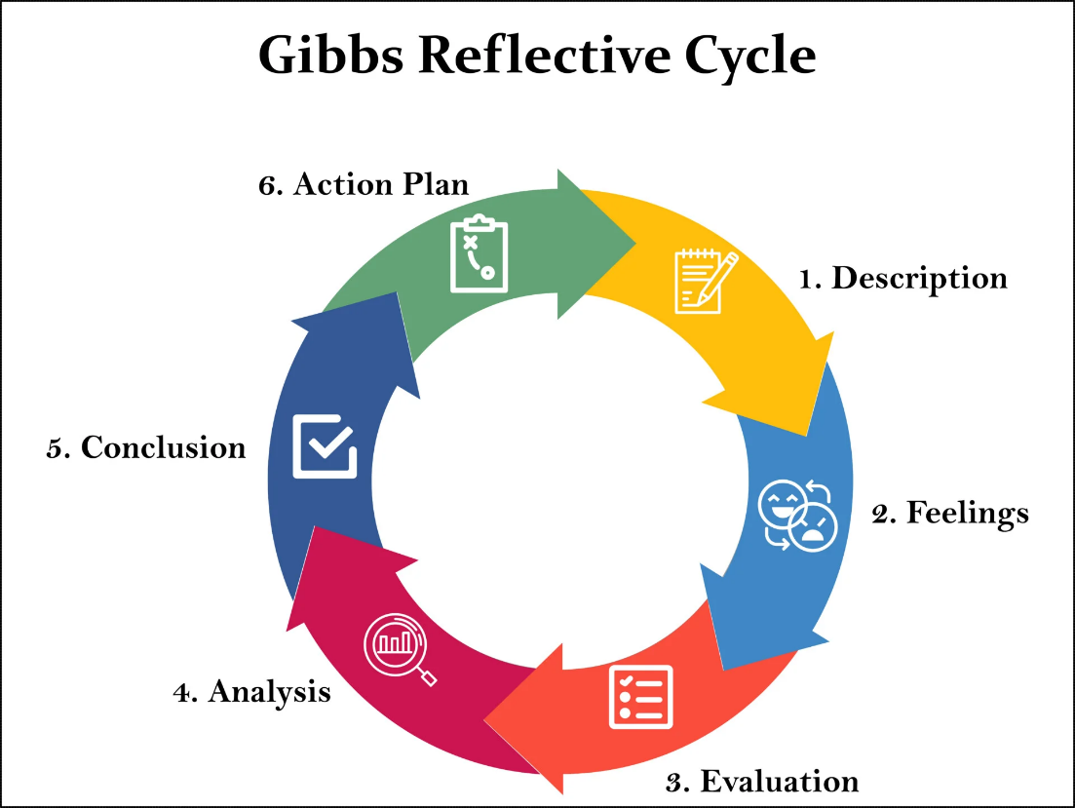
Figure 23: Gibbs’ Reflective Cycle
(Source: Simply Psychology, 2025)

6.2 Description
This research project was all about offering details on the influence of social media marketing on the purchasing behavior of college and university students in the UK. The process of this research project included all stages of the research process, from topic selection and literature review to research methodology development, survey and data analysis. The preparation of this dissertation demanded skills such as planning, independent learning and problem solving. In addition, I acquired the skills of literature search, academic writing, questionnaire design, data analysis and referencing.

6.3 Feelings
Initially, I was not quite sure whether I could manage to choose the right topic and develop an appropriate research methodology for it. Specifically, I was concerned about the collection of valid primary data and analysis of statistical results. However, as my research project progressed, I grew more and more confident due to my increasing knowledge of academic sources, research methodology and data analysis.

6.4 Evaluation
Overall, this dissertation offered me with good experience for me both on the academic and personal level. First of all, the main advantage of this research is the well-developed planning that helped to formulate research goals and ensure that all the chapters of my work are focused on meeting those goals. Conducting the literature review helped me to improve my skills of analysis and evaluation of existing approaches to the research topic, finding research gaps, and creating the questionnaire helped me to enhance my knowledge of quantitative research.
However, there were some problems related to the process of research. Firstly, it was quite hard to choose the suitable participants. In addition, the interpretation of statistical data and its critical relation to the information from literature became more difficult task than I expected because it requires the combination of numerical data and theoretical information. Managing time became especially hard when I was revising the chapters. All those problems helped to develop me professionally.

6.5 Analysis
When I was in the middle of doing my research, I realised that academic research is quite complicated. It takes a lot of effort in planning, ethical consideration as well as reflection at any given stage and has put a lot of effort in doing the literature review, creating research questions along with the questionnaire as well. But later on I came to a realisation that the structure of the research plays a pivotal role in making the entire procedure easier with better interpretation. Also forming the relationship among the theory and empirical evidence is quite necessary. Other than this, I even understood the importance of critical reflection while using the theoretical concepts including Stimulus–Organism–Response Model and Source Credibility Theory. This dissertation taught me the importance of ethical research, on how to maintain confidentiality and how to attain informed consent from the participants. Thus, it could be suggested that this research assisted me in developing my skills of academic research.

6.6 Conclusion
Using Gibbs' Reflective Cycle, I managed to critically analyze my whole experience of doing the research, not just describe my activities. Even though the process of research was complicated and contained some difficulties, it was helpful for me because challenges assisted me in research, analytical, communication and problem-solving skills. Furthermore, I understood the importance of such aspects as planning, critical analysis and ethical research. Overall, doing the dissertation was a helpful experience for me to create my research skills.

6.7 Action Plan
In the future, I will try to improve my skills of planning and keep myself more engaged in literature review, recruiting participants and data analysis. In addition, I will try to optimize my skills of statistical analysis to be able to analyze data better. Also, I want to develop my skills of critical writing and will work with literature and receive constant feedback.

References
Ahmed, J.N., Adalıer, A., Özgit, H. and Kamyabi, M., 2025. Do social media platforms control the sustainable purchase intentions of younger people?. Sustainability, 17(12), p.5488. Available at: https://doi.org/10.3390/su17125488
Akayleh, F.A. (2021) ‘The influence of social media advertising on consumer behaviour’, Middle East Journal of Management, 8(4), pp.344-366. Available at: https://www.inderscienceonline.com/doi/abs/10.1504/MEJM.2021.116443
Al-Adwan, A.S., Li, N., Al-Adwan, A., Abbasi, G.A., Albelbisi, N.A. and Habibi, A. (2023) ‘Extending the technology acceptance model (TAM) to predict university students’ intentions to use metaverse-based learning platforms’, Education and Information Technologies, 28(11), pp.15381-15413. Available at: https://link.springer.com/article/10.1007/s10639-023-11816-3
Almond Solutions (2023. How Social Media is Reshaping Consumer Behavior. Available at: https://www.almondsolutions.com/blog/how-social-media-is-reshaping-consumer-behavior (Accessed: 03 July 2026).
AlShawabkeh, A., Nuseir, M.T. and Aljumah, A. (2021) ‘Impacts of social media on the buying intention of the consumers in Edinburgh, UK’, International Journal of Procurement Management, 14(4), pp.470-486. Available at: https://www.inderscienceonline.com/doi/abs/10.1504/IJPM.2021.116036
Alyahya, M., Agag, G., Aliedan, M. and Abdelmoety, Z.H. (2023) ‘Understanding the factors affecting consumers’ behaviour when purchasing refurbished products: A chaordic perspective’, Journal of Retailing and Consumer Services, 75, p.103492. Available at: https://doi.org/10.1016/j.jretconser.2023.103492
Andersson, M., Boateng, K. and Abos, P. (2024). Validity and Reliability: The extent to which your research findings are accurate and consistent. Civil Engineer and Researcher, 1(1), pp.1-7.https://www.researchgate.net/publication/384402476_Validity_and_Reliability_The_extent_to_which_your_research_findings_are_accurate_and_consistent
Antczak, B. (2024). The influence of digital marketing and social media marketing on consumer buying behavior. Journal of modern science, 56(2), pp.310-335.https://www.jomswsge.com/pdf-189429-114019?filename=The-influence-of-digital-.pdf
Azungah, T., (2018). Qualitative research: deductive and inductive approaches to data analysis. Qualitative research journal, 18(4), pp.383-400.https://www.emerald.com/qrj/article/18/4/383/361440
Barbu, F.S., Sanda, G., Rusu, C.M. and Balint, P.G. (2024). The impact of social networks on the choice of tourist destinations. In Proceedings of the International Conference on Business Excellence (Vol. 18, No. 1, pp. 2327-2343). Sciendo.https://sciendo.com/2/v2/download/article/10.2478/picbe-2024-0197.pdf
Bilal, M., Jianqu, Z. and Ming, J. (2021) ‘How consumer brand engagement effect on purchase intention? The role of social media elements’, Journal of Business Strategy Finance and Management, 2(1), pp.44-55. Available at: https://www.jbsfm.org/pdf/vol2no1/JBSFM_Vol2_No1_p_44-55.pdf
Capili, B. and Anastasi, J.K. (2024). Ethical research and the institutional review board: An introduction. AJN The American Journal of Nursing, 124(3), pp.50-54.https://journals.lww.com/ajnonline/fulltext/2024/03000/ethical_research_and_the_institutional_review.23.aspx
Chaffey, D. (2025). Global social media statistics research summary. Smart Insights. https://www.smartinsights.com/social-media-marketing/social-media-strategy/new-global-social-media-research/
Chan, F. (2022) ‘A study of social media influencers and impact on consumer buying behaviour in the United Kingdom’, International Journal of Business & Management Studies, 3(07), pp.2694-1449. Available at: http://mail.ijbms.net/assets/files/1659111546.pdf
Conner, M. (2020) ‘Theory of planned behavior’, Handbook of sport psychology, pp.1-18. Available at: https://onlinelibrary.wiley.com/doi/abs/10.1002/9781119568124.ch1
Daniel, B. and George, G. (2025). Inductive vs. Deductive Research Methods: A Comprehensive Methodological Guide for Bachelor’s and Master’s Theses. The International Journal of Scientific Research in Engineering and Management, 9(9), pp.1-9.https://doi.org/10.55041/IJSREM52576
Divecha, C.A., Tullu, M.S. and Karande, S. (2023). Utilizing tables, figures, charts and graphs to enhance the readability of a research paper. Journal of postgraduate medicine, 69(3), pp.125-131.https://journals.lww.com/jopm/fulltext/2023/69030/utilizing_tables,_figures,_charts_and_graphs_to.1.aspx
Elkatmış, M. (2024). Examination of social media usage habits of generation Z. Frontiers in psychology, 15, p.1370823.https://www.frontiersin.org/journals/psychology/articles/10.3389/fpsyg.2024.1370823/full?gad_source=1&gad_campaignid=23251497049&gclid=Cj0KCQiAiebIBhDmARIsAE8PGNKe3ER8gRZG6sNGWWcSdHWsGjZ9wGz4jB8E03SbQtFMbk7AVjgF-pkaAqFEEALw_wcB
Farrell, J.R., Campbell, C. and Sands, S. (2022). What drives consumers to engage with influencers? Segmenting consumer response to influencers: Insights for managing social-media relationships. Journal of Advertising Research, 62(1), pp.35-48. https://www.researchgate.net/profile/Colin-Campbell-16/publication/359040202_What_Drives_Consumers_To_Engage_with_Influencers_Segmenting_Consumer_Response_to_Influencers_Insights_for_Managing_Social-Media_Relationships/links/62947a028d19206823e7150e/What-Drives-Consumers-To-Engage-with-Influencers-Segmenting-Consumer-Response-to-Influencers-Insights-for-Managing-Social-Media-Relationships.pdf
Gertschnig, M. (2025). 'Research Design – Definition, Examples & Types,' BachelorPrint, 21 March. https://www.bachelorprint.com/methodology/research-design/.
Grøndahl Glavind, J., Montes De Oca, L., Pechmann, P., Brauner Sejersen, D. and Iskov, T. (2023). Student-centred learning and teaching: a systematic mapping review of empirical research. Journal of Further and Higher Education, 47(9), pp.1247-1261.https://www.tandfonline.com/doi/abs/10.1080/0309877X.2023.2241391
Guttmann, A. (2026). Social media advertising and marketing worldwide – statistics & facts. [Available at: https://www.statista.com/topics/1538/social-media-marketing/?srsltid=AfmBOoqDw1f3by9erb9Cji8lN_isdsa9TqTMRCKb42pURXkJm2K2vuk1#topicOverview ]
Hai Nguyen, T. (2025) ‘Fatigue in the Virtual World: The Impact of Intrinsic Motivation and External Pressures on Young Vietnamese Users’ Intentions to Switch Social Media Platforms’, Sage Open, 15(4), p.21582440251399900. Available at: https://doi.org/10.1177/21582440251399900
Hampson, D.P., Gong, S. and Xie, Y. (2021) ‘How consumer confidence affects price conscious behavior: The roles of financial vulnerability and locus of control’, Journal of Business Research, 132, pp.693-704. Available at: https://doi.org/10.1016/j.jbusres.2020.10.032
Jeswani, R. (2023). The role and importance of social media marketing in brand building. Irish Interdisciplinary Journal of Science & Research, 7(04), pp.01-09.https://iijsr.com/data/uploads/57471.pdf
Johannesson, P. and Perjons, E. (2021). Research strategies and methods. In An introduction to design science (pp. 41-75). Cham: Springer International Publishing.https://link.springer.com/chapter/10.1007/978-3-030-78132-3_3
Khanom, M.T. (2023) ‘Using social media marketing in the digital era: A necessity or a choice’, International Journal of Research in Business and Social Science, 12(3), pp.88-98. Available at: https://10.20525/ijrbs.v12i3.2507
King, B. (2023). Research Philosophy. Medium [Available at: https://medium.com/@kingbradleyfoo/research-philosophy-a9780d2346f3
Kumar, H., (2024) ‘Virtual worlds, real opportunities: A review of marketing in the metaverse’, Acta Psychologica, 250, p.104517. Available at: https://www.sciencedirect.com/science/article/pii/S0001691824003950
Lajnef, K. (2023) ‘The effect of social media influencers' on teenagers Behavior: an empirical study using cognitive map technique’, Current Psychology, 42(22), pp.19364-19377. Available at: https://doi.org/10.1007/s12144-023-04273-1
Li, F., Larimo, J. and Leonidou, L.C. (2021) ‘Social media marketing strategy: definition, conceptualization, taxonomy, validation, and future agenda’, Journal of the Academy of Marketing science, 49(1), pp.51-70. Available at: https://link.springer.com/article/10.1007/s11747-020-00733-3
Liu, Y., Wang, X. and Chen, Y. (2025) ‘Does inconsistency between influencer‐generated and user‐generated content hurt brands? The role of perceived content credibility’, Psychology & Marketing, 42(9), pp.2444-2472. Available at: https://onlinelibrary.wiley.com/doi/abs/10.1002/mar.22240
Mahajan, K and Pangarkar, T (2026). Social Media Statistics and Facts (2026). [Available at: https://market.biz/social-media-statistics/ ]
Mari, I.H., Mahfooz, M. and Yaqub, M.Z. (2023) ‘The Impact of Social Media Marketing on the Consumer Buying Behavior’, International Journal of Emerging Business and Economic Trends, 2(1), pp.102-114. Available at: http://journals.sbbusba.edu.pk/ebet/index.php/abc/article/view/12
Matin, A., Khoshtaria, T. and Tutberidze, G. (2020) ‘The impact of social media engagement on consumers' trust and purchase intention’, International Journal of Technology Marketing, 14(3), pp.305-323. Available at: https://www.inderscienceonline.com/doi/abs/10.1504/IJTMKT.2020.111547
Mbanaso, U.M., Abrahams, L. and Okafor, K.C. (2023). Research philosophy, design and methodology. In Research techniques for computer science, information systems and cybersecurity (pp. 81-113). Cham: Springer Nature Switzerland.https://link.springer.com/chapter/10.1007/978-3-031-30031-8_6
Melnikovas, A. (2019). Towards an Explicit Research Methodology: Adapting Research Onion Model for Futures Studies.Journal of Futures Studies, December 2018, 23(2): 29–44. https://jfsdigital.org/articles-and-essays/2018-2/towards-an-explicit-research-methodology-adapting-research-onion-model-for-futures-studies/
Miteu, G.D. (2024). Ethics in scientific research: a lens into its importance, history, and future. Annals of Medicine and Surgery, 86(5), pp.2395-2398.https://journals.lww.com/annals-of-medicine-and-surgery/fulltext/2024/05000/ethics_in_scientific_research__a_lens_into_its.10.aspx
Mtisi, S. (2022). The qualitative case study research strategy as applied on a rural enterprise development doctoral research project. International Journal of Qualitative Methods, 21, p.16094069221145849.https://journals.sagepub.com/doi/abs/10.1177/16094069221145849
Palalic, R., Ramadani, V., Mariam Gilani, S., Gërguri-Rashiti, S. and Dana, L.P. (2021) ‘Social media and consumer buying behavior decision: what entrepreneurs should know?’, Management Decision, 59(6), pp.1249-1270. Available at: https://doi.org/10.1108/MD-10-2019-1461
Pan, J., Ishak, N.A. and Qin, Y. (2024) ‘The application of Moore's online learning interactions model in learning outcomes: The SOR (stimulus-organism-response) paradigm perspective’, Heliyon, 10(7). Available at: https://doi.org/10.1016/j.heliyon.2024.e28505
Park, Y.S., Konge, L. and Artino Jr, A.R. (2020). The positivism paradigm of research. Academic medicine, 95(5), pp.690-694.https://academic.oup.com/academicmedicine/article-abstract/95/5/690/8347124
Peredy, Z., Vigh, L., Wei, Q. and Jiang, M. (2024) ‘Analysing generation Z communication attitudes, values and norms’, Acta Periodica (Edutus), 30, pp.4-19. Available at: https://doi.org/10.47273/AP.2024.30.4-19
Robinson, O.C. and Bailey-Rodriguez, D. (2026). Deductive qualitative research: an integrative approach to designing studies. Qualitative research in psychology, 23(2), pp.369-384.https://www.tandfonline.com/doi/abs/10.1080/14780887.2025.2604773
Rodrigues, R.I., Lopes, P. and Varela, M. (2021) ‘Factors affecting impulse buying behavior of consumers’, Frontiers in Psychology, 12, p.697080. Available at: https://doi.org/10.3389/fpsyg.2021.697080
Saunders, M. N. K., Lewis, P., and Thornhill, A. (2019). Research methods for business students (Eighth ed.). Pearson. https://go.exlibris.link/24MYqtdX
Serman, Z.E. and Sims, J. (2023) ‘Source credibility theory: SME hospitality sector blog posting during the Covid-19 pandemic’, Information Systems Frontiers, 25(6), pp.2317-2334. Available at: https://link.springer.com/article/10.1007/s10796-022-10349-3
Sharma, L.R. (2023). Choosing appropriate probability sampling designs in research. Health, 2(1), pp.4-21.https://primerascientific.com/pdf/psmph/PSMPH-02-036.pdf
Siedlecki, S.L. (2020). Understanding descriptive research designs and methods. Clinical Nurse Specialist, 34(1), pp.8-12.https://journals.lww.com/cns-journal/fulltext/2020/01000/understanding_descriptive_research_designs_and.4.aspx
Simply Psychology. (2025, March 26). Gibbs Reflective Cycle. https://www.simplypsychology.org/gibbs-reflective-cycle.html
Singh, M. (2020) ‘Instagram marketing—The ultimate marketing strategy’, International Journal of Advance and Innovative Research, 7(1), pp.379-382. Available at: https://www.researchgate.net/profile/Gauri-Vartak-3/publication/400345848_Gauri_Vartak-Smart_Security_system/links/6980798e42f94d1212a5cc40/Gauri-Vartak-Smart-Security-system.pdf#page=393
Siregar, T. (2025). Descriptive statistics: Concepts, data collection methods, and sampling techniques in quantitative research. Jurnal Aplikasi Matematika Dan Statistik, pp.1-43.https://www.researchgate.net/publication/396983535_Descriptive_Statistics_Concepts_Data_Collection_Methods_and_Sampling_Techniques_in_Quantitative_Research
Slater, P. and Hasson, F. (2025). Quantitative research designs, hierarchy of evidence and validity. Journal of Psychiatric and Mental Health Nursing, 32(3), pp.656-660.https://onlinelibrary.wiley.com/doi/abs/10.1111/jpm.13135
Smith, M.J., Buckton, C., Patterson, C. and Hilton, S. (2023) ‘User-generated content and influencer marketing involving e-cigarettes on social media: a scoping review and content analysis of YouTube and Instagram’, BMC public health, 23(1), p.530. Available at: https://link.springer.com/article/10.1186/s12889-023-15389-1
Solanki. P., Mahaveer, P and Nair, S (2026). Influence Of Social Media on Purchasing Decision of Youth. [Available at: https://www.researchgate.net/publication/406150269_Influence_Of_Social_Media_on_Purchasing_Decision_of_Youth ]
Statista (2026a) Number of social media users worldwide from 2017 to 2030. Available at: https://www.statista.com/forecasts/278414/number-of-worldwide-social-network-users/?srsltid=AfmBOoqoo1zlPLqbf7KxbiOnFv9ErC9FBBxxaKxnK2qUBeSCcaClSkWk (Accessed: 03 July 2026).
Statista (2026b) Social Media Advertising – Worldwide. Available at: https://www.statista.com/outlook/amo/advertising/social-media-advertising/worldwide/?srsltid=AfmBOooWwTTx38D0UDCF6RArqZTep7v7MVS55zYgBHIupp6rU_xYa-5s (Accessed: 03 July 2026).
Statista (2026c) Share of Gen Z shoppers who discovered a new product or brand on social media and purchased it in 2023 and 2024. Available at: https://www.statista.com/statistics/1455391/shoppers-social-media-discovery-and-purchase-worldwide/?srsltid=AfmBOorQ8xjHq3VEhhDnu4MlQBwM8pWJLdcpK8C29-eB5PtTnS6LNVlY (Accessed: 03 July 2026).
Statista (2026d) Distribution of social network users in the United Kingdom as of September 2024, by education. Available at: https://www.statista.com/statistics/1401035/uk-social-media-users-by-education/?srsltid=AfmBOoqWwX5NrgCbDr8f8kmFIqvSfgVn95_k2HCordOhErkJC_y3NKlB (Accessed; 03 July 2026).
Statista (2026e) Influencer marketing market size worldwide from 2015 to 2025. Available at: https://www.statista.com/statistics/1092819/global-influencer-market-size/?srsltid=AfmBOorB51RHRM36ZAn0FEaYUyLZ6p0NgooENw2yQy5htd82HXA02btz (Accessed: 04 July 2026).
Statista (2026f) Facebook Ads Are the Most Noticeable. Available at: http://statista.com/chart/25937/advertisement-awareness-on-social-media-platforms/?srsltid=AfmBOoqLLugt6clUpWzyU2PlwQPZARx_OFkyKbP_OEhXr3huGliffk8y (Accessed: 04 July 2026).
Statista (2026g) Influencer marketing market size worldwide from 2015 to 2025. Available at: https://www.statista.com/statistics/1092819/global-influencer-market-size/?srsltid=AfmBOor513T9jTK5pNNaGwlbzq7Uz2J44qQQq_W1JSC7y2Jdtd2cYXIW (Accessed: 04 July 2026).
Sürücü, L. (2020). Validity and reliability in quantitative research. Business & management studies: an international journal.https://www.academia.edu/download/64671760/Validity_and_Reliability_In_Quantitative_Research.pdf
Taherdoost, H. (2022). What are Different Research Approaches? Comprehensive Review of Qualitative, Quantitative, and Mixed Method Research, Their Applications, Types, and Limitations. Journal of Management Science & Engineering Research. https://www.semanticscholar.org/paper/What-are-Different-Research-Approaches-Review-of-Taherdoost/f9f8abd601fdc80e0b2264082aea44e75f6ff62a
Thuy, D (2026). Share of social network users in the United Kingdom as of May 2026, by generation. [Available at: https://www.statista.com/statistics/1401041/uk-social-media-users-by-generation/?srsltid=AfmBOorK7JSDWoWKLGTtY4wedTZ0QkTe6flpPkiyez3gHZ_CxMO0pfbh]
Varghese, S. and Agrawal, M. (2021) ‘Impact of social media on Consumer Buying Behavior’, Saudi Journal of Business and Management Studies, 6(3), pp.51-55. Available at: 10.36348/sjbms.2021.v06i03.001 5.pdf
Vázquez-Herrero, J., Negreira-Rey, M.C. and Sixto-García, J. (2022). Mind the gap! Journalism on social media and news consumption among young audiences. International Journal of Communication, 16, pp.21-21. https://ijoc.org/index.php/ijoc/article/download/19643/3854
Venciute, D., Mackeviciene, I., Kuslys, M. and Correia, R.F. (2023) ‘The role of influencer–follower congruence in the relationship between influencer marketing and purchase behaviour’, Journal of Retailing and Consumer Services, 75, p.103506. Available at: https://doi.org/10.1016/j.jretconser.2023.103506
Wang, X. and Cheng, Z. (2020). Cross-sectional studies: strengths, weaknesses, and recommendations. Chest, 158(1), pp.S65-S71.https://www.sciencedirect.com/science/article/pii/S0012369220304621
Wiese, M., Martínez-Climent, C. and Botella-Carrubi, D. (2020). ‘A framework for Facebook advertising effectiveness: A behavioral perspective’, Journal of Business Research, 109, pp.76-87. Available at: https://www.sciencedirect.com/science/article/pii/S0148296319307155
Wilska, T.A., Holkkola, M. and Tuominen, J. (2023). ‘The role of social media in the creation of young people’s consumer identities’, Sage Open, 13(2), p.21582440231177030. Available at: https://journals.sagepub.com/doi/abs/10.1177/21582440231177030
Xue, L., Mahat, J. and Ghazali, N. (2026) ‘Technology Acceptance Model in Artificial Intelligence in Education: A Meta-Analysis’, Sage Open, 16(1), p.21582440251409441. Available at: https://doi.org/10.1177/21582440251409441
Yougov (2025). Social media shopping trends among Britons. Available at: https://yougov.com/en-gb/articles/51817-social-media-shopping-trends-among-britons (Accessed: 03 July 2026).
Zaineldeen, S., Hongbo, L., Koffi, A.L. and Hassan, B.M.A. (2020). ‘Technology acceptance model’concepts, contribution, limitation, and adoption in education’, Universal Journal of Educational Research, 8(11), pp.5061-5071. Available at: https://10.13189/ujer.2020.081106
Zhao, J., Butt, R.S., Murad, M., Mirza, F. and Saleh Al-Faryan, M.A. (2022) ‘Untying the influence of advertisements on consumers buying behavior and brand loyalty through brand awareness: the moderating role of perceived quality’, Frontiers in Psychology, 12, p.803348. Available at: https://doi.org/10.3389/fpsyg.2021.803348

Appendices

Appendix 1: Questionnaire
Participant Information
Dear Participant,
You are invited to participate in this academic research study conducted as a part of a postgraduate dissertation. The purpose of this study is to examine how social media marketing influences the buying behavior of college and University going students in the United Kingdom. The questionnaire will take approximately 5-7 minutes to complete.
Your participation is entirely voluntary. All responses will remain anonymous and confidential and will be used solely for academic purpose. No personally identifiable information will be collected, and you may withdraw from the survey at any time before submitting your response.
Thank you for your valuable participation.
1. Consent to Participate: I have read the participant information provided above. I understand the pupose of this study and voluntarily agree to participate.
Yes, I agree to participate.
No, I do not agree to participate.

2. I have read and understood the participant information above.
Yes
No

3. I understand that my participation is voluntary and that I may withdraw before submitting my responses.
Yes
no
4. I voluntary agree to participate in this research study.
Yes
No

Section B: Demographic information
Q1. Age
18-20 years
21-23 years
24-26 years
above 26 years

Q2. Gender
Male
Female
Non Binary
Prefer not to say
Q3. Level of Study
College (Further Education)
Undergraduate
Postgraduate
Doctoral
Q4. Which Social Media Platform do you use more frequently?
Instagram
Tik Tok
Facebook
Other

Section C: Non -Demographic Section
Please indicate your level of agreement with each statement
Scale
1= Strongly Disagree
2= Disagree
3=Neutral
4= Agree
5=Strongly Agree
Q5. You rely on social media to search for information before purchasing a product
Strongly Disagree
Disagree
Neutral
Agree
Strongly Agree

Q6. Social media helps me compare products before making purchase decisions
Strongly Disagree
Disagree
Neutral
Agree
Strongly Agree
Q7. The customers rely on social media reviews when deciding whether to buy a product
Strongly Disagree
Disagree
Neutral
Agree
Strongly Agree
Q8. Advertisements on social media influence my preference for certain products.
Strongly Disagree
Disagree
Neutral
Agree
Strongly Agree

Q9. Recommendations from social media influencers affects my product choices.
Strongly Disagree
Disagree
Neutral
Agree
Strongly Agree

Q10. User-generated content (such as reviews and testimonials) increases the consumers trust in products.
Strongly Disagree
Disagree
Neutral
Agree
Strongly Agree

Q11. Social media marketing increases my intention to purchase products.
Strongly Disagree
Disagree
Neutral
Agree
Strongly Agree

Q12. Promotional offers shared through social media encourage me to buy products.
Strongly Disagree
Disagree
Neutral
Agree
Strongly Agree

Q13. Customers are more likely to purchase products promoted through social media than through traditional advertising.
Strongly Disagree
Disagree
Neutral
Agree
Strongly Agree

Q14. Instagram has the greatest influence on my purchasing decisions compared with other social media platforms.
Strongly Disagree
Disagree
Neutral
Agree
Strongly Agree
Q15. TikTok marketing content influences my buying behavior more than Facebook.
Strongly Disagree
Disagree
Neutral
Agree
Strongly Agree

Q16. The effectiveness of social media marketing varies depending on the platform (Instagram, TikTok or Facebook).
Strongly Disagree
Disagree
Neutral
Agree
Strongly Agree

Appendix 2: Research Project Proposal

Appendix 3: Ethics form

Appendix 4: Role of the Supervisor & the Supervisory Process

