Installation Instructions for Ruby
(needed by the TurnParser tool for Alamaze)

First, you need to download an installer (RubyInstaller.org). Make sure you get one of the 1.9.3 versions and not any of the 2.*.* versions.

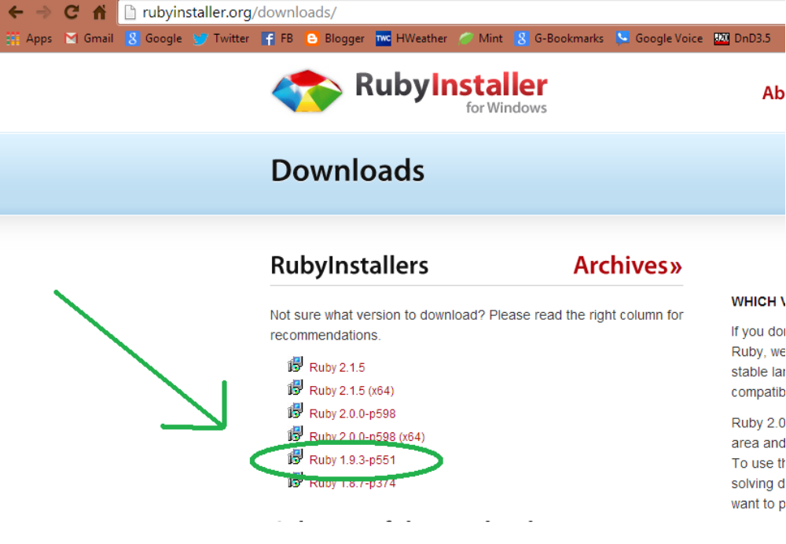
Once you have it downloaded, you need to install it. (Well, you should probably scan it for viruses first. Always remember to always scan everything you ever download from the Internet, even if you completely trust where it came from. Even if the last 1000 things you downloaded from that site and scanned have been clean.).

When you run the installer, it first asks what language you want. I chose English. Then you have to accept their license.
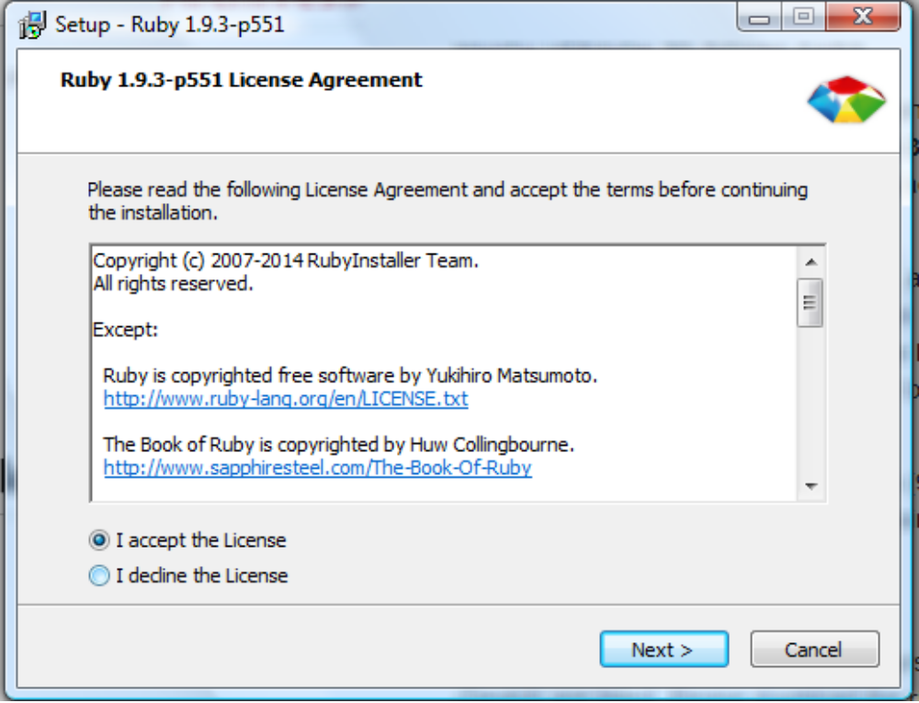
Once you accept the license, it asks where to install it. MAKE SURE YOU HAVE ALL THREE BOXES CHECKED.
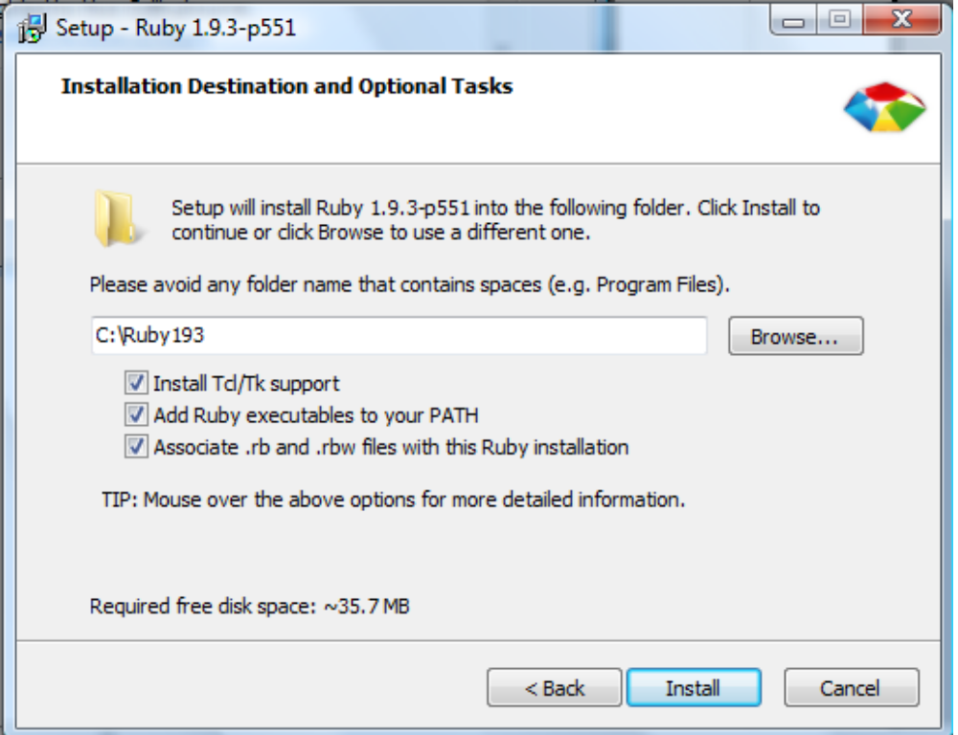

Once you click Install, it does its stuff and you eventually see this:

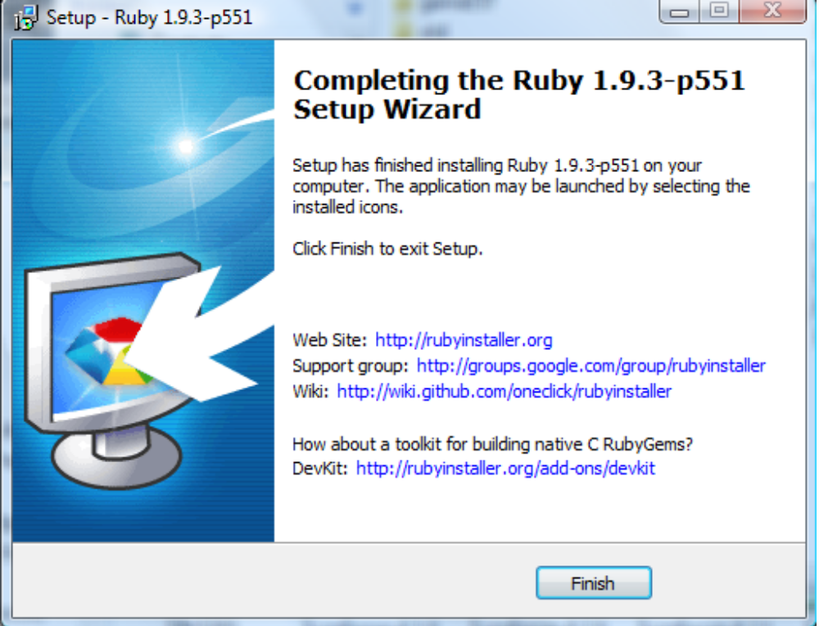

Go ahead and click Finish. But alas, we are not done. We need to install a Ruby Gem to handle reading the PDF files that the Alamaze turn results come in.

From the Start menu, navigate to the All Programs → Ruby 1.9.3 folder.. Click on the “Start Command Prompt with Ruby” icon.

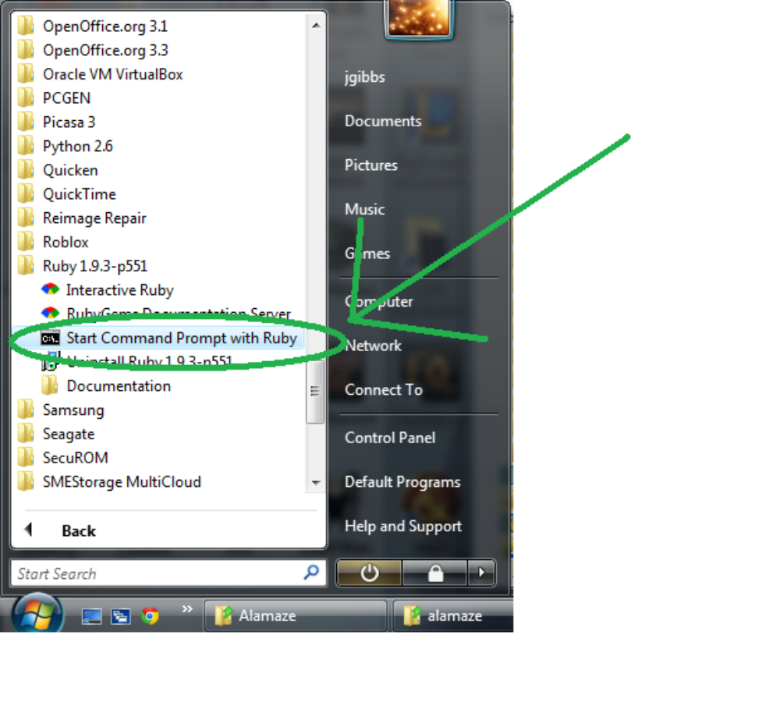
In the window that appears, all you have to do is type “gem install pdf-reader” and hit Enter. MAKE SURE YOU USE A DASH AND NOT AN UNDERSCORE. There is both a 'pdf-reader' and a 'pdf_reader' and they are very different. Thank you Internet :). Anyway, if you type it right, you should see something like this:

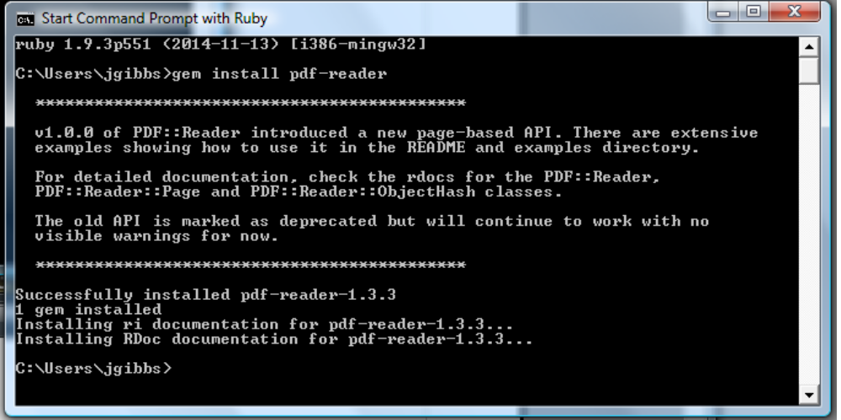

OK, now you are done! See, that was easy.

