Alamaze Turn Parser Instructions

This document contains general instructions for running the Turn Parser tool for Alamaze turn results.

Getting Started
There are two ways the parser is distributed. One way is a stand alone binary that you just run like any other exe. The other way is via a zip file containing the Ruby scripts and graphics files. Before you can run the turn parser that way, you need to have Ruby installed. See the RubyInstallationInstructions.docx document. Once Ruby is installed, you can download the turn parser zip file. Once you expand that zip file, you can run the parser simply by clicking on 'amap'.

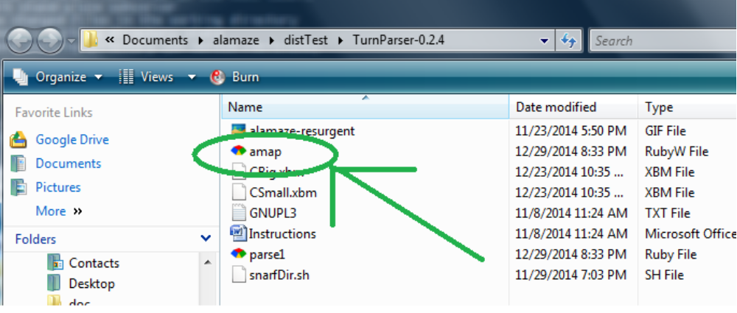

Regardless of which method you use, when the parser gui starts, you should see something like this (although the Text Output window might be hiding behind the map window).

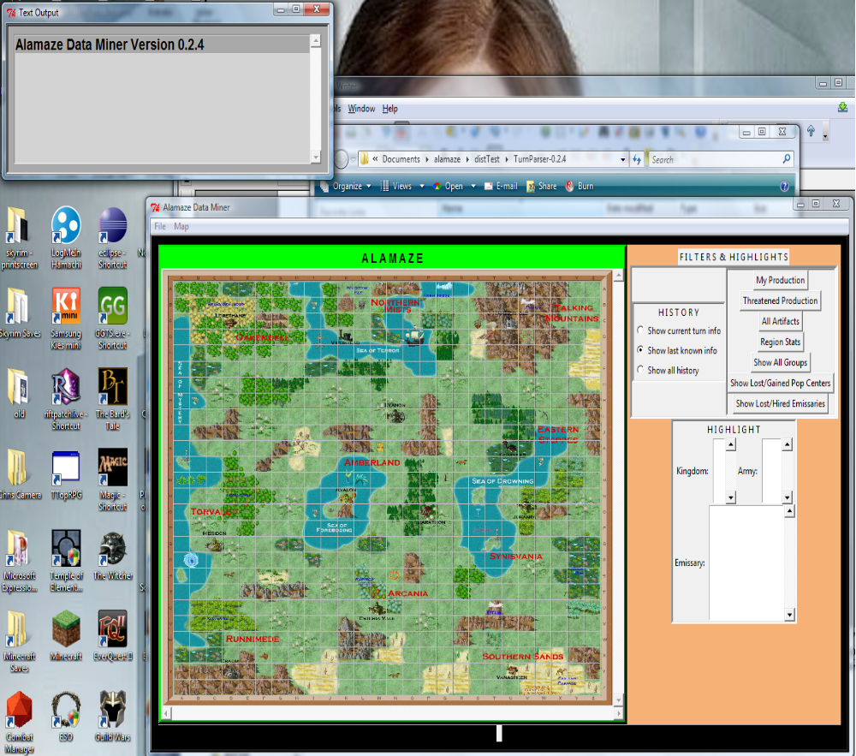
So what do you do now?

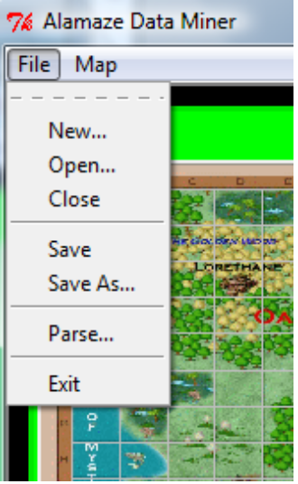
Loading in Data
If you have never used it before, you will want to start parsing the turns for one of your games. I'll assume you have all of the PDF turn results saved off in a separate directory for each game (not that it matters). Use the File->Parse... menu option to parse in a turn.

Just select Parse, navigate to your *R0.pdf file. Once it is done, you should probably see four population centers appear on the map (the ones you start with in that game). Repeat that process until you get all of the results you currently have parsed in. Then select File->Save and put the saved output somewhere.

Later, when you get your next turn and want to parse it in too, you do NOT have to re-parse the old turns. Instead, select File->Open.. and find the file you saved earlier. The map should populate with all the pretty little population centers you saw before. Now, select File->Parse.. and navigate to your latest results. Don't forget to save afterwards.

Note that New.. and Close do the same thing (clear the map and data so you can load in or start parsing in a new or the same game).

So let's talk about what this tool can do once you have parsed your turns.

Click on a Population Center
Clicking on a population center icon on the map will generate a report in the Text Output window showing the stats of the PC as well as list any emissaries and armies that are there. Note that this output is directly affected by the HISTORY button to the right.

Show Current Turn Only
As it implies, the only data in this report will what was gleaned from the current turn results. In some instances, that will be nothing. Current information is shown in a normal, black font. The 'Trn' column indicates the current turn. The 'Source' column is just a clue on where that data came from in the turn results.

Show Last Known Information
If this button is selected, the report will contain not only the current turn's info (if any), but the latest bits of old information about the PC, emissaries, and armies. The non-current (or stale) information is shown in light blue so as not to get it confused with current information.
By last know, we mean just that. For example, say we have information for a given emissary in that population center for several turns, only the last one will be shown. That is also why the first column indicates which turn that row's worth of info is from.

Show All History
This setting will generate a row of text for every turn you have information on the given pc as well as any emissaries or armies that were ever there. If you are very late in the game, this can be quite a lot of date. Is it useful? It might be, so it is there.

The Highlight List Boxes
There are three list boxes toward the bottom/middle of the right panel of the main display. They will highlight areas on the map as well as generate data in the Text Output window. Not that you must DOUBLE-CLICK on the values in the list boxes. (that is a bug we are calling a feature right now )

Kingdom
This listbox is populated with only the kingdoms the parser has pulled out of your turn results ( as opposed to a kingdom that showed up in your turn results but was not in a section that the parser extracted).
Double clicking on one of the kingdoms there will highlight (in red) every area of the map you have ever seen stuff from that kingdom. In the Text Output window, you will see the last known information about every pc, emissary, and group for that kingdom that have ever been parsed out of your turns.

Army
Similar to the Kingdom listbox, this one is populated the the ID of every group from every kingdom that have shown up in your turns. Double clicking on one will show you the entire history of that unit, regardless of area. On the map, you will also see arrows showing the unit moving from one location to the next. Note that these arrows are just a straight line between the areas, not the path the unit followed.

Emissary
Similar to the Army listbox, this one is populated with every emissary you've seen. Note that the kingdom name is prepended to each emissary name to help tell them apart. (e.g. the Troll envoy Drooler would show up as “TR-DROOLER”). Double clicking on one of these will generate the entire known history of that emissary as well as draw arrows on the map.

Special Buttons
There is a set of buttons in the upper right hand portion of the right panel. Each generates a specialized report in the Text Output window.

My Production
This just shows the stats for all your population centers. Above that, though, is a breakdown of the food and gold production by region.

Threatened Production
This report will list any of your population centers which currently have a foreigh army at the door or a foreign emissary in them this turn. (At the moment, it will not alert on an emissary that we know about from an old turn, even if we can logically assume he is still there and a danger).

All Artifacts
This generates a report listing the latest information on every artifact that was parsed out of your turn results. Very useful for looking up the short name of an artifact.

Region Stats
This button generates a report on all of the regions and the population centers within. The goal was to show you exactly what percentage you controlled, but it only goes off of what you have seen. (eg if you have one village in a region and know of no other pcs in that region, it would say 100% control. And that is just silly. So it currently does not show % controlled. Look on your regular turn results for that).

Show All Groups
This button does two things. First, it causes the icons for all groups (with current info) to be displayed on the map. Why are they not there by default? Because I have not made them play nicely with the population centers and they simply overlap. To keep the display uncluttered, they are normally not there. Click this button when you want to see them.
The other thing it does is report the last known information on all known groups.

Show Lost/Gained Pop Centers
This report tries to list any population centers that you lost or gained. Basically, if you controlled it last turn but not this turn, it is lost. If you didn't control it last turn but do now, it is gained.

Show Lost/Hired Emissaries
Same as above, but for emissaries.

Map Menu
If you click on Map->Mark Explored.., you will get an odd looking window appear.

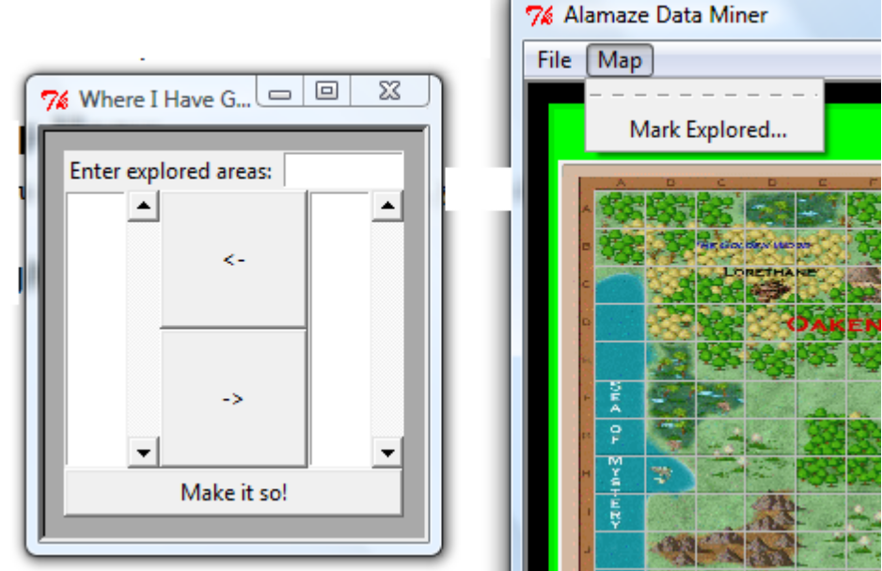
While I could probably parse out exactly where your groups moved and your agents searched, I didn't. Instead, you have a menu where you can enter areas manually. The easiest way to use this is to copy the areas out of the movement order listed near the end of your turn resutls. Paste them into the top box and hit enter. At that point, they show up in the right hand list box. Also, those areas are highlighted on the map so you can see if you made a mistake. For any areas you don't want, just move them to the left hand box via the '←' button. That will unhighlight them. When you hit the 'Make it so!” button, that window goes away and the highlighted areas are marked with a NoPC marker.
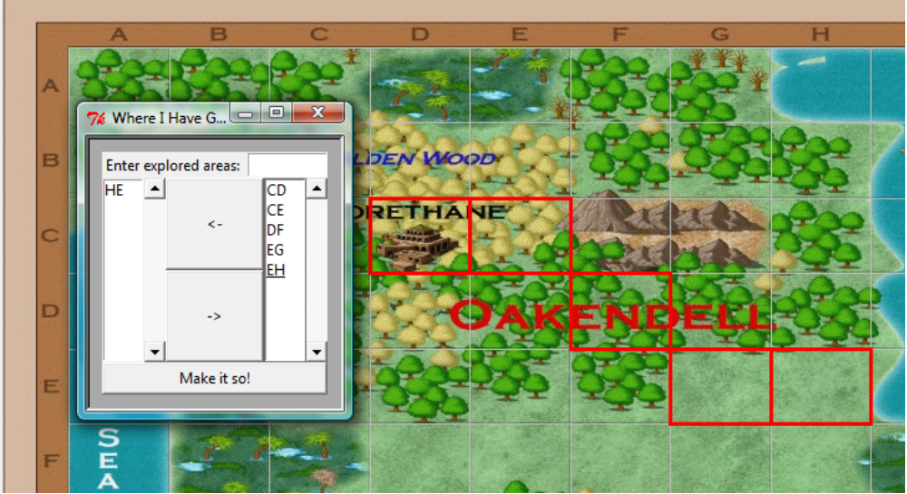

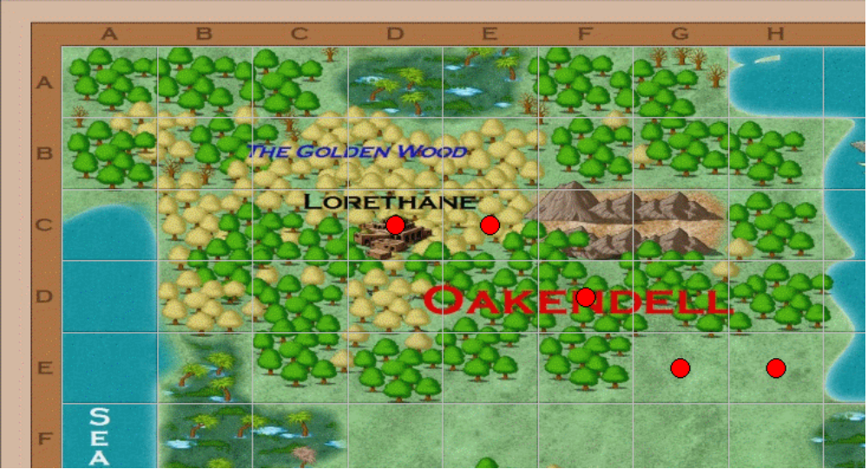
DO NOT FORGET TO SAVE AFTERWARDS.

Right Click Menus
At the moment, there are only two right-click, context menus available.

Change PC Owner
Right clicking on the icon of a PC will bring up a menu allowing you to change the PC owner. Selet this and you get a small dialog where you can enter the abbreviation for a kingdom. Hit Enter and the population center will be updated to show the newly entered owner for this turn. Do not forget to save afterwards.

Delete Explored Marker
If you right-click on one of the little red NoPC dots, you will see a menu allowing you to delete it. Select that option and it will go away. Do not forget to save afterwards.

