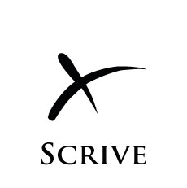

**Product**

Scrive is a cloud service for signing documents electronically. We make signing procedures and administration much simpler. (“We make signing much simpler” Or “We make the procedures and administration for signing much simpler” The sentence scans badly because first read through you think : why would you sign a procedure?) In just 1 year we have become market leaders in Sweden.

**Potential**

Each year 1.1 billion contracts and tenures what's a tenure in this context? are signed in Sweden alone ~~only~~. 99% could be made digital.

In the US the market is already growing exponentially. Our 2 main competitors have received 8M€ and 40M€ in investments and the largest competitor signed 80M contracts in 2010.

*Window of opportunity: In Europe the market is still untapped.*

**Customer value**

By making their signing procedures digital our customers:

* Save 10-30€/document
* Increase closing rates
* Improve customer satisfaction

*Selected reference customers, first 2 months of sales: Coop, Mynewsdesk, Paynova and Resurs Bemanning*

**Core strategy**

Our service has a proven strong virality with sales reps. To scale sales rapidly we will exploit the sales rep virality to set up partner sales organizations throughout Europe. Q3 2011 to Q1 2012 is for preparations and local Swedish sales, at Q2 2012 we start roll-out.

**Financials**

On average we charge 2.5€ per signature today. In 2013 we expect to sell 5.6M signatures. One enterprise customer can use millions of signatures per year and they´re all looking into digital signing right now.

*Expected revenue in 2013: 11.5M€, EBIT 16.5%*

Lukas Duczko

CEO, SkrivaPå CM AB

+46-70-456 0404

[lukas@skrivapa.se](mailto:lukas@skrivapa.se)

<http://skrivapa.se/>