![InfiIoT](https://infiiot.com/static/images/logo.png)

- Home
- Platform
Features Request for Quote!
- Resources
Getting Started Documentation - Hardware Documentation - Software Community Forum Blog Help Center FAQ
- About Us
Know About Us! Contact Us! Privacy Policy Terms of Service
- Login

Explore world of IoT with InfiIoT
Welcome to the most advanced and futuristic IoT development platform.
Connect your devices and securely access, monitor, analyze, predict
and act on data in newer and simpler ways.

Get Started for Free

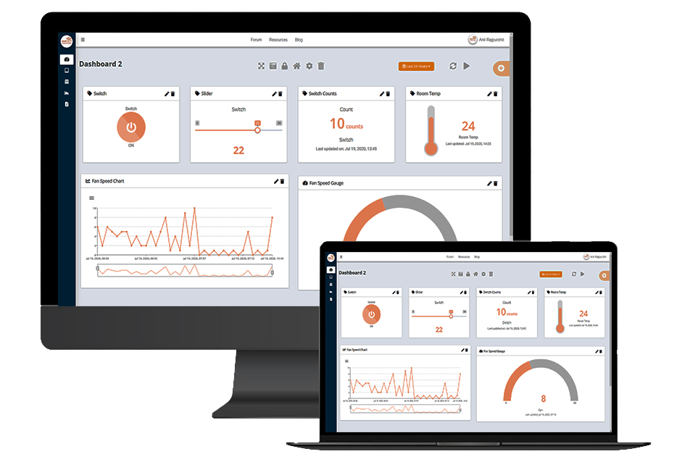

Easy & Futuristic
Super-Easy integration. Customizable data formats. No point count
restrictions. On-the-fly Future Prediction.

Secure
Supports AES Secure Payloads. Transport Layer Security(TLS) based
User and Payload Authentication.

One-Stop Solution
Don't waste your time integrating. Our libraries, Software UI/UX,
and connectivity work together out of the box.

Visualize data with Real-Time Dashboard
Analyze and Control your devices using our futuristic widgets
including interactive graphs, charts, tables, labels, indicators
and controls.

Visualize%20data%20with%20Real-Time%20Dashboard.webp)

Acclerate%20your%20projects%20agility.webp)

Acclerate your projects agility and decision-making with InfiIoT
Swift project turnaround-time with easy integrations. Get real
time data insights from globally dispersed devices and acclerate decision making using
our daily, weekly and monthly reports.

Smarter Future with IoT and Machine Learning
Eliminate human errors and enable big data to generate real-time insights and allow
Internet of Things devices to reach their full potential.

Smarter%20Future%20with%20IoT.webp)

Visualize%20data%20with%20Real-Time%20Dashboard.webp)

Visualize data with Real-Time Dashboard
Analyze and Control your devices using our futuristic widgets
including interactive graphs, charts, tables, labels, indicators
and controls.

Acclerate%20your%20projects%20agility.webp)

Acclerate your projects agility and decision-making
Swift project turnaround-time with easy integrations. Get real
time data insights from globally dispersed devices and acclerate decision making using
our daily, weekly and monthly reports.

Smarter%20Future%20with%20IoT.webp)

Smarter Future with IoT and Machine Learning
Eliminate human errors and enable big data to generate real-time insights and allow
Internet of Things devices to reach their full potential.

Drive Innovation by Connecting with us!
Get powerfull new capabilities to digitally transform your
bussiness.

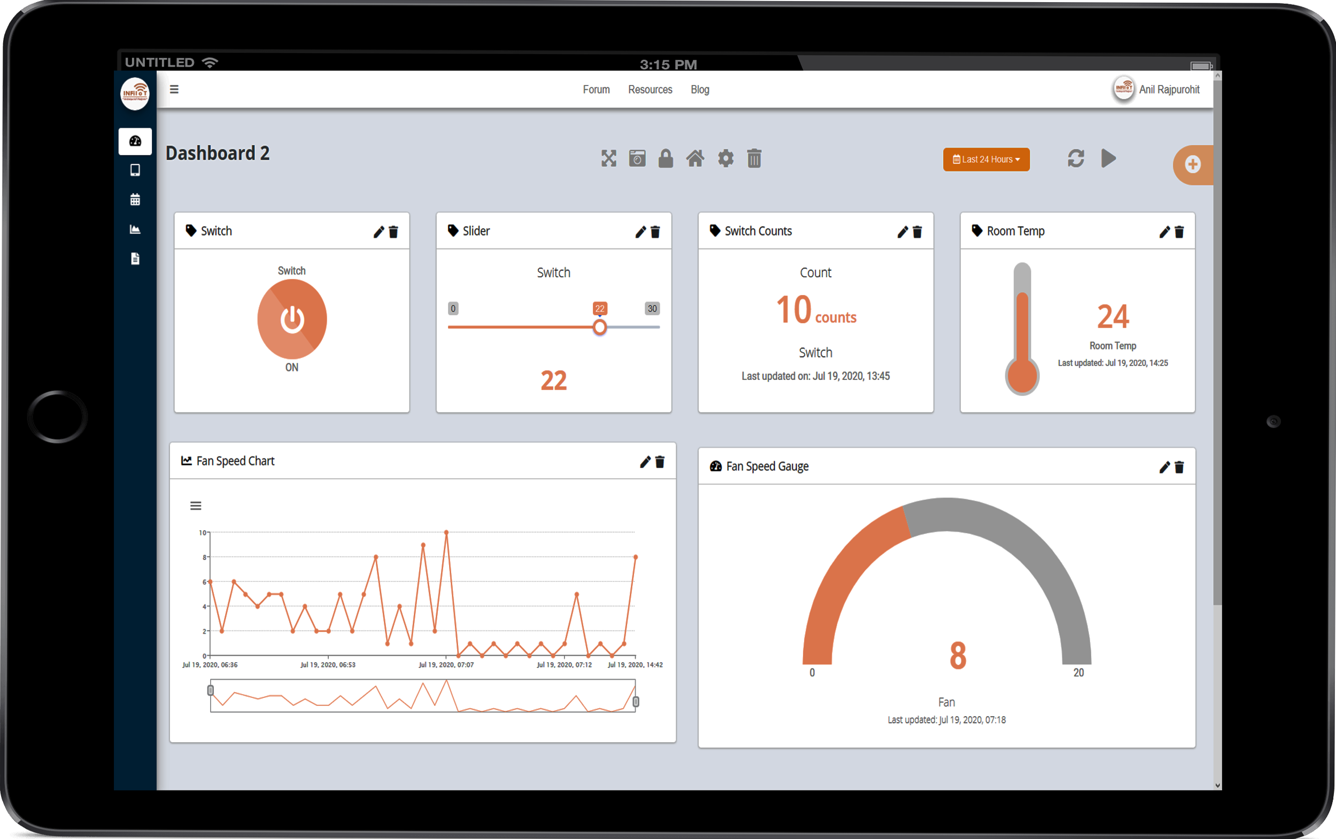

Extend Product Life
Track real-time device status and predict when your products
will need maintenance.

Enhanced Asset Utilization
Improve tracking of assets (equipment, machinery, tools, etc.)
using sensors and connectivity.

Data Perception
Utilise IoT devices to teack and record patterns in which
consumers interact with your devices.

Efficiency and Productivity
Connect your bussiness's key processes. Easily identify ways
to boost Efficiency and Productivity.

Watch Our Promo Video
I have tried using different IoT Platforms. IoT is not my strong
side.

There is excellent support behind InfiIoT helpdesk and
people to walk you through. If you have any questions, they will
go over that and explain to you how to do that.

Mrs. Sai Wable, TCS

Easy to use. Great Service and a great way to getting started
with sending Sensor data to IoT Platforms.

I got my project POC running within few minutes of time.

The best part of InfiIoT is there is no need of any cloud-side
configurations, I could directly send my data and they organized
it for me.

Mr. Rohit Gupta, Student

We have been using InfiIoT since 2 months, and I have to say
that it has transformed the way we do Bussiness.

Real-Time Dashboard provides us with critical insight into our
bussiness and ultimately become moredynamic and competetive
inthe marketplace.

Mr. R Krishnan, Rhodo Labz

I have tried using different IoT Platforms. IoT is not my strong
side.

There is excellent support behind InfiIoT helpdesk and
people to walk you through. If you have any questions, they will
go over that and explain to you how to do that.

Mrs. Sai Wable, TCS

Easy to use. Great Service and a great way to getting started
with sending Sensor data to IoT Platforms.

I got my project POC running within few minutes of time.

The best part of InfiIoT is there is no need of any cloud-side
configurations, I could directly send my data and they organized
it for me.

Mr. Rohit Gupta, Student

We have been using InfiIoT since 2 months, and I have to say
that it has transformed the way we do Bussiness.

Real-Time Dashboard provides us with critical insight into our
bussiness and ultimately become moredynamic and competetive
inthe marketplace.

Mr. R Krishnan, Rhodo Labz

I have tried using different IoT Platforms. IoT is not my strong
side.

There is excellent support behind InfiIoT helpdesk and
people to walk you through. If you have any questions, they will
go over that and explain to you how to do that.

Mrs. Sai Wable, TCS

prev

next

![InfiIoT](https://infiiot.com/static/images/logo-alt.png)

Services & Products
- Products & Design
- Industry Consultancy
- InfiIoT Platform
- Web Development Services
- View Products!

Resources
- Getting Started
- Documentation- Hardware
- Documentation- Software
- Community Forum
- Blog
- Help Centre
- FAQs

Company
- About
- Contact Us
- Features
- Pricing
- Privacy Policy
- Terms of Service

Copyright © 2026
infiiot.com

