![InfiIoT](https://infiiot.com/static/images/logo.png)

- Home
- Platform
Features Request for Quote!
- Resources
Getting Started Documentation - Hardware Documentation - Software Community Forum Blog Help Center FAQ
- About Us
Know About Us! Contact Us! Privacy Policy Terms of Service
- Login

Our Features
%20Features.png)

Easy to Integrate - SDK’s and APIs
InfiIoT Device SDK helps you
easily and quickly connect your hardware device
or your mobile application to InfiIoT Platform. The InfiIoT Device SDK enables your devices to
connect, authenticate, and exchange messages with InfiIoT Platform using the
HTTP, MQTT protocols.

No Platform side setup required, get started on the go by using our APIs and SDKs, we
automatically update and configure variables, device properties, and appearance each time a new
piece of hardware is detected.

%20Easy%20to%20Integrate.webp)

%20Reduce%20Risk%20with%20world.webp)

Reduce Risk with world-class Security
InfiIoT Platform provides mutual authentication and encryption at all points of connection, so that
data is never exchanged between devices and InfiIoT without a proven identity.

Live Dashboard
Using InfiIoT\\
dashboard tools create real-time dashboards to analyze data and control devices. Visualize data
with InfiIoT's interactive widgets including charts, graphs, tables, indicators, labels. Take
screenshot of dashboard, export data, make live
reports on-the go for better analysis.

%20Live%20Dashboard.webp)

%20Events%20and%20Notifications.webp)

Events and Notifications
Notification is a great way to
send alarms or other kinds of information to the users who need to know. Send SMS, email, WhatsApp, Slack, Telegram,
Webhooks or set a variable when a device message indicates that a state has
changed, or on all events.

Scheduled Reports
You can set up a report to run
itself daily, weekly, or monthly and send the results automatically to the people who need to see
them, so that you don’t have to remember to log in and
do it yourself.

%20Scheduled%20Reports.webp)

Spark%20innovation.webp)

Spark innovation with AI & data analytics
Our easy-to-use artificial intelligence and machine learning capabilities are embedded in our core solutions and
infrastructure, making them accessible and easily deployed across the enterprise.

Immersive Industrial AR Experience
Industrial AR experiences are created and viewed using real-time connected
asset and system data via InfiIoT AR app integration. Now control and view live data of your
infrastructure and make decisions backed by more in-depth real time anaysis.

%20Immersive%20Industrial%20AR%20Experience.webp)

InfiIoT%20Mobile%20App.webp)

InfiIoT Mobile App
InfiIoT gives decision makers the exact information needed for critical decisions in real-time,
regardless of where the users are. Whether in the office, on the production floor, at home, or on
the road, InfiIoT keeps the users informed and empowered
to consistently make data-driven decisions for improving production.

INFI-IOT

APPLICATION

DATA

RUNTIME

OS

HARDWARE

SERVICES

INFRASTRUCTURE

PLATFORM

FUNCTIONS

WHAT YOU MANAGE

AS A SERVICE

%20Easy%20to%20Integrate.webp)

Easy to Integrate - SDK’s and APIs
InfiIoT Device SDK helps you
easily and quickly connect your hardware device
or your mobile application to InfiIoT Platform. The InfiIoT Device SDK enables your devices to
connect, authenticate, and exchange messages with InfiIoT Platform using the
HTTP, MQTT protocols.

No Platform side setup required, get started on the go by using our APIs and SDKs, we
automatically update and configure variables, device properties, and appearance each time a new
piece of hardware is detected.

%20Reduce%20Risk%20with%20world.webp)

Reduce Risk with world-class Security
InfiIoT Platform provides mutual authentication and encryption at all points of connection, so that
data is never exchanged between devices and InfiIoT without a proven identity.

%20Live%20Dashboard.webp)

Live Dashboard
Using InfiIoT\\
dashboard tools create real-time dashboards to analyze data and control devices. Visualize data
with InfiIoT's interactive widgets including charts, graphs, tables, indicators, labels. Take
screenshot of dashboard, export data, make live
reports on-the go for better analysis.

%20Events%20and%20Notifications.webp)

Events and Notifications
Notification is a great way to
send alarms or other kinds of information to the users who need to know. Send SMS, email, WhatsApp, Slack, Telegram,
Webhooks or set a variable when a device message indicates that a state has
changed, or on all events.

%20Scheduled%20Reports.webp)

Scheduled Reports
You can set up a report to run
itself daily, weekly, or monthly and send the results automatically to the people who need to see
them, so that you don’t have to remember to log in and
do it yourself.

Spark%20innovation.webp)

Spark innovation with AI & data analytics
Our easy-to-use artificial intelligence and machine learning capabilities are embedded in our core solutions and
infrastructure, making them accessible and easily deployed across the enterprise.

%20Immersive%20Industrial%20AR%20Experience.webp)

Immersive Industrial AR Experience
Industrial AR experiences are created and viewed using real-time connected
asset and system data via InfiIoT AR app integration. Now control and view live data of your
infrastructure and make decisions backed by more in-depth real time anaysis.

InfiIoT%20Mobile%20App.webp)

InfiIoT Mobile App
InfiIoT gives decision makers the exact information needed for critical decisions in real-time,
regardless of where the users are. Whether in the office, on the production floor, at home, or on
the road, InfiIoT keeps the users informed and empowered
to consistently make data-driven decisions for improving production.

No matter how large or small your business, InfiIoT Platform is ready to work with you to transform your business.

SMEs and startups

With physical products looking to add digital connectivity to their device.

Enterprises

Aspiring to transform their businesses from traditional selling to a subscription-based model with new IoT-based revenue streams.

Production facilities

Looking to improve efficiency through monitoring, control and analysis of fields, factories or equipment.

Existing R&D users within larger enterprises

Wishing to transfer their Arduino prototypes to larger volume field trials or initial production runs.

Screenshots
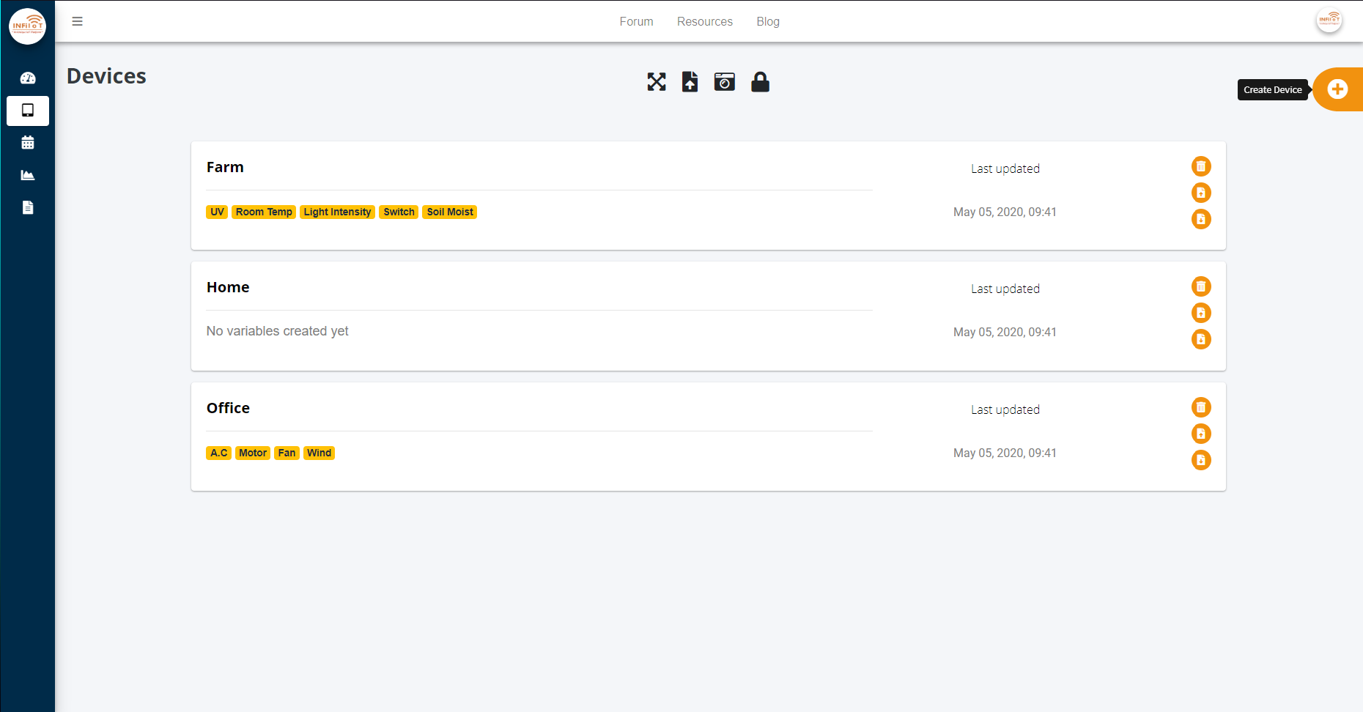

Devices

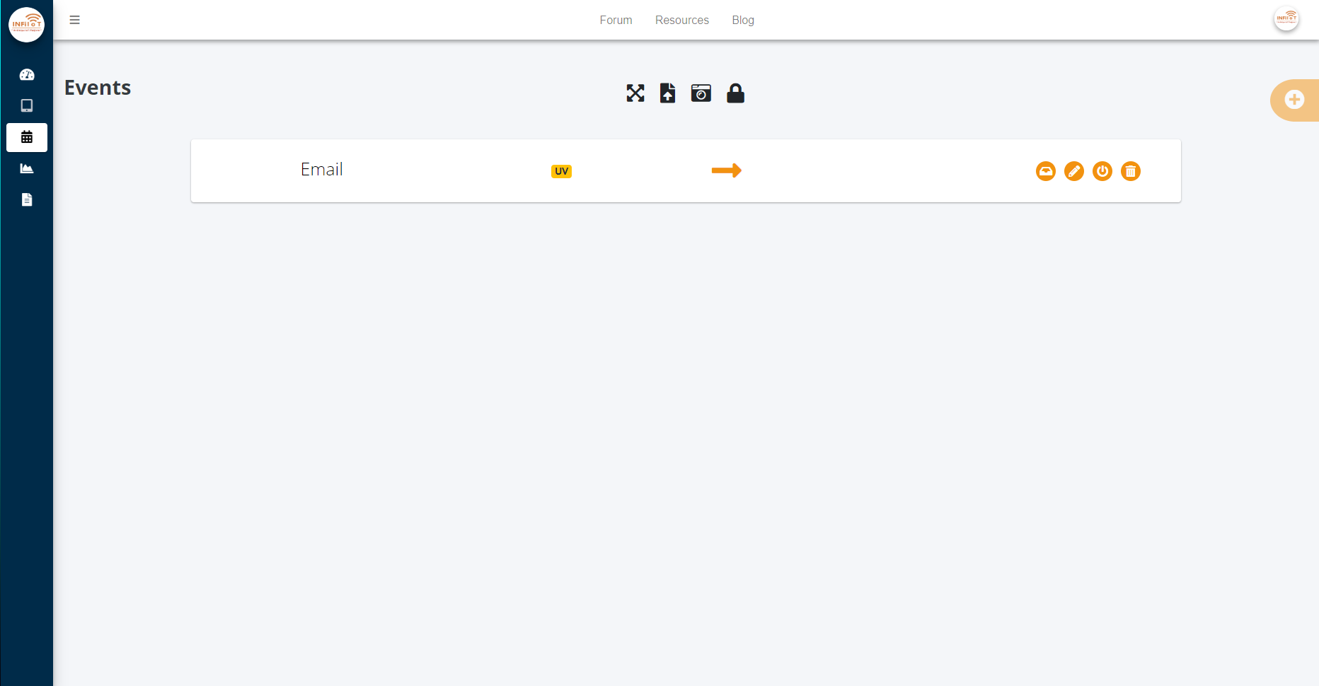

Events

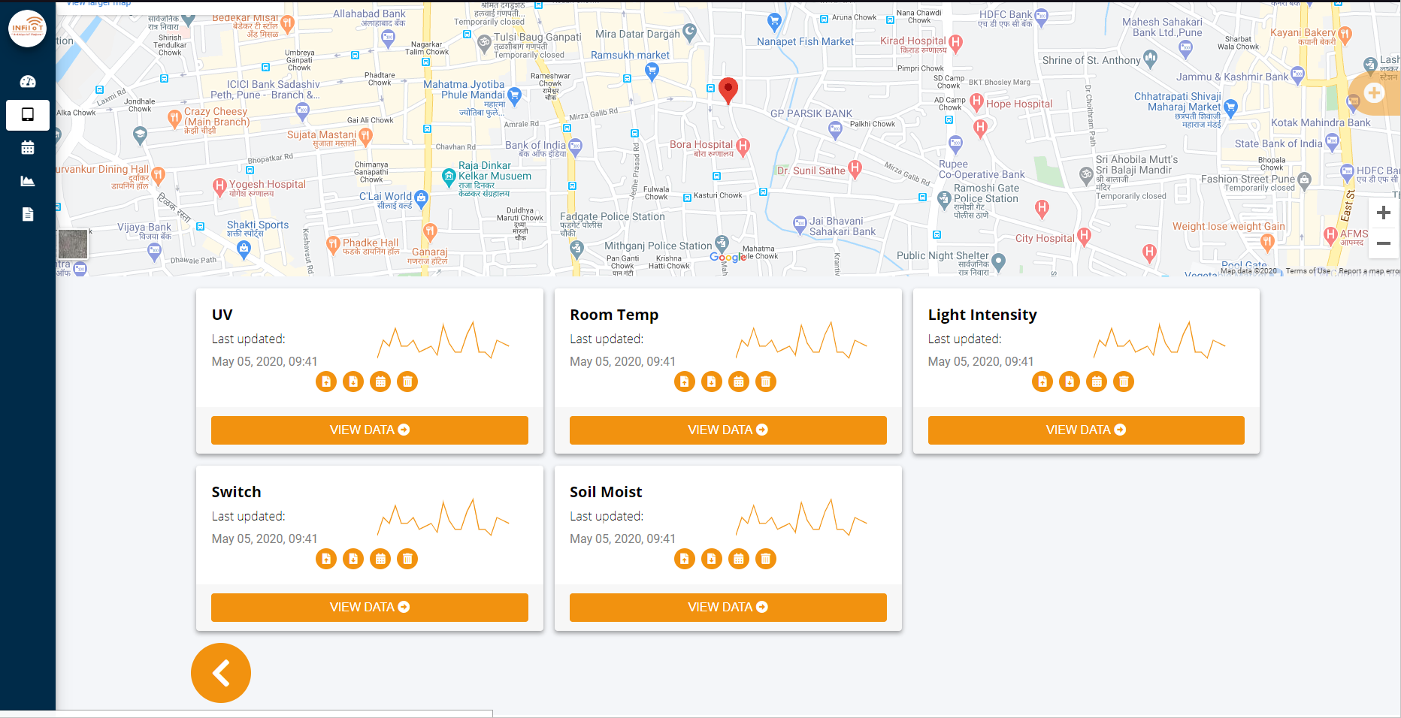

Variables

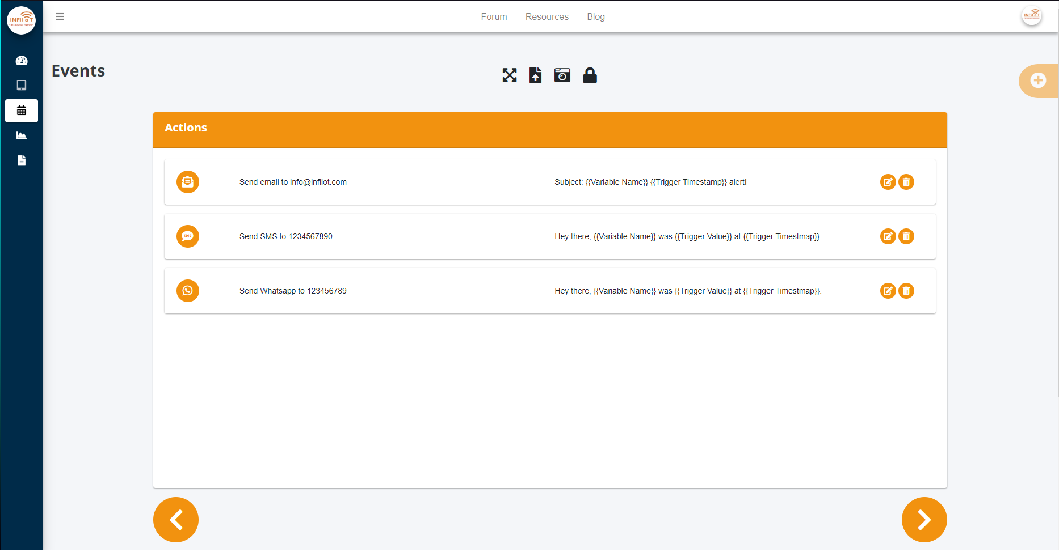

Actions

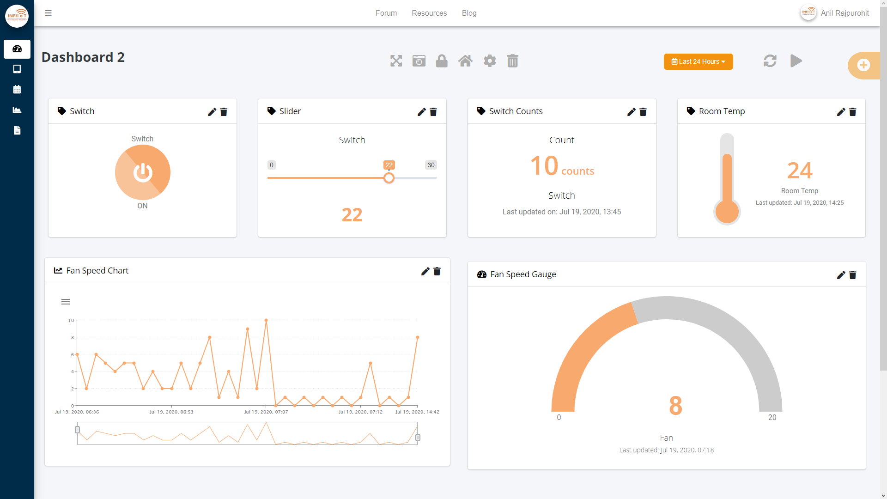

Dashboard



Devices



Events



Variables



Actions



Dashboard



Devices

prev

next

![InfiIoT](https://infiiot.com/static/images/logo-alt.png)

Services & Products
- Products & Design
- Industry Consultancy
- InfiIoT Platform
- Web Development Services
- View Products!

Resources
- Getting Started
- Documentation- Hardware
- Documentation- Software
- Community Forum
- Blog
- Help Centre
- FAQs

Company
- About
- Contact Us
- Features
- Pricing
- Privacy Policy
- Terms of Service

Copyright © 2026
infiiot.com

