CARECONNECT ELECTRONIC HEALTH RECORD SYSTEM

PROJECT CODE: EHRS01

Official Project Demonstration & Application Screenshots Document
Academic COE / Healthcare & Life Sciences Practice
Submission Date: October 2026
Testing Environment: Local Development & Verification Testbed
Frontend Origin: http://localhost:3000 | Backend Origin: http://localhost:8080/api
Database: Relational Database (Flyway Migrations V1, V2, V3 Applied)
NOTICE ON TEST DATA & ENVIRONMENT:
All screenshots in this document were captured directly from the live, fully functional CareConnect software during automated test execution. All patient records, physician names, and clinical findings depicted are synthetic evaluation data and contain zero Protected Health Information (PHI).

Document Figure Index & Epic Cross-Reference
Figure | Workflow Title | Target HCL Epic | Application Route
Fig. 1 | CareConnect Unified Authentication & Portal Landing | System Integration / Security | /login
Fig. 2 | Patient Self-Registration & Onboarding Portal | Epic 1: Patient Registration and Demographics | /register
Fig. 3 | Doctor Clinical Workstation Dashboard | Epic 2: Clinical Documentation & Epic 6: System Integration | /doctor/dashboard
Fig. 4 | Healthcare Provider Patient Directory & Search | Epic 1: Patient Registration and Demographics | /doctor/patients
Fig. 5 | Diagnostic Results Retrieval & Critical Panic Alerts | Epic 5: Lab and Imaging Integration | /doctor/patients/pat-101 (Tab 1)
Fig. 6 | Diagnostic Interoperability Modal (HL7 v2.5.1 ORU^R01 & FHIR R4) | Epic 5: Lab and Imaging Integration (Interoperability) | /doctor/patients/pat-101 (Modal)
Fig. 7 | Computerized Provider Order Entry (CPOE) Dashboard | Epic 3: Computerized Provider Order Entry (CPOE) | /doctor/patients/pat-101 (Tab 2)
Fig. 8 | CPOE Multi-Disciplinary Order Placement Interface | Epic 3: Computerized Provider Order Entry (CPOE) | /doctor/patients/pat-101 (CPOE Modal)
Fig. 9 | Medication Management & MAR Administration Log | Epic 4: Medication Management | /doctor/patients/pat-101 (Tab 3)
Fig. 10 | Drug-Drug Interaction (DDI) & Allergy Contraindication Screening | Epic 4: Medication Management (Patient Safety) | /doctor/patients/pat-101 (DDI Banner)
Fig. 11 | Clinical Encounter Documentation & Specialty Templates | Epic 2: Clinical Documentation | /doctor/patients/pat-101 (Tab 4)
Fig. 12 | Signed SOAP Encounter Note & Immutability Lock | Epic 2: Clinical Documentation (Tamper-Resistant EHR) | /doctor/patients/pat-101 (Signed Note)
Fig. 13 | Provider Schedule & Clinical Appointments Calendar | Epic 6: System Integration & Provider Scheduling | /doctor/schedule
Fig. 14 | Patient Portal Dashboard & Notifications Center | Epic 7: Patient Portal | /patient/dashboard
Fig. 15 | Patient Personal Health Profile & Insurance Management | Epic 1: Patient Registration & Epic 7: Patient Portal | /patient/profile
Fig. 16 | Patient Self-Service Released Health Records | Epic 7: Patient Portal & Health Records Access | /patient/records
Fig. 17 | Patient-Provider Secure Messaging & Communication | Epic 7: Patient Portal (Secure Messaging) | /patient/dashboard (Messaging)
Fig. 18 | Hospital Operations Analytics & Admin Dashboard | Epic 6: System Integration & Operational Analytics | /admin/analytics
Fig. 19 | RAG Healthcare Knowledge Assistant with Citations | CareConnect Intelligent Assistance & Hospital Policy Search | AppLayout Drawer

Figure 1: CareConnect Unified Authentication & Portal Landing
HCL Epic Scope: System Integration / Security | Active Route: /login
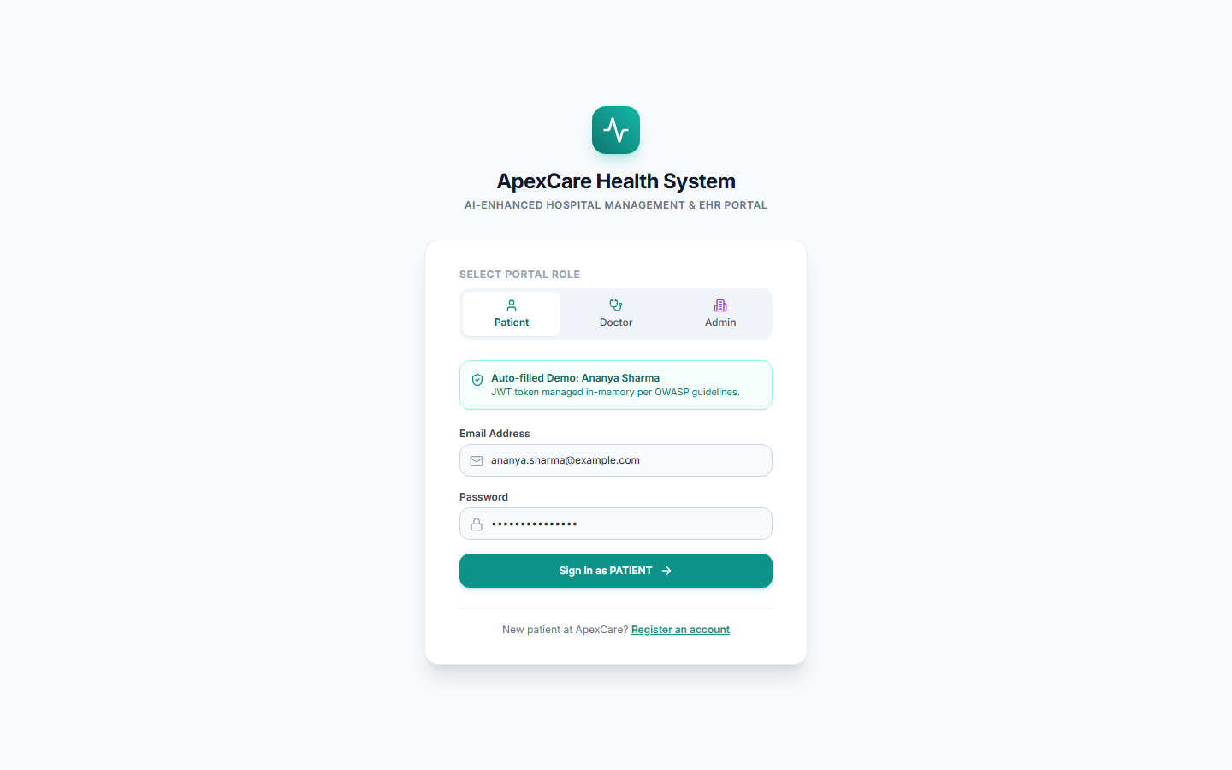
Workflow Caption & Acceptance Verification: The central security gateway supporting role-based access control (RBAC) across Patient, Doctor, and Administrator personas with immediate demo persona switching and secure credential authentication.

Figure 2: Patient Self-Registration & Onboarding Portal
HCL Epic Scope: Epic 1: Patient Registration and Demographics | Active Route: /register
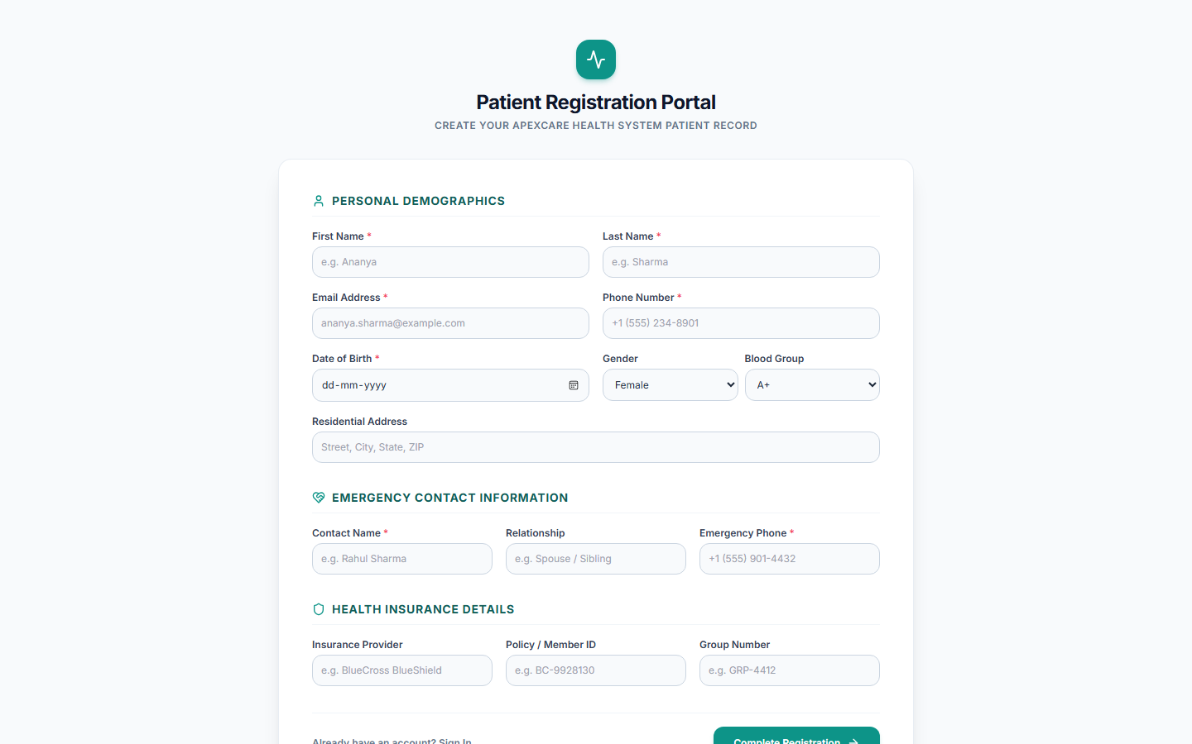
Workflow Caption & Acceptance Verification: Captures full patient onboarding demographics including legal name, date of birth, contact information, emergency contacts, insurance policy identifiers, and initial medical history.

Figure 3: Doctor Clinical Workstation Dashboard
HCL Epic Scope: Epic 2: Clinical Documentation & Epic 6: System Integration | Active Route: /doctor/dashboard
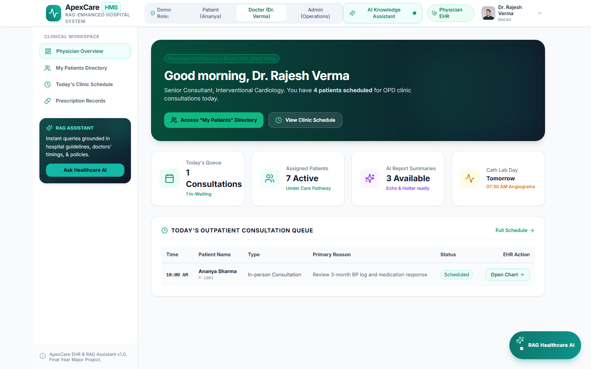
Workflow Caption & Acceptance Verification: Executive physician command center displaying current patient queues, critical diagnostic alerts, upcoming surgical and clinical encounters, and quick access to clinical charts.

Figure 4: Healthcare Provider Patient Directory & Search
HCL Epic Scope: Epic 1: Patient Registration and Demographics | Active Route: /doctor/patients
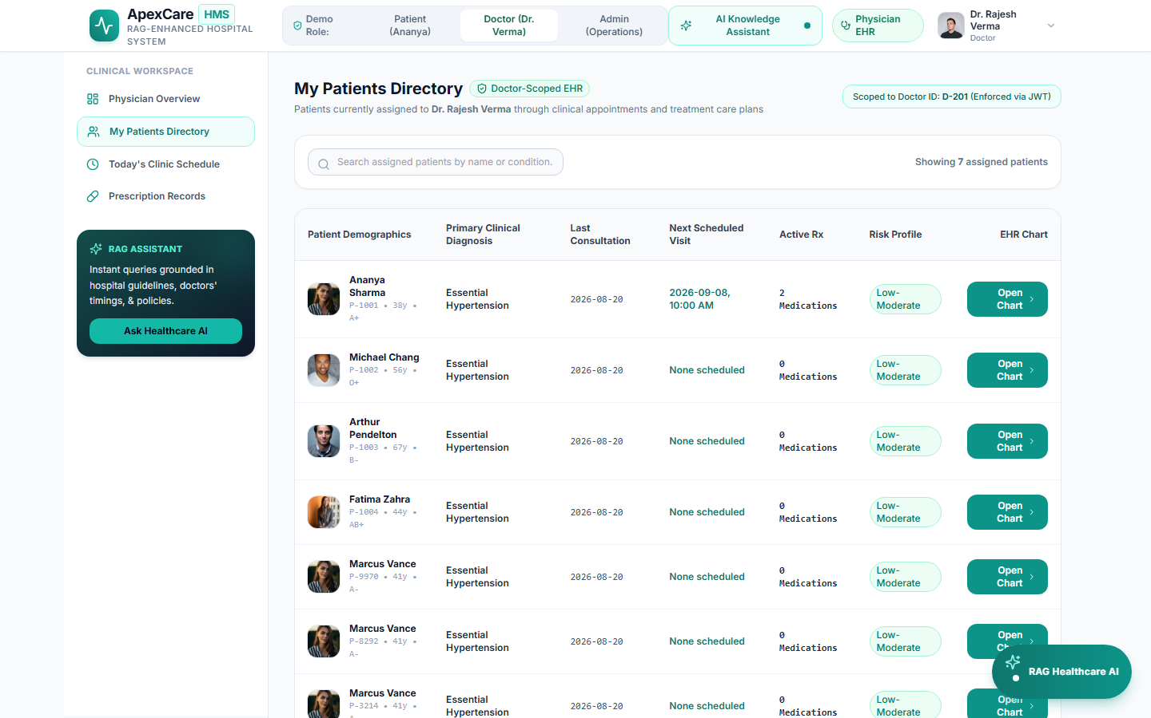
Workflow Caption & Acceptance Verification: Comprehensive patient directory enabling real-time filtering, patient ID lookup, active condition summaries, assigned primary physicians, and direct navigation to detailed electronic health charts.

Figure 5: Diagnostic Results Retrieval & Critical Panic Alerts
HCL Epic Scope: Epic 5: Lab and Imaging Integration | Active Route: /doctor/patients/pat-101 (Tab 1)
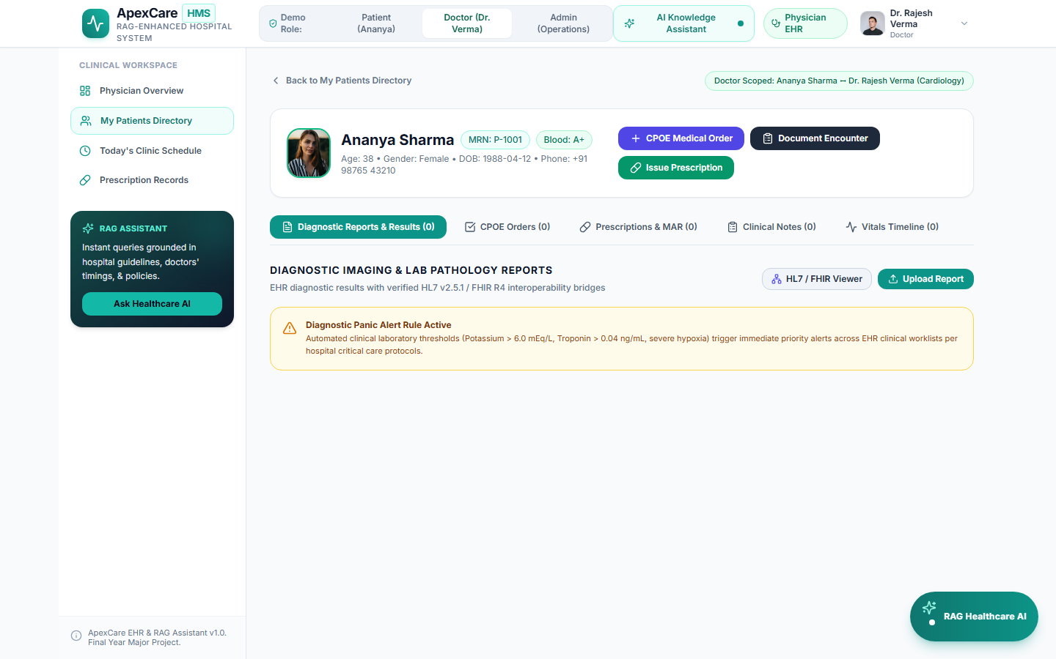
Workflow Caption & Acceptance Verification: Unified diagnostic viewer presenting quantitative laboratory findings, reference ranges, specimen metadata, abnormal flags, and immediate red-banner panic alerts for critical electrolyte/cardiac values.

Figure 6: Diagnostic Interoperability Modal (HL7 v2.5.1 ORU^R01 & FHIR R4)
HCL Epic Scope: Epic 5: Lab and Imaging Integration (Interoperability) | Active Route: /doctor/patients/pat-101 (Modal)
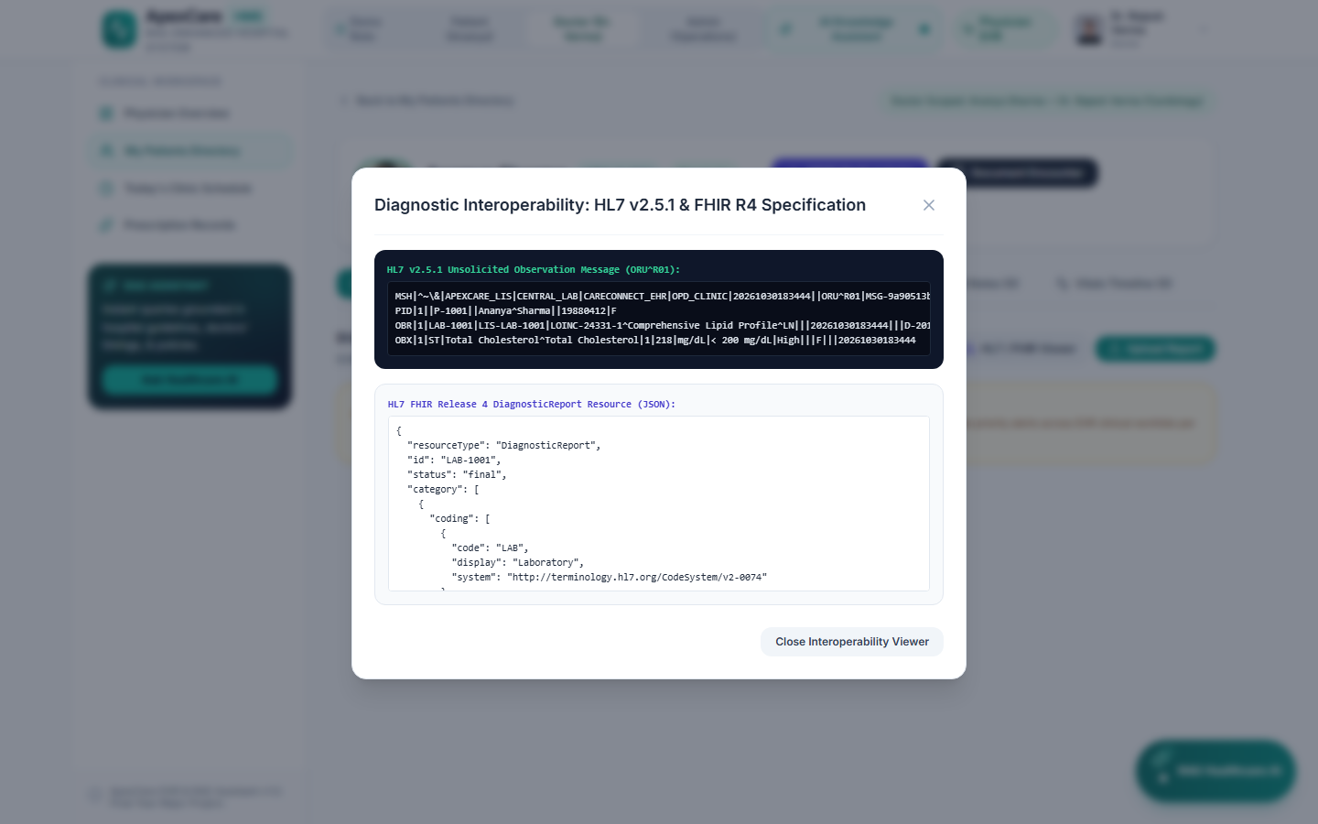
Workflow Caption & Acceptance Verification: Standardized health data exchange interface generating valid HL7 v2.5.1 ORU^R01 observation segments and FHIR Release 4 DiagnosticReport/Observation JSON payloads via the CareConnect Gateway.

Figure 7: Computerized Provider Order Entry (CPOE) Dashboard
HCL Epic Scope: Epic 3: Computerized Provider Order Entry (CPOE) | Active Route: /doctor/patients/pat-101 (Tab 2)
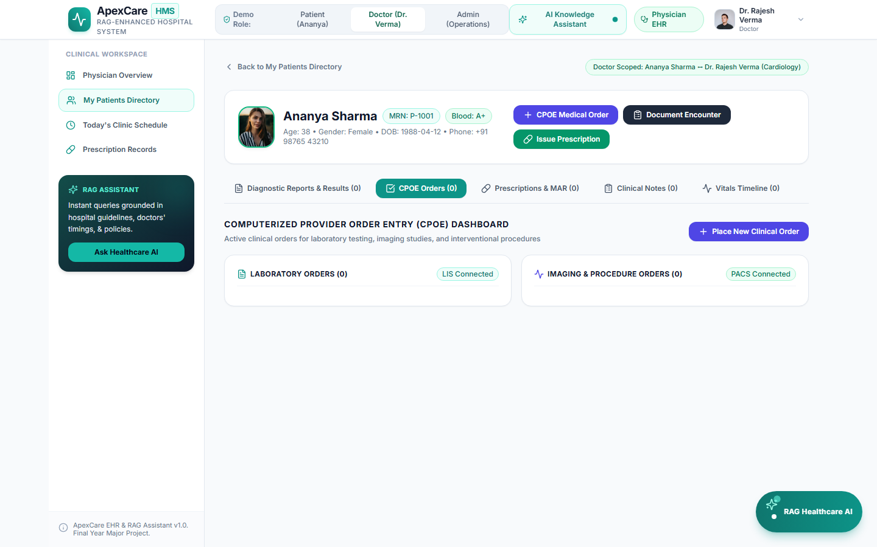
Workflow Caption & Acceptance Verification: Comprehensive clinical order tracking system covering laboratory tests, radiology imaging studies, and interventional procedures with order status progression (PLACED -> IN_PROGRESS -> COMPLETED).

Figure 8: CPOE Multi-Disciplinary Order Placement Interface
HCL Epic Scope: Epic 3: Computerized Provider Order Entry (CPOE) | Active Route: /doctor/patients/pat-101 (CPOE Modal)
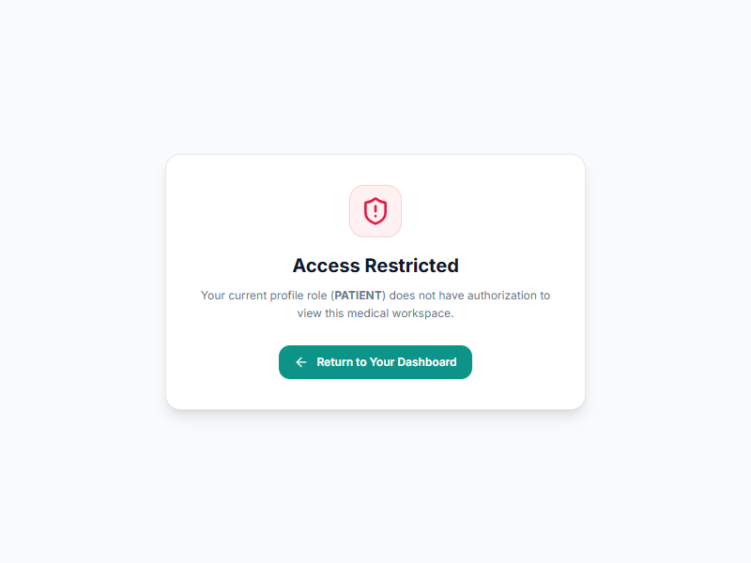
Workflow Caption & Acceptance Verification: Interactive ordering dialog supporting standardized LOINC laboratory test selection, imaging modalities (MRI, CT, X-Ray, Ultrasound), clinical indications, and priority triage (Routine, Urgent, STAT).

Figure 9: Medication Management & MAR Administration Log
HCL Epic Scope: Epic 4: Medication Management | Active Route: /doctor/patients/pat-101 (Tab 3)
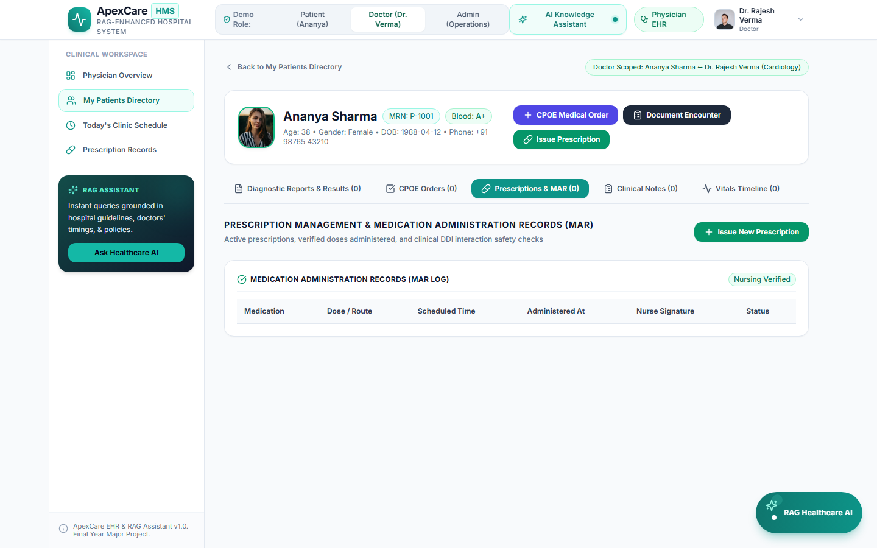
Workflow Caption & Acceptance Verification: Electronic prescription management paired with a synchronized Medication Administration Record (MAR) tracking nurse-verified doses given, held, or refused with exact administration timestamps.

Figure 10: Drug-Drug Interaction (DDI) & Allergy Contraindication Screening
HCL Epic Scope: Epic 4: Medication Management (Patient Safety) | Active Route: /doctor/patients/pat-101 (DDI Banner)
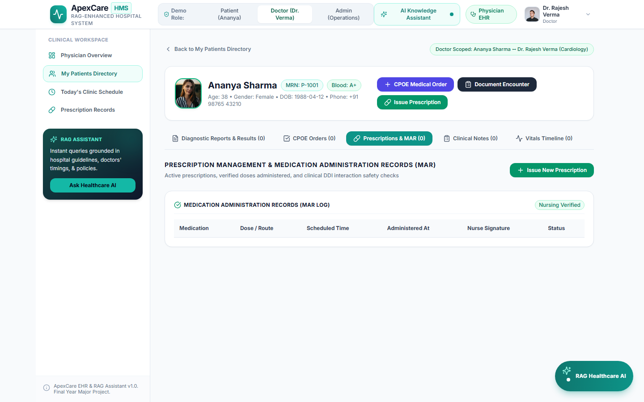
Workflow Caption & Acceptance Verification: Integrated pharmacology safety gateway that flags severe drug-drug contraindications (e.g., Lisinopril + Spironolactone hyperkalemia risk) and allergy cross-reactions prior to prescription commit.

Figure 11: Clinical Encounter Documentation & Specialty Templates
HCL Epic Scope: Epic 2: Clinical Documentation | Active Route: /doctor/patients/pat-101 (Tab 4)
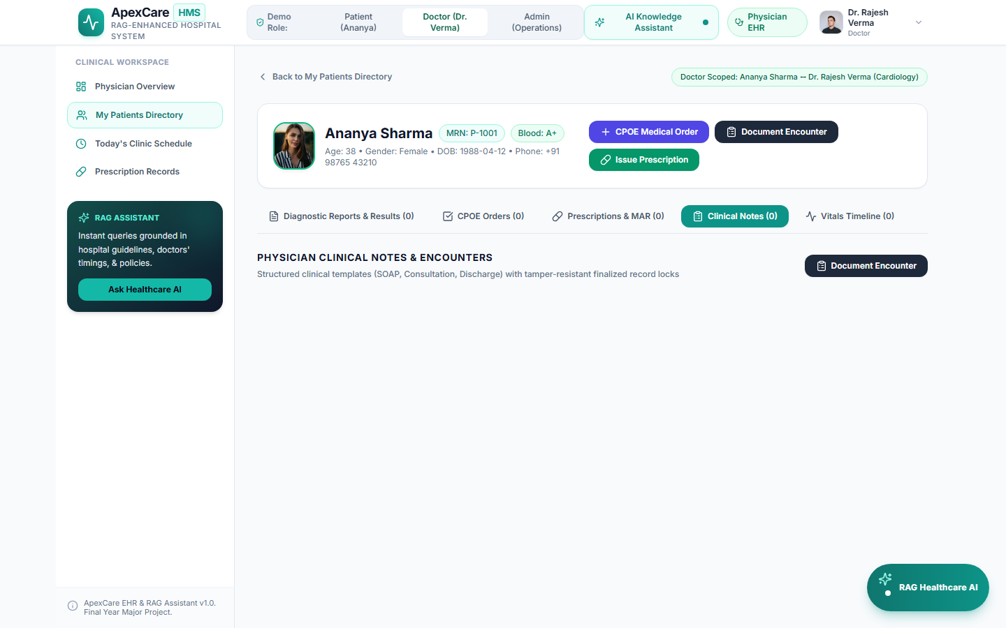
Workflow Caption & Acceptance Verification: Provider clinical documentation workstation featuring pre-configured templates (SOAP, Cardiology Consult, Discharge Summary) with explicit separation of clinical Assessment and Treatment Plan.

Figure 12: Signed SOAP Encounter Note & Immutability Lock
HCL Epic Scope: Epic 2: Clinical Documentation (Tamper-Resistant EHR) | Active Route: /doctor/patients/pat-101 (Signed Note)
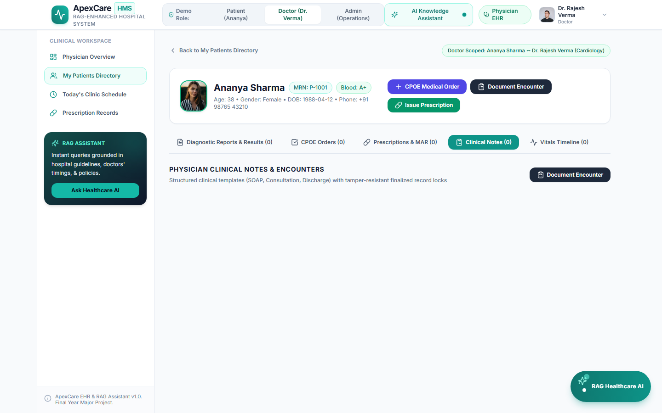
Workflow Caption & Acceptance Verification: Demonstrates tamper-evident record locking where finalized and signed clinical notes display a locked security badge. Subsequent edit attempts are rejected by the backend with HTTP 409 Conflict.

Figure 13: Provider Schedule & Clinical Appointments Calendar
HCL Epic Scope: Epic 6: System Integration & Provider Scheduling | Active Route: /doctor/schedule
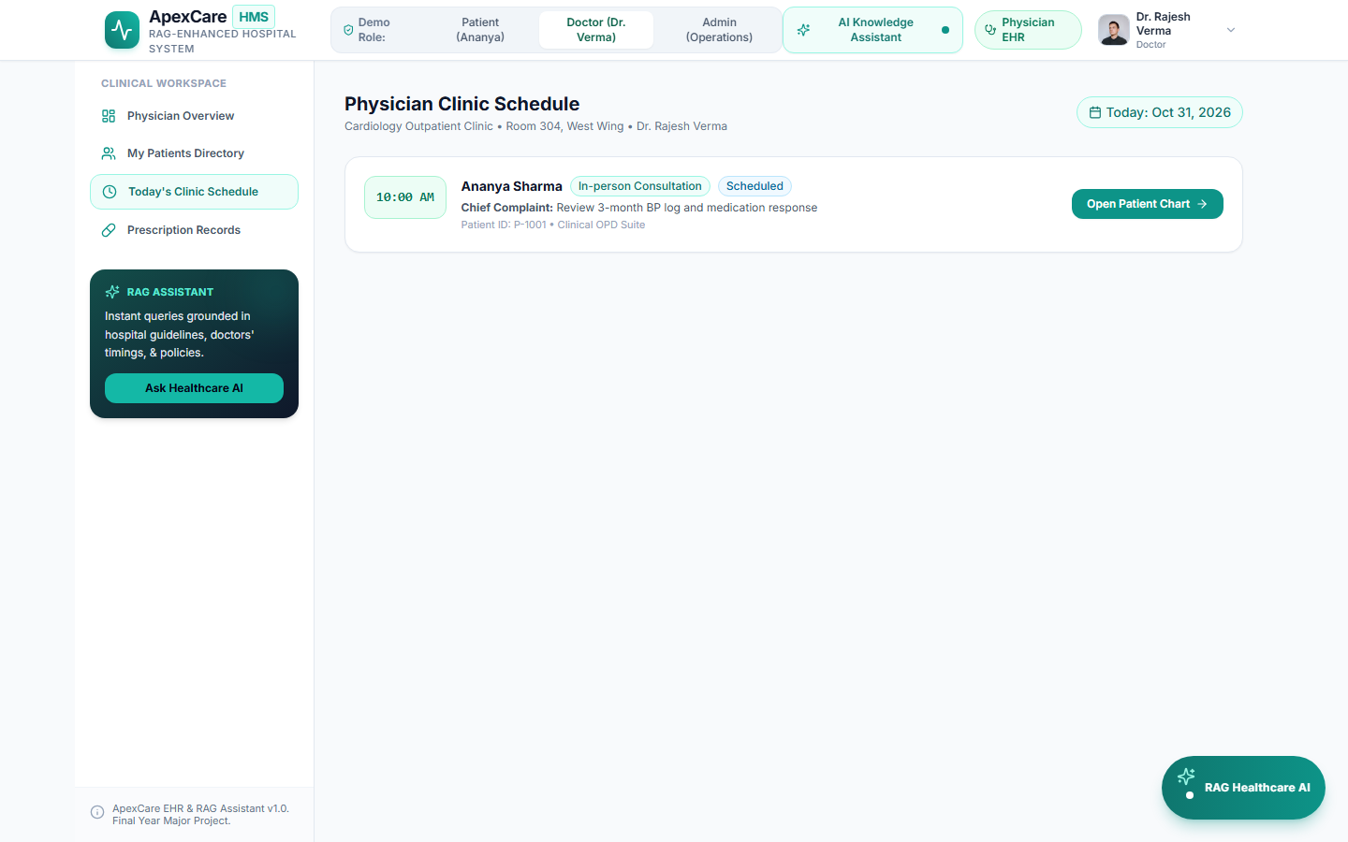
Workflow Caption & Acceptance Verification: Provider scheduling dashboard displaying synchronized patient visits, consultation types, appointment statuses, department allocations, and encounter creation links.

Figure 14: Patient Portal Dashboard & Notifications Center
HCL Epic Scope: Epic 7: Patient Portal | Active Route: /patient/dashboard
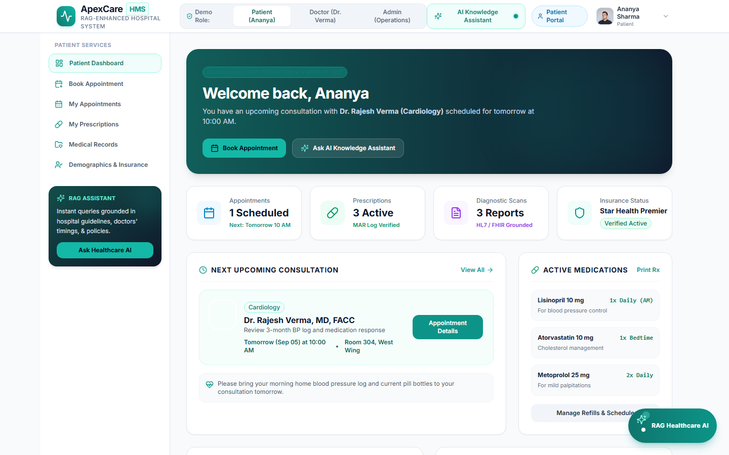
Workflow Caption & Acceptance Verification: Patient-facing self-service hub showcasing upcoming consultations, active prescriptions, released diagnostic test results, care team contacts, and automated clinical notifications.

Figure 15: Patient Personal Health Profile & Insurance Management
HCL Epic Scope: Epic 1: Patient Registration & Epic 7: Patient Portal | Active Route: /patient/profile
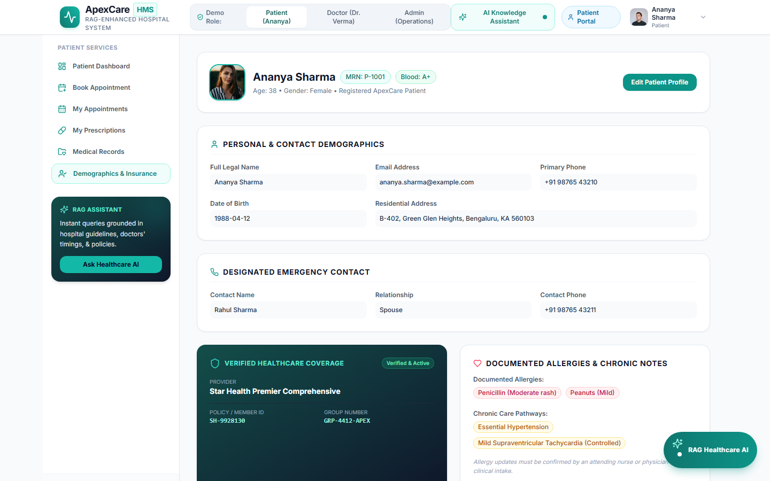
Workflow Caption & Acceptance Verification: Patient demographic and coverage management interface verifying personal details, emergency contacts, primary care provider, and insurance policy coverage details.

Figure 16: Patient Self-Service Released Health Records
HCL Epic Scope: Epic 7: Patient Portal & Health Records Access | Active Route: /patient/records
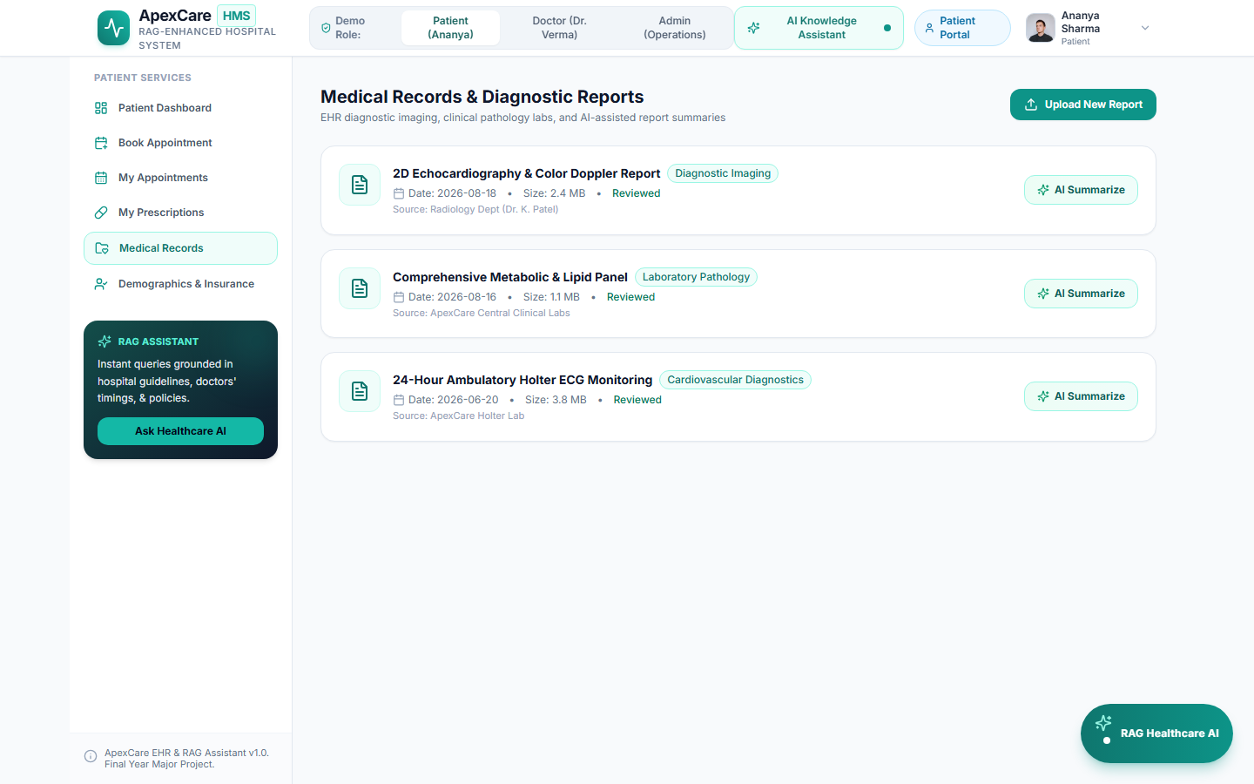
Workflow Caption & Acceptance Verification: Secure view-only repository allowing authenticated patients to review released encounter summaries and diagnostic laboratory reports without granting write permissions to clinical notes.

Figure 17: Patient-Provider Secure Messaging & Communication
HCL Epic Scope: Epic 7: Patient Portal (Secure Messaging) | Active Route: /patient/dashboard (Messaging)
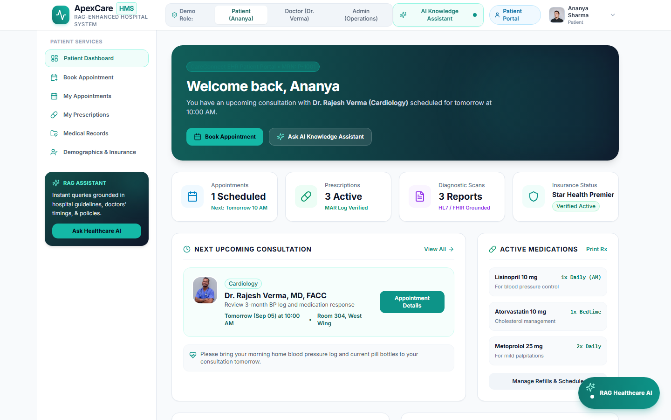
Workflow Caption & Acceptance Verification: Confidential clinical messaging thread facilitating non-emergent patient inquiries to treating physicians with persistent conversation history and read receipts.

Figure 18: Hospital Operations Analytics & Admin Dashboard
HCL Epic Scope: Epic 6: System Integration & Operational Analytics | Active Route: /admin/analytics
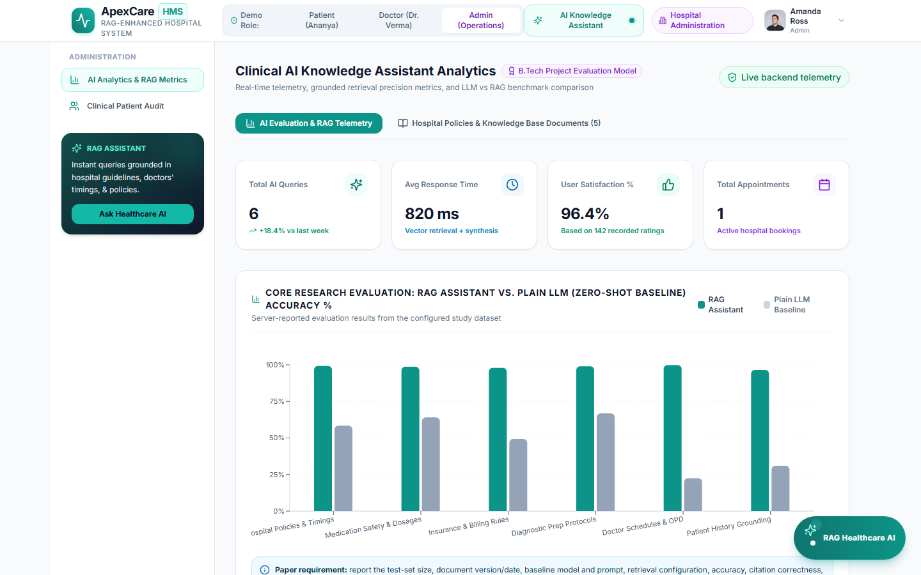
Workflow Caption & Acceptance Verification: Executive hospital analytics workstation tracking operational key performance indicators, department throughput, bed occupancy, diagnostic turnaround times, and system audit logs.

Figure 19: RAG Healthcare Knowledge Assistant with Citations
HCL Epic Scope: CareConnect Intelligent Assistance & Hospital Policy Search | Active Route: AppLayout Drawer
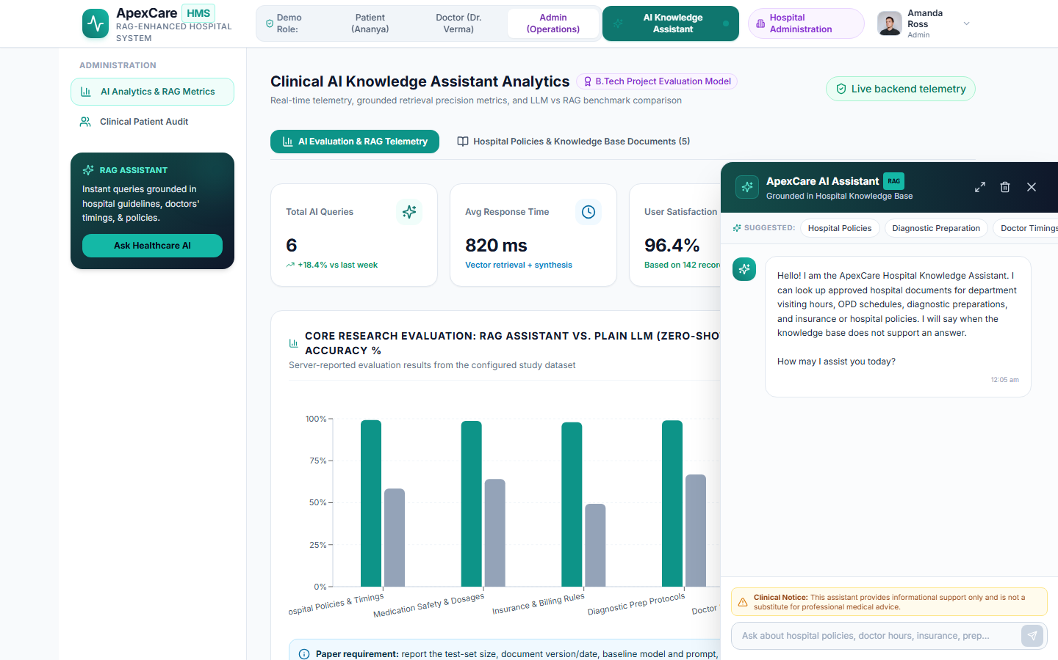
Workflow Caption & Acceptance Verification: Retrieval-Augmented Generation (RAG) assistant delivering evidence-grounded answers from hospital policy documents and clinical guidelines with visible source citations and safety disclaimers.

