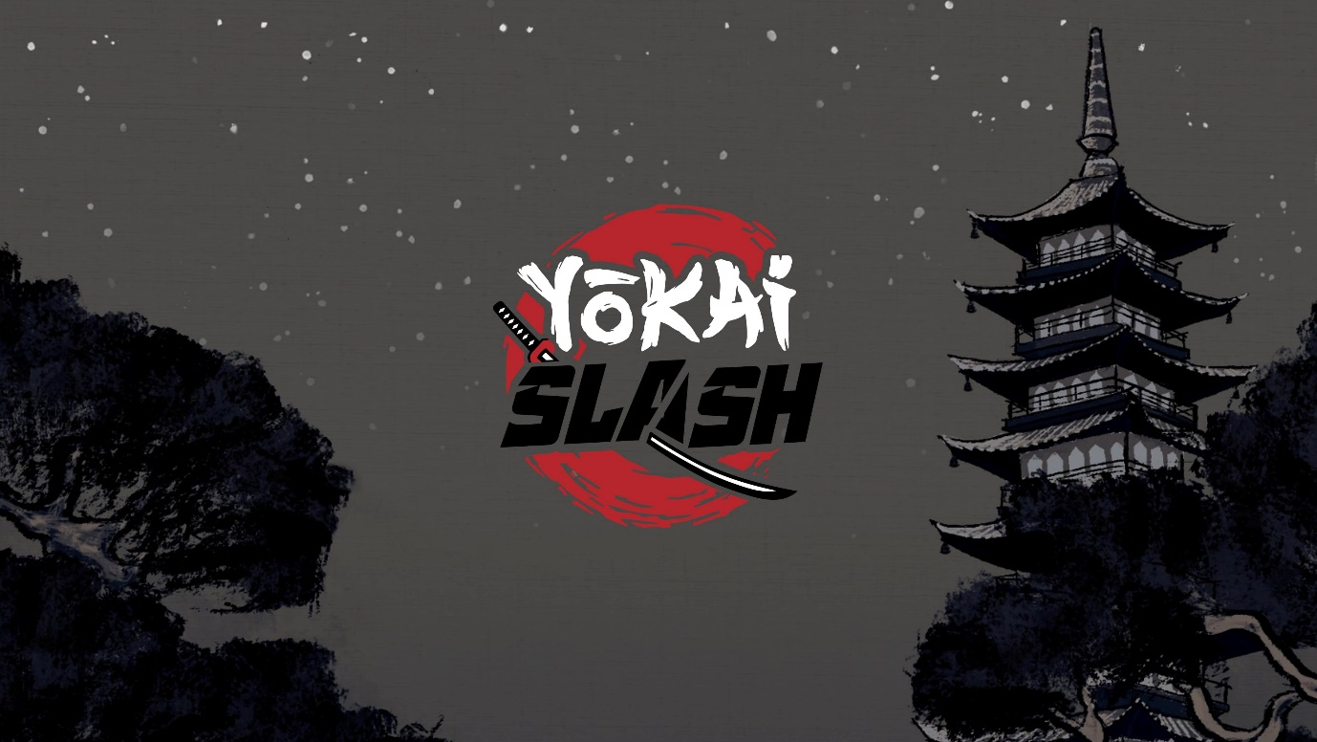

Yōkai Slash is a skill-based combat game, which relies on touch input and the players memory and timing. Set in fantasy version of Edo Japan, the player has to fight a number of different monsters in rapid succession to cleanse several locations from the yōkai.

Features:

* A simple but challenging combat mechanic which requires good memory and reflexes
* Multiple different enemy types and levels
* Detailed 2D animations
* A highly responsive feedback system which creates an intense game feel
* Traditional instrumental soundtrack and SFX

|  |  |
| --- | --- |
| Developer: | Crunchy Bits (formerly Owkammz Razor) |
| Platform: | Android for Mobile |
| Launch Date: | August 17th, 2023 |
| Genre: | Arcade |
| Players: | Single player |