Top Bar

Header

Hero section with video and CTA

Apex logos

**Heading: Trusted by more than 1000 developers**

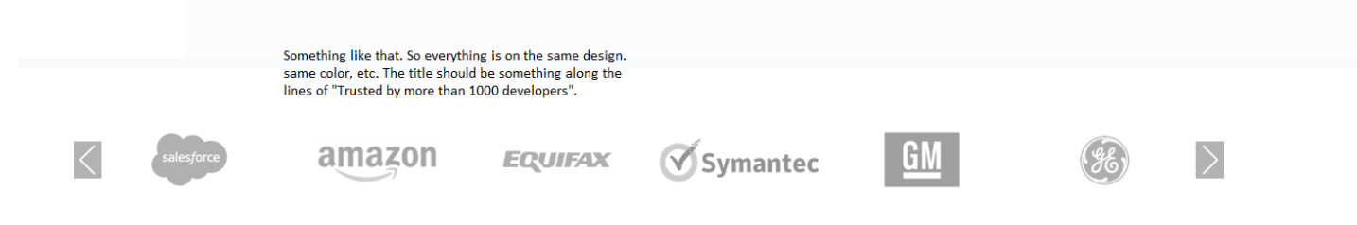

**New Section**



Heading: **Why CodeScan**

1 Define and Control Code Standards

2 Enforce Standards for new Development

3 Gain Visibility on code review

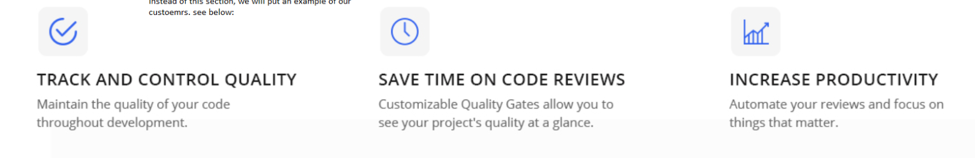

Feature comparison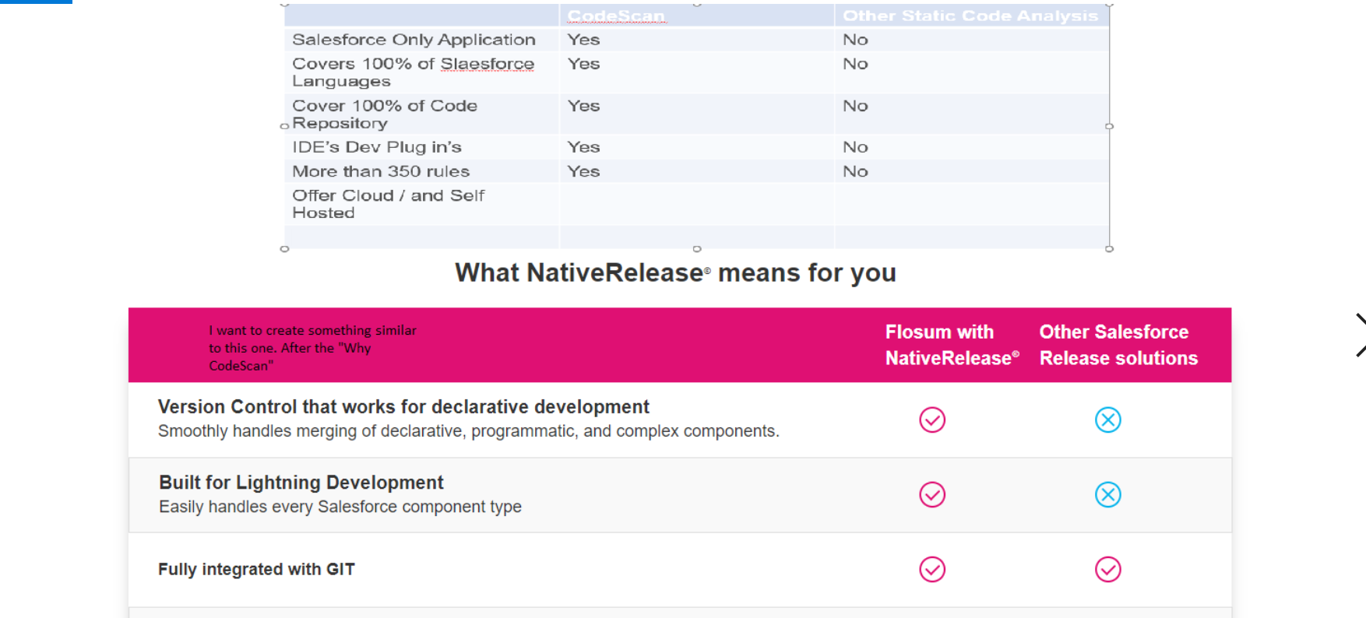

ROI

1 Graph

2 Usage How much hour

3 Improve code Scab

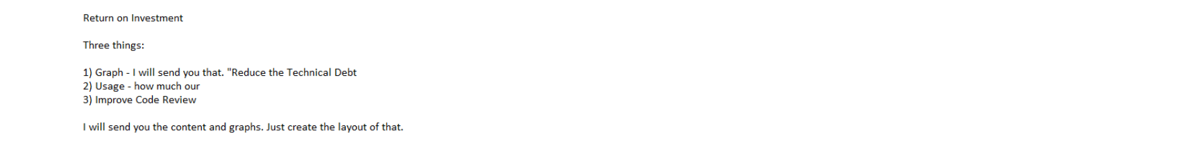

Products