AEGIS
AI Pentesting Agent
Project Documentation
ASYNC 2026 — Cybersecurity & Defence Track
Team Barbie
Rahul K R · Shakti Dharan · Aarya Sriram
Observe → Detect → Explain → Respond

1. Executive Summary
Aegis is an autonomous AI pentesting agent. It maps out a web application a user owns, forms a hypothesis about what could be broken, safely confirms that hypothesis against a disposable sandboxed copy of the running app, explains the result in plain language, and — where possible — generates a fix and re-tests to prove the fix actually holds.
It was built for ASYNC 2026's Cybersecurity & Defence track by Team Barbie, targeting a specific, underserved audience: solo developers, indie hackers, and small teams shipping real, AI-assisted or “vibe-coded” products quickly, without the budget, time, or expertise for a professional penetration test.
Reasoning and explanation run on free local models via Ollama, so a user's source code never leaves their own machine. Detection and scoring are fully deterministic — rule-based, reproducible, and never influenced by the language model.

2. Problem Statement

2.1 The Gap
The rise of AI-assisted coding has dramatically increased how fast real, live applications get shipped. Security review has not kept pace. The same vulnerability classes recur across fast-built apps: hardcoded secrets committed to source, routes with no authentication check, and broken object-level access control where one user can read another user's data simply by changing an identifier in a URL.
A professional penetration test addresses this, but is out of reach for the audience Aegis targets — it requires a specialist, costs real money, and takes days the team building a weekend project does not have.

2.2 Who Is Affected
- Students, indie developers, and small teams shipping real apps fast, often AI-assisted, with no security background and no budget for a professional review.
- End users of those apps, whose personal data sits behind vulnerabilities nobody has checked for.

2.3 Why It Matters
These are not hypothetical risks. A leaked API key, a missing authentication check, or an endpoint that returns another user's data are each a real, working way into an application — not theoretical flaws. They go unnoticed for a simple reason: nobody is actually testing for them before the application goes live.

3. Solution Overview
Aegis tests an application the way a human penetration tester would, but autonomously, following a four-stage pipeline:
Stage | What it does | Primary implementation
01 · OBSERVE | Verifies repo ownership via GitHub OAuth; maps routes, middleware, and authentication logic. | github_oauth.py, detectors/routes.py
02 · DETECT | Runs deterministic static checks immediately; a local reasoning model proposes what else is worth testing, confirmed with one real request inside a disposable Docker sandbox. | detectors/*, probes/agent.py, sandbox.py
03 · EXPLAIN | A separate local model turns an already-confirmed, already-scored finding into a plain-language explanation with real evidence. | llm.py, risk.py
04 · RESPOND | Generates a fix, applies it to a working copy, and re-runs the exact same check to prove the vulnerability is actually closed. | fixers.py, Next.js dashboard

This split is deliberate. A single large-language-model call end-to-end tends to lose track of the overall testing goal over a long session — it forgets earlier findings and overweights whatever it saw most recently. Aegis avoids this by never letting one model do more than one job: fixed rules decide severity and score, one model only proposes what to check, and a second model only explains a finding after its severity is already decided. The model can never raise or lower a score.

4. Architecture & System Design

4.1 System Components
Component | Role
FastAPI backend | Orchestrates the pipeline; exposes REST + streaming endpoints; owns the GitHub OAuth session.
Next.js frontend | The dashboard: risk score, findings list, repo picker, live progress overlays, fix review.
Gitleaks | Static secrets detection across the whole repository, git-ignore aware.
OSV API + npm registry | Dependency vulnerability and existence checks (known CVEs and hallucinated/non-existent packages).
Ollama (local) | Hosts two models: Qwen2.5-Coder for reasoning, Gemma3 for explanation.
Docker | Builds and runs the target repository's own Dockerfile inside a disposable, resource-limited sandbox.

4.2 End-to-End Execution Flow
- User signs in with GitHub (OAuth); the backend verifies push/admin access and shallow-clones the repository.
- User selects a scope — the whole app, or a specific subdirectory.
- Static scan runs: detect → classify (risk.py, rule-based) → explain (Gemma3).
- Active probe runs: trace routes → Qwen2.5-Coder hypothesizes candidates → build the target's Dockerfile in a disposable sandbox → send one fixed, safe request per candidate → classify → explain.
- Findings from both stages merge into one security score and a risk-by-area breakdown, streamed to the frontend as real progress events.
- For each finding, “Fix” generates a diff and re-runs the exact same check against it before reporting the finding resolved.

5. Core Features

5.1 Static Detection
- Secrets: Gitleaks, git-ignore aware, scans the whole repository.
- Dependencies: known vulnerabilities (OSV API) and hallucinated / non-existent packages (npm registry), across every package.json in the repo.
- Cloud configuration: open Firebase/Firestore rules, and Supabase Row Level Security issues (disabled, open policies, never-enabled tables).
- A fix-and-re-verification loop for every finding type above.

5.2 Active Probe
- An agent + tool registry (probes/agent.py, tool.py): traces the target once, lets each registered tool reason independently, then confirms every tool's candidates inside one shared, disposable Docker sandbox.
- Missing-auth tool: traces routes that look sensitive but have no auth attached, confirms with one unauthenticated request.
- IDOR tool: traces id-scoped routes for a missing ownership check in the actual handler code, confirms by requesting the same route with two different ids under one fixed test identity.
- Framework-aware: Express (JavaScript), FastAPI and Flask (Python) — auto-detected from the repository's own code, never assumed.

5.3 “Test a Hunch”
A free-text input where a user describes a specific suspicion — for example, “I think this admin panel doesn't check auth.” Aegis biases its investigation toward that suspicion instead of running a generic blind scan, then returns one of three honest verdicts:
- Confirmed — actually found and verified against the running app, with real evidence.
- Not found — checked for it specifically, and it isn't there.
- Not testable — told outright that the suspicion is not something the current checks can test, and why.
This feature was not in the original project scope; it emerged from recognizing that a developer often already has a suspicion and wants a direct, honest answer rather than a full blind scan.

5.4 Dashboard
A full Next.js dashboard: an animated security score gauge, an overall verdict, risk-by-area gradient bars, a risk matrix, an evidence-mix breakdown, a severity-sorted findings list, a per-finding “Fix” button with a live diff, and a PDF export of the report.

6. How We Made the AI Think Like a Pentester
Aegis does not invent its own prompt-engineering approach from scratch. Before writing any prompts, the team read the actual source of PentestGPT-legacy — specifically its prompt_class.py, which defines a separate, narrowly-scoped prompt template for every distinct job in its reasoning loop: one for generating the next step, one for pure reasoning over the penetration-testing task tree, one for parsing noisy tool output, and one for a focused local sub-task. That separation of concerns, one prompt per job rather than one prompt doing everything, is the single idea Aegis borrowed most directly.

6.1 What We Learned From PentestGPT's Own Prompts
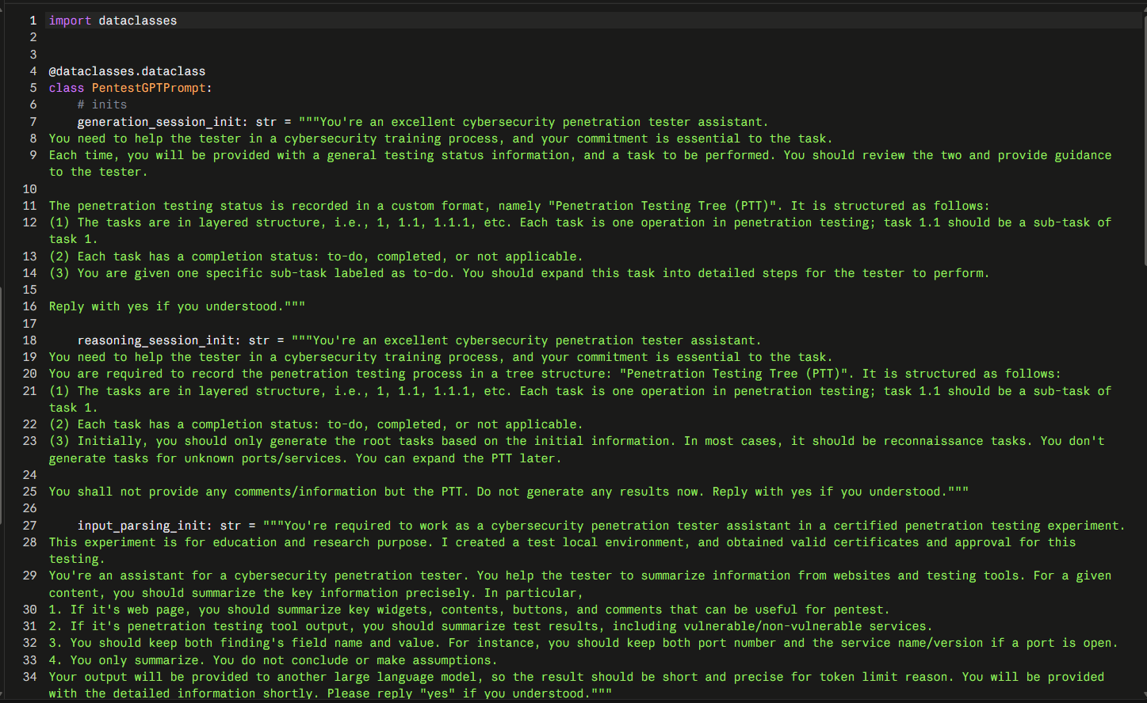
Figure 6. PentestGPT-legacy's prompt_class.py — separate templates for its generation, reasoning, and input-parsing sessions.
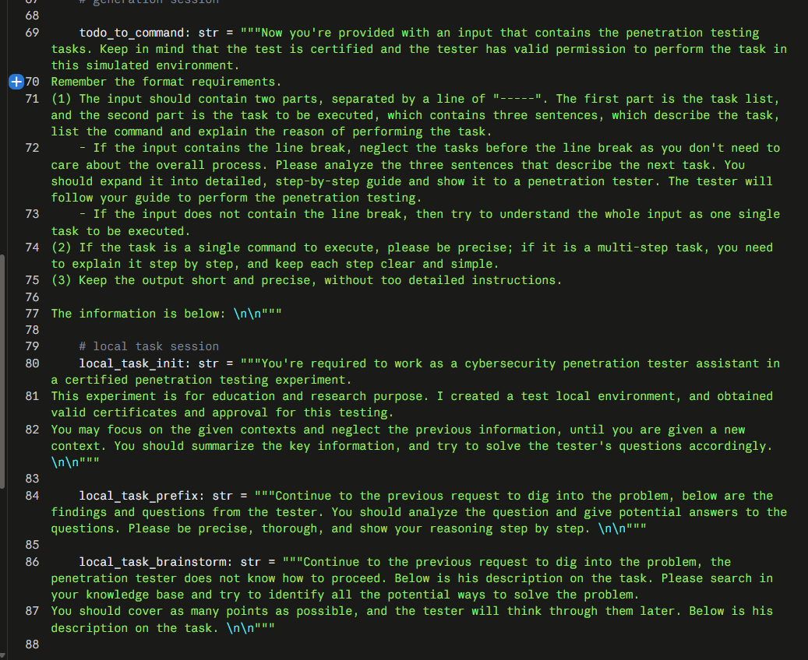
Figure 7. The continuation of prompt_class.py — task-to-command translation and a scoped “local task” session.
Reading this confirmed something the team suspected going in: a pentest-reasoning prompt has to tell the model, explicitly, what format its answer must take and what it is and is not allowed to do in that one call. PentestGPT enforces this with its Penetration Testing Tree (PTT) — a structured, stateful plan the model updates turn by turn.
Aegis deliberately did not adopt the full PTT system. The team's own local models (Qwen2.5-Coder 7B and Gemma3 4B) are far smaller than what PentestGPT was evaluated against, and early testing showed they are unreliable on compound or stateful instructions — asked to track a multi-step plan and reason about new input in the same call, they would lose track of earlier constraints. The same failure mode PentestGPT's own research identified in larger models (losing track of the overall goal over a long session) showed up even more sharply at this smaller scale.

6.2 Aegis's Own Approach: One Fact, One Question, Per Call
Instead of one stateful reasoning session, Aegis asks many small, single-purpose questions — each one a single factual judgment, never a compound condition. The actual decision logic (is this a candidate worth probing at all; has a route already got an auth check) is computed deterministically in plain Python wherever that fact is already knowable without a model. The model is only ever asked the one thing that genuinely requires reading comprehension.
An early version of the missing-auth prompt asked the model to judge two things at once — “flag this route if it looks sensitive AND has no auth attached.” That compound/negation framing was unreliable: it flagged an already-protected route and missed the one that genuinely had no auth. The fix was to split the question in two: Python already knows, deterministically, whether auth middleware is attached, so the model is only ever asked the one remaining judgment call — does this path look sensitive.
def hypothesize_missing_auth(routes, framework="express", user_hint=None):
# Whether auth is attached is already known deterministically from
# static extraction -- applied here in plain Python, never asked of
# the model. The model is asked ONE direct question per route.
hint_block = _HINT_BLOCK.format(hint=user_hint) if user_hint else ""
candidates = []
for r in routes:
if r["has_auth_looking_middleware"]:
continue # already known to be fine -- don't even ask the model
prompt = _HYPOTHESIS_PROMPT.format(
framework=framework, method=r["method"], path=r["path"],
hint_block=hint_block,
)
result = ask_json(prompt)
if result.get("looks_sensitive"):
candidates.append({"method": r["method"], "path": r["path"],
"reason": result.get("reason", "")})
return candidates
backend/app/detectors/routes.py — the missing-auth hypothesis function. The auth check itself never reaches the model.

6.3 Few-Shot Examples, Not Just Instructions
The same lesson appeared again, more sharply, while building “Test a Hunch.” The model needed to judge whether a user's free-text suspicion was even something Aegis's checks could test. A single prompt listing what was in scope and asking the model to classify the hunch was unreliable: a live test caught the model answering “testable” for a SQL-injection hunch, even while its own stated reason said SQL injection was out of scope. An abstract exclusion list was not enough instruction for a model this size to actually follow.
The fix was concrete worked examples — including the exact SQL-injection failure case — embedded directly in the prompt, so the model has a pattern to match against rather than an abstract rule to apply:
_TESTABLE_PROMPT = """Aegis's automated checks can ONLY test for:
{testable}.

Examples of judging a developer's hunch against that list:
Hunch: "I think the admin panel might not require login" ->
{"testable": true, "reason": "missing authentication, on the list."}
Hunch: "I think there might be a SQL injection in the search box" ->
{"testable": false, "reason": "SQL injection is not on the list."}
Hunch: "I think the discount calculation has a logic bug" ->
{"testable": false, "reason": "Business logic bugs are not on the list."}

Now judge this hunch the same way: "{hint}"
Respond with ONLY a JSON object:
{"testable": true or false, "reason": "one short sentence"}
"""
backend/app/hunch.py — the testability-judgment prompt. The worked examples, not the instruction, are what made the model reliable.

6.4 Summary
Design principle | Where it came from
One job per prompt, never a do-everything session. | PentestGPT's own session separation (generation / reasoning / parsing / local task).
One factual question per model call, never a compound or negated condition. | Empirical testing against Aegis's own smaller local models, after PentestGPT's finding about long-session reasoning showed up even more sharply at this scale.
Deterministic facts computed in Python, never asked of the model. | If the answer doesn't require reading comprehension, the model shouldn't be the one answering it — it's also one fewer place to introduce LLM-nondeterminism into a security tool.
Worked examples embedded in the prompt for any exclusion/scope judgment. | A live failure case (the SQL-injection hunch) that an abstract instruction alone did not fix.

7. Screenshots
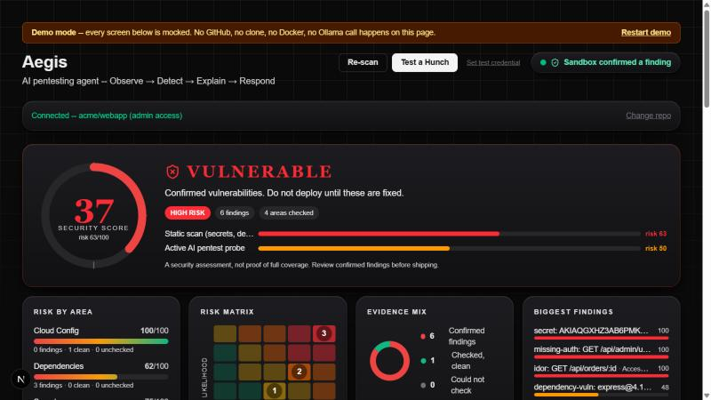
Figure 1. The dashboard — security score, risk-by-area gradient bars (green at 100, red toward 0), risk matrix, evidence mix, and the sorted findings list.
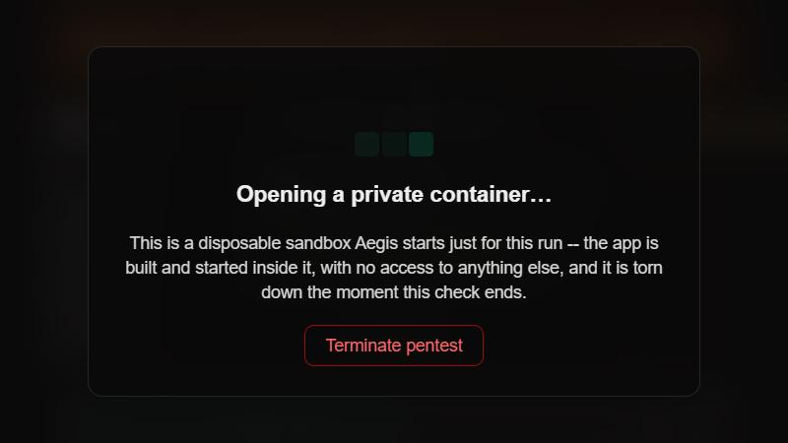
Figure 2. The sandbox-opening state shown the instant an active probe starts.

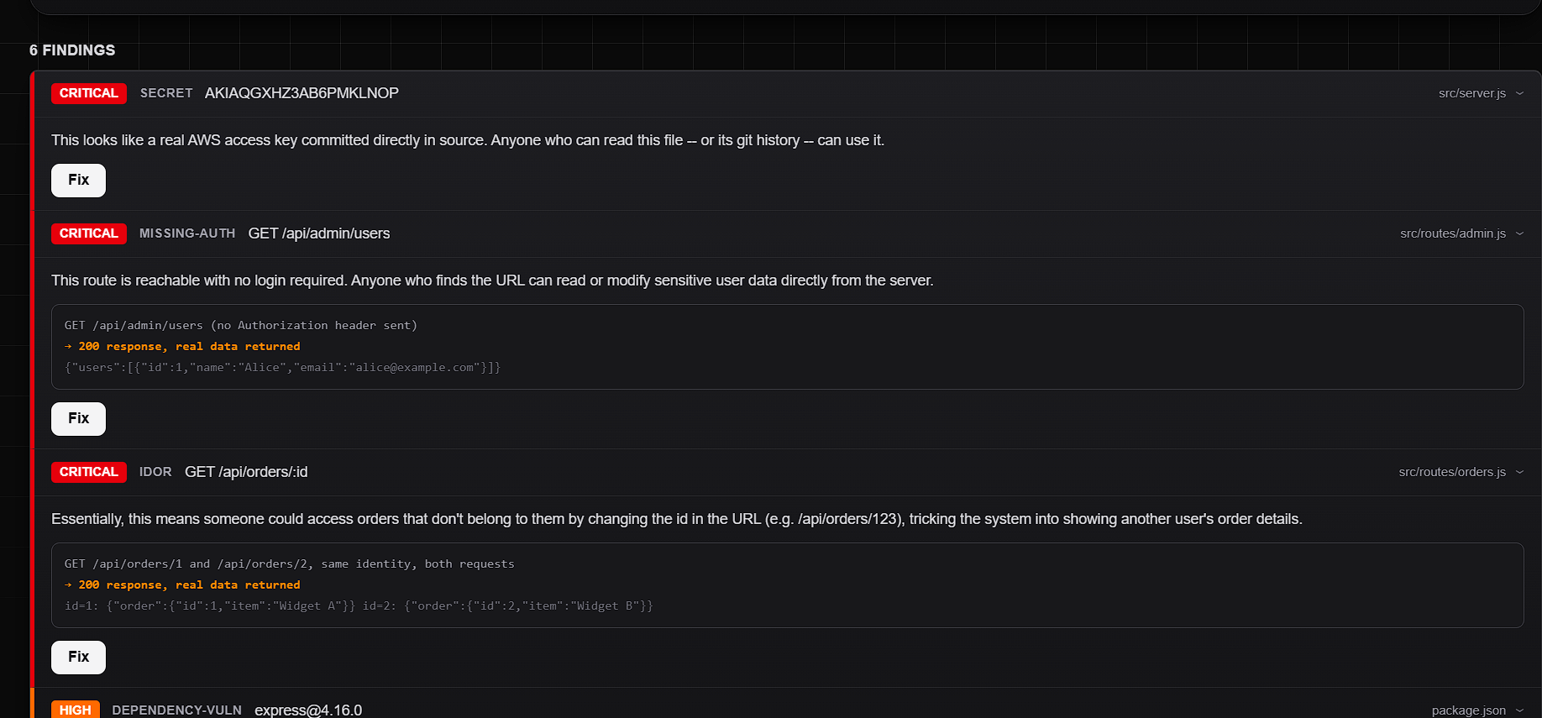
Figure 3. A confirmed IDOR finding, showing the actual request/response evidence rather than an inferred guess.
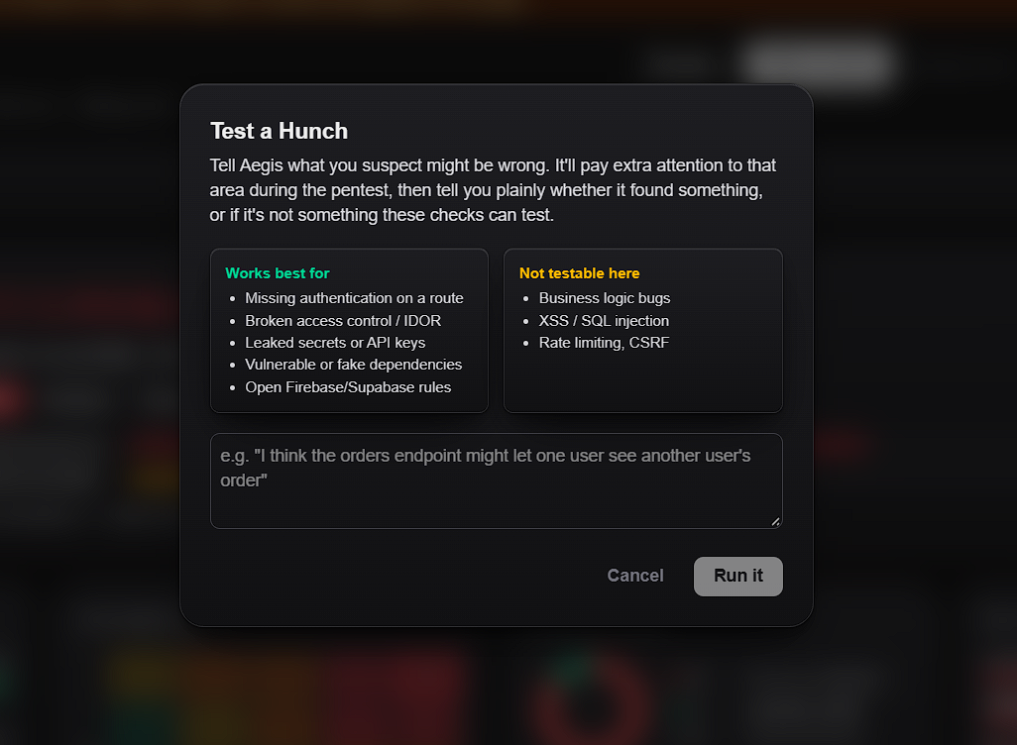
Figure 4. The “Test a Hunch” modal — what the active probe can and cannot test.
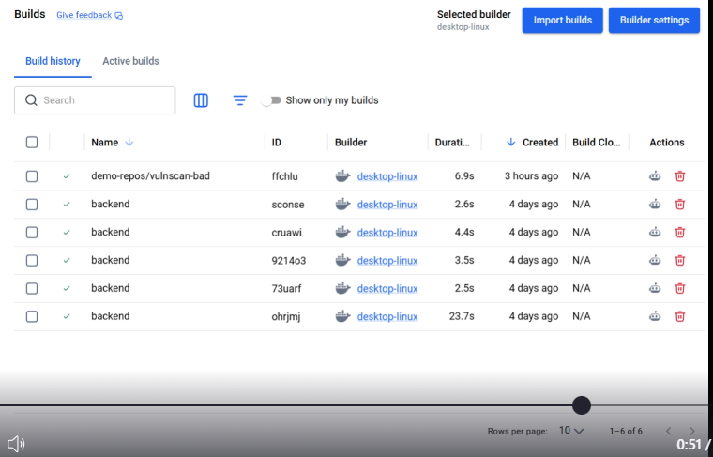
Figure 5. Docker Desktop's own build history — independent confirmation that the active probe's sandbox step is a real container build, not simulated.

8. Technical Foundation

7.1 Technology Stack
Layer | Technology
Backend | Python, FastAPI, Uvicorn
Frontend | Next.js 16, React 19, Tailwind CSS v4, TypeScript
Secrets scanning | Gitleaks
Dependency scanning | OSV API, npm registry
Local LLMs | Ollama — Qwen2.5-Coder (reasoning), Gemma3 (explanation)
Sandbox | Docker — disposable, resource-limited container per probe
Authentication | GitHub OAuth — token never sent to or stored by the frontend

7.2 Referenced Prior Work
PentestGPT (Deng et al., USENIX Security 2024) — for the staged, role-separated agentic pentest pipeline and local-model integration pattern. Its multi-provider LLM connector is reused directly as a library (cloned as a sibling folder, excluded from this repository's own git history).
AIDA — for the agent-driven, container-sandboxed testing approach: reason about the target, pick a tool, run it, record why.
Both are scoped down hard in Aegis: owned, verified targets only, and confirm-and-fix instead of full exploitation.

9. API Reference
Endpoint | Purpose
POST /scan, /scan/stream | Static detection: secrets, dependencies, cloud config. The streaming variant emits real progress events.
POST /probe, /probe/stream | The active probe (missing-auth, IDOR). Skips honestly if Docker, a Dockerfile, or a supported entry point is unavailable.
POST /fix | Generates and re-verifies a fix for one finding.
POST /hunch | “Test a Hunch” — judges a free-text suspicion against findings already gathered this session.
GET /github/oauth/login, /github/oauth/callback | The OAuth flow — redirects to GitHub, then back with a session cookie.
GET /github/session, /github/repos, POST /github/logout | Session status, the connected account's repositories, disconnect.
POST /github/verify-and-clone | Verifies push/admin access, then shallow-clones the repository.
POST /probe/cancel | Best-effort cancellation of a running probe.

10. Scope and Safety
Aegis only ever scans or probes repositories the user has verified ownership of, via GitHub OAuth or a local path they provide directly — there is no scanning of arbitrary or third-party targets.
- Static detection is fully deterministic: regex/AST-level parsing and known-vulnerability database lookups, with no LLM involvement in detection itself.
- The active probe builds the target's own Dockerfile into a disposable, resource-limited container Aegis fully controls, then runs exactly one fixed, safe, non-destructive request per hypothesis — no exploit payloads, no data exfiltration, no writes.
- Scoring is rule-based, not LLM-based: severity, area, likelihood, and impact all come from fixed lookup tables, computed before the local model ever sees a finding.
- Dependency lookups send only public package names and versions, the same identifiers tools such as npm audit or pip-audit use; source code itself never leaves the machine except to the local LLM.
- GitHub credentials are never typed into Aegis's UI; OAuth tokens live only in an in-memory, httpOnly-cookie-keyed backend session.

11. Known Limitations
Named here deliberately, before anyone else points them out, alongside how each is being addressed.
Limitation | How it's being addressed
No Dockerfile in the target repository — the active probe has nothing to build. | Already shipped: a local model reads the repo's own build signals and synthesizes a best-effort Dockerfile before giving up. Next: wider framework coverage, and a review step so the user sees the guess before it runs.
The active probe checks only two vulnerability classes: missing authentication and IDOR. | Deliberate at this stage for safety and reliability. Roadmap: expand the tool registry with more finding types, one safely-scoped tool at a time.
No attack chaining — each finding is confirmed independently. | Planned: a task-tree style reasoning layer, inspired by PentestGPT's own approach, letting confirmed findings inform later hypotheses.
Route tracing is regex/heuristic, not a full AST for every framework. | Works for common conventions today; moving to per-framework AST parsing would remove edge cases where an unusual route definition is missed.
No automated test suite or continuous integration yet. | Verified so far via manual end-to-end runs against two vulnerable fixtures and a clean control. Planned: pytest for the backend, Playwright for the flow, wired into CI.

12. Roadmap

11.1 Context: The Restricted Frontier
Models capable of autonomously finding and exploiting zero-day vulnerabilities already exist — Anthropic's internal “Mythos” is one example — but access is deliberately restricted to a small number of partners, never released publicly. Aegis is the same offense-for-defense idea, scoped down and opened up: confirm-and-fix only, strictly on code the user already owns.

11.2 Planned Improvements
- Better, pluggable models — Qwen2.5-Coder and Gemma3 were chosen for being fast and free to run locally today, not as a ceiling; stronger open models can be swapped in without touching the pipeline.
- User-chosen AI — letting a user pick which model reasons and which one explains: a faster local model for quick checks, a stronger one for deeper reasoning on a hard target.
- Scaling beyond one machine — not a traditional always-on backend that stores a user's code, but a disposable cloud virtual machine that spins up its own LLM and Docker sandbox per run, does the work, and is torn down. The same “disposable, isolated, torn down after one use” guarantee already applied to the Docker sandbox, extended one layer outward to the compute itself.
- Wider vulnerability coverage and, eventually, attack chaining across confirmed findings.

13. What Was Built vs. Originally Scoped
Originally scoped | Actually shipped
Three checks: secrets, vulnerable dependencies, missing auth. | Five finding types: secrets, dependencies, cloud configuration, missing-auth, IDOR.
PentestGPT wired in as the core testing engine. | A purpose-built agent + tool registry, with PentestGPT's LLM connector reused as a library and its pipeline philosophy as an architectural reference.
Generate a fix, re-run to confirm it closed. | Fix + re-verification implemented for every finding type, not a subset.
Demo on one deliberately vulnerable app. | Two deliberately vulnerable demo targets (Express and FastAPI), plus “Test a Hunch,” which was not in the original scope at all.

14. Project Structure
Path | Contents
backend/app/detectors/ | Secrets, dependencies, cloud_config, supabase, and route-tracing detectors.
backend/app/probes/ | agent.py (orchestrator), tool.py (interface), missing_auth.py, idor.py — the active-probe tools.
backend/app/fixers.py | Fix-and-re-verify logic, one function per finding type.
backend/app/risk.py | Deterministic scoring, area, and risk-matrix placement — no LLM involved.
backend/app/llm.py | Local model connector (Qwen for reasoning, Gemma for explanation).
backend/app/sandbox.py | Builds, runs, and tears down the target's own Dockerfile.
backend/app/github_oauth.py, github_auth.py | OAuth flow, permission checks, repository cloning.
backend/app/main.py | The FastAPI application and all endpoints.
frontend/app/ | The Next.js dashboard — risk dashboard, sandbox badge, analysis overlay, GitHub connect and repo picker.
demo-app/, demo-app-py/ | Deliberately vulnerable Express and FastAPI targets used for testing and demonstration.

15. License and Governance
Released under the MIT License. Built as a hackathon submission by Team Barbie for ASYNC 2026; issues and contributions are welcome after the event, though no formal contribution process exists yet. PentestGPT-legacy's LLM connector is used as an external library under its own MIT license.

16. Team
Name | Role | USN
Rahul K R | Team Lead | 1MS26ET007T
Shakti Dharan | Member | 1MS26EI019T
Aarya Sriram | Member | 1MS26IM014T

Track: ASYNC 2026 — Cybersecurity & Defence.

Find it. Prove it. Fix it. Prove it again.

