Catia Plugin – Native Side Architecture and Automation Interfaces for Third-party DLLs

By Wei Mao

01/08/2005

CONTENTS

- INTRODUCTION --------------------------------------------------------- 2

- NATIVE SIDE ARCHITECTURE OF CATIA PLUGIN --------- 3

- HOW TO IMPLEMENT COMMUNICATION BETWEEN NATIVE SIDE OF CATIA PLUGIN AND CATIA ----------------- 4

- WHY AND HOW TO CREATE AUTOMATION INTERFACES FOR THIRD-PARTY DLLS --------------------------------------------- 8

- HOW TO INTEGRATE THIRD-PARTY DLLS INTO CATIA PLUGIN VIA OUR OWN AUTOMATION INTERFACES ---- 17

- HOW TO SET UP ALL CATIA THINGS ON A MACHINE -- 22

1 INTRODUCTION

This document explains what the native side architecture of Catia plugin looks like. It doesn’t involve plugin’s Java side since Java side architecture and the relation between Java side and native side have been described in some other documents.

This document is focused on explaining why we choose current way to implement the communication between Catia plugin’s native side and CATIA, why we have to create our own Automation Interfaces in order to use third-party dlls, how to do that by using RADE, a development environment provided by CATIA, and how to integrate third-party dlls into Catia plugin via our own Automation Interfaces.

2 NATIVE SIDE ARCHITECTURE OF CATIA PLUGIN

Catia Plugin

CATIA

Model and data structure

User Library Manager

Geometry features

Third-party DLLs
Interactive Mode and
Automation API
Automation Interfaces (created by us)
Fig. 2.1 Native side architecture of Catia plugin

Catia plugin and CATIA will be running in two different processes respectively. Catia plugin uses the functionality of CATIA in two ways, general use and special use.

General use means that, Catia plugin, by interactive mode and via Automation API provided by CATIA, can get and set geometry dimensions of part, properties of part and so on. Section 3 will explain why we choose interactive mode and Automation API instead of other ways to implement general use.

Special use is to call third-party dlls which are running in CATIA process to do some special computation and analysis. In order to call them, we have to create a set of Automation Interfaces between Catia plugin and third-party dlls, which are general for different third-party dlls. Section 4 and 5 will tell in detail how to implement special use.

Note: A third-party dll here means a dll program developed by a third party in CAA (Component Application Architecture) C++, which is provided by CATIA. Third-party dlls should be running in CATIA process.

3 HOW TO IMPLEMENT COMMUNICATION BETWEEN NATIVE SIDE OF CATIA PLUGIN AND CATIA

3.1 Batch mode and interactive mode

CATIA provides two modes, batch mode and interactive mode ^{[1]}, by which the external programs can have a talk with CATIA. One important difference of these two modes is that, batch mode creates a session to some CATIA service, however, interactive mode starts up a CATIA process so that it can make full use of the functionality exposed by CATIA.

The behavior of batch mode is similar to that of a batch file in DOS.
- No more than one session can exist at one time.
- It can only use limited functionality of CATIA since there is no CATIA process running in batch mode.
- It can only be used when no visualization is necessary.

We used batch mode before to write CATIA plugin in order to implement the communication between plugin and CATIA, but there were some problems that could not be solved under batch mode.
- Two or more plugin models could not work fine at the same time due to batch behavior.
- Vrml and other types of files exported by plugin could not get updated due to limitation of batch mode.
- You could not see what’ going on in CATIA since there was no CATIA process running.

Dome plugin has an interactive behavior to talk to CAD program, which is not consistent with batch mode. That is an important reason why we had those problems when we used batch mode. The way to solve those problems is to write CATIA plugin in interactive mode.

3.2 Automation API and CAA API

To implement an interactive talk to CATIA, two different sets of API, Automation API and CAA API, are provided by CATIA.

The difference between CAA API and Automation API is that, CAA API is in-Process and Automation API is out-Process ^{[2]}. In-Process means the code written in CAA API can only be running in CATIA process, and out-Process means the code in Automation API can be running in a process out of CATIA process.

We choose Automation API in Catia plugin since Dome plugin will be running in a separate process out of CATIA process. In section 5 of this document, we will use CAA API to integrate third-party dlls into our own Automation interfaces.

3.3 How to communicate with CATIA under interactive mode and in Automation API

To have an interactive talk with CATIA, we must start a CATIA process first. All Windows applications register their COM (Component Object Model) classes in the Windows System Registry. Each class is associated with a globally unique identifier (or GUID) called a class identifier. In the registry, each class identifier (or CLSID) is mapped to a programmatic identifier (or PROGID) and to its application ^{[3]}. Taking CATIA as an example, Fig. 3.1 gives the relationship between PROGID, CLSID and application.

PROGID

CATIA.Application

CLSID
{87fd6f40-e252-11d5-8040-0010b5fa1031}

APPLICATION
C:\DS\B13\intel_a\code\bin\CATSTART.exe
Fig. 3.1 The relationship between PROGID, CLSID and APPLICATION

Usually, we know the version-independent PROGID of an application. Here “CATIA.Application” is the version-independent PROGID of CATIA. Then we can get CLSID of CATIA application from PROGID by using C++ global function CLSIDFromProgID:

CLSID clsid;
HRESULT hr;
hr = CLSIDFromProgID(L"CATIA.Application", &clsid);

By CLSID we got, plugin can find where CATIA is installed and then start up a CATIA process.

IUnknown* pUnk = NULL;
hr = CoCreateInstance(clsid, NULL, CLSCTX_LOCAL_SERVER, IID_IUnknown, (void
**)&pUnk);

For now, what we have got is an interface of IUnknown type. To get an interface of CATIAApplication type, we need to query interface on IUnknown.

CATIAApplication* m_pCatiaApp;
hr = pUnk->QueryInterface(IID_CATIAApplication, (void **)&m_pCatiaApp);

Now, we get CATIA application object, which is the main entrance of CATIA object models. Like other Windows applications, CATIA exposes its functionality as a set of hierarchical programmable COM objects.

The following is the object models that CATIA exposes to the external applications ^{[4]}.

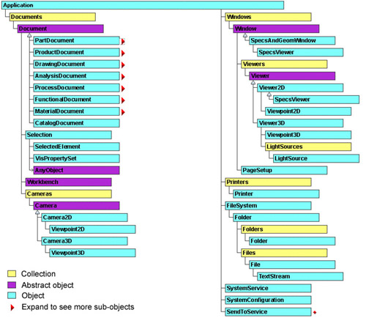
Fig. 3.2 Object Models exposed by CATIA

If we expand PartDocument object, we can see object models of Part as Fig. 3.3 ^{[4]}.

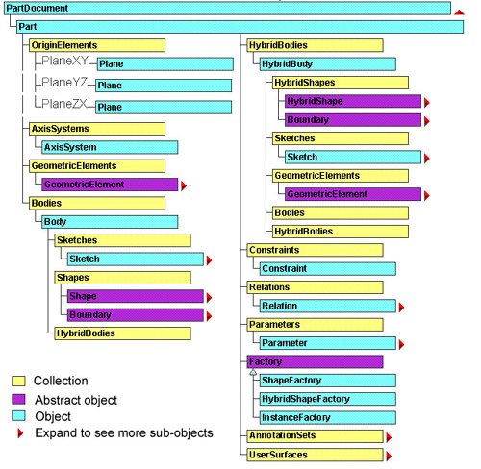
Fig. 3.3 Part Object Models exposed by CATIA

Thanks to the object models exposed by CATIA, we can explore all objects in the object tree from the top down, beginning with the root object Application. As a result, plugin can create a connection between a general parameter on DOME side and a geometry dimension or a property of a part on CATIA side. For a CATIA model, on DOME side, parameters are divided into two types, general parameters for general use and special parameters for special use. In the section 6, you will see how special parameters are passed between DOME and a third-party dll.

For more implementation details, please refer to native code and comments of CATIA plugin.

To succeed to compile and link: You need to choose Multithreaded DLL under the menu “Project->Settings…->C/C++->Category: Code Generation->Use run-time library” in Microsoft Visual C++.

4 WHY AND HOW TO CREATE AUTOMATION INTERFACES FOR THIRD-PARTY DLLS

4.1 Why do we create our own automation interfaces for a third-party dll

A third-party dll, developed in CAA (Component Application Architecture) C++ by a third-party user of CATIA, is to be running in a CATIA process to do some special task, such as some computation and analysis on a certain CATIA model. Here, CAA C++ is an extension based on standard C++, including large numbers of API and some conventions made by Dassault Systemes.

For example, Ford has a dll to do an analysis of seal interference with a car’s door, which will be used by our CATIA plugin.

Usually, a third-party dll is used in such a way that a user executes it through a customized menu in CATIA. As a result, it will be running in CATIA process. It often requires the user to input some parameters before it’s running and generates some results in CATIA process.

Apparently, our CATIA plugin can not use this way to run a third-party dll since CATIA plugin will be running without a user’s intervention and it has to call a third-party dll itself.

How to call a third-party dll to be running in a CATIA process, in another process (plugin process) which is independent and out from the CATIA process? The only way is via the Automation Interfaces which we have to create ourselves.

(The old plugin call a third-party dll without any intermedia, and as a result, the third-party will be running in the process of plugin, not in CATIA process. That is not what we expect and will cause some unsolvable problems)

4.2 CAA RADE– A tool to be used

CAA RADE is a Rapid Application Development Environment provided by Dassault Systemes in which you can program in CAA C++ to redevelop CATIA. All code you write in RADE have to be running in CATIA process. Usually, a third-party dll is developed in RADE. To create our own Automation Interfaces, we also need to use RADE.

RADE is not an independent development environment. It exists in Microsoft Visual C++ in terms of add-ins. After you install RADE, start up Microsoft Visual C++ and go to the menu “Tools->Customize…->Add-ins and Macro files”, choose the items related to CAA RADE, just like what is shown Fig. 4.1.

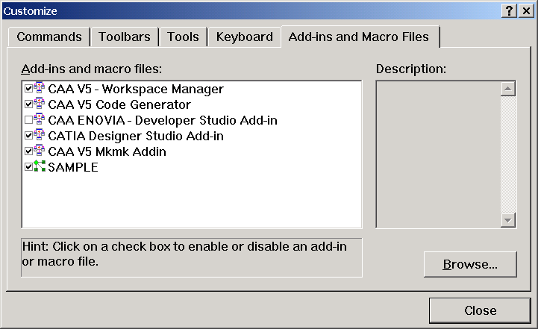

Fig. 4.1 Choose add-ins of RADE in Microsoft Visual C++

You need to restart Microsoft Visual C++. Then you can see that two new RADE menus, CAAV5 Workspace and Source Code Manager, are added, as Fig. 4.2 shows.

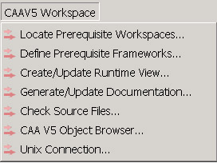
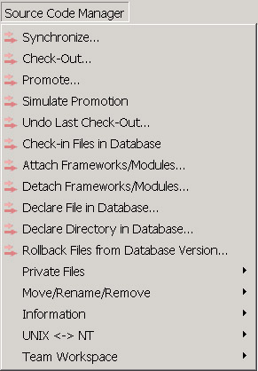
Fig. 4.2 Two new RADE menus added into Microsoft Visual C++

Also the following new menu items, with a red arrow, are added into standard menus of Microsoft Visual C++, shown in Fig. 4.3.

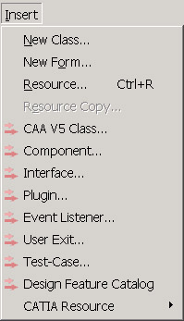
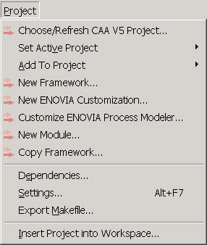
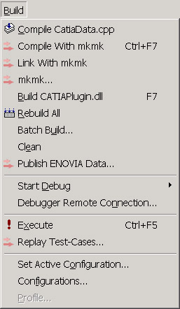
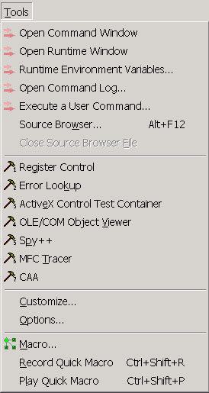
Fig. 4.3 New RADE menu items added

License to use RADE: A separate license in addition to the CATIA license will be required to use RADE. A concurrent license server has been installed on the machine cadlab20.mit.edu which enables several people to use a same license to run RADE on their own machines at the same time.

4.3 Procedure to create our own Automation Interfaces by using RADE

- Create a new CAA V5 Workspace named “CATIADomeInterfaces” by the menu “File->New CAA V5 Workspace…”.

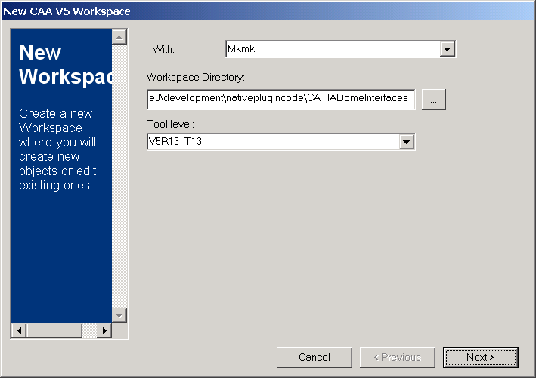
Fig. 4.4 Create a new CAA V5 Workspace

- CAAV5 Workspace->Locate Prerequisite Workspaces…: Indicate the installation path of CATIA and CAA API.

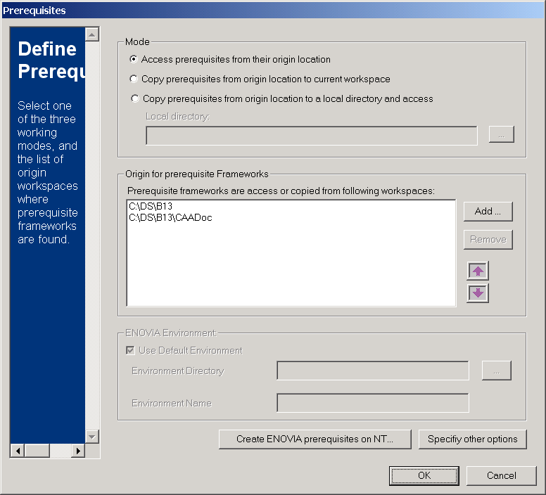
Fig. 4.5 Locate CATIA and CAA API

- Project->New FrameWork…: Create an Interface Framework named CATIADome with IDL support.
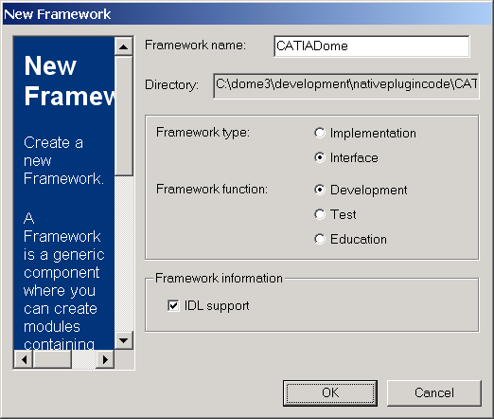
Fig. 4.6 Create an Interface Framework

There are two types of framework in RADE: Interface framework and Implementation framework. Interface framework is used to create interfaces. Here IDL support means the interface we will create is an Automation Interface.

IDL: Interface Definition Language, a language which is specific to the definition of interfaces that can be used in a multi-languages environment ^{[5]}. An IDL file will be compiled to C++ header file and type library by IDL compiler. RADE has its own compiler mkmk, which includes an IDL compiler.

- Insert->Interface…: Add an Automation Interface named “CATIADomeInterface” which derives from CATIABase. Language is “Automation IDL” for an Automation Interface. The name of an Automation Interface must be “XXXIA…” which has three letters right before “IA”, followed by any letters. (The name of a CAA interface must be “XXXI…”)

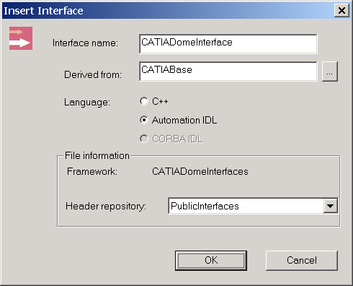
Fig. 4.7 Add an Automation Interface

Then, a new IDL file “CATIADomeInterface.idl” is created under the folder “PublicInterfaces” of the interface framework “CATIADomeInterfaces”.

Note: in this file, we define an Automation Interface named CATIADomeInterface and its interface methods:

HRESULT SetDllItem (in short iIndex, in CATVariant iValue);
HRESULT Run();
HRESULT GetDllItem (in short iIndex, inout /*IDLRETVAL*/ CATVariant iValue);

The method SetDllItem is used by CATIA plugin to pass a parameter, that comes from a CATIA model, into a third-party dll.

The method Run is to run the functionality provided by a third-party dll in CATIA process.

The method GetDllItem is used to retrieve the results generated by running of a third-party dll.

For more details, please refer to the code and comments.

- CAAV5 Workspace->Define prerequisite Frameworks…: Indicate prerequisite frameworks to be used. Here, CATIABase is the base interface of CATIADomeInterface, and as a result, the framework System, which includes the interface CATIABase, will be a prerequisite framework we should add. By default, RADE has added the framework System. If the base interface does not belong to System framework, we need to add the right prerequisite framework by ourselves, as Fig. 4.8 shows.

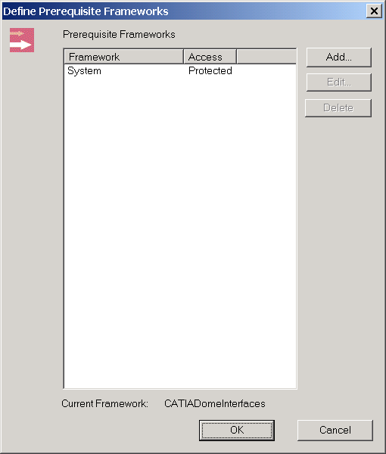
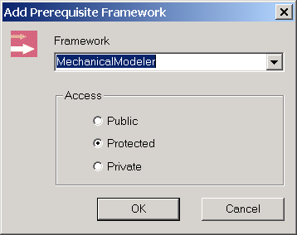
Fig. 4.8 Add prerequisite frameworks

- Project->Choose/Refresh CAA V5 Project…: Get the modules created by RADE. There are totally five modules. Each of them has a suffix “.m” in their names and is used for a specific purpose, shown in Fig. 4.9.

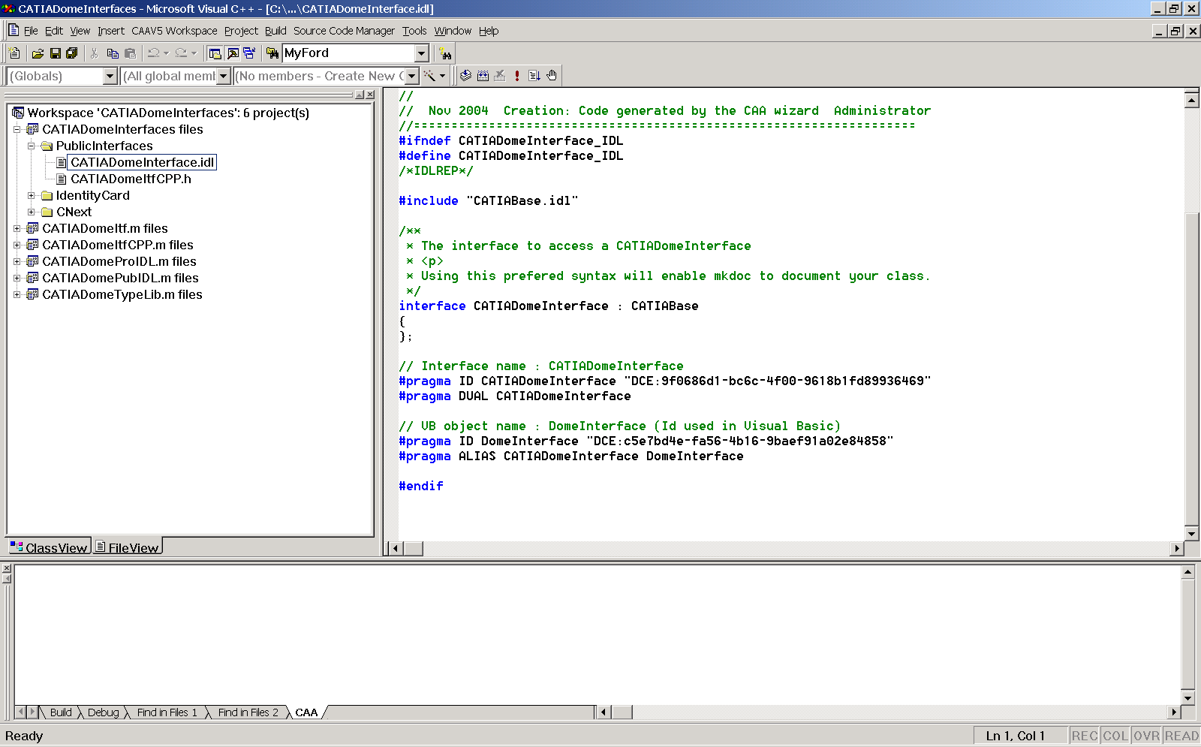
Fig. 4.9 Refresh projects

- Comment out “LINK_WITH” in the file “imakefile.mk” of the module “***TypeLib.m”, that is a bug of RADE. Add a file named “XXX.iid” into the folder “CNext\code\dictionary” of the interface framework. XXX must be the name of the interface framework which is “CATIADomeInterfaces” here and it’s the same with the name of the “.dico” file under the same folder. Read the line in the “.idl” file: #pragma ID CATIADomeInterface "DCE:9f0686d1-bc6c-4f00-9618b1fd89936469". In the .iid file, add the following line: “9f0686d1-bc6c-4f00-9618-b1fd89936469 CATIADomeInterface DomeInterface”(take care of the new minus).

- In the file “imakefile.mk” of the module “***Itf.m”, add the lib to “LINK_WITH” which will be used by link. By default, RADE has added the lib “JS0GROUP”, which has included the interface CATIABase from which our Automation Interface CATIADomeInterface derives. In other cases, for example, if your Automation Interface derives from CATIAFactory, the lib CATMecModInterfaces will be added for CATIAFactory.

- In the file “***TypeLib.tplib” of the module “***TypeLib.m”, add the type lib to “#pragma REPREQ XXX”, that will be used by compiler. By default, RADE has added the type lib “InfTypeLib”, which has included the interface CATIABase from which our Automation Interface CATIADomeInterface derives. In other cases, for example, if your interface derives from CATIAFactory, the type lib MecModTypeLib will be used for CATIAFactory.

Note: How to find the lib name and the type lib name for a given interface, for example, CATIAFactory?

Way one:
- Use CAAV5 Object Browser provided by RADE to find out which framework “CATIAFactory.h” belongs to.
- Under this framework, usually there will be a module named “**Itf.m” and a module named “**TypeLib.m”, where **Itf is the lib name and **TypeLib is the type name we are looking for.

Way two:
Open the file “CATIAFactory.h”, you will find the statement “ExportedByMecModPubIDL”, which provides some clues.

Way three:
In the CAA help documentation for each class or interface, the header file and the lib are often given on the bottom.

- Build->mkmk…: Build all projects. In RADE, each framework and module corresponds to a project. So there are six projects in the workspace, shown in Fig. 4.10.
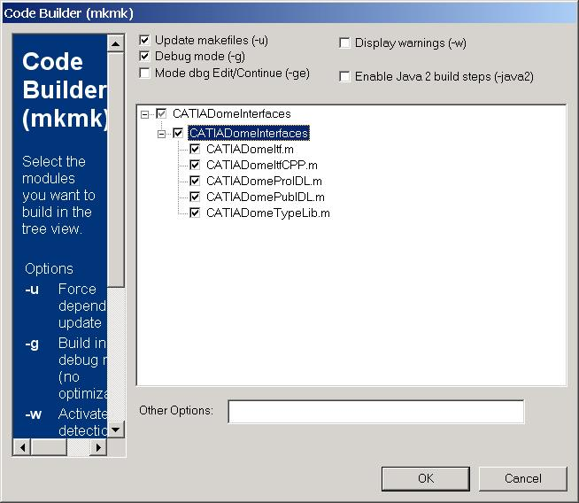
Fig. 4.10 Build projects in RADE

Note: RADE has its own compiler mkmk which is different from the compiler of Microsoft Visual C++. Mkmk also has an IDL compiler.

After compiling and linking successfully, a C++ header file “CATIADomeInterface.h” is generated. It will be used by CATIA plugin to call and run a third-party dll.

Note: For now, the Automation Interface CATIADomeInterface and its methods we created are general to call and run any third-party dll. If necessary, new Automation Interfaces and new methods can be added into what we have done by following the instruction above.

- CAAV5 Workspace->Create/Update Runtime View…: Create or update all resources that will be used at runtime, shown in Fig. 4.11.

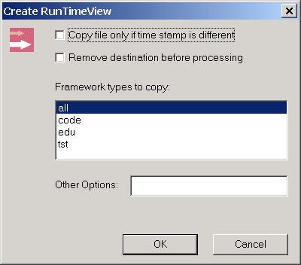
Fig. 4.11 Create/Update Runtime View

5 HOW TO INTEGRATE THIRD-PARTY DLLS INTO CATIA PLUGIN VIA OUR OWN AUTOMATION INTERFACES

Now a bridge between CATIA plugin and a third-party dll has been created, which is our own Automation Interface CATIADomeInterface. To go through the path from CATIA plugin to a third-party dll, we need to join plugin and Automation Interface together, and also join a third-party dll and Automation Interface together.

5.1 Join CATIA plugin and CATIADomeInterface – User Library Manager

User Library Manager is a class used in CATIA plugin to communicate with our automation interface CATIADomeInterface so as to call and run a third-party dll. Each User Library Manager keeps an interface pointer of CATIADomeInterface type. It also stores the information that comes from the CATIA model and is needed by a third-party dll. In the definition of User Library Manager, we have:

CATIADomeInterface * m_CATIADomeInterface;
char *m_LibraryName;
CATIAData **m_Parameters;
int m_NumParameters;

As we know, CATIADomeInterface is general for all third-party dlls and it has to know which third-party dll it will call. m_LibraryName stores the name of the third-party dll so that CATIADomeInterface can call the third-party dll by name. m_Parameters stores all parameters which will be passed into the third-party dll via CATIADomeInterface and the results to be passed back by the third-party dll via CATIADomeInterface.

If we have a look at a CATIA model which will run a third-party dll, for example, Ford door seal interference analysis model in Fig. 4.12, we can find that it provides the information clearly.
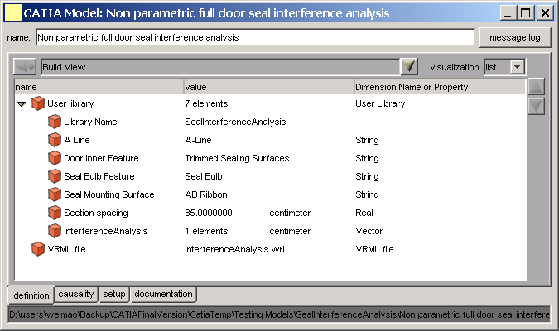
Fig. 4.12 Ford door seal interference analysis model

In a CATIA model, a List data is used for special use which means running a third-party dll (See section 2). The List data keeps all information needed to run the third-party dll. The first parameter under it must be the name of the third-party dll and the others are the parameters which will be passed into the third-party dll via CATIADomeInterface and the results to be passed back by the third-party dll via CATIADomeInterface.

5.2 Join CATIADomeInterface and a third-party dll

The basic idea to join CATIADomeInterface and a third-party dll is to wrap the third-party dll as a component of CATIA, which implements the interface CATIADomeInterface, so that the external applications can call and run the third-party dll in CATIA process via our automation interface CATIADomeInterface.

Here the instruction to wrap the third-party dll up by using RADE is given, taking Ford door seal interference analysis as an example.

  - File->Open CAA V5 Workspace…: Open the CAA V5 Workspace we created in Section 4.

  - Project-> New FrameWork…: Create an Implementation Framework named “CATIADomeImpl” which will wrap up all third-party dlls.

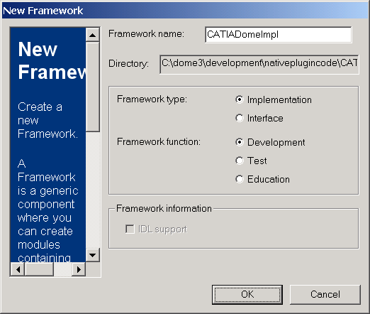
Fig. 5.1 Create an Implementation Framework

  - Project->New Module…: Create an Implementation Module named “SealInterferenceAnalysisImpl” which keeps all materials related to Ford door seal interference analysis. It should be a “Shared object”, shown in Fig. 5.2.

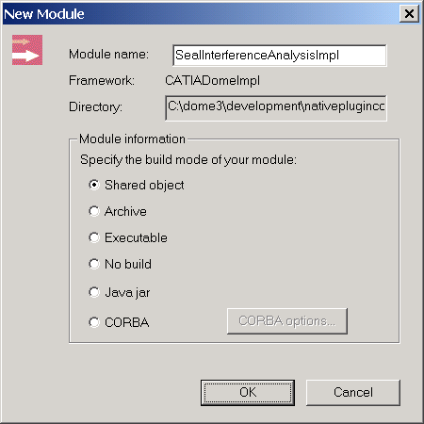
Fig. 5.2 Create an Implementation Module

  - Insert->Component…: Create a component named “SealInterferenceAnalysis” to wrap up Ford door seal interference analysis. It implements CATIVBExtension and the automation interface CATIADomeInterface without an extension.

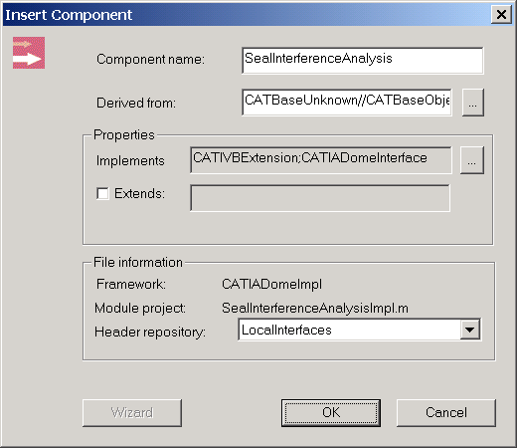
Fig. 5.3 Create a component of CATIA to wrap up the third-party dll

Add code to GetObjects method of SealInterferenceAnalysis. This method will do QueryInterface on the component SealInterferenceAnalysis to get and return the automation interface CATIADomeInterface to the external application.

HRESULT SealInterferenceAnalysis::GetObjects (CATBaseUnknown * iGetItemTarget , CATBaseDispatch *& oGetItemResult) const
{
HRESULT hr = ((CATBaseUnknown*) this)->QueryInterface(IID_CATBaseDispatch, (void **)&oGetItemResult);
return hr;
}

  - Insert->Component…: Create a component named “CreateSealInterferenceAnalysis” which implements CATICreateInstance and extends the component SealInterferenceAnalysis.

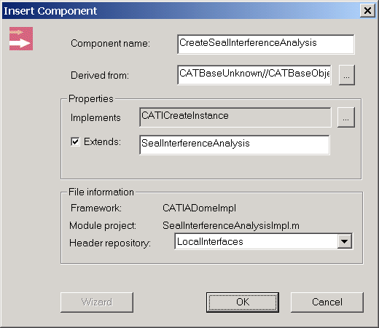
Fig. 5.4 Create a component to instantiate SealInterferenceAnalysis

The component CreateSealInterferenceAnalysis is responsible to create an instance of the component SealInterferenceAnalysis. To do that, add the following code to CreateInstance method of CreateSealInterferenceAnalysis.

HRESULT __stdcall CreateSealInterferenceAnalysis::CreateInstance (void ** oPPV)
{
*oPPV = new SealInterferenceAnalysis();
return S_OK;
}

Note: Include “SealInterferenceAnalysis.h” in “CreateSealInterferenceAnalysis.cpp” and change “DataExtension” to “CodeExtension” in the statement “CATImplementClass(…)”.

  - Implement the methods of the component SealInterferenceAnalysis: SetDllItem, Run and GetDllItem for the third-party dll.

Please refer to the code and comments for more details.

  - Build->mkmk…: Don’t forget to define necessary Prerequisite Framework for the Implementation Framework and add lib to the file “imakefile.mk” of the implementation module.

  - CAAV5 Workspace->Create/Update Runtime View…: Create or update all resources that will be used at runtime.

6 HOW TO SET UP ALL CATIA THINGS ON A MACHINE

- Install CATIA, CAA API, and CAA RADE.

There are a few things to be taken care of:

- Install CATIA first, then CAA API, and install CAA RADE at last. All of them should have the same version.

- CATIA and CAA API should be installed in the same directory and CAA RADE will be in a different directory.

- No blank space in the installation directories.

- Start up CATIA, go to the menu “Options->General->General”, and choose “No automatic backup”. This is to void showing the warning window during start-up of CATIA.

- Add the following paths into the environment variable “path” of Windows: “C:\DS\B13\intel_a\code\bin;C:\DS\B13\intel_a\code\command;C:\DS\T13\intel_a\code\bin;C:\DS\T13\intel_a\code\command”. Here “C:\DS\B13” is the installation directory of CATIA and CAA API and “C:\DS\T13” is the installation directory of CAA RADE.

- Check out the two folders from CVS: “CATIAPluginNew” and “CATIADomeInterfaces”.

- Delete all “CVS” folders under the folder “CATIADomeInterfaces”.

- Build the CAA V5 Workspace CATIADomeInterfaces.

The folder “CATIADomeInterfaces” contains a CAA V5 Workspace named CATIADomeInterfaces, which includes our own Automation Interfaces CATIADomeInterface and the third-party dll wrapped up as a component of CATIA.

Before we build the workspace, we need to relocate where CATIA and CAA API are installed. Do the same thing with what is done in step 2 of section 4.3. Then use RADE compiler mkmk to build the whole workspace.

After building, there will be two lib files (“CATIADomeItf.lib” from “CATIADomeItf.m” module in interface framework; “SealInterferenceAnalysisImpl.lib” from “SealInterferenceAnalysisImpl.m” module in implementation framework) and two dll files (“CATIADomeItf.dll” from “CATIADomeItf.m” module in interface framework; “SealInterferenceAnalysisImpl.dll” from “SealInterferenceAnalysisImpl.m” module in implementation framework) and one automation interface header file “CATIADomeInterface.h”.

For a RADE Workspace XXX, all generated lib files are put under the folder “XXX\intel_a\code\lib” and all generated dll files are under the folder “XXX\intel_a\code\bin”.

The name of lib and dll file is the same with the module’s name. Each module has an “imakefile.mk” file and each framework has an “identityCard.h” file

Don’t forget to go to “CAAV5 Worksapce->Create/Update Runtime View…” to create or update the runtime view.

- Add the path “…\CATIADomeInterfaces\intel_a\code\bin” into the environment variable “path” of Windows.

- Create a new CATIA environment using CATIA Environment Editor. Add the directory of the workspace CATIADomeInterfaces before CATIA directory.

- Build CATIA plugin.

  - In Microsoft Visual C++, go to the menu “Project settings->C/C++->Preprocessor->Additional include directories”, add the directory “…\CATIADomeInterfaces\CATIADomeInterfaces\PublicGenerated\intel_a”. This is to use automation interface header file “CATIADomeInterface.h”. Also change the other directories to the corresponding directories on your machine.

  - Go to the menu “Project settings->link->Input”, under “Additional library path”, add the directory “…\CATIADomeInterfaces\intel_a\code\lib” and under “Object/library modules”, add “CATIADomeItf.lib”. Also change the other directories to the corresponding directories on your machine.

- Under “My Computer\HKEY_CLASSES_ROOT\CLSID\{…}” and “My Computer\HKEY_LOCAL_MACHINE\SOFTWARE\CLASSES\CLSID\{…}” in Windows System Registry, change the shortcut of CATIA to be the same with that of the CATIA environment created in step 4.

REFERENCE

  - Dassault Systemes, “ObjectModelerBase Class CATDocumentServices”, CAA V5 Encyclopedia, 2000.

  - Dassault Systemes, “Creating Interfaces for Automation”, CAA V5 Encyclopedia, 2000.

  - Microsoft, “Automating Microsoft Office 97 and Office 2000”, Microsoft Product Support Services White Paper, 1999.

  - Dassault Systemes, “CATIA Automation Objects”, CAA V5 Encyclopedia, 2000.

  - Dassault Systemes, “The CAA V5 IDL Compiler”, CAA V5 Encyclopedia, 2000.

