Vensim + Excel Integration Demonstration

Sangmok Han (sangmok@mit.edu)

The demo system is based on three DOME models:

(1) Excel plug-in model for creating coefficient used in the Vensim model (A)
(2) Vensim plug-in model for simulating the world system dynamics (B)
(3) DOME integration project based on the above two models (A+B)

Each tab found in the page at http://18.80.1.101:8001/vensimdemo/start.jsp can be used to navigate through these three models.

The Vensim plug-in model is backed by a Vensim model file called WORLDAPP.VPM, which came as one of sample models with Vensim DSS installation. The Vensim model is a fairly complex one having multiple views, as shown in Fig 1. A model variable such as birth rate, initial population, and initial capital can be taken as an input to the model to produce simulated behaviors. References for the equations used in the model can be found in World Dynamics, a book written Jay W. Forrester in 1973.

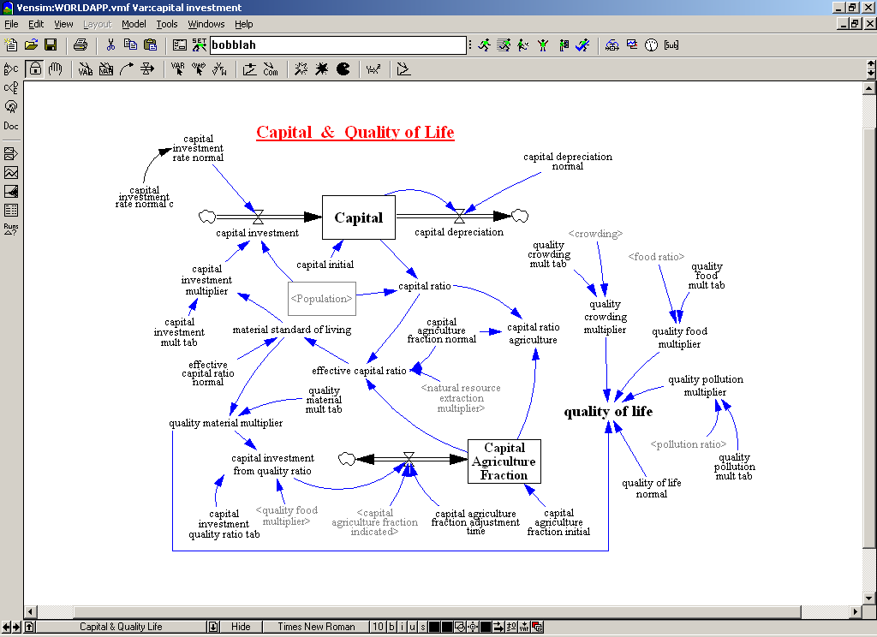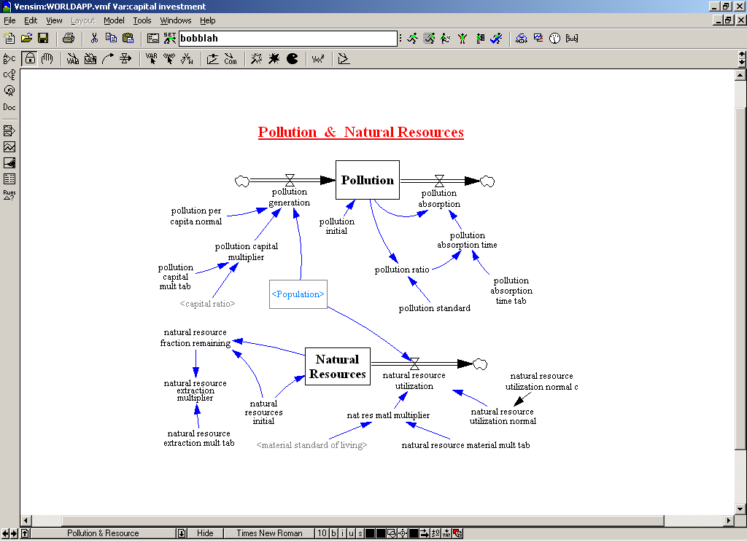
Fig 1. Vensim model simulating dynamics among population, resource and capital

Among many variables in the Vensim model, several interesting were chosen and added to the Vensim plug-in model: birth rate, death rate, capital investment rate and population density as input and capital ratio trend, population trend, and pollution trend as output. Note that all of the input variables are numbers while the output variables are arrays of numbers because they represent a set of values captured at multiple temporal points. The wrapping process for the Vensim model took less then 10 min and the resulting Vensim plug-in model is shown in Fig 2.
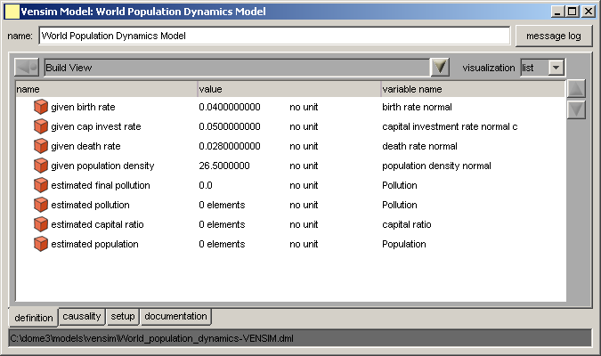
Fig 3. Vensim plug-in model wrapping the Vensim file, WORLDAPP.VPM

A simple Excel file called coefficient_estimator.xls has been created to provide several key coefficients for the Vensim plug-in model (Fig 3). For example, the Excel file has cells for sample population size and sampled number of birth and has another cell for birth rate, calculated as sampled number of birth divided by sample population size. The death rate and population density are also calculated in a similar manner and stored in some cells in the spreadsheet. The Excel file also contains notes on the equations used in it.

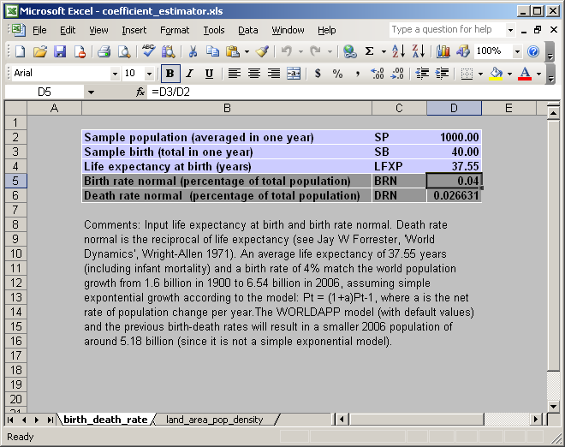
Fig 3. Excel file for estimating key coefficients

Fig 4 shows an Excel plug-in model wrapping the Excel file just created. Each parameter in the model is mapped to a cell in the Excel spreadsheet: parameter sample population is mapped to a cell at D2 of the birth_death_rate sheet. Adding seven parameters and defining mapping for them will complete the Excel plug-in model.

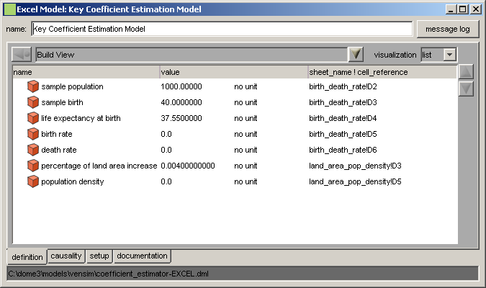
Fig 4. Excel plug-in model wrapping the Excel file, coefficient_estimator.xls

Now two plug-in models are ready to be deployed. After deploying them on a DOME server, we create an integration model called iModel, which subscribes interfaces of the plug-in models (Fig 5). Next, we define which parameter should be equal to which parameter by mapping. For instance, parameter birth rate of the Excel plug-in model is mapped with parameter given birth rate of the Vensim plug-in model. Note that mapping process does not require a user to specify the direction of information flow, which will be automatically determined from causality information in the model, making the process quick, easy and less error-prone. After completing the mapping, we can deploy the integration model and execute it using the default DOME browser or other compatible browsers that can be developed using DOME API. In order to build custom web GUI as shown in the demo URL, additional steps that uses DOME API, a tutorial on which can be found at http://cadlab6.mit.edu/sangmok/DomeAPI_Tutorial.zip, will follow.

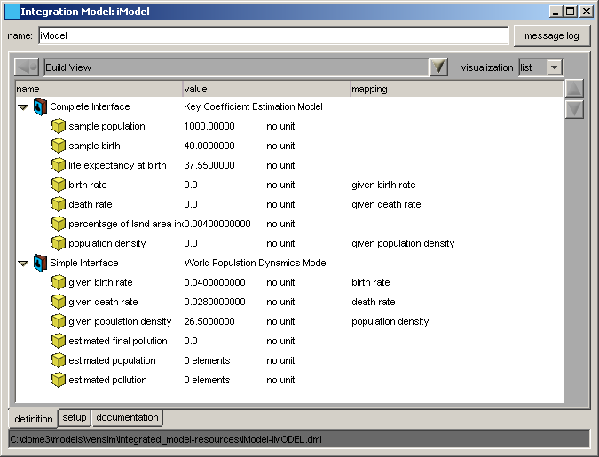
Fig 5. An integration model subscribing interfaces of Vensim and Excel plug-in models

