

Practical Malware Analysis & Triage
Malware Analysis Report

C2.Bootstrap.Dropper.Loader

January 2, 2026 | Clinton Asprey| v1.0

Table of Contents
Table of Contents 3
Executive Summary 4
High-Level Technical Summary 5
Malware Composition 7
EmbedDLL.dll 7
embed.vbs: 7
embed.xml: 7
Basic Static Analysis 9
Basic Dynamic Analysis 11
Advanced Static Analysis 16
Advanced Dynamic Analysis 17
Indicators of Compromise 18
Network Indicators 18
Host-based Indicators 19
Rules & Signatures 21
Appendices 22
A. Yara Rules 22
B. Callback URLs 23
C. Decompiled Code Snippets 23
Updated Indicators of Compromise (IOC) 24
Network IOCs 24
Host-Based IOCs 24
Analyst Summary 24
Executive Summary (Updated) 24
MITRE ATT&CK Technique Mapping 24
Execution Timeline 25

Executive Summary

SHA256 hash | 732f235784cd2a40c82847b4700fb73175221c6ae6c5f7200a3f43f209989387

This report analyzes the EmbedDLL.dll malware, a .NET-based encrypted dropper and loader that deploys a secondary payload using DLL reflection and Living-off-the-Land binaries. The malware is designed to evade static detection through AES-encrypted embedded resources and reflective assembly loading. Persistence is achieved via registry Run keys and execution is proxied through MSBuild. C2 server beaconing is also established.

High-Level Technical Summary

The analyzed DLL functions as a persistence-focused payload dropper. Upon execution, it decrypts a hardcoded password-derived key, writes the decrypted XML payload to disk, and installs a VBScript launcher in the user’s startup registry. This VBScript leverages MSBuild to execute the embedded XML payload, enabling fileless or proxy execution while maintaining persistence across reboots. Callback to a C2 server is also initiated.

Execution Timeline
- Execution of EmbedDLL.dll
- AES decryption of embedded payload
- Decrypted XML payload written to disk
- VBS launcher created
- Persistence via Run registry key
- MSBuild execution of decrypted payload
- Reflective assembly load
- Encrypted C2 communication begins

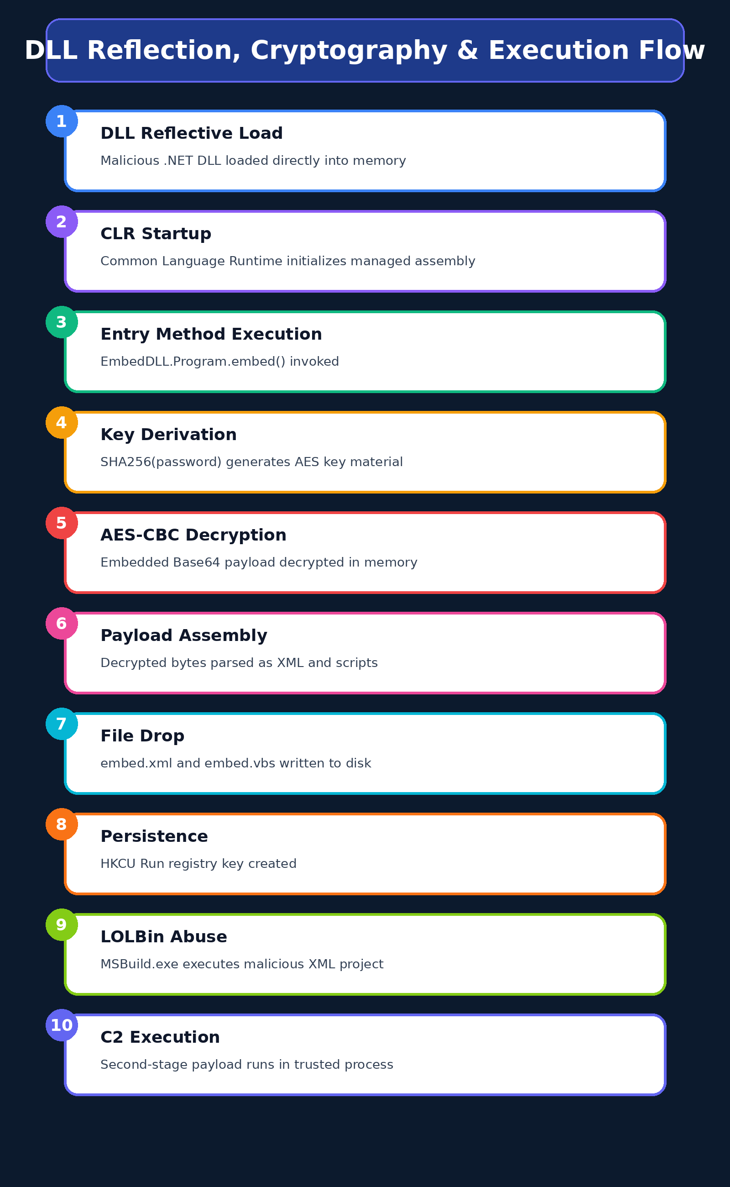

Malware Composition
Malware.cryptlib64.dll consists of the following components:

File Name | SHA256 Hash
EmbedDLL.dll | 732f235784cd2a40c82847b4700fb73175221c6ae6c5f7200a3f43f209989387
embed.vbs | 66fd543f31545082cf8fcc45a6ab1094bc118c45634f2be450f84f4e5745b291
embed.xml | f1548cd02784606c8abac865abf5ed6220d34eea88c7a5715e0183d7f050f4ab

EmbedDLL.dll
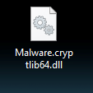
Figure 1: The hidden file name of Malware.cryptlib64.dll is EmbedDLL.dll which is detonated in this lab with rundll32.

embed.vbs:

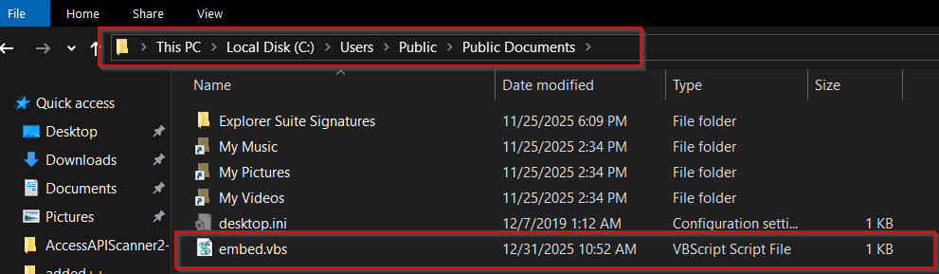
Figure 2: embed.vbs VBscript dropped by EmbedDLL.dll and ran upon user login

embed.xml:

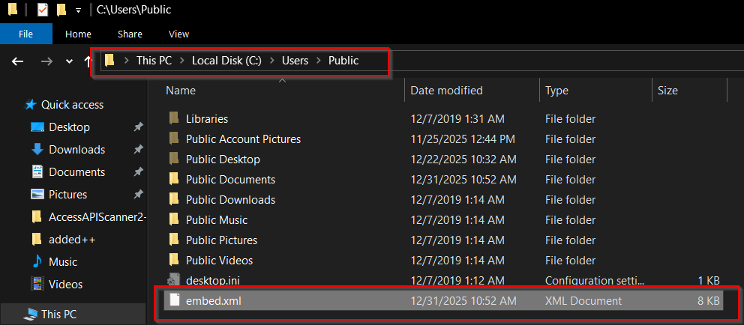
Figure 3: The XML payload is dropped in Public user folder

Basic Static Analysis
{Screenshots and description about basic static artifacts and methods}

- Filename: Malware.cryptlib64.dll
- File size: 29184 bytes
- Entropy: 4.178
- File type: dynamic-link-library, 64-bit, console
- Architecture: x64
- Compilation timestamp: Sun Oct 10 18:14:49 2021 (UTC)
- Digital signature: None
- Suspicious sections: .sdata
- Embedded resources: EmbedDLL.dll
- Indicators of packing or encryption: AES Encryption
- Anti-analysis techniques observed: Hidden File Name (EmbedDLL.dll)
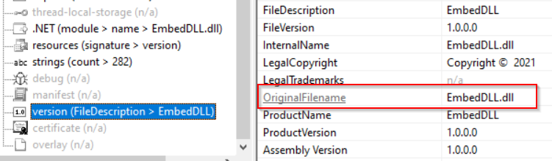
Figure : Hidden file name
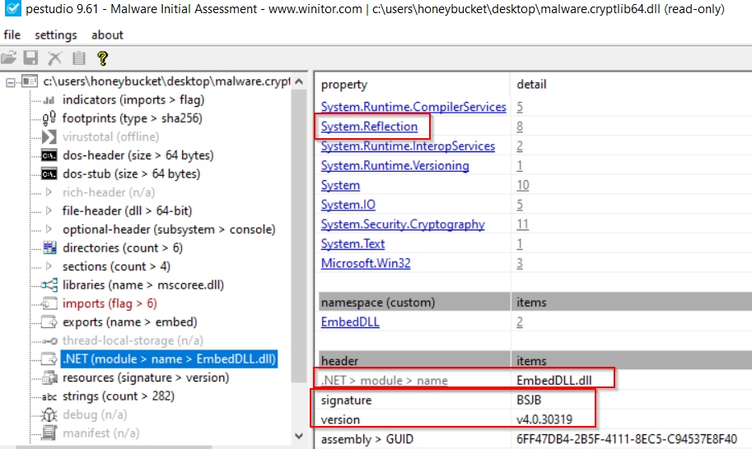
Figure : .NET module detected

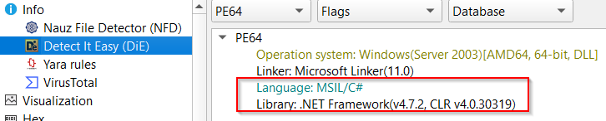
Figure : Indicators of C# language and .NET Framework

Imported functions / APIs:
AES_Encrypt
AES_Decrypt
CreateEncryptor
GetEnvironmentVariable
WriteAllText
MemoryStream

Suspicious Strings:

Basic Dynamic Analysis
{Screenshots and description about basic dynamic artifacts and methods}

This DLL functions as an encrypted dropper-loader responsible for decrypting, staging, and executing a secondary payload via MSBuild, while establishing user-level persistence.

During execution, the malware encrypts command-and-control (C2) communications using AES-256 in CBC mode. Key material is derived via PBKDF2 with SHA-1 (1,000 iterations) and a hard-coded password encoded as UTF-16LE. Network traffic captured from the sample shows that encrypted messages are Base64-encoded prior to transmission.

Once decrypted, the C2 payload does not conform to any standard serialization or compression format. Instead, it consists of a proprietary binary protocol composed of fixed-length fields. These fields include a session identifier resembling a GUID, followed by structured metadata such as opcode values, host identifiers, and status or command data. No evidence of secondary compression or obfuscation is present beyond the initial AES encryption layer.

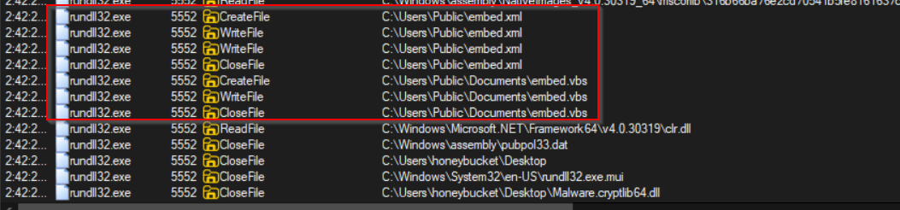
Figure : ProcMon shows files dropped and registry key set upon first run

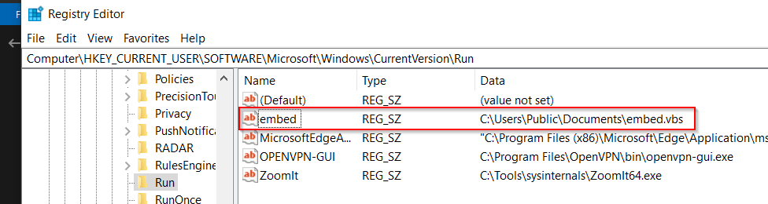
Figure : Persistence registry key created after initial EmbedDLL.dll execution

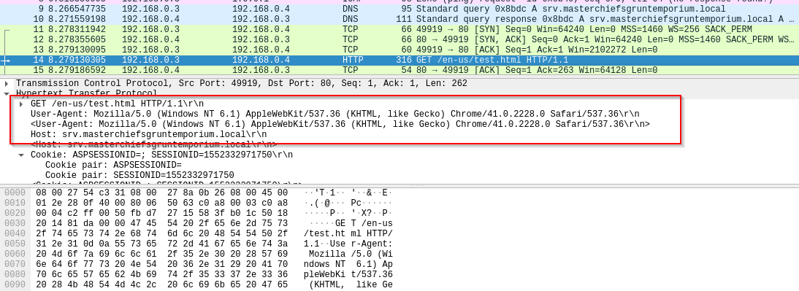
Figure : Wireshark packet capture showing HTTP call to C2 server

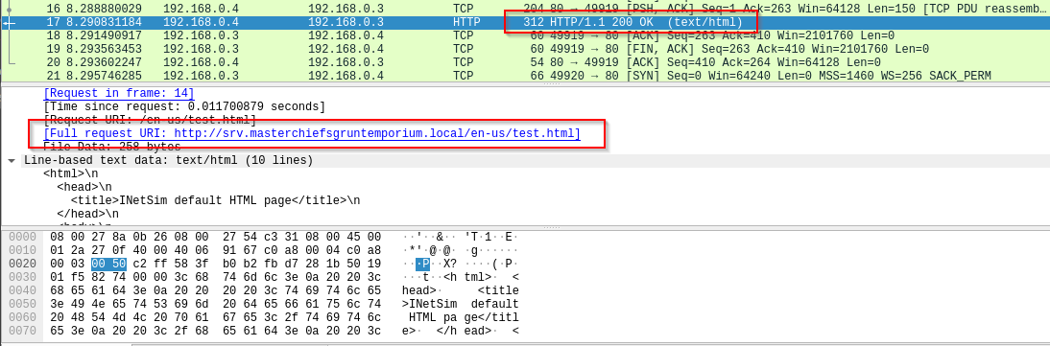
Figure : Successful request on port 80

Each time the infected machine’s user logs back in, embed.vbs is executed with embed.xml arguments and the C2 server is contacted. VBScript is used to launch a system shell and run MSBuild indirectly to evade detection.
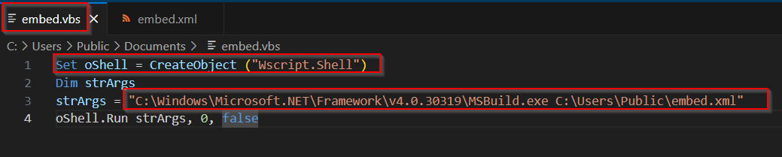

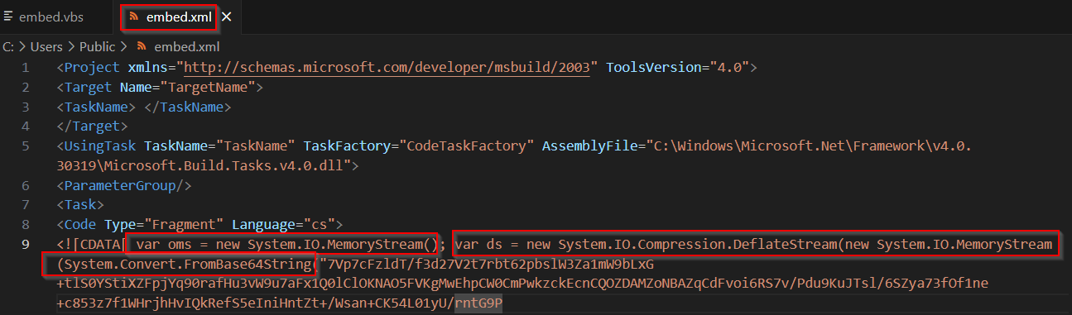
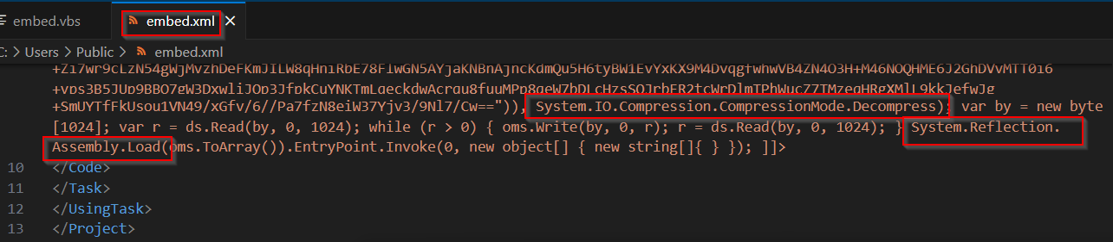
Figure : XML arguments for embed.vbs to run MSBuild

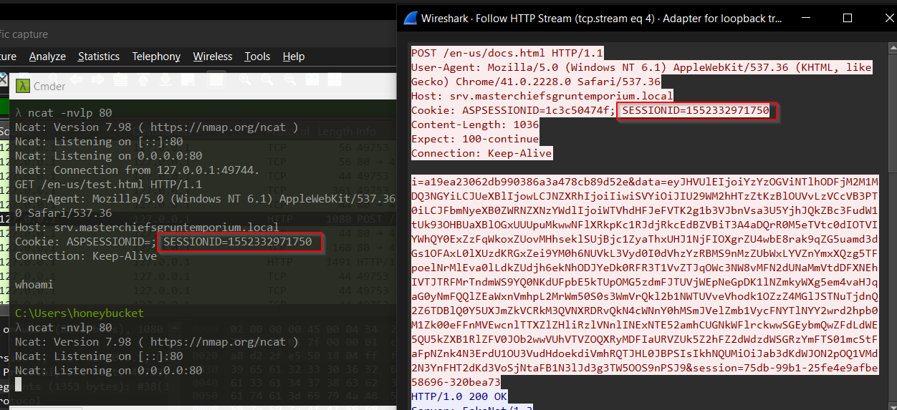
Figure : Ncat and Wireshark captured C2 beacon for decryption

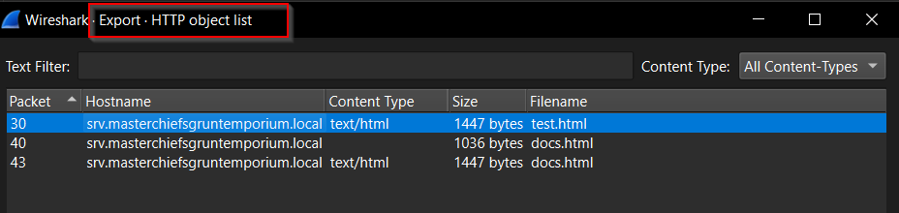
Figure : Exported HTML POST file from PCAP

After decrypting the message portion in this HTTP POST we can identify these possible parts:
Total bytes: 64
GUID : 4f1113988d3b14972c77
Opcode : 0x154615aa
Payload length: 50
Beacon ID : 0x8938d318 (2302202648)
Uptime low : 0x38a4de1c (950328860)
Uptime high : 0xdd007378 (3707794296)
Flags : 0x5d30d302 (1563480834)
OS version : 0x0d221e46 (220339782)
PID : 0x1db5043a (498402362)
PPID : 0xd584cc5d (3582250077)
Arch : 0x981f4c53 (2552187987)
Privilege : 0x8e487bff (2387115007)
Net status : 0x162a26c5 (371861189)
Unknown 1 : 0x30ca19da (818551258)
Unknown 2 : 0x3c6764c9 (1013408969)
Checksum : 0x00005a13 (23059)

Advanced Static Analysis
{Screenshots and description about findings during advanced static analysis}

Advanced static analysis of the malware reveals a multi-stage dropper and loader implemented as a .NET DLL with deliberate obfuscation and nonstandard execution behavior to hinder debugging and automated analysis.

The DLL is not intended to be executed directly via standard loaders, which explains debugger errors such as “invalid extension” when attempting to run it in dnSpy. Instead, it is designed for reflective or indirect loading.

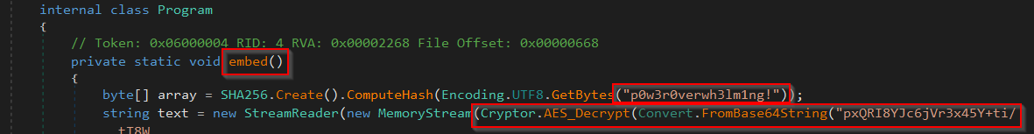
Figure : Hardcoded password and AES decryption of a base64 string

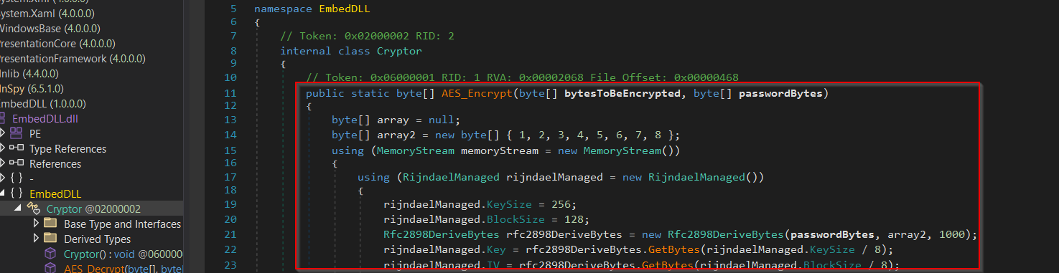
Figure : AES encryption function

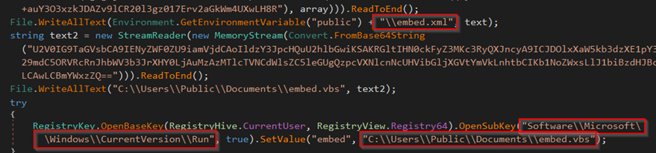
Figure : Name and location of dropped VBS script and XML file to be loaded at user logon

Static Analysis Key Findings
- The malware stores its primary payload as an encrypted, Base64-encoded embedded resource within the DLL, preventing plaintext exposure on disk. Decryption is performed at runtime using a custom AES-256-CBC implementation with PBKDF2 (SHA-1, 1000 iterations) and a hardcoded UTF-16LE password, with all cryptographic parameters statically defined.

- Once decrypted, the payload is assembled entirely in memory as a custom binary structure rather than a standard PE or serialized format. The data layout includes fixed-length fields consistent with session identifiers, timestamps, flags, and command metadata.

- Execution relies on reflective loading and dynamic invocation of managed code, avoiding disk-backed module loading. Static code paths also reveal registry-based persistence and indirect execution via trusted Windows binaries, enabling living-off-the-land techniques.

- Network communication uses a bespoke binary C2 protocol, with manually packed and parsed messages instead of common serialization formats, indicating deliberate evasion of signature-based detection.

Advanced Dynamic Analysis
{Screenshots and description about advanced dynamic artifacts and methods}

Indicators of Compromise
The full list of IOCs can be found in the Appendices.

Network Indicators
Domains:
- hxxp://srv[.]masterchiefsgruntemporium[.]local
Protocols:
- HTTP POST with Base64 AES-encrypted payloads
- AES-256-CBC with PBKDF2 (SHA1, 1000 iterations)

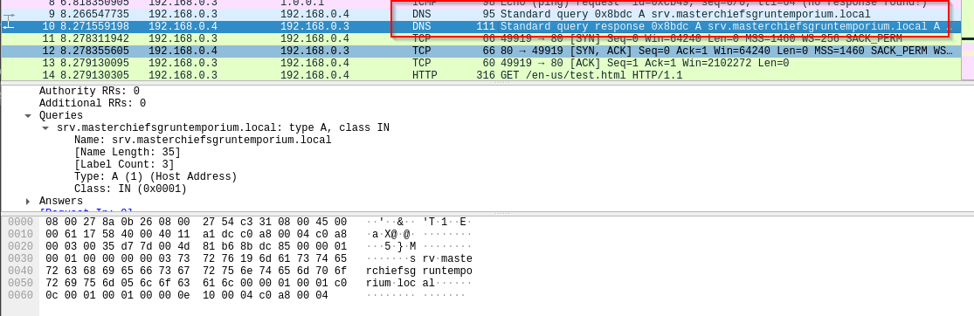
Fig 3: Wireshark packet capture of initial DNS query for callback to C2 server

Fig 4:.

Host-based Indicators

Files:
- C:\Users\Public\embed.xml
- C:\Users\Public\Documents\embed.vbs
Registry:
- HKCU\Software\Microsoft\Windows\CurrentVersion\Run\embed
Processes:
- MSBuild.exe spawned from VBS

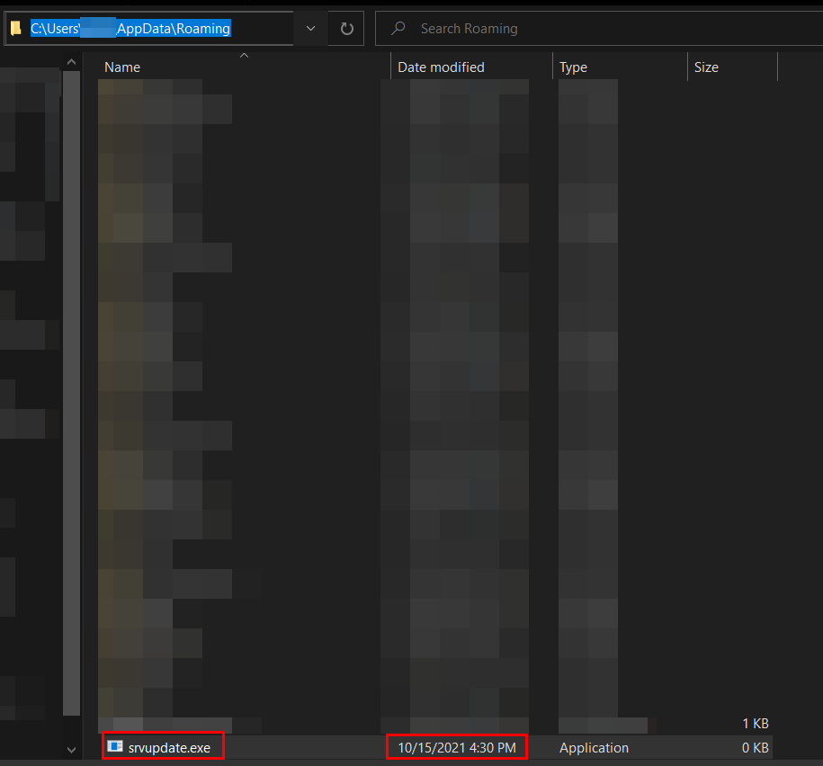

Rules & Signatures
A full set of YARA rules is included in Appendix A.
{Information on specific signatures, i.e. strings, URLs, etc}
Static File Signatures
The malware can be reliably identified using a combination of the following static indicators:
- Hardcoded cryptographic artifacts
  - UTF-16LE encoded AES password string used for PBKDF2 key derivation
  - Fixed PBKDF2 parameters (SHA-1, 1000 iterations, static salt)
- Embedded resource indicators
  - Presence of encrypted Base64 blobs stored in .rsrc / .rsdata sections
  - Resource names and namespaces consistent with embedded payload handling (e.g., EmbedDLL)
- .NET reflection artifacts
  - References to System.Reflection.Assembly::Load
  - Dynamic invocation patterns (GetType, GetMethod, Invoke)
- Custom protocol constants
  - Fixed-length binary structures used after decryption (e.g., 64-byte beacon headers)
  - Repeated magic values and field offsets associated with GUID/session identifiers
Behavioral / Heuristic Signatures
Additional detection opportunities exist through behavior-based rules:
- In-memory execution
  - Assembly loading directly from byte arrays without dropping a PE to disk
- Persistence mechanisms
  - Registry modification under:
  - HKCU\Software\Microsoft\Windows\CurrentVersion\Run
- Living-off-the-Land execution
  - Use of trusted Windows binaries (e.g., MSBuild.exe) to execute attacker-controlled code indirectly
- Custom cryptographic routines
  - Manual AES decryption logic rather than use of standard secure communication libraries
Network & C2 Signatures
Although encrypted, C2 traffic exhibits detectable structure:
- Deterministic AES-CBC encryption
  - Static key derivation allows retrospective decryption of captured traffic
- Non-standard application protocol
  - Fixed-size binary messages rather than JSON, XML, or known serialization formats
  - Consistent ordering of fields such as session identifiers, timestamps, command IDs, and flags
- Absence of compression
  - Payload entropy consistent with encryption only, without secondary compression layers

Strings Analysis:
- These indicate a .NET loader:
v4.0.30319
mscoree.dll
System.Reflection
Assembly.Load

- Embedded Payload Indicators:
EmbedDLL.dll
EmbedDLL
\EmbedDLL.dll
InternalName: EmbedDLL.dll
OriginalFilename: EmbedDLL.dll

- AES Encryption of Embedded Payload Indicators:
System.Security.Cryptography
RijndaelManaged
Rfc2898DeriveBytes
AES_Encrypt
AES_Decrypt
passwordBytes
bytesToBeEncrypted
bytesToBeDecrypted

- Hardcoded Password:
p0w3r0verwh3lm1ng!

- Large Base64 / High Entropy Blobs:
pxQRI8YJc6jVr3x45Y+ti/tT8W+3HpQHbcw1yZJQ9goNh...

- In-Memory Execution Indicators:
System.Reflection
MemoryStream
Assembly
InitializeArray
MethodInfo.Invoke (implied)

- Script-based Secondary Execution:
U2V0IG9TaGVsbCA9IENyZWF0ZU9iamVjdCAoIldzY3JpcHQuU2hlbGwiKSAK... which converts to C:\Windows\Microsoft.NET\Framework\v4.0.30319\MSBuild.exe

- LoL Execution Script Drop Location:
C:\Users\Public\Documents\embed.vbs

- Persistence Mechanism Registry Key:
HKCU\Software\Microsoft\Windows\CurrentVersion\Run

Appendices

Yara Rules
Full Yara repository located at: https://github.com/scryptic86/EmbedDLL-C2-C-Sharp

rule EmbedDLL_PowerOverwhelming_AES_C2
{
meta:
author = "Clinton Asprey"
description = "Detects EmbedDLL AES-C2 implementation"
confidence = "high"
malware_family = "Custom C2 .NET backdoor"
last_updated = "2026-01-02"

strings:
/* Password (UTF-16LE) */
$pwd = "p0w3r0verwh3lm1ng!" wide

/* PBKDF2 salt */
$salt = { 01 02 03 04 05 06 07 08 }

/* .NET crypto */
$rij = "RijndaelManaged"
$pbkdf = "Rfc2898DeriveBytes"

/* JSON C2 fields */
$json1 = "\"EncryptedMessage\""
$json2 = "\"IV\""
$json3 = "\"HMAC\""
$json4 = "\"GUID\""

/* Reflection loading */
$reflect = "System.Reflection"

condition:
uint16(0) == 0x5A4D and // PE
all of ($json*) and
$salt and
$pwd and
2 of ($rij, $pbkdf, $reflect)
}

Callback URLs

Domain | Port
hxxp:// srv.masterchiefsgruntemporium.local | 80

Decompiled Code Snippets

Fig 5:

Analyst Summary
This malware represents a classic encrypted loader design leveraging AES encryption, registry persistence, and LOLBins (MSBuild) for stealthy execution. The use of reflection and encrypted embedded payloads significantly complicates static detection while maintaining simple operational logic.
Detection should prioritize cryptographic API usage, registry persistence patterns, and anomalous MSBuild invocation.

MITRE ATT&CK Technique Mapping
T1055 – Process Injection / Reflective DLL Loading
T1027 – Obfuscated / Encrypted Payloads
T1059.005 – Command and Scripting Interpreter: Visual Basic
T1218.005 – Signed Binary Proxy Execution: MSBuild
T1547.001 – Registry Run Keys
T1071.001 – Application Layer Protocol: Web
T1041 – Exfiltration Over C2 Channel

