

Practical Malware Analysis & Triage
Malware Analysis Report

C2.Bootstrap.Dropper.Loader

January 2, 2026 | Clinton Asprey| v1.0

Table of Contents
Table of Contents 2
Executive Summary 4
Analysis Environment & Methodology 5
High-Level Technical Summary 7
Execution Timeline 8
Malware Composition 10
EmbedDLL.dll 10
embed.vbs 10
embed.xml 11
Basic Static Analysis 12
Stage 1 - Loader 12
Stage 2 - EmbedDLL 13
Stage 3 – VBScript Launcher 15
Stage 4: C2 Agent 16
Basic Dynamic Analysis 17
Stage 1 21
Stage 2 21
Stage 3 21
Stage 4 21
Advanced Static Analysis 22
Stage 1 24
Stage 2 24
Stage 3 24
Stage 4 24
Advanced Dynamic Analysis 25
Indicators of Compromise 26
Stage 1 26
Stage 2 27
Stage 3 29
Stage 4 29
Rules & Signatures 30
Appendices 34
A. Yara Rules 34
B. Callback URLs 35
C. Decompiled Code Snippets 35
Analyst Summary 36
MITRE ATT&CK Technique Mapping 36

Executive Summary

SHA256 hash | 732f235784cd2a40c82847b4700fb73175221c6ae6c5f7200a3f43f209989387

This report analyzes the EmbedDLL.dll malware, a .NET-based encrypted dropper and loader that deploys a secondary payload using DLL reflection and Living-off-the-Land binaries. The malware is designed to evade static detection through AES-encrypted embedded resources and reflective assembly loading. Persistence is achieved via registry Run keys and execution is proxied through MSBuild. C2 server beaconing is also established.

Analysis Note: The DLL sample (Malware.cryptlib64.dll) requires a hosting process for execution. For this analysis, a minimal .NET loader was created to facilitate dynamic analysis. The loader is not part of the malware distribution chain but serves as an analysis tool.

Analysis Environment & Methodology

Controlled Execution Setup
To analyze the managed .NET DLL (Malware.cryptlib64.dll), a controlled execution environment was established. The DLL requires a hosting process, as it contains managed code entry points that cannot execute standalone.

Custom Loader Implementation
To debug Malware.cryptlib64.dll, this analyst created a .NET 4.7.2 console application named Loader.exe in Visual Studio Community to load the DLL code.

Loader.exe is not part of the original malware sample.

This loader mimics real-world execution patterns by:

- Loading Mechanism: Using .NET Reflection APIs Assembly[.]LoadFile(), MethodInfo[.]Invoke()
- Entry Point: Calling EmbedDLL[.]Program[.]embed() method
- Isolation: Running in a controlled VM with monitoring tools

Loader Purpose: Enable observation of DLL’s core functionality independent of specific delivery chains.

Real-World Equivalents: Similar loading techniques are observed in:
- Office macro payloads
- PowerShell/Cscript stagers
- Exploit kit second-stage loaders
- Legitimate process abuse (e.g., regsvr32, installutil)

Monitoring Tools & Setup
- Static Analysis: Floss, PEStudio, Cutter
- Network: Wireshark, FakeNet-NG, Inetsim
- System: Process Monitor, API Monitor
- Memory: System Informer
- .NET-specific: dnSpy, dnSpy-x86

Assumptions & Limitations
- The DLL's behavior is analyzed independent of initial infection vector
- C2 infrastructure was simulated/isolated to prevent external communication
- All findings reflect the DLL's capabilities when properly loaded

High-Level Technical Summary

The analyzed DLL functions as a persistence-focused payload dropper. Upon execution, it decrypts a hardcoded password-derived key, writes the decrypted XML payload to disk, and installs a VBScript launcher in the user’s startup registry. This VBScript leverages MSBuild to execute the embedded XML payload, enabling fileless or proxy execution while maintaining persistence across reboots. Callback to a C2 server is also initiated.

Execution Timeline
- Execution of EmbedDLL.dll
- AES decryption of embedded payload
- Decrypted XML payload written to disk
- VBS launcher created
- Persistence via Run registry key
- MSBuild execution of decrypted payload
- Reflective assembly load
- Encrypted C2 communication begins

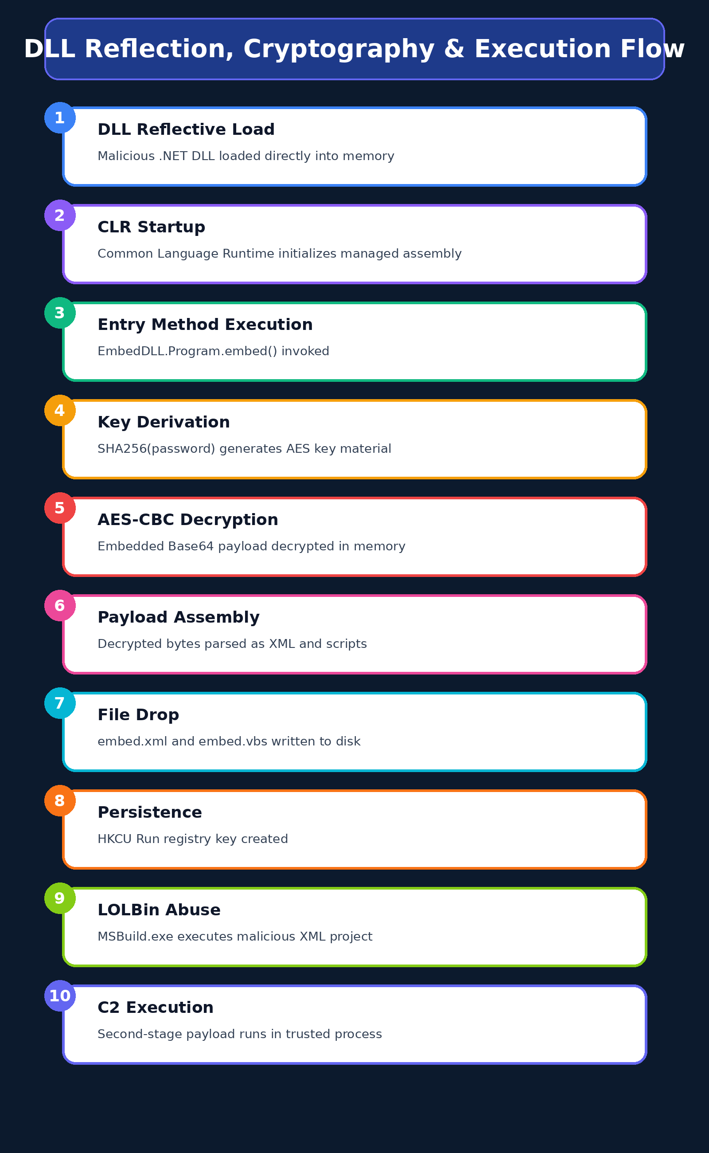

Malware Composition

Malware.cryptlib64.dll consists of the following components:

File Name | SHA256 Hash
EmbedDLL.dll | 732f235784cd2a40c82847b4700fb73175221c6ae6c5f7200a3f43f209989387
embed.vbs | 66fd543f31545082cf8fcc45a6ab1094bc118c45634f2be450f84f4e5745b291
embed.xml | f1548cd02784606c8abac865abf5ed6220d34eea88c7a5715e0183d7f050f4ab

EmbedDLL.dll
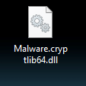
Figure 1: The hidden file name of Malware.cryptlib64.dll is EmbedDLL.dll which is detonated in this lab with rundll32.

embed.vbs

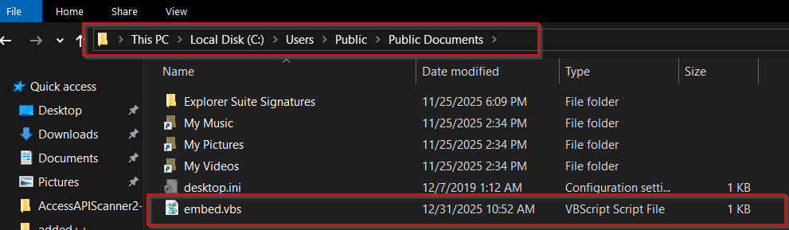
Figure 2: embed.vbs VBscript dropped by EmbedDLL.dll and ran upon user login

embed[.]xml

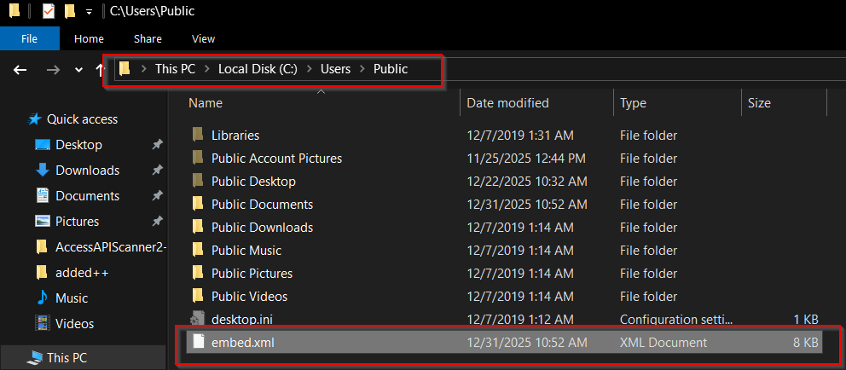
Figure 3: The XML payload is dropped in Public user folder

Basic Static Analysis
{Screenshots and description about basic static artifacts and methods}

Stage 1 – EmbedDLL.dll

- Filename: Malware.cryptlib64.dll
- File size: 29184 bytes
- Entropy: 4.178
- File type: dynamic-link-library, 64-bit, console
- Architecture: x64
- Compilation timestamp: Sun Oct 10 18:14:49 2021 (UTC)
- Digital signature: None
- Suspicious sections: .sdata
- Embedded resources: EmbedDLL.dll
- Indicators of packing or encryption: AES Encryption
- Anti-analysis techniques observed: Hidden File Name (EmbedDLL.dll)
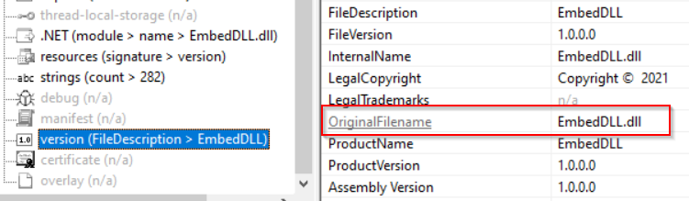
Figure : Hidden file name
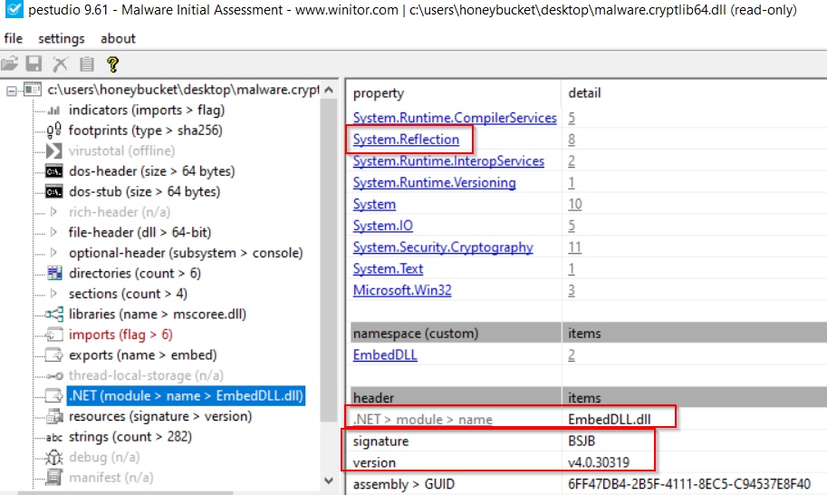
Figure : .NET module detected

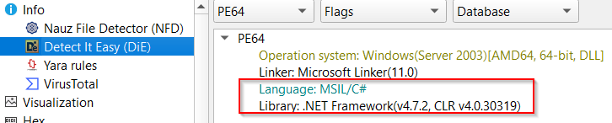
Figure: Indicators of C# language and .NET Framework

Notable Embedded Strings and Indicators

Imported functions / APIs:
AES_Encrypt
AES_Decrypt
CreateEncryptor
GetEnvironmentVariable
WriteAllText
MemoryStream

Suspicious Strings:

Stage 2 – VBScript Persistent Launcher

Notable Embedded Strings and Indicators

Stage 3: Grunt HTTP Stager

- Filename: bk1ha411.4nu.exe
- SHA256: B8E0EC99C18BF28062FFB9BB385C0109A27AF71D332BC7FC00580D88D3A30721
- Entropy: 5.181
- File Size: 11776 bytes
- File Type: MZ
- Architecture: x64

Notable Embedded Strings and Indicators
- Hardcoded C2 endpoint:
hxxp://srv[.]masterchiefsgruntemporium[.]local:80
- Beacon parameter format:
i=<id>&data={encrypted}&session=<token>
- HTTP masquerading:
  - User-Agent: Mozilla/5.0 (Windows NT 6.1)…Chrome/41.0…
  - Cookie template: ASPSESSIONID={GUID}; SESSIONID=…
- Encrypted message structure:
{"GUID":"{0}","Type":{1},"Meta":"{2}","IV":"{3}",
"EncryptedMessage":"{4}","HMAC":"{5}"}
- Certificate pinning indicators:
UseCertPinning, ValidateCert, CovenantCertHash
- Framework identifiers:
GruntStager, ExecuteStager, CookieWebClient

Stage 4: Final Covenant Implant

Basic Dynamic Analysis
{Screenshots and description about basic dynamic artifacts and methods}

This DLL functions as an encrypted dropper-loader responsible for decrypting, staging, and executing a secondary payload via MSBuild, while establishing user-level persistence.

During execution, the malware encrypts command-and-control (C2) communications using AES-256 in CBC mode. Key material is derived via PBKDF2 with SHA-1 (1,000 iterations) and a hard-coded password encoded as UTF-16LE. Network traffic captured from the sample shows that encrypted messages are Base64-encoded prior to transmission.

Once decrypted, the C2 payload does not conform to any standard serialization or compression format. Instead, it consists of a proprietary binary protocol composed of fixed-length fields. These fields include a session identifier resembling a GUID, followed by structured metadata such as opcode values, host identifiers, and status or command data. No evidence of secondary compression or obfuscation is present beyond the initial AES encryption layer.

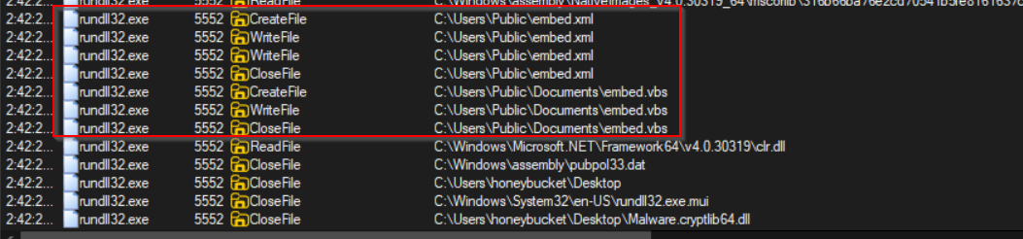
Figure : ProcMon shows files dropped and registry key set upon first run

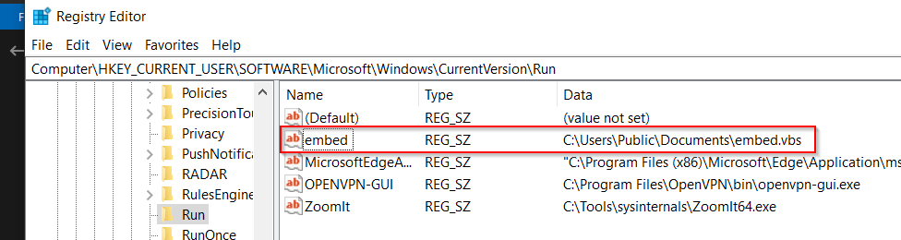
Figure : Persistence registry key created after initial EmbedDLL.dll execution

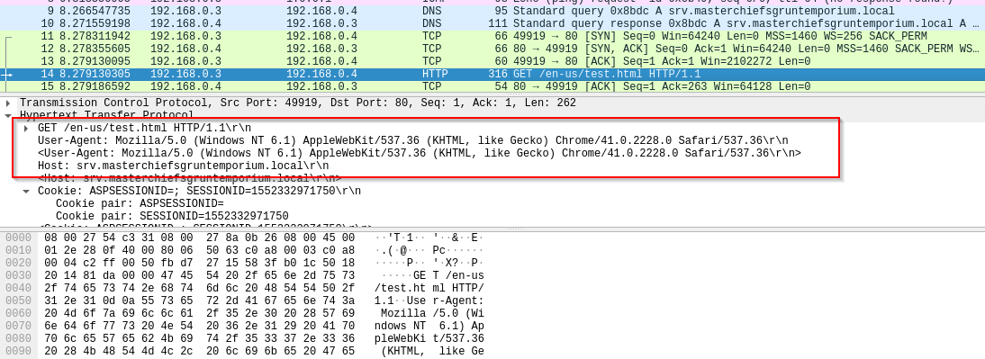
Figure : Wireshark packet capture showing HTTP call to C2 server

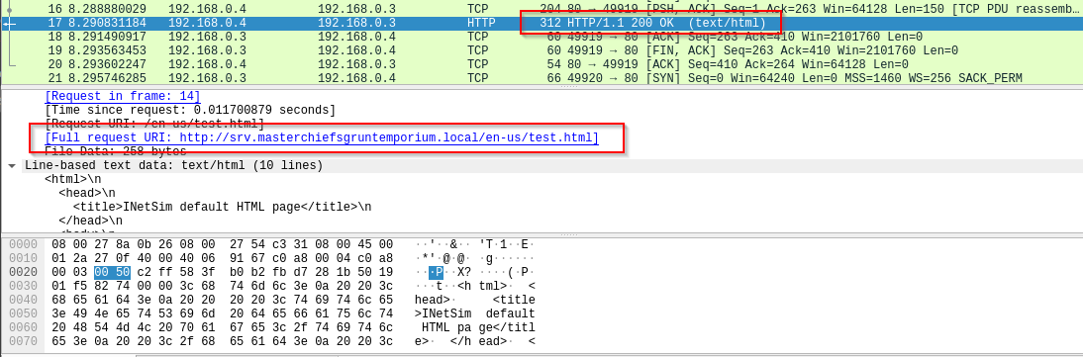
Figure : Successful request on port 80

Each time the infected machine’s user logs back in, embed.vbs is executed with embed.xml arguments and the C2 server is contacted. VBScript is used to launch a system shell and run MSBuild indirectly to evade detection.
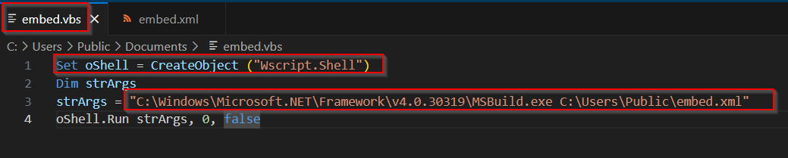

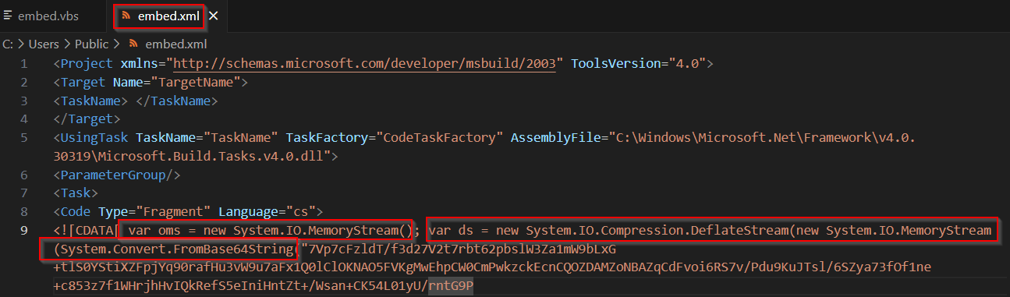
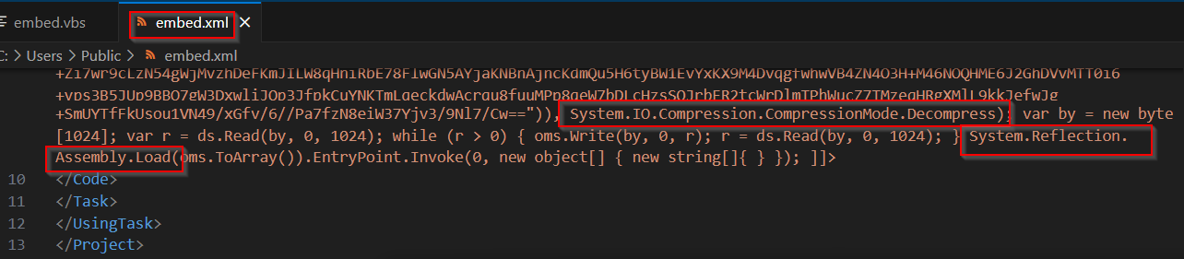
Figure : XML arguments for embed[.]vbs to run MSBuild

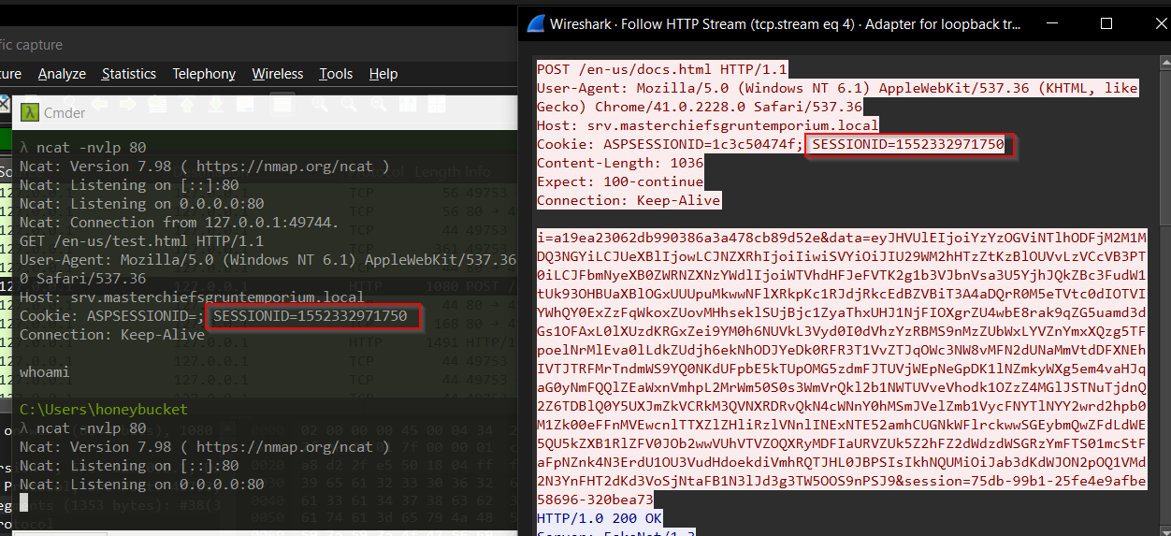
Figure : Ncat and Wireshark captured C2 beacon for decryption

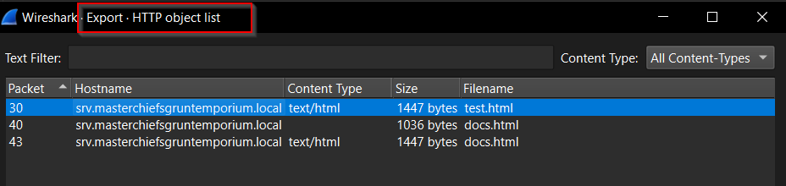
Figure : Exported HTML POST file from PCAP

After decrypting the message portion in this HTTP POST we can identify these possible parts:
Total bytes: 64
GUID : 4f1113988d3b14972c77
Opcode : 0x154615aa
Payload length: 50
Beacon ID : 0x8938d318 (2302202648)
Uptime low : 0x38a4de1c (950328860)
Uptime high : 0xdd007378 (3707794296)
Flags : 0x5d30d302 (1563480834)
OS version : 0x0d221e46 (220339782)
PID : 0x1db5043a (498402362)
PPID : 0xd584cc5d (3582250077)
Arch : 0x981f4c53 (2552187987)
Privilege : 0x8e487bff (2387115007)
Net status : 0x162a26c5 (371861189)
Unknown 1 : 0x30ca19da (818551258)
Unknown 2 : 0x3c6764c9 (1013408969)
Checksum : 0x00005a13 (23059)

Stage 1 – EmbedDLL.dll

Stage 2 – VBScript Persistent Launcher

Stage 3: Grunt HTTP Stager

Stage 4: Final Covenant Implant

Advanced Static Analysis
{Screenshots and description about findings during advanced static analysis}

Advanced static analysis of the malware reveals a multi-stage dropper and loader implemented as a .NET DLL with deliberate obfuscation and nonstandard execution behavior to hinder debugging and automated analysis.

The DLL is not intended to be executed directly via standard loaders, which explains debugger errors such as “invalid extension” when attempting to run it in dnSpy. Instead, it is designed for reflective or indirect loading.

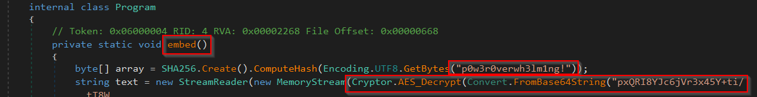
Figure : Hardcoded password and AES decryption of a base64 string

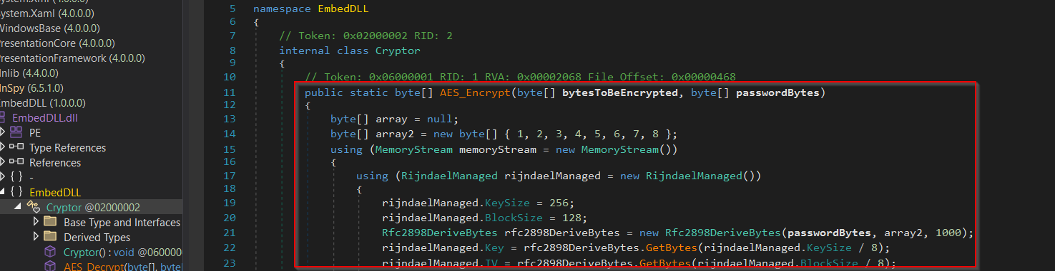
Figure : AES encryption function

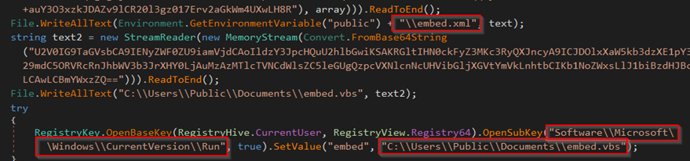
Figure : Name and location of dropped VBS script and XML file to be loaded at user logon

Static Analysis Key Findings
- The malware stores its primary payload as an encrypted, Base64-encoded embedded resource within the DLL, preventing plaintext exposure on disk. Decryption is performed at runtime using a custom AES-256-CBC implementation with PBKDF2 (SHA-1, 1000 iterations) and a hardcoded UTF-16LE password, with all cryptographic parameters statically defined.

- Once decrypted, the payload is assembled entirely in memory as a custom binary structure rather than a standard PE or serialized format. The data layout includes fixed-length fields consistent with session identifiers, timestamps, flags, and command metadata.

- Execution relies on reflective loading and dynamic invocation of managed code, avoiding disk-backed module loading. Static code paths also reveal registry-based persistence and indirect execution via trusted Windows binaries, enabling living-off-the-land techniques.

- Network communication uses a bespoke binary C2 protocol, with manually packed and parsed messages instead of common serialization formats, indicating deliberate evasion of signature-based detection.

Stage 1 – EmbedDLL.dll

Stage 2 – VBScript Persistent Launcher

Stage 3: Grunt HTTP Stager

Stage 4: Final Covenant Implant

Advanced Dynamic Analysis
{Screenshots and description about advanced dynamic artifacts and methods}

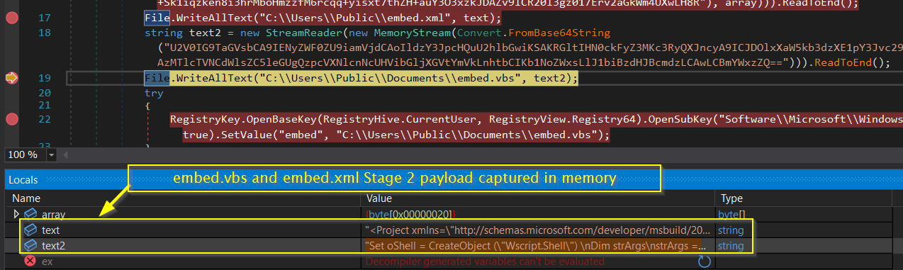
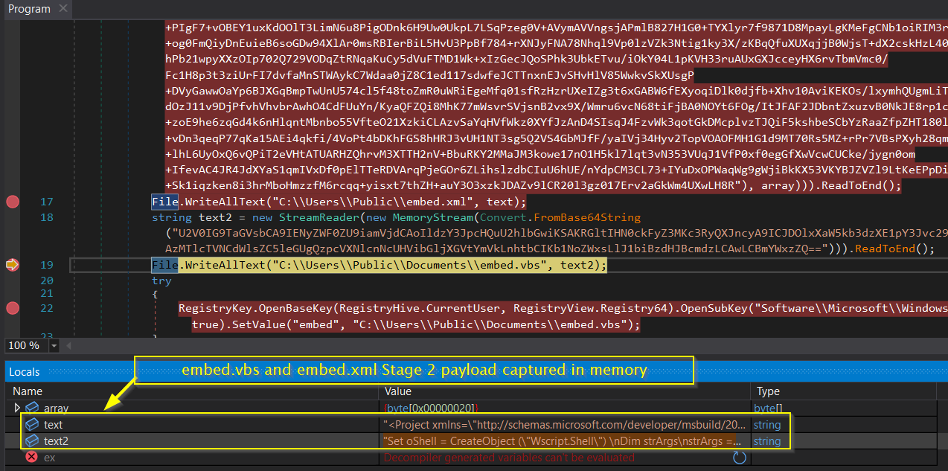

Indicators of Compromise
The full list of IOCs can be found in the Appendices.

Stage 1 – EmbedDLL.dll
Category | Indicator | Type | Stage | Description
File | Malware.cryptlib64.dll | DLL | Stage 1 | Primary dropper and decrypter component
File | embed.xml | XML Payload | Stage 1 | Contains decrypted Stage 2 payload
File | embed.vbs | VBS Script | Stage 1 | Executes decrypted payload and establishes persistence
Registry | HKCU...\Run | Run Key | Stage 1 | Registry auto-start persistence mechanism
API | Assembly.LoadFile | Reflection API | Stage 1 | Dynamically loads malicious DLL into memory
Crypto | AES_Decrypt | Function Call | Stage 1 | Decrypts embedded encrypted payload

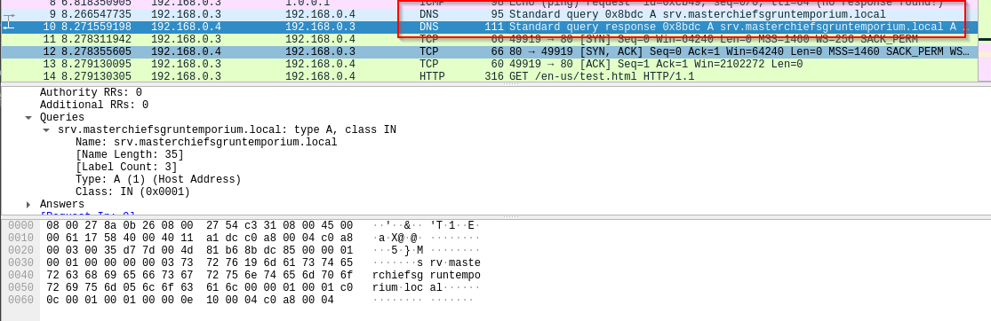
Fig 3: Wireshark packet capture of initial DNS query for callback to C2 server

Fig 4:.

Stage 2 – VBScript Persistent Launcher
Category | Indicator | Type | Description
Network | hxxp://srv[.]masterchiefsgruntemporium[.]local:80 | C2 URL | Hardcoded command-and-control endpoint used by the implant
Network | /en-us/index[.]html | URI Path | Decoy HTTP path used during beaconing
Network | /en-us/docs[.]html | URI Path | Alternate decoy path for C2 communications
Network | /en-us/test[.]html | URI Path | Alternate decoy path for C2 communications
Network | i=a19ea23062db990386a3a478cb89d52e&data={0}&session=75db-99b1-25fe4e9afbe58696-320bea73 | HTTP Parameter Pattern | Beacon request format containing implant ID, encrypted payload, and session token
Network | Mozilla/5.0 (Windows NT 6.1) AppleWebKit/537.36 (KHTML, like Gecko) Chrome/41.0.2228.0 Safari/537.36 | User-Agent | Hardcoded User-Agent string used to masquerade as Chrome traffic
Network | ASPSESSIONID={GUID}; SESSIONID=1552332971750 | Cookie Template | Session cookie format used for C2 communication
C2 Protocol | {"GUID":"{0}","Type":{1},"Meta":"{2}","IV":"{3}","EncryptedMessage":"{4}","HMAC":"{5}"} | JSON Message Format | Encrypted C2 message structure containing IV, ciphertext, and HMAC
Host | bk1ha411.4nu.exe | Filename | Observed implant executable filename
Host | bk1ha411.4nu | Implant ID | Base implant name used internally by the malware
Crypto | HMACSHA256 | Algorithm | Message authentication algorithm used to protect C2 traffic
Crypto | aFM+yqzILW3R/AY/pnxI8VIYvdjnPdfYw8Xlqy31tvU= | Base64 Key / Hash | Embedded cryptographic material used for HMAC or key derivation
Crypto | c638eb59a8 | Token / Identifier | Short embedded identifier associated with encryption or session handling
TLS / Evasion | UseCertPinning | Function Name | Enables certificate pinning to prevent TLS interception
TLS / Evasion | ValidateCert | Function Name | Custom certificate validation routine
TLS / Evasion | CovenantCertHash | Certificate Hash Label | Pinned certificate hash associated with Covenant framework
Malware Family | GruntStager | Class Name | Covenant framework stager identifier
Malware Family | ExecuteStager | Function Name | Primary routine responsible for staging payload execution
Malware Family | CookieWebClient | Class Name | Custom HTTP client wrapper used for C2 communications

Stage 3: Grunt HTTP Stager

Stage 4: Final Covenant Implant

Analysis Artifacts (NOT MALICIOUS)
- Loader.exe (custom analysis tool, SHA256: ...)
- Debug symbols from controlled execution

Rules & Signatures
A full set of YARA rules is included in Appendix A.
{Information on specific signatures, i.e. strings, URLs, etc}
Static File Signatures
The malware can be reliably identified using a combination of the following static indicators:
- Hardcoded cryptographic artifacts
  - UTF-16LE encoded AES password string used for PBKDF2 key derivation
  - Fixed PBKDF2 parameters (SHA-1, 1000 iterations, static salt)
- Embedded resource indicators
  - Presence of encrypted Base64 blobs stored in .rsrc / .rsdata sections
  - Resource names and namespaces consistent with embedded payload handling (e.g., EmbedDLL)
- .NET reflection artifacts
  - References to System.Reflection.Assembly::Load
  - Dynamic invocation patterns (GetType, GetMethod, Invoke)
- Custom protocol constants
  - Fixed-length binary structures used after decryption (e.g., 64-byte beacon headers)
  - Repeated magic values and field offsets associated with GUID/session identifiers
Behavioral / Heuristic Signatures
Additional detection opportunities exist through behavior-based rules:
- In-memory execution
  - Assembly loading directly from byte arrays without dropping a PE to disk
- Persistence mechanisms
  - Registry modification under:
  - HKCU\Software\Microsoft\Windows\CurrentVersion\Run
- Living-off-the-Land execution
  - Use of trusted Windows binaries (e.g., MSBuild.exe) to execute attacker-controlled code indirectly
- Custom cryptographic routines
  - Manual AES decryption logic rather than use of standard secure communication libraries
Network & C2 Signatures
Although encrypted, C2 traffic exhibits detectable structure:
- Deterministic AES-CBC encryption
  - Static key derivation allows retrospective decryption of captured traffic
- Non-standard application protocol
  - Fixed-size binary messages rather than JSON, XML, or known serialization formats
  - Consistent ordering of fields such as session identifiers, timestamps, command IDs, and flags
- Absence of compression
  - Payload entropy consistent with encryption only, without secondary compression layers

Strings Analysis:
- These indicate a .NET loader:
v4.0.30319
mscoree.dll
System.Reflection
Assembly.Load

- Embedded Payload Indicators:
EmbedDLL.dll
EmbedDLL
\EmbedDLL.dll
InternalName: EmbedDLL.dll
OriginalFilename: EmbedDLL.dll

- AES Encryption of Embedded Payload Indicators:
System.Security.Cryptography
RijndaelManaged
Rfc2898DeriveBytes
AES_Encrypt
AES_Decrypt
passwordBytes
bytesToBeEncrypted
bytesToBeDecrypted

- Hardcoded Password:
p0w3r0verwh3lm1ng!

- Large Base64 / High Entropy Blobs:
pxQRI8YJc6jVr3x45Y+ti/tT8W+3HpQHbcw1yZJQ9goNh...

- In-Memory Execution Indicators:
System[.]Reflection
MemoryStream
Assembly
InitializeArray
MethodInfo.Invoke (implied)

- Script-based Secondary Execution:
U2V0IG9TaGVsbCA9IENyZWF0ZU9iamVjdCAoIldzY3JpcHQuU2hlbGwiKSAK... which converts to C:\Windows\Microsoft[.]NET\Framework\v4.0.30319\MSBuild[.]exe

- LoL Execution Script Drop Location:
C:\Users\Public\Documents\embed[.]vbs

- Persistence Mechanism Registry Key:
HKCU\Software\Microsoft\Windows\CurrentVersion\Run

Appendices

Yara Rules
Full Yara repository located at: https://github.com/scryptic86/EmbedDLL-C2-C-Sharp

rule EmbedDLL_PowerOverwhelming_AES_C2
{
meta:
author = "Clinton Asprey"
description = "Detects EmbedDLL AES-C2 implementation"
confidence = "high"
malware_family = "Custom C2 .NET backdoor"
last_updated = "2026-01-02"

strings:
/ Password (UTF-16LE) /
$pwd = "p0w3r0verwh3lm1ng!" wide

/ PBKDF2 salt /
$salt = { 01 02 03 04 05 06 07 08 }

/ .NET crypto /
$rij = "RijndaelManaged"
$pbkdf = "Rfc2898DeriveBytes"

/ JSON C2 fields /
$json1 = "\"EncryptedMessage\""
$json2 = "\"IV\""
$json3 = "\"HMAC\""
$json4 = "\"GUID\""

/ Reflection loading /
$reflect = "System[.]Reflection"

condition:
uint16(0) == 0x5A4D and // PE
all of ($json) and
$salt and
$pwd and
2 of ($rij, $pbkdf, $reflect)
}

Callback URLs

Domain | Port
hxxp:// srv[.]masterchiefsgruntemporium[.]local | 80

Decompiled Code Snippets

Fig 5:

Analyst Summary
This malware represents a classic encrypted loader design leveraging AES encryption, registry persistence, and LOLBins (MSBuild) for stealthy execution. The use of reflection and encrypted embedded payloads significantly complicates static detection while maintaining simple operational logic.
Detection should prioritize cryptographic API usage, registry persistence patterns, and anomalous MSBuild invocation.

MITRE ATT&CK Technique Mapping
T1055 – Process Injection / Reflective DLL Loading
T1027 – Obfuscated / Encrypted Payloads
T1059.005 – Command and Scripting Interpreter: Visual Basic
T1218.005 – Signed Binary Proxy Execution: MSBuild
T1547.001 – Registry Run Keys
T1071.001 – Application Layer Protocol: Web
T1041 – Exfiltration Over C2 Channel

