**When working from home adopt the 6 R’s**

**Reduce, Reuse, Recycle, Repurpose, Refuse & Rejuvenate**

You have been working from home for a while. Are you suffering from Zoom fatigue? Let’s learn how to practice the 6 R’s to help you sustain yourself and the environment while working from home. We will take one R at a time. You will learn how you can relax, stretch and recharge yourself while on Zoom. You can make simple changes to your surroundings at home to have a more inviting and sustainable environment. Do you take breaks while sitting? We will finish with a few chair stretches you can do. Just taking a few minutes to do stretches at your desk can relieve stress, increase productive and most importantly make you feel better. Cahir yoga participants can also enjoy other health benefits including improved muscle tone, better breathing habits, stress reduction, better sleep and an improved sense of well-being.

**Reduce**

Use less electricity by having your office by a window and use natural light

Get LED light bulbs

Turn off power or unplug when not using

Dress in layers turn down your heater

Make one trip and stop at all the locations making a list before you shop so that you are efficient in running your errands

Stay away from single use purchases and buy in bulk and use a bowl for your snacks

When you go outside for your walk and to get fresh air take a bag to pick up garbage along your route

**Reuse**

Use water bottles instead of bottled water

Use mug for coffee or tea

Use reusable bags

Practice minimization Beach towels/Pool towels/Bath towels

Use rechargeable batteries

Get an eco-friendly straw

**Recycle**

Gather the hard to recycle items and find a collection site near you

Save your glass and find a glass collection area near you

Buy Nothing Sell Nothing – Facebook Group for your area

Shop the Grove for cleaning products grove.co/home

**Repurpose**

Create a theme for you’re at home work place and use some forgotten items to change up your space. We have been working from home for a while. Do you need to change up your surroundings?

Add plants to your location

Wear second hand clothes to your Zoom meetings

Compost your food waste

Get that comfy chair

Free yourself of stuff so you will have more time to focus on what you truly care about.

**Refuse**

Zoom only schedules meetings on the half hour – block time for a break from Zoom for yourself

Adopt small rituals

Set parameters

Unsubscribe from unwanted email lists

Reply STOP to unwanted texts

Stop being a water waster – make sure you don’t have any drips, install new water saving fixtures, time your showers, turn off the water when brushing your teeth, use the water from your dehumidifier to water plants or for your laundry – cultivate good water habits

Run full loads for your dishwasher and washing machine

You can request no utensils with your to go or pick up orders and there are dining locations that you need to ask for utensils and napkins to keep waste to a minimum. Refuse the straw use a disposable one.

One take-out restaurant that mostly avoids single use plastics is Chipotle.  They food tray is paper and the top is aluminum.  Find more green restaurants here. <https://sustainablepghrestaurants.org/site/restaurant-finder/>

Don’t print – scan, screen shot, copy to chat or screen share, etc. End the paper clutter!

REWARD yourself with something small to look forward to

Manage distractions by putting up a sign or close the door so you can focus and pay attention

Get up earlier and do your harder tasks while it’s quiet and you have a fresh start to your day

When you will be distracted do your low attention tasks or take shifts with another adult so your distraction is minimized when you need to focus

**Rejuvenate**

Look out 2021 – Here I come! I am taking care of number one. ME!

Goals:

Exercise 4 times a week for 20 minutes to develop a habit

Drink more water

Eat more fresh fruits & vegetables

Practice balance daily

Have a meditation/gratitude session

One line a day journal – write a positive comment

Get more sleep

Choose kind and happy

Give yourself grace and patience

Make healthy choices?

Focus on what you can do and control

Avoid Zoom fatigue. Don’t be sedentary try some chair stretches or chair yoga poses to move around between your calls

**Things that may surprise you:**

* Do not bag your curbside items. Place them directly into a blue recycling bin.
* Glass may not be recyclable in your area anymore. Check with your local municipality.
* No pizza boxes if they are soiled. If the top is not soiled, you can cut the top off of it and recycle it separately from the soiled portion.

**Glass:**

There are permanent drop-off locations and many temporary drop-offs. The city has roll offs for glass at Construction Junction and the 31st Street City site in the Strip District. Click on this link for more information

https://pittsburghpa.gov/dpw/drop-off

* Beltzhoover/Knoxville 24 hour drop off

623 Bausman St Pittsburgh, PA 15210

412-225-2631

* Strip District 24 hour drop off

3001 Railroad St Pittsburgh, PA 15201

412-255-2631

* Construction Junction 9am-5pm Monday – Saturday; Sunday Noon-3

214 North Lexington St Pittsburgh, PA 15208

412-243-5025

*To find other locations outside the City of Pittsburgh and/or temporary drop-offs,* [*click here*](https://prc.org/programs/collection-events/glassrecycling/) *or see link below.*

*https://prc.org/programs/collection-events/glassrecycling/*

*Pennsylvania Resources Council’s website is a valuable resource on how to find other drop off locations for other kinds of recyclables (i.e. chemicals, prescriptions, etc.).* [*Click here*](https://prc.org/programs/collection-events/) *or see link below for more info.*

*https://prc.org/programs/collection-events/*

**Household Hazardous Waste (HHW)**

Household Hazardous Waste is typically comprised of unused household products that may explode, catch fire or be generally harmful to the environment if not properly disposed. Follow the link below for more information.

<https://www.dep.pa.gov/Citizens/RecyclingDisposal/HouseholdHazardousWaste/Pages/default.aspx>

Don’t know what an HHW is? Review this document by following the link below

<http://files.dep.state.pa.us/Waste/Bureau%20of%20Waste%20Management/lib/landrecwaste/hhw/hhw.pdf>

Household Hazardous Waste Collection Programs information is found by following this link

<https://www.dep.pa.gov/Business/Land/Waste/SolidWaste/HazardousWaste/Household/Pages/HHW-Collection-Programs.aspx>

Curbside HHW Collection Programs can be found by following this link

https://www.dep.pa.gov/Business/Land/Waste/Recycling/Electronics/Pages/Special-Waste-Materials-Curbside-Collection-Programs.aspx

**Other items:**

Not sure how to recycle books, paper, electronics or other items? Checkout the Allegheny County Recycling Resource Directory by [clicking here](https://www.alleghenycounty.us/uploadedFiles/Allegheny_Home/Health_Department/Programs/Waste-_and_Water-Related/Recycling/Recycling_Resource_Directory.pdf) or see the link below.

https://www.alleghenycounty.us/uploadedFiles/Allegheny_Home/Health_Department/Programs/Waste-_and_Water-Related/Recycling/Recycling_Resource_Directory.pdf

**Need more help?**

* Your County Recycling Coordinator is the number one resource for details on your county’s drop-off locations, municipal recycling programs, special collection events and programs, and other useful local recycling information.

Allegheny County Recycling Coordinator

Joy Smallwood

412-578-8390 or [Joy.Smallwood@AlleghenyCounty.US](mailto:Joy.Smallwood@AlleghenyCounty.US)

*Pennsylvania residents outside of Allegheny County?* [*Click here*](https://www.dep.pa.gov/Business/Land/Waste/Recycling/PublicResources/Pages/County-Recycling-Coordinators.aspx) *or see link below to find your recycling coordinator.*

*https://www.dep.pa.gov/Business/Land/Waste/Recycling/PublicResources/Pages/County-Recycling-Coordinators.aspx*

* Pennsylvania DEP’s Recycling Hotline

800-346-4242

**At home recycling & hazardous waste resources**

The City has roll offs for glass at Construction Conjunction and at the 31st Street City site.

<https://prc.org/programs/collection-events/glassrecycling/>

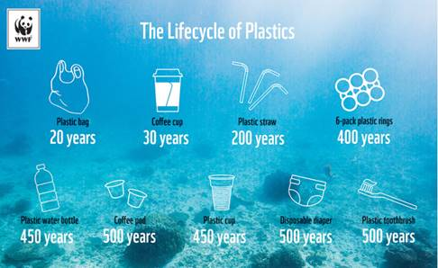

**Deeper Dive** The Ultimate Guide to Working from Home: 26 Tips for Maximum Productivity Here is a helpful guide to help you stay focused and productive working from home.

• **Dean Bokhari Working from Home**

https://www.deanbokhari.com/working-from-home/

**The People’s Ecochallenge 2020 Actions** The People's EcoChallenge is our global community's most popular EcoChallenge, offering a vast library of actions. Check out the 200+ actions that you can practice anytime.

• **People’s EcoChallenge**

https://peoples.ecochallenge.org/

**Compiled by the CMU Green Practices Committee October 30, 2020**

• **Environment at CMU Website**

https://www.cmu.edu/environment/

Chair yoga video and poses

<https://www.verywellfit.com/chair-yoga-poses-3567189?utm_campaign=fitsl&utm_medium=email&utm_source=cn_nl&utm_content=19858007&utm_term>=

* 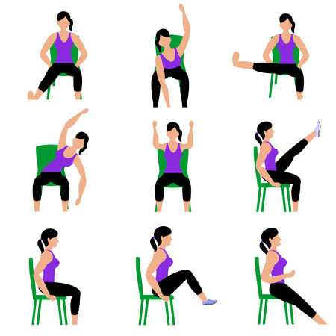

|  |  |
| --- | --- |
| * Chair Exercises | * Stretches |
| * Head | * Head forward and back/side to side |
| * Shoulders | * Shoulders up and down |
| * Arms | * Arm circle |
| * Waist | * Waist bend side to side |
| * Twist | * Twist rotate side to side |
| * Reach | * Reach overhead |
| * Forward Lean | * Forward Bend |
| * Side Bend | * Side Bend and reach |
| * Figure 4 | * Figure 4 lean forward |
| * Knees | * Knee Squeeze |
| * Knee Lift | * Lift both knees up |
| * Legs | * Both legs straight and lean forward |
| * Leg lift | * Lift both legs straight |
| * Wrists | * Move up and down, side to side, supinate & pronate |