data cleaning - vocab size

Stephen Skalicky

22/09/2021

### Thanks to TJ for providing the data and guiding us through the discussion!

The goal of this lesson is to practice data wrangling and exploration with less scaffolding. TJ has provided a data set and what that final data set should look like.

## Loading and observing the dataset

More often than not, raw data looks very different to data that appears in a publication. This means that a lot of time is spent cleaning the data. In this exercise, we will practice the process of cleaning up data. The first thing we need to do is import the data and look at it.

You can download the data from [here](https://www.stephenskalicky.com/r_data/testData.csv).

Or you can pass the URL directly to read_csv to get the data into R.

dat <- read_csv('https://www.stephenskalicky.com/r_data/testData.csv')

##   
## ── Column specification ────────────────────────────────────────────────────────  
## cols(  
## .default = col_double()  
## )  
## ℹ Use `spec()` for the full column specifications.

Examine the data. What does each row represent? What are the column names?

# Main task

## What is the score for each participant, and what is their vocabulary size?

In order to answer these questions we need to do a variety of things.

In the session, we decided it would be fun to compare and contrast the tidyverse and base r methods to answer these questions. The objects with tv at the end are the tidyverse methods, while the objects with b at the end are base R.

### the first task is to get only the VST data (don’t need anything related to levels, age, etc.).

# subset VST data (so we want ID + all of the columns with vst.qX in the name)  
  
# pipe using tidyverse  
vst_data_tv <- dat %>%  
 dplyr::select(c(ID, contains('vst.')))  
  
# subset function from base R  
vst_data_b <- subset(dat, select = grep("ID|vst.", names(dat), value = T))  
  
identical(vst_data_tv, vst_data_b)

## [1] TRUE

### the next task is to remove anyone who has NA for a vst test

# remove NAs (n should = 16) (any row that has an NA anywhere)  
  
# Tidyverse will drop a row where ANY column has an NA  
vst_data_tv1 <- vst_data_tv %>%  
 drop_na(vst.q1)  
  
# Slicing with Base R - looking for NA in the second column only  
# Slicing is a technique used by other programming language (with different syntax) - so it can be a useful method but harder to read  
vst_data_b1 <- vst_data_b[!is.na(vst_data_b[,2]),]

### in case you want to go through some potentially redundant steps here they are

compute sums for each ten questions that make up a 1k freq band rename datvst_summed_by_level's columns to appropriate names

### the next step is to create a table/df/tibble with three columns: person, total score (VST), and total vocabulary (Vsize)

# create a table of person, total score, total vocab size  
# the vst ranges from 0 - 100. let's calculate each subject's score on the vst.  
  
  
# tidyverse method one  
vst_data_tv2 <- vst_data_tv1 %>%  
 rowwise(ID) %>%   
 mutate(VST = sum(c_across(contains('vst'))))  
  
# tidyverse method two (via Micky Vale)  
vst_data_tv2 <- vst_data_tv1 %>%  
 mutate(VST = rowSums(select(., contains('vst'))))  
  
# glue it into a df.   
finalResults_tv <- tibble(person = vst_data_tv1$ID, VST = vst_data_tv2$VST)  
   
# baseRisbestR  
# will need to use apply here because this needs to be done row-wise (i think?)  
vst_data_b2 <- apply(vst_data_b1[,2:ncol(vst_data_b1)], 1, sum)  
  
finalResults_b <- data.frame(person = vst_data_b1$ID, VST = vst_data_b2)  
  
  
finalResults_b <- data.frame(person = vst_data_b1$ID, VST = vst_data_b2, Vsize = vst_data_b2*200)

finalResults2 <- vst_data_tv1 %>%  
 mutate(person = ID, VST = rowSums (select(., contains ('vst'))), Vsize = VST * 200) %>%  
 select(person, VST, Vsize)

### add Vsize (this is also done above - we adjusted the above code after doing the below). This shows you that Vsize was just VST*200.

# add one more column which is vsize  
# what is vsize? Well, it looks like each correct answer is indicative of 200 words or something like that  
# so we can easily create a new column by multiplying VST*200  
  
# we can actually use mutate here...  
finalResults_tv <- finalResults_tv %>%  
 mutate(Vsize = VST * 200)  
  
# what about base R?   
finalResults_b['Vsize'] <- finalResults_b$VST*200  
# this is probably a better way to to do it this way  
finalResults_b$Vsize <- finalResults_b[,'VST'] * 200

### plots for fun

ggplot(finalResults_b, aes(x = VST, y = Vsize)) +  
 #geom_point() +   
 geom_text(aes(label = person))

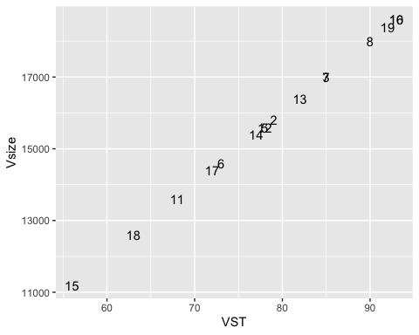

## Your final dataframe should look like this:

person VST Vsize  
01 79 15800  
02 85 17000  
03 78 15600  
04 73 14600  
05 85 17000  
06 90 18000  
07 93 18600  
08 68 13600  
09 78 15600  
10 82 16400  
11 77 15400  
12 56 11200  
13 93 18600  
14 72 14400  
15 63 12600  
16 92 18400