
Tabletop Strategy Game

© 2008 by Santo Ciaravino
http://scskwirl.webs.com

GAME INSTRUCTIONS

*

Welcome to the game of Arsisesi! In this game, each player has to bring all of their tokens to their opposite side of the game board and back, but must be aware of the other player's moves that could ultimately turn the game around. There are three different modes of play for even more enduring challenges that will have you play a different game every time.

Equipment
To play this game, you will need to have:
- 10 small-sized “tokens” (such as glass stones, coins, small figurines, etc.)
  - One set of 5 tokens goes to one player, and the other set of 5 goes to the other player.
  - Each token should have opposite faces or a mark so the player can tell the token's direction on the board.
- A 6-sided die
- Arsisesi Game Board (included as the last page of this document)

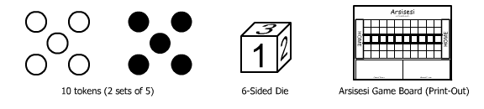
Setup
Place the game board between the two players, with a “Home” space facing each player. Each player must then place their tokens on their Home with the tokens in one position (facing upright, pointing toward the other player, etc.). After both players agree on a game type, both players will roll the die to see who goes first. The highest roller takes the first turn.
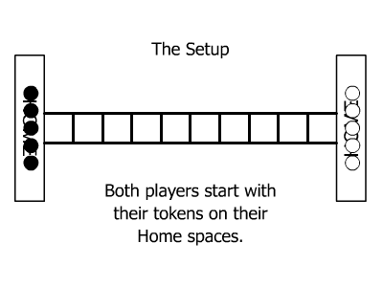

Game Type A: Arsisesi
This is the standard game mode. It uses the center row of the Arsisesi game board, called the “Bridge”. The goal in this mode is to get all of your tokens across the Bridge to your opponent's Home and back to your own.

The first player to send all five of their tokens to their opponent's Home and back to their own Home wins the game. The game ends in a stalemate if both players cannot make anymore moves to continue the game flow.

Movement
A player begins his/her turn by rolling the die to see how many “points of movement” can be used to move the tokens. You may move any of your tokens forward on the Bridge, one space for each point on the die. Multiple tokens of either player may be on the Bridge, but multiple tokens cannot occupy one space on the Bridge. You have to reach for the opponent's Home and then return to your own by moving your tokens, so you cannot move any of your tokens backward until after landing on the opponent's Home, and you cannot go backward to the opponent's Home after having landed on it.
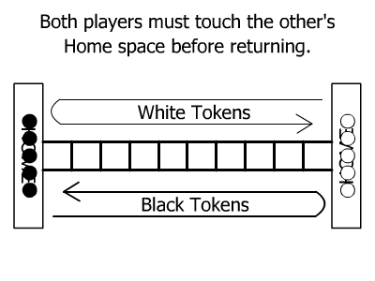
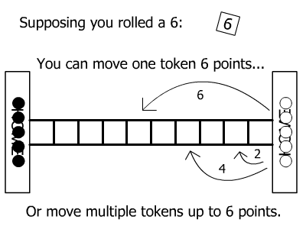
You do not have to move only one token with one die roll. For example, one player may roll a six, and instead of moving one token six spaces from Home, he or she may move a token four spaces, and move another token two spaces. If you cannot make anymore movements, or wish not to use anymore of your “points of movement”, you can forfeit your turn and the other player can start.

Jumping
Should a token meet another, it may only continue by “jumping” over the confronted token. Only one token may be jumped at a time. You may jump over your own tokens as well as your opponent's tokens. You may only jump one token at a time; you cannot jump two or more tokens at once. You are also allowed to jump over any token that is directly in front of a Home space, as long as there is no extra token behind it.
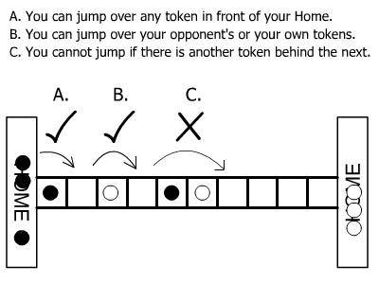

Kicking
If on your way to your opponent's Home you have jumped over your opponent's token, or if on your way back to your Home you confront your opponent's token, you may take a step in the direction toward your Home onto your opponent's space to replace your opponent's token with your own and bring the opponent's token back to its Home. This is called “Kicking”, as in kicking your opponent's token away from the space for your own. This uses up one point of movement, as you replace your opponent's token.

No matter which way you are going, you may only kick in the direction toward your Home, not toward your opponent's Home, and an opponent's token must be next to your token's side facing your Home. You may kick your opponent's token when directly coming out from your opponent's Home as well.
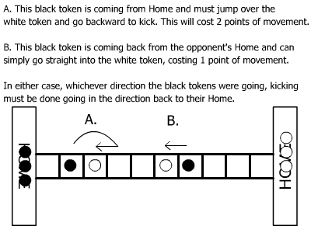
If your token is kicked, you must bring it back to your Home and start going back to reach your opponent's Home once more.

Returning Home
After reaching your opponent's Home, your token is safe in your opponent's Home until you choose for it to go back. It cannot be kicked back by your opponent as long as it remains on the Home space. Any amount of your tokens can stay at the opponent's Home.

When you are ready to bring a token back, turn the token over (so you can tell which direction it is headed) and begin to move it on the Bridge, going back to your Home. When going back Home, you can kick the opponent's tokens in your direction as you go back in your direction. You cannot kick backward in the direction of your opponent's Home.

When you make it back to your Home, that token is cleared from the game, put in the “Cleared Tokens” box, and considered a scored point for the player. The player must clear all five of his/her tokens by reaching back Home after reaching the opponent's Home to win the game.

Game Type B: Simple Arsisesi
A much faster and simpler version of Arsisesi. This is played in the same way as as Game Type A, with the following variations:
- Only one token from each player is allowed on the Bridge at a time. Thus, you can only move one piece at a time on your turn. You can still decide to forfeit your points of movement in a roll. As well, if there are more points of movement left on the die after scoring, you can continue using those points by using another piece to start.
- The tokens do not have to return Home to score a point. They score a point as soon as they reach the opponent's Home, and the token is cleared.

Game Type C: Wide Arsisesi
A much more strategic version of Arsisesi. This game uses all five rows on the Arsisesi game board. It is played the same way as Game Type A, with the following variations:
- All five tokens from each player can go on the playing field simultaneously on any of the five columns. Each token can start on any of the first five tiles in front of the Home, and even jump over an occupied front tile to count as a first step in.
- Tokens can move sideways, and doing so also counts as kicking if the opponent's token is to the side. You still cannot kick forward, away from your Home.
- The scoring is the same as with Game Type B; you only need to land on the opponent's Home to count a score.

History of the Game
One night, Santo was researching about games from the ancient era, such as “Senet” from Ancient Egypt. He woke up very early the next morning (around 4AM) with this idea of a small and simple game similar to the work of games from the ancient era. That idea was “Game Type B” in this game; and he also went on to include what would be “Game Type C” as the second way to play.

He couldn't come up with a name for the idea, so he went on the Internet for a name generator site and the result was “Arsisesi”, which turned out that no one used it, and he thought it sounded stylish enough to work with. Then, after testing it with a friend, they worked it to make the game more strategic, which then built up to become “Game Type A”. This completed the game to have three different modes, including the original two, and making the new mode the standard.

Disclaimer
“Arsisesi” created in 2008 by Santo Ciaravino.

http://scskwirl.webs.com
