
Sport Game

© 2009 by Santo Ciaravino

http://scskwirl.webs.com

GAME INSTRUCTIONS

*

Welcome to the game of Quadball! This is a sport game you can start up in your yard or local field, even indoors with enough space. Run to the four zones in order and try not to lose the ball to the other team to score points until the end of the game.

Equipment
To play this game, you will need to have:
- Enough space to play.
  - The field's marks are about 30'x30' (30 feet by 30 feet), so you may want 40'x40' to make room for the scoring zones, to get at least 5 feet around the field.
- Some way to mark the field's zones and lines.
  - When outdoors you can use dyes, ribbons, flags, etc. When indoors (provided there is enough space and no extra clutter), you can improvise markers for each region, such as cups on each corner of the Safety Zone and traffic cones or other large objects on each corner of the main field.
- A fairly large ball that can be passed and caught easily.
  - A football or a dodgeball should be fine.
- 2 teams of players to play, and a referee.
  - There should be around 2-4 players per team.

Whatever you use or do to play your game, please play safely!

Setup
Before playing the game, the first thing you want to do is find a suitable area to set up the playing field. You want to have a lot of space, perhaps about 40 feet by 40 feet. The game's field would be in the exact center of this plot. It can be played in a yard, a field, or indoors with enough space, such as a gymnasium.

Using what you will to mark the field, make 2 squares, one large (about 30 feet long and wide), and the other one much smaller (about 5 feet long and wide) and in the exact middle of the larger square. Choose one side of the square and draw a line from the center of that side to the center of the side of the smaller square.
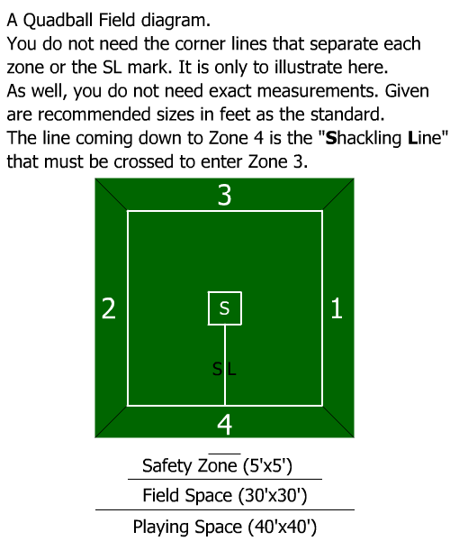
The positions of each player in the field does not matter. The offensive team should look to make way to land on the first zone successfully and continue to the other zones in order, while the defensive team should try to stop the offensive and take the ball back to safety and start a new round as the offensive; so each team can go where they wish for their strategy, as long as they are not inside a scoring zone or the middle Safety Zone.

Playing
The objective of the game is to land on all four goal zones to score points. To do so, the team with the ball must not lose the ball to the opponents for their turn. The team with the most points before the end of the game's time (1 hour, can be broken into 15 minute quarters) is the winner.

To start the game, a coin is flipped to decide which team captain will get the ball at the start. The winning captain stays in the Safety Zone with the ball, while the losing captain joins the rest of his/her team in the field. When everyone is ready, the referee signals for the timer to begin, and the captain must exit the Safety Zone, with the option of either charging for the first zone, or passing to another player to go land on the first zone.

Rounds
A round consists of the offensive team trying to land on all four zones in order, and the defensive team trying to intercept the ball to begin a new round as the offensive. The offensive team must land on all four zones to score a point for the team. Rounds exist for as long as the offensive team is still active to land on the zones in order. Rounds end when the ball is cleared in the Safety Zone at any time by anyone, a point is scored, when a penalty happens, or when a period of time has been reached, such as staying inside the Safety Zone or a scoring zone for too long or when a quarter is finished. The referee signals the beginning and end of every round.

If you are the offensive and you have the ball, do not step in the Safety Zone unless you absolutely mean to start the round over. You will be safe from getting your ball stolen, but you will have to start landing on the zones in order all over again. When starting a new round, the player in the Safety Zone must step out before doing anything else, whether charging for the first scoring zone, or passing to another player outside of the zone to go there.

Safety Zone
The smaller square in the field is the Safety Zone. This is where no other player, except for the one with the ball, is allowed to enter. If a player with the ball enters the Safety Zone, the round starts over with that player's team as the offensive, whether the ball still belongs to the offensive, or the defensive intercepted the ball and must clear the ball in safety to begin a new round as the offensive. At any time in the game the Safety Zone is landed on by the player with the ball to reset a round, the player has up to 10 seconds to get out and play the game or take the penalty for the team.

Scoring Zones
The 4 scoring zones work just like the Safety Zone, and only the player with the ball can enter them. When a player lands on a zone with the ball, all of the other players on both teams cannot enter the zone and it works as a safe point for the player with the ball. However, like the Safety Zone, the player must not stay inside a scoring zone for more than 10 seconds and must exit it before making a pass.

Landing on the fourth zone after having landed on the other three counts as a scored point, and a new round begins, with the opposite team as the new offensive.

Stealing
Initially, the ball belongs to the offensive team at all times, until the defensive team has intercepted the ball and brought it back to the Safety Zone. Before stealing, after stealing, and on the way back to safety, the ball still belongs to the offensive team, until safety is reached by the defensive team.

The ball can be stolen at any point. The defensive player can smack the ball out of the player's hands, tackle and wrestle to get the ball, intercept it from a pass, or pick it up from the ground after a fumble*.

For a safer method of stealing, you can simply tag the player and have them forfeit the ball so you begin the next round without hassle.

* If at any point the ball is fumbled and ends up staying inside a scoring zone or the Safety Zone, the referee signals the end of the round, and the captain of the defensive team (at the time of the fumble) begins a new round as the offensive.

Penalties
Penalties are when any of the players have done something against the rules of normal play. Referees should alert the players when a penalty happens so it can be assessed. Penalties include:
- Shackling. This is when the player with the ball is on Zone 2 and cuts the corner that is a direct move into Zone 3 as a shortcut. The ball must cross over the Shackling Line from the left side to the right, either by pass or by run (to complete a path going around the Safety Zone), before bringing the ball anywhere towards Zone 3. If a player shackles, the other team simply begins a new round as the offensive.
- Passing to a player already inside the next zone. You must pass to any of your teammates who are within the field and not in a zone, for them to run to the next zone; otherwise if you pass to a teammate inside the next zone, the opposite team scores a point and begins a new round.
- Entering the Safety Zone or a scoring zone without the ball. Only the player with the ball is allowed in the Safety Zone and scoring zones. If you step inside without the ball, the opposite team scores a point and begins a new round.
- Entering the incorrect scoring zone. You have to touch the four scoring zones in number order. If you land on the incorrect number, forfeit the ball to the other team so they can begin their turn.
- Staying too long in safety. Whoever stays inside the Safety Zone or the scoring zones for more than 10 seconds must forfeit the ball to the other team.

Suggestions
If you wish, you can make your game to better accommodate your players. For example, if young children are playing, you can make the field smaller, or if you want teams of ten or so players, you can make the field even larger, and change the rules as seen fit. For example, you do not want to tackle in an indoor game, so you simply tag.

You can also just use a two-sided version of the game field. Instead of having to cross the Shackling Line using four zones, run back to the first zone to clear in place of Zone 3, and then back to Zone 2 to clear in place of Zone 4.

If something new happens that is out of the scope of this current rulebook, feel free to make up a new rule for it. Sports games can still be fun to play with house rules.

History of the Game
In the middle to late 1990's, Santo was inspired to make his own sport to play in the backyard, instead of the usual games like Baseball, Football, or Catch. He and his brother worked to make the rules and fictional teams together, and with the help of their siblings they tested the game. Afterward, he showed it to his friends during a school recess and they also played the game.

Disclaimer
“Quadball” created in 2009 by Santo Ciaravino.

http://scskwirl.webs.com

