**Gender**

Gender representation of the company

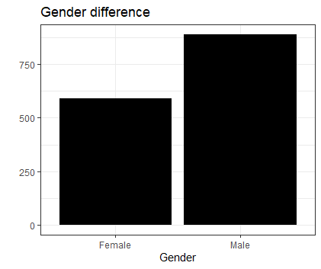

This bar chart represent the gender difference representation of the above HR data set

According to this bar chart clearly we can see there are males working in this company

More than female employees

**Code:**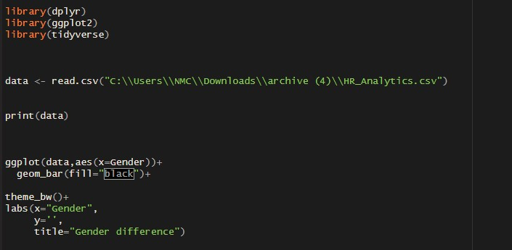

**Gender distribution among departments**

HR-Human Resources Department

Re&Dev- Research and Development Department

Sales-Sales Department

This is a pie chart crated using “Gender” column and department column . There are three different departments inside the above company . According to the data set all the employees divided in to these three departments. The least number of employees are working in “HR” department. The second largest number of employees are working in “sales department”. And the largest number of employees are working in research and development department. In this each and every department we can see the number of male employees are higher than the number of female employees are working in.

**Code:**

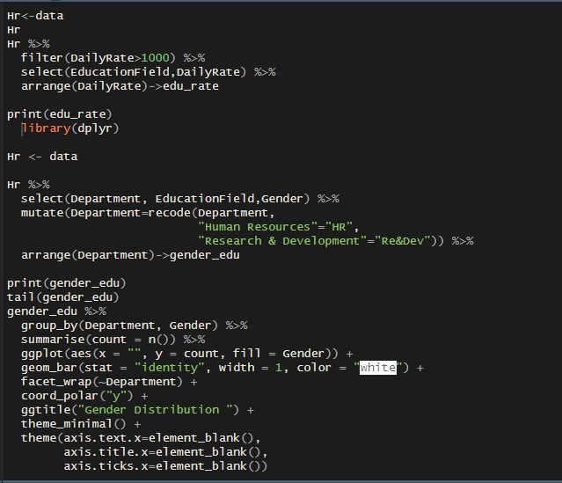

**Education distribution among Department**

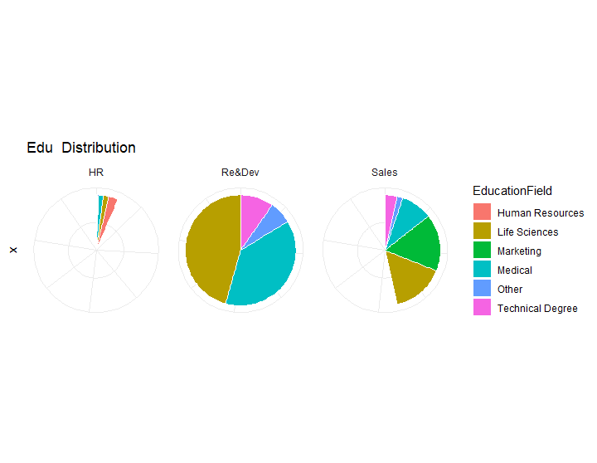

HR-Human Resources Department

Re&Dev- Research and Development Department

Sale – Sale Department

This above three pie charts are created using “Department column” and “Educational field column”. Using this three plots we and understand the diversity of education fields among departments. According to this three pie charts ” sales department” shows the highest diversity .

And “HR Department” shows the lowest diversity .In this company the highest number of employees are from “Life Science” stream . The lowest number is the employees who followed other education streams. According to this data we can see there was a high demand for Life science stream employees.

**Code:**

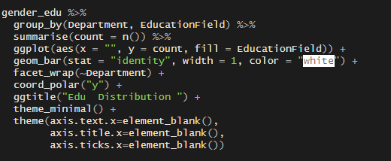

**Salary difference between gender**

This bar chart was plotted using “Hourly Rate”, ”Gender” and “job role ”.According to this bar chart we can see there are no big salary gap between “Genders” in different job roles. This

Is a good sign about this company for the female employees who willing to join this company.

**Code:**

**Environment Satisfaction between gender**

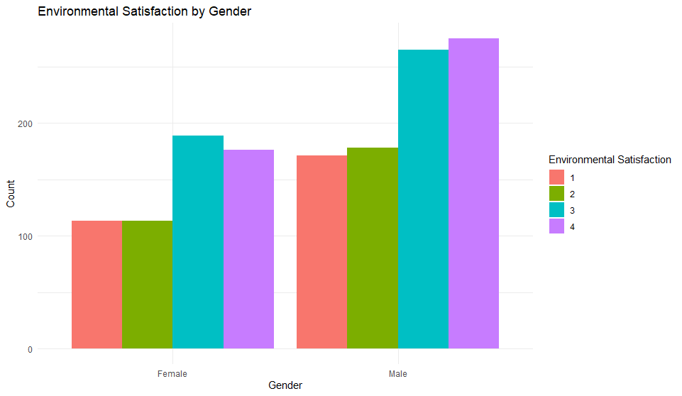

1-Poor

2-Good

3-Great

4-Exelent

This above bar chart was plotted to visualize the environment satisfaction between gender. According to this bar chart overall we can identify they is a excellent environment satisfaction about the company among males. The environment satisfaction of females is great but comparing to males it is low .And we can identify the is a environment issue among females.

As a suggestion this company needs to maintain their environment as a female friendly environment .

**Code:**

**Job Satisfaction between gender**

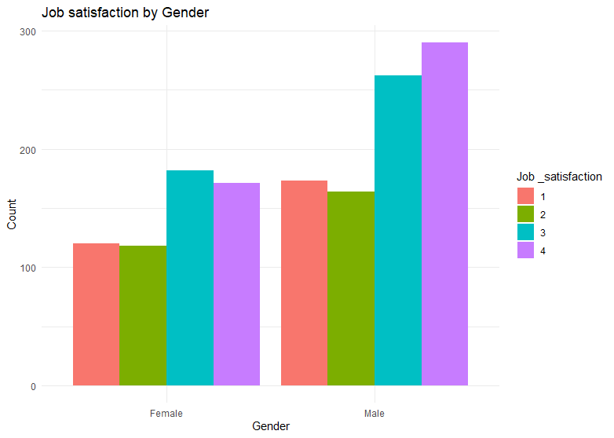

1-Poor

2-Good

3-Great

4-Exelent

This bar chart was plotted using “Gender ”and “Job satisfaction ” columns . According to this bar chart we can identify the overall job satisfaction of the male is excellent .But the overall average job satisfaction of females is Good but comparing to males it is low .The environment satisfaction from above bar chart there where also an issue from females about their environment satisfaction . As a company this company needs to find a quick solution for this problem.

**Code:**

**Work and life balance between gender**

1-poor

2-Good

3-Great

4-Exellent

According to this bar chart we can clearly see that there is a Great work and life balance between their employees both males and females have very good work and life balance .The number of employees who have poor work and life balance between both male and female employees are very low . And this is a big green light for the company and company health.

**Code:**

**Job involvement between gender**

1-poor

2-good

3-great

4-Exellent

According to this bar chart we can see the job involvement of both male and female is good. And as a average It also very satisfying measure . This is a good signal for a company . And the number of poor job satisfied people also very low number .

**Code:**

**Salary difference between gender**

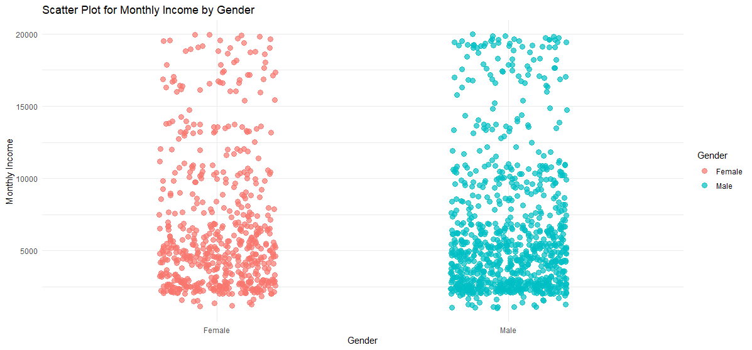

According to this scatter plot we can see most employees having salary among 5000 to 6000. The number of female employees having more than that salary is lower than the number of male employees having more than 6000 salary. The number of male employees who are having near 20000 salary is more than the number of female employees having that salary. According to this bar chart we can identify the number of male employees who having a top post I the company are greater than the number of female employees who have top posts.

**Code:**

**Female**

With the below scatter plot we can see the largest number of employees are getting salary among 2500$ to 7500$ the number of female employees who are getting a salary greater than 7500$ s very less when compared to the majority .And the number of female employees who are getting top range salary like 20000$ are very less when it compared to the number of male employees who are getting that salary. According to this chart we can identify there is a lack of female representation in top job positions . In the above bar charts there were also a lack of job involvement among female employees when it compared to the male employees .And as a solution for that I can suggest the company needs to encourage female employees for a positive job involvement and need to create a positive environment and job satisfaction among them

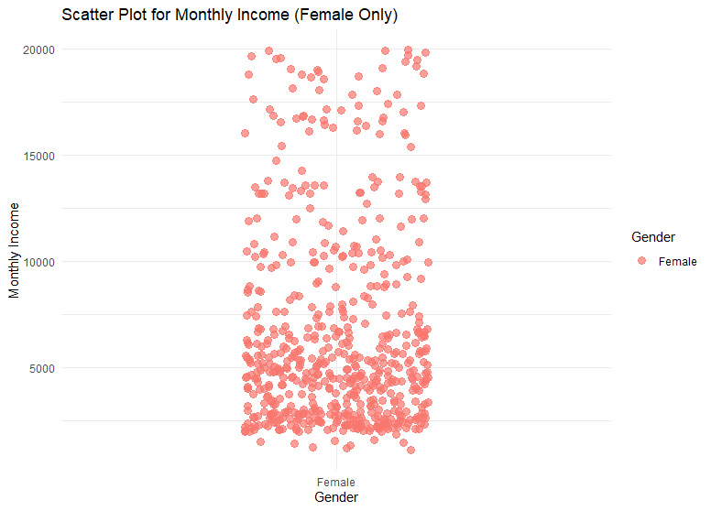

**Code:**

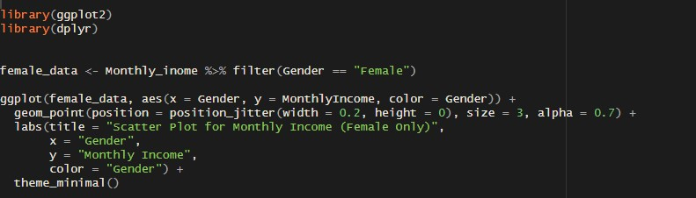

**Male:**

The below scatter plot shows the salary distribution of female employees .Majority of female employees are getting among 2500$ to 5000$ .And in there are more number of male employees who are getting to range salary when it compared to the female employees.

Also in above charts there was a good job involvement ,good job satisfaction and good environment satisfaction among male employees .According to these data we can decide male employees are more productive than male employees .

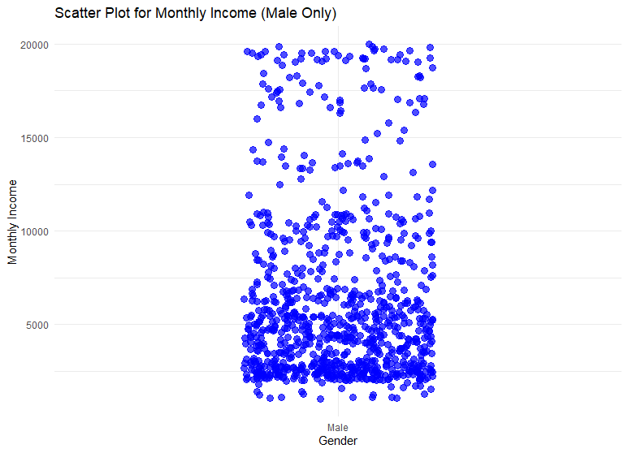

**Code:**

**Implementing Navi bayes classification to Gender**

The expected outcomes of this model are correctly categorize workers as male or female,find the important variables that have a significant impact on gender prediction, providing information about trends in HR and possible prejudices. And provide insight for HR choices and plans pertaining to personnel management, recruiting, inclusion, and diversity.

**Code:**

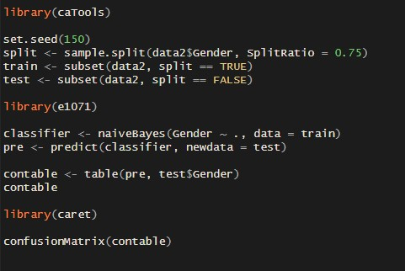

**Implementing Kmeans clustering for the Gender ,Age and Years at the company**

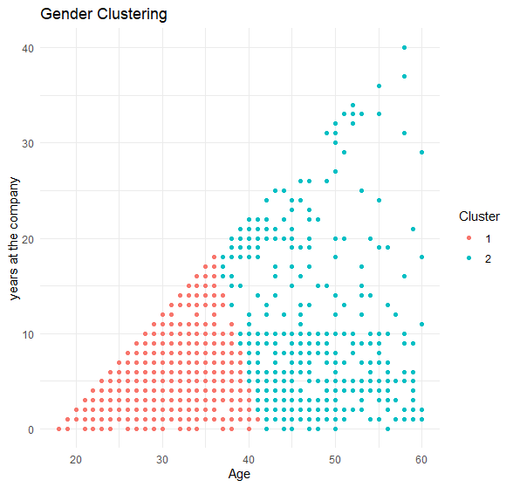

In this scatter plot here are two clusters the cluster 1 represents younger employees and the cluster 2 represents older employees in the company . According to the clustering the most employees have less than 10 year experience .The number of employees who have a great work experience in that company is low when compared to the total number of employees.

**Code:**

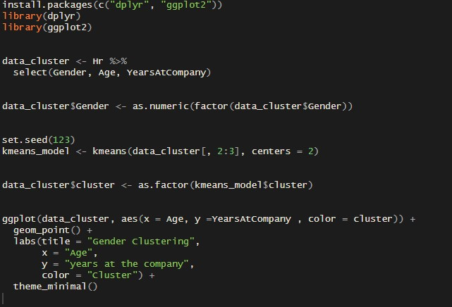

**Applying clustering Algorithm for the Gender**

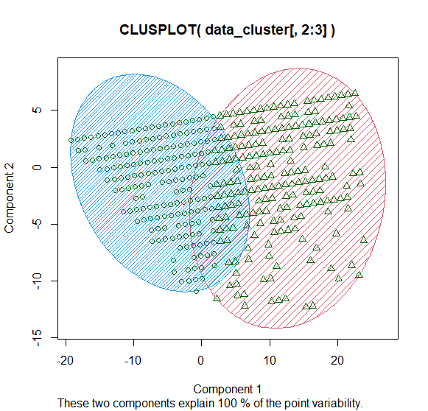

This clustplot visually represents the gender distribution among clusters. And Plotting illustrates the variation in years worked for the firm across genders and maybe between clusters. In this plot each point represent a employee. .The x axis of the plot represent Gender and the y axis of the plot represent years at the company.

**Code:**

