Bo Mrvic
Antonios
CSC 400
4/12/19
Student Planner Application (SPA)
Introduction:
The Student Planner Application (SPA) is an application intended for active students that will sort or at least help sort out the mental mess they may be going through during their studies.
The SPA is a system that will organize a student’s classes into a single place and allow them to track active assignments as they proceed through the semester. While there are existing systems that schools use currently, SPA will allow a user to have a more detailed look into their work so far.
SPA will have an array of features that will put the scrambled pieces in place for a student who’s hard at work. The student user can first create a simple list of their classes. Each class with have details within it which will aid in creating detail reviews later on. These details include the weighted components of the course. After establishing a class list, the student will be able to add assignments to a given class. Each assignment can be attributed different tags depending on if the user elects to add any. Those tags include; a level of importance for a given assignment, corresponding footnotes regarding the assignment. As expected, each assignment will have a grade given to it. All of featured stated are nothing too unique, but once a student opts to use the grade analysis, then they will see the SPA bringing some clarity. The grade analysis will not only take the already established details of the class and provide a weighted grade, it will further detail the grade break down as a visual for the user to see. This can simply be just a general overview of how the grades look depending on assignment type or a user can specify a different view of the grades. This could entail seeing the grade behavior based on a certain window of time or a review of the grade and their behavior based on the assignments importance. SPA will then take given parameters and provided a synopsis of any trend that may exist.
Architecture:
The SPA is based on a client server model. Anything the user saves within the application will be saved to the cloud. Therefore the only exchange of information/processes occurs between the user and cloud database. The SPA will run within a desktop environment.
The major inputs of the system will be provided by the student using it. They will input their profile details, course listing/course details, assignment listing/details, and corresponding grades. The output of the system will be detailed analysis of the grades saved within the cloud. This, like all parts of the application will be displayed through a GUI.
Use Cases:
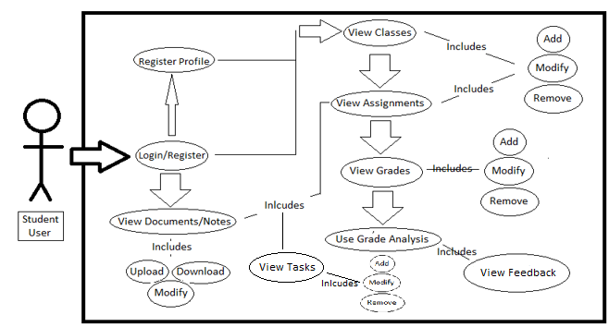
A student user launches SPA and access the main features of it by either logging in with an already existing profile or by registering a new profile. Should the user be new to SPA, they will be prompted to enter basic information to make the profile unique to themselves.
Upon entering the main UI, the student can now begin using the applications features. Assuming the student is new to SPA, they may add classes to the initial listing. The class itself will not only act as an item within a list. A class will include information specific to the course, specifically the weight of the course components (homework, quizzes, labs etc.) Under each class listing, a student can add or remove assignments they would like. Also, each assignment can be given a tag to determine the level of importance within its respective class. Each assignment will not only have a grade attributed to it, but it will also have, for the time being, corresponding footnotes.
Another feature of SPA is the task manager. A task can be assigned to a course or assignment. This will help the user track their progress on given tasks by having a clean visual representation of what we would traditionally put in our “to-do list.” Each task will have a statues defining the progress and any notes that may go along with it.
As stated previously, a grade can be input for each assignment and said grades can be input in the grade analyzer which provides a synopsis of each class. Using the information provided when creating the initial class listing, the application will calculate the grade using the weighed components provided previously.
This feedback would have a detailed view of the grade and how it distributes. Should the student elect to do so, they can request an analysis based on a specific criterion. For example, the user can request a feedback view that shows the grade behavior over time. Another view can include grade behavior respective to assignment importance.
Structural Design:
user
username: String
password: String
id: String
major: String
setUserName()
getUserName()
setPassword()
getPassword()
setId()
setMajor()

1

0 n

course
courseName: String
courseId: String
courseWeightType: String
courseWeight: Double
addCourse()
modifyCourse()
removeCourse()
setWeightType()
setWeight()
getWeightType()
getWeight()
assignments
assignmentType: String
assignmentName: String
assignmentImp: String
assignmentGrade: Int
assignmentNote: String
assignemntNeed: Int
addAssignment()
removeAssignment()
modifyAssignment()
inputGrade()
addNote()
addImp()

1
0
n
tasks
taskName:String
taskCourse:String
taskAssignment:String
taskStatus:String
taskNotes:String
setNotes()
showNotes()
getName()
setName()
setCourse()
setAssign()
setStatus()
getStatus()

n
n
1
1

Data:
Using the structural design above, we have an understanding as to what data is present within the system and how it behaves with one another.
The first level of the database schema is the user level.
Data Item | Data Type
username | String
password | String
id | String
major | String

The user level of the schema contains the student’s username, password, id, and major. Upon using SPA for the first time, a user will record the data provided and save it to the cloud storage. The only major operation/process that will use the data provided after registration will be the login prompt used by a returning user.
The next level of the schema contains the course listing created by a user.
Data Item | Data Type
name | String
id | String
weightType | String
weightVal | double

The course level contains the name and id of the course. Like the user level, no operations or processes will be done using this data after inputting it for the first time. The weight, however, is different. Weight type defines the type of assignment found on a syllabus. The weight itself is the numerical value that defines the percentage value that specifc assignment type holds. This weight will be used to calculate the weighted average for the course.
The final level of the schema is the assignment level.
Data Item | Data Type
assignmentType | String
assignmentName | String
assignmentImportance | String
assignmentGrade | Double
assignmentNote | String
assignmentNeed | Int
assignmentInvestment | Int

Here we have two items which will not be used in calculation and those are the assignment name and the assignment notes. The assignment importance will be one of the ways a student can view their grade behavior. The assignment type will be used to match the weight type previously defined in the course level. This will ensure the correct corresponding weight will be used in calculating a given assignment type. Upon finding that, the assignment grade is then averaged versus the weight found previously. This will conclude the analysis and will be displayed through the applications GUI. An integer value will be given for an assignment based on how much time (minutes) it will need or how much time has already been invested.
The last remaining part of the schema behind the task manager.
Data Item | Data Type
taskName | String
taskNotes | String
taskStatus | String
taskAssignment | String
taskCourse | String
taskNeed | Int
taskInvestment | Int

The last part of the SPA includes a task manager. A user can create tasks to keep track of throughout the semester. Each task has a name to it and a corresponding course/assignment attribute. While a course or assignment may have multiple tasks, a task can only exist for 1 class/assignment at most. This will ensure that no overlapping occurs and the possibility of missing a task based on variable declaration is limited. Each task will have a status attributed to it. This will be an indicator of progression for the given task. Depending on the progress of the task, the status will reflect on it accordingly. Alongside the status, each task will have a note attached to it. These two bits of data will be displayed as “Task 1; Status: Nearly Complete; Notes: Needs revision for final draft.” Like the assignment schema above, tasks will also have values that reflect the time needed for them and the time invested into them.
User Interface Design:
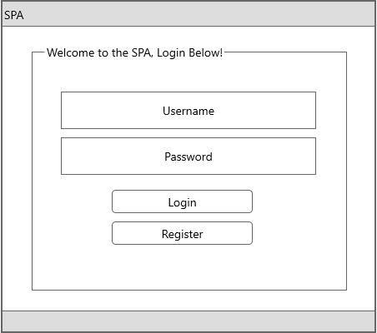
The prompt above is the first UI that will appear in the SPA.
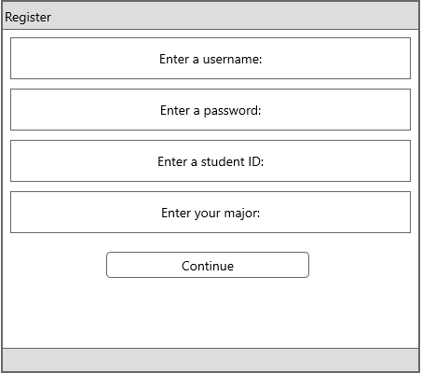
A new user will be directing to this prompt when looking to create a new profile.
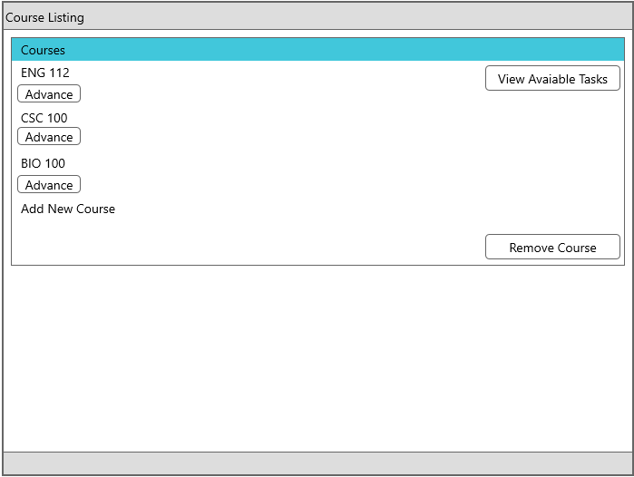
Here we have reached the main UI. The list of courses can be found above by the student. They have the option to add a new course to the already existing list. Should they chose to remove a course, all the student has to do is press “Remove Course” followed by a corresponding radio button that would appear next to the course. The other option available on the main UI is a button allowing access to the task manager within the SPA.
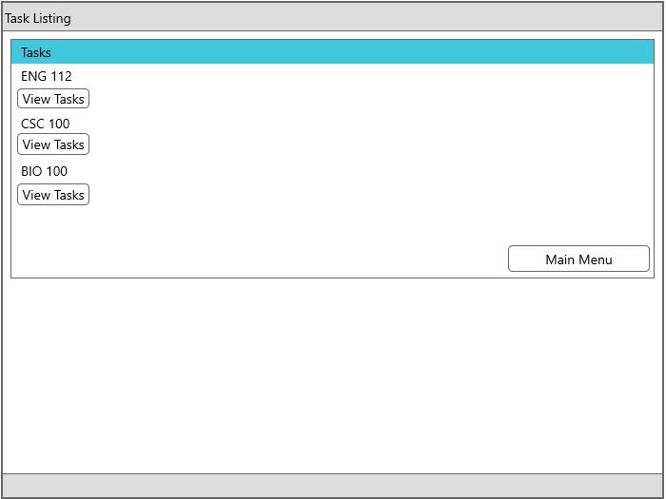
After opting to enter the task manager, the user is presented with a UI similar to that of the course listing. The difference being is each course will expand with the tasks attributed to it.
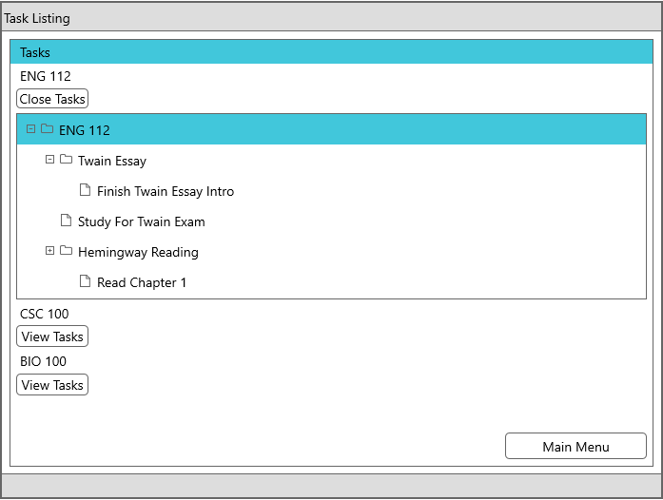
The user will select which course tasks they would like to see. A display like the example above should show as a result. Using an English class as an example, the folder icon indicates an assignment listed and the resulting file icon is the task itself. Here we see that the task of finishing an essay into is attributed to the Twain Essay specifically. This differs from the “Study For Twain Exam” task which acts solely as a task for the course. Upon selecting a task, a brief summary appears for the task which features any notes relating to the task and the status of the task.
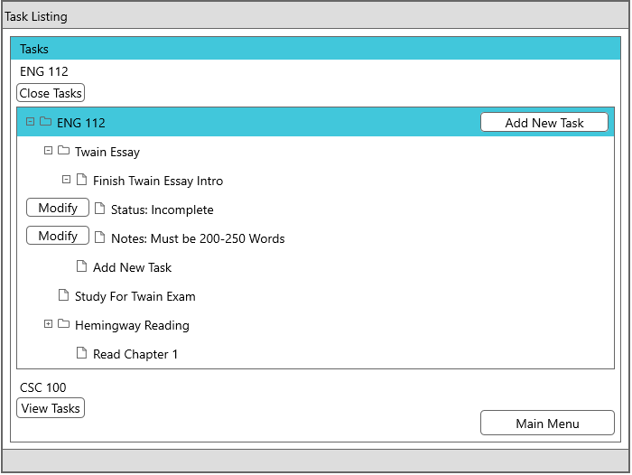
Now we have the display showing what it would look like once a user decides to open up a specific task. Here we see the status and corresponding notes to the “Finish Twain Intro” task. Should a user elect to modify either the status or notes, all they would have to do is click modify and make the appropriate text changes within a pop up. A user can add a task however they see fit within the hierarchy. If a user would like to add a task to only the course with no assignment attached to it, the appropriate button is located in the top right. The “add new task” button found within the Twain Essay will add a task to that assignment specifically. This will alter the schema accordingly. Because we define the location of the task by where the user declares it, adding a task is easier to do and to follow.
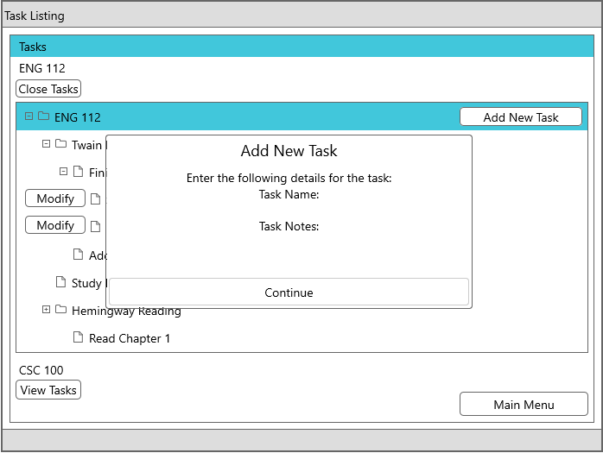
Above, we see how it would look to add a new task. It is simple enough but omits one detail, the task status. Because the task is new, the task status will be set to a default value of “incomplete.” If the user feels this should be changed, they can modify it through the task list to a different radio option available. The options included will be “incomplete”, “mostly incomplete”, “partly incomplete”, and “complete.”
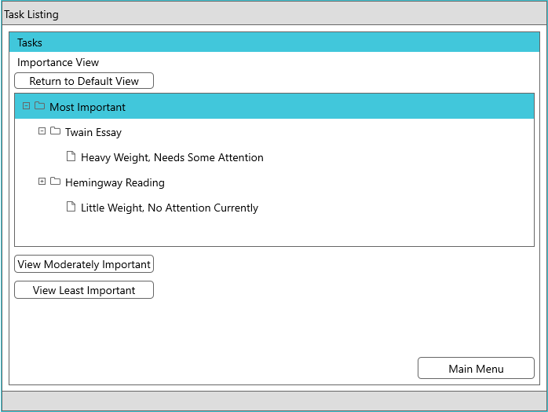
The user can change the view of the tasks listed by viewing them based on importance. This value of “importance” is calculated by using a few factors. The first being the weight of the assignment in a given course. The next factor is the attention (in time) the assignment requires and the last factor is the attention already given to an assignment. As seen in the example above, the Twain essay is list amongst the most important as it is heaviest in weight and still needs attention. The Hemmingway reading on the other hand is not weight as heavily but has had no attention given to it, leaving it amongst the most important tasks. This ensures that there is some variance in the task list and the importance view does not simply list the most valuable assignments.
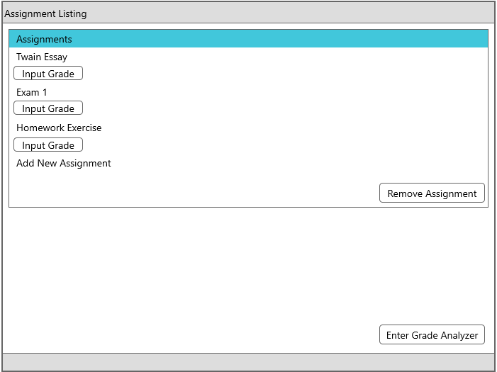
Like the previous UI, the assignment UI is the same as the course UI except with a few changes. The most important being input grade is now an option. Here a user can input the decimal grade given to a specific assignment. Should a user need to change an existing grade, the student would only need to click add grade again and enter their new submission overwriting the old one.
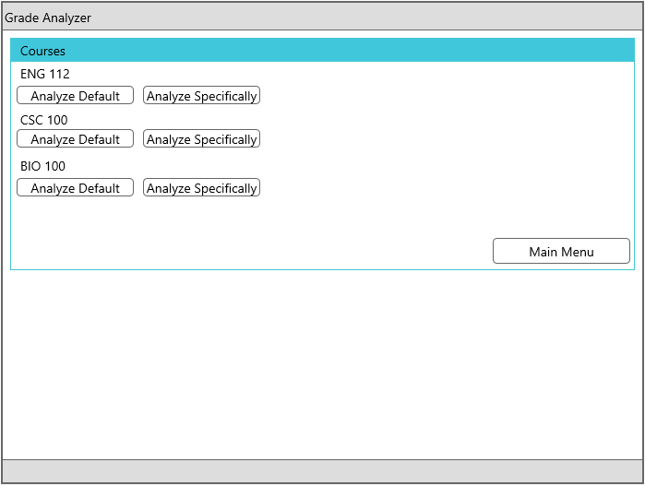
Upon entering the grade analyzer, the user is prompted with two options per course. The default analysis will give the user the weighted average for the given course and show general grade trends just based on value alone.
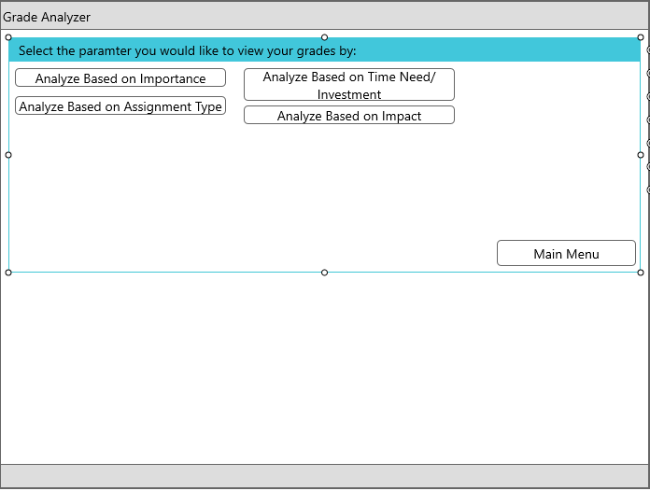
Should a user elect to view their grade behavior given a specific parameter, the user will select one of the options listed above. Grades can be analyzed based on assignment type. This would be base the analysis on the assignment type/weights in the course and see if a trend occurs. (See next image.) Analyzing the grades based on time need/investment takes the amount of time assignments required, the time actually put into an assignment and determines if there is any sort of trend. This would mean that the total time invested over the total time needed yields a percentage. This percentage will sum within an assignment time yielding an average in the end. A certain assignment type could show that a low grade in one area is the result of a distinctly greater time need versus a lack of investment elsewhere. Analyzing grades based on impact focuses on the weight of assignments and how impactful they are to the overall grade. While this may sound like a simple, default analysis, it isn’t. The grades provided will be skimmed through and should a subset of grades appear causing a disruption to the calculation, it will be explained in the synopsis. An example of this would be; a student has ten homework assignments, 8 of them are worth 20 points, while two are worth 50. If the two assignments worth 50 points yield worse results, the overall grade is impacted more. Lastly, the user can analyze based on importance. As stated previously, importance is determined by a combination of the weight of an assignment versus the time need/investment.
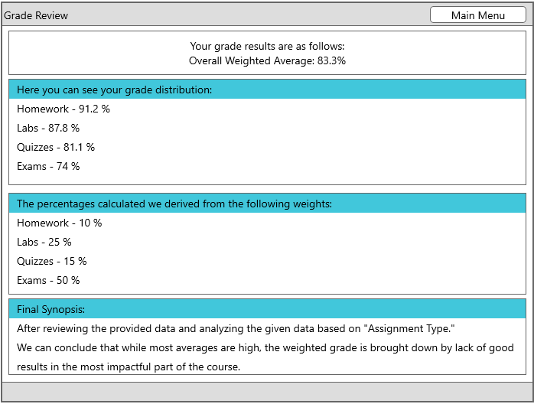
Lastly, we’re given the final feedback from the grade analyzer. The synopsis features the overall weighted average and further analyzes the grade behavior based on the assignment type with a course. After the math is displayed, the end of the analysis provides a text description as to the grade distribution and possible explanation with regards to a noticeable trend or pattern within the data.
Detailed Workchart:

