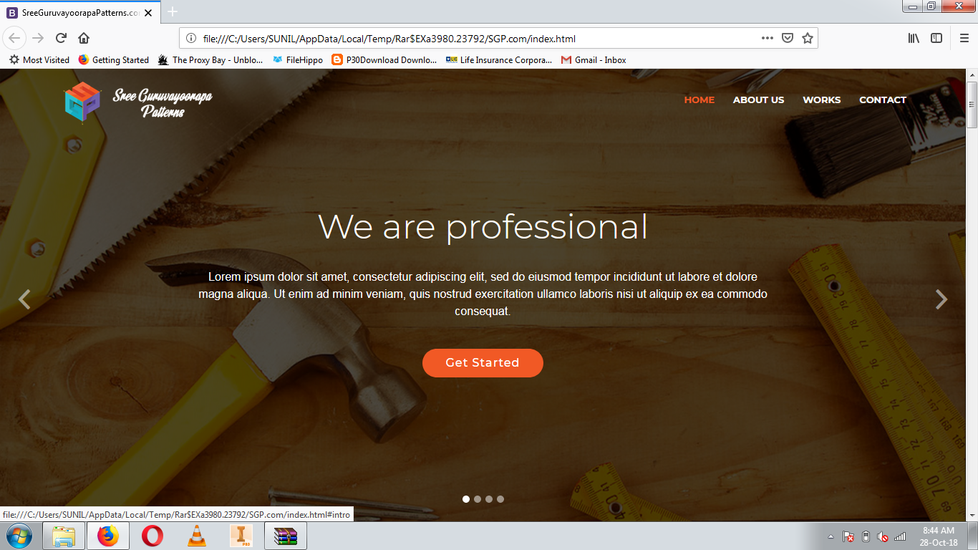

Name must be in single line with Pvt ltd and 3d projected type golden colored letters without shadow effect same fond..

No need subtitle

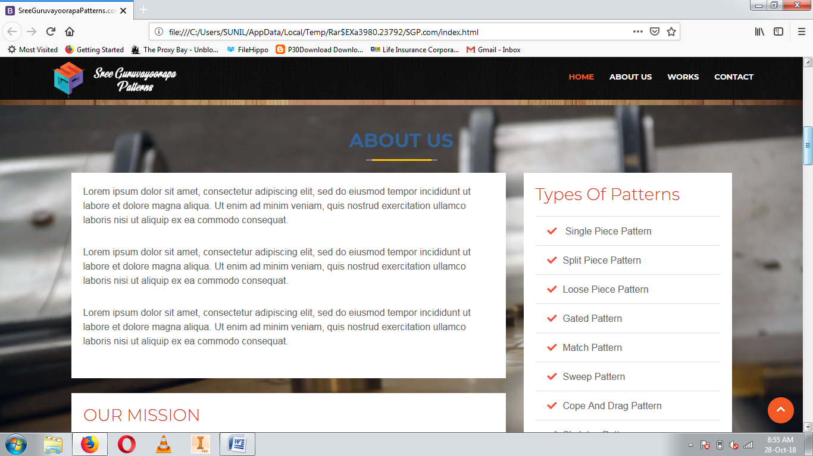23 years of excellent services….

This topic must be under OUR WORK title ( app1,app2 like single piece pattern ,loosepiece pattern etc…

**1) SREE GURUVAYURAPPA ENGINEERING WORKS**

**YEAR : 1995**

**PLACE : CHUNCHUGATTE,J.P NAGAR,BANGLORE, KARNATAKA**

**2) SREE GURUVAYURAPPA WOOD & DIE WORKS YEAR : 2010**

**23 years of excellent services……**

**PLACE : THAIKKAD ,GURUVAYOOR ,KERALA**

**OUR MISSION**:- **IT IS OUR GOAL TO ENSURE OUR MISSION BY CONTINUOUS SELF IMPROVEMENT, GROWTH IN OUR OPERATIONS AND EMPLOYEES; WHILE MAINTAINING PROFITABILITY TO THE BENEFIT OF OUR CUSTOMERS, EMPLOYEES, AND COMMUNITY.**

***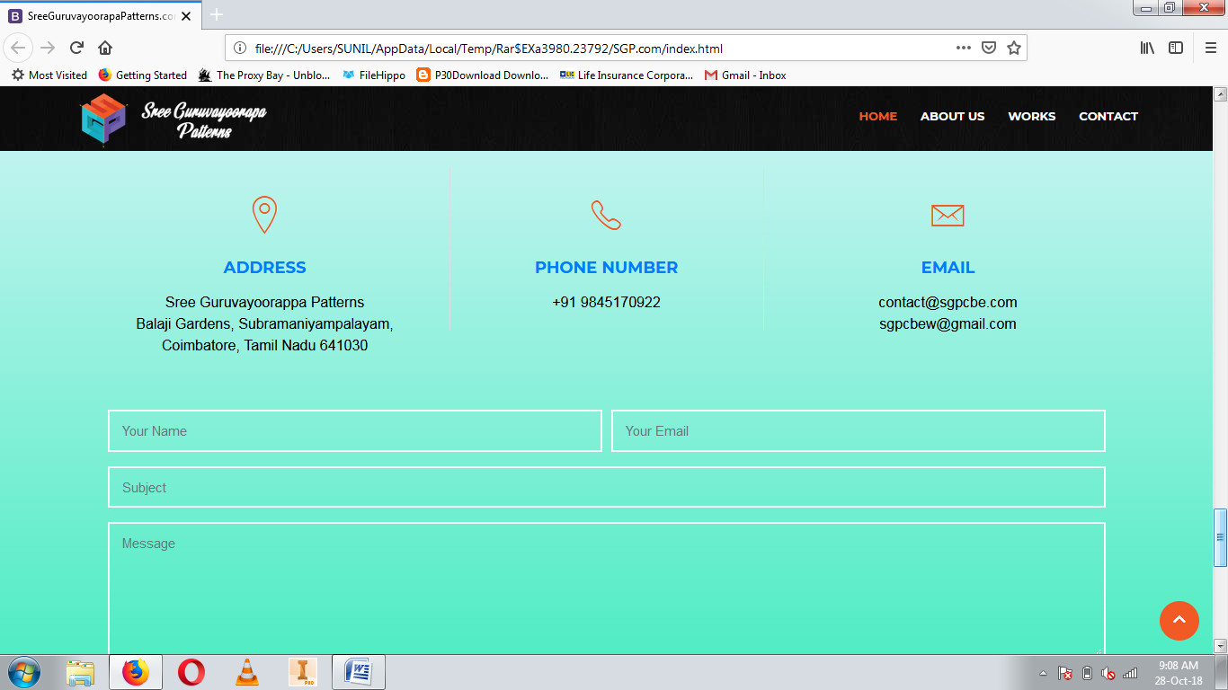*OUR PLAN :-** **IT UTILIZES THE RESOURCE ALLOCATION OF ACTIVITIES OF EMPLOYEES, MATERIALS AND PRODUCTION CAPACITY, IN ORDER TO SERVE DIFFERENT CUSTOMERS**.

sgewblr@yahoo.in

Add 9846144114

**OUR VISION** :- **COMPETITIVE THROUGH BETTER QUALITY AND PERFORMANCE**

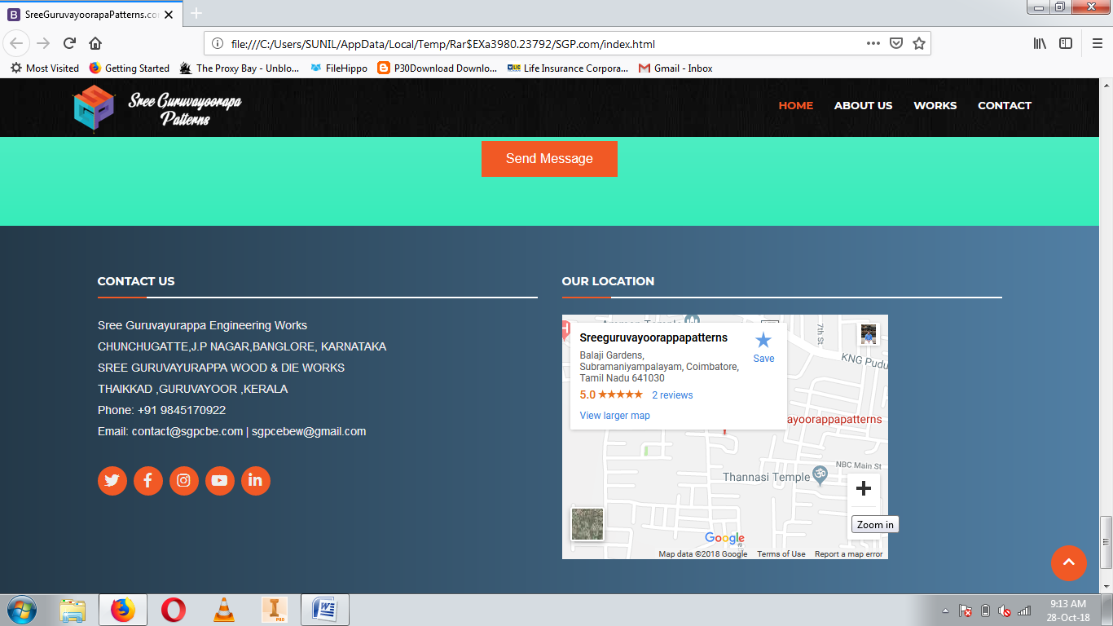 **LATEST TECHNOLOGY**

COIMBATORE address only With 2 mobile no and including mail id

sgewblr@yahoo.in