SCCS 2009-2010 Registration and Refund Policies

- Registration Policy:
- First school day for 2009-2010 Fall term is 9/13/2009
- Annual registration for Fall and Spring terms during summer.
- Change (drop, switch, add) between enrichment class for Spring is allowed before end of Fall term
- Annual family membership (non-refundable, due on 9/13/2009): $20
- Tuition for language class (two terms): $240
- Tuition for enrichment class: $70 per term, $140 per year
- Annual Registration fee: $20 (non-refundable, due on 9/13/2009)
- Early registration (2 weeks before the first day, on or before 8/30): registration fee waived.
- Late registration (after the first day): $10 late registration fee will be added to $20 regular registration fee, total registration fee will be $30 (late registration fee does not apply to New Students, who needs pay $20 regular registration fee if not registered before early registration deadline)
- Full payment of all annual fees and tuitions of both terms before Fall term starts is preferable, but class tuition can be paid with two payments, Fall and Spring payments.
- Due date of Fall payment is the first school day: 9/13/2009
- Due date of the Spring payment: 12/31/2009
- $5 late payment charge is added after due date
Period | One Payment | Two Payments | Note
<= 8/30 | $0 registration fee |  | Additional $5 after the 2nd due date 12/31
> 8/30 - <= 9/13 | $20 reg fee | $20 reg fee; | same
>9/13 | $20 reg fee +  $10 late reg fee | $20 reg fee;  $10 late reg fee; | same

- $25 is charged for bounced check

- Refund Policy
- Before 3rd class (10/27/2009): full refund
- Cancelled class by school: full refund
- Before the 4th class (10/04/2009): 75%
- On or after the 4th class (10/04/2009): no refund
- Membership fee: no refund
- Registration Fee: no refund

Example for one child if pay on time
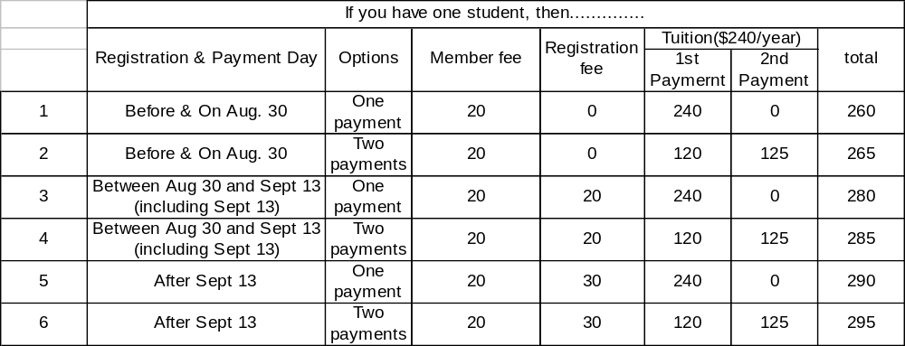It could have additional $5 if 2nd payment is made after 2nd due date

