7th Grade Homework #2
Due Date: Sept. 29, 2013
1.
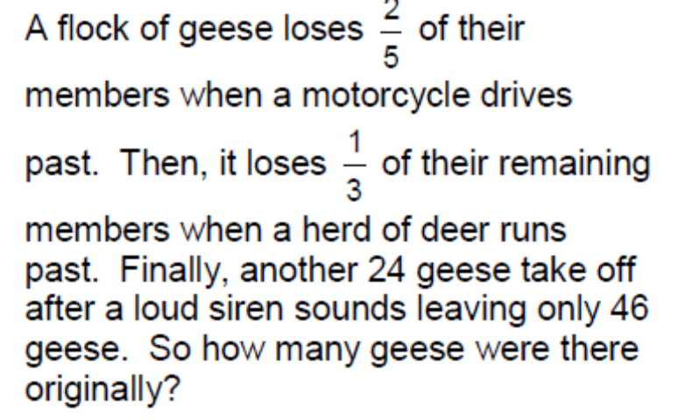
2.

3.


