7th Grade Homework #3
Due Date: October 06, 2013
1.
A small water pipe takes three times longer to fill a tank than does a large water pipe. With both pipes it takes 4 h to fill the tank. Fine the time it would take the small ippe working alone to fill the tank.

2.
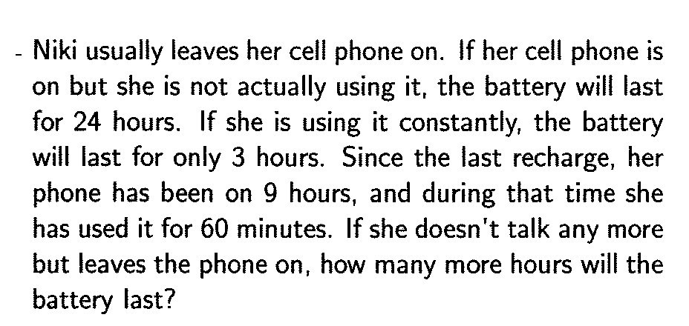
3.
The ratio of Sally’s age to Lucy’s age is 8 : 5. 30 years later, this ratio will be 6 : 5. How much older is Sally than Lucy now?
4.
If A : B = 3 : 5, B : C = 7 : 1, C : D = 4 : 9, find A : B : C : D.

5 .
Allison rode her bike to school at an average speed of 14 mph. When she got out of school she found her bike had a flat tire so she had to walk her bike home at an average speed of 4 mph. What is the average speed of Allison’s trips to school and back home? Express your answer as a mixed number.

