7th Grade Homework #5
Due Date: October 27, 2013
1.
What is the measure, in degrees, of the smaller angle by the hour and the minute hand of a clock at 3:20?
2.
What is the first time after 1 PM at which the minute hand and the hour hand of a clock point in the exact opposite directions?
3.
What is the first time after 7 PM at which the minute hand and the hour hand of a clock point in the exact same directions?
4.
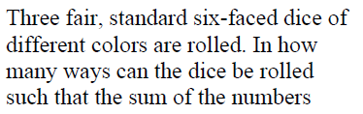
rolled is 10.
5.
6.
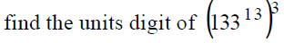

7.
