7th Grade Homework #6
Due Date: Nov. 03, 2013

1.
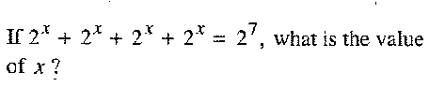
2.
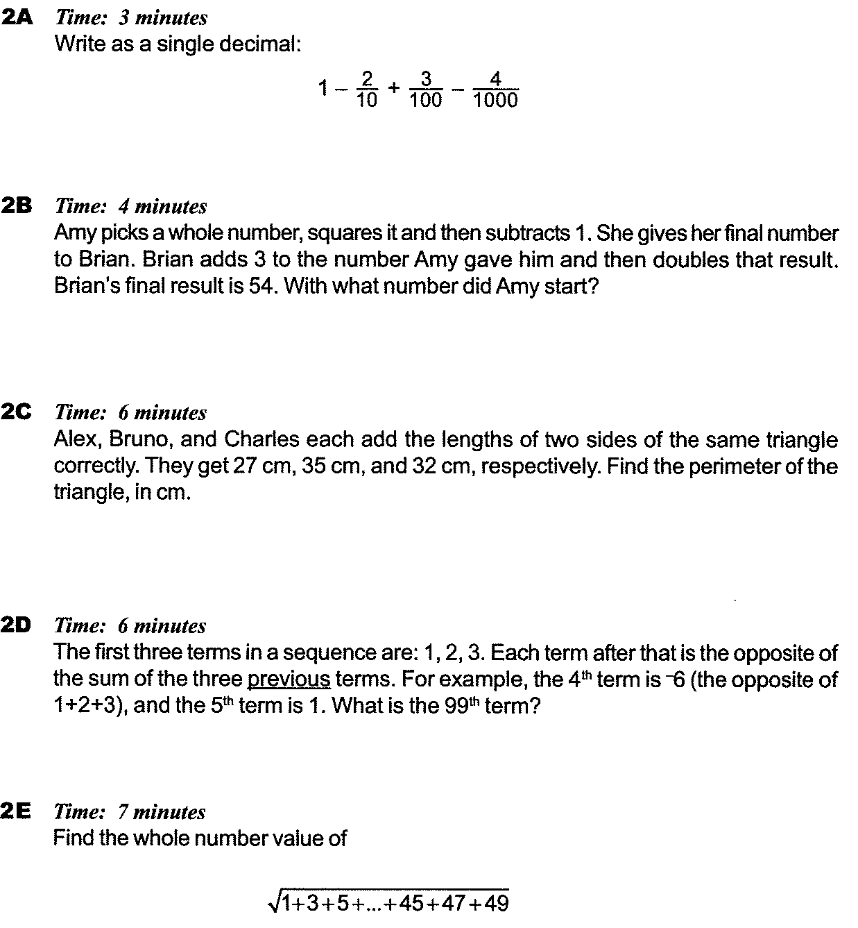
3.
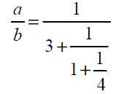
a/b is expressed in its lowest term.
Find a + b.

4.

5.
When Sarah rowed down Black river with the current, she took one hour to go four miles. When she rowed back the same distance, at the same rowing speed, but against the current, her trip required two hours. What is the speed, in miles per hour, of the current in Black river?
6.
.